MSR framework training

Introduction

This exercise provides a hands-on practical introduction to working with the Model Supply Regions (MSR) framework. The MSR framework identifies attractive sites for variable renewable energy (VRE) deployment that can serve as candidate investment options in energy-system models.

In this fictional example, the Ecuadorian Ministry of Energy and Mines is preparing a national power system capacity expansion study as part of their Electricity Master Plan. The existing model represents the country as a single renewable-energy region, which hides important differences in solar and wind quality, distance from existing road and grid infrastructure and land availability. Use the MSR framework to construct spatially explicit renewable model supply regions that can be used in the capacity expansion model.

Part 1: Downloading MSR framework and accompanying software

Part 1.1: GitHub repository

The MSR framework is provided as a collection of Python scripts, control files and input datasets compiled within the GitHub repository. Clone the MSR framework GitHub repository, including the training material, to a local folder on your system.

The repository contains the following folders and files:

1_msr_creator/
2_profile_generator/
3_attribute_combiner/
4_screener/
5_clustering/
inputs/
outputs/
envs/
training/
README

Each workflow folder contains the relevant Python script and control file. The inputs folder stores the required input datasets, while the outputs folder stores the results generated by the MSR framework.

Part 1.2: Python environment

Anaconda is used to manage the Python environment and the packages required by the MSR framework. The environment is defined in the env_msr.yaml file, located in the envs folder.

Open an Anaconda Prompt or terminal, navigate to the envs folder and create and activate the environment using the following commands.

conda env create -f env_msr.yaml
conda activate env_msr

Visual Studio Code is used as integrated development environment (IDE) for running the Python scripts. Open the MSR repository in Visual Studio Code and select the env_msr Python environment as the active interpreter.

Further installation and setup information is provided in the README file.

Part 1.3: QGIS

QGIS is used to visualise the spatial input data and the outputs generated by the MSR framework. The QGIS project includes regional geospatial input datasets, exclusion layers and MSR results for Ecuador. The layers are organised into four thematic groups.

- Infrastructure
- MSR
- Exclusion layers
- Characteristics

Part 2: MSR Creator

The MSR Creator processes regional geospatial datasets and converts suitable renewable-resource areas into Model Supply Regions.

The workflow consist of six stages:

- Process regional geospatial inputs
- Score land-suitability layers
- Identify competitive renewable-resource areas
- Optionally relax resource thresholds in resource-lagging regions
- Polygonise contiguous suitable areas
- Attribute the resulting MSRs with capacity, infrastructure-distance, load-centre, land-cover, climate class and elevation metrics

Part 2.1: QGIS regional geospatial inputs

The infrastructure and characteristics layers are input datasets stored in the inputs folder, describing Ecuador’s existing road and grid networks, physical geography and renewable-resource availability.

When exploring the characteristics of Ecuador, the country is bisected from north to south by the Andes mountains. This is clearly visible in the elevation and slope layer (Figure 1). Across the mountain range, there are areas with high solar and wind resource potential (Figure 2). Divided across both sides of the Adean range there are distinct Köppen-Geiger climate and land-cover classes. Given Ecuador’s diverse landscape it is important to represent distinct sites for solar PV and wind rather than a single-renewable energy region in order to reveal important variation in resource strength, land availability and infrastructure access.

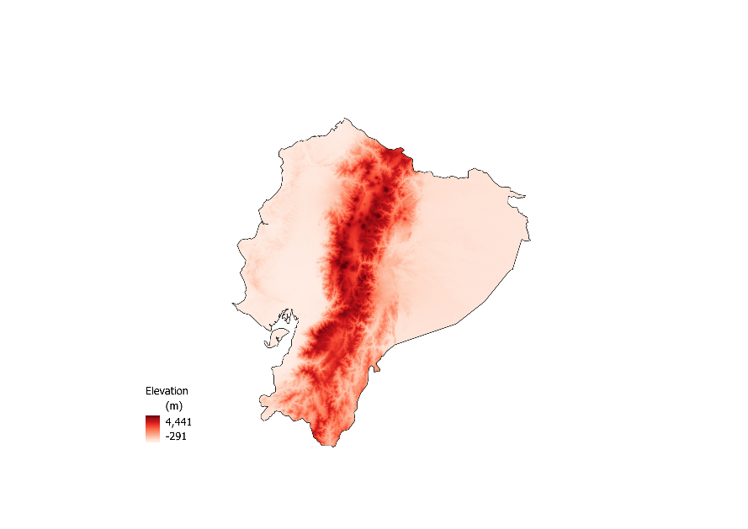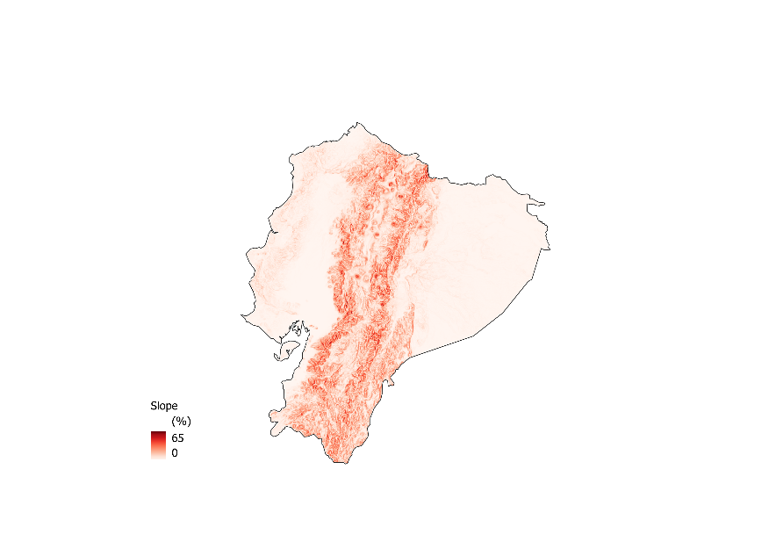
Figure 1: a) Elevation (meters above sea level, m.a.s.l) in Ecuador from the NASA Shuttle Radar Topography Mission (STRM). b) Slope (%) calculated from the elevation raster. Basemap from the Database of Global Administrative Areas (GADM).

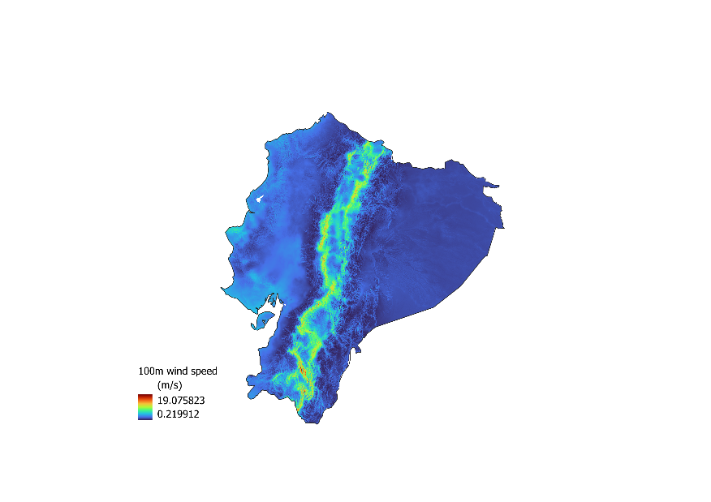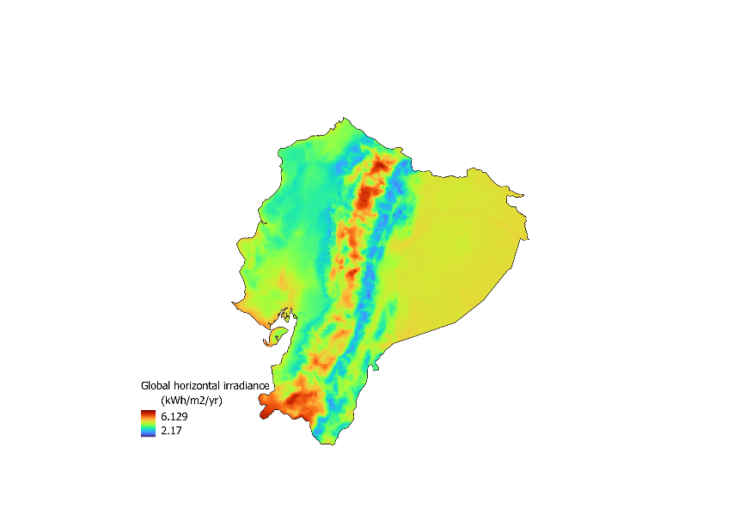
Figure 2: a) Mean wind speed at 100 m (m/s) in Ecuador from the Global Wind Atlas (GWA). b) Global horizontal irradiance (kWh/m2/yr) in Ecuador from Global Solar Atlas (GSA).

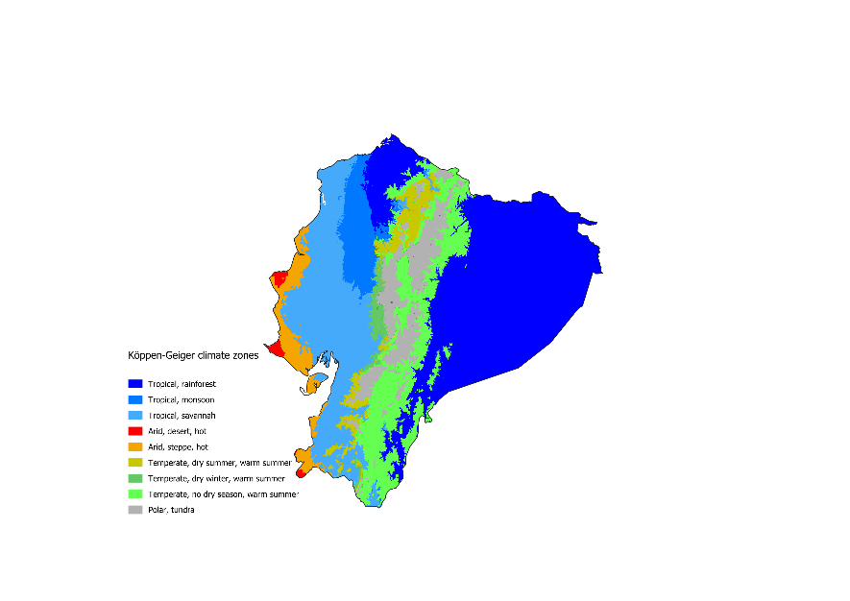
Figure 3: a) Köppen-Geiger climate classes in Ecuador. b) Land-cover classes in Ecuador from ESA GlobCover.

Part 2.2: Exclusion criteria

The MSR Creator excludes areas that are not considered suitable for renewable-energy development.

The exclusion criteria include:
- Very densely populated areas, e.g. cities, are excluded from consideration.
- Locations above a certain elevation and slope are excluded.
- Sites are only considered if they fall within certain classes of land-cover.
- Natural reserves and other protected sites are excluded.
- Sites within a certain vicinity of existing road networks are considered.
- Sites where average VRE resources (irradiation and wind speed) are above a certain minimum threshold, typical for commercial exploitation, are considered.

The above criteria define the exclusion areas, and only regions that meet all criteria are retained as suitable land for subsequent processing for wind and solar PV deployment in Ecuador (Figure 4).

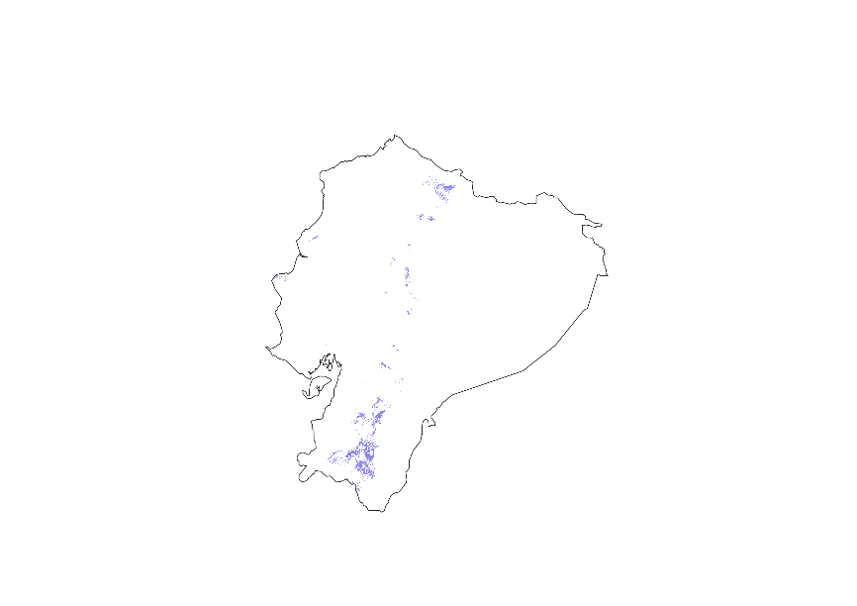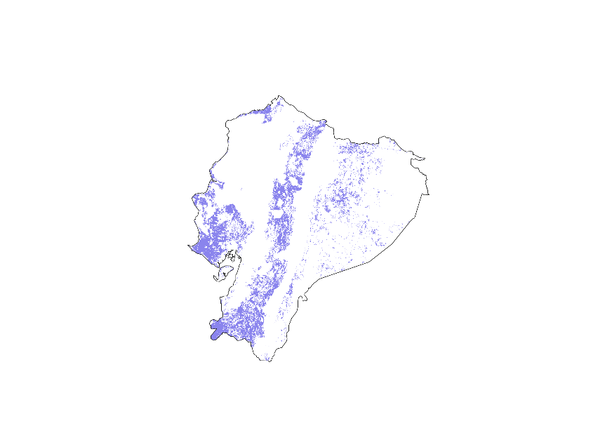
Figure 4: Suitable land area (purple) remaining after the application of exclusion criteria for a) wind and b) solar PV in Ecuador.

Part 2.3: Setting up the control file

The control file, control_file_msr_creator.xlsx, is an Excel workbook containing four worksheets:

- paths
- datasets
- configurations
- parameters

Open the control file and go to the paths worksheet.

This worksheet specifies the paths locating the input and the output folders. Copy the datasets provided in the training folder to the inputs folder. Specify the paths to the inputs and outputs folders in the appropriate cells.

Go to the datasets worksheet.

This worksheet specifies the file names of the required input datasets in the value column as discussed in Part 2.1: QGIS regional geospatial inputs. A description of each dataset is provided in the comments column.

The file names required for this exercise are listed in training_datasets.xlsx, in the msr_creator worksheet. The file names are arranged in the correct order and can be copied directly into the value column of the control file.

Go to the configurations worksheet.

This worksheet specifies the code run configurations and determines which technologies and workflow stages are included. For the first run, enable wind by setting the run_code_for_wind configuration equal to 1 and disable the other technologies. Enable stages 1, 2, 3, 5 and 6. Leave the optional resource-threshold relaxation stage, stage 4, disabled.

Go to the parameters worksheet.

This worksheet specifies general and technology-specific parameters, including resource thresholds, slope and elevation limits, population thresholds, suitable land-cover classes, minimum and maximum MSR capacities, etc. as discussed in Part 2.2: Exclusion criteria. The parameters required for this exercise are listed in training_parameters.xlsx, in the msr_creator worksheet. The parameters are arranged in the correct order and can be copied directly into the value column of the control file. Further information on the methodological assumptions is provided in the MSR paper.

Part 2.4: Running the MSR Creator

Once the input datasets and control file have been prepared, open a terminal in your preferred IDE, here we use VS Code. Navigate to the 1_msr_creator folder and run

python msr_creator.py

Follow the log messages in the terminal to monitor the progress of the workflow. The script reports the active region, technology and workflow stage. The run is complete when the message “MSR Creator workflow completed” appears in the terminal.

The script creates a subfolder for each modelled region in the output folder. For this exercise, the outputs are stored in the Ecuador subfolder, and intermediate outputs are organised by workflow stage.

The region-specific input datasets are stored in the stage1_input_datasets folder. The outputs from stage 1 were shown in Part 2.1: QGIS regional geospatial inputs. The suitability and exclusion layers are stored in the stage2_scored_datasets folder providing the suitable area. The resource competitive area is located in the stage3_competitive_resource_area folder. The suitable land area for wind and solar PV MSRs were shown in Part 2.2: Exclusion criteria. The suitable MSRs locations are defined in the wind_2000_final_msrs.shp shapefile and is stored in the stage6_attribution folder (Figure 5). The region subfolder also contains summary figures showing the composition of MSR areas by elevation range (Figure 6).

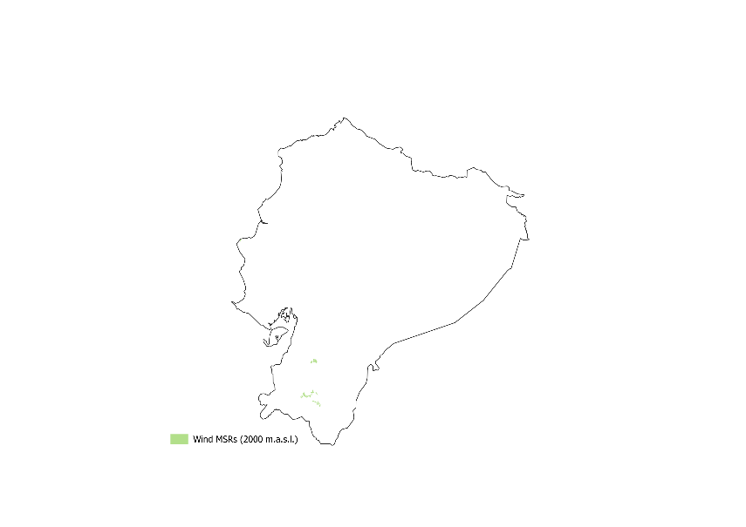
Figure 5: Wind MSRs in Ecuador with an elevation threshold at 2,000 m.a.s.l.
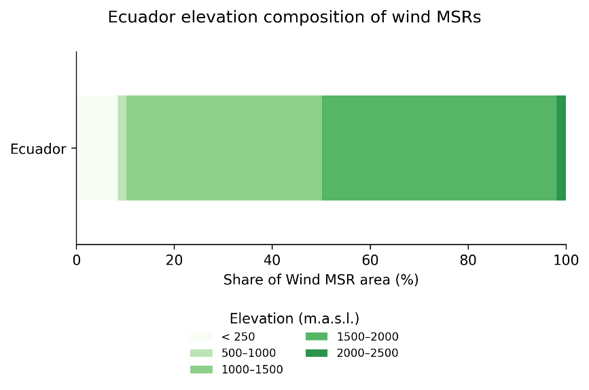
Figure 6: Composition of wind MSRs by elevation in Ecuador.

Part 2.5: Evaluating the elevation threshold

Given Ecuador’s topography and resource potential, the strongest wind resources are located in the Andes mountain range. In this exercise, the elevation threshold is increased from 2,000 to 3,000 m.a.s.l to investigate how access to higher-elevation areas affects the resulting MSRs.

Go to the configurations worksheet.

Keep the run_code_for_wind configuration equal to 1 and leave the other technologies disabled. Disable stage 1, as the region-specific input datasets were previously created, and enable stages 2, 3, 5 and 6. Leave the optional resource-threshold relaxation stage, stage 4, disabled.

Go to the parameters worksheet.

Change the elevation_threshold parameter from 2,000 to 3,000 m.a.s.l.

Run the MSR creator script from the dedicated terminal.

A new shapefile is created in the stage6_attribution folder, including suitable MSR locations for the adapted elevation threshold (Figure 7). The composition of MSR areas by elevation range indicates that the majority of the suitable MSR area is located at higher-altitude areas between 2,000 to 3,000 m.a.s.l. (Figure 8).

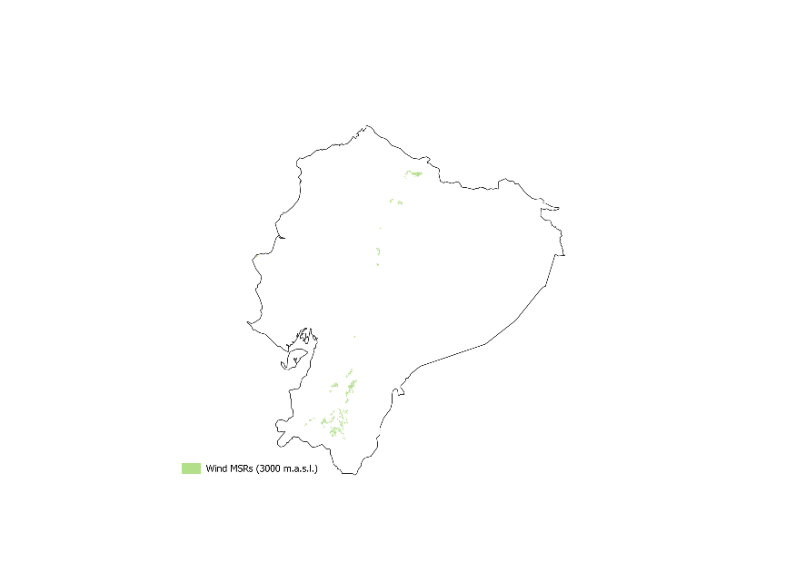
Figure 7: Wind MSRs in Ecuador with an elevation threshold at 3000 m.a.s.l.

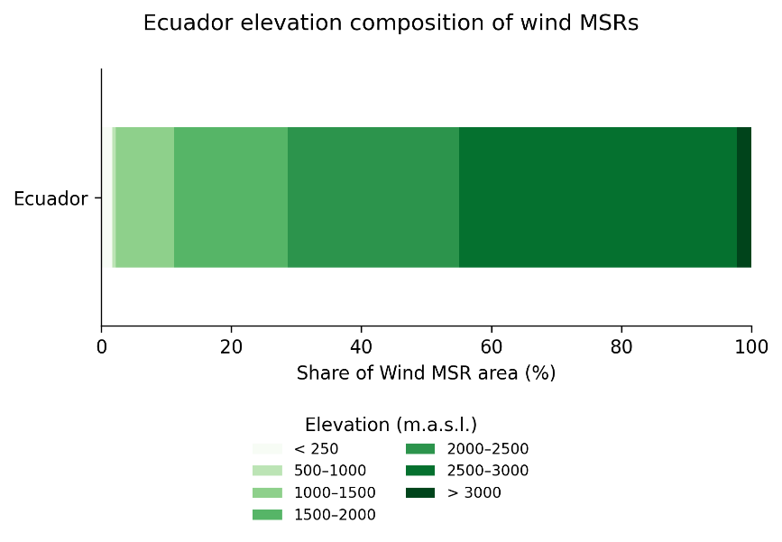
Figure 8: Composition of wind MSRs by elevation in Ecuador.

The region subfolder also contains summary figures showing the composition of suitable MSR area by land-cover class (Figure 9) and Köppen-Geiger climate class (Figure 10).

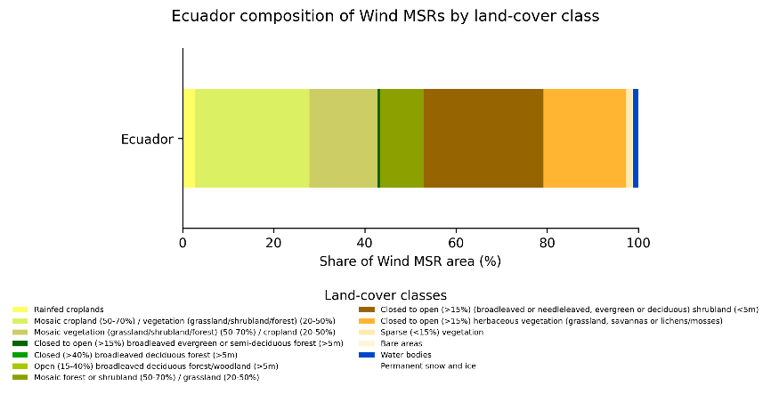
Figure 9: Composition of wind MSRs by land-cover class in Ecuador.
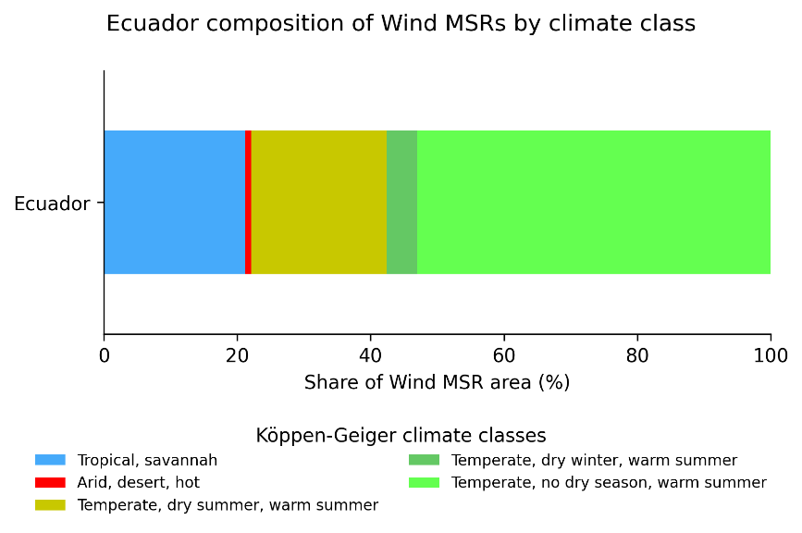
Figure 10: Composition of wind MSRs by Köppen-Geiger climate class in Ecuador.

Part 2.6: Running MSR Creator for solar PV

Investigate suitable solar PV MSRs and repeat the MSR Creator workflow.

Go to the configurations worksheet.

Enable solar PV technology by setting the run_code_for_solarpv configuration equal to 1 and disable the other technologies. Enable stages 1, 2, 3, 5 and 6. Leave the optional resource-threshold relaxation stage, stage 4, disabled.

Run the MSR creator script from the dedicated terminal. A new shapefile is created in the stage6_attribution folder including suitable MSR locations for Solar PV.

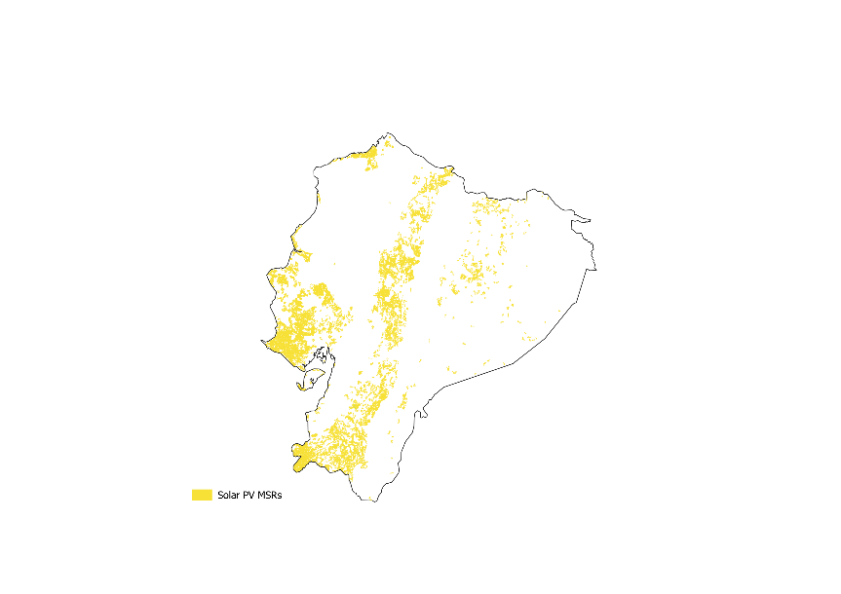
Figure 11: Solar PV MSRs in Ecuador.

Part 3: Profile Generator

- Plot duration curves.
- Plot frequency distribution.
- Plot daily and seasonal profile.
- Plot composition of CF.

Part 5: Attributor Combiner

- Understand the cost assumptions.
- Plot composition of distance to grid.
- Plot composition of LCOE

Part 6: Screener

- Move from suitable to attractive MSRs.
- For both solar and wind power the most attractive locations are seen to be found across the Andean mountain range traversing the country longitudinally, where solar irradiation and wind speeds are highest and the transmission grid is never too distant.

Part 7: Clustering

