MSR training dataset
Contents
Introduction 2
Downloading MSR framework and accompanying software 2
GitHub repository 2
Python environment 2
QGIS 2
Part 1: MSR Creator 3
Part 1.1: Regional geospatial inputs 3
Part 1.2: Exclusion criteria 4
Part 1.3: Setting up the control file 5
Part 1.4: Running the MSR Creator for wind power 7
Part 1.5: Evaluating the elevation threshold 8
Part 1.6: Running the MSR Creator for solar PV 10
Part 2: Profile Generator 11
Part 2.1: Obtaining meteorological input data 11
Part 2.2: Setting up the control file 12
Part 2.3: Running the Profile Generator 12
Part 3: Attributor Combiner 14
Part 3.1: Setting up the control file 14
Part 3.2: Running the Attributor Combiner 14
Part 4: Screener 18
Part 4.1: Setting up the control file 18
Part 4.2: Running the Screener 19
Part 5: Clustering 20

Introduction

This exercise provides a hands-on practical introduction to working with the Model Supply Regions (MSR) framework. The MSR framework identifies attractive sites for variable renewable energy (VRE) deployment that can serve as candidate investment options in energy-system models.

In this fictional example, consultants are preparing a national power system capacity expansion study for Ecuador. Their existing model represents the country as a single renewable-energy region, which hides important differences in solar and wind quality, distance from existing road and grid infrastructure, and land availability. They intend to use the MSR framework to construct spatially explicit renewable model supply regions that can be used in the capacity expansion model.

Downloading MSR framework and accompanying software

GitHub repository

The MSR framework is provided as a collection of Python scripts, control files and input datasets compiled within the GitHub repository. Clone the MSR framework GitHub repository, including the training material, to a local folder on your system.

The repository contains the following folders and files:
1_msr_creator/
2_profile_generator/
3_attribute_combiner/
4_screener/
5_clustering/
inputs/
outputs/
envs/
training/
README

Each workflow folder (1-5) contains the relevant Python script and control file. The inputs folder stores the required input datasets, while the outputs folder stores the results generated by the MSR framework.

Python environment

Anaconda (https://www.anaconda.com/download/success?reg=skipped) is used to manage the Python environment and the packages required by the MSR framework. The environment is defined in the msr_env_update.yaml file, located in the envs folder.

👉🏼 Open an Anaconda Prompt or terminal, navigate to the envs folder and create and activate the environment using the following commands:

conda env create -f mrs_env_update.yaml
conda activate mrs_env_update

Spyder is used as integrated development environment (IDE) for running the Python scripts (launch spyder from the terminal inside the msr_env_update environment).

QGIS

QGIS is used to visualise the spatial input data and the outputs generated by the MSR framework.

Part 1: MSR Creator

The MSR Creator processes regional geospatial datasets and converts suitable renewable-resource areas into Model Supply Regions.

The workflow consist of five stages:

- Process regional geospatial inputs.
- Score land-suitability layers.
- Identify competitive renewable-resource areas.
- Polygonise contiguous suitable areas.
- Attribute the resulting MSRs with capacity, infrastructure-distance, land-cover class, climate class, elevation, and other relevant metrics.

Part 1.1: Regional geospatial inputs

The infrastructure and land characteristics layers are input datasets stored in the inputs folder, describing Ecuador’s existing road and grid networks, physical geography, and renewable resource availability.

When exploring the topographic characteristics of Ecuador (here excluding the Galápagos islands), the country is bisected from north to south by the Andes mountains. This is clearly visible in the elevation and slope layer (Figure 1).

Across the mountain range, there are areas with high solar and wind resource potential (Figure 2).

Divided across both sides of the Andean range there are distinct Köppen-Geiger climate and land-cover classes (Figure 3).

Given Ecuador’s diverse landscape, it is important to represent distinct sites for solar PV and wind, rather than a single renewable energy representation, in order to reveal important variations in resource strength, land availability, and infrastructure access.

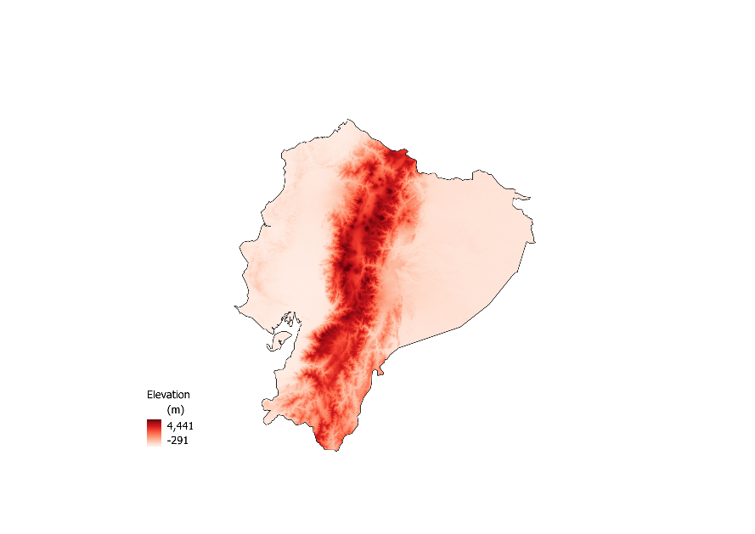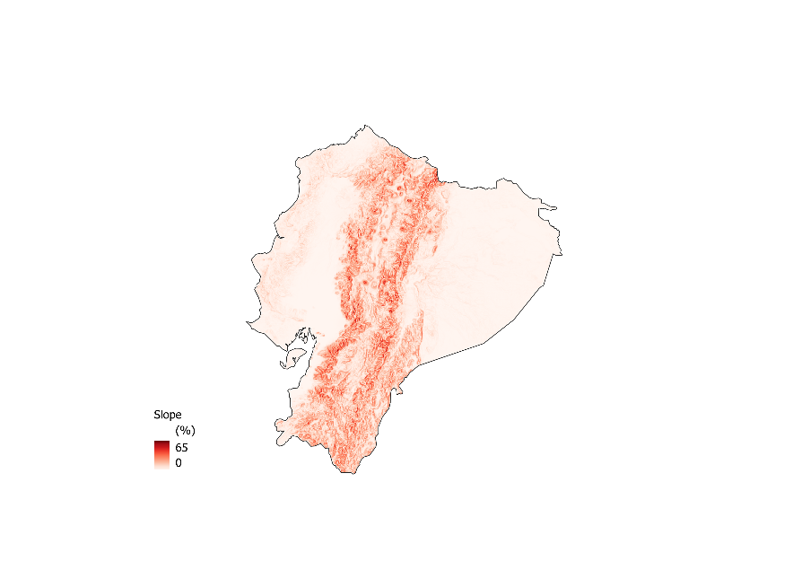

Figure 1: a) Elevation (meters above sea level, m.a.s.l) in Ecuador from the NASA Shuttle Radar Topography Mission (STRM). b) Slope (%) calculated from the elevation raster. Basemap from the Database of Global Administrative Areas (GADM).

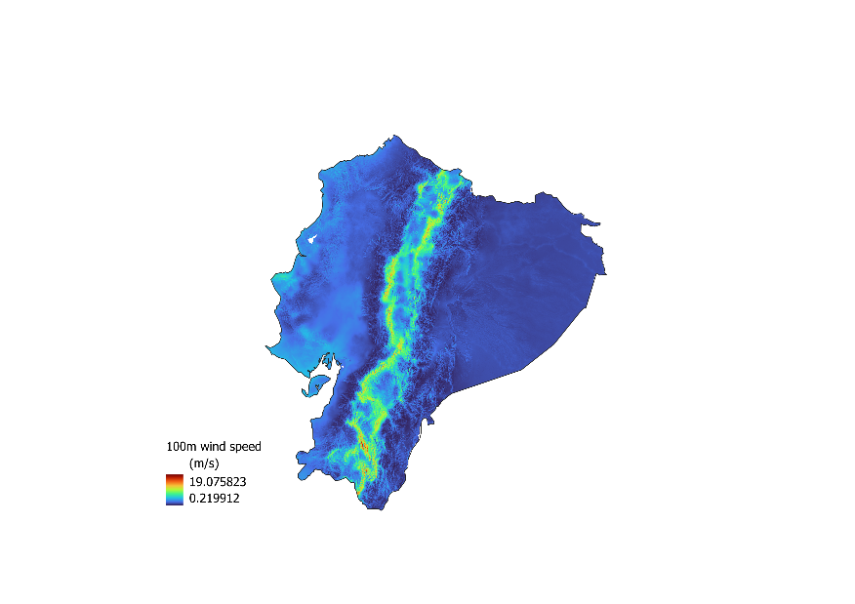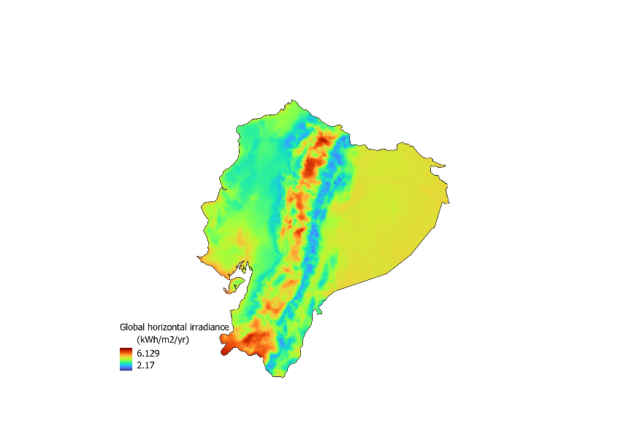

Figure 2: a) Mean wind speed at 100 m (m/s) in Ecuador from the Global Wind Atlas (GWA). b) Global horizontal irradiance (kWh/m²/yr) in Ecuador from Global Solar Atlas (GSA).

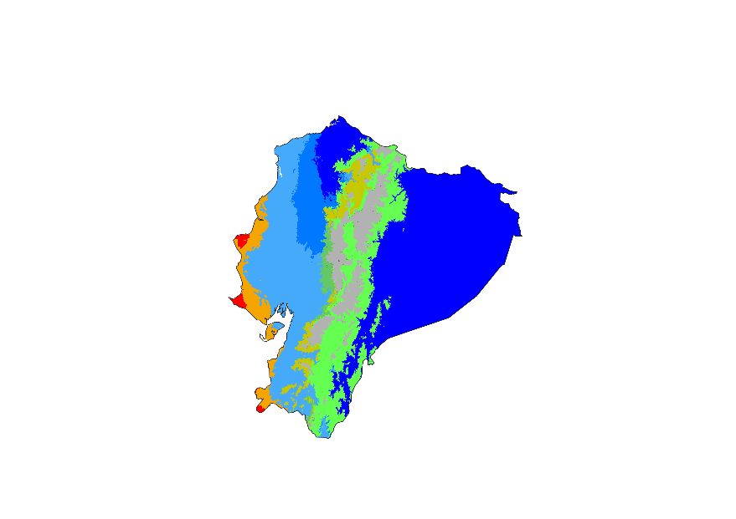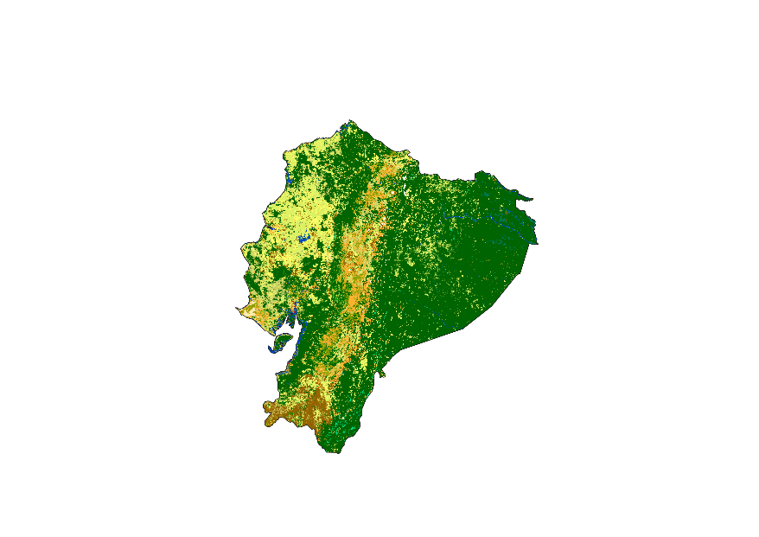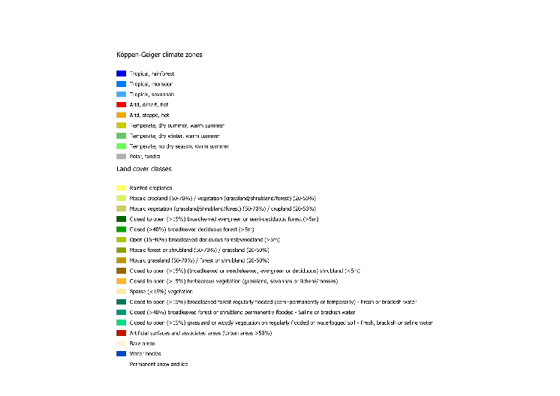

Figure 3: a) Köppen-Geiger climate classes in Ecuador. b) Land-cover classes in Ecuador from ESA GlobCover.

Part 1.2: Exclusion criteria

The MSR Creator excludes areas that are not considered suitable for renewable-energy development.

The exclusion criteria, which can be strengthened or loosened by the user, include:
- Very densely populated areas, e.g. cities;
- Locations above a certain elevation and slope;
- Selected classes of land-cover;
- Natural reserves and other protected sites;
- Sites outside of a certain vicinity of existing road and electricity networks can be discarded;
- Sites where average VRE resources (irradiation and wind speed) are below a certain minimum threshold, typical for commercial exploitation, can be discarded.

The above criteria define the exclusion areas, and only regions that meet all criteria are retained as suitable land for subsequent processing for wind and solar PV deployment (Figure 4).

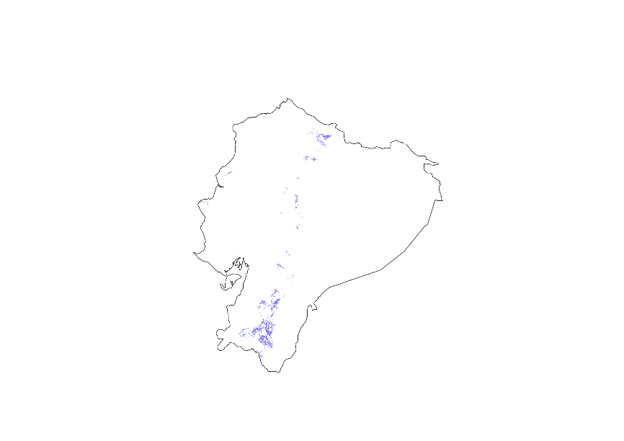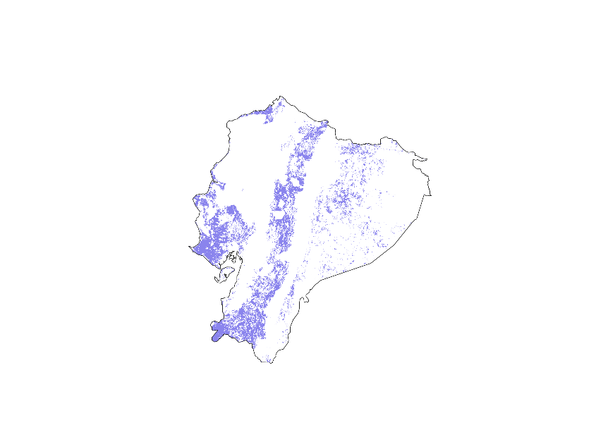
Figure 4: Example of suitable land area (purple) remaining after the application of exclusion criteria for a) wind and b) solar PV in Ecuador.

Part 1.3: Setting up the control file

The control file for the MSR Creator script, control_file_msr_creator.xlsx, is an Excel workbook containing four worksheets:

- paths
- datasets
- configurations
- parameters

👉🏼 Open the control file (MSR creator) and go to the paths worksheet.

This worksheet specifies the paths locating the input and the output folders. Specify the paths to the inputs and outputs folders in the appropriate cells (see Figure 5).

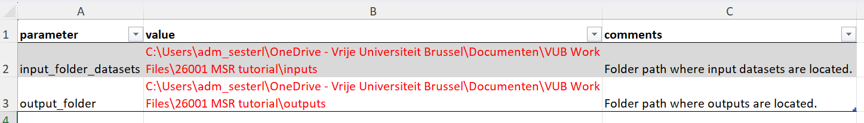
Figure 5: Entering file paths to input and output folders in the control file paths worksheet.

👉🏼 Go to the datasets worksheet.

This worksheet specifies the file names of the required input datasets in the value column (B) as discussed in Part 1.1: Regional geospatial inputs. A description of each dataset is provided in the comments column (D).

The file names required for this exercise are listed in training_datasets.xlsx msr_creator worksheet (the corresponding files are in the inputs folder). The file names are already arranged in the correct order. Copy them directly into the value column of the control file (see Figure 6).

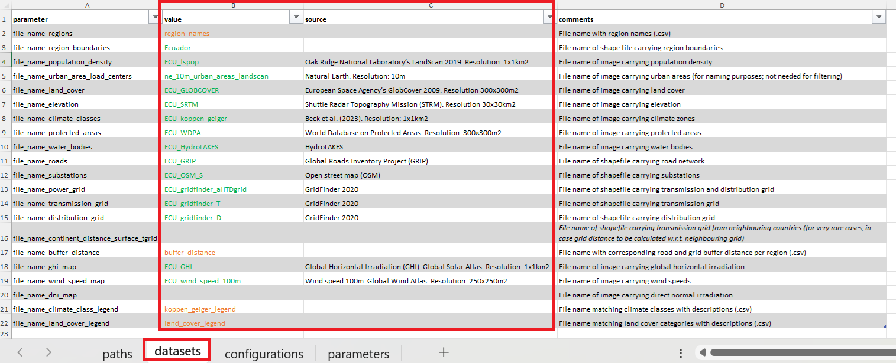
Figure 6: Filling the control file datasets worksheet with input data file names.

👉🏼 Go to the configurations worksheet.

This worksheet specifies the code run configurations and determines which technologies and workflow stages are included. For the first run, enable wind by setting the run_code_for_wind configuration equal to 1 and disable the other technologies. Enable stages 1, 2, 3, 4 and 5. See Figure 7.

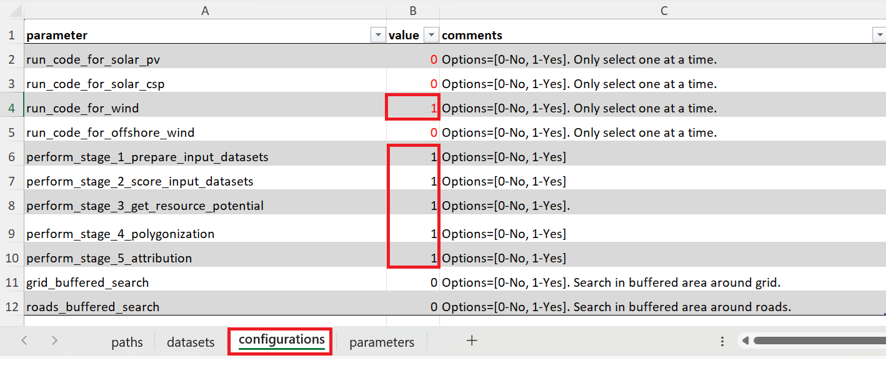
Figure 7: Setting run configurations for the MSR creator using the control file configurations worksheet.

👉🏼 Go to the parameters worksheet.

This worksheet specifies general and technology-specific parameters, including resource thresholds, slope and elevation limits, population thresholds, suitable land-cover classes, minimum and maximum MSR capacities, etc. as discussed in Part 1.2: Exclusion criteria.

The parameters required for this exercise are listed in training_parameters.xlsx msr_creator worksheet. The parameters are arranged in the correct order and can be copied directly into the value column of the control file, as shown in Figure 8.

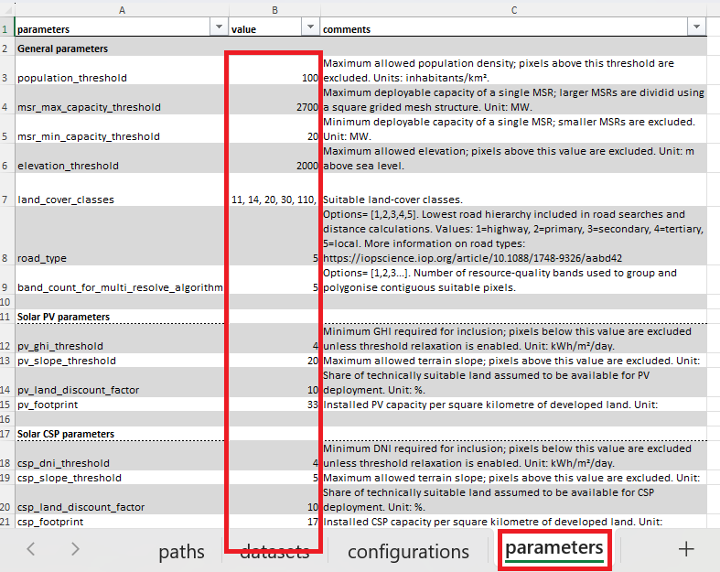
Figure 8: Entering exclusion parameters in the control file parameters worksheet.

Part 1.4: Running the MSR Creator for wind power

Once the input datasets and control file have been prepared, the MSR creator script can be run.

🏃🏽 CODE RUN 🏃🏽

Navigate to the 1_msr_creator folder and run msr_creator.py.

Follow the log messages in the terminal to monitor the progress of the workflow. The script reports the active region, technology and workflow stage. The run is complete when the message “MSR Creator workflow completed” appears in the terminal.

In the outputs folder, the script creates a new folder 1_msr_creator with subfolders for each modelled region. For this exercise, the outputs are stored in the Ecuador subfolder, and intermediate outputs are organised by workflow stage.

The region-specific input datasets are stored in the stage1_input_datasets folder. (The outputs from stage 1 were shown in Part 1.1: Regional geospatial inputs.)

The suitability and exclusion layers are stored in the stage2_scored_datasets folder providing the suitable area according to each separate exclusion layer.

The resource competitive area, combining the different exclusion layers, is located in the stage3_competitive_resource_area folder.

The suitable MSRs locations are defined in the wind_final_msrs.shp shapefile and is stored in the stage5_attribution folder (Figure 9). (The suitable land area for wind and solar PV MSRs were shown in Part 1.2: Exclusion criteria.)

The region subfolder also contains summary figures showing the composition of MSR areas by elevation range, land use, and climate zone (Figure 10).

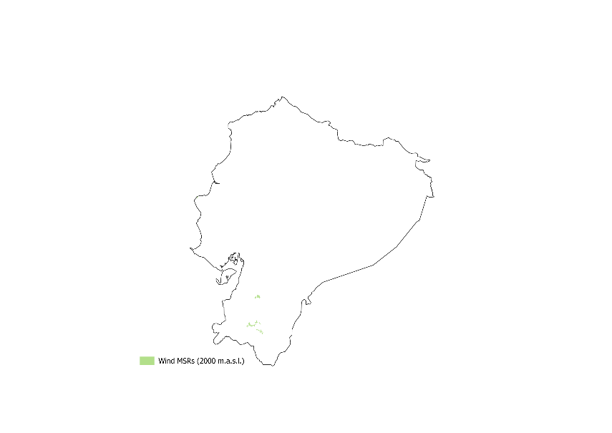
Figure 9: Example wind MSRs in Ecuador with an elevation threshold at 2,000 m.a.s.l.

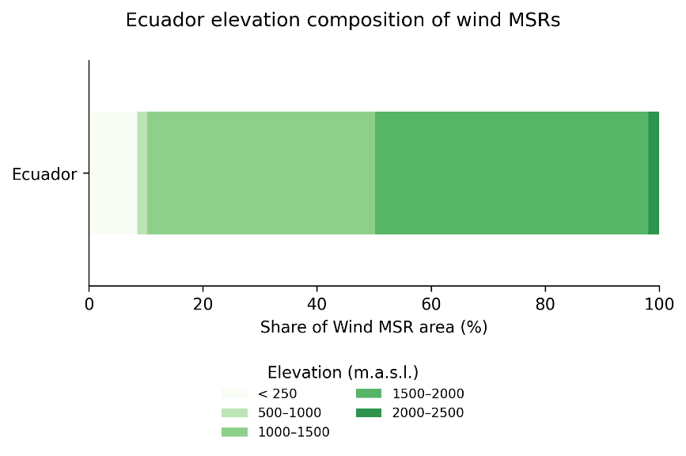
Figure 10: Example composition of wind MSRs by elevation in Ecuador (for a run with altitude exclusion above 2000 m.a.s.l.).

Part 1.5: Changing exclusion criteria

Given Ecuador’s topography and resource potential, the strongest wind resources are located in the Andes mountain range. In this exercise, the elevation threshold is increased from 2,000 to 3,000 m.a.s.l to investigate how access to higher-elevation areas affects the resulting MSRs.

👉🏼 Go to the control file configurations worksheet.

Keep the run_code_for_wind configuration equal to 1 and leave the other technologies disabled. Disable stage 1, as the region-specific input datasets were previously created, and leave stages 2, 3, 4 and 5 enabled.

👉🏼 Go to the control file parameters worksheet. Change the elevation_threshold parameter from 2,000 to 3,000 m.a.s.l.

🏃🏽 CODE RUN 🏃🏽

Run msr_creator.py again.

A new shapefile is created in the stage5_attribution folder, including suitable MSR locations for the adapted elevation threshold (Figure 11). The composition of MSR areas by elevation range indicates that the majority of the suitable MSR area is located at higher-altitude areas between 2,000 to 3,000 m.a.s.l. (Figure 12).

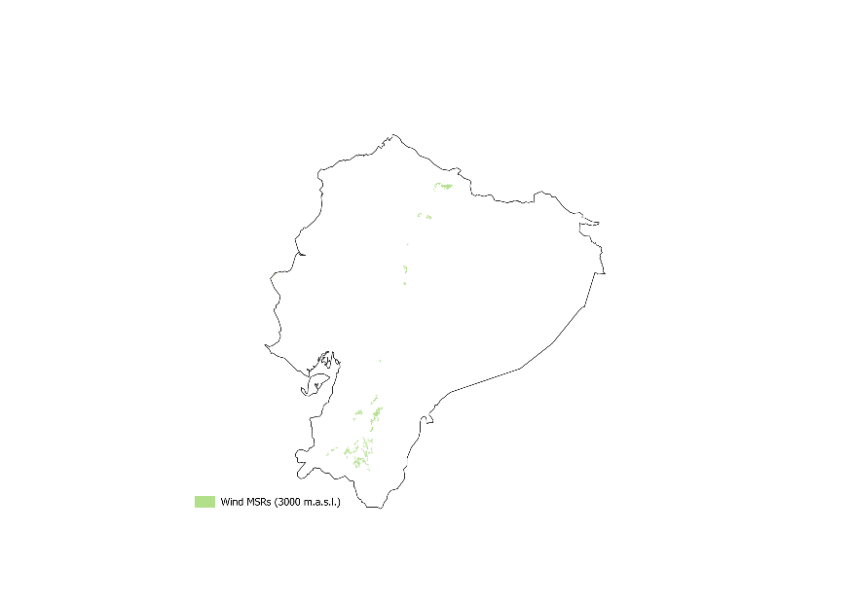
Figure 11: Example wind MSRs in Ecuador with an elevation threshold at 3000 m.a.s.l.

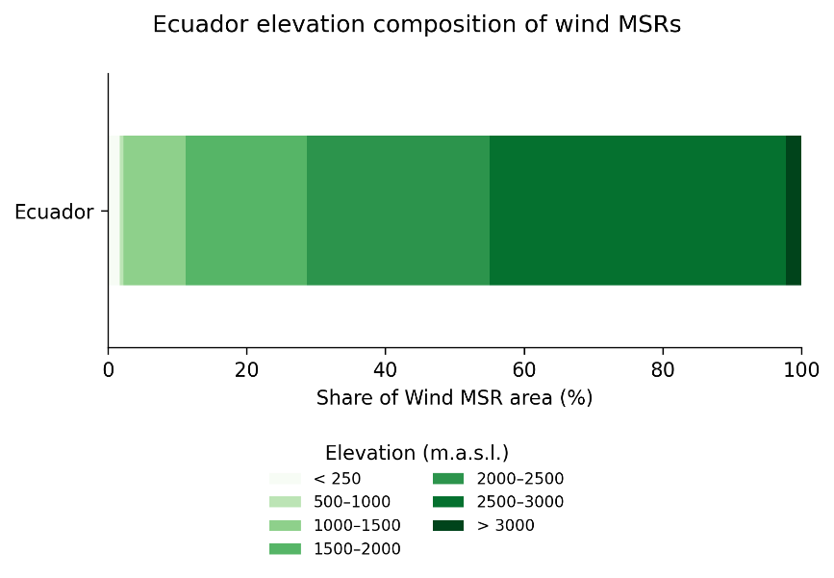
Figure 12: Example composition of wind MSRs by elevation in Ecuador (for a run with altitude exclusion above 3000 m.a.s.l.).

As indicated, the region subfolder also contains summary figures showing the composition of suitable MSR area by land-cover class (example in Figure 13) and Köppen-Geiger climate class (example in Figure 14).

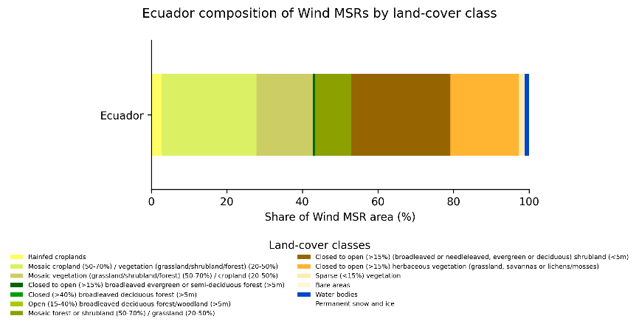

Figure 13: Example composition of wind MSRs by land-cover class in Ecuador.
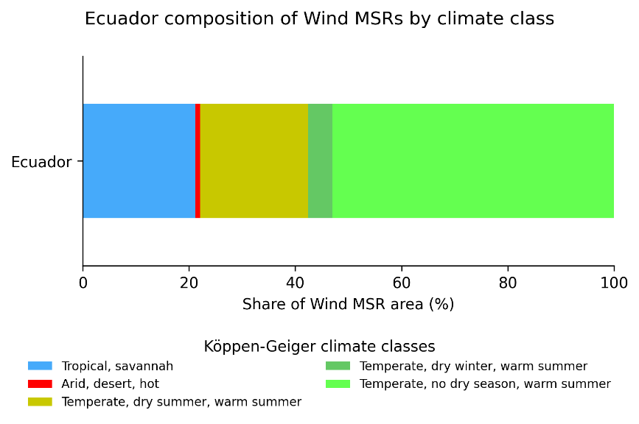

Figure 14: Example composition of wind MSRs by Köppen-Geiger climate class in Ecuador.

Part 1.6: Running the MSR Creator for solar PV

Here, we will investigate suitable solar PV MSRs and repeat the MSR Creator workflow.

👉🏼 Go to the control file configurations worksheet.

👉🏼 Enable solar PV technology by setting the run_code_for_solarpv configuration equal to 1 and disable the other technologies. Enable stages 1, 2, 3, 4 and 5.

🏃🏽 CODE RUN 🏃🏽

Run msr_creator.py again.

A new shapefile is created in the stage5_attribution folder including suitable MSR locations for solar PV (Figure 15).
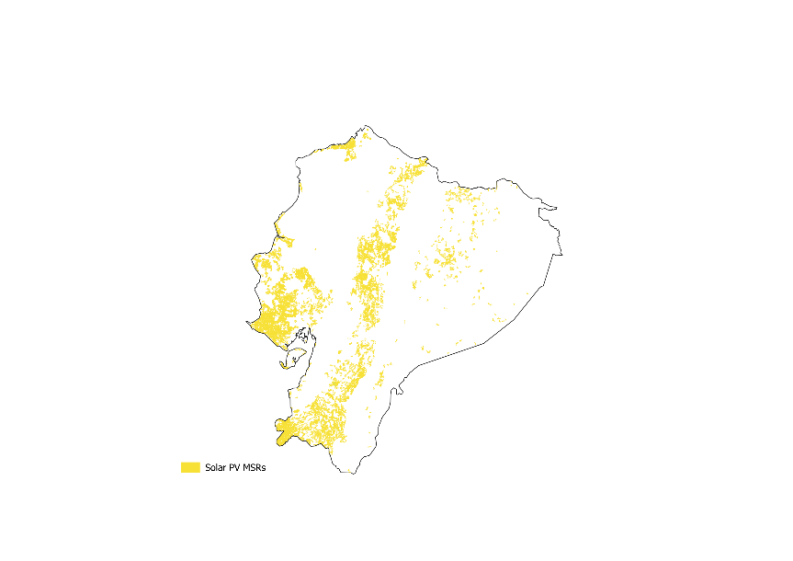
Figure 15: Example solar PV MSRs in Ecuador.

Part 2: Profile Generator

The Profile Generator extracts meteorological time series from netCDF (.nc) files obtained from the ECMWF’s ERA5 reanalysis (https://cds.climate.copernicus.eu/datasets/reanalysis-era5-single-levels?tab=overview), available through the Climate Data Store, and uses it to calculate time series of power generation potential at the created MSR sites.

Part 2.1: Obtaining meteorological input data

In principle, the meteorological input data can be obtained by creating an account on the Climate Data Store (CDS), obtaining a CDS API (more information can be found on https://cds.climate.copernicus.eu/how-to-api), and running a script to download the relevant data.

For the Profile Generator, the data must be downloaded and organised in the following format:
- One file of meteorological data per year (to avoid too large data files)
- Hourly resolution (all hours of the year)
- .netCDF format
- File name: [year]_[identifier].nc, for instance “2012_ssrd.nc” for ssrd data (surface solar radiation downwards) for the year 2012

For instance, downloading ssrd data for the year 2012 for Ecuador would be done by running the following script after having installed the CDS API:

import cdsapi

dataset = "reanalysis-era5-single-levels"
request = {
"product_type": ["reanalysis"],
"year": ["2012"],
"month": ["01", "02", "03", "04", "05", "06", "07", "08", "09", "10", "11", "12"],
"day": [
"01", "02", "03", "04", "05", "06", "07", "08", "09", "10", "11", "12",
"13", "14", "15", "16", "17", "18", "19", "20", "21", "22", "23", "24",
"25", "26", "27", "28", "29", "30", "31"
],
"time": [
"00:00", "01:00", "02:00", "03:00", "04:00", "05:00", "06:00", "07:00", "08:00", "09:00", "10:00", "11:00",
"12:00", "13:00", "14:00", "15:00", "16:00", "17:00", "18:00", "19:00", "20:00", "21:00", "22:00", "23:00"
],
"data_format": "netcdf",
"download_format": "unarchived",
"variable": ["surface_solar_radiation_downwards"],
"area": [1.5, -81, -5, -75.25]
}

client = cdsapi.Client()
client.retrieve(dataset, request).download()

The following meteorological datasets are necessary to run the Profile Generator:

- Surface solar radiation downwards (ssrd) [for solar PV]
- 2-m temperature (t2m) [for solar PV and wind]
- 10-m wind speed (u10, v10) [for wind]
- 100-m wind speed (u100, v100) [for wind]
- geopotential (z) [for wind]

For this exercise, the data has already been downloaded and is located in the inputs folder, in separate .nc files for the years 2012, 2013 and 2014.

👉🏼 Open the control file (Profile Generator) and go to the paths worksheet. Enter here again the correct paths to the inputs and outputs folders, as in Figure 5.

Part 2.2: Setting up the control file

👉🏼 Go to the datasets worksheet. Link here the netCDF files, plus resource rasters and a few data tables in the input folder, to the correct entries in the table. The .nc files will be linked with the [identifier] in their file name (see above). The result should look as in Figure 16.

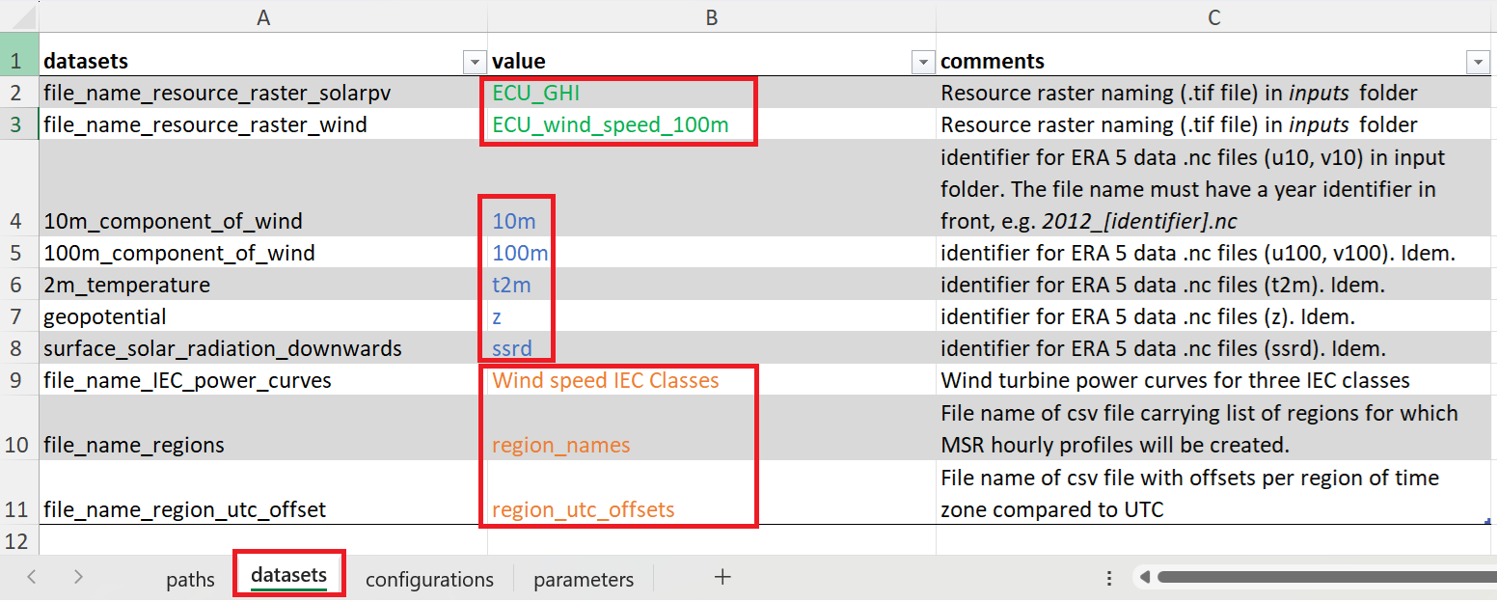
Figure 16: Linking entries to the correct datasets in the control file datasets worksheet.

👉🏼 Go to the configurations worksheet. Select here run_code_for_wind = 1 and set the others to zero, to run the Profile Generator for wind.

👉🏼 Go to the parameters worksheet. Set the years to analyse under weather_years as semicolon-separated list, as in Figure 17. The reference_year can be any year in the weather_years set (it is necessary to perform the spatial downscaling of wind profiles to higher resolution).

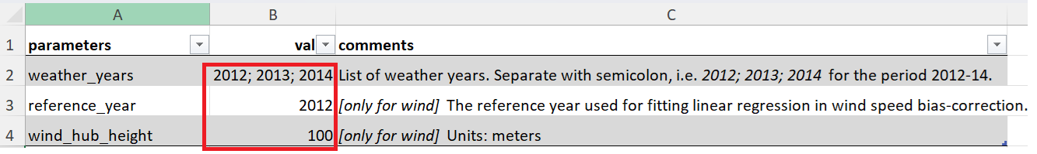
Figure 17: Specifying the Profile Generator parameters in the control file parameters worksheet.

Part 2.3: Running the Profile Generator

🏃🏽 CODE RUN 🏃🏽

Run profile_generator.py for wind power.

Follow the log messages in the terminal to monitor the progress of the workflow. The script reports the active region, technology and workflow stage. The run is complete when the message “Profile Generator workflow completed” appears in the terminal.

In the outputs folder, the script creates a folder 2_profile_generator with a subfolder for each modelled region. The output consist of .csv files with time series for all MSRs in UTC and local time, plus graphics showing statistics of diurnal and seasonal profiles of capacity factors (weighted by MSR size), as in the example in Figure 18 and Figure 19 for wind power.

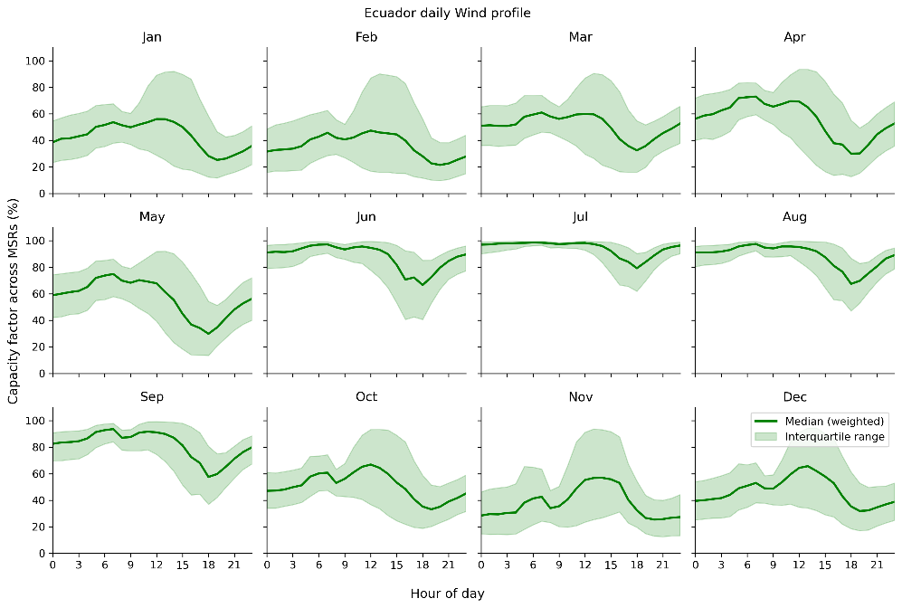
Figure 18: Example diurnal capacity factor profiles for wind power per month across MSRs after the Profile Generator run.

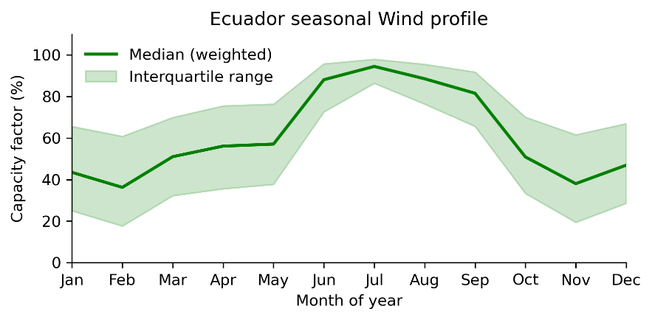
Figure 19: Example seasonal capacity factor profile for wind power across MSRs after the Profile Generator run.

Let us now generate the profiles for solar PV.

👉🏼 Go to the configurations worksheet. Select here run_code_for_solar_pv = 1 and the others to zero.

🏃🏽 CODE RUN 🏃🏽

Run profile_generator.py for solar PV. Have a look at the output profiles.

Part 3: Attributor Combiner

The attributor combiner determines, for each individual MSR, the production and cost attributes including loss adjusted annual capacity factors and three part-wise Levelised Cost of Electricity (LCOE) metrics for supply, grid and substation connection, and road connection.

Part 3.1: Setting up the control file

Open the control file for the Attributor Combiner script, control_file_attributor_combiner.xlsx, that includes the same worksheet structure as the other control files.

👉🏼 Open the control file paths worksheet.

Specify the paths to the inputs and outputs folders in the appropriate cells, as in Figure 5.

👉🏼 Go to the datasets worksheet.

The file names required for this exercise are listed in training_datasets.xlsx attributor_combiner worksheet. The file names are arranged in the correct order. Copy them directly into the value column of the control file, which should look as in Figure 20.

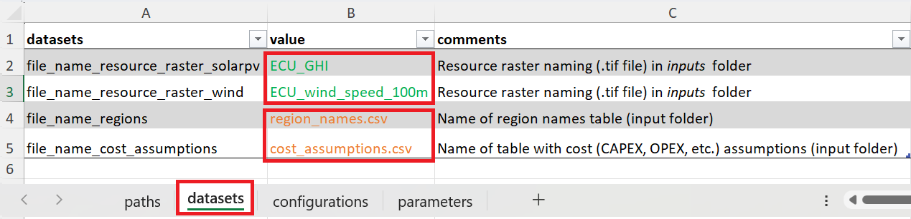
Figure 20: Specifying the input datasets to run the Attributor Combiner script in the control file datasets worksheet.

👉🏼 Go to the configurations worksheet.

For the first run, enable wind by setting the run_code_for_wind configuration equal to 1 and disable the other technologies. Enable local_time_profile to use the local time profiles that were generated by the Profile Generator.

👉🏼 Go to the parameters worksheet.

The parameters required for this exercise are listed in training_parameters.xlsx, in the attributor_combiner worksheet. The parameters are arranged in the correct order. Copy them directly into the value column of the control file.

Part 3.2: Running the Attributor Combiner

👉🏼 Once the control file has been prepared, navigate to the 3_attributor_combiner folder.

🏃🏽 CODE RUN 🏃🏽

Run attributor_combiner.py for wind power.

Follow the log messages in the terminal to monitor the progress of the workflow. The script reports the active region, technology and workflow stage. The run is complete when the message “Attributor Combiner workflow completed” appears in the terminal.

In the output folder, the script creates a folder 3_attributor_combiner with a subfolder for each modelled region. Here, the outputs are stored in the Ecuador subfolder where the attributed wind MSRs are defined in the wind_prescreen.shp shapefile. This new shapefile contains cost attributes for every MSR (related to power generation, transmission, and road infrastructure), as well as corresponding LCOE values.

The region subfolder also contains summary figures showing the composition of suitable MSR areas by distance from the grid (example in Figure 21), capacity factor (example in Figure 22) and LCOE (example in Figure 23).

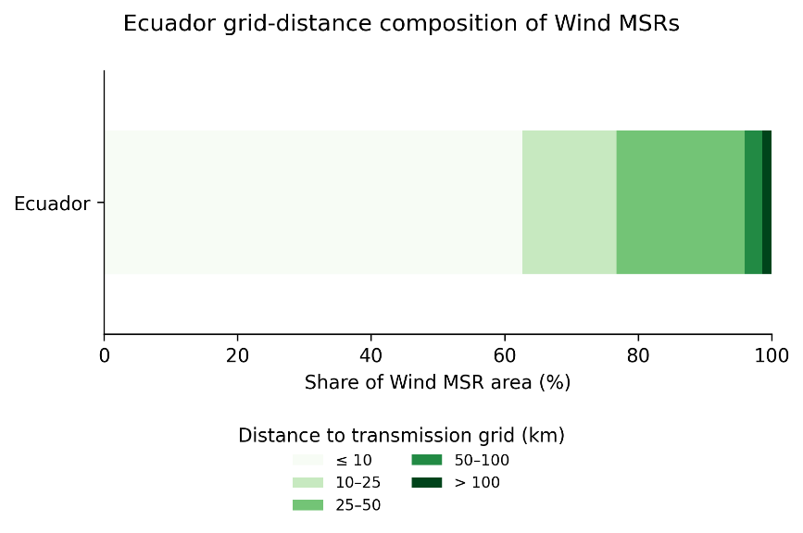
Figure 21: Example composition of wind MSRs by distance to transmission grid (km) in Ecuador.
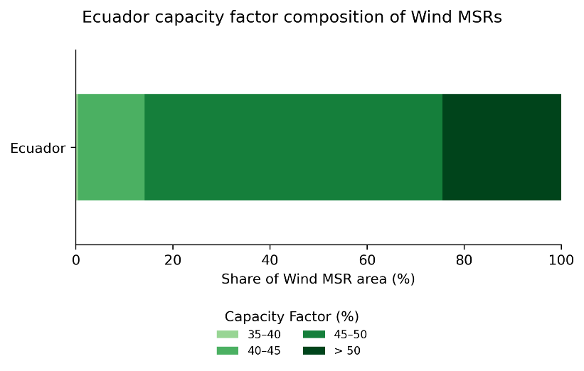

Figure 22: Example composition of wind MSRs by capacity factor (%) in Ecuador.

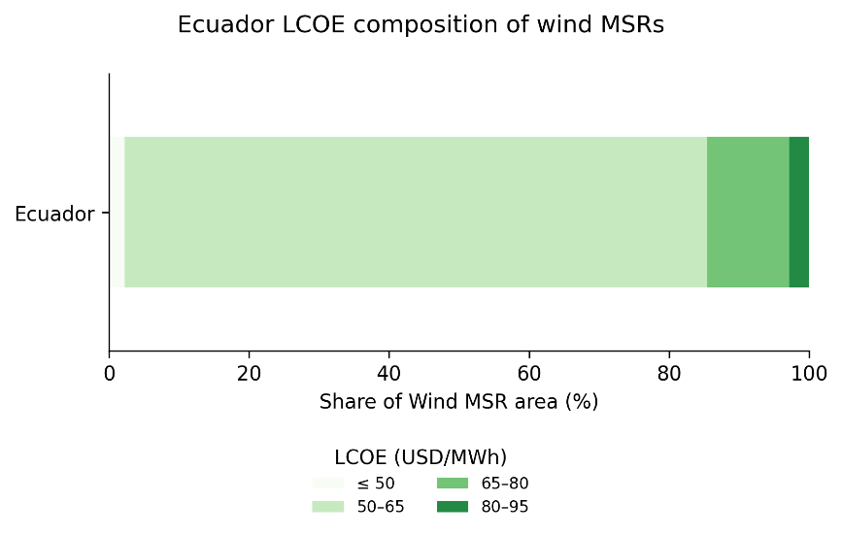
Figure 23: Composition of wind MSRs by LCOE (USD/MWh) in Ecuador.

👉🏼 Go back to the control file configurations worksheet, and enable solar by setting the run_code_for_solar configuration equal to 1 and disabling the other technologies.

🏃🏽 CODE RUN 🏃🏽

Run attributor_combiner.py for solar PV.

The summary figures show the composition of suitable solar PV MSR areas by distance from the grid (example in Figure 24), capacity factor (example in Figure 25) and LCOE (example in Figure 26). We can also investigate how the attributes compositions is distributed spatially across the country by visualizing in QGIS the shapefile created by the Attributor Combiner (Figure 27).

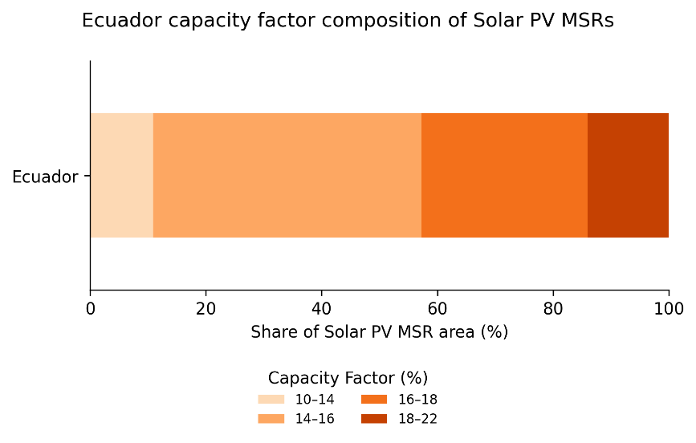
Figure 24: Example composition of solar PV MSRs by distance to transmission grid (km) in Ecuador.
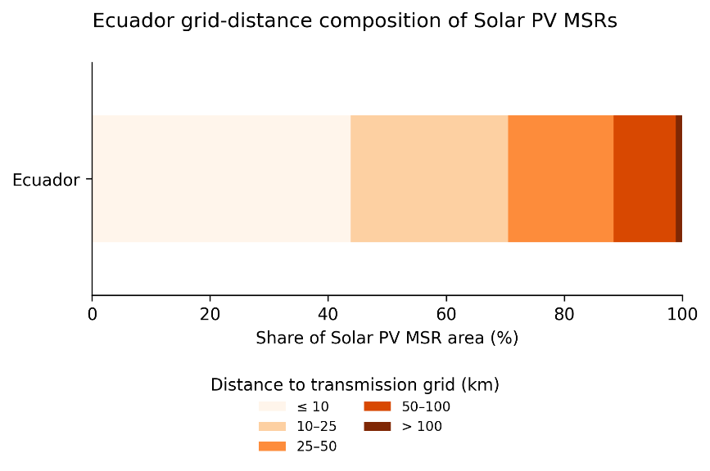
Figure 25: Example composition of solar PV MSRs by capacity factor (%) in Ecuador.

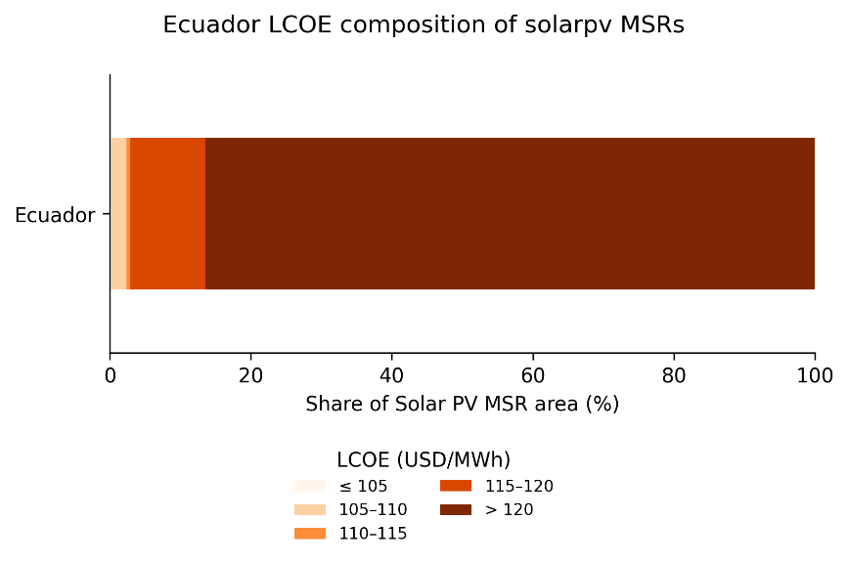

Figure 26: Example composition of solar PV MSRs by LCOE (USD/MWh) in Ecuador.

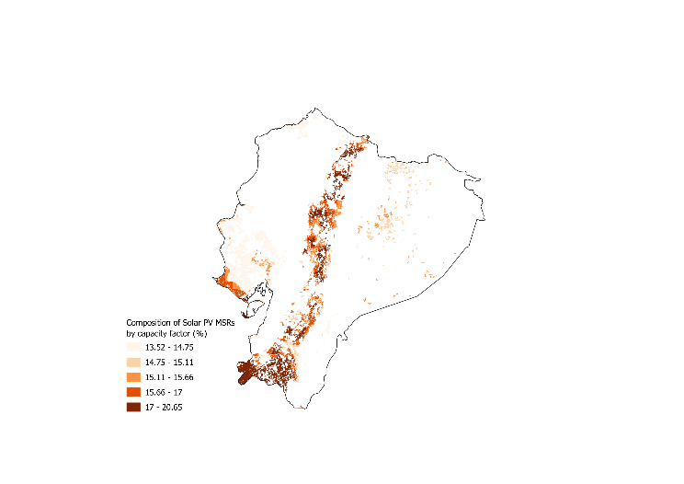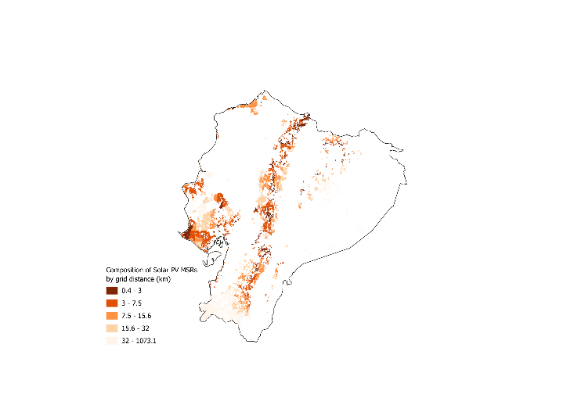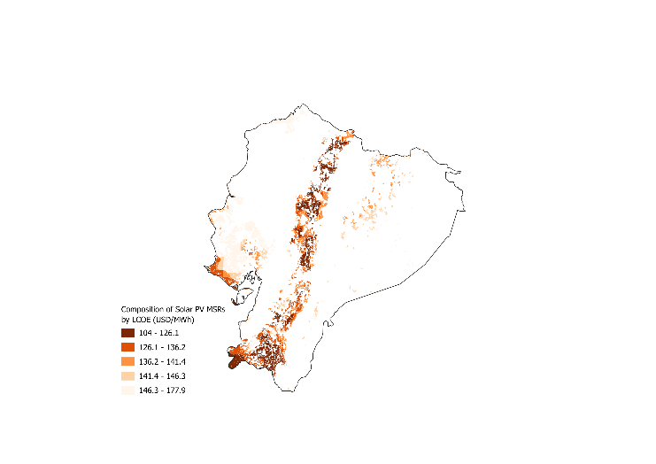

Figure 27: Example spatial distribution of a) grid distance (km), b) capacity factor (%) and c) LCOE (USD/MWh) composition of solar PV MSRs in Ecuador.

Part 4: Screener

The next step consists of creating a subset of MSRs suitable for model inclusion. The standard approach in the MSR workflow is to rank the MSRs by expected LCOE (including costs of infrastructure for generation, transmission network extension, and road network extension), and create a sub-selection of those where power generation would be cheapest according to this LCOE.

This sub-selection is put in practice through a user-defined area parameter that allows selecting the best MSRs up to a coverage of a certain percentage of a country’s surface area.

Part 4.1: Setting up the control file

Open the control file for the Screener script, control_file_screener.xlsx, that includes the same worksheet structure as the other control files.

👉🏼 Open the control file paths worksheet.

Specify the paths to the inputs and outputs folders in the appropriate cells, as in Figure 5.

👉🏼 Go to the datasets worksheet.

Enter the names of the datasets to be imported, as in Figure 28. In particular, make sure the .csv files holding the area cutoff percentages in the inputs folder are correctly linked.

Have a look at those files as well, and make sure a 5% cutoff has been allocated to Ecuador.

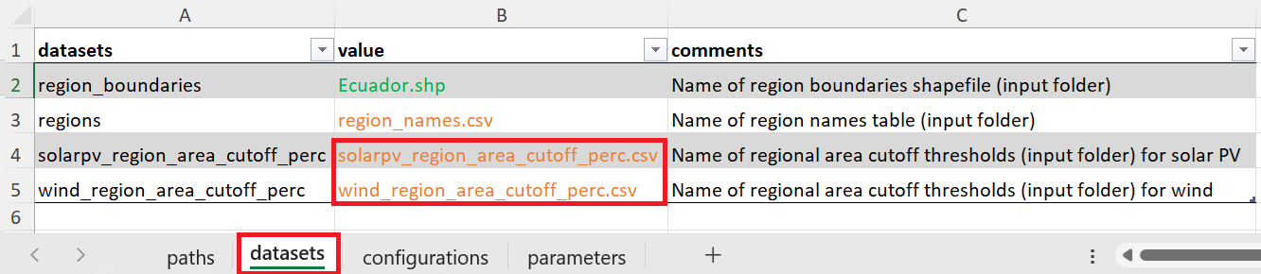
Figure 28: Linking the correct input datasets in the Sceener control file datasets worksheet.

👉🏼 Go to the configurations worksheet.

Set run_code_for_solar_pv = 1 and run_code_for_wind = 1 (this code can run both simultaneously), as in Figure 29. Also set add_cf_profiles = 1. This way, the code will provide model-ready hourly time series output of solar and wind capacity factors across the analysed meteorological years (here 2012-2014).

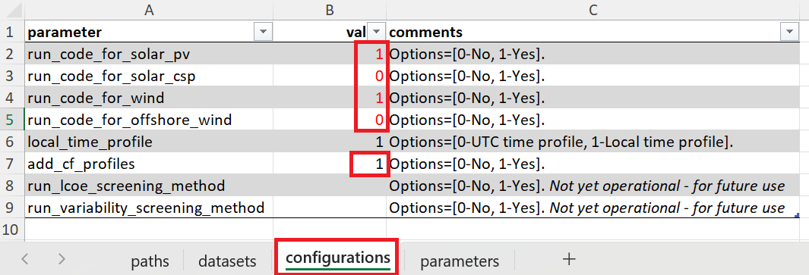
Figure 29: Setting the configuration for the Screener output in the Sceener control file configurations worksheet.

Part 4.2: Running the Screener

🏃🏽 CODE RUN 🏃🏽

Run screener.py.

Follow the log messages in the terminal to monitor the progress of the workflow. The script reports the active region, technology and workflow stage. The run is complete when the message “Screener workflow completed” appears in the terminal.

In the output folder, the script creates a folder 4_screener with a subfolder for each modelled region. Here, the outputs are stored in the Ecuador subfolder, where the following files are created:

- Shapefiles for the filtered “best ranked” MSRs for solar and wind power;
- A .csv file with the “best ranked” MSRs and their attributes, including time series.

👉🏼 Have a look at the shapefiles. Where are the “best ranked” MSRs located spatially, when compared to the full set of MSRs (output of the MSR Creator)? How can this be explained taking into account resource strength and remoteness metrics?

👉🏼 Have a look at the output time series in the produced .csv files. The best ranked MSRs are shown in columns, as in Figure 30. Scrolling down, one finds (from row 68 onwards) the full hourly time series of capacity factors across the analysed period.

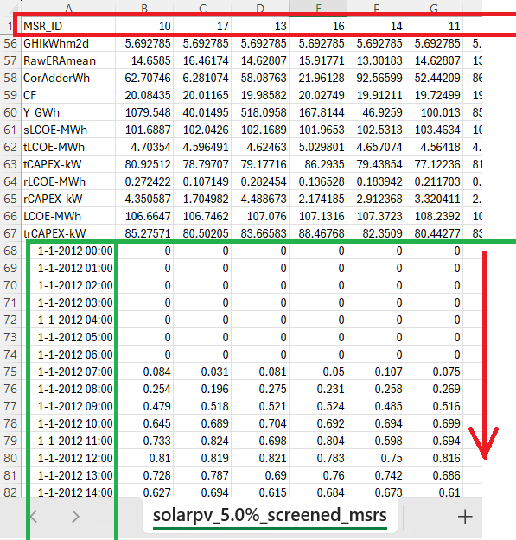
Figure 30: Full hourly time profiles for the “best ranked” MSRs (example for solar PV).

Part 5: Clustering

[not yet completed]

