Python

Printing into console
print() is the function used to print the item in the console
Syntax: print(‘ ’) or print(“ ”)
We can use both single and double quotation inside the parentheses to print the desired value.
If we want to print the double quotations then we need to use it under single quotations and vice versa.
Eg: print(‘ eg: print(“we are print function using print”)’)

We can also print a particular in the string by mentioning its index.
Eg: print(“Hello[1]”)
Output: e

OS Module
To know the current directory or change directories

Eg;
Import os
Curdir=os.getcwd()
Print(curdir)

Os.mkdir(‘newDir’)
Import time
Time.sleep(2)
Os.rename(newDir,’newDir2’)
Input Method
A=input()
B=input(“ Enter the Value”)
The string written in the functional brackets will be printed in the console.
All inputs takes using the input function there type will be string.

Variable Declaration

We can directly declare the variable by variable we no need to declare it with any data type and we can the value of variable from one data type to other by reinitializing it. So, python is called Dynamic
Rules for declaring variable:
- It should not start with number.
- No space are allowed will declaring variable.
Eg: city name--- wrong
city_name--- correct

Global
Global variable are declared out side of function, mostly at the beginning of program.
Local variable is variable whose scope is limited to a particular function.
Eg;
A=20 #global variable
Def something():
A=10. #local variable
Print(a)

For accessing global variable in local function we need to use global key word

A=10
Def something():
Global a
Print(a)

Output:
10

a=10
Print(id(a)) #address of a
Def something():
X=globals()[‘a’]
Print(a)
Globals()[‘a’]=15
Print(a)

Output:
10
15

Special Variables
1.__name__:
This will return the name of the module
If __name__ is directly used in file it will return name as main
If the module is imported into other file and __name__ is used in the module which is being imported then it will return the name of module.

Eg:
cal.py
print(“this will return”+__name__)

demo.py
Import cal
print(“Demo says:”+__name__)

Output:
If cal is run directly
This will return main

If demo is run directly
This will return cal
Demo says main

Arithmetic Operators

+ ->Addition operator
-
*
/ ->Division operator, after division it will return floating point value
** ->exponential value eg:2**3=6
// ->Division operator, after division it will return integer value.
round() ->it will return a floating point to integer.
round(2.666,2) ->It will convert to 2 point floating value.

F-String
It will convert all data types to string and also give the corresponding value of variable
A=5
B=”hello”
print(f ’the value of a={A},the value of b={B}’)

n: int= 1000000
print(f’{n:_}’)
print(f’{n:,}’)

output:
1_000_000
1,000,000

From datetime import datetime
Now: datetime=datetime.now()
Print(f’{now:%d.%m.%y (%h:%m:%s)}’)
Print(f’{now:%c}’)
Print(f’{now:%I%p}’)

A=10
B=5
Print(f’{a + b =}’)

Output:
A+B=15
Because of = the content before =

Silicing
listname[start:end:step]
n[1:] = from index 1 to last element
n[:-1]= from starting to last but one element

Lists
Lists in python are used to store the data in sequence manner but no need similar datatype to be present.
Letters_num=[‘a’,’s’,’d’,’f’,’g’,’1’,’2’,’3’,’4’]
Num=list(5,4,3,21,3)
We can have Nested lists
We can insert lists, tuples, dictionaries in a single list
Letters = [‘a’,’b’,’c’,’g’,’f’,Num]
Num=[0,1,2,3]
Letters[5][1] will give the output 1

len(Letters)= gives the length of list
letter.pop()=delete the last element from the list
pop(index)=delete the element in that index
remove(value)=delete the particular value that is occurred if it is existing multiple times
count(value)=it returns the occurrence of value in a list
they are many function to apply of lists

Tuples
Tuples are similar to list but tuples are immutable once assigned we can change the values in the tuples

Append,insert,remove,pop commands won’t for tuple

Sets

Sets in python are unordered, immutable as we can not access them using indexs
By using sets we can get only unique values in it
We can add, remove elements from the set

Using set()
When we add a element to set it will at the last position
When we use remove it will remove a particular element from the set
Sets are non indexed means we can retrieve elements from sets using indexs

Random

Random is one library in python which is used to get random number
Before using random we need to import it by using import command
We can choice range of integers from where we can get the random numbers by using the command randint(0,100)
Similarly randfloat()
To get random character from a list we use the function choice(List_name)
Eg: num=random.randint(0,50)
Flo=random.randfloat(0,1)
Character=random.choice(List_name)

Lambda
Lambda is also one type one type of function.
That takes multiple inputs but returns only one output
Syntax
Lambda input : expression
Eg:
f= lambda a,b : a+b

we will call the lambda expression by f(a,b)

difference between function and lambda
1.lambda has no return value
2.one line
3.Not used for code reusability
4. No name
5. return complete function

Why?
Along with higher order functions

Higher order function
Function which takes function as input and output as function
Eg:
Def return_sum(func,L):
Result=0
For I in L:
If func(i);
Result=result + i
Return result
L=[11,2,3,10,5,6]
X=lambda x:x%2==0
Y=lambda y:y%2==0
Z=lambda z:Z%2==0

Print(return_sum(x,L))
Print(return_sum(y,L))
Print(return_sum(z,L))
Name Spaces
Decorators

Decorators in pythons are used to change the functionality of function without changing the actual function.
In these we create another function and pass the main function as parameter to the second function and make the changes in the second function
Decorators are often used when our main function is in other file and if we are importing in our present program. We can change the functionality.
Functions
Types of Arguments
- Default Argument
- Positional Argument
- Keyword Argument
# positional argument
power(2,3)
# keyword argument
power(b=3,a=2)

*args and **kwargs
*args and **kwargs are special Python keywords that are used to pass the variable length of arguments to a function.

Eg:
def multiply(*kwargs):
product = 1
for i in kwargs:
product = product * i

print(kwargs)
return product

multiply(1,2,3,4,5,6,7,8,9,10,12)

Eg:
# **kwargs
# **kwargs allows us to pass any number of keyword arguments.
# Keyword arguments mean that they contain a key-value pair, like a Python dictionary.

def display(**salman):

for (key,value) in salman.items():
print(key,'->',value)

display(india='delhi',srilanka='colombo',nepal='kathmandu',pakistan='islamabad')
Points to remember while using *args and **kwargs
- order of the arguments matter(normal -> *args -> **kwargs)
- The words “args” and “kwargs” are only a convention, you can use any name of your choice

Filter,Reduce,Map

Filter, Reduce, Map are functions that accept two arguments function, list.
Filter:
It is in-built function to filter the list items and return list.
It will iterate over the list and function should return true, false. Filter will create a new list for true values of list.
Filter takes two arguments 1. Function 2. List
Eg;
Nums= [3,2,6,4,6,2,5]
Evens=list(filter(lambda n:n%2, nums))

Map: it will iterate over the list items and execute over the function. It will return list of values.
Eg:
Nums= [3,2,6,4,6,2,5]
Evens=list(filter(lambda n:n%2, nums))
Doubles=list(map(lambda n: n+2,evens))
Reduce: this will return a single value. It will iterate over list and store the previous result and perform operation on next element in list.

It belongs to module functools

Eg:
From functool import reduce
Nums= [3,2,6,4,6,2,5]
Evens=list(filter(lambda n:n%2, nums))

Doubles=list(map(lambda n: n+2,evens))
Sum=reduce(lambda a,b: a+b,doubles)

Dictionary
we will store the data in the form of key, value pairs
dict() is the constructor used to create the dictionary

using index notation:
# Example dictionary
my_dict = {'a': 1, 'b': 2, 'c': 3}

# Append a new key-value pair
my_dict['d'] = 4

print(my_dict)

using update() method:
# Example dictionary
my_dict = {'a': 1, 'b': 2, 'c': 3}

# Append new key-value pairs using update()
my_dict.update({'d': 4, 'e': 5})

print(my_dict)

using setdefault():
# Example dictionary
my_dict = {'a': 1, 'b': 2, 'c': 3}

# Append a new key-value pair using setdefault()
my_dict.setdefault('d', 4)

print(my_dict)

using dict() contructor:
# Example dictionary
my_dict = {'a': 1, 'b': 2, 'c': 3}

# Append a new key-value pair using dict() constructor
my_dict = dict(my_dict, d=4)

print(my_dict)

OOPS
campusx
https://colab.research.google.com/drive/1-NeInkiKPBT_oRlVXa7QA-TvIIqIaPll?usp=sharing

Class- is the blueprint of a model
We will declare the class name in the form of Pascal case.
Functions will be declared in snake case.
Class is having either data or functions.
Object- Instance of a class. Used to reference the methods, attributes(variables) in class.

Ex:
class Car:
color=’blue’
model=’sports’
def calculate_milage():
#some code

waganR=Car()

Special method:
def __init__(self): it is similar to the constructor means when we create object for the class, __init__ method will be called by itself.

Ex:
class ATM:
def __init__(self):
self.pin=””
self.balance=0
self.menu()
def menu(self):
user_input=input(“”””
Hello how would you like to proceed
1.ATM Pin Generetion
2.withdraw
3.balance”””)
If user_input==’1’:

##some code

Magic method:
It start and end with __
Eg: __init__ , __add__ , __str__
This method are called without need of object
Magic method call by it-self.

__str__:
This method will print the value whatever we write in the print()

Eg:
Class Fraction:
Def __init__(self):
Self.a=3
Self.b=4
Def __str__(self):
Return ”hello”

X=Fraction()
Print(x)

Output:
hello

Why we use ‘self’ as argument in every method?
Because in oops each and every function,data should be accessed with the object itself so self here act as the object of that class.

Access modifiers:
Private= __variablename
Eg:
__pin
It is same for method as well

To access private variables;
_classname__variablename

Variables in class:
1.static variables/class variable: which are created in class but not in __init__ method.
These are accessed used class name. if we modify the class variable it will effect to all the objects that are created to a object.
2.instance variables : these are declared when instance of class(object) is created. These are declared inside _init_ method.

Class Atm:
Counter=1
Def __init__(self):
Self.__pin=””
Self.sno=Atm.Counter
Atm.counter+=1

Methods In Class:
1.instance method:
Working with instance variables.
2.class method:
Works with class variables
We need a decorators @classmethod
3.static method:
No need to work with both of them.
Decorator @staticmethod

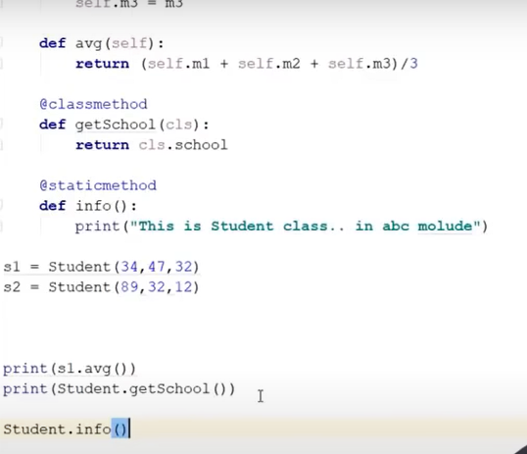

Pass by reference:
Class Customer:
Def __init__(self,name):
Self.name=name
Def greet(customer):
Print(id(customer))
Customer.name=’Nitish’
Print(customer.name)

Cust=customer(‘Ankit’)
Print(id(cust))
Greet(cust)
Class ke objects are also mutable like lists,sets,dict

Encapsulation:
Encapsulation in object-oriented programming (OOP) is the process of bundling data and methods together in a class to protect the data from outside interference.
Encapsulation is the process of combining data with the methods that operate on it. It can also refer to limiting direct access to some of the data.
Benefits
Encapsulation can help with:
  - Hiding data: Users won't know how classes are implemented or stored.
  - Flexibility: Variables can be set as read or write-only.
  - Reusability: It's easy to change and adapt to new requirements.
  - Security: Encapsulation can protect information from being modified or having new errors introduced.

Collection of Objects:

Class Customer:
Del __init__(self,name,age):
Self.name=name
Self.age=age
Def intro(self):
Print(“I am”,self.name,”and I am ”,self.age)
C1=Customer(“Nitish”,34)
C2=Customer(“Ankit”,45)
C3=Customer(“Neha”,32)

L=[c1,c2,c3]
For i in L:
i.intro()
We can not send objects in tuples, as tuples are immutable, and objects are mutable

Aggregation:
aggregation is a relationship between two or more classes where one class contains reference to another class, but both can exist independently. It's a type of association that represents a "has-a" relationship.
Has-A Relation

Class Customer:
Def __init__(self,name,gender,address):
Self.name=name
Self.gender=gender
Self,address=address
Def edit_profile(self,new_name=self.name,new_city,new_pincode,new_state):
Self.name=new_name
Self.address.change_address(new_city,new_pin,new_state)

Class Address:
Def __init__(self,city,pincode,state):
Self.city=city
Self.pincode=pincode
Self.state=state

Def change_address(self,new_city,new_pincode,new_state):
Self.city=new_city
Self.pin=new_pincode
Self.state=new_state

add=Address(“kolkate“,700156,“WB“)
Cust=Customer(“Nitish“,“Male“,add)
Cust.edit_profile(“Gurgoen“,122011,“haryana“)

Inheritance:
Is-A Relation
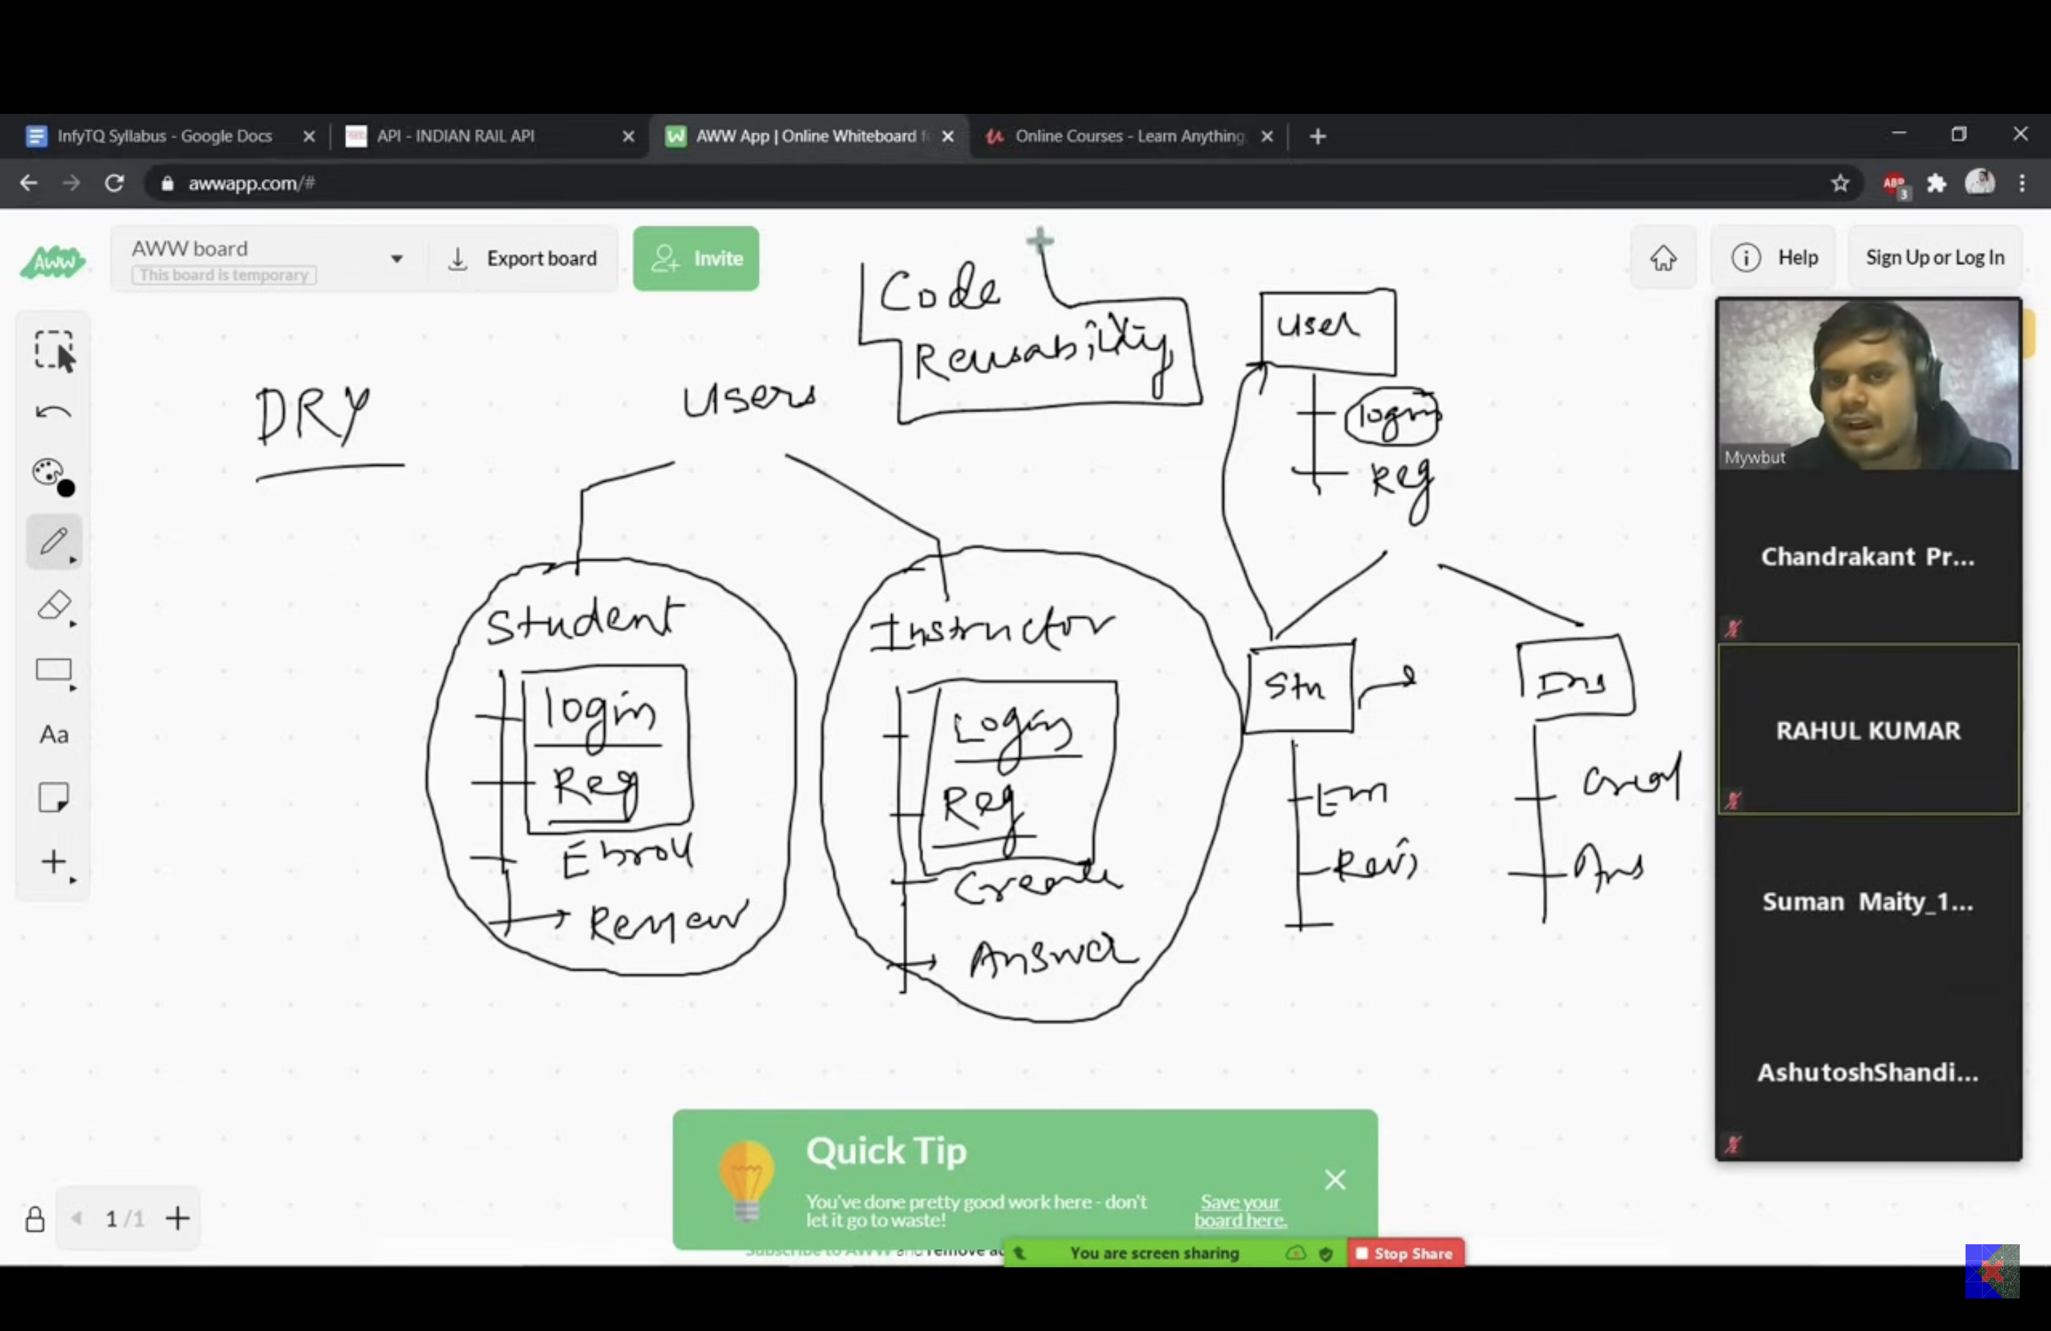
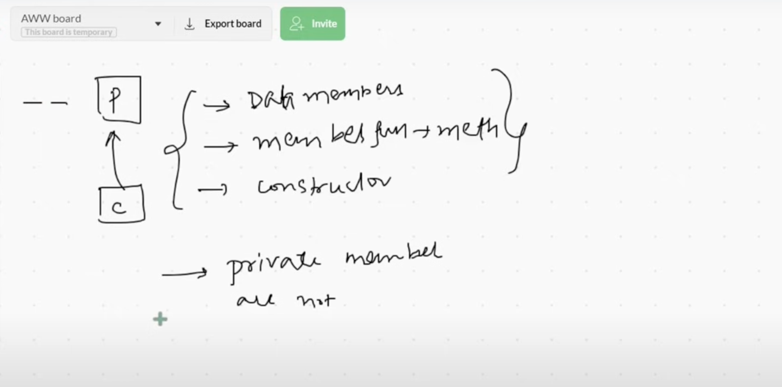

Class User:
Def login(self):
Print(“login”)
Def register(self):
Print(“Register”)
Class Student(User):
Def enroll(self):
Print(“enroll”)
Def review(self):
Print(“review”)
Stu=student()
Stu.login()
Stu.register()
Stu.enroll()

Types of Inheritance:
1.single level
2.Multi level
3.Hierarchical
4.Multiple
5.Hybrid

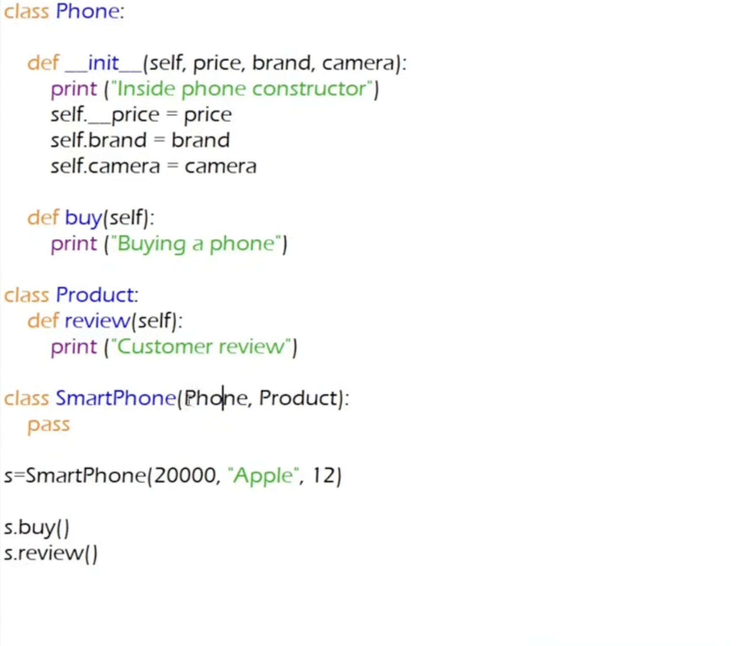

Polymorphism:
Method Overriding
Method Overloading
Method Overloading | Method Overriding
Method overloading is a compile-time polymorphism. | Method overriding is a run-time polymorphism.
Method overloading helps to increase the readability of the program. | Method overriding is used to grant the specific implementation of the method which is already provided by its parent class or superclass.
It occurs within the class. | It is performed in two classes with inheritance relationships.
Method overloading may or may not require inheritance. | Method overriding always needs inheritance.
In method overloading, methods must have the same name and different signatures. | In method overriding, methods must have the same name and same signature.
In method overloading, the return type can or can not be the same, but we just have to change the parameter. | In method overriding, the return type must be the same or co-variant.
Static binding is being used for overloaded methods. | Dynamic binding is being used for overriding methods.
Private and final methods can be overloaded. | Private and final methods can’t be overridden.
The argument list should be different while doing method overloading. | The argument list should be the same in method overriding.

Class Geometry:
Def area(self,a,b=0):
If b==0:
Print(“circle”,3.14*a*a)
Else
Print(“rectangle”,a*b)
A=Geometry()
A.area(5)
A.area(5,4)

Operator Overloading
Abstraction:
from abc import ABC,abstractmethod
class BankApp(ABC):

def database(self):
print('connected to database')

@abstractmethod
def security(self):
pass

@abstractmethod
def display(self):
pass

class MobileApp(BankApp):

def mobile_login(self):
print('login into mobile')

def security(self):
print('mobile security')

def display(self):
print('display')
mob = MobileApp()
mob.security()
error we can not create objects for Abstract classes
obj = BankApp()
Duck Typing:

Exception Handling
Two types of error may occur
- Syntax Error
- Execution Error
Syntax Error:
This error will occur when we didn’t write the program according to syntax.
Execution Error:
This will occur during the execution of the program.this are exceptions

Exception which interrupts the normal flow of the program
When an exception occur program terminates at that point.
Examples:
Memory Overflow
Divide by zero.

Why Exception Handlings:
1.security
2. to improve user experience.

Handling exceptions :
try:
code containing eceptions
except[ExceptionName]:
code to handle exceptions(if coocur)
else:
code to execute if no exception
finally:
Always executed

Else block and finally block both are optional
Finally block is excuted every time.
We can handle multiple exceptions at a time

Every exception is handled by class
Eg: ZeroDivisionError
Eg:
Try:
F=open(‘sample.txt’,’r’)
Print(f.read())
Except FileNotFoundError:
Print(“file not founD’)
Except Exception as e:
Print(e.with_traceback)
Finally:
Print(‘rest of code’)

Output:
If error occur e.with_traceback will give the name of the Exception need to be handled
How to print the exception:
Sys.exc_info()[0] -- gives the name of exception class
Sys.exc_info()[1] -- gives the information about the exception
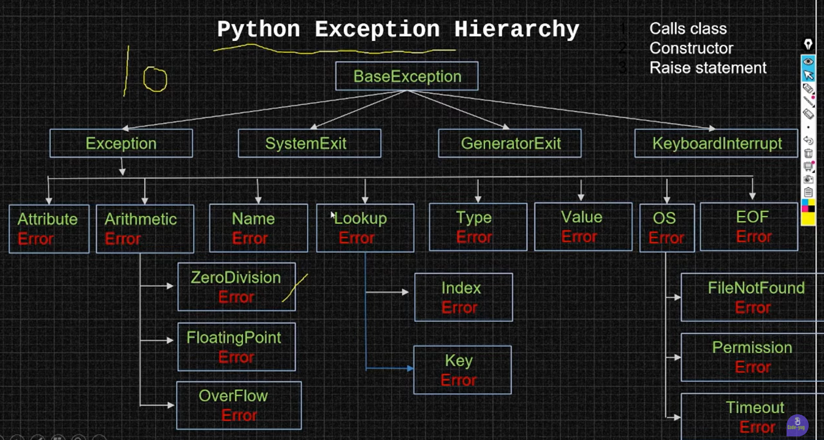

User defined exception:
These exception are created by programmers
Class Myexception(Exception):
Def _init_(self,message):

Try:

Except Myexception as x:

Raise Exception keyword:
Used to raise the exception forcefully
Eg:
Class Bank:
Def __int__(self,balance);
Self.balance
Def withdraw(self,amount):
If amount < 0:
Raise Exception(‘amount cannot be -ve’)
If …..

End of class
Obj=Bank(1000)
Try:
Obj.withdraw(15000)
Except Exception as e:
Print(e)

Output:
It will return the raised exception

Ex:
Try:
Age-int(input(“enter the age:”))
If age<0:
Raise ValueError() or raise ValueError(“invalid age”)
Print(“your age is :”,age)
Except ValueError: or Except ValueError as var:
Print(“enter valid age”) or print(var)
Print(“rest of code”)

Here ValueError is the user defined exception and it that raised by using raise keyword

ExceptionHook:
If we didn’t use exception handling exceptionhook will araise

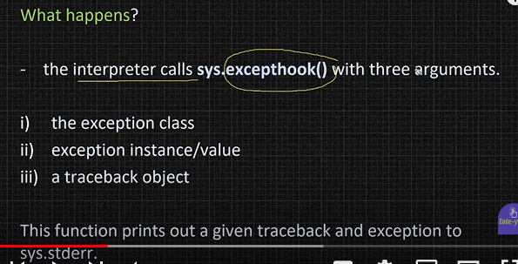

Regex

Source: https://www.python-engineer.com/posts/regular-expressions/
Regular expressions in python are used to find the patterns in the string.

‘re’ is the module used to work with regular expressions
Eg:
Import re
test_string=’123abc456789abc123ABC’
pattern= e.compile(r’abc’) #for compiling the pattern to be find
matches= pattern.finditer(test_string) or matches = re.finditer(r’abc’, test_string)
for match in matches:
print(match)
output:
this program will return the match object

Methods used to find the patterns
1.match() :
This method will find the first match of the pattern at the beginning of the string. If pattern is at beginning it will return the matched pattern otherwise it will reurn None
Eg:
Import re
test_string=’123abc456789abc123ABC’
pattern= e.compile(r’abc’)
match= pattern.match(test_string)
print(match)
output:
None

2.search():
This method will find the first match of pattern in the string if avaible it will return the object of match
Import re
test_string=’123abc456789abc123ABC’
pattern= e.compile(r’abc’)
match= pattern.search(test_string)
print(match)

3.findall():
This method will find all the matched pattern in the string in the form of list
Eg;
Import re
test_string=’123abc456789abc123ABC’
pattern= re.compile(r’abc’)
matches= pattern.findall(test_string)
for match in matches:
print(match)
output:
abc
abc
4.finditer():
As this method will return the match pattern object, here some methods to work with this object.

Methods on a Match object

a.span();
it will return the tuple containing the starting and ending index of pattern.
b.group():
this will return the matched string pattern
c.start():
starting index of pattern
d.end():
ending index of pattern
Eg:
test_string = '123abc456789abc123ABC'
pattern = re.compile(r'abc')
matches = pattern.finditer(test_string)
for match in matches:
print(match)
print(match.span(), match.start(), match.end())
print(match.group()) # returns the substring that was matched by the RE
output;
<re.Match object; span=(3, 6), match='abc'>
(3, 6) 3 6
abc
<re.Match object; span=(12, 15), match='abc'>
(12, 15) 12 15
abc

Meta characters

Metacharacters are characters with a special meaning:
All meta characters: . ^ $ * + ? { } [ ] \ | ( )
Meta characters need need to be escaped (with ) if we actually want to search for the char.
- . Any character (except newline character) "he..o"
- ^ Starts with "^hello"
- \$ Ends with "world\$"
- * Zero or more occurrences "aix*"
- + One or more occurrences "aix+"
- { } Exactly the specified number of occurrences "al{2}"
- [] A set of characters "[a-m]"
- \ Signals a special sequence (can also be used to escape special characters) "\d"
- | Either or "falls|stays"
- ( ) Capture and group

More Metacharacters / Special Sequences¶
A special sequence is a \ followed by one of the characters in the list below, and has a special meaning:
- \d :Matches any decimal digit; this is equivalent to the class [0-9].
- \D : Matches any non-digit character; this is equivalent to the class [^0-9].
- \s : Matches any whitespace character;
- \S : Matches any non-whitespace character;
- \w : Matches any alphanumeric (word) character; this is equivalent to the class [a-zA-Z0-9_].
- \W : Matches any non-alphanumeric character; this is equivalent to the class [^a-zA-Z0-9_].
- \b Returns a match where the specified characters are at the beginning or at the end of a word r"\bain" r"ain\b"
- \B Returns a match where the specified characters are present, but NOT at the beginning (or at the end) of a word r"\Bain" r"ain\B"
- \A Returns a match if the specified characters are at the beginning of the string "\AThe"
- \Z Returns a match if the specified characters are at the end of the string "Spain\Z"

Eg:
test_string = 'hello 123_ heyho hohey'
pattern = re.compile(r'\d')
matches = pattern.finditer(test_string)
for match in matches:
print(match)

print()
pattern = re.compile(r'\s')
matches = pattern.finditer(test_string)
for match in matches:
print(match)

print()
pattern = re.compile(r'\w')
matches = pattern.finditer(test_string)
for match in matches:
print(match)

print()
pattern = re.compile(r'\bhey')
matches = pattern.finditer('heyho hohey') # ho-hey, ho\nhey are matches!
for match in matches:
print(match)

print()
pattern = re.compile(r'\Ahello')
matches = pattern.finditer(test_string)
for match in matches:
print(match)

print()
pattern = re.compile(r'123_\Z')
matches = pattern.finditer(test_string)
for match in matches:
print(match)
<re.Match object; span=(6, 7), match='1'>
<re.Match object; span=(7, 8), match='2'>
<re.Match object; span=(8, 9), match='3'>

<re.Match object; span=(5, 6), match=' '>
<re.Match object; span=(10, 11), match=' '>
<re.Match object; span=(16, 17), match=' '>

<re.Match object; span=(0, 1), match='h'>
<re.Match object; span=(1, 2), match='e'>
<re.Match object; span=(2, 3), match='l'>
<re.Match object; span=(3, 4), match='l'>
<re.Match object; span=(4, 5), match='o'>
<re.Match object; span=(6, 7), match='1'>
<re.Match object; span=(7, 8), match='2'>
<re.Match object; span=(8, 9), match='3'>
<re.Match object; span=(9, 10), match='_'>
<re.Match object; span=(11, 12), match='h'>
<re.Match object; span=(12, 13), match='e'>
<re.Match object; span=(13, 14), match='y'>
<re.Match object; span=(14, 15), match='h'>
<re.Match object; span=(15, 16), match='o'>
<re.Match object; span=(17, 18), match='h'>
<re.Match object; span=(18, 19), match='o'>
<re.Match object; span=(19, 20), match='h'>
<re.Match object; span=(20, 21), match='e'>
<re.Match object; span=(21, 22), match='y'>

<re.Match object; span=(0, 3), match='hey'>
<re.Match object; span=(0, 5), match='hello'>
Quantifier
- * : 0 or more
- + : 1 or more
- ? : 0 or 1, used when a character can be optional
- {4} : exact number
- {4,6} : range numbers (min, max)
my_string = 'hello_123'
pattern = re.compile(r'\d*')
matches = pattern.finditer(my_string)
for match in matches:
print(match)

print()
pattern = re.compile(r'\d+')
matches = pattern.finditer(my_string)
for match in matches:
print(match)

print()
my_string = 'hello_1_2-3'
pattern = re.compile(r'_?\d')
matches = pattern.finditer(my_string)
for match in matches:
print(match)

print()
my_string = '2020-04-01'
pattern = re.compile(r'\d{4}') # or if you need a range r'\d{3,5}'
matches = pattern.finditer(my_string)
for match in matches:
print(match)
<re.Match object; span=(0, 0), match=''>
<re.Match object; span=(1, 1), match=''>
<re.Match object; span=(2, 2), match=''>
<re.Match object; span=(3, 3), match=''>
<re.Match object; span=(4, 4), match=''>
<re.Match object; span=(5, 5), match=''>
<re.Match object; span=(6, 9), match='123'>
<re.Match object; span=(9, 9), match=''>

<re.Match object; span=(6, 9), match='123'>

<re.Match object; span=(5, 7), match='_1'>
<re.Match object; span=(7, 9), match='_2'>
<re.Match object; span=(10, 11), match='3'>

<re.Match object; span=(0, 4), match='2020'>
dates = '''
2020.04.01

2020-04-01
2020-05-23
2020-06-11
2020-07-11
2020-08-11

2020/04/02

2020_04_04
2020_04_04
'''
pattern = re.compile(r'\d{4}.\d{2}.\d{2}')
matches = pattern.finditer(dates)
for match in matches:
print(match)
print()

pattern = re.compile(r'\d+.\d+.\d+')
matches = pattern.finditer(dates)
for match in matches:
print(match)
<re.Match object; span=(1, 11), match='2020.04.01'>
<re.Match object; span=(13, 23), match='2020-04-01'>
<re.Match object; span=(24, 34), match='2020-05-23'>
<re.Match object; span=(35, 45), match='2020-06-11'>
<re.Match object; span=(46, 56), match='2020-07-11'>
<re.Match object; span=(57, 67), match='2020-08-11'>
<re.Match object; span=(69, 79), match='2020/04/02'>
<re.Match object; span=(81, 91), match='2020_04_04'>
<re.Match object; span=(92, 102), match='2020_04_04'>

<re.Match object; span=(1, 11), match='2020.04.01'>
<re.Match object; span=(13, 23), match='2020-04-01'>
<re.Match object; span=(24, 34), match='2020-05-23'>
<re.Match object; span=(35, 45), match='2020-06-11'>
<re.Match object; span=(46, 56), match='2020-07-11'>
<re.Match object; span=(57, 67), match='2020-08-11'>
<re.Match object; span=(69, 79), match='2020/04/02'>
<re.Match object; span=(81, 91), match='2020_04_04'>
<re.Match object; span=(92, 102), match='2020_04_04'>
Conditions¶
Use the | for either or condition.
my_string = """
Mr Simpson
Mrs Simpson
Mr. Brown
Ms Smith
Mr. T
"""
pattern = re.compile(r'Mr\.?\s\w+')
matches = pattern.finditer(my_string)
for match in matches:
print(match)

print()
pattern = re.compile(r'(Mr|Ms|Mrs)\.?\s\w+')
matches = pattern.finditer(my_string)
for match in matches:
print(match)
<re.Match object; span=(1, 11), match='Mr Simpson'>
<re.Match object; span=(24, 33), match='Mr. Brown'>
<re.Match object; span=(43, 48), match='Mr. T'>

<re.Match object; span=(1, 11), match='Mr Simpson'>
<re.Match object; span=(12, 23), match='Mrs Simpson'>
<re.Match object; span=(24, 33), match='Mr. Brown'>
<re.Match object; span=(34, 42), match='Ms Smith'>
<re.Match object; span=(43, 48), match='Mr. T'>

Grouping
( ) is used to group substrings in the matches.
emails = """
pythonengineer@gmail.com
Python-engineer@gmx.de
python-engineer123@my-domain.org
"""
pattern = re.compile('[a-zA-Z1-9-]+@[a-zA-Z-]+\.[a-zA-Z]+')
pattern = re.compile('[a-zA-Z1-9-]+@[a-zA-Z-]+\.(com|de)')
pattern = re.compile('([a-zA-Z1-9-]+)@([a-zA-Z-]+)\.([a-zA-Z]+)')
matches = pattern.finditer(emails)
for match in matches:
print(match)
print(match.group(0))
print(match.group(1))
print(match.group(2))
print(match.group(3))
<re.Match object; span=(1, 25), match='pythonengineer@gmail.com'>
pythonengineer@gmail.com
pythonengineer
gmail
com
<re.Match object; span=(26, 48), match='Python-engineer@gmx.de'>
Python-engineer@gmx.de
Python-engineer
gmx
de
<re.Match object; span=(49, 81), match='python-engineer123@my-domain.org'>
python-engineer123@my-domain.org
python-engineer123
my-domain
org

Modifying strings
split(): Split the string into a list, splitting it wherever the RE matches
- sub(): Find all substrings where the RE matches, and replace them with a different string
my_string = 'abc123ABCDEF123abc'
pattern = re.compile(r'123') # no escape for the . here in the set
matches = pattern.split(my_string)
print(matches)

my_string = "hello world, you are the best world"
pattern = re.compile(r'world')
subbed_string = pattern.sub(r'planet', my_string)
print(subbed_string)
['abc', 'ABCDEF', 'abc']
hello planet, you are the best planet
urls = """
http://python-engineer.com
https://www.python-engineer.org
http://www.pyeng.net
"""
pattern = re.compile(r'https?://(www\.)?(\w|-)+\.\w+')
pattern = re.compile(r'https?://(www\.)?([a-zA-Z-]+)(\.\w+)')
matches = pattern.finditer(urls)
for match in matches:
#print(match)
print(match.group()) # 0
#print(match.group(1))
#print(match.group(2))
print(match.group(3))

# substitute using back references to replace url + domain name
subbed_urls = pattern.sub(r'\2\3', urls) #2,3 groups will be substituted in urls
print(subbed_urls)
http://python-engineer.com
.com
https://www.python-engineer.org
.org
http://www.pyeng.net
.net

python-engineer.com
python-engineer.org
pyeng.net

Compilation Flags
- ASCII, A : Makes several escapes like \w, \b, \s and \d match only on ASCII characters with the respective property.
- DOTALL, S : Make . match any character, including newlines.
- IGNORECASE, I : Do case-insensitive matches.
- LOCALE, L : Do a locale-aware match.
- MULTILINE, M : Multi-line matching, affecting ^ and $.
- VERBOSE, X (for ‘extended’) : Enable verbose REs, which can be organized more cleanly and understandably.
my_string = "Hello World"
pattern = re.compile(r'world', re.IGNORECASE) # No match without I flag
matches = pattern.finditer(my_string)
for match in matches:
print(match)

my_string = '''
hello
cool
Hello
'''
# line starts with ...
pattern = re.compile(r'^[a-z]', re.MULTILINE) # No match without M flag
matches = pattern.finditer(my_string)
for match in matches:
print(match)
<re.Match object; span=(6, 11), match='World'>
<re.Match object; span=(1, 2), match='h'>
<re.Match object; span=(7, 8), match='c'>

Iterators
https://colab.research.google.com/drive/1rCmKWloJOKd9OTOVgYpL17iUZnZn-tZ1?usp=sharing
What is an Iteration?
Iteration is a general term for taking each item of something, one after another. Any time you use a loop, explicit or implicit, to go over a group of items, that is iteration.

What is Iterator?
An Iterator is an object that allows the programmer to traverse through a sequence of data without having to store the entire data in the memory
What is Iterable?
Iterable is an object, which one can iterate over
It generates an Iterator when passed to iter() method.

Point to remember
- Every Iterator is also and Iterable
- Not all Iterables are Iterators
Trick
- Every Iterable has an iter function
- Every Iterator has both iter function as well as a next function

Generators
https://colab.research.google.com/drive/1-C9_moK_Z6g5OjqsxHOWeQvm84S_b6aa?usp=sharing

File Handling
To open a file which is not present and to write something into it

