Comparing spatial prioritization methods for biodiversity conservation and ecosystem service supply in Europe
Joona Lehtomäki^{1*}, Luigi Maiorano² and Peter verburg¹

¹ Environmental Geography Group, Department of Earth Sciences, De Boelelaan 1105, 1081 HV Amsterdam, Vrije Universiteit Amsterdam, the Netherlands.
² XXX
* Corresponding author

Contact: j.lehtomaki@vu.nl, tel. +31-20-59-87294
ORCID: 0000-0002-7891-0843
XXX XXX
peter.verburg@vu.nl, tel. +31-20-59-83594

Running title: Spatial prioritization comparison
Keywords: spatial prioritization; ecosystem services; biodiversity conservation; Zonation; optimization; environmental decision-making
Manuscript version: 0.5.0
Manuscript statistics: 236 words (abstract)
1643 words (main body, from the introduction through the Biosketch)
7 references
5 figures
1+1 tables

Abstract:
Aim.
Location. Europe.
Methods.
Results.
Main conclusions.
Identifying priority areas that simultaneously supply ecosystem services and are important for biodiversity underlying the supply of ecosystem services is essential for well-informed decision-making on land use and conservation planning. Multiple methods for spatial prioritization of locations supplying individual or multiple ecosystem services, and for the balanced or optimal allocation of biodiversity conservation actions exist, but the benefits and disadvantages of using these methods are seldom explored. Furthermore, the technical complexity, data requirements and the transparency of the method parameterization further make a great difference in the usability of each method in practical work. Here, we compare a simple scoring method, heuristic prioritization software Zonation, and an exact spatial optimization method in prioritizing locations important for multiple ecosystem services and biodiversity at the European scale. Each method is used within a realistic, but hypothetical decision-making context. We show that for very simple analysis types, the scoring-type of approach performs very similarly to Zonation and the exact optimization method. However, more complex - and arguably more policy-relevant - analysis types can only be accommodated by the more complex methods. We demonstrate the practical implications of using each approach in operationalizing the concept ecosystem services and biodiversity conservation planning into more widespread practical use. We argue that the road forward in using planning methods is a combination of technical credibility, decision-making relevance, and effort in opening up the planning process to the stakeholders involved.

Highlights
- We compare three different spatial prioritization methods of identifying priority locations for both the supply of ecosystem services and biodiversity conservation on European scale.
- The prioritization results show that for a relatively simple prioritization analyses, all the methods perform similarly
- Priority areas for the selected ecosystem services are aggregated to central parts of Europe, whereas biodiversity priorities are found in the Mediterranean basin and Northern Fennoscandia.
- We provide information to guide the selection of a suitable approaches, including methods and the types of data needed, in operationalizing the spatial planning for ecosystem services and biodiversity.
- Importantly, our methods and results can help to characterize and quantify the potential trade-offs between ecosystem services supply and biodiversity conservation.

(A) INTRODUCTION

Ecosystem services (ES), activities or functions of ecosystems that provide benefit (or occasionally disbenefit) to humans (Mace et al., 2012)⁠, has quickly risen in popularity in guiding environmental management decisions. Ecosystems are thought to provide a broad spectrum of different services that directly or indirectly contribute to the human well-being on multiple spatiotemporal scales (REFS). Given the strong emphasis placed on ecosystem services especially in the national and international policy arenas (REFS), the operationalization of the concept of ecosystem services is still well underway. Part of this operationalization process is the development of methods and tools for spatial planning that integrates multiple objectives simultaneously in a transparent and cost-effective manner. Spatial planning and spatial support systems are widely studied and used in environmental context in land use, natural resource, urban and conservation planning (REFS). For practical relevance, spatial planning needs to be able to include ecological, economic and social factors relevant for whatever decision-making problem is at hand. Integrating spatial planning with decision-analytical methods has been done under the rubrics such as multi-criteria decision making (REFS), XXX (REFS) and XXX (REFS). Management decisions will increasingly need to account for both biodiversity conservation and the provision of ecosystem services (Goldman and Tallis, 2009)⁠ and therefore methods able to quantify the associated trade-offs are urgently needed (Cordingley et al., 2016)⁠. It is crucial, however, to be fully aware of the assumptions behind methods used to assess their suitability for the task.

In practice, spatial planning is useful for guiding environmental management only if the planning methods and the information they provide can been embedded into real-life management context. In the field of conservation science, systematic conservation planning (Margules and Pressey, 2000)⁠ has been perhaps to most influential framework combining aspects of spatial planning to implementation of biodiversity conservation (Kukkala and Moilanen, 2012)⁠. Within this broader decision-analytical framework, the more technical biogeographic-economic assessment of which areas are the most important for biodiversity and when and how particular actions should be implemented to achieving conservation goals, is called spatial conservation prioritization (SCP) (Ferrier and Wintle, 2009; Kukkala and Moilanen, 2012; Wilson et al., 2007)⁠. In addition to ecological effectiveness, socio-economic efficiency is a key aspect of SCP: how should limited resources be invested to maximize expected outcomes (the persistence o fbiodiversity) (Evans et al., 2015)⁠. While SCP was originally developed for designing more effective protected area networks, the underlying principles and methods developed based on them are suitable for prioritizing between a suite of different actions (REFS). For example, spatial conservation prioritization has been applied in context of natural resource extraction (Kareksela et al., 2013)⁠, habitat restoration (Thomson et al., 2009)⁠ and food production (Dobrovolski et al., 2014)⁠. Many SCP methods have also been implemented as software tools (REFS), increasing the uptake and usability of the methods and concepts in practice.
Spatial prioritization methods have also been applied to prioritizing areas suitable for the provision of ecosystem services (Chan et al., 2006; Schröter et al., 2014)⁠, provision of ecosystem services and urban development (Casalegno et al., 2014)⁠ and both provision of ecosystem services and biodiversity conservation (Moilanen et al., 2011; Nin et al., 2016; Reyers et al., 2012)⁠. Spatial prioritization of ecosystem services provision is fundamentally different to spatial conservation prioritization of biodiversity, but the two share enough similarities for SCP methods to be useful for management concerning ecosystem services. The basic elements of a prioritization problem are the same for both biodiversity conservation and ecosystem services provision: quantitative and spatial features that need to be protected or secured, potential threats that features are facing, potential actions that can be taken to retain the features and mitigate threats, and information on the costs of the potential actions (Ferrier and Wintle, 2009; Luck et al., 2012)⁠. According to Luck et al. (2012)⁠, the prioritization of ecosystem services provision must additionally consider at least the availability of alternative means of providing benefits supplied by services, the capacity of an ecosystem services to meet human demands, and the scale of, and site dependency in, the delivery of services. Furthermore, asymptotic benefit-functions often used in SCP (Arponen et al., 2005; Wilson et al., 2009)⁠ are not suitable for all ecosystem services for which either linear or more complex relationships are more appropriate (Barbier et al., 2008; Luck et al., 2012)⁠. Emphasizing the relative importance of rare features over more common features (Moilanen et al., 2005; Williams et al., 1996)⁠ is another principle which may be more suitable for biodiversity rather than ecosystem services features.
One practical strength of adapting SCP methods in spatial prioritization of ecosystem services supply is that SCP has already seen wide operationalization and adaptation in real-life decision-making (Knight et al., 2009; Lehtomäki and Moilanen, 2013)⁠. Based on experiences from a broad array of applied projects and the existing literature on the applicability of methods and tools to practice, it is possible to assess the potential of SCP methods in the context of ecosystem services. In the broader context of providing decision-support tools capable of dealing with ecosystem services, there are multiple good reviews available assessing the technical and practical aspects of different software tools (Bagstad et al., 2013; Langemeyer et al., 2016)⁠. However, only few assessments explicitly consider explicitly consider spatial methods and combining both ecosystem provision and biodiversity conservation simultaneously.

A broad set of methods with variable complexity and flexibility are available for spatial prioritization. Relatively simple methods that sum the occurrence of biodiversity features (e.g. species) in a given area of interest have been popular exactly because of the simplicity of the approach (REFS). However, since most of these so-called “scoring” methods do not take into account complementarity, […], solutions produced are inefficient (Wilson et al., 2009)⁠. Spatial conservation prioritization problems concerning the selection of an optimal set of areas based on some selection criteria are also solvable exactly using spatial optimization techniques such as integer linear programming (ILP) (Beyer et al., 2016)⁠. The advantage of ILP methods is that they produce a truly optimal solution or a quantitative estimate on the sub-optimality of the solution. The downside is that accounting for all the factors relevant for real-life prioritization problems quickly renders the optimization computationally infeasible (REFS), or require simplifications reducing the relevance of the solution (Moilanen, 2008)⁠. This is why heuristic methods have proven to be popular in spatial conservation prioritization: they are flexible enough to accommodate factors relevant for decision-making while retaining computational tractability (Moilanen and Ball, 2009)⁠. They cannot, however, guarantee the optimality of the solution and are typically on the same level of technical complexity as exact optimization methods.

Here, we compare three spatial prioritization methods that fall into the three categories of methods described above: rarity-weighted richness (RWR, scoring method), Zonation (heuristic), and ILP approach (exact optimization). We apply each of the methods on a prioritization problem constituting of 11 spatially explicit features describing ecosystem services capacity and 759 features of estimated extents of occurrence of tetrapods (amphibians, birds, mammal and reptiles) on European scale. While the prioritization results are indicative of true priority areas, we are more interested in the assumptions one needs to make in order to use each method, and the relative differences between the methods. This work contributes to the understanding of operational requirements of spatial planning integrating ecosystem services and biodiversity conservation, as well as developing operational instruments for such planning. We are interested in how the different methods used to identify important areas for ecosystem services and biodiversity are suited for operational planning and provide guidelines for doing so.

(A) METHODS

(B) Area of interest

Our original aim was to cover all 28 member states of the European Union, but we had to leave Croatia, Cyprus and Malta out because they were not covered by all the selected ecosystem services and biodiversity datasets. As a result, our area of interest is a subset of EU member states of 25 countries (EU25 from now on) (Fig. 1). Despite of being heterogeneous both socioeconomically and biogeographically, the EU forms a coherent supranational administrative region dealing with complex environmental management structures and issues. While our aim here is not to inform any particular policy process, comparing the prioritization methods at the EU-level does at least in principle hold potential to actual policy-relevance.

[Figure 1 approximately here]

(B) Data

We reviewed (non-systematically) a group of studies that have generated quantitative mappings of a broad set of ecosystem services and biodiversity in Europe and used the outputs of these studies as inputs for our prioritization analyses. We used the following criteria for selecting the datasets: 1) relevance as collection (datasets are broad and representative sample of both ecosystem services and biodiversity), 2) spatiotemporal resolution (datasets have fine enough spatial grain and are collected around the same time) and 3) geographical coverage (datasets cover the same geographical region). Screening the available datasets left us with 770 selected datasets 11 features of ecosystem services capacity (from here on ES) and 759 features of biodiversity features (from here on BD) (Table 1) .

[Table 1 approximately here]

(C) Ecosystem services features (ES)

We selected a collection of datasets that broadly indicate supporting, provisioning, regulating and cultural ecosystem services (Millennium Ecosystem Assessment, 2005). For all the ecosystem services datasets (data group ES) included⁠, we assume a linear relationship between the estimated quantity and the perceived benefit. While some ES datasets include aspects of both supply and demand, we consider the datasets to indicate the ES capacity at any given location. The ES datasets are a subset of datasets preciously collated and harmonized as part of a Horizon 2020 project PROVIDE (http://www.provide-project.eu/) and we obtained the datasets directly from project partners (Komossa et al., 2016)⁠.

For our prioritization analysis, we settled for spatial resolution of 1 km². This resolution is fine enough to be relevant for regional scale decision-making (REF) while still being computationally feasible at European scale. To further harmonize all the ES datasets into the same geographical extent and coordinate reference system (ETRS89 / ETRS-LAEA, EPSG:3035), we developed pre-processing components as part of the study workflow implementation (see section 2.5) using the Python bindings to the Geospatial Data Abstraction Library (version 2.0.2, GDAL Development Team, 2016)⁠.⁠ If a datasets contained negative values (only one datasets: climate regulation), the dataset was rescaled so that all values were positive.

(C) Biodiversity features (BD)

To assess the priority locations for biodiversity conservation in Europe, we considered the refined extent of occurrence (EOO) models for terrestrial vertebrates. The EOO models have been collated from several sources and refined to take into account the suitability of different land-use/land-cover classes based on the habitat preferences of different species (Maiorano et al., 2013; Thuiller et al., 2015). We extracted a subset (BD from now on) of the original data for species that, according the EOO models, occur in EU25 countries, which constituted of 759 species (64 mammal, 404 bird, 83 amphibian, and 112 reptile species). The original data has a spatial resolution of 300 meters, which we aggregated to 1 km while matching the geographical extent of the ES datasets using ArcGIS XX (REF). In the aggregated datasets, the value r_{ij} of each cell i describes the fraction of the cell that is considered, by expert evaluation, to be either primarily or marginally suitable habitat for species j.⁠

(C) Auxiliary data

For delineating and selecting the area if interest, we used the spatial version of the NUTS (Nomenclature of territorial units for statistics) classification (both level 0 and level 2) for the EU available from EUROSTAT (REF).

(B) Prioritization methods

(C) Rarity-weighted richness (RWR)

In implementing the RWR algorithm, we followed the description originally given by Williams et al. (1996)⁠ and later revisited by Albuquerque and Beier (2015) with small modifications. More specifically, where as Albuquerque and Beier (2015) used species presence/absence data, we do not restrict the values of features in the prioritization (ES and BD) to binary values only. Instead, the whatever values are present in the datasets are retained. Thus, we define RWR score s for cell i as:

(1)

where c_{ij} is the value of feature j in cell i, w_{j} is the weight for feature j, c_{j} is the sum of all cells for feature j and the values are summed for the N features that occur in cell i. Because the feature-specific normalization results in relative values, the original units do not matter and the datasets are not required to be in the same scale. We calculated the RWR scores for each of the data groups resulting in three computational variants: RWR_ALL, RWR_ES and RWR_BD (Fig. S1). Because we used many more biodiversity than ecosystem services ⁠features (759 and 11, respectively), we also defined a weighting scheme when calculating the RWR scores for the variant RWR_ALL. The weight w_{j} for a single feature j in data group g (ES or BD) is 1/n_{g} where n_{g} is the number of features in that group. This way, the aggregate weights for both data groups are the same. We implemented the RWR algorithm using Python (version 3.5, Python Development Team, 2016)⁠ and NumPy (version 1.10.4, van der Walt et al., 2011).⁠

(C) Zonation (ZON)

As the second prioritization method, we used Zonation (version 4.0, Moilanen et al., 2014) spatial conservation prioritization software. Zonation works on a given set of inputs that describe the occurrence of features to be prioritized in a spatially explicit manner. Starting from the full set of features, it starts iteratively removing the least valuable cells while accounting for the initial occurrence of features and the remaining occurrence of each feature. On each iteration, the features are normalized by their remaining occurrence levels, a step very similar to the occurrence level normalization in computing the RWR scores. Zonation then calculates the marginal loss value for each cell and removes the cell with the smallest marginal loss value. Zonation has several cell removal rules available for defining how exactly the marginal loss is calculated. Here, we used the Additive Benefit Function (ABF) rule, which sums the values over all features in a given cell according to a given benefit function (Arponen et al., 2005)⁠. Given the full set of pixels S, the marginal loss δ for cell i is

(2)

where R_{j}() is a benefit function quantifying the value of feature j in the set of remaining cells s and s – I (s,i ∊ S) and w_{j} is the weight for feature j. As a feature gets rarer in the cell-removal process, it also becomes relatively more valuable. This process leads to the maintenance of a balanced representation of all features in the solution. We chose to use ABF for two reasons. First, an (utility maximizing) additive benefit function (Arponen et al., 2005; Laitila and Moilanen, 2012)⁠ seems suitable for calculating the aggregate value of cells in our case, because the resulting priority areas will have relatively high occurrence levels of a large number of features. For ESs, this translates into giving priority to ES bundles, and for biodiversity feature, giving priority to species richness. Second, ABF can be regarded as a generalization of a maximum coverage problem (Laitila and Moilanen, 2012)⁠ and hence comparable (in its simple form) to RWR and ILP methods.

We created 3 main variants for Zonation: ZON_ALL, ZON_ES and ZON_BD (Fig. S1). In the variant with all features included (ZON_ALL), we balanced the prioritization between data groups ES and BD by using the same weighting scheme as with RWR. We disabled the “edge removal” feature in Zonation and used warp factor of 1000, otherwise we used the default values for all parameters controlling the actual prioritization (for full implementation, see “Workflow system” below).

(C) Exact optimization (ILP)
We also formulate the spatial prioritization problem as a hierarchical maximum coverage problem which can solved exactly with integer linear programming. In a maximum coverage problem, we seek to find a set of cells that maximizes the overall level of representation over all features while keeping the number of selected cells below a given threshold. By hierarchical, we mean solving several maximum coverage problems using the top priority fraction of the landscape as a constraint.

(3)

where x_{i} ∊ {0,1} indicates whether cell i is included in the solution or not, r_{ij} gives the representation level of feature j in cell i and w_{j} is the weight given to feature j. As a constraint, we define that the number of cells included in the solution must be smaller than a given fraction of the landscape c ∊ {0.02, 0.04, …, 0.98}. We used Gurobi optimization solver (version 7.0.0, Gurobi Optimization Inc., 2016) and its Python bindings⁠ for solving 57 optimization problems defined above. Gurobi is a proprietary software using multiple algorithms to solve linear programming problems with a guarantee, given enough time, of finding an optimal solution or a gap measure of the level of sub-optimality. Recently Beyer et al. (2016) found that Gurobi performs very well for reasonably complex spatial conservation planning problems.

After solving the optimization problems, we created aggregated the solutions into a hierarchical rank priority maps by first calculating the selection frequency of each cell over solutions for each value of c, then ranking the result and rescaling it into range [0, 1]. We repeated this procedure to the 3 main variants: ILP_ALL, ILP_ES and ILP_BD (Fig. S1). In the variant with all features included (ILP_ALL), we balanced the prioritization between data groups ES and BD by using the same weighting scheme as with RWR in the optimization.

(B) Comparing solution similarity and performance

We compared the solutions for all nine variants (Fig. S1) for the solution i) similarity and ii) performance. In addition, we also quantified to overall patterns in rank priorities over all solutions.

To quantify the different aspects of the similarity between the solutions, we used three different measures. First, to account for the spatial overlap we calculated the Jaccard’s index between solution subsets. Jaccard’s index J between solutions A and B is calculated as dividing the number of cells in both A and B by the number of cells in either or both solutions(for implementation details, see “Workflow implementation”). Value of J = 1 indicates a complete overlap between the solutions (or subsets). In addition to calculating J between the best 10% of all solution pairs, we also calculated J for the worst 10%. Second, we computed the rank correlation coefficients (Kendall τ, tau-b accounting for ties) between the priority rankings in all solutions using the implementation available in Scipy (Jones et al., 2001; Knight, 1966)⁠. Third, to quantify the similarity of the solutions when the aggregated to a meaningful administrative level (NUTS2 regions), we computed the Map Comparison statistic (MCS) between all solutions pairs. MCS is an index summarizing the relative difference between spatial datasets as the average difference between mean ranks in NUTS2 regions, expressed as a fraction of the highest value (Schulp et al., 2014)⁠:

where a and b are the mean ranks in a particular NUTS2 region and N is the total number of NUTS2 regions considered. To present MCS in the same scale as the Jaccard’s index and Kendall τ (1.0 signifies solutions are the same), we use 1 – MCS.⁠⁠

We also examined how well the different methods performed compared to each other. As a performance measure, we use how much of the overall feature representation levels can be covered by a given fraction of the landscape. While Zonation produces this type of performance data automatically, our RWR and ILP implementations do not. We used the so called solution loading functionality in Zonation to compute performance data for RWR and ILP. This way, the rank priority solution produced by RWR and ILP is loaded into Zonation, which then proceeds with the usual cell-removal following the rank order from the loaded solutions while also producing the performance data (Moilanen et al., 2014). The ILP solution produced by the Gurobi solver is the only method that produces a measure of the optimality of the result. To assess the sub-optimality of the solutions produced by the other methods (RWR and ZON), we compared the performance in relation to ILP in particular.

To quantify how similar the average rank priories calculated for each NUTS2 regions are, we also calculated the mean and the standard deviation of the priority rank of all NUTS2 regions over all solutions.

(B) Workflow implementation

We combined the individual processing steps of the data pre-processing, analyses and post-processing in a semi-automated workflow implementation using the Snakemake workflow engine (Köster and Rahmann, 2012)⁠

(A) RESULTS

(B) Spatial patterns and similarity

In terms of spatial priority patterns

- Figure 2: Prioritization rank maps for ALL variants (9 panels: 3 methods x 3 variants [ALL, ES, BD] by NUTS2 aggregations)

[Figure 2 approximately here]

- Figure 3: Similarity dissimilarity between the complete set of analysis variants (ALL + ES + BD) as measured by A) Jaccard’s index, B) Kendall’s Tau rank correlation, and c) MCS.

[Figure 3 approximately here]

(B) Solution performance and optimality
- Figure 4: Solution performance comparison. Performance curves for ALL, ES and BD plotted based on the removal order given by ILP_ALL, ILP_ES and ILP_BD.

[Figure 4 approximately here]
[Figure 5 approximately here]

(A) DISCUSSION

(B) Method performance
- Our results show that for a very simple type of prioritization problems, the more complex methods (ZON and ILP) do not produce significantly better results than the simpler scoring method (RWR). However, this is not very surprising given that all the algorithms are similar in their function.
- However, for more complex problems which most conservation prioritization problems typically are (Moilanen, 2008) , more complex methods are needed. This is particularly true if we aim at prioritizing actions instead of places as more complicated factors (costs, willingness to participate etc) must be accounted for.
  - RWR cannot be extended for example to account for connectivity and costs in a realistic manner
  - Zonation can do this
  - ILP could be implemented, particularly given the recent improvements both in software and hardware (Beyer et al. 2016).

(B) Selecting the right tool
- Many prioritization methods designed with biodiversity features in mind give high emphasis on relative rarity of features. Furthermore, ways of accounting for spatial arrangement of features are predominantly done with the ecology of species mind (e.g. ecological connectivity).
- The extent to which spatial prioritization methods and tools are applicable also to the prioritization of areas important for the supply of ecosystem services depends on multiple factors. First, many spatial conservation prioritization methods have been developed primarily with biodiversity in mind (Wilson et al., 2009a). Some key features any many prioritization methods, such as placing higher value on rare features (Arponen et al., 2005) or ecological connectivity (Rudnick et al., 2012), do not necessarily make sense in context of ecosystem services.

- Ecosystem services require additional considerations (e.g. the availability of alternative means of providing benefits supplied by services, human demand, and the scale of, and site dependency in, the delivery of services), which can be considerably different to those of species. In terms of selecting the suitable prioritization tool for the job, we recommend the following:
  - Study the assumptions behind the tools you are about to use. Is it geared more towards species or ES?
  - Embrace flexibility, but avoid complexity.
- Zonation: ABF vs CAZ
- Qualitative method comparison. Bagstad et al. (2013) provide a useful set of criteria against which methods and software tools can be assessed.
  - The fit of the underlying assumption/concepts with topic and research question
  - Quantification and uncertainty
  - Time requirements
  - Capacity for independent application
  - Level of development and documentation
  - Scalability
  - Generalizability
  - Nonmonetary and cultural perspectives
  - Affordability, insights, integration with existing environmental assessment

(B) Integrated prioritization of biodiversity conservation and ecosystem services supply
- Trade-offs between ecosystem service provision and biodiversity conservation are most likely common. It does not necessarily follow that priority areas for the provision of ecosystem services are automatically priority areas also for biodiversity (Anderson et al., 2009; Thomas et al., 2012).

- In still remains unclear how exactly ecosystem services should best be incorporated into prioritization schemes that have been developed with biodiversity conservation in mind.
  - Complicating factors
    - Spatiotemporal scales
    - Supply/demand
    - Places/actions
- In addition to quantifying the differences between the different spatial prioritization methods, we also present the full implementation of the analysis that can be adjusted to other types of data.
- The shape of benefit functions especially for ES is not always linear.
- Operationalizing ecosystem services requires institutional adaptation, case-specific tailoring of methods, and deliberation among practitioners and stakeholders (Rinne and Primmer, 2015).

(A) ACKNOWLEDGEMENTS
- OPERAs
- SURFsara
- Matt Strimas-Mackey for the prioritizr R package
- Beyer et al. (2016) for making the ILP implementation available.

(A) SUPPORTING INFORMATION

(A) BIOSKETCH

(A) REFERENCES

Albuquerque, F.S., Beier, P., 2015. Rarity-Weighted Richness: A Simple and Reliable Alternative to Integer Programming and Heuristic Algorithms for Minimum Set and Maximum Coverage Problems in Conservation Planning. PLoS One 10, e0119905. doi:10.1371/journal.pone.0119905
Arponen, A., Heikkinen, R.K., Thomas, C.D., Moilanen, A., 2005. The Value of Biodiversity in Reserve Selection: Representation, Species Weighting, and Benefit Functions. Conserv. Biol. 19, 2009–2014. doi:10.1111/j.1523-1739.2005.00218.x
Bagstad, K.J., Semmens, D.J., Waage, S., Winthrop, R., 2013. A comparative assessment of decision-support tools for ecosystem services quantification and valuation. Ecosyst. Serv. 5, 27–39. doi:10.1016/j.ecoser.2013.07.004
Barbier, E.B., Koch, E.W., Silliman, B.R., Hacker, S.D., Wolanski, E., Primavera, J., Granek, E.F., Polasky, S., Aswani, S., Cramer, L. a, Stoms, D.M., Kennedy, C.J., Bael, D., Kappel, C. V, Perillo, G.M.E., Reed, D.J., 2008. Coastal Ecosystem – Based Ecological Functions and Values. Science 319, 321–323. doi:10.1126/science.1150349
Beyer, H.L., Dujardin, Y., Watts, M.E., Possingham, H.P., 2016. Solving conservation planning problems with integer linear programming. Ecol. Modell. 328, 14–22.
Casalegno, S., Bennie, J.J., Inger, R., Gaston, K.J., 2014. Regional scale prioritisation for key ecosystem services, renewable energy production and urban development. PLoS One 9. doi:10.1371/journal.pone.0107822
Chan, K.M.A., Shaw, M.R., Cameron, D.R., Underwood, E.C., Daily, G.C., 2006. Conservation Planning for Ecosystem Services. PLoS Biol. 4, e379. doi:10.1371/journal.pbio.0040379
Cordingley, J.E., Newton, A.C., Rose, R.J., Clarke, R.T., Bullock, J.M., 2016. Can landscape-scale approaches to conservation management resolve biodiversity-ecosystem service trade-offs? J. Appl. Ecol. 53, 96–105. doi:10.1111/1365-2664.12545
Dobrovolski, R., Loyola, R.D., Gustavo, A.B., Araújo, M.B., Da Fonseca, G.A.B., Diniz-Filho, J.A.F., Araújo, M.B., 2014. Globalizing Conservation Efforts to Save Species and Enhance Food Production. Bioscience XX, 1–7. doi:10.1093/biosci/biu064
Evans, M.C., Tulloch, A.I.T., Law, E.A., Raiter, K.G., Possingham, H.P., Wilson, K.A., 2015. Clear consideration of costs, condition and conservation benefits yields better planning outcomes. Biol. Conserv. 191, 716–727. doi:10.1016/j.biocon.2015.08.023
Ferrier, S., Wintle, B.A., 2009. Quantitative approaches to spatial conservation prioritization: matching the solution to the need, in: Moilanen, A., Wilson, K.A., Possingham, H.P. (Eds.), Spatial Conservation Prioritization: Quantitative Methods & Computational Tools. Oxford University Press, Oxford, p. 304.
GDAL Development Team, 2016. GDAL - Geospatial Data Abstraction Library, version 2.1.0. Open Source Geospatial Foundation.
Goldman, R.L., Tallis, H., 2009. A critical analysis of ecosystem services as a tool in conservation projects: The possible perils, the promises, and the partnerships. Ann. N. Y. Acad. Sci. 1162, 63–78. doi:10.1111/j.1749-6632.2009.04151.x
Gurobi Optimization Inc., 2016. Gurobi Optimizer Reference Manual.
Jones, E., Oliphant, T., Peterson, P., 2001. SciPy: Open source scientific tools for Python.
Kareksela, S., Moilanen, A., Tuominen, S., Kotiaho, J.S., 2013. Use of Inverse Spatial Conservation Prioritization to Avoid Biological Diversity Loss Outside Protected Areas. Conserv. Biol. 27, 1294–1303. doi:10.1111/cobi.12146
Knight, A.T., Cowling, R.M., Possingham, H.P., Wilson, K., 2009. From Theory to Practice: Designing and Situating Spatial Prioritization Approaches to Better Implement Conservation Action, in: Moilanen, A., Wilson, K., Possingham, H.P. (Eds.), Spatial Conservation Prioritization: Quantitative Methods & Computational Tools. Oxford University Press, Oxford, pp. 249–259.
Knight, W.R., 1966. A Computer Method for Calculating Kendall’s Tau with Ungrouped Data. J. Am. Stat. Assoc. 61, 436–439.
Komossa, F., Schulp, C.J.E., van der Zanden, E.H., Verburg, P.H., Parikka, H., Kurttila, M., 2016. Deliverable D3.1: Set of maps and short analysis showing demand, supply and hotspots of public goods in the the EU at 1 km2 and relevant NUTS levels.
Köster, J., Rahmann, S., 2012. Snakemake-a scalable bioinformatics workflow engine. Bioinformatics 28, 2520–2522. doi:10.1093/bioinformatics/bts480
Kukkala, A.S., Moilanen, A., 2012. Core concepts of spatial prioritisation in systematic conservation planning. Biol. Rev. 88, 443–464. doi:10.1111/brv.12008
Laitila, J., Moilanen, A., 2012. Use of many low-level conservation targets reduces high-level conservation performance. Ecol. Modell. 247, 40–47. doi:10.1016/j.ecolmodel.2012.08.010
Langemeyer, J., Haase, D., Elmqvist, T., Scheuer, S., Gómez-Baggethun, E., 2016. Bridging the gap between ecosystem service assessments and landuse planning through Multi-Criteria Decision Analysis (MCDA). Environ. Sci. Policy 62, 45–56. doi:10.1016/j.envsci.2016.02.013
Lehtomäki, J., Moilanen, A., 2013. Methods and workflow for spatial conservation prioritization using Zonation. Environ. Model. Softw. 47, 128–137. doi:10.1016/j.envsoft.2013.05.001
Luck, G.W., Chan, K.M., Klein, C.J., 2012. Identifying spatial priorities for protecting ecosystem services. F1000 Res. 1–16. doi:10.3410/f1000research.1-17.v1
Mace, G.M., Norris, K., Fitter, A.H., 2012. Biodiversity and ecosystem services: A multilayered relationship. Trends Ecol. Evol. 27, 19–25. doi:10.1016/j.tree.2011.08.006
Maiorano, L., Amori, G., Capula, M., Falcucci, A., Masi, M., Montemaggiori, A., Pottier, J., Psomas, A., Rondinini, C., Russo, D., Zimmermann, N.E., Boitani, L., Guisan, A., 2013. Threats from Climate Change to Terrestrial Vertebrate Hotspots in Europe. PLoS One 8, 1–14. doi:10.1371/journal.pone.0074989
Margules, C.R., Pressey, R.L., 2000. Systematic Conservation Planning. Nature 405, 243–253. doi:10.1038/35012251
Millennium Ecosystem Assessment, 2005. Millenium Ecosystem Assessment. 2005. Ecosystems and human well-being: General synthesis. Washington D.C.
Moilanen, A., 2008. Two paths to a suboptimal solution once more about optimality in reserve selection. Biol. Conserv. 141, 1919–1923. doi:10.1016/j.biocon.2008.04.018
Moilanen, A., Anderson, B.J., Eigenbrod, F., Heinemeyer, A., Roy, D.B., Gillings, S., Armsworth, P.R., Gaston, K.J., Thomas, C.D., 2011. Balancing alternative land uses in conservation prioritization. Ecol. Appl. 21, 1419–1426. doi:10.1890/10-1865.1
Moilanen, A., Ball, I.R., 2009. Heuristic and Approximate Optimization Methods for Spatial Conservation Prioritization, in: Moilanen, A., Wilson, K.A., Possingham, H.P. (Eds.), Spatial Conservation Prioritization: Quantitative Methods & Computational Tools. Oxford University Press, Oxford, pp. 58–69.
Moilanen, A., Franco, A.M.A., Early, R.I., Fox, R., Wintle, B.A., Thomas, C.D., 2005. Prioritizing multiple-use landscapes for conservation: methods for large multi-species planning problems. Proc. R. Soc. B Biol. Sci. 272, 1885–1891. doi:10.1098/rspb.2005.3164
Moilanen, A., Pouzols, F.M., Meller, L., Veach, V., Arponen, A., Leppänen, J., Kujala, H., 2014. Zonation spatial conservation planning methods and software v. 4, user manual. Helsinki.
Nin, M., Soutullo, A., Rodríguez-Gallego, L., Di Minin, E., 2016. Ecosystem services-based land planning for environmental impact avoidance. Ecosyst. Serv. 17, 172–184. doi:doi:10.1016/j.ecoser.2015.12.009
Overmars, K.P., Schulp, C.J.E., Alkemade, R., Verburg, P.H., Temme, A.J.A.M., Omtzigt, N., Schaminée, J.H.J., 2014. Developing a methodology for a species-based and spatially explicit indicator for biodiversity on agricultural land in the EU. Ecol. Indic. 37, 186–198. doi:10.1016/j.ecolind.2012.11.006
Pérez-Soba, M., Verburg, P.H., Koomen, E., Hilferink, M., Benito, P., Lesschen, J.P., Banse, M., Woltjer, G., Eickhout, B., Prins, A.-G., Staritsky, I., 2010. Land use modelling — implementation. Wageningen.
Python Development Team, 2016. Python Language Reference, version 3.5.
Reyers, B., Polasky, S., Tallis, H., Mooney, H.A., Larigauderie, A., 2012. Finding Common Ground for Biodiversity and Ecosystem Services. Bioscience 62, 503–507. doi:10.1525/bio.2012.62.5.12
Schröter, M., Rusch, G.M., Barton, D.N., Blumentrath, S., Nordén, B., 2014. Ecosystem services and opportunity costs shift spatial priorities for conserving forest biodiversity. PLoS One 9. doi:10.1371/journal.pone.0112557
Schulp, C.J.E., Burkhard, B., Maes, J., Van Vliet, J., Verburg, P.H., 2014. Uncertainties in Ecosystem Service Maps: A Comparison on the European Scale. PLoS One 9, e109643. doi:10.1371/journal.pone.0109643
Schulp, C.J.E., Nabuurs, G.-J., Verburg, P.H., de Waal, R.W., 2008. Effect of tree species on carbon stocks in forest floor and mineral soil and implications for soil carbon inventories. For. Ecol. Manage. 256, 482–490. doi:10.1016/j.foreco.2008.05.007
Thomson, J., Moilanen, A., Vesk, P.A., Bennett, A., Nally, R. Mac, MacNally, R.M., 2009. Where and when to revegetate: a quantitative method for scheduling landscape reconstruction. Ecol. Appl. 19, 817–828. doi:10.1890/08-0915.1
Thuiller, W., Maiorano, L., Mazel, F., Guilhaumon, F., Ficetola, G.F., Lavergne, S., Renaud, J., Roquet, C., Mouillot, D., 2015. Conserving the functional and phylogenetic trees of life of European tetrapods. Philos. Trans. R. Soc. Lond. B. Biol. Sci. 370, 20140005. doi:10.1098/rstb.2014.0005
van der Walt, S., Colber, S.C., Varoquaux, G., 2011. The NumPy array : a structure for efficient numerical computation. Comput. Sci. Eng. 1–8.
Williams, P., Gibbons, D., Margules, C., Rebelo, A., Humphries, C., Pressey, R., 1996. A Comparison of Richness Hotspots , Rarity Hotspots , and Complementary Areas for Conserving Diversity of British Birds. Conserv. Biol. 10, 155–174.
Wilson, K.A., Cabeza, M., Klein, C.J., 2009. Fundamental concepts of spatial conservation prioritization, in: Moilanen, A.J., Wilson, K.A., Possingham, H.P. (Eds.), Spatial Conservation Prioritization: Quantitative Methods & Computational Tools. Oxford University Press, Oxford, pp. 16–27.
Wilson, K.A., Underwood, E.C., Morrison, S.A., Klausmeyer, K.R., Murdoch, W.W., Reyers, B., Wardell-Johnson, G., Marquet, P.A., Rundel, P.W., McBride, M.F., Pressey, R.L., Bode, M., Hoekstra, J.M., Andelman, S.J., Looker, M., Rondinini, C., Kareiva, P.M., Shaw, M.R., Possingham, H.P., 2007. Conserving biodiversity efficiently: what to do, where, and when. PLoS Biol. 5, 12. doi:10.1371/journal.pbio.0050223

(A) TABLES

Table 1. Spatially explicit datasets used in the study.
Dataset Group Description Unit Temporal Source
coverage
Ecosystem services
Climate ES Response of terrestrial carbon Mg / C / ha 2006 Schulp et al.
regulation balance to land use change scenarios. ⁠ (2008)
Erosion ES Protection of land cover against Tonnes / ha 2000 – 2030 Pérez-Soba
prevention erosion in erosion prone areas. et al. (2010)⁠
Flood ES Water retention capacity. Index (relative flood flows) 2007 – 2011 Stürck et al.
regulation regulation of land use and (2014)
soil on river high flows)
Heritage: ES A cultural heritage index that is used Index 2000 – 2015 Tieskens et al.
agricultural to show the spatial distribution of (submitted)
landscapes the overall cultural heritage index
scores in agricultural land.
Heritage: ES A cultural heritage index that is used Index 2000 – 2015 Tieskens et al.
agricultural to show the spatial distribution of (submitted)
forests the overall cultural heritage index
scores in forests.
Pollination flows ES Unmanaged pollinators that live in Index (the ratio between 2000 Serna-Chavez
suitable natural and semi-natural the proportion of benefiting et al. (2014)
habitats provide pollination services areas located within the flow
especially to near croplands. area and the total benefiting
areas)
Tourism ES Supply of assets for tourism Index 1999-2009 Van Berkel et al.
supported by ecosystems. (2011)
Wild food ES Species richness of wild edible plants, Species richness of vascular 1999 – 2012 Schulp et al.
provisioning mushrooms and game (supply) and plants (2014)
demand of wild food.
Wood ES High-resolution wood production 1000 m³ / pixel Average of Verkerk et al.
production maps for European forests. 2000-2010 (2015)
Biodiversity features
European BD Species-specific expert-based Percentage of habitat in the 1997 – 2013 Thuiller et al
terrestrial distribution models for 164 mammal, cell (primary + non-primary (2015)
vertebrates 404 bird, 83 amphibian, and 112 habitat)
reptile species. See Table S1 for a
complete listing.

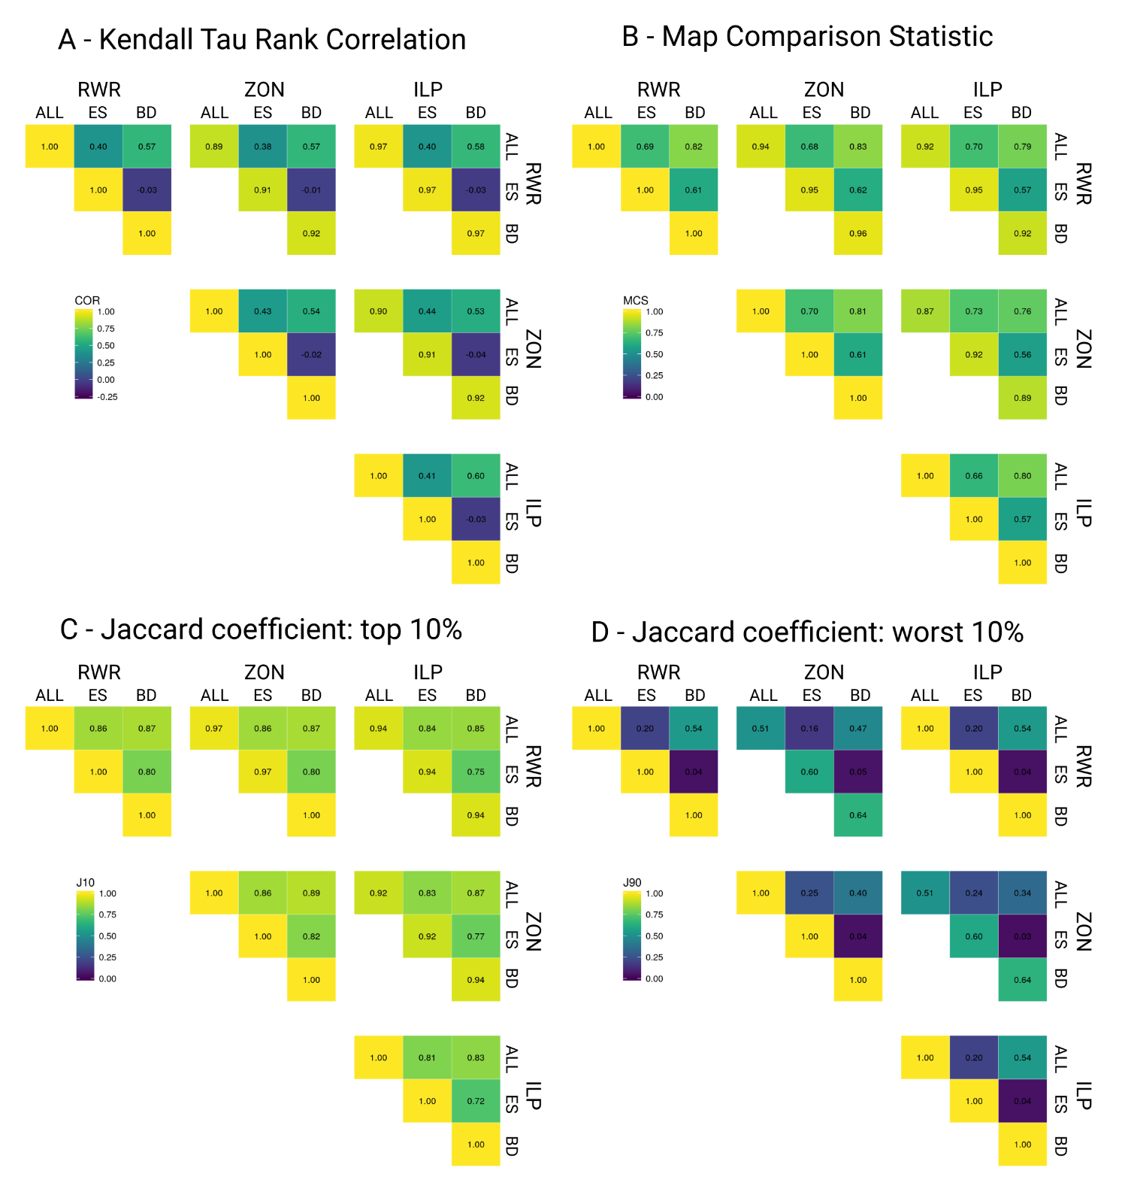
(A) FIGURE LEGENDS

Figure 1. The 25 European countries included in the study.

Figure 2. Rank priority maps for different methods (RWR, ZON and ILP) in columns, and for different datasets in rows (ALL, ES, BD).

Figure 3. Similarity dissimilarity between the complete set of analysis variants (ALL + ES + BD) as measured by A) Kendall’s Tau rank correlation, B) MCS, and Jaccard’s coefficient between the best 10% (C) and the worst 10% (D) of the landscape.

Figure 4. Performance curves for RWR_ALL (A), ZON_ALL (B) and ILP_ALL (C). XX curve is an average over all features, YY and ZZ are groups average for ES and BD respectively. Panel D show the average representation of features in RWR and ZON solutions when the rank order is taken from ILP (since it is guaranteed optimal).

Figure 5. Mean priority rank and standard deviation of mean priority ranks between NUTS2-regions in the area of interest.

Figure S1. Schematics of the study workflow.

(A) FIGURES, SUPPORTING INFROMATION
Figure 1.
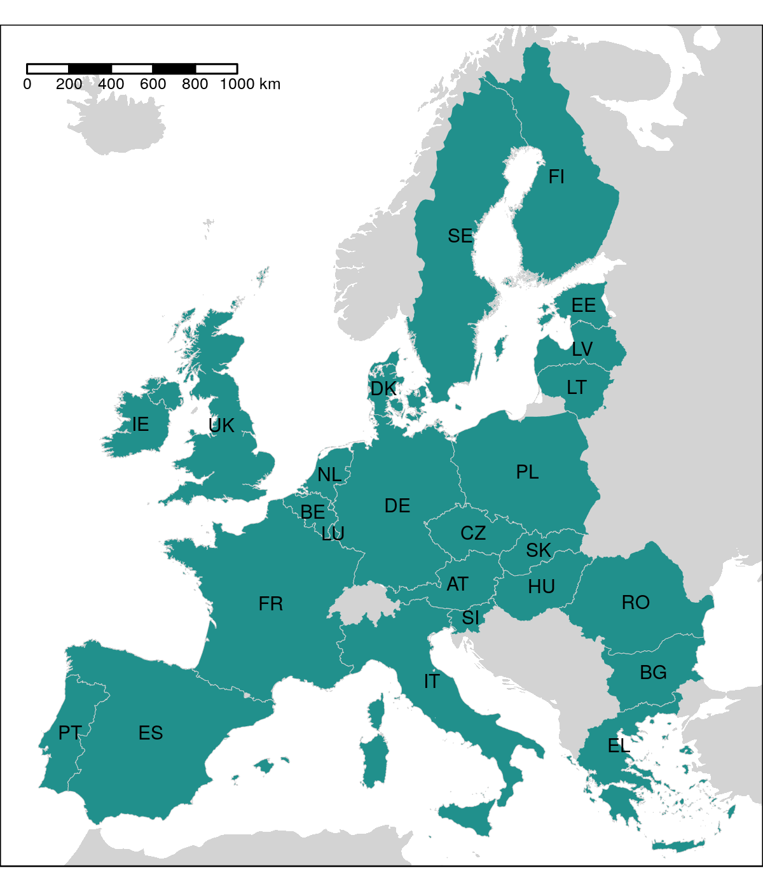
Figure 2.
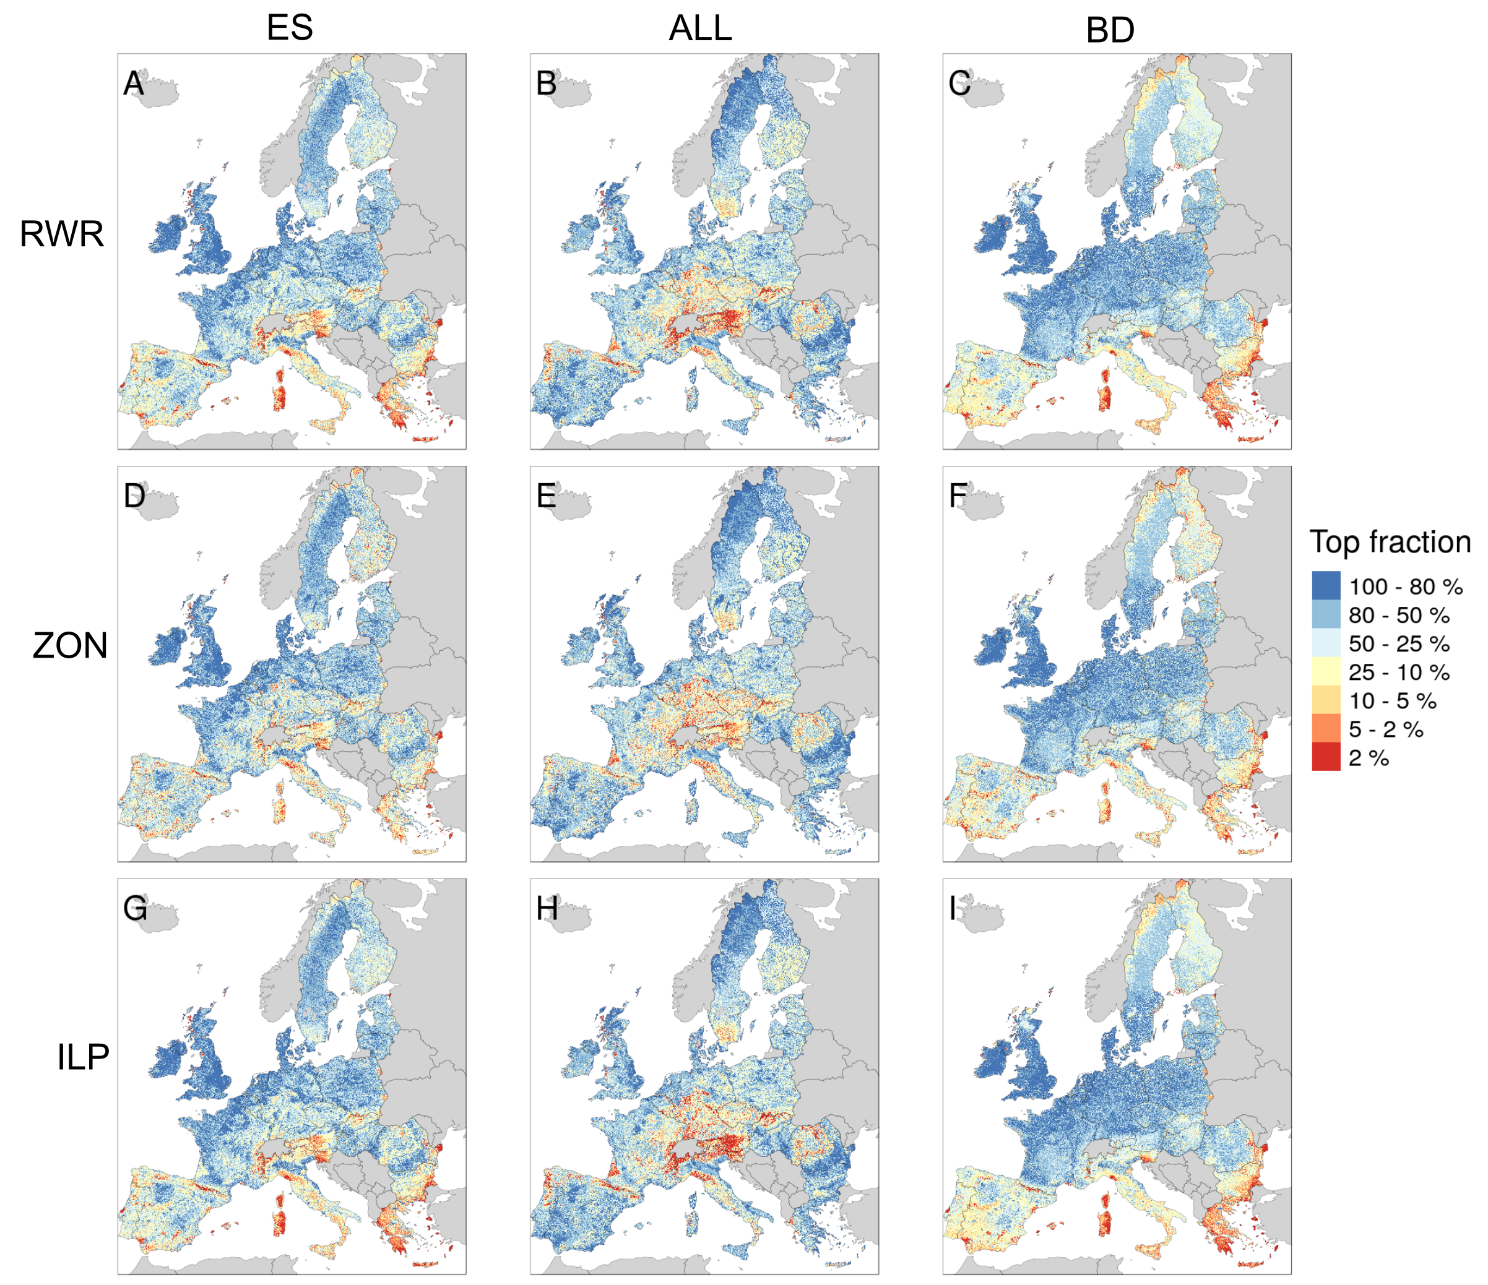
Figure 3.
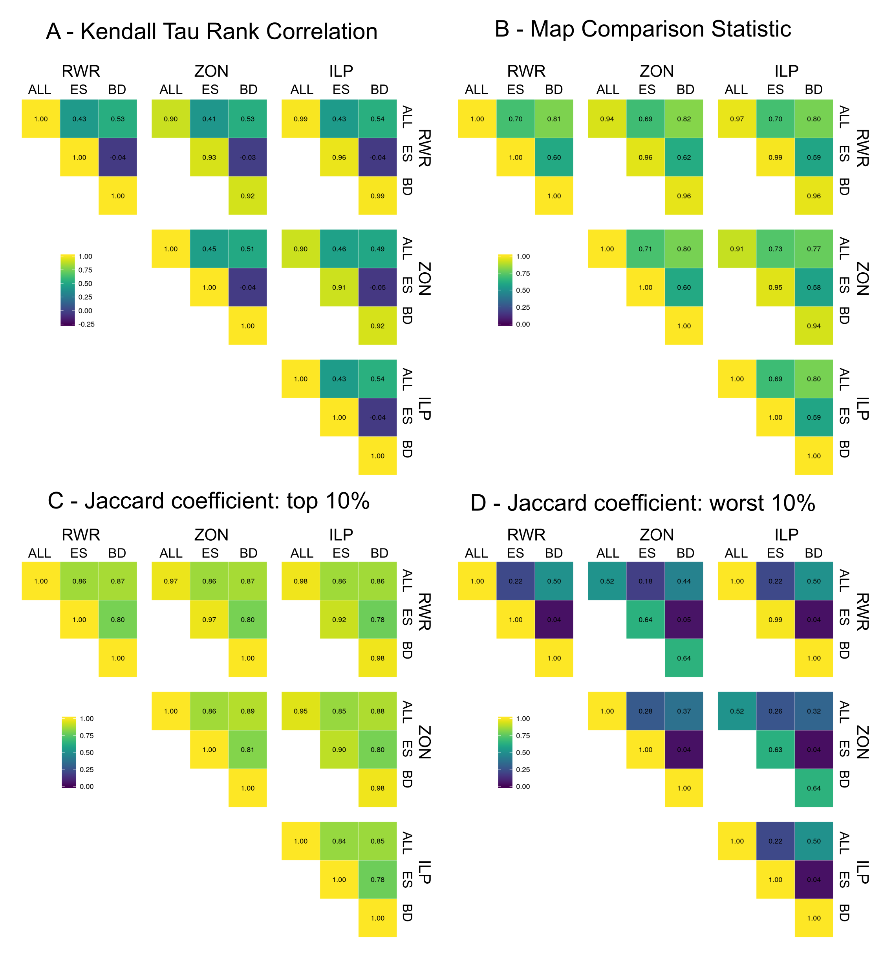
Figure 4.
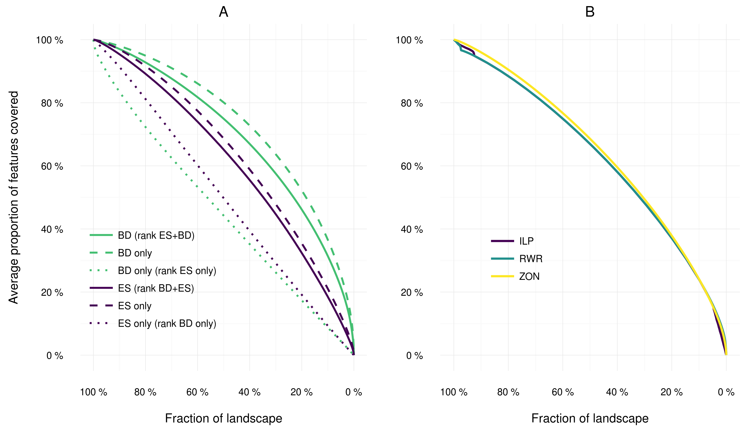
Figure 5.
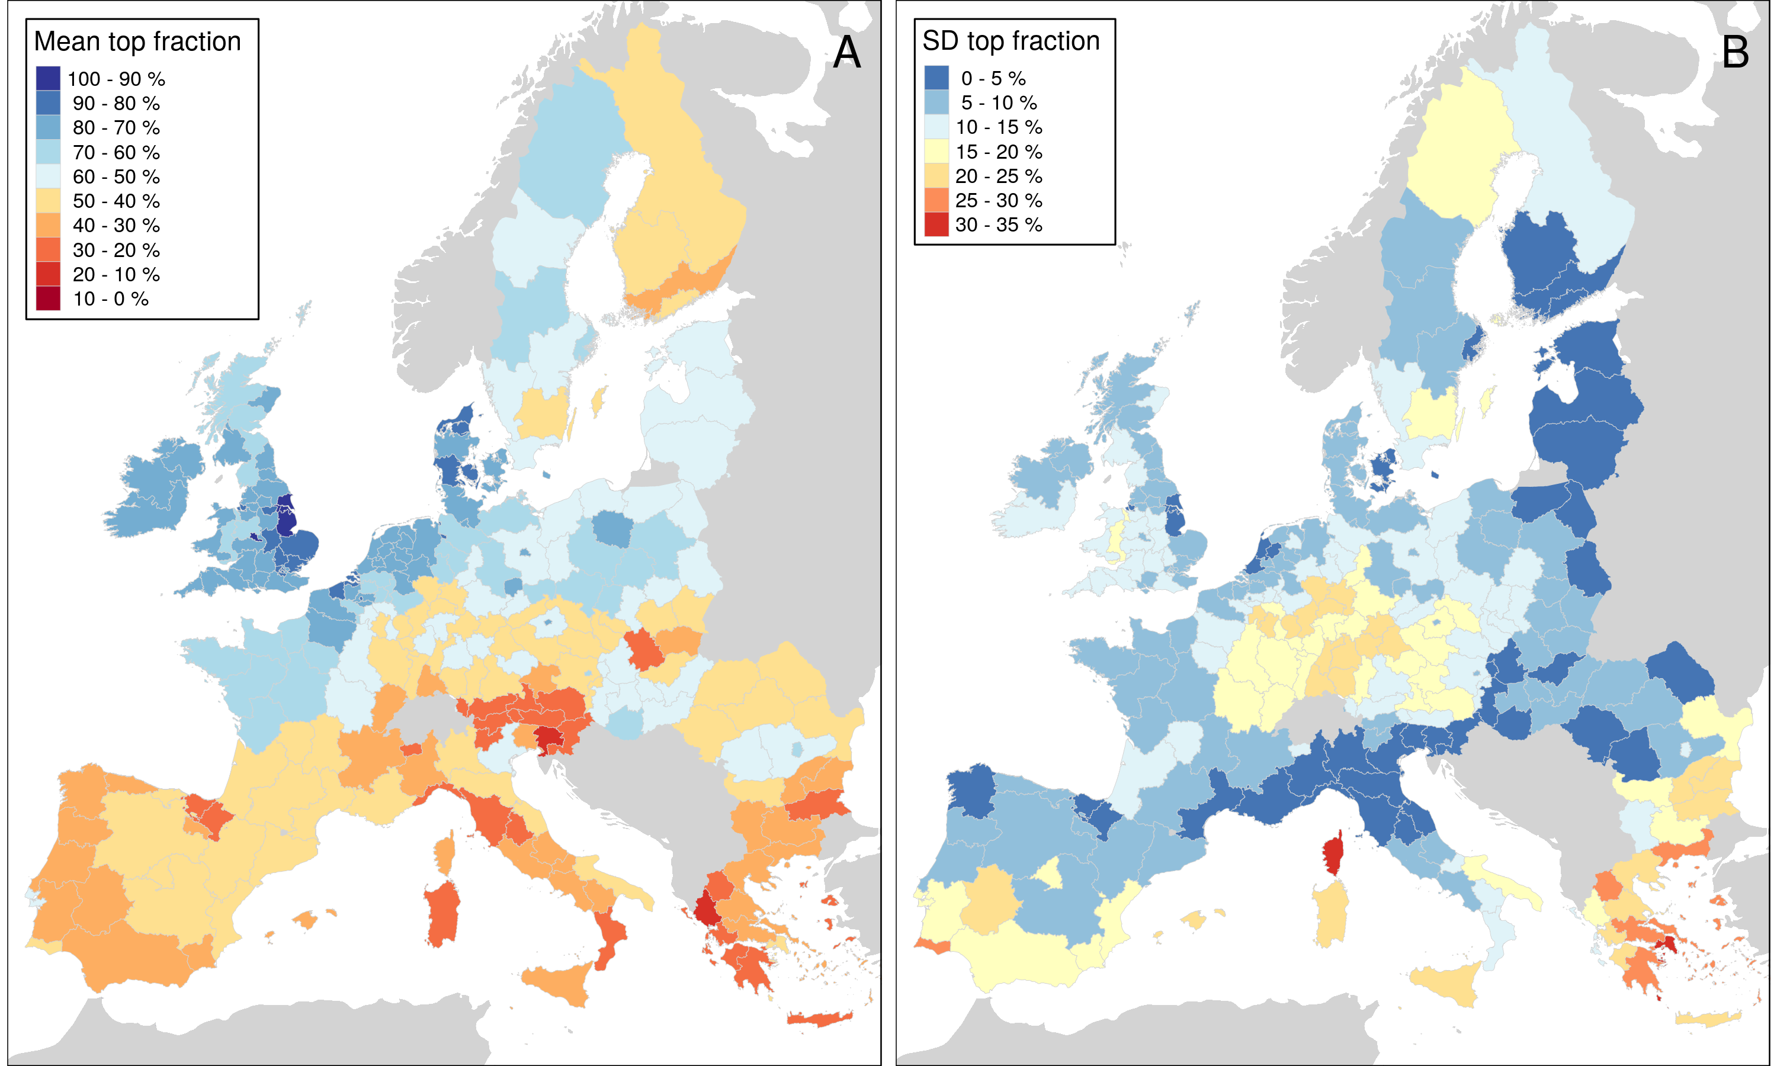
Figure S1.
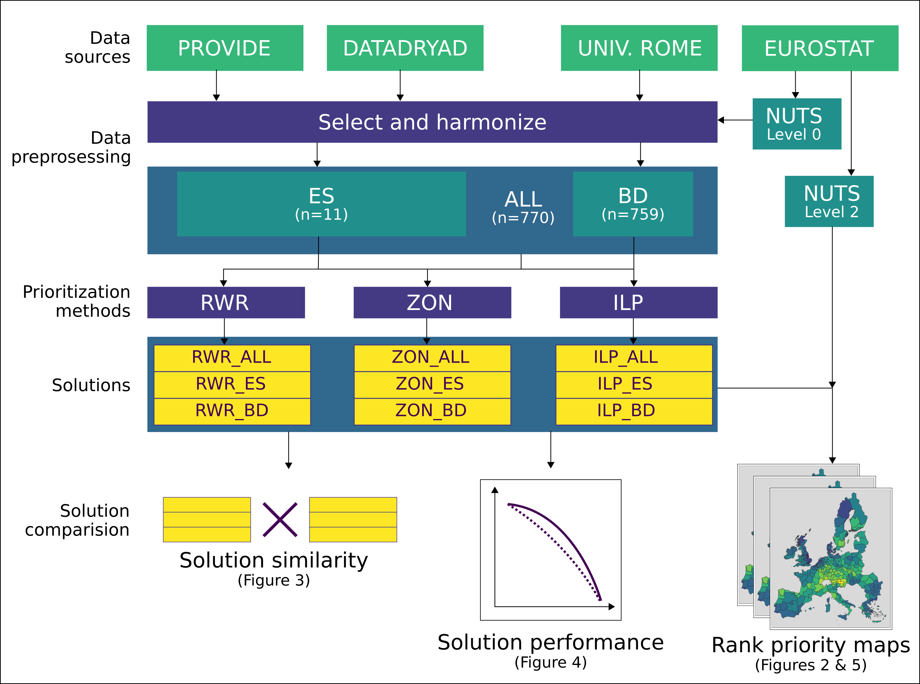
Table S1 Biodiversity features (n=759) used in the prioritization analyses.
Amphibians
Alytes cisternasii
Alytes dickhilleni
Alytes muletensis
Alytes obstetricans
Atylodes genei
Bombina bombina
Bombina pachypus
Bombina variegata
Bufo bufo
Calotriton arnoldi
Calotriton asper
Chioglossa lusitanica
Discoglossus galganoi
Discoglossus jeanneae
Discoglossus montalentii
Discoglossus pictus
Discoglossus sardus
Epidalea calamita
Euproctus montanus
Euproctus platycephalus
Hyla arborea
Hyla intermedia
Hyla meridionalis
Hyla sarda
Lissotriton boscai
Lissotriton helveticus
Lissotriton italicus
Lissotriton montandoni
Lissotriton vulgaris
Lyciasalamandra helverseni
Lyciasalamandra luschani
Mesotriton alpestris
Pelobates cultripes
Pelobates fuscus
Pelobates syriacus
Pelodytes ibericus
Pelodytes punctatus
Pelophylax bedriagae
Pelophylax bergeri
Pelophylax cerigensis
Pelophylax cretensis
Pelophylax epeirotcus
Pelophylax esculentus
Pelophylax grafi
Pelophylax hispanicus
Pelophylax kurtmuelleri
Pelophylax lessonae
Pelophylax perezi
Pelophylax ridibundus
Pleurodeles waltl
Proteus anguinus
Pseudepidalea balearica
Pseudepidalea sicula
Pseudepidalea variabilis
Pseudepidalea viridis
Rana arvalis
Rana dalmatina
Rana graeca
Rana iberica
Rana italica
Rana latastei
Rana pyrenaica
Rana temporaria
Salamandra atra
Salamandra corsica
Salamandra lanzai
Salamandra salamandra
Salamandrina perspicillata
Salamandrina terdigitata
Speleomantes ambrosii
Speleomantes flavus
Speleomantes imperialis
Speleomantes italicus
Speleomantes sarrabusensis
Speleomantes strinatii
Speleomantes supramontis
Triturus carnifex
Triturus cristatus
Triturus dobrogicus
Triturus karelinii
Triturus macedonicus
Triturus marmoratus
Triturus pygmaeus
Birds
Accipiter brevipes
Acrocephalus agricola
Acrocephalus arundinaceus
Acrocephalus dumetorum
Acrocephalus melanopogon
Acrocephalus paludicola
Acrocephalus palustris
Acrocephalus schoenobaenus
Acrocephalus scirpaceus
Actitis hypoleucos
Aegithalos caudatus
Aegolius funereus
Aegypius monachus
Alauda arvensis
Alca torda
Alcedo atthis
Alectoris barbara
Alectoris chukar
Alectoris graeca
Alectoris rufa
Anas acuta
Anas clypeata
Anas crecca
Anas penelope
Anas platyrhynchos
Anas querquedula
Anas strepera
Anser anser
Anser brachyrhynchus
Anser erythropus
Anser fabalis
Anthus campestris
Anthus cervinus
Anthus petrosus
Anthus pratensis
Anthus spinoletta
Anthus trivialis
Apus apus
Apus caffer
Apus melba
Apus pallidus
Aquila adalberti
Aquila chrysaetos
Aquila clanga
Aquila heliaca
Aquila pomarina
Ardea cinerea
Ardea purpurea
Ardeola ralloides
Arenaria interpres
Asio flammeus
Asio otus
Athene noctua
Aythya ferina
Aythya fuligula
Aythya marila
Aythya nyroca
Bombycilla garrulus
Bonasa bonasia
Botaurus stellaris
Branta bernicla
Branta leucopsis
Bubo bubo
Bubulcus ibis
Bucanetes githagineus
Bucephala clangula
Burhinus oedicnemus
Buteo buteo
Buteo lagopus
Buteo rufinus
Calandrella brachydactyla
Calandrella rufescens
Calcarius lapponicus
Calidris canutus
Calidris maritima
Calidris minuta
Calidris temminckii
Calonectris diomedea
Caprimulgus europaeus
Caprimulgus ruficollis
Carduelis cannabina
Carduelis carduelis
Carduelis chloris
Carduelis flammea
Carduelis flavirostris
Carduelis hornemanni
Carduelis spinus
Carpodacus erythrinus
Cepphus grylle
Cercotrichas galactote
Certhia familiaris
Cettia cetti
Charadrius alexandrinus
Charadrius dubius
Charadrius hiaticula
Charadrius morinellus
Chersophilus duponti
Chlidonias hybridus
Chlidonias leucopterus
Chlidonias niger
Ciconia ciconia
Ciconia nigra
Cinclus cinclus
Circaetus gallicus
Circus aeruginosus
Circus cyaneus
Circus macrourus
Circus pygargus
Cisticola juncidis
Clamator glandarius
Clangula hyemalis
Coccothraustes coccothraustes
Columba livia
Columba oenas
Coracias garrulus
Corvus corax
Corvus corone
Corvus frugilegus
Corvus monedula
Coturnix coturnix
Crex crex
Cuculus canorus
Cuculus saturatus
Cyanopica cyana cyanus
Cygnus cygnus
Cygnus olor
Delichon urbica
Dendrocopos leucotos
Dendrocopos major
Dendrocopos medius
Dendrocopos minor
Dendrocopos syriacus
Dryocopus martius
Egretta alba
Egretta garzetta
Elanus caeruleus
Emberiza aureola
Emberiza caesia
Emberiza cia
Emberiza cineracea
Emberiza cirlus
Emberiza citrinella
Emberiza hortulana
Emberiza melanocephala
Emberiza pusilla
Emberiza rustica
Emberiza schoeniclus
Eremophila alpestris
Erithacus rubecula
Falco biarmicus
Falco cherrug
Falco columbarius
Falco eleonorae
Falco naumanni
Falco peregrinus
Falco rusticolus
Falco subbuteo
Falco tinnunculus
Falco vespertinus
Ficedula albicollis
Ficedula hypoleuca
Ficedula parva
Ficedula semitorquata
Fratercula arctica
Fringilla montifringilla
Fulica atra
Fulica cristata
Fulmarus glacialis
Galerida cristata
Galerida theklae
Gallinago gallinago
Gallinago media
Gallinula chloropus
Garrulus glandarius
Gavia arctica
Gavia immer
Gavia stellata
Gelochelidon nilotica
Glareola nordmanni
Glareola pratincola
Glaucidium passerinum
Grus grus
Gypaetus barbatus
Gyps fulvus
Haematopus ostralegus
Halcyon smyrnensis
Haliaeetus albicilla
Hieraaetus fasciatus
Hieraaetus pennatus
Himantopus himantopus
Hippolais icterina
Hippolais olivetorum
Hippolais pallida
Hippolais polyglotta
Hirundo daurica
Hirundo rustica
Hoplopterus spinosus
Hydrobates pelagicus
Ixobrychus minutus
Jynx torquilla
Lagopus lagopus
Lagopus mutus
Lanius collurio
Lanius excubitor
Lanius meridionalis
Lanius minor
Lanius nubicus
Lanius senator
Larus argentatus
Larus audouinii
Larus cachinnans
Larus canus
Larus fuscus
Larus genei
Larus marinus
Larus melanocephalus
Larus minutus
Larus ridibundus
Limicola falcinellus
Limosa lapponica
Limosa limosa
Locustella fluviatilis
Locustella luscinioides
Locustella naevia
Loxia curvirostra
Loxia leucoptera
Loxia pytyopsittacus
Loxia scotica
Lullula arborea
Luscinia luscinia
Luscinia megarhynchos
Luscinia svecica
Lymnocryptes minimus
Marmaronetta angustirostris
Melanitta fusca
Melanitta nigra
Melanocorypha calandra
Mergus albellus
Mergus merganser
Mergus serrator
Merops apiaster
Miliaria calandra
Milvus migrans
Milvus milvus
Monticola saxatilis
Monticola solitarius
Montifringilla nivalis
Morus bassanus
Motacilla alba
Motacilla cinerea
Motacilla citreola
Motacilla flava
Muscicapa striata
Neophron percnopterus
Netta rufina
Nucifraga caryocatactes
Numenius arquata
Numenius phaeopus
Nyctea scandiaca
Nycticorax nycticorax
Oceanodroma castro
Oceanodroma leucorhoa
Oenanthe hispanica
Oenanthe isabellina
Oenanthe leucura
Oenanthe oenanthe
Oenanthe pleschanka
Oriolus oriolus
Otis tarda
Otus scops
Oxyura leucocephala
Pandion haliaetus
Panurus biarmicus
Parus caeruleus
Parus cinctus
Parus cristatus
Parus lugubris
Parus major
Parus montanus
Parus palustris
Passer domesticus
Passer hispaniolensis
Passer italiae
Passer montanus
Pelecanus crispus
Pelecanus onocrotalus
Perisoreus infaustus
Pernis apivorus
Petronia petronia
Phalaropus lobatus
Phalocrocorax carbo
Phalocrocorax pygmaeus
Phasianus colchicus
Philomachus pugnax
Phoenicopterus roseus
Phoenicurus ochruros
Phoenicurus phoenicurus
Phylloscopus bonelli
Phylloscopus borealis
Phylloscopus collybita
Phylloscopus sibilatrix
Phylloscopus trochiloides
Phylloscopus trochilus
Pica pica
Picoides tridactylus
Picus canus
Picus viridis
Pinicola enucleator
Platalea leucorodia
Plectrophenax nivalis
Plegadis falcinellus
Pluvialis apricaria
Podiceps auritus
Podiceps cristatus
Podiceps grisegena
Podiceps nigricollis
Porphyrio porphyrio
Porzana parva
Porzana porzana
Porzana pusilla
Prunella collaris
Prunella modularis
Pterocles alchata
Pterocles orientalis
Ptyonoprogne rupestris
Puffinus mauretanicus
Puffinus puffinus
Puffinus yelkouan
Pyrrhocorax graculus
Pyrrhocorax pyrrhocorax
Pyrrhula pyrrhula
Rallus aquaticus
Recurvirostra avosetta
Regulus ignicapillus
Regulus regulus
Remiz pendulinus
Riparia riparia
Rissa tridactyla
Saxicola rubetra
Saxicola torquata
Scolopax rusticola
Serinus citrinella
Serinus serinus
Sitta europaea
Sitta krueperi
Sitta neumayer
Sitta whiteheadi
Somateria mollissima
Stercorarius longicaudus
Stercorarius parasiticus
Stercorarius skua
Sterna albifrons
Sterna bengalensis
Sterna caspia
Sterna dougallii
Sterna hirundo
Sterna paradisaea
Sterna sandvicensis
Streptopelia decaocto
Streptopelia turtur
Strix aluco
Strix nebulosa
Strix uralensis
Sturnus roseus
Sturnus unicolor
Sturnus vulgaris
Surnia ulula
Sylvia atricapilla
Sylvia borin
Sylvia cantillans
Sylvia communis
Sylvia conspicillata
Sylvia curruca
Sylvia hortensis
Sylvia melanocephala
Sylvia nisoria
Sylvia rueppelli
Sylvia sarda
Sylvia undata
Tachybaptus ruficollis
Tadorna ferruginea
Tadorna tadorna
Tarsiger cyanurus
Tetrao urogallus
Tetrax tetrax
Tichodroma muraria
Tringa erythropus
Tringa glareola
Tringa nebularia
Tringa ochropus
Tringa stagnatilis
Tringa totanus
Turdus iliacus
Turdus merula
Turdus philomelos
Turdus pilaris
Turdus torquatus
Turdus viscivorus
Turnix sylvatica
Tyto alba
Upupa epops
Uria lomvia
Vanellus vanellus
Xenus cinereus
Mammals
Acomys minous
Alces alces
Alopex lagopus
Apodemus agrarius
Apodemus alpicola
Apodemus epimelas
Apodemus flavicollis
Apodemus mystacinus
Apodemus sylvaticus
Apodemus uralensis
Apodemus witherbyi
Arvicola amphibius
Arvicola sapidus
Arvicola scherman
Atelerix algirus
Barbastella barbastellus
Bison bonasus
Canis aureus
Capra ibex
Capra pyrenaica
Capreolus capreolus
Chionomys nivalis
Cricetulus migratorius
Cricetus cricetus
Crocidura leucodon
Crocidura pachyura
Crocidura russula
Crocidura sicula
Crocidura suaveolens
Crocidura zimmermanni
Dama dama
Dinaromys bogdanovi
Dryomys nitedula
Eliomys quercinus
Eptesicus bottae
Eptesicus nilsonii
Eptesicus serotinus
Erinaceus europaeus
Erinaceus roumanicus
Felis silvestris
Galemys pyrenaicus
Genetta genetta
Glis glis
Gulo gulo
Hystrix cristata
Lemmus lemmus
Lepus capensis
Lepus castroviejoi
Lepus corsicanus
Lepus europaeus
Lepus granatensis
Lepus timidus
Lutra lutra
Lynx pardinus
Martes foina
Martes martes
Meles meles
Meriones tristami
Mesocricetus newtoni
Micromys minutus
Microtus agrestis
Microtus arvalis
Microtus bavaricus
Microtus brachycercus
Microtus cabrerae
Microtus duodecimcostatus
Microtus felteni
Microtus gerbei
Microtus guentheri
Microtus levis
Microtus liechtesteini
Microtus lusitanicus
Microtus multiplex
Microtus oeconomus
Microtus savii
Microtus subterraneus
Microtus tatricus
Microtus thomasi
Miniopterus schreibersi
Mus macedonicus
Mus musculus
Mus spicilegus
Mus spretus
Muscardinus avellanarius
Mustela erminea
Mustela eversmanii
Mustela lutreola
Mustela nivalis
Mustela putorius
Myodes glareolus
Myodes rufocanus
Myodes rutilus
Myomimus roachi
Myopus schisticolor
Myotis alcathoe
Myotis aurascens
Myotis bechsteinii
Myotis blythii
Myotis brandtii
Myotis capaccinii
Myotis dasycneme
Myotis daubentonii
Myotis emarginatus
Myotis myotis
Myotis mystacinus
Myotis nattereri
Myotis punicus
Neomys anomalus
Neomys fodiens
Nyctalus lasiopterus
Nyctalus leisleri
Nyctalus noctula
Oryctolagus cuniculus
Ovis aries
Pipistrellus kuhlii
Pipistrellus nathusii
Pipistrellus pipistrellus
Pipistrellus pygmaeus
Pipistrellus savii
Plecotus auritus
Plecotus austriacus
Plecotus kolombatovici
Plecotus macrobullaris
Plecotus sardus
Pteromys volans
Rhinolophus blasii
Rhinolophus euryale
Rhinolophus ferrumequinum
Rhinolophus hipposideros
Rhinolophus mehelyi
Rupicapra rupicapra
Sciurus anomalus
Sciurus vulgaris
Sicista betulina
Sicista severtzovi
Sicista subtilis
Sorex alpinus
Sorex antinorii
Sorex araneus
Sorex caecutiens
Sorex coronatus
Sorex granarius
Sorex isodon
Sorex minutissimus
Sorex minutus
Sorex samniticus
Spalax graecus
Spalax leucodon
Spalax nehringi
Spermophilus citellus
Spermophilus suslicus
Suncus etruscus
Sus scrofa
Tadarida teniotis
Talpa caeca
Talpa europaea
Talpa levantis
Talpa occidentalis
Talpa romana
Talpa stankovici
Ursus arctos
Vespertilio murinus
Vormela peregusna
Vulpes vulpes
Ablepharus kitaibelii
Acanthodactylus erythrurus
Reptiles
Algyroides fitzingeri
Algyroides marchi
Algyroides moreoticus
Algyroides nigropunctatus
Anatolacerta anatolica
Anatolacerta oertzeni
Anguis cephallonica
Anguis fragilis
Archaeolacerta bedriagae
Blanus cinereus
Blanus strauchi
Chalcides bedriagai
Chalcides chalcides
Chalcides ocellatus
Chalcides striatus
Chamaeleo africanus
Chamaeleo chamaeleon
Coronella austriaca
Coronella girondica
Cyrtopodion kotschyi
Darevskia praticola
Dolichophis caspius
Dolichophis jugularis
Eirenis modestus
Elaphe quatuorlineata
Elaphe sauromates
Emys orbicularis
Emys trinacris
Eremias arguta
Eryx jaculus
Euleptes europaea
Eumeces schneideri
Hellenolacerta graeca
Hemidactylus turcicus
Hemorrhois hippocrepis
Hemorrhois nummifer
Hierophis gemonensis
Hierophis gyarosensis
Hierophis viridiflavus
Iberolacerta aranica
Iberolacerta aurelioi
Iberolacerta bonnali
Iberolacerta cyreni
Iberolacerta galani
Iberolacerta horvathi
Iberolacerta martinezricai
Iberolacerta monticola
Lacerta agilis
Lacerta bilineata
Lacerta schreiberi
Lacerta trilineata
Lacerta viridis
Laudakia stellio
Macroprotodon brevis
Macroprotodon cucullatus
Macroprotodon mauritanicus
Macrovipera schweizeri
Malpolon monspessulanus
Mauremys leprosa
Mauremys rivulata
Montivipera xanthina
Natrix maura
Natrix tesselleta
Ophiomorus punctatissimus
Ophisops elegans
Parvilacerta parva
Platyceps collaris
Platyceps najadum
Podarcis bocagei
Podarcis carbonelli
Podarcis erhardii
Podarcis filfolensis
Podarcis gaigeae
Podarcis hispanica
Podarcis lilfordi
Podarcis melisellensis
Podarcis milensis
Podarcis muralis
Podarcis peloponnesiaca
Podarcis pityusensis
Podarcis raffonei
Podarcis sicula
Podarcis taurica
Podarcis tiliguerta
Podarcis vaucheri
Podarcis wagleriana
Psammodromus hispanicus
Psammodromus jeanneae
Psammodromus manuelae
Pseudopus apodus
Rhinechis scalaris
Tarentola mauritanica
Telescopus fallax
Testudo graeca
Testudo hermanni
Testudo marginata
Timon lepidus
Trachylepis aurata
Trionyx triunguis
Typhlops vermicularis
Vipera ammodytes
Vipera aspis
Vipera berus
Vipera latastei
Vipera renardi
Vipera seoanei
Vipera ursinii
Zamenis lineatus
Zamenis longissimus
Zamenis situla

