Comparing spatial prioritization methods for biodiversity conservation and ecosystem service supply in Europe
Joona Lehtomäki^{1*}, Luigi Maiorano² and Peter verburg¹

¹ Environmental Geography Group, Department of Earth Sciences, De Boelelaan 1105, 1081 HV Amsterdam, Vrije Universiteit Amsterdam, the Netherlands.
² XXX
* Corresponding author

Contact: j.lehtomaki@vu.nl, tel. +31-20-59-87294
ORCID: 0000-0002-7891-0843
XXX XXX
peter.verburg@vu.nl, tel. +31-20-59-83594

Running title: Spatial prioritization comparison
Keywords: spatial prioritization; ecosystem services; biodiversity conservation; Zonation; optimization; environmental decision-making
Manuscript version: 0.5.3
Manuscript statistics: 236 words (abstract)
1643 words (main body, from the introduction through the Biosketch)
7 references
6 figures
1+1 tables

Abstract:

Aim. Identifying areas that are important both for biodiversity and the supply of ecosystem services (ESs) is an important component in the process of prioritizing between alternative land-use and conservation management actions. Methods developed for spatial conservation prioritization of primarily species may be suitable for ESs as well, but it is important to know how the methods perform depending on whether both biodiversity and ecosystem services are considered and in relation to each other. Furthermore, the technical complexity, data requirements and the transparency of the method parameterization further make a great difference in the usability of each method in practical work.

Location. Europe.

Methods. We compare three methods (rarity-weighted richness, Zonation and integer linear programming) to assess their suitability for spatial prioritization integrating both biodiversity and ES data. With each method, we run a spatial prioritization analysis for 759 European tetrapod species and for 9 ESs separately and together. We then characterize the spatial similarity and performance of 1) the methods used and 2) the data groups.

Results. We show that all methods used produce very similar results both in terms of the spatial pattern of the rank priority maps as well as the method performance. For biodiversity, the distribution of priority areas is bimodal within Europe with high-priority areas both in the north and south. For ESs, Central Europe is the highest priority region. For ESs, Zonation is able to produce a more balanced solution when the highest priority areas are compared. Selecting top priority areas based only on biodiversity data can lead the 60% loss of performance in terms of the ESs covered, and 76% vice versa.

Main conclusions. When selecting a method for spatial prioritization of both biodiversity and ESs, it is important to consider the objectives of prioritization and what the data used is actually representing. Rarity-weighted richness is considerably simpler and faster to implement and run that the two other methods. However, its capabilities to accommodate analysis features needed for realistic prioritization, such as costs and connectivity, is very limited.

(A) INTRODUCTION

Management decisions concerning the future of biodiversity increasingly need to account for both biodiversity and ecosystem services (ESs) (Cimon-Morin et al., 2013; Cordingley et al., 2016; Goldman and Tallis, 2009; Larigauderie et al., 2012; Reyers et al., 2012). In particular, there is an urgent need to develop methods capable of prioritizing between management actions in a spatial context accounting both for species occurrence and the supply and demand of ESs (Luck et al., 2012)⁠. Importantly, such prioritization must go beyond the mere objective of identifying the congruence of areas highly suitable for both, or the so called win-win scenarios, to explicitly account for trade-offs involved in this multi-objective planning (Cordingley et al., 2016; McShane et al., 2011; Wilson and Law, 2016)⁠. This potential has not gone unnoticed as there is increasing interest in mapping of both on the occurrence of biodiversity (Ferrier et al., 2010; Maiorano et al., 2013; Meyer et al., 2015)⁠, ecosystem services (Egoh et al., 2008; Maes et al., 2012; Wolff et al., 2015)⁠⁠ and the interactions between the two (Mace et al., 2012; Manhães et al., 2016)⁠. Despite the strong emphasis placed on ESs in the international policy arenas (Demissew et al., 2015; Millennium Ecosystem Assessment, 2005; Silvertown, 2015)⁠, the operationalization of the concept of ESs is still remarkably varied country to country (Schröter et al., 2016)⁠. Part of this operationalization process is the careful consideration both of the data being used as well as the suitability and performance of methods available.

Spatial conservation prioritization (SCP) is the technical biogeographic-economic assessment of which areas are important for biodiversity and when and how actions should be implemented to achieve conservation goals (Ferrier and Wintle, 2009; Kukkala and Moilanen, 2012; Wilson et al., 2007)⁠. In addition to ecological effectiveness, socio-economic efficiency is a key aspect of SCP: how should limited resources be invested to maximize expected outcomes (Evans et al., 2015)⁠. While SCP was originally developed for designing more effective protected area networks, the underlying principles and methods are suitable for supporting a diverse set of decision-making contexts, including for example natural resource extraction (Kareksela et al., 2013)⁠, habitat restoration (Thomson et al., 2009)⁠ and food production (Dobrovolski et al., 2014)⁠. ⁠

Multiple methods with variable complexity and flexibility are available for spatial prioritization. Perhaps the simplest way of calculating the aggregate value of, and ultimately the priority, of a given location is simply to give that location score based on features that occur there. This scoring can be done in an additive fashion by e.g. summing up the number of features (richness score) (Ferrier and Wintle, 2009; Williams et al., 1996)⁠. However, this measure considers each given location (e.g. a grid cell) independently and does not consider the relative contribution of location to the total are under selection (i.e. complementarity) as defined by the objectives of the prioritization. Lack of complementarity can lead to highly inefficient solutions and hence most modern spatial prioritization methods incorporate complementarity somehow (Wilson et al., 2009)⁠. A relatively simple adjustment to the richness score, accounting for the rarity of each feature, leads to rarity-weighted richness (RWR) score that already includes aspects of complementarity (Albuquerque and Beier, 2015; Williams et al., 1996)⁠. This method has the advantage of being very simple and intuitive. In addition, for simple prioritization problems RWR performs reasonably well when compared against more complex methods (Albuquerque and Beier, 2015)⁠. SCP problems are also solvable exactly using spatial optimization techniques such as integer linear programming (ILP) (Beyer et al., 2016)⁠. The advantage of ILP methods is that they produce a truly optimal solution or a quantitative estimate on the sub-optimality of the solution. Additionally, the can accommodate more complex problem features, such as costs, than RWR. The downside, especially for more complex and realistic problem definitions is that the optimization problem is quickly rendered infeasible (Beyer et al., 2016)⁠, or require simplifications reducing the relevance of the solution (Moilanen, 2008)⁠. This is why heuristic methods have proven to be popular in spatial conservation prioritization: they are flexible enough to accommodate factors relevant for decision-making while retaining computational tractability (Moilanen and Ball, 2009)⁠. They cannot, however, guarantee the optimality of the solution and are typically on the same level of technical complexity as exact optimization methods.

Spatial prioritization of ESs provision is fundamentally different to spatial conservation prioritization of biodiversity, but the two share enough similarities for SCP methods to be relevant also in the context of ESs. The basic elements of a prioritization problem are the same for both biodiversity conservation and ESs: quantitative and spatial features that need to be protected or secured, potential threats that features are facing, potential actions that can be taken to retain the features and mitigate threats, and information on the costs of the potential actions (Ferrier and Wintle, 2009; Luck et al., 2012)⁠. For ESs, it is important to understand the conceptual and practical implications between ES capacity (the long-term potential of ecosystems to provide services under given management regimes) and ES flows (the actual use of ES), which is still different from ES demand (individual agents’ preferences for specific ESs) (Schröter et al., 2014a)⁠. Therefore, full spatial prioritization for ESs should, in principle, consider the capacity of ecosystem services to meet human demands, the scale of, and site dependency in, the delivery of services (flows), and the availability of alternative means of providing benefits supplied by services (Luck et al., 2012)⁠. However, even a very basic prioritization effectively only concentrating on ES capacity can be useful to summarize the distributional patterns of ESs (Kukkala and Moilanen, 2016)⁠. SCP methods have also been applied to prioritizing areas suitable for the provision of ecosystem services (Chan et al., 2006; Schröter et al., 2014b)⁠, provision of ecosystem services and urban development (Casalegno et al., 2014)⁠ and both provision of ecosystem services and biodiversity conservation (Moilanen et al., 2011; Nin et al., 2016; Reyers et al., 2012)⁠. However, most of the studies have concentrated on single or a relatively low number of ESs features (Kukkala and Moilanen, 2016). Even when a methods used may in principle be suitable for the simultaneous prioritization of biodiversity and ES features, the underlying assumption and premises of the method used receive only little attention.

Here, we compare three spatial prioritization methods that fall into the three categories of methods described above: rarity-weighted richness, Zonation (heuristic), and ILP approach (exact optimization). We apply each of the methods on a prioritization problem constituting of 9 spatially explicit features describing ecosystem services capacity and 759 features of estimated extents of occurrence of tetrapods (amphibians, birds, mammal and reptiles) on European scale. While the prioritization results are indicative of true priority areas, we are more interested in the assumptions one needs to make in order to use each method, and the relative differences between the methods. This work contributes to the understanding of operational requirements of spatial planning integrating ecosystem services and biodiversity conservation, as well as developing operational instruments for such planning. We are interested in how the different methods used to identify important areas for ecosystem services and biodiversity are suited for operational planning and provide guidelines for doing so.

(A) METHODS

(B) Area of interest

Our original aim was to cover all 28 member states of the European Union, but we had to leave Croatia, Cyprus and Malta out because they were not covered by all the selected ecosystem services and biodiversity datasets. As a result, our area of interest is a subset of EU member states of 25 countries (EU25 from now on) (Fig. 1). Despite of being heterogeneous both socioeconomically and biogeographically, the EU forms a coherent supranational administrative region dealing with complex environmental management structures and issues. While our aim here is not to inform any particular policy process, comparing the prioritization methods at the EU-level does at least in principle hold potential to actual policy-relevance.

[Figure 1 approximately here]

(B) Data

We reviewed (non-systematically) a group of studies that have generated quantitative mappings of a broad set of ecosystem services and biodiversity in Europe and used the outputs of these studies as inputs for our prioritization analyses. We used the following criteria for selecting the datasets: 1) relevance as collection (datasets are broad and representative sample of both ecosystem services and biodiversity), 2) spatiotemporal resolution (datasets have fine enough spatial grain and are collected around the same time) and 3) geographical coverage (datasets cover the same geographical region). Screening the available datasets left us with 770 selected datasets 11 features of ecosystem services capacity (from here called data group ES) and 759 features of biodiversity features (data group BD) (Table 1) .

[Table 1 approximately here]

(C) Ecosystem services features (ES)

We selected a collection of datasets that broadly indicate supporting, provisioning, regulating and cultural ecosystem services (Millennium Ecosystem Assessment, 2005). For all the ecosystem services datasets (data group ES) included⁠, we assume a linear relationship between the estimated quantity and the perceived benefit. While some ES datasets include aspects of both supply and demand, we consider the datasets to indicate the ES capacity at any given location. The ES datasets are a subset of datasets preciously collated and harmonized as part of a Horizon 2020 project PROVIDE (http://www.provide-project.eu/) and we obtained the datasets directly from project partners (Komossa et al., 2016)⁠.

For our prioritization analysis, we settled for spatial resolution of 1 km². This resolution is fine enough to be relevant for regional scale decision-making (REF) while still being computationally feasible at European scale. To further harmonize all the ES datasets into the same geographical extent and coordinate reference system (ETRS89 / ETRS-LAEA, EPSG:3035), we developed pre-processing components as part of the study workflow implementation (see section 2.5) using the Python bindings to the Geospatial Data Abstraction Library (version 2.0.2, GDAL Development Team, 2016)⁠.⁠ If a datasets contained negative values (only one datasets: climate regulation), the dataset was rescaled so that all values were positive.

(C) Biodiversity features (BD)

To assess the priority locations for biodiversity conservation in Europe, we considered the refined extent of occurrence (EOO) models for terrestrial vertebrates. The EOO models have been collated from several sources and refined to take into account the suitability of different land-use/land-cover classes based on the habitat preferences of different species (Maiorano et al., 2013; Thuiller et al., 2015). We extracted a subset (BD from now on) of the original data for species that, according the EOO models, occur in EU25 countries, which constituted of 759 species (64 mammal, 404 bird, 83 amphibian, and 112 reptile species). The original data has a spatial resolution of 300 meters, which we aggregated to 1 km while matching the geographical extent of the ES datasets using ArcGIS XX (REF). In the aggregated datasets, the value r_{ij} of each cell i describes the fraction of the cell that is considered, by expert evaluation, to be either primarily or marginally suitable habitat for species j.⁠

(C) Auxiliary data

For delineating and selecting the area if interest, we used the spatial version of the NUTS (Nomenclature of territorial units for statistics) classification (both level 0 and level 2) for the EU available from EUROSTAT (REF).

(B) Prioritization methods

(C) Rarity-weighted richness (RWR)

In implementing the RWR algorithm, we followed the description originally given by Williams et al. (1996)⁠ and later revisited by Albuquerque and Beier (2015) with small modifications. More specifically, where as Albuquerque and Beier (2015) used species presence/absence data, we do not restrict the values of features in the prioritization (ES and BD) to binary values only. Instead, the whatever values are present in the datasets are retained. Thus, we define RWR score s for cell i as:

(1)

where c_{ij} is the value of feature j in cell i, w_{j} is the weight for feature j, c_{j} is the sum of all cells for feature j and the values are summed for the N features that occur in cell i. Because the feature-specific normalization results in relative values, the original units do not matter and the datasets are not required to be in the same scale. We calculated the RWR scores for each of the data groups resulting in three computational variants: RWR_ALL, RWR_ES and RWR_BD (Fig. S1). Because we used many more biodiversity than ecosystem services ⁠features (759 and 11, respectively), we also defined a weighting scheme when calculating the RWR scores for the variant RWR_ALL. The weight w_{j} for a single feature j in data group g (ES or BD) is 1/n_{g} where n_{g} is the number of features in that group. This way, the aggregate weights for both data groups are the same. We implemented the RWR algorithm using Python (version 3.5, Python Development Team, 2016)⁠ and NumPy (version 1.10.4, van der Walt et al., 2011).⁠

(C) Zonation (ZON)

As the second prioritization method, we used Zonation (version 4.0, Moilanen et al., 2014) spatial conservation prioritization software. Zonation works on a given set of inputs that describe the occurrence of features to be prioritized in a spatially explicit manner. Starting from the full set of features, it starts iteratively removing the least valuable cells while accounting for the initial occurrence of features and the remaining occurrence of each feature. On each iteration, the features are normalized by their remaining occurrence levels, a step very similar to the occurrence level normalization in computing the RWR scores. Zonation then calculates the marginal loss value for each cell and removes the cell with the smallest marginal loss value. Zonation has several cell removal rules available for defining how exactly the marginal loss is calculated. Here, we used the Additive Benefit Function (ABF) rule, which sums the values over all features in a given cell according to a given benefit function (Arponen et al., 2005)⁠. Given the full set of pixels S, the marginal loss δ for cell i is

(2)

where R_{j}() is a benefit function quantifying the value of feature j in the set of remaining cells s and s – I (s,i ∊ S) and w_{j} is the weight for feature j. As a feature gets rarer in the cell-removal process, it also becomes relatively more valuable. This process leads to the maintenance of a balanced representation of all features in the solution. We chose to use ABF for two reasons. First, an (utility maximizing) additive benefit function (Arponen et al., 2005; Laitila and Moilanen, 2012)⁠ seems suitable for calculating the aggregate value of cells in our case, because the resulting priority areas will have relatively high occurrence levels of a large number of features. For ESs, this translates into giving priority to ES bundles, and for biodiversity feature, giving priority to species richness. Second, ABF can be regarded as a generalization of a maximum coverage problem (Laitila and Moilanen, 2012)⁠ and hence comparable (in its simple form) to RWR and ILP methods.

We created 3 main variants for Zonation: ZON_ALL, ZON_ES and ZON_BD (Fig. S1). In the variant with all features included (ZON_ALL), we balanced the prioritization between data groups ES and BD by using the same weighting scheme as with RWR. We disabled the “edge removal” feature in Zonation and used warp factor of 1000, otherwise we used the default values for all parameters controlling the actual prioritization (for full implementation, see “Workflow system” below).

(C) Exact optimization (ILP)

We also formulate the spatial prioritization problem as a hierarchical maximum coverage problem which can solved exactly with integer linear programming. In a maximum coverage problem, we seek to find a set of cells that maximizes the overall level of representation over all features while keeping the number of selected cells below a given threshold. By hierarchical, we mean solving several maximum coverage problems using the top priority fraction of the landscape as a constraint.

(3)

where x_{i} ∊ {0,1} indicates whether cell i is included in the solution or not, r_{ij} gives the representation level of feature j in cell i and w_{j} is the weight given to feature j. As a constraint, we define that the number of cells included in the solution must be smaller than a given fraction of the landscape c ∊ {0.01, 0.02, …, 1.00}. We used Gurobi optimization solver (version 7.0.0, Gurobi Optimization Inc., 2016) and its Python bindings⁠ for solving 100 optimization problems defined above. Gurobi is a proprietary software using multiple algorithms to solve linear programming problems with a guarantee, given enough time, of finding an optimal solution or a gap measure of the level of sub-optimality.

After solving the optimization problems, we created aggregated the solutions into a hierarchical priority rank maps by first calculating the selection frequency of each cell over solutions for each value of c, then ranking the result and rescaling it into range [0, 1]. We repeated this procedure to the 3 main variants: ILP_ALL, ILP_ES and ILP_BD (Fig. S1). In the variant with all features included (ILP_ALL), we balanced the prioritization between data groups ES and BD by using the same weighting scheme as with RWR in the optimization.

(B) Comparing solution similarity and performance

We compared the solutions for all nine variants (Fig. S1) for the solution i) similarity and ii) performance. In addition, we also quantified to overall patterns in rank priorities over all solutions.

To quantify the different aspects of the similarity between the solutions, we used three different measures. First, to account for the spatial overlap we calculated the Jaccard’s index between solution subsets. Jaccard’s index J between solutions A and B is calculated as dividing the number of cells in both A and B by the number of cells in either or both solutions(for implementation details, see “Workflow implementation”). Value of J = 1 indicates a complete overlap between the solutions (or subsets). In addition to calculating J between the best 10% of all solution pairs, we also calculated J for the worst 10%. Second, we computed the rank correlation coefficients (Kendall τ, tau-b accounting for ties) between the priority rankings in all solutions using the implementation available in Scipy (Jones et al., 2001; Knight, 1966)⁠. Third, to quantify the similarity of the solutions when the aggregated to a meaningful administrative level (NUTS2 regions), we computed the Map Comparison statistic (MCS) between all solutions pairs. MCS is an index summarizing the relative difference between spatial datasets as the average difference between mean ranks in NUTS2 regions, expressed as a fraction of the highest value (Schulp et al., 2014)⁠:

where a and b are the mean ranks in a particular NUTS2 region and N is the total number of NUTS2 regions considered. To present MCS in the same scale as the Jaccard’s index and Kendall τ (1.0 signifies solutions are the same), we use 1 – MCS.⁠⁠

We also examined how well the different methods performed compared to each other. As a performance measure, we use how much of the overall feature representation levels can be covered by a given fraction of the landscape. While Zonation produces this type of performance data automatically, our RWR and ILP implementations do not. We used the so called solution loading functionality in Zonation to compute performance data for RWR and ILP. This way, the priority rank solution produced by RWR and ILP is loaded into Zonation, which then proceeds with the usual cell-removal following the rank order from the loaded solutions while also producing the performance data (Moilanen et al., 2014). We used this pre-loading functionality in two ways. First, using only ZON we examine the trade-offs in prioritizing areas on all available features (ALL) as opposed to ESs (ES) or biodiversity features (BD) only. Second, we compare the RWR and ZON solutions to the ILP solution. The Gurobi solver is the only method that produces a measure of the optimality of the result thus giving a benchmark against which the sub-optimality of the solutions produced by the other methods (RWR and ZON) can be compared to.

To quantify how similar the average rank priories calculated for each NUTS2 regions are, we also calculated the mean and the standard deviation of the priority rank of all NUTS2 regions over all solutions.

(B) Workflow implementation

We combined the individual processing steps of the data pre-processing, analyses and post-processing in a semi-automated workflow implementation using the Snakemake workflow engine (Köster and Rahmann, 2012)⁠

(A) RESULTS

(B) Spatial patterns and similarity

The priority rank maps showed different spatial patterns when compared across the different data groups. When we included all features in the analyses (ALL), the highest priority areas were found mostly in Southern Europe (Spain, Italy and Greece) with the some priorities also in Northern Fennoscandia (Fig. 2A-C). The highest priority areas for ESs only (Fig. 2 D-F) were concentrated in mountainous regions in Central Europe, Spain and Italy. We identified more isolated high-priority areas also in the North-Western UK and Portugal as well as in the southern part of Fennoscandia. The priority rank patterns for biodiversity features (BD) had a distinct bimodal distribution with high priority areas both in the south (the Mediterranean basin) and north (the subarctic Fennoscandia) (Fig. 2H-I). The patterns on rank priorities were spatially much more similar when compared across the different methods (RWR, ZON and ILP). On a visual inspection, RWR (Fig. 2A, 2D and 2H) and ILP (Fig. 2C, 2F and 2I) produced almost identical priority patterns, whereas ZON (Fig. 2B, 2E and 2G) produced slightly more dispersed priority patterns.

[Figure 2 approximately here]

On an aggregate NUTS2-level, the mean rank priorities over all nine analysis variants were the highest in central and southern Europe (Fig. 3A). The only exception the this general pattern is Finland, for which the rank priorities in all variants were relatively high. Both the highest and lowest mean rank priorities were quite consistent over the different analysis variants as measured by the standard deviation of the mean rank (Fig. 3B) with two exceptions. First, the most Southern Europe (Southern Spain, Greece, Corsica and Sardinia) had high mean rank and relatively high variation across variants. Second, Central Europe (North-Eastern France, Southern Germany) had medium high ranks and relatively high variation across the variants.

[Figure 3 approximately here]

More quantitative comparison of the priority rank using the various comparison statistics was in line with the visual observations of the similarity between the different data groups and methods. Between the data groups and within the methods, ES and BD solutions were not correlated with Kendall tau correlation coefficients of -0.04 for all methods RWR, ZON and ILP (Fig. 4A). Both ES and BD were weakly correlated with ALL with correlation coefficients of 0.42, 0.45 and 0.43 (ES) and 0.53, 0.51 and 0.54 (BD) for RWR, ZON and ILP. On a more regional scale, the MCS gives similar results with MCS of 0.60, 0.60 and 0.58 between ES and BD in RWR, ZON and ILP respectively (Fig. 4B). MCSs bewof 0.70, 0.71 and 0.68, and BD 0.80, 0.80, 0.79 for RWR, ZON and ILP respectively. The spatial overlaps as measured by the Jaccard’s coefficient between the best and worst 10% of the solution were, again, similar between the data groups and within the same method. The overlaps between the best 10% of solution ranged from 0.80 (ILP ES / ILP BD) to 0.89 (RWR BD / RWR ALL and ZON BD / ZON ALL) (Fig. 4C). There was less spatial overlap with the worst 10% of the solutions ranging from 0.04 (ES / BD in all methods) to 0.52 (RWR DB / RWR ALL and ILP BD / ILP ALL) (Fig. 4D).

Between the methods and within the data groups, solutions produced by RWR and ILP in particular were very similar. The rank correlation coefficients for the different data groups between RWR and ILP were 0.99, 0.96 and 0.99 for ALL, ES and BD respectively (Fig. 4A). Rank correlation between RWR and ZON (0.90, 0.93, 0.92 for ALL, ES and BD), and ILP and ZON (0.91, 0.90, 0.92 for ALL, ES and BD) were not quite as high but still strong. MCSs were equally strong between the methods ranging from 0.92-0.96 between ZON and ILP to 0.96–0.98 between RWR and ILP (Fig. 4B). The spatial overlap of the best 10% of the solution was 1.0 (i.e. complete) between RWR and ZON, and strong (0.90–0.98) between RWR and ILP, and ZON and ILP (Fig. 4C). Notably, the ES solution for RWR and ZON was slightly less overlapping (0.90) with that of ILP. The worst 10% of the solution were almost completely overlapping (0.99-1.00) for RWR and ILP, and fairly overlapping (0.53-0.64) for RWR and ZON, and ZON and ILP (Fig. 4D).

[Figure 4 approximately here]

(B) Solution performance and optimality

Figure 5 shows the differences in performance per data group (ES or BD) depending on which data group (ALL, ES and BD) was used in the Zonation prioritization (results we obtained by using the other methods (RWR and ILP) are qualitatively similar and omitted here). Here, performance is measured as the average proportion of features covered in each data group by a given (top) fraction of the solution. The highest levels of performance per data group are obtained when the prioritization is based on those data groups only. This way, for example, the top 10% (vertical dashed line in Fig. 5) would cover on average 36.4% of features in group BD when the prioritization is based on BD only, 30.7% when the prioritization is based on ALL, and 8.6% when the prioritization is based on ES only. Corresponding figures for ES features covered are 23.0%, 18.6% and 9% (Fig. 5). In other words, for features in BD selecting top 10% of the solution based on ES only leads to a performance loss of 76.3% compared to to a solution based only on BD. Similarly, when selecting the top 10% of solution based on features from BD only leads to performance loss of 60% for ES.
[Figure 5 approximately here]

An optimal solution with a gap of 0% was found for all 49 ILP problems and the performance of the combined hierarchical solutions is shown in Figure 6A. When compared against the optimal solution, the performance of the RWR solutions for data group ALL was almost identical while ZON solutions performed only slightly worse (Fig. 6A). The performance for data group ES, however, was slightly better for ZON. The better performance of ZON for ES is more evident when the whole distribution of feature values and the median – rather than the mean – over features in ES is examined (Fig. 6B). For the top fraction of the solutions (e.g. top 10% and top 2% in Fig. 6B), both the median and interquartile range indicate higher average feature distribution covered.

[Figure 6 approximately here]

(A) DISCUSSION

We show that for a simple prioritization problem formulation and for all data feature included in this study, RWR performance is very close to that of an exact optimization method and slightly better than Zonation. However, for the highest priority fraction of the prioritization solutions Zonation produced a more balanced solution for ESs. We also show that the rank priority patterns for ESs and biodiversity features are different within Europe and that notable trade-offs for individual data groups are induced when spatial prioritization is done for all data.

(B) Priority rank patterns

While our primary objective was not to carry out a directly policy-relevant prioritization, the results are still informative for examining the distributional patterns of both biodiversity and ES features. For ES, the highest priorities were concentrated in Central Europe (Fig. 2). Two ES features in particular had a high influence on the patterns. Erosion prevention has high values in mountainous regions, but is relatively rare elsewhere. Carbon sequestration and wood production had a minor, but still noticeable effect concentrating priorities in Southern Fennoscandia and South-Western France. For BD, the distributional pattern for all solutions was bimodal in terms of latitudinal gradient. Since all methods prioritize based on a combined measure of rarity and richness, the interpretation is that both the southern (the Mediterranean basin) and the northern (the subarctic Fennoscandia) have relatively many species with restricted range-sizes. ALL, being a combination of ES and BD, strikes a balance between ES and BD prioritizations.

(B) Method performance

Our results are in line with Albuquerqeue and Beier (2015) that the performance of RWR is slightly better than Zonation for a set of plant and bird species in Africa, Europe and North America. However, where Albuquerqeue and Beier (2015) used the core-area cell-removal rule in Zonation (CAZ), we chose to use the additive benefit function rule. ABF is conceptually closer to our implementations of RWR and ILP and thus forms a better basis for comparison. Which one of ABF (somewhat emphasizes richness) or CAZ (somewhat emphasizes rarity) is better suited for prioritization of ESs in particular is an important question, but outside the scope of the current work. However, we do highlight the importance of addressing this question whenever deciding which method is used for the prioritization analysis.

The methods we used also differed in the amount of time and resources required for both setting up the analysis and running them. Excluding the data pre-processing (which was almost identical for all methods) and the actual implementation of the RWR algorithm (which we did using free and open source software), the prioritization analyses using RWR took very little extra effort. RWR was also the fastest method to run. On a cloud-based server configuration running Ubuntu 14.04.5, an Intel Xeon E5-2698 2.30GHz CPU and 70 GB of RAM, the run times for RWR_ALL, RWR_ES and RWR_BD were ~10 min, 12 s and ~9.5 min respectively. Setting up the Zonation analyses takes more work, but documentation for this is available online (e.g. Lehtomäki et al., 2016; Moilanen et al., 2014). For the final analyses, Zonation took considerably longer to run (ZON_ALL ~2.6 days⁠, ZON_ES ~30 min and ZON_BD ~2.4 days), but this is mostly because conservative parameter settings. Run times could be greatly reduced without much effect on the results. Setting up the ILP prioritization analyses using the Gurobi solver also was very straight forward thanks to good online documentation and a recent study (Beyer et al., 2016)⁠ using a similar approach. The run times of ILP were longer than for RWR, but shorter than for ZON: ~2 hours 37 min (ILP_ALL), ~1 hour 57 min (ILP_ES) and ~2 hours 33 min (ILP_BD).

The high similarity of RWR and ILP both in terms of performance as well as spatial patterns, however, is not surprising as their implementations have a lot of similarities; the only significant difference is how the aggregate value of each cell is calculated. For RWR, the aggregate value is a simple sum over rarity-weighted range sizes. For ILP, the aggregate value is the selection frequency in a set of hierarchical maximum coverage optimizations. It is also possible, that the hierarchical structure if the ILP solution (1% intervals in target coverage, see Methods) incurs a small performance penalty which could be avoided by running the optimizations with a smaller interval.

(B) Integrated prioritization of biodiversity conservation and ecosystem services supply

While not our primary objective here, the prioritization results we produced using the different methods are informative for assessing the spatial distribution of both the selected European tetrapod species and ES capacity.

(B) Selecting the right tool

Simplicity and speed are both valuable features of a method supposed to provide support for decision-making, but both come with a prize: simple and fast methods may not be able to accommodate all the components required to model a real-life spatial prioritization problem. For example, our current analysis assumes no spatial interactions within or between the features included in the analyses. In reality, however, spatial connectivity between the planning units (pixels) is probably required both for biodiversity (Beyer et al., 2016; Lehtomäki et al., 2009)⁠ ESs features (Kukkala and Moilanen, 2016)⁠. Cost-effective spatial prioritization often also requires prioritizing between actions, not places (Brown et al., 2015)⁠. This then implies, that prioritization methods used should, in principle, be capable of factoring in such real-life complexities such costs, condition, and clearly defined objectives and benefits (Evans et al., 2015)⁠. Equally, for ESs models for ES capacity, flows and demand potentially need to be incorporated (Luck et al., 2012; Schröter et al., 2014a)⁠. If this is the case, then simple (and fast) methods such as RWR are not enough as they cannot handle such complications.

(A) ACKNOWLEDGEMENTS
- OPERAs
- SURFsara
- Matt Strimas-Mackey for the prioritizr R package
- Beyer et al. (2016) for making the ILP implementation available.

(A) SUPPORTING INFORMATION

(A) BIOSKETCH

(A) REFERENCES

Albuquerque, F.S., Beier, P., 2015. Rarity-Weighted Richness: A Simple and Reliable Alternative to Integer Programming and Heuristic Algorithms for Minimum Set and Maximum Coverage Problems in Conservation Planning. PLoS One 10, e0119905. doi:10.1371/journal.pone.0119905
Arponen, A., Heikkinen, R.K., Thomas, C.D., Moilanen, A., 2005. The Value of Biodiversity in Reserve Selection: Representation, Species Weighting, and Benefit Functions. Conserv. Biol. 19, 2009–2014. doi:10.1111/j.1523-1739.2005.00218.x
Beyer, H.L., Dujardin, Y., Watts, M.E., Possingham, H.P., 2016. Solving conservation planning problems with integer linear programming. Ecol. Modell. 328, 14–22.
Brown, C.J., Bode, M., Venter, O., Barnes, M.D., McGowan, J., Runge, C.A., Watson, J.E.M., Possingham, H.P., 2015. Effective conservation requires clear objectives and prioritizing actions, not places or species. Proc. Natl. Acad. Sci. 201509189. doi:10.1073/pnas.1509189112
Casalegno, S., Bennie, J.J., Inger, R., Gaston, K.J., 2014. Regional scale prioritisation for key ecosystem services, renewable energy production and urban development. PLoS One 9. doi:10.1371/journal.pone.0107822
Chan, K.M.A., Shaw, M.R., Cameron, D.R., Underwood, E.C., Daily, G.C., 2006. Conservation Planning for Ecosystem Services. PLoS Biol. 4, e379. doi:10.1371/journal.pbio.0040379
Cimon-Morin, J., Darveau, M., Poulin, M., 2013. Fostering synergies between ecosystem services and biodiversity in conservation planning: A review. Biol. Conserv. 166, 144–154. doi:10.1016/j.biocon.2013.06.023
Cordingley, J.E., Newton, A.C., Rose, R.J., Clarke, R.T., Bullock, J.M., 2016. Can landscape-scale approaches to conservation management resolve biodiversity-ecosystem service trade-offs? J. Appl. Ecol. 53, 96–105. doi:10.1111/1365-2664.12545
Demissew, S., Carabias, J., Dı, S., Joly, C., Lonsdale, M., Ash, N., Adhikari, J.R., Arico, S., Bartuska, A., Baste, I.A., Bilgin, A., Brondizio, E., Chan, K.M. a, Figueroa, V.E., Duraiappah, A., Fischer, M., Hill, R., Koetz, T., Leadley, P., Lyver, P., Mace, G.M., Martin-lopez, B., Okumura, M., Pacheco, D., Reyers, B., Pascual, U., Pe, E.S., Roth, E., Saito, O., Scholes, R.J., Sharma, N., Tallis, H., Thaman, R., Watson, R., Yahara, T., Hamid, Z.A., Akosim, C., Al-hafedh, Y., Amankwah, E., Asah, T.S., Asfaw, Z., Bartus, G., Brooks, A.L., Caillaux, J., Dalle, G., Darnaedi, D., Driver, A., Erpul, G., Escobar-Eyzaguirre, P., Failler, P., Moustafa, A., Fouda, M., Fu, B., Gundimeda, H., Hashimoto, S., Homer, F., Lavorel, S., Lichtenstein, G., Mala, W.A., Mandivenyi, W., Matczak, P., Mbizvo, C., Mehrdadi, M., Metzger, J.P., Mikissa, J.B., Moller, H., Mooney, H. a, Mumby, P., Nagendra, H., Nesshover, C., Oteng-Yeboah, A.A., Rubis, J., Schultz, M., Smith, P., Sumaila, R., Takeuchi, K., Thomas, S., Díaz, S., Demissew, S., Carabias, J., Joly, C., Lonsdale, M., Ash, N., Larigauderie, A., Adhikari, J.R., Arico, S., Báldi, A., Bartuska, A., Baste, I.A., Bilgin, A., Brondizio, E., Chan, K.M. a, Figueroa, V.E., Duraiappah, A., Fischer, M., Hill, R., Koetz, T., Leadley, P., Lyver, P., Mace, G.M., Martin-lopez, B., Okumura, M., Pacheco, D., Pascual, U., Pérez, E.S., Reyers, B., Roth, E., Saito, O., Scholes, R.J., Sharma, N., Tallis, H., Thaman, R., Watson, R., Yahara, T., Hamid, Z.A., Akosim, C., Al-hafedh, Y., Allahverdiyev, R., Amankwah, E., Asah, S.T., Asfaw, Z., Bartus, G., Brooks, L.A., Caillaux, J., Dalle, G., Darnaedi, D., Driver, A., Erpul, G., Escobar-Eyzaguirre, P., Failler, P., Fouda, A.M.M., Fu, B., Gundimeda, H., Hashimoto, S., Homer, F., Lavorel, S., Lichtenstein, G., Mala, W.A., Mandivenyi, W., Matczak, P., Mbizvo, C., Mehrdadi, M., Metzger, J.P., Mikissa, J.B., Moller, H., Mooney, H. a, Mumby, P., Nagendra, H., Nesshover, C., Oteng-Yeboah, A.A., Pataki, G., Roué, M., Rubis, J., Schultz, M., Smith, P., Sumaila, R., Takeuchi, K., Thomas, S., Verma, M., Yeo-Chang, Y., Zlatanova, D., 2015. The IPBES Conceptual Framework — connecting nature and people. Curr. Opin. Environ. Sustain. 14, 1–16. doi:10.1016/j.cosust.2014.11.002
Dobrovolski, R., Loyola, R.D., Gustavo, A.B., Araújo, M.B., Da Fonseca, G.A.B., Diniz-Filho, J.A.F., Araújo, M.B., 2014. Globalizing Conservation Efforts to Save Species and Enhance Food Production. Bioscience XX, 1–7. doi:10.1093/biosci/biu064
Egoh, B., Reyers, B., Rouget, M., Richardson, D.M., Le Maitre, D.C., van Jaarsveld, A.S., 2008. Mapping ecosystem services for planning and management. Agric. Ecosyst. Environ. 127, 135–140. doi:10.1016/j.agee.2008.03.013
Evans, M.C., Tulloch, A.I.T., Law, E.A., Raiter, K.G., Possingham, H.P., Wilson, K.A., 2015. Clear consideration of costs, condition and conservation benefits yields better planning outcomes. Biol. Conserv. 191, 716–727. doi:10.1016/j.biocon.2015.08.023
Ferrier, S., Powell, G.V.N., Richardson, K.S., Manion, G., Overton, J.M., Allnutt, T.F., Cameron, S.E., Mantle, K., Burgess, N.D., Daniel, P., 2010. Mapping More of Terrestrial Biodiversity for Global Conservation Assessment. Bioscience 54, 1101–1109.
Ferrier, S., Wintle, B.A., 2009. Quantitative approaches to spatial conservation prioritization: matching the solution to the need, in: Moilanen, A., Wilson, K.A., Possingham, H.P. (Eds.), Spatial Conservation Prioritization: Quantitative Methods & Computational Tools. Oxford University Press, Oxford, p. 304.
GDAL Development Team, 2016. GDAL - Geospatial Data Abstraction Library, version 2.1.0. Open Source Geospatial Foundation.
Goldman, R.L., Tallis, H., 2009. A critical analysis of ecosystem services as a tool in conservation projects: The possible perils, the promises, and the partnerships. Ann. N. Y. Acad. Sci. 1162, 63–78. doi:10.1111/j.1749-6632.2009.04151.x
Gurobi Optimization Inc., 2016. Gurobi Optimizer Reference Manual.
Jones, E., Oliphant, T., Peterson, P., 2001. SciPy: Open source scientific tools for Python.
Kareksela, S., Moilanen, A., Tuominen, S., Kotiaho, J.S., 2013. Use of Inverse Spatial Conservation Prioritization to Avoid Biological Diversity Loss Outside Protected Areas. Conserv. Biol. 27, 1294–1303. doi:10.1111/cobi.12146
Knight, W.R., 1966. A Computer Method for Calculating Kendall’s Tau with Ungrouped Data. J. Am. Stat. Assoc. 61, 436–439.
Komossa, F., Schulp, C.J.E., van der Zanden, E.H., Verburg, P.H., Parikka, H., Kurttila, M., 2016. Deliverable D3.1: Set of maps and short analysis showing demand, supply and hotspots of public goods in the the EU at 1 km2 and relevant NUTS levels.
Köster, J., Rahmann, S., 2012. Snakemake-a scalable bioinformatics workflow engine. Bioinformatics 28, 2520–2522. doi:10.1093/bioinformatics/bts480
Kukkala, A.S., Moilanen, A., 2016. Ecosystem services and connectivity in spatial conservation prioritization. Landsc. Ecol. doi:10.1007/s10980-016-0446-y
Kukkala, A.S., Moilanen, A., 2012. Core concepts of spatial prioritisation in systematic conservation planning. Biol. Rev. 88, 443–464. doi:10.1111/brv.12008
Laitila, J., Moilanen, A., 2012. Use of many low-level conservation targets reduces high-level conservation performance. Ecol. Modell. 247, 40–47. doi:10.1016/j.ecolmodel.2012.08.010
Larigauderie, A., Prieur-Richard, A.-H., Mace, G.M., Lonsdale, M., Mooney, H.A., Brussard, L., Coopers, D., Cramer, W., Daszak, P., Díaz, S., Duraiappah, A.K., Elmqvist, T., Faith, D.P., Jackson, L.E., Krug, C., Leadley, P.W., Le Prestre, P., Matsuda, H., Palmer, M.A., Perrings, C., Pulleman, M., Reyers, B., Rosa, E.A., Scholes, R.J., Spehn, E., Turner II, B.L., Yahara, T., 2012. Biodiversity and ecosystem services science for a sustainable planet: the DIVERSITAS vision for 2012–20. Curr. Opin. Environ. Sustain. 100, 130–134. doi:10.1016/j.pestbp.2011.02.012.Investigations
Lehtomäki, J., Moilanen, A., Toivonen, T., Leathwick, J., 2016. Running a Zonation Planning Project. Helsinki. doi:10.13140/RG.2.1.4919.5289
Lehtomäki, J., Tomppo, E., Kuokkanen, P., Hanski, I., Moilanen, A., 2009. Applying spatial conservation prioritization software and high-resolution GIS data to a national-scale study in forest conservation. For. Ecol. Manage. 258, 2439–2449. doi:10.1016/j.foreco.2009.08.026
Luck, G.W., Chan, K.M., Klein, C.J., 2012. Identifying spatial priorities for protecting ecosystem services. F1000 Res. 1–16. doi:10.3410/f1000research.1-17.v1
Mace, G.M., Norris, K., Fitter, A.H., 2012. Biodiversity and ecosystem services: A multilayered relationship. Trends Ecol. Evol. 27, 19–25. doi:10.1016/j.tree.2011.08.006
Maes, J., Egoh, B., Willemen, L., Liquete, C., Vihervaara, P., Schägner, J.P., Grizzetti, B., Drakou, E.G., Notte, A. La, Zulian, G., Bouraoui, F., Luisa Paracchini, M., Braat, L., Bidoglio, G., 2012. Mapping ecosystem services for policy support and decision making in the European Union. Ecosyst. Serv. 1, 31–39. doi:10.1016/j.ecoser.2012.06.004
Maiorano, L., Amori, G., Capula, M., Falcucci, A., Masi, M., Montemaggiori, A., Pottier, J., Psomas, A., Rondinini, C., Russo, D., Zimmermann, N.E., Boitani, L., Guisan, A., 2013. Threats from Climate Change to Terrestrial Vertebrate Hotspots in Europe. PLoS One 8, 1–14. doi:10.1371/journal.pone.0074989
Manhães, A.P., Mazzochini, G.G., Oliveira-Filho, A.T., Ganade, G., Carvalho, A.R., 2016. Spatial associations of ecosystem services and biodiversity as a baseline for systematic conservation planning. Divers. Distrib. 1–12. doi:10.1111/ddi.12459
McShane, T.O., Hirsch, P.D., Trung, T.C., Songorwa, A.N., Kinzig, A., Monteferri, B., Mutekanga, D., Thang, H. Van, Dammert, J.L., Pulgar-Vidal, M., Welch-Devine, M., Peter Brosius, J., Coppolillo, P., O’Connor, S., 2011. Hard choices: Making trade-offs between biodiversity conservation and human well-being. Biol. Conserv. 144, 966–972. doi:10.1016/j.biocon.2010.04.038
Meyer, C., Kreft, H., Guralnick, R., Jetz, W., 2015. Global priorities for an effective information basis of biodiversity distributions. Nat. Commun. 6, 1–8. doi:10.1038/ncomms9221
Millennium Ecosystem Assessment, 2005. Millenium Ecosystem Assessment. 2005. Ecosystems and human well-being: General synthesis. Washington D.C.
Moilanen, A., 2008. Two paths to a suboptimal solution once more about optimality in reserve selection. Biol. Conserv. 141, 1919–1923. doi:10.1016/j.biocon.2008.04.018
Moilanen, A., Anderson, B.J., Eigenbrod, F., Heinemeyer, A., Roy, D.B., Gillings, S., Armsworth, P.R., Gaston, K.J., Thomas, C.D., 2011. Balancing alternative land uses in conservation prioritization. Ecol. Appl. 21, 1419–1426. doi:10.1890/10-1865.1
Moilanen, A., Ball, I.R., 2009. Heuristic and Approximate Optimization Methods for Spatial Conservation Prioritization, in: Moilanen, A., Wilson, K.A., Possingham, H.P. (Eds.), Spatial Conservation Prioritization: Quantitative Methods & Computational Tools. Oxford University Press, Oxford, pp. 58–69.
Moilanen, A., Pouzols, F.M., Meller, L., Veach, V., Arponen, A., Leppänen, J., Kujala, H., 2014. Zonation spatial conservation planning methods and software v. 4, user manual. Helsinki.
Nin, M., Soutullo, A., Rodríguez-Gallego, L., Di Minin, E., 2016. Ecosystem services-based land planning for environmental impact avoidance. Ecosyst. Serv. 17, 172–184. doi:doi:10.1016/j.ecoser.2015.12.009
Pérez-Soba, M., Verburg, P.H., Koomen, E., Hilferink, M., Benito, P., Lesschen, J.P., Banse, M., Woltjer, G., Eickhout, B., Prins, A.-G., Staritsky, I., 2010. Land use modelling — implementation. Wageningen.
Python Development Team, 2016. Python Language Reference, version 3.5.
Reyers, B., Polasky, S., Tallis, H., Mooney, H.A., Larigauderie, A., 2012. Finding Common Ground for Biodiversity and Ecosystem Services. Bioscience 62, 503–507. doi:10.1525/bio.2012.62.5.12
Schröter, M., Albert, C., Marques, A., Tobon, W., Lavorel, S., Maes, J., Brown, C., Klotz, S., Bonn, A., 2016. National Ecosystem Assessments in Europe: A Review. Bioscience 66, biw101. doi:10.1093/biosci/biw101
Schröter, M., Barton, D.N., Remme, R.P., Hein, L., 2014a. Accounting for capacity and flow of ecosystem services: A conceptual model and a case study for Telemark, Norway. Ecol. Indic. 36, 539–551. doi:10.1016/j.ecolind.2013.09.018
Schröter, M., Rusch, G.M., Barton, D.N., Blumentrath, S., Nordén, B., 2014b. Ecosystem services and opportunity costs shift spatial priorities for conserving forest biodiversity. PLoS One 9. doi:10.1371/journal.pone.0112557
Schulp, C.J.E., Burkhard, B., Maes, J., Van Vliet, J., Verburg, P.H., 2014. Uncertainties in Ecosystem Service Maps: A Comparison on the European Scale. PLoS One 9, e109643. doi:10.1371/journal.pone.0109643
Schulp, C.J.E., Nabuurs, G.-J., Verburg, P.H., de Waal, R.W., 2008. Effect of tree species on carbon stocks in forest floor and mineral soil and implications for soil carbon inventories. For. Ecol. Manage. 256, 482–490. doi:10.1016/j.foreco.2008.05.007
Silvertown, J., 2015. Have Ecosystem Services Been Oversold? Trends Ecol. Evol. xx, 1–8. doi:10.1016/j.tree.2015.08.007
Thomson, J., Moilanen, A., Vesk, P.A., Bennett, A., Nally, R. Mac, MacNally, R.M., 2009. Where and when to revegetate: a quantitative method for scheduling landscape reconstruction. Ecol. Appl. 19, 817–828. doi:10.1890/08-0915.1
Thuiller, W., Maiorano, L., Mazel, F., Guilhaumon, F., Ficetola, G.F., Lavergne, S., Renaud, J., Roquet, C., Mouillot, D., 2015. Conserving the functional and phylogenetic trees of life of European tetrapods. Philos. Trans. R. Soc. Lond. B. Biol. Sci. 370, 20140005. doi:10.1098/rstb.2014.0005
van der Walt, S., Colber, S.C., Varoquaux, G., 2011. The NumPy array : a structure for efficient numerical computation. Comput. Sci. Eng. 1–8.
Williams, P., Gibbons, D., Margules, C., Rebelo, A., Humphries, C., Pressey, R., 1996. A Comparison of Richness Hotspots , Rarity Hotspots , and Complementary Areas for Conserving Diversity of British Birds. Conserv. Biol. 10, 155–174.
Wilson, K.A., Cabeza, M., Klein, C.J., 2009. Fundamental concepts of spatial conservation prioritization, in: Moilanen, A.J., Wilson, K.A., Possingham, H.P. (Eds.), Spatial Conservation Prioritization: Quantitative Methods & Computational Tools. Oxford University Press, Oxford, pp. 16–27.
Wilson, K.A., Law, E.A., 2016. How to Avoid Underselling Biodiversity with Ecosystem Services: A Response to Silvertown. Trends Ecol. Evol. xx, 2014–2015. doi:10.1016/j.tree.2016.03.002
Wilson, K.A., Underwood, E.C., Morrison, S.A., Klausmeyer, K.R., Murdoch, W.W., Reyers, B., Wardell-Johnson, G., Marquet, P.A., Rundel, P.W., McBride, M.F., Pressey, R.L., Bode, M., Hoekstra, J.M., Andelman, S.J., Looker, M., Rondinini, C., Kareiva, P.M., Shaw, M.R., Possingham, H.P., 2007. Conserving biodiversity efficiently: what to do, where, and when. PLoS Biol. 5, 12. doi:10.1371/journal.pbio.0050223
Wolff, S., Schulp, C.J.E., Verburg, P.H., 2015. Mapping ecosystem services demand: A review of current research and future perspectives. Ecol. Indic. 55, 159–171. doi:10.1016/j.ecolind.2015.03.016

(A) TABLES

Table 1. Spatially explicit datasets used in the study.
Dataset Group Description Unit Temporal Source
coverage
Ecosystem services
Climate ES Response of terrestrial carbon Mg / C / ha 2006 Schulp et al.
regulation balance to land use change scenarios. ⁠ (2008)
Erosion ES Protection of land cover against Tonnes / ha 2000 – 2030 Pérez-Soba
prevention erosion in erosion prone areas. et al. (2010)⁠
Flood ES Water retention capacity. Index (relative flood flows) 2007 – 2011 Stürck et al.
regulation regulation of land use and (2014)
soil on river high flows)
Heritage: ES A cultural heritage index that is used Index 2000 – 2015 Tieskens et al.
agricultural to show the spatial distribution of (submitted)
landscapes the overall cultural heritage index
scores in agricultural land.
Heritage: ES A cultural heritage index that is used Index 2000 – 2015 Tieskens et al.
to show the spatial distribution of (submitted)
forests the overall cultural heritage index
scores in forests.
Pollination flows ES Unmanaged pollinators that live in Index (the ratio between 2000 Serna-Chavez
suitable natural and semi-natural the proportion of benefiting et al. (2014)
habitats provide pollination services areas located within the flow
especially to near croplands. area and the total benefiting
areas)
Tourism ES Supply of assets for tourism Index 1999-2009 Van Berkel et al.
supported by ecosystems. (2011)
Wild food ES Species richness of wild edible plants, Species richness of vascular 1999 – 2012 Schulp et al.
provisioning mushrooms and game (supply) and plants (2014)
demand of wild food.
Wood ES High-resolution wood production 1000 m³ / pixel Average of Verkerk et al.
production maps for European forests. 2000-2010 (2015)
Biodiversity features
European BD Species-specific expert-based Percentage of habitat in the 1997 – 2013 Thuiller et al
terrestrial distribution models for 164 mammal, cell (primary + non-primary (2015)
vertebrates 404 bird, 83 amphibian, and 112 habitat)
reptile species. See Table S1 for a
complete listing.

(A) FIGURE LEGENDS

Figure 1. The 25 European countries included in the study.

Figure 2. Priority rank maps (spatial solutions) for the nine analysis variants in the study. The maps are grouped by method used (RWR, ZON and ILP) in columns, and by data groups (ALL, ES, BD) in rows. The color scale indicates rank priorities from the lowest 20% (in blue) to the highest 2% (in red).

Figure 3. Mean priority rank and standard deviation of mean priority ranks over all analysis variants in NUTS2-regions.

Figure 4. Similarity between all analysis variants as measured by A) Kendall’s Tau rank correlation, B) map comparison statistic, and Jaccard’s coefficient between the best 10% (C) and the worst 10% (D) of all solutions. All statistics are symmetrical between the solutions compared, hence the lower triangular matrix is omitted.

Figure 5. The performance trade-off for individual data groups ES and BD conditional on which data groups (ES, BD, ALL) is used as the basis of the prioritization. Results are only shown for ZON. Solid lines indicate how much on average a given fraction of the solution (x-axis) covers of the features in ES (purple) and BD (green) (y-axis) when the prioritization is based only on features in those respective groups. The dashed lines show the performance per data group when the prioritization is based on both data groups (ALL). The dotted lines show the performance per data group when the prioritization is based on the other data group (e.g. the purple dotted line shows the performance for ES when the prioritization is based only on features from BD). The vertical dotted line indicates the top 10% fraction of the solution.

Figure 6. The performance of different methods (RWR, ZON and ILP). In panel A the solid lines indicate how much on average a given fraction of the solution (x-axis) covers of the features (y-axis) in all features (ALL) in solutions obtained with RWR (green), ZON (purple) and ILP (lime). Curves for RWR and ILP are almost completely overlapping and hence only RWR is visible. The dashed lines show, per method, the performance only for data group BD and the dotted lines only for data group ES. The vertical dotted lines indicate the top 25%, 10% and 2% fraction in the solutions. Panel B shows the distributions and median values over all features in each data group and for each method. The information in panel B corresponds to the top fractions marked in panel A.

Figure S1. Schematics of the study workflow.

(A) FIGURES, SUPPORTING INFROMATION
Figure 1.
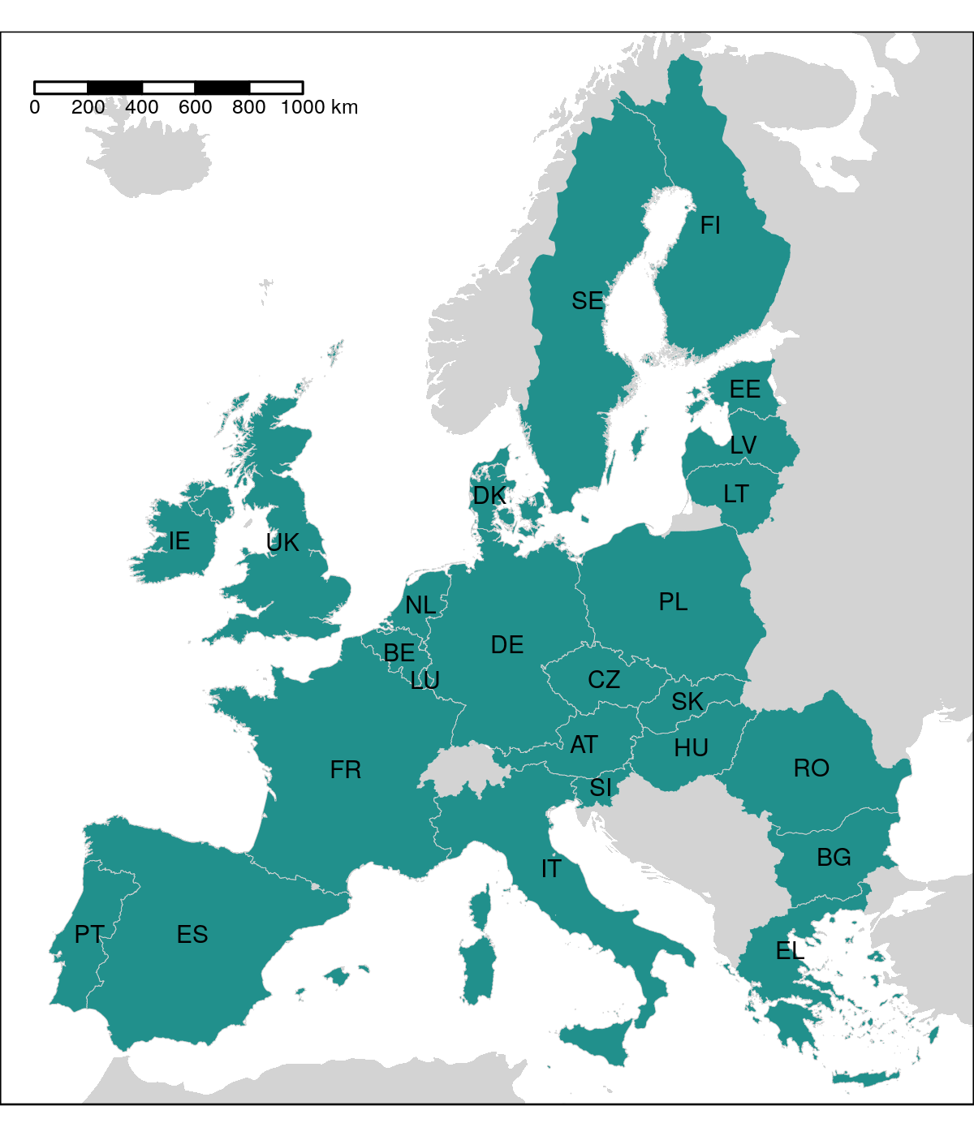
Figure 2.
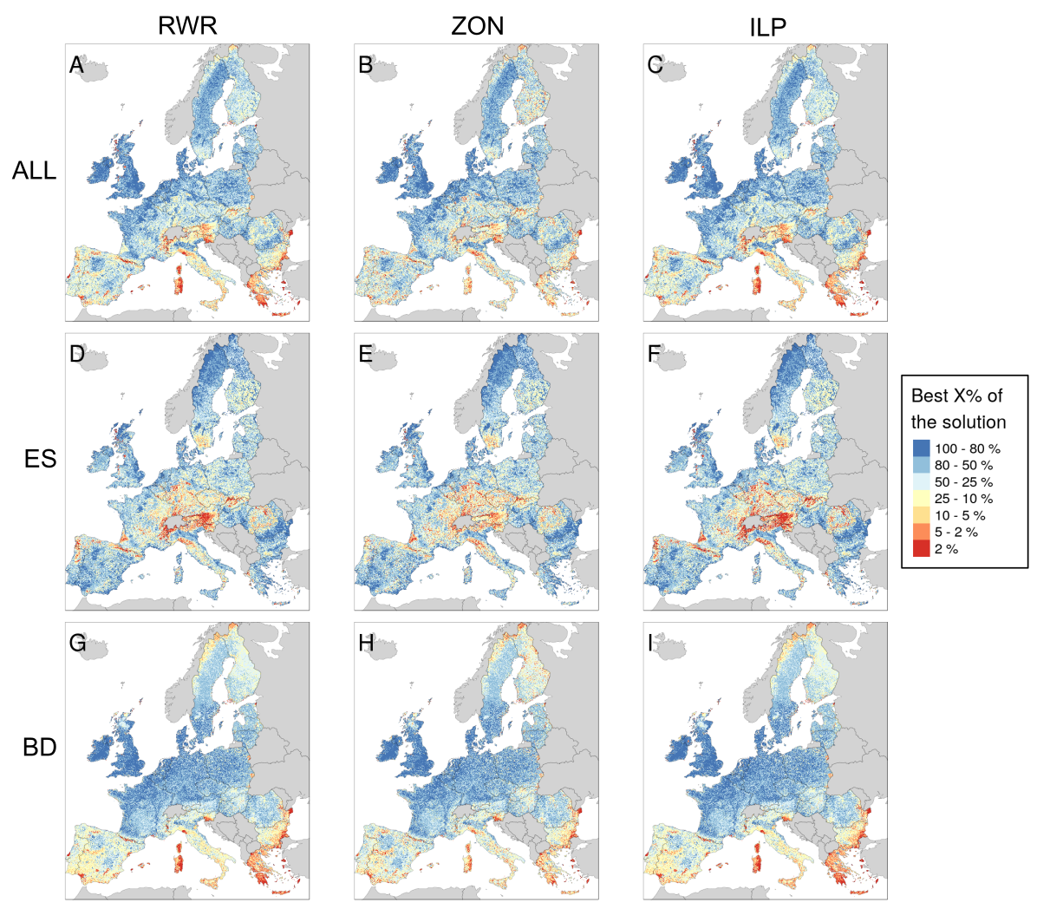
Figure 3.
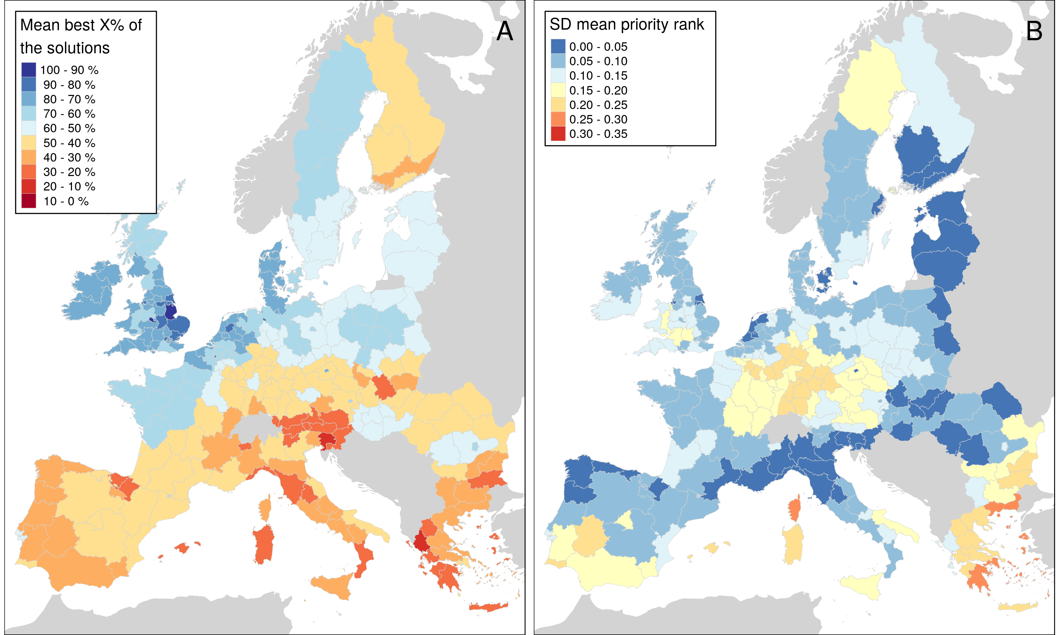
Figure 4.
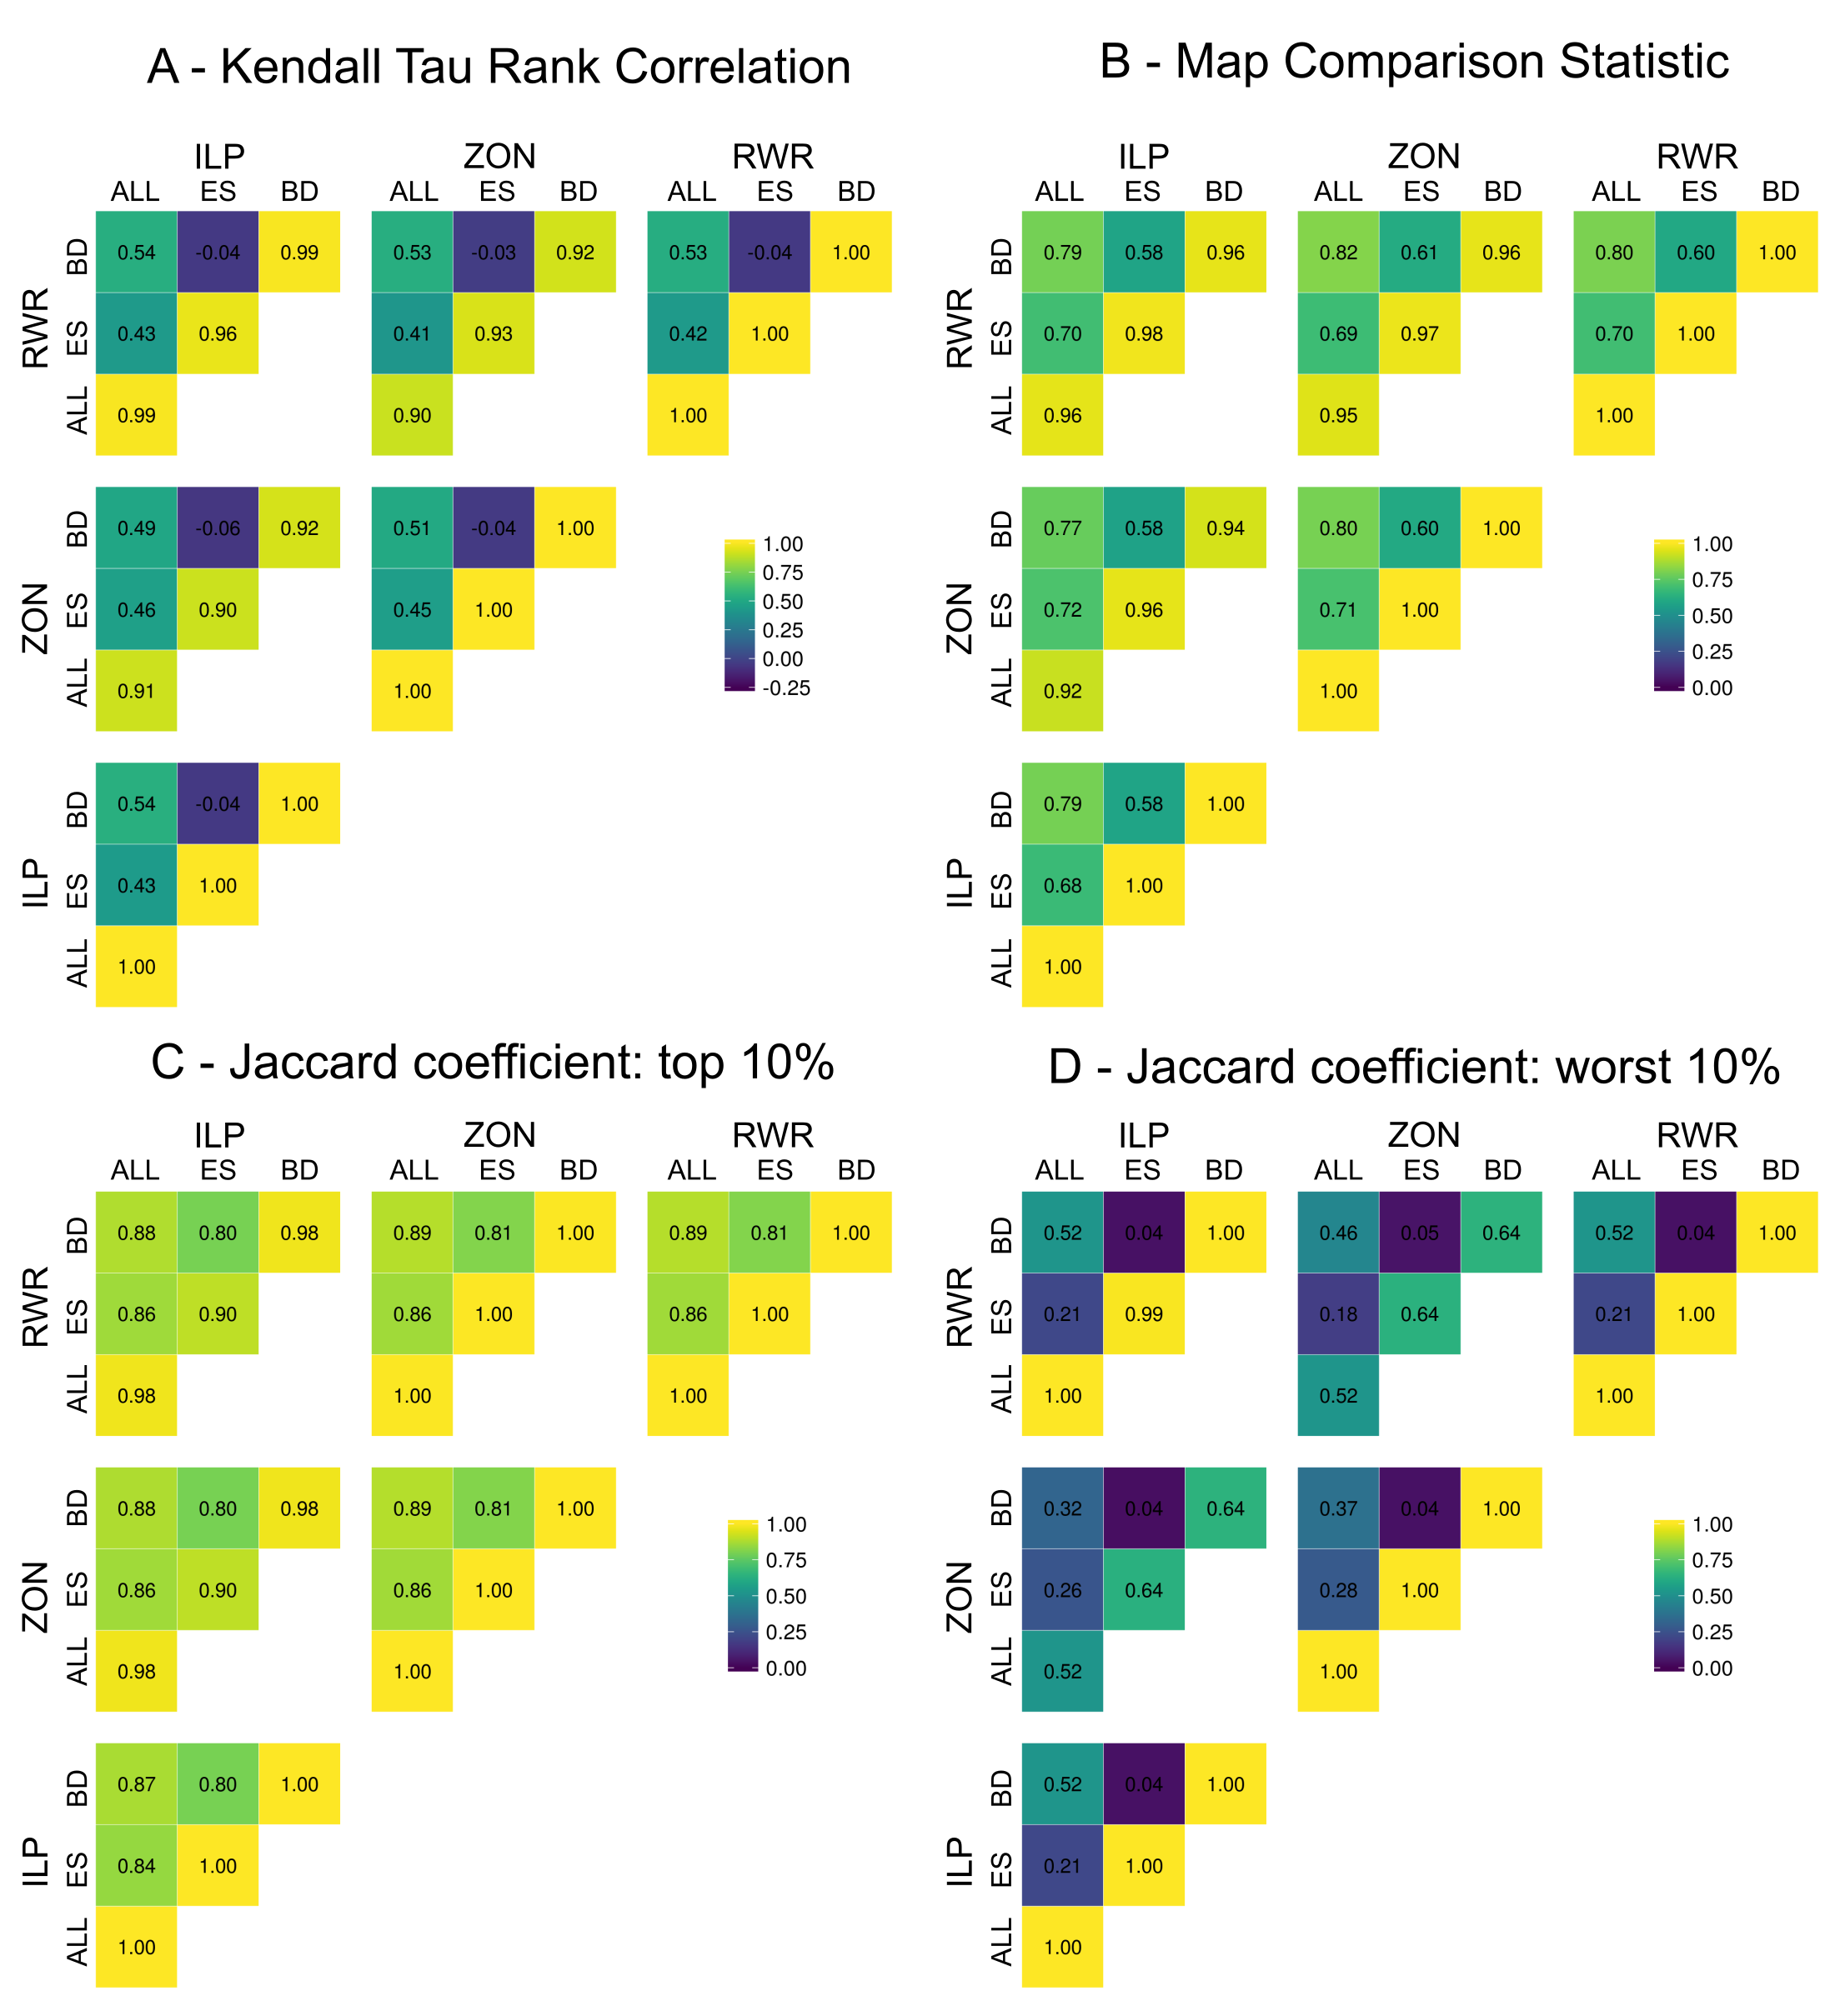
Figure 5.
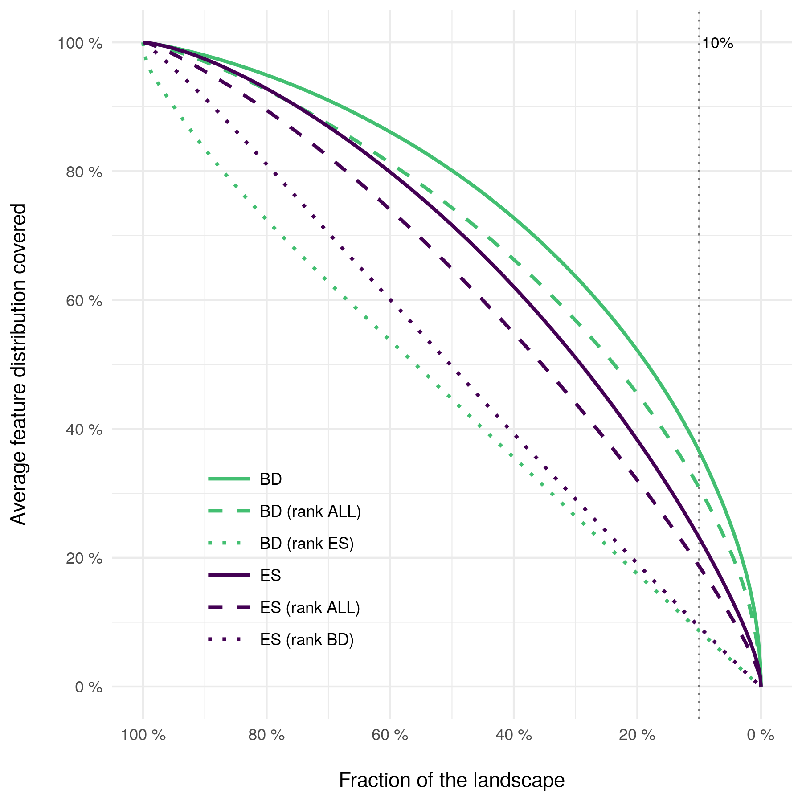
Figure 6.
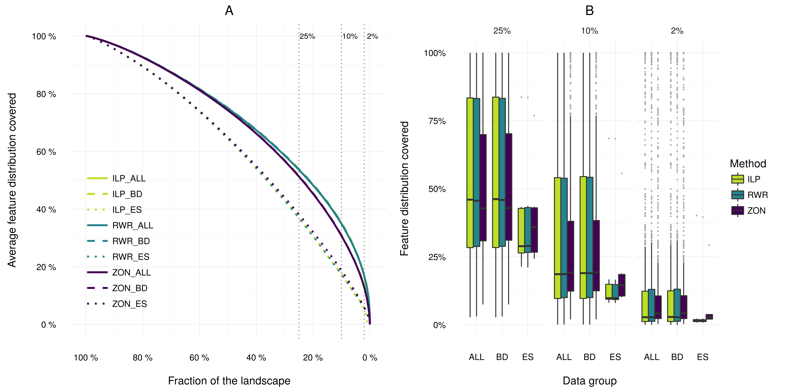

Figure S1.
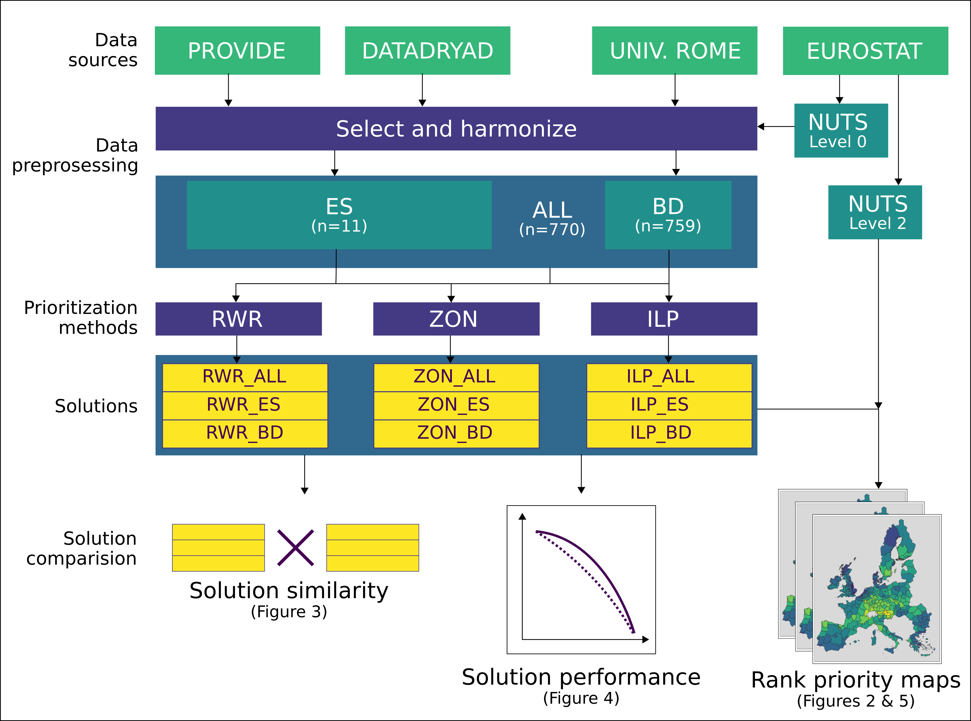
Table S1 Biodiversity features (n=759) used in the prioritization analyses.
Amphibians
Alytes cisternasii
Alytes dickhilleni
Alytes muletensis
Alytes obstetricans
Atylodes genei
Bombina bombina
Bombina pachypus
Bombina variegata
Bufo bufo
Calotriton arnoldi
Calotriton asper
Chioglossa lusitanica
Discoglossus galganoi
Discoglossus jeanneae
Discoglossus montalentii
Discoglossus pictus
Discoglossus sardus
Epidalea calamita
Euproctus montanus
Euproctus platycephalus
Hyla arborea
Hyla intermedia
Hyla meridionalis
Hyla sarda
Lissotriton boscai
Lissotriton helveticus
Lissotriton italicus
Lissotriton montandoni
Lissotriton vulgaris
Lyciasalamandra helverseni
Lyciasalamandra luschani
Mesotriton alpestris
Pelobates cultripes
Pelobates fuscus
Pelobates syriacus
Pelodytes ibericus
Pelodytes punctatus
Pelophylax bedriagae
Pelophylax bergeri
Pelophylax cerigensis
Pelophylax cretensis
Pelophylax epeirotcus
Pelophylax esculentus
Pelophylax grafi
Pelophylax hispanicus
Pelophylax kurtmuelleri
Pelophylax lessonae
Pelophylax perezi
Pelophylax ridibundus
Pleurodeles waltl
Proteus anguinus
Pseudepidalea balearica
Pseudepidalea sicula
Pseudepidalea variabilis
Pseudepidalea viridis
Rana arvalis
Rana dalmatina
Rana graeca
Rana iberica
Rana italica
Rana latastei
Rana pyrenaica
Rana temporaria
Salamandra atra
Salamandra corsica
Salamandra lanzai
Salamandra salamandra
Salamandrina perspicillata
Salamandrina terdigitata
Speleomantes ambrosii
Speleomantes flavus
Speleomantes imperialis
Speleomantes italicus
Speleomantes sarrabusensis
Speleomantes strinatii
Speleomantes supramontis
Triturus carnifex
Triturus cristatus
Triturus dobrogicus
Triturus karelinii
Triturus macedonicus
Triturus marmoratus
Triturus pygmaeus
Birds
Accipiter brevipes
Acrocephalus agricola
Acrocephalus arundinaceus
Acrocephalus dumetorum
Acrocephalus melanopogon
Acrocephalus paludicola
Acrocephalus palustris
Acrocephalus schoenobaenus
Acrocephalus scirpaceus
Actitis hypoleucos
Aegithalos caudatus
Aegolius funereus
Aegypius monachus
Alauda arvensis
Alca torda
Alcedo atthis
Alectoris barbara
Alectoris chukar
Alectoris graeca
Alectoris rufa
Anas acuta
Anas clypeata
Anas crecca
Anas penelope
Anas platyrhynchos
Anas querquedula
Anas strepera
Anser anser
Anser brachyrhynchus
Anser erythropus
Anser fabalis
Anthus campestris
Anthus cervinus
Anthus petrosus
Anthus pratensis
Anthus spinoletta
Anthus trivialis
Apus apus
Apus caffer
Apus melba
Apus pallidus
Aquila adalberti
Aquila chrysaetos
Aquila clanga
Aquila heliaca
Aquila pomarina
Ardea cinerea
Ardea purpurea
Ardeola ralloides
Arenaria interpres
Asio flammeus
Asio otus
Athene noctua
Aythya ferina
Aythya fuligula
Aythya marila
Aythya nyroca
Bombycilla garrulus
Bonasa bonasia
Botaurus stellaris
Branta bernicla
Branta leucopsis
Bubo bubo
Bubulcus ibis
Bucanetes githagineus
Bucephala clangula
Burhinus oedicnemus
Buteo buteo
Buteo lagopus
Buteo rufinus
Calandrella brachydactyla
Calandrella rufescens
Calcarius lapponicus
Calidris canutus
Calidris maritima
Calidris minuta
Calidris temminckii
Calonectris diomedea
Caprimulgus europaeus
Caprimulgus ruficollis
Carduelis cannabina
Carduelis carduelis
Carduelis chloris
Carduelis flammea
Carduelis flavirostris
Carduelis hornemanni
Carduelis spinus
Carpodacus erythrinus
Cepphus grylle
Cercotrichas galactote
Certhia familiaris
Cettia cetti
Charadrius alexandrinus
Charadrius dubius
Charadrius hiaticula
Charadrius morinellus
Chersophilus duponti
Chlidonias hybridus
Chlidonias leucopterus
Chlidonias niger
Ciconia ciconia
Ciconia nigra
Cinclus cinclus
Circaetus gallicus
Circus aeruginosus
Circus cyaneus
Circus macrourus
Circus pygargus
Cisticola juncidis
Clamator glandarius
Clangula hyemalis
Coccothraustes coccothraustes
Columba livia
Columba oenas
Coracias garrulus
Corvus corax
Corvus corone
Corvus frugilegus
Corvus monedula
Coturnix coturnix
Crex crex
Cuculus canorus
Cuculus saturatus
Cyanopica cyana cyanus
Cygnus cygnus
Cygnus olor
Delichon urbica
Dendrocopos leucotos
Dendrocopos major
Dendrocopos medius
Dendrocopos minor
Dendrocopos syriacus
Dryocopus martius
Egretta alba
Egretta garzetta
Elanus caeruleus
Emberiza aureola
Emberiza caesia
Emberiza cia
Emberiza cineracea
Emberiza cirlus
Emberiza citrinella
Emberiza hortulana
Emberiza melanocephala
Emberiza pusilla
Emberiza rustica
Emberiza schoeniclus
Eremophila alpestris
Erithacus rubecula
Falco biarmicus
Falco cherrug
Falco columbarius
Falco eleonorae
Falco naumanni
Falco peregrinus
Falco rusticolus
Falco subbuteo
Falco tinnunculus
Falco vespertinus
Ficedula albicollis
Ficedula hypoleuca
Ficedula parva
Ficedula semitorquata
Fratercula arctica
Fringilla montifringilla
Fulica atra
Fulica cristata
Fulmarus glacialis
Galerida cristata
Galerida theklae
Gallinago gallinago
Gallinago media
Gallinula chloropus
Garrulus glandarius
Gavia arctica
Gavia immer
Gavia stellata
Gelochelidon nilotica
Glareola nordmanni
Glareola pratincola
Glaucidium passerinum
Grus grus
Gypaetus barbatus
Gyps fulvus
Haematopus ostralegus
Halcyon smyrnensis
Haliaeetus albicilla
Hieraaetus fasciatus
Hieraaetus pennatus
Himantopus himantopus
Hippolais icterina
Hippolais olivetorum
Hippolais pallida
Hippolais polyglotta
Hirundo daurica
Hirundo rustica
Hoplopterus spinosus
Hydrobates pelagicus
Ixobrychus minutus
Jynx torquilla
Lagopus lagopus
Lagopus mutus
Lanius collurio
Lanius excubitor
Lanius meridionalis
Lanius minor
Lanius nubicus
Lanius senator
Larus argentatus
Larus audouinii
Larus cachinnans
Larus canus
Larus fuscus
Larus genei
Larus marinus
Larus melanocephalus
Larus minutus
Larus ridibundus
Limicola falcinellus
Limosa lapponica
Limosa limosa
Locustella fluviatilis
Locustella luscinioides
Locustella naevia
Loxia curvirostra
Loxia leucoptera
Loxia pytyopsittacus
Loxia scotica
Lullula arborea
Luscinia luscinia
Luscinia megarhynchos
Luscinia svecica
Lymnocryptes minimus
Marmaronetta angustirostris
Melanitta fusca
Melanitta nigra
Melanocorypha calandra
Mergus albellus
Mergus merganser
Mergus serrator
Merops apiaster
Miliaria calandra
Milvus migrans
Milvus milvus
Monticola saxatilis
Monticola solitarius
Montifringilla nivalis
Morus bassanus
Motacilla alba
Motacilla cinerea
Motacilla citreola
Motacilla flava
Muscicapa striata
Neophron percnopterus
Netta rufina
Nucifraga caryocatactes
Numenius arquata
Numenius phaeopus
Nyctea scandiaca
Nycticorax nycticorax
Oceanodroma castro
Oceanodroma leucorhoa
Oenanthe hispanica
Oenanthe isabellina
Oenanthe leucura
Oenanthe oenanthe
Oenanthe pleschanka
Oriolus oriolus
Otis tarda
Otus scops
Oxyura leucocephala
Pandion haliaetus
Panurus biarmicus
Parus caeruleus
Parus cinctus
Parus cristatus
Parus lugubris
Parus major
Parus montanus
Parus palustris
Passer domesticus
Passer hispaniolensis
Passer italiae
Passer montanus
Pelecanus crispus
Pelecanus onocrotalus
Perisoreus infaustus
Pernis apivorus
Petronia petronia
Phalaropus lobatus
Phalocrocorax carbo
Phalocrocorax pygmaeus
Phasianus colchicus
Philomachus pugnax
Phoenicopterus roseus
Phoenicurus ochruros
Phoenicurus phoenicurus
Phylloscopus bonelli
Phylloscopus borealis
Phylloscopus collybita
Phylloscopus sibilatrix
Phylloscopus trochiloides
Phylloscopus trochilus
Pica pica
Picoides tridactylus
Picus canus
Picus viridis
Pinicola enucleator
Platalea leucorodia
Plectrophenax nivalis
Plegadis falcinellus
Pluvialis apricaria
Podiceps auritus
Podiceps cristatus
Podiceps grisegena
Podiceps nigricollis
Porphyrio porphyrio
Porzana parva
Porzana porzana
Porzana pusilla
Prunella collaris
Prunella modularis
Pterocles alchata
Pterocles orientalis
Ptyonoprogne rupestris
Puffinus mauretanicus
Puffinus puffinus
Puffinus yelkouan
Pyrrhocorax graculus
Pyrrhocorax pyrrhocorax
Pyrrhula pyrrhula
Rallus aquaticus
Recurvirostra avosetta
Regulus ignicapillus
Regulus regulus
Remiz pendulinus
Riparia riparia
Rissa tridactyla
Saxicola rubetra
Saxicola torquata
Scolopax rusticola
Serinus citrinella
Serinus serinus
Sitta europaea
Sitta krueperi
Sitta neumayer
Sitta whiteheadi
Somateria mollissima
Stercorarius longicaudus
Stercorarius parasiticus
Stercorarius skua
Sterna albifrons
Sterna bengalensis
Sterna caspia
Sterna dougallii
Sterna hirundo
Sterna paradisaea
Sterna sandvicensis
Streptopelia decaocto
Streptopelia turtur
Strix aluco
Strix nebulosa
Strix uralensis
Sturnus roseus
Sturnus unicolor
Sturnus vulgaris
Surnia ulula
Sylvia atricapilla
Sylvia borin
Sylvia cantillans
Sylvia communis
Sylvia conspicillata
Sylvia curruca
Sylvia hortensis
Sylvia melanocephala
Sylvia nisoria
Sylvia rueppelli
Sylvia sarda
Sylvia undata
Tachybaptus ruficollis
Tadorna ferruginea
Tadorna tadorna
Tarsiger cyanurus
Tetrao urogallus
Tetrax tetrax
Tichodroma muraria
Tringa erythropus
Tringa glareola
Tringa nebularia
Tringa ochropus
Tringa stagnatilis
Tringa totanus
Turdus iliacus
Turdus merula
Turdus philomelos
Turdus pilaris
Turdus torquatus
Turdus viscivorus
Turnix sylvatica
Tyto alba
Upupa epops
Uria lomvia
Vanellus vanellus
Xenus cinereus
Mammals
Acomys minous
Alces alces
Alopex lagopus
Apodemus agrarius
Apodemus alpicola
Apodemus epimelas
Apodemus flavicollis
Apodemus mystacinus
Apodemus sylvaticus
Apodemus uralensis
Apodemus witherbyi
Arvicola amphibius
Arvicola sapidus
Arvicola scherman
Atelerix algirus
Barbastella barbastellus
Bison bonasus
Canis aureus
Capra ibex
Capra pyrenaica
Capreolus capreolus
Chionomys nivalis
Cricetulus migratorius
Cricetus cricetus
Crocidura leucodon
Crocidura pachyura
Crocidura russula
Crocidura sicula
Crocidura suaveolens
Crocidura zimmermanni
Dama dama
Dinaromys bogdanovi
Dryomys nitedula
Eliomys quercinus
Eptesicus bottae
Eptesicus nilsonii
Eptesicus serotinus
Erinaceus europaeus
Erinaceus roumanicus
Felis silvestris
Galemys pyrenaicus
Genetta genetta
Glis glis
Gulo gulo
Hystrix cristata
Lemmus lemmus
Lepus capensis
Lepus castroviejoi
Lepus corsicanus
Lepus europaeus
Lepus granatensis
Lepus timidus
Lutra lutra
Lynx pardinus
Martes foina
Martes martes
Meles meles
Meriones tristami
Mesocricetus newtoni
Micromys minutus
Microtus agrestis
Microtus arvalis
Microtus bavaricus
Microtus brachycercus
Microtus cabrerae
Microtus duodecimcostatus
Microtus felteni
Microtus gerbei
Microtus guentheri
Microtus levis
Microtus liechtesteini
Microtus lusitanicus
Microtus multiplex
Microtus oeconomus
Microtus savii
Microtus subterraneus
Microtus tatricus
Microtus thomasi
Miniopterus schreibersi
Mus macedonicus
Mus musculus
Mus spicilegus
Mus spretus
Muscardinus avellanarius
Mustela erminea
Mustela eversmanii
Mustela lutreola
Mustela nivalis
Mustela putorius
Myodes glareolus
Myodes rufocanus
Myodes rutilus
Myomimus roachi
Myopus schisticolor
Myotis alcathoe
Myotis aurascens
Myotis bechsteinii
Myotis blythii
Myotis brandtii
Myotis capaccinii
Myotis dasycneme
Myotis daubentonii
Myotis emarginatus
Myotis myotis
Myotis mystacinus
Myotis nattereri
Myotis punicus
Neomys anomalus
Neomys fodiens
Nyctalus lasiopterus
Nyctalus leisleri
Nyctalus noctula
Oryctolagus cuniculus
Ovis aries
Pipistrellus kuhlii
Pipistrellus nathusii
Pipistrellus pipistrellus
Pipistrellus pygmaeus
Pipistrellus savii
Plecotus auritus
Plecotus austriacus
Plecotus kolombatovici
Plecotus macrobullaris
Plecotus sardus
Pteromys volans
Rhinolophus blasii
Rhinolophus euryale
Rhinolophus ferrumequinum
Rhinolophus hipposideros
Rhinolophus mehelyi
Rupicapra rupicapra
Sciurus anomalus
Sciurus vulgaris
Sicista betulina
Sicista severtzovi
Sicista subtilis
Sorex alpinus
Sorex antinorii
Sorex araneus
Sorex caecutiens
Sorex coronatus
Sorex granarius
Sorex isodon
Sorex minutissimus
Sorex minutus
Sorex samniticus
Spalax graecus
Spalax leucodon
Spalax nehringi
Spermophilus citellus
Spermophilus suslicus
Suncus etruscus
Sus scrofa
Tadarida teniotis
Talpa caeca
Talpa europaea
Talpa levantis
Talpa occidentalis
Talpa romana
Talpa stankovici
Ursus arctos
Vespertilio murinus
Vormela peregusna
Vulpes vulpes
Ablepharus kitaibelii
Acanthodactylus erythrurus
Reptiles
Algyroides fitzingeri
Algyroides marchi
Algyroides moreoticus
Algyroides nigropunctatus
Anatolacerta anatolica
Anatolacerta oertzeni
Anguis cephallonica
Anguis fragilis
Archaeolacerta bedriagae
Blanus cinereus
Blanus strauchi
Chalcides bedriagai
Chalcides chalcides
Chalcides ocellatus
Chalcides striatus
Chamaeleo africanus
Chamaeleo chamaeleon
Coronella austriaca
Coronella girondica
Cyrtopodion kotschyi
Darevskia praticola
Dolichophis caspius
Dolichophis jugularis
Eirenis modestus
Elaphe quatuorlineata
Elaphe sauromates
Emys orbicularis
Emys trinacris
Eremias arguta
Eryx jaculus
Euleptes europaea
Eumeces schneideri
Hellenolacerta graeca
Hemidactylus turcicus
Hemorrhois hippocrepis
Hemorrhois nummifer
Hierophis gemonensis
Hierophis gyarosensis
Hierophis viridiflavus
Iberolacerta aranica
Iberolacerta aurelioi
Iberolacerta bonnali
Iberolacerta cyreni
Iberolacerta galani
Iberolacerta horvathi
Iberolacerta martinezricai
Iberolacerta monticola
Lacerta agilis
Lacerta bilineata
Lacerta schreiberi
Lacerta trilineata
Lacerta viridis
Laudakia stellio
Macroprotodon brevis
Macroprotodon cucullatus
Macroprotodon mauritanicus
Macrovipera schweizeri
Malpolon monspessulanus
Mauremys leprosa
Mauremys rivulata
Montivipera xanthina
Natrix maura
Natrix tesselleta
Ophiomorus punctatissimus
Ophisops elegans
Parvilacerta parva
Platyceps collaris
Platyceps najadum
Podarcis bocagei
Podarcis carbonelli
Podarcis erhardii
Podarcis filfolensis
Podarcis gaigeae
Podarcis hispanica
Podarcis lilfordi
Podarcis melisellensis
Podarcis milensis
Podarcis muralis
Podarcis peloponnesiaca
Podarcis pityusensis
Podarcis raffonei
Podarcis sicula
Podarcis taurica
Podarcis tiliguerta
Podarcis vaucheri
Podarcis wagleriana
Psammodromus hispanicus
Psammodromus jeanneae
Psammodromus manuelae
Pseudopus apodus
Rhinechis scalaris
Tarentola mauritanica
Telescopus fallax
Testudo graeca
Testudo hermanni
Testudo marginata
Timon lepidus
Trachylepis aurata
Trionyx triunguis
Typhlops vermicularis
Vipera ammodytes
Vipera aspis
Vipera berus
Vipera latastei
Vipera renardi
Vipera seoanei
Vipera ursinii
Zamenis lineatus
Zamenis longissimus
Zamenis situla

