**hComparing spatial prioritization methods for biodiversity conservation and ecosystem service supply in Europe**

**Joona Lehtomäki1\***, **Luigi Maiorano2** and **Peter verburg1, 3**

1 Environmental Geography Group, Faculty of Earth and Life Sciences, De Boelelaan 1105, 1081 HV Amsterdam, Vrije Universiteit Amsterdam, the Netherlands.

2 TBA

3 Swiss Federal Research Institute WSL, Zürcherstrasse 111, CH-8903 Birmensdorf, Switzerland

* Corresponding author

**Contact:** j.lehtomaki@vu.nl, tel. +31-20-59-87294  
 ORCID: 0000-0002-7891-0843

XXX XXX

peter.verburg@vu.nl, tel. +31-20-59-83594

**Running title:** Spatial prioritization comparison

**Keywords:** spatial prioritization; ecosystem services; biodiversity conservation; Zonation; optimization; environmental decision-making

**Manuscript version:** 0.11.0 (2017-07-19)

**Manuscript statistics:** 229 words (abstract)  
 7471 words (main body)  
 84 references  
 6+1 figures (main body + appendix)  
 2+1 tables (main body + appendix)

1 electronic Supplement

**Abstract:**

Identification of areas important both for biodiversity and the supply of ecosystem services (ESs) is an important part of operational decision-support for planning land-use and conservation management actions. Multiple methodological frameworks, such as multi-criteria decision making and spatial conservation prioritization, exist, but the degree to which they are applicable to both biodiversity conservation and ES still needs to be established. We compare three methods widely used for spatial conservation prioritization (simple scoring, heuristic and exact optimization) to assess their suitability for spatial prioritization integrating both biodiversity and ESs. With each method, we run a spatial prioritization analysis for 763 European tetrapod species and for 9 ESs separately. We then characterize the spatial similarity and performance of 1) the methods used and 2) for biodiversity and ESs respectively. We show that while all methods produce similar results in terms of average performance, the spatial pattern of especially the high priority ranked locations varies substantially. Priority rank patterns for biodiversity and ESs are almost complements to each other. These differences are attributed to underlying assumptions and conceptualizations in the methods. When selecting a method for spatial prioritization of both biodiversity and ESs, it is important to consider the objectives of prioritization and what the data used is actually representing.

# 1. Introduction

Land-use planning decisions increasingly need to account for both biodiversity and ecosystem services (ESs) {Formatting Citation}(Cimon-Morin et al., 2013; Cordingley et al., 2016; Goldman and Tallis, 2009; Larigauderie et al., 2012; Reyers et al., 2012)(Goldman and Tallis 2009; Larigauderie et al. 2012; Reyers et al. 2012; Cimon-Morin et al. 2013; Cordingley et al. 2016)(Schröter et al., 2016). Spatially explicit mapping of both biodiversity (Ferrier and Drielsma 2010; Maiorano et al. 2013; Meyer et al. 2015) and ESs (Mace et al. 2012; Manhães et al. 2016) and the complex interactions between the two have been intensely studied (Lavorel et al. 2017). While better models and data are still needed, more emphasis also needs to be placed on translating the knowledge acquired into decision-support. There is an urgent need for spatial prioritization methods accounting both for biodiversity and the supply and demand of ESs (Luck et al. 2012; Verhagen et al. 2016). Despite the strong uptake of ESs especially in the policy-sphere (Millennium Ecosystem Assessment 2005; Demissew et al. 2015; Silvertown 2015), the operationalization of ESs into practical land-use planning is still remarkably varied across countries (Schröter et al. 2016; Prip 2017). This may well be due to the conceptual ambiguity of ESs and the lack of clear technical articulation of what methods need to account for when working with ESs.

Spatial planning methods for ESs and biodiversity often fall into one of two broad frameworks: Multi-criteria decision making (MCDA) and spatial conservation prioritization (SCP). Whereas the former has been gaining popularity in the ES literature (Langemeyer et al. 2016; Saarikoski et al. 2016), the latter is commonly used in biodiversity conservation research (Moilanen et al. 2009). With the proliferation of available decision-support methods within both frameworks, it is worth considering what the strengths and weaknesses these methods are including the built-in, and often implicit, assumptions underlying the methods. Providing decision-support using models and computational tools is complicated and fraught with potential problems related to technical (Langford et al. 2011; Verburg et al. 2015), social (Voinov and Bousquet 2010; Hämäläinen 2015) and policy (van Voorn et al. 2016) aspects of decision-making. Only through being open and explicit about the underlying assumptions, can we start to alleviate such problems.

First studies combining biodiversity and ESs in the same spatial planning framework were done already more than ten years ago (e.g. Chan et al. 2006; Egoh et al. 2007), but to date studies have mostly concentrated on one or the other. The conceptualization of the planning problem has also been mixed: sometimes biodiversity features are treated as one component of ESs (Chan et al. 2011; Schröter et al. 2014b), sometime as a separate group of features (Durán et al. 2014; Di Minin et al. 2017). Regardless of how ESs and biodiversity are conceptualized in the framework, the (spatial) planning problems generally involve multiple objectives: species should be protected where they are and ES supply should be maximized where they can fulfill demand. MCDA is a branch of decision analysis dedicated to establishing the best course of action given such multiple criteria and a set of potential alternatives (Keisler and Linkov 2014) covering a broad range of methods, some of which are spatially explicit (Mustajoki and Marttunen 2017). MCDA has been used extensively in studies addressing environmental decision-making (Zucca et al. 2008; Koschke et al. 2012; Grêt-Regamey et al. 2016; Langemeyer et al. 2016). Further, it may be particularly well-suited for the valuation of ESs because the methods can be used to analyze the performance of different alternatives (i.e. actions) in terms of evaluation criteria which in turn can include the subjective preferences of decision-makers (Saarikoski et al. 2016).

Spatial conservation prioritization can be seen as the technical, biogeographic-economic assessment of which areas are important for biodiversity and when and how actions should be implemented to achieve conservation goals (Wilson et al. 2007; Moilanen et al. 2009; Kukkala and Moilanen 2012)(Ferrier and Wintle, 2009; Kukkala and Moilanen, 2012; Wilson et al., 2007). In addition to ecological effectiveness, socio-economic efficiency is a key aspect of SCP: how should limited resources be invested to maximize expected outcomes (Evans et al. 2015)(Evans et al., 2015). SCP problems are commonly solved by analyzing the relevant features (e.g. species or ecosystem services) as spatially uniform grids where each cell (or planning unit more broadly) can be either selected or not conditional to relevant decision-making constraints (e.g. costs). The problem to solve then becomes which areas to prioritize given the occurrence of features and relevant constraints. Technically, this problem has two important facets: 1) how conservation value is aggregated over multiple features (aggregation step), and 2) how is the suitable subset of planning units selected out of all possible combinations (selection step). Both of these facets are defined by the method used. Another central concept of SCP is complementarity, i.e. the degree to which individual sites complement the representational composition of a set of locations (e.g. protected areas). Lack of complementarity can lead to highly inefficient solutions and hence most modern spatial prioritization methods incorporate complementarity (Wilson et al. 2009; Cimon-Morin et al. 2016). While SCP was born out of need for designing effective protected area networks for biodiversity, the underlying principles and methods have been applied to many different decision-making problems, such as natural resource extraction (Kareksela et al. 2013)(Kareksela et al., 2013), habitat restoration (Thomson et al. 2009)(Thomson et al., 2009) and food production (Dobrovolski et al. 2014)(Dobrovolski et al., 2014). Especially, there are now a wide range of applications in the realm of ecosystem services aiming at prioritizing areas suitable for the supply of ecosystem services (Chan et al. 2006; Schröter et al. 2014b)(Chan et al., 2006; Schröter et al., 2014b), supply of ecosystem services and urban development (Casalegno et al. 2014)(Casalegno et al., 2014) and both supply of ecosystem services and biodiversity conservation (Moilanen et al. 2011; Reyers et al. 2012; Nin et al. 2016)(Moilanen et al., 2011; Nin et al., 2016; Reyers et al., 2012).

Most MCDA methods use relatively simple linear additive scoring models to combine the distinct features, even if mathematically more complex models of value aggregation are available (Keisler and Linkov 2014). The simplest way of calculating the aggregate value, and ultimately the priority, of a given location is simply to give that location a score based on features that occur there. This scoring can be done additively by e.g. summing up the number of features (richness score) (Williams et al. 1996; Ferrier and Wintle 2009)(Ferrier and Wintle, 2009; Williams et al., 1996). In contrast, most modern methods for SCP are built with the special characteristics of biodiversity in mind. More specifically, they combine two aspects of biodiversity occurrence: rarity and richness. With this combination, we express preference for having more features over having fewer features, and having rarer features over having more common features (Arponen et al. 2005). Simple scoring as a value-aggregation method is common in MCDA and sometimes also in SCP. However, just counting the occurrence of features does not account for how relatively common or rare any give feature is. A richness score adjusted with the rarity of each feature is called rarity-weighted richness (RWR) score (Williams et al. 1996; Albuquerque and Beier 2015)(Albuquerque and Beier, 2015; Williams et al., 1996). This method has the advantage of being very simple and intuitive: the value aggregation is a simple sum of rarity-weighted occurrences of features in a given cell. The highest priority cells are the ones with the highest RWR score and there is no need for an additional selection step. For simple prioritization problems RWR also performs reasonably well when compared against more complex methods (Albuquerque and Beier 2015)(Albuquerque and Beier, 2015).

Prioritization problems may also be solvable in a mathematically exact manner by using spatial optimization techniques such as integer linear programming (ILP) (Beyer et al. 2016)(Beyer et al., 2016). In ILP, an optimal subset of cells can be selected by minimizing or maximizing an objective function (i.e. the mathematical relationship between actions and outcomes) potentially subject to constraints (such as cost) and conditional on binary decision variables (the selection of actions). Minimizing the objective function is done in so called minimum-set problems, where the aim is to minimize the resources needed to achieve all targets, however they are defined (Underhill 1994). Maximizing the objective function is related to so called maximum-coverage problems, where the value gained from a particular action (i.e. setting aside a cell) is maximized for given resources (Camm et al. 1996). Value aggregation of multiple features in each cell can be done in several ways, but a simple sum over features is common. The advantage of exact optimization methods is that they produce a truly optimal solution, or if one cannot be found, a quantitative estimate on the sub-optimality of the solution reached. Additionally, more complex problem formulations, such as spatial configurations, can be accommodated as so long as the objective function can be linearized. The downside therefore is that especially for more complex and realistic problem formulations, a complex optimization problem is quickly rendered computationally infeasible (Beyer et al. 2016)(Beyer et al., 2016), or it requires simplifications reducing the relevance of the solution (Moilanen 2008)(Moilanen, 2008).

Heuristic methods strike a balance between simple scoring (e.g. RWR) and exact optimization (e.g. ILP) methods: they are flexible enough to accommodate factors relevant for decision-making while retaining computational tractability (Moilanen and Ball 2009)(Moilanen and Ball, 2009). Zonation is a SCP software based on a reverse stepwise heuristic algorithm which iteratively removes cells while minimizing the marginal loss of conservation value caused by each removal (Moilanen et al. 2014). Marginal loss of conservation value (which is closely related to the aggregate value over multiple features) can be defined a few distinct ways depending the overall objective of the prioritization and the priority rank is defined by the inverse removal order of cells. Heuristic methods cannot, however, guarantee the optimality of the solution and are typically on the same level of technical complexity as exact optimization methods.

Independent of the method used, spatial prioritization for ESs is fundamentally different to that of biodiversity (Luck et al. 2012; Kukkala and Moilanen 2016; Verhagen et al. 2016). However, there are enough similarities for SCP methods to be relevant for spatial planning involving ESs. The basic problem elements are the same for spatial prioritization of both biodiversity conservation and ESs supply: quantitative and spatial features that need to be protected or secured, potential threats to the features, potential actions for retaining the features and mitigating threats, and information on the costs of potential actions (Ferrier and Wintle 2009; Luck et al. 2012)(Ferrier and Wintle, 2009; Luck et al., 2012). However, Luck et al. (2012) identified the following additional factors affecting the spatial prioritization of ESs supply: the availability of alternative means of providing benefits supplied by a given service, the capacity of ESs to meet human demand, and the site and scale dependency related to the delivery of services. Nevertheless, a simple prioritization accounting only for the capacity of ecosystems to provide ES can be useful to summarize the distributional patterns of ESs (Kukkala and Moilanen 2016)(Kukkala and Moilanen, 2016). Most studies have concentrated on a single or a relatively low number of ESs features (Kukkala and Moilanen 2016)(Kukkala and Moilanen, 2016) and the suitability of the methods for ESs in particular has not been studied extensively. This is surprising given that each method to calculate spatial priorities implements a particular model of what exactly we value in the occurrence of the feature (e.g. how common or rare the feature is), how value is aggregated over multiple features, and how we can express our preferences relative to desired outcomes (**Fig. 1**).

[Figure 1 approximately here]

In this study, we have two broad objectives. First, we compare three spatial prioritization methods: rarity-weighted richness (scoring), Zonation (heuristic), and ILP approach (exact optimization) in terms of the identified priority areas for biodiversity and ecosystem services. We selected these methods because they are all built on the same conceptual foundations of combing feature richness and rarity. The methods differ both in terms of how they aggregate value over multiple features and how the select the subset of cells most pertinent for the planning objective (**Fig. 1**). We apply each of the methods to a prioritization problem constituting of nine ecosystem services and the occurrence of 759 tetrapods (amphibians, birds, mammal and reptiles) on European scale. The second objective is to analyze how the assumptions underlying each method might affect the usability of the method for spatial prioritization integrating biodiversity conservation and ESs supply. This work aims to contribute to the understanding of operational requirements of spatial planning integrating ecosystem services and biodiversity conservation, as well as to developing operational instruments for such planning.

# 2. Methods

## 2.1 Area of interest

Our original aim was to cover all 28 member states of the European Union in 2017, but we had to leave Croatia, Cyprus and Malta out because they were not covered by all the selected ecosystem services and biodiversity datasets. As a result, our area of interest is a subset of EU member states of 25 countries (EU25 from now on) (**Fig. S1**). Despite of being heterogeneous both socioeconomically and biogeographically, the EU forms a coherent supranational administrative region dealing with complex environmental management structures and issues. While our aim here is not to inform any particular policy process, comparing the prioritization methods at the EU-level does at least in principle hold potential to actual policy-relevance.

[Figure 2 approximately here]

## 2.2 Data

The datasets we use in this study satisfy three broad criteria: 1) relevance as collection (datasets are a representative sample of both ecosystem services and biodiversity), 2) spatiotemporal resolution (datasets have fine enough spatial grain and are collected around the same time) and 3) geographical coverage (datasets cover the same geographical region). within total, we used 770 datasets constituting of 11 datasets for ecosystem services capacity (from here called data group ES) and 759 datasets for biodiversity (data group BD) (Table 1).

[Table 1 approximately here]

### 2.2.1 Ecosystem services features (ES)

We selected a collection of datasets that broadly indicate supporting, provisioning, regulating and cultural ecosystem services (Millennium Ecosystem Assessment 2005)(Millennium Ecosystem Assessment, 2005). For all the ecosystem services datasets (data group ES) included, we assume a linear relationship between the estimated quantity and the perceived benefit. While some ES datasets include aspects of both supply and demand, we consider the datasets to indicate the ES capacity at any given location. The ES datasets are a subset of datasets previously collated and harmonized as part of a Horizon 2020 project PROVIDE (http://www.provide-project.eu) (Komossa et al. 2016)(Komossa et al., 2016).

For our prioritization analysis, we settled for a spatial resolution of 1 km2. This resolution is fine enough to be relevant for regional scale decision-making while still being computationally feasible at European scale. To further harmonize all the ES datasets into the same geographical extent and coordinate reference system (ETRS89 / ETRS-LAEA, EPSG:3035), we developed pre-processing components as part of the study workflow implementation (see section 2.5) using the Python bindings to the Geospatial Data Abstraction Library (version 2.0.2, GDAL Development Team 2016)(version 2.0.2, GDAL Development Team, 2016). If a dataset contained negative values (only one dataset: climate regulation), the dataset was rescaled so that all values were positive.

### 2.2.2 Biodiversity features (BD)

To assess the priority locations for biodiversity conservation in Europe, we considered the refined extent of occurrence (EOO) models for terrestrial vertebrates. The EOO models have been collated from several sources and refined to take into account the suitability of different land-use/land-cover classes based on the habitat preferences of different species (Maiorano et al. 2013; Thuiller et al. 2015)(Maiorano et al., 2013; Thuiller et al., 2015). We extracted a subset of the original data for species that, according the EOO models, occur in EU25 countries, which constituted of 759 species (64 mammal, 404 bird, 83 amphibian, and 112 reptile species; BD from now on). The original data has a spatial resolution of 300 meters, which we aggregated to 1 km while matching the geographical extent of the ES datasets. In the aggregated datasets, the value *rij* of each cell *i* describes the fraction of the cell that is considered, by expert evaluation, to be either primarily or marginally suitable habitat for species *j*.

## 2.3 Prioritization methods

### 2.3.1 Rarity-weighted richness (RWR)

In implementing the RWR algorithm, we followed the description originally given by Williams et al. (1996)(1996) and later revisited by Albuquerque and Beier (2015)(2015) with small modifications. More specifically, whereas Albuquerque and Beier (2015) used species presence/absence data, we do not restrict the values of features in the prioritization (ES and BD) to binary values only. Instead, the occurrence level values as present in the datasets are retained. Thus, we define RWR score *s* for cell *i* as:

(1)

where *cij* is the value of feature *j* in cell *i, wj* is the weight for feature *j*, *cj* is the sum of all cells for feature *j* and the values are summed for the *N* features that occur in cell *i*. Because the feature-specific occurrence level normalization results in relative values, the original units do not matter and the datasets are not required to be in the same scale. After summing up the RWR score, we ranked it and rescaled it into range [0, 1] to produce the final priority rank map. We calculated the RWR scores for each of the data groups resulting in three computational variants: RWR_ALL, RWR_ES and RWR_BD (**Fig. S2**). Because we used many more biodiversity than ecosystem services features (763 and 9, respectively), we also defined a weighting scheme when calculating the RWR scores for the variant RWR_ALL. The weight *wj* for a single feature *j* in data group *g* (ES or BD) is 1/*ng* where *ng* is the number of features in that group. This way, the aggregate weights for both data groups are the same, i.e., BD and ES given the same importance in defining priority areas. We implemented the RWR algorithm using Python (version 3.5, Python Development Team 2016)(version 3.5, Python Development Team, 2016) and NumPy (version 1.10.4, van der Walt et al. 2011)(version 1.10.4, van der Walt et al., 2011).

### 2.3.2 Zonation (ZON)

As the second prioritization method, we used Zonation (version 4.0, Moilanen et al. 2014)(version 4.0, Moilanen et al., 2014) spatial conservation prioritization software. Zonation works on a given set of inputs that describe the occurrence of features to be prioritized in a spatially explicit manner. Starting from the full set of features, it iteratively removes the least valuable cells while accounting for the initial occurrence of features and the remaining occurrence of each feature. On each iteration, the features are normalized by their remaining occurrence levels, a step very similar to the occurrence level normalization in computing the RWR scores. Zonation then calculates the marginal loss value for each cell and removes the cell with the smallest marginal loss value. Zonation has several cell removal rules available for defining how exactly the marginal loss is calculated. Here, we used the Additive Benefit Function (ABF) rule, which sums the values over all features in a given cell according to a given benefit function (Moilanen et al. 2014)(Arponen et al., 2005). Given the full set of cells *S*, the marginal loss *δ* for cell *i* is

(2)

where *Rj()* is a benefit function quantifying the value of feature *j* in the set of remaining cells *s* andthe remaining set of cells without cell *i* *s – i* (*s*,*i* *S*), and *wj* is the weight for feature *j*. As a feature becomes rarer in the cell-removal process, it also becomes relatively more valuable. This process leads to the maintenance of a balanced representation of all features in the solution. We chose to use ABF for two reasons. First, an (utility maximizing) additive benefit function (Arponen et al. 2005; Laitila and Moilanen 2012)(Arponen et al., 2005; Laitila and Moilanen, 2012) seems suitable for calculating the aggregate value of cells in our case, because the resulting priority areas will have relatively high occurrence levels of a large number of features. For ESs, this translates into giving priority to ES bundles, and for BD, giving priority to species richness. Second, ABF can be regarded as a generalization of a maximum coverage problem (Laitila and Moilanen 2012)(Laitila and Moilanen, 2012) and hence comparable (in its simple form) to RWR and ILP methods.

We created three main variants for Zonation: ZON_ALL, ZON_ES and ZON_BD (**Fig. S2**). In the variant with all features included (ZON_ALL), we balanced the prioritization between data groups ES and BD by using the same weighting scheme as with RWR. We disabled the “edge removal” feature in Zonation and used warp factor of 1000, otherwise we used the default values for all parameters controlling the actual prioritization (for full implementation, see “Workflow system” in section 2.6).

### 2.3.3 Exact optimization (ILP)

We also formulate the spatial prioritization problem as a hierarchical maximum coverage problem which can solved exactly with integer linear programming. In a maximum coverage problem, we seek to find a set of cells that maximizes the overall level of representation (as measured by the occurrence level) over all features while keeping the number of selected cells below a given threshold (defined by the target fraction, e.g. 10% of the landscape). By hierarchical, we mean solving several maximum coverage problems varying the thresholds between 1% to 99%.. Before solving the optimization problems, we occurrence level normalized all features:

(3)

where *cij* is the value of feature *j* in cell *i* and *cj* is the sum of all cells for feature *j*. We define the optimization problem as:

(4)

where *xi* {0,1} indicates whether cell *i* is included in the solution or not, *rij* gives the occurrence level of feature *j* in cell *i* and *wj* is the weight given to feature *j*. As a constraint, we define that the number of cells included in the solution must be smaller than a given fraction of the landscape *c* {0.01, 0.02, …, 1.00}. We used Gurobi optimization solver (version 7.0.0, Gurobi Optimization Inc. 2016)(version 7.0.0, Gurobi Optimization Inc., 2016) and its Python bindings for solving 100 optimization problems defined above. Gurobi is a proprietary software using multiple algorithms to solve linear programming problems with a guarantee, given enough time, of finding an optimal solution or a gap measure of the level of sub-optimality.

After solving the optimization problems, we aggregated the solutions into a hierarchical priority rank maps by first calculating the selection frequency of each cell over solutions for each value of *c*, then ranking the result and rescaling it into range [0, 1]. We repeated this procedure to the 3 main variants: ILP_ALL, ILP_ES and ILP_BD (**Fig. S2**). In the variant with all features included (ILP_ALL), we balanced the prioritization between data groups ES and BD by using the same weighting scheme as with RWR in the optimization.

## 2.4 Comparing solution similarity and performance

We compared the solutions for all nine variants (**Fig. S2**) for the solution i) similarity and ii) performance. In addition, we also quantified to overall patterns in rank priorities over all solutions.

To quantify the different aspects of the similarity between the solutions, we used three different measures. First, to account for the spatial overlap we calculated the Jaccard’s index between solution subsets. Jaccard’s index *J* between solutions A and B is calculated as dividing the number of cells in both A and B by the number of cells in either or both solutions (for implementation details, see section 2.6). Value of *J* = 1 indicates a complete overlap between the solutions (or subsets). In addition to calculating *J* between the best 10% of all solution pairs, we also calculated J for the worst 10%. Second, we computed the rank correlation coefficients (Kendall τ, tau-b accounting for ties) between the priority rankings in all solutions using the implementation available in Scipy(Jones et al., 2001; Knight, 1966). Third, to quantify the similarity of the solutions when the aggregated to a meaningful administrative level (Nomenclature of territorial units for statistics, NUTS2 regions), we computed the Map Comparison statistic (MCS) between all solutions pairs. We obtained the NUTS data from EUROSTAT (**REF**). MCS is an index summarizing the relative difference between spatial datasets as the average difference between mean ranks in NUTS2 regions, expressed as a fraction of the highest value (Schulp et al. 2014)(Schulp et al., 2014):

(5)

where *a* and *b* are the mean ranks in a particular NUTS2 region and *N* is the total number of NUTS2 regions considered. To present MCS in the same scale as the Jaccard’s index and Kendall τ (1.0 signifies solutions are the same), we use *1 – MCS*.

We also examined how well the different methods performed compared to each other. As a performance measure, we use how much of the overall feature representation levels can be covered by a given fraction of the landscape. While ZON produces this type of performance data automatically, our RWR and ILP implementations do not. We used the so-called solution loading functionality in ZON to compute performance data for RWR and ILP. This way, the priority rank solution produced by RWR and ILP is loaded into ZON, which then proceeds with the usual cell-removal following the rank order from the loaded solutions while also producing the performance data(Moilanen et al., 2014). We used this pre-loading functionality in two ways. First, using only ZON we examine the trade-offs in prioritizing areas on all available features (ALL) as opposed to ESs (ES) or biodiversity features (BD) only. Second, we compare the RWR and ZON solutions to the ILP solution. ILP is the only method that produces a measure of the optimality of the result thus giving a benchmark against which the sub-optimality of the solutions produced by the other methods (RWR and ZON) can be compared to.

To quantify how similar the average rank priories calculated for each NUTS2 region is, we also calculated the mean and the standard deviation of the priority rank of each NUTS2 region over all solutions.

## 2.5 Testing for the effect of including costs

The spatial prioritization can be made more relevant for real-life planning by incorporating factors such as costs, ecological condition and connectivity into the methods (Ferrier and Wintle 2009). However, exactly which factors can be accounted for by prioritization methods vary greatly and comparing the results is complicated by every new analysis layer and additional model assumptions. Therefore, we chose to concentrate our comparison on the simple (i.e. comparable) basic setups for each method, but also tested how including a proxy for costs affects the results of each method. The following results section presents all prioritization analyses without costs, but a subset of analyses including costs can be found in the Supplementary Material.

## 2.6 Workflow implementation

We combined the individual processing steps of data pre-processing, analyses and post-processing in a semi-automated workflow using the Snakemake workflow engine (version 3.10.0, Köster and Rahmann 2012). The complete implementation is available at XXX.(Köster and Rahmann, 2012)

# 3. Results

## 3.1 Spatial patterns and similarity

The priority rank maps showed different spatial patterns when accounting for either species occurrence, ecosystem services or both. With all features included in the analyses (ALL), the highest priority areas were found mostly in Southern Europe (Spain, Italy and Greece) and South-Eastern Europe (Bulgaria and Romania) with some priorities also in Northern Fennoscandia (**Fig. 2A-C**). The highest priority areas for ESs only (**Fig. 2D-F**) were concentrated in mountainous regions in Central Europe, Spain and Italy. We identified more isolated high-priority areas also in the North-Western UK and Portugal as well as in the southern part of Fennoscandia. The priority rank patterns for biodiversity features (BD) had a distinct bimodal distribution with high priority areas both in the south (the Mediterranean basin) and north (the subarctic Fennoscandia) (**Fig. 2H-I**). The patterns on rank priorities were spatially much more similar when compared across the different methods (RWR, ZON and ILP). On a visual inspection, RWR (**Fig. 2A**, **2D** and **2H**) and ILP (**Fig**. **2C**, **2F** and **2I**) produced almost identical priority patterns, whereas ZON (**Fig. 2B**, **2E** and **2G**) produced slightly more dispersed priority patterns.

[Figure 3 approximately here]

On an aggregate NUTS2-level, the mean rank priorities over all nine analysis variants were the highest in central and southern Europe (**Fig. 3A**), meaning that these regions were consistently high-priority areas across all variants. The only exception to this general pattern is Finland, for which the rank priorities in all variants were relatively high. Both the highest and lowest mean rank priorities were quite consistent over the different analysis variants as measured by the standard deviation of the mean rank (**Fig. 3B**) with two exceptions. First, the larger part of Southern Europe (Southern Spain, Greece, Corsica and Sardinia) had high mean rank and relatively high variation across variants. Second, Central Europe (North-Eastern France, Southern Germany) had medium high ranks and relatively high variation across the variants.

[Figure 4 approximately here]

Quantitative comparison of the priority rank using the various comparison statistics was in line with the visual observations of the similarity between the different data groups and methods. Between the data groups and within the methods, ES and BD solutions were not correlated with Kendall tau correlation coefficients of -0.04 for RWR and ILP, and -0.03 for ZON (**Fig. 4A**). Both ES and BD were moderately correlated with ALL with correlation coefficients of 0.42, 0.45 and 0.45 (ES) and 0.53, 0.51 and 0.49 (BD) for RWR, ZON and ILP, respectively. On a more regional scale, the MCS gives similar results with MCS of 0.60, 0.61 and 0.60 between ES and BD in RWR, ZON and ILP respectively (**Fig. 4B**). Compared to ALL, MCSs were 0.70, 0.69 and 0.69 for ES, and 0.80, 0.82, 0.80 for BD (RWR, ZON and ILP respectively). The spatial overlaps as measured by the Jaccard’s coefficient between the best and worst 10% of the solution were, again, similar between the data groups and within the same method. The overlaps between the best 10% of solution ranged from 0.04 (between ES and BD for all methods) to 0.52 (RWR_BD / RWR_ALL) (**Fig. 4C**). The worst 10% of all solutions were very similar ranging from 0.95 (ES / BD in all methods) to 0.97 (BD / ALL in all methods) (**Fig. 4D**).

Between the methods and within the data groups, solutions produced by RWR and ILP in particular were very similar. The rank correlation coefficients for the different data groups between RWR and ILP were 0.91, 0.99 and 0.99 for ALL, ES and BD respectively (**Fig. 4A**). Rank correlation between RWR and ZON (0.90, 0.93, 0.92 for ALL, ES and BD), and ILP and ZON (0.87, 0.93, 0.92 for ALL, ES and BD) were not quite as high but still very strong. MCSs were equally strong between the methods ranging from 0.92-0.97 between ZON and ILP to 0.91–0.99 between RWR and ILP (**Fig. 4B**). Between RWR and ILP, the spatial overlaps of the best 10% of the solution were 1.0 (exactly the same) for ES and BD, but only 0.51 for ALL. Between ZON and both RWR and ILP, however, overlaps were more modest (0.52, 0.64, 0.64 for ALL, ES and BD) (**Fig. 4C**). The worst 10% of the solution were almost completely overlapping (0.97-1.00) for RWR, ZON and ILP (**Fig. 4D**).

[Figure 5 approximately here]

## 3.2 Solution performance and optimality

In terms of feature representation, the performance of all methods was very similar for variants RWR_ALL, ZON_ALL and ILP_ALL with some differences (**Fig. 5** and **Table 2**). Most notably, while RWR had the highest average performance, ZON produced the most balanced results in the sense that the priority areas identified covered a higher median fraction of all features. The median performance over all features for the best 10% of the solution (i.e. the median value of feature occurrence level covered by the top 10% fraction) was 18.5%, 19.1% and 15.3% for RWR_ALL, ZON_ALL and ILP_ALL, respectively (**Table 2**). For some features, the top 10% fraction of the solution covered already 100% of the occurrence level and so the mean performance levels were higher for all methods (34.7%, 30.6% and 25.4% for RWR, ZON, and ILP). While RWR achieved the highest mean performance, ZON had a more balanced performance than RWR and ILP over all features as shown by the interquartile range (**Fig. 5**) and higher median value for the top 10% fraction (**Table 2**). This is particularly so for ESs, which have a higher median performance for ZON (14.5%) and ILP (12.8%) than for RWR (9.8%). For BD, the top 10% fraction captured on average much more of the feature ranges than for ES: 34.9% (RWR), 30.8% (ZON) and 25.5% (ILP). Median values for the methods were lower than the mean values (18.9%, 19.4% and 15.4% for RWR, ZON and ILP respectively) indicating different underlying spatial patterns in the feature distributions as compared to ES.

[Figure 6 approximately here]

[Table 2 approximately here]

Including a proxy for the cost of conservation or management action (Supplementary Material) resulted in making the both the spatial priority patterns and performance between the different methods becoming more similar. [TBA] (describe where the results are to be found)

# 4. Discussion

While the origin and computational implementation of the different methods compared in this study are different, the spatial priority patterns produced by and the overall performance of the different methods were very similar. The similarities can be explained upon reconsidering the method designs and especially our implementation of the methods. To avoid apples-and-oranges comparisons, we chose methods that are variations on the same underlying concept and harmonized the implementations as far as the methods allowed.

## 4.1 Priority rank patterns

The overall similarity in the spatial priority patterns produced by the different methods was very high: as measured by the correlation between priority rank rasters, RWR and ILP were practically the same for ES and BD, and ZON was very similar (**Fig. 3**). This similarity also applies to the spatial overlap between best (and worst) 10% of the solution for RWR and ILP, but less for the best 10% of the solution for ZON and the two other methods. Conspicuously, the worst 10% of the solution for ZON and the two other methods were again very similar. While overall correlations and overlaps are determined especially by the lower ranks (e.g. the lower 90% fraction), it is the higher ranks (i.e. the top 10% fraction or the high-priority areas) that are more interesting as these typically determine where different actions (such as setting aside areas, or management actions) are targeted. Our results show that it is especially those areas where variations between methods become apparent. For ALL, however, the spatial overlap for the top 10% fraction was surprisingly low between RWR and ILP. This is most likely due to the implementation of ILP and the way in which we weight the feature groups (ES and BD) in the combined optimization.

The priority maps produced are informative for examining the distributional patterns of both biodiversity and ES features. For ES, the highest priorities were concentrated in Central Europe (**Fig. 2D-F**). Using different set of ES features, Stürck and Verburg (2017) found high diversity of relative representations of ES bundles in roughly the same regions that have high priorities in our analyses. Not only have these regions high diversity of ESs, they also have capacity for some of the rarer ESs, which is what all the methods in this study account for. Two ES features in particular had a high influence on the patterns. Erosion prevention has high values in mountainous regions, but is relatively rare elsewhere. Carbon sequestration and wood production had a minor, but still noticeable effect concentrating priorities in Southern Fennoscandia and South-Western France. For BD, the distributional pattern for all solutions was bimodal in terms of latitudinal gradient (**Fig. 2G-I**). Since all methods prioritize based on a combined measure of rarity and richness, the interpretation is that both the southern (the Mediterranean basin) and the northern (the subarctic Fennoscandia) have relatively many species with restricted range-sizes. This result is qualitatively the same as what Kukkala et al. (2016)(2016) observed for 395 terrestrial vertebrate species listed in the EU nature legislation, a subset of the data used in this study.

There are differences in where the priorities are especially for ES and BD variants and a simple approach for identifying areas that have consistently high priority over all nine variants is given in **Fig. 3A**. Reflecting the priority patterns already discussed, Southern Europe is higher priority on average than Northern Europe (except for Finland, which receives medium priorities). Further analysis (**Fig. 3B**) shows how consistent the priorities are across the nine variants. For example, Central Europe and Greece both have relatively high mean rank (**Fig. 3A**), but also high relative variation in the mean rank (**Fig. 3B**). This is caused by ES variants having high priority rank in the former, and BD variants in the latter.

## 4.2 Method performance

The performance of the different methods was very similar across the variants in the same feature group (**Fig. 5**), but some differences are worth noting. Overall, ZON produces a more balanced solution throughout the whole priority range (**Fig. 5C-D**). This is evident from a higher median value over all features, narrower interquartile range, and higher minimum and lower maximum values. This balance is achieved through the iterative cell removal process in which the values are constantly updated (Moilanen et al. 2014), something which the other two methods do not have. This balance is also reflected when we consider only the top 10% fraction of the solution for ALL variants: ZON achieves a higher median performance for feature groups ES and BD (14.5% and 19.4%, respectively) than RWR (9.8% and 18.9%) or ILP (12.8% and 15.4%) (**Table 2**). Similarly, ILP retains a better balance between the two feature groups that RWR. RWR on the other hand has the highest mean performance value for the top 10% fraction (34.7%) when compared to ZON (30.6%) and ILP (25.4%). While differences in our case are small, the results do emphasize an important point: if balance between multiple feature groups is desired, then ZON or ILP is a better option than RWR. In reality, this balancing effect will depend on the characteristics of the prioritization features used and the number and relative structure of the feature groups. What is also noteworthy is that depending on the prioritization features, similar performance levels can be attained with different spatial configurations. This can be observed in our results: while the performance levels are relatively similar between all features, the best 10% fractions of the solutions overlap spatially only moderately (**Fig. 4**). Especially when the top priorities are spatially dissimilar, attaining similar performance may signal one of multiple things. It may be that there are alternative realizations of the same performance, or that the aggregate measures for performance (such as the mean) are similar, but individual features or feature groups may be represented very differently. Therefore, it is always recommended to examine in detail how the performance and the location of top priorities are related for a given prioritization method.

Our results are also in line with Albuquerqeue and Beier (2015) in(2015) that the performance (measured as mean over all features) of RWR is slightly better than Zonation for a set of plant and bird species in Africa, Europe and North America. However, where Albuquerqeue and Beier (2015) used the core-area cell-removal rule in Zonation (CAZ), we chose to use the additive benefit function rule. ABF is conceptually closer to our implementations of RWR and ILP and thus forms a better basis for comparison. Which one of ABF (somewhat emphasizes richness) or CAZ (somewhat emphasizes rarity) is better suited for prioritization of ESs in particular is an important question, but outside the scope of the current work (but see e.g. Greve et al. (2013)). However, we do highlight the importance of addressing this question whenever deciding which method is used for the prioritization analysis.

## 4.3 Integrated prioritization of biodiversity conservation and ecosystem services supply

The validity of the spatial priorities we have produced rests upon whether or not the core-principles of our methods - a combination of rarity/richness and value aggregation - makes sense when we consider the spatial nature of ESs included. In terms of richness, providing multiple ESs in the same location can certainly be desirable. However, it is important to understand the conceptual and practical implications between ES capacity (the long-term potential of ecosystems to provide services under given management regimes) and ES flows (the actual use of ES), which is still different from ES demand (Schröter et al. 2014a; Verhagen et al. 2016)(Schröter et al., 2014a). Given this interplay between capacity, flow and demand, valuing rarity of ESs is not straightforward either. For some ESs, such as recreational value, lower supply capacity (rarity) may translate into higher value. For others, such as carbon sequestration, not necessarily so (in principle, the first carbon ton sequestered is as valuable as the nth). A full spatial prioritization for ESs should therefore consider the capacity of ecosystem services to meet human demands, the scaleof, and site dependencyin, the delivery of services (flows), and the availability of alternative meansof providing benefits supplied by services (Luck et al. 2012; Verhagen et al. 2016)(Luck et al., 2012). Depending on the ESs under consideration, spatial connectivity may also be relevant (Kukkala and Moilanen 2016).

While the considerations above are necessary for a fully developed spatial prioritization for ESs , the prioritization principles we have considered here are highly relevant for biodiversity and hence a prioritization scheme including biodiversity should incorporate them on some level. Spatial prioritization including only ES capacity and biodiversity serves as the first step towards a fully operational planning with emphasis on the occurrence of biotic features and their capacity to provide ESs. Biodiversity underlies all ecosystem services, but the relationship between the two is non-linear, complex and often case-specific (Reyers et al. 2012). It does not follow that priority areas for the supply of ecosystem services are automatically priority areas also for biodiversity (Anderson et al. 2009; Thomas et al. 2012). Our results show this clearly as the top-priority areas for ES and BD are almost complementary (**Fig. 2D-I**). Furthermore, much of the work done has been concentrated on analyzing the co-occurrence of biodiversity and ESs in order to identify so-called “win-win” outcomes (Wilson and Law 2016). Such framing may be appealing for policy-makers facing difficult decisions, but in reality we are more probably faced with multiple trade-offs between biodiversity and ESs (McShane et al. 2011; Cordingley et al. 2016). For example, using the C-Plan SCP software in eastern Canada, Cimon-Morin et al. (2016)(2016) reported a two to five-fold reduction in efficiency in a conservation area network built primarily either for ESs or biodiversity features as opposed to considering both simultaneously. When doing prioritization for both ESs and biodiversity features, the best strategy is to prioritize both separately and together in order to quantify the trade-offs involved (Kukkala and Moilanen 2016). The ability to identify and quantify such trade-offs is one of the main motivations for spatial prioritization and warrants further research.

## 4.4 Selecting the right tool

Our findings show that the difference between the three prioritization methods we used are relatively small and subtle, but still important when considering which method to use for spatial prioritization of both biodiversity and ESs. RWR performs well when there is no special need to emphasize balance between prioritization features or feature groups. ZON produces a more balanced solution with still high average performance. ILP is in between RWR and ZON in terms of the balance, but guarantees an optimal solution. When considering both feature groups ES and BD in the prioritization, the spatial overlap between the solution top-fractions were only moderate. This is important, because it implies that relatively similar performance can lead to different spatial locations of the top priorities.

From a technical perspective, RWR has the advantage of being very simple to implement and execute. In our case, using a cloud-based server configuration running Ubuntu 14.04.5, an Intel Xeon E5-2698 2.30GHz CPU and 70 GB of RAM, executing RWR_ALL took approx. 10 minutes to complete, whereas ILP_ALL took approx. 2.5 hours and ZON_ALL approx. 2.6 days. Such comparison, however, is useful only insofar as the spatial prioritization problem is kept very simple. The main reason for ZON taking much longer to complete is the iterative cell-removal process, which can also be considered a desired feature that is lacking in the two other methods. Simplicity and speed are both valuable features of a method supposed to provide support for decision-making, but both come with a prize: simple and fast methods may not be able to accommodate all the components required to model a real-life spatial prioritization problem (such as costs and connectivity).

Operationalizing ESs into spatial planning and decision-support systems is not, however, only a technical issue. It also requires institutional adaptation, case-specific tailoring of methods, and deliberation among practitioners and stakeholders (Rinne and Primmer 2016). For any method to be seriously considered as decision-support tool, it must address these aspects and many more (Voinov and Bousquet 2010; Bagstad et al. 2013; Lehtomäki and Moilanen 2013; Rose et al. 2016; van Voorn et al. 2016). Operational tools must facilitate the translation of high-level objectives into something that they can analyze (low-level objectives, see **Fig. 1**) either directly, or this must be done by operators familiar with the tool. Both MCDA (e.g. Saarikoski et al. 2016) and SCP (Knight et al. 2009) frameworks include this facilitation process, and in principle, all of the methods we have used could be used within either framework.

In our opinion, the so called “model-on-the-shelf” (van Voorn et al. 2016) phenomenon is all too common in selecting decision-support methods: with severe time and resource limitations, it is often tempting to re-use existing models and methods without proper consideration of their fundamental applicability to the problem at hand. There is also a tendency to concentrate on model *outputs* (articles, software, data) rather than *outcomes* (real-world socio-ecological changes) (Matthews et al. 2010). We believe that the much needed shift in emphasis from outputs to outcomes is facilitated by careful consideration on which methods are perceived not only credible, but also salient and legitimate (van Voorn et al. 2016) by a broad community of scientists, decision-makers and stakeholders. Our work is a small, but resolute step to that direction.

# 5. Conclusions

[TBA]

# Aknowledgements

* OPERAs
* SURFsara
* Matt Strimas-Mackey for the prioritizr R package
* Beyer et al. (2016) for making the ILP implementation available.

# References

Albuquerque FS, Beier P (2015) Rarity-Weighted Richness: A Simple and Reliable Alternative to Integer Programming and Heuristic Algorithms for Minimum Set and Maximum Coverage Problems in Conservation Planning. PLoS One 10:e0119905. doi: 10.1371/journal.pone.0119905

Anderson BJ, Armsworth PR, Eigenbrod F, et al (2009) Spatial covariance between biodiversity and other ecosystem service priorities. J Appl Ecol 46:888–896. doi: 10.1111/j.1365-2664.2009.01666.x

Arponen A, Heikkinen RK, Thomas CD, Moilanen A (2005) The Value of Biodiversity in Reserve Selection: Representation, Species Weighting, and Benefit Functions. Conserv Biol 19:2009–2014. doi: 10.1111/j.1523-1739.2005.00218.x

Bagstad KJ, Semmens DJ, Waage S, Winthrop R (2013) A comparative assessment of decision-support tools for ecosystem services quantification and valuation. Ecosyst Serv 5:27–39. doi: 10.1016/j.ecoser.2013.07.004

Beyer HL, Dujardin Y, Watts ME, Possingham HP (2016) Solving conservation planning problems with integer linear programming. Ecol Modell 328:14–22.

Camm JD, Polasky S, Solow A, Csuti B (1996) A note on optimal algorithms for reserve site selection. Biol Conserv 78:353–355. doi: 10.1016/0006-3207(95)00132-8

Casalegno S, Bennie JJ, Inger R, Gaston KJ (2014) Regional scale prioritisation for key ecosystem services, renewable energy production and urban development. PLoS One. doi: 10.1371/journal.pone.0107822

Chan KMA, Hoshizaki L, Klinkenberg B (2011) Ecosystem services in conservation planning: Targeted benefits vs. co-benefits or costs? PLoS One. doi: 10.1371/journal.pone.0024378

Chan KMA, Shaw MR, Cameron DR, et al (2006) Conservation Planning for Ecosystem Services. PLoS Biol 4:e379. doi: 10.1371/journal.pbio.0040379

Cimon-Morin J, Darveau M, Poulin M (2013) Fostering synergies between ecosystem services and biodiversity in conservation planning: A review. Biol Conserv 166:144–154. doi: 10.1016/j.biocon.2013.06.023

Cimon-Morin J, Darveau M, Poulin M (2016) Site complementarity between biodiversity and ecosystem services in conservation planning of sparsely-populated regions. Environ Conserv 43:56–68. doi: 10.1017/S0376892915000132

Cordingley JE, Newton AC, Rose RJ, et al (2016) Can landscape-scale approaches to conservation management resolve biodiversity-ecosystem service trade-offs? J Appl Ecol 53:96–105. doi: 10.1111/1365-2664.12545

Demissew S, Carabias J, Dı S, et al (2015) The IPBES Conceptual Framework — connecting nature and people. Curr Opin Environ Sustain 14:1–16. doi: 10.1016/j.cosust.2014.11.002

Di Minin E, Soutullo A, Bartesaghi L, et al (2017) Integrating biodiversity , ecosystem services and socio-economic data to identify priority areas and landowners for conservation actions at the national scale. Biol Conserv 206:56–64. doi: 10.1016/j.biocon.2016.11.037

Dobrovolski R, Loyola RD, Gustavo AB, et al (2014) Globalizing Conservation Efforts to Save Species and Enhance Food Production. Bioscience XX:1–7. doi: 10.1093/biosci/biu064

Durán AP, Duffy JP, Gaston KJ (2014) Exclusion of agricultural lands in spatial conservation prioritization strategies: consequences for biodiversity and ecosystem service representation. Proc R Soc B Biol Sci 281:1–9. doi: 10.1190/1.9781560802129.ch1

Egoh B, Rouget M, Reyers B, et al (2007) Integrating ecosystem services into conservation assessments: A review. Ecol Econ 63:714–721. doi: 10.1016/j.ecolecon.2007.04.007

Evans MC, Tulloch AIT, Law EA, et al (2015) Clear consideration of costs, condition and conservation benefits yields better planning outcomes. Biol Conserv 191:716–727. doi: 10.1016/j.biocon.2015.08.023

Ferrier S, Drielsma M (2010) Synthesis of pattern and process in biodiversity conservation assessment: a flexible whole-landscape modelling framework. Divers Distrib 16:386–402. doi: 10.1111/j.1472-4642.2010.00657.x

Ferrier S, Wintle BA (2009) Quantitative approaches to spatial conservation prioritization: matching the solution to the need. In: Moilanen A, Wilson KA, Possingham HP (eds) Spatial conservation prioritization: quantitative methods & computational tools. Oxford University Press, Oxford, p 304

GDAL Development Team (2016) GDAL - Geospatial Data Abstraction Library, version 2.1.0. Open Source Geospatial Foundation

Goldman RL, Tallis H (2009) A critical analysis of ecosystem services as a tool in conservation projects: The possible perils, the promises, and the partnerships. Ann N Y Acad Sci 1162:63–78. doi: 10.1111/j.1749-6632.2009.04151.x

Grêt-Regamey A, Altwegg J, Sirén EA, et al (2016) Integrating ecosystem services into spatial planning - A spatial decision support tool. Landsc Urban Plan. doi: 10.1016/j.landurbplan.2016.05.003

Greve M, Reyers B, Mette Lykke A, et al (2013) Spatial optimization of carbon-stocking projects across Africa integrating stocking potential with co-benefits and feasibility. Nat Commun 4:2975. doi: 10.1038/ncomms3975

Gurobi Optimization Inc. (2016) Gurobi Optimizer Reference Manual.

Hämäläinen RP (2015) Behavioural issues in environmental modelling – The missing perspective. Environ Model Softw 73:244–253. doi: 10.1016/j.envsoft.2015.08.019

Kareksela S, Moilanen A, Tuominen S, Kotiaho JS (2013) Use of Inverse Spatial Conservation Prioritization to Avoid Biological Diversity Loss Outside Protected Areas. Conserv Biol 27:1294–1303. doi: 10.1111/cobi.12146

Keisler J, Linkov I (2014) Environment models and decisions. Environ Syst Decis 34:369–372. doi: 10.1007/s10669-014-9515-4

Knight AT, Cowling RM, Possingham HP, Wilson K (2009) From Theory to Practice: Designing and Situating Spatial Prioritization Approaches to Better Implement Conservation Action. In: Moilanen A, Wilson K, Possingham HP (eds) Spatial Conservation Prioritization: Quantitative Methods & Computational Tools. Oxford University Press, Oxford, pp 249–259

Komossa F, Schulp CJE, van der Zanden EH, et al (2016) Deliverable D3.1: Set of maps and short analysis showing demand, supply and hotspots of public goods in the the EU at 1 km2 and relevant NUTS levels.

Koschke L, Fürst C, Frank S, Makeschin F (2012) A multi-criteria approach for an integrated land-cover-based assessment of ecosystem services provision to support landscape planning. Ecol Indic 21:54–66. doi: 10.1016/j.ecolind.2011.12.010

Kukkala AS, Arponen A, Maiorano L, et al (2016) Matches and mismatches between national and EU-wide priorities: Examining the Natura 2000 network in vertebrate species conservation. Biol Conserv 198:193–201. doi: 10.1016/j.biocon.2016.04.016

Kukkala AS, Moilanen A (2016) Ecosystem services and connectivity in spatial conservation prioritization. Landsc Ecol. doi: 10.1007/s10980-016-0446-y

Kukkala AS, Moilanen A (2012) Core concepts of spatial prioritisation in systematic conservation planning. Biol Rev 88:443–464. doi: 10.1111/brv.12008

Köster J, Rahmann S (2012) Snakemake-a scalable bioinformatics workflow engine. Bioinformatics 28:2520–2522. doi: 10.1093/bioinformatics/bts480

Laitila J, Moilanen A (2012) Use of many low-level conservation targets reduces high-level conservation performance. Ecol Modell 247:40–47. doi: 10.1016/j.ecolmodel.2012.08.010

Langemeyer J, Haase D, Elmqvist T, et al (2016) Bridging the gap between ecosystem service assessments and landuse planning through Multi-Criteria Decision Analysis (MCDA). Environ Sci Policy 62:45–56. doi: 10.1016/j.envsci.2016.02.013

Langford WT, Gordon A, Bastin L, et al (2011) Raising the bar for systematic conservation planning. Trends Ecol Evol 26:634–640. doi: 10.1016/j.tree.2011.08.001

Larigauderie A, Prieur-Richard A-H, Mace GM, et al (2012) Biodiversity and ecosystem services science for a sustainable planet: the DIVERSITAS vision for 2012–20. Curr Opin Environ Sustain 100:130–134. doi: 10.1016/j.pestbp.2011.02.012.Investigations

Lavorel S, Bayer A, Bondeau A, et al (2017) Pathways to bridge the biophysical realism gap in ecosystem services mapping approaches. Ecol Indic 74:241–260. doi: 10.1016/j.ecolind.2016.11.015

Lehtomäki J, Moilanen A (2013) Methods and workflow for spatial conservation prioritization using Zonation. Environ Model Softw 47:128–137. doi: 10.1016/j.envsoft.2013.05.001

Luck GW, Chan KM, Klein CJ (2012) Identifying spatial priorities for protecting ecosystem services. F1000 Res 1–16. doi: 10.3410/f1000research.1-17.v1

Mace GM, Norris K, Fitter AH (2012) Biodiversity and ecosystem services: A multilayered relationship. Trends Ecol Evol 27:19–25. doi: 10.1016/j.tree.2011.08.006

Maiorano L, Amori G, Capula M, et al (2013) Threats from Climate Change to Terrestrial Vertebrate Hotspots in Europe. PLoS One 8:1–14. doi: 10.1371/journal.pone.0074989

Manhães AP, Mazzochini GG, Oliveira-Filho AT, et al (2016) Spatial associations of ecosystem services and biodiversity as a baseline for systematic conservation planning. Divers Distrib 1–12. doi: 10.1111/ddi.12459

Matthews KB, Rivington M, Blackstock K, et al (2010) Raising the bar? The challenges of evaluating the outcomes of environmental modelling and software. Environ Model Softw 1–11. doi: 10.1016/j.envsoft.2010.03.031

McShane TO, Hirsch PD, Trung TC, et al (2011) Hard choices: Making trade-offs between biodiversity conservation and human well-being. Biol Conserv 144:966–972. doi: 10.1016/j.biocon.2010.04.038

Meyer C, Kreft H, Guralnick R, Jetz W (2015) Global priorities for an effective information basis of biodiversity distributions. Nat Commun 6:1–8. doi: 10.1038/ncomms9221

Millennium Ecosystem Assessment (2005) Millenium Ecosystem Assessment. 2005. Ecosystems and human well-being: General synthesis. Washington D.C.

Moilanen A (2008) Two paths to a suboptimal solution once more about optimality in reserve selection. Biol Conserv 141:1919–1923. doi: 10.1016/j.biocon.2008.04.018

Moilanen A, Anderson BJBJ, Eigenbrod F, et al (2011) Balancing alternative land uses in conservation prioritization. Ecol Appl 21:1419–1426. doi: 10.1890/10-1865.1

Moilanen A, Ball IR (2009) Heuristic and Approximate Optimization Methods for Spatial Conservation Prioritization. In: Moilanen A, Wilson KA, Possingham HP (eds) Spatial Conservation Prioritization: Quantitative Methods & Computational Tools. Oxford University Press, Oxford, pp 58–69

Moilanen A, Pouzols FM, Meller L, et al (2014) Zonation spatial conservation planning methods and software v. 4, user manual. Helsinki

Moilanen A, Wilson KA, Possingham HP (2009) Spatial conservation prioritization: quantitative methods and computational tools. Oxford University Press, Oxford, UK

Mustajoki J, Marttunen M (2017) Comparison of multi-criteria decision analytical software for supporting environmental planning processes. Environ Model Softw 93:78–91. doi: 10.1016/j.envsoft.2017.02.026

Nin M, Soutullo A, Rodríguez-Gallego L, Di Minin E (2016) Ecosystem services-based land planning for environmental impact avoidance. Ecosyst Serv 17:172–184. doi: doi:10.1016/j.ecoser.2015.12.009

Prip C (2017) The Convention on Biological Diversity as a legal framework for safeguarding ecosystem services. Ecosyst Serv 1–6. doi: 10.1016/j.ecoser.2017.02.015

Python Development Team (2016) Python Language Reference, version 3.5.

Reyers B, Polasky S, Tallis H, et al (2012) Finding Common Ground for Biodiversity and Ecosystem Services. Bioscience 62:503–507. doi: 10.1525/bio.2012.62.5.12

Rinne J, Primmer E (2016) A Case Study of Ecosystem Services in Urban Planning in Finland: Benefits, Rights and Responsibilities. J Environ Policy Plan 18:286–305. doi: 10.1080/1523908X.2015.1076721

Rose DC, Sutherland WJ, Parker C, et al (2016) Decision support tools for agriculture: Towards effective design and delivery. Agric Syst 149:165–174. doi: 10.1016/j.agsy.2016.09.009

Saarikoski H, Mustajoki J, Barton DN, et al (2016) Multi-Criteria Decision Analysis and Cost-Benefit Analysis: Comparing alternative frameworks for integrated valuation of ecosystem services. Ecosyst Serv 0–1. doi: 10.1016/j.ecoser.2016.10.014

Schröter M, Albert C, Marques A, et al (2016) National Ecosystem Assessments in Europe: A Review. Bioscience 66:biw101. doi: 10.1093/biosci/biw101

Schröter M, Barton DN, Remme RP, Hein L (2014a) Accounting for capacity and flow of ecosystem services: A conceptual model and a case study for Telemark, Norway. Ecol Indic 36:539–551. doi: 10.1016/j.ecolind.2013.09.018

Schröter M, Rusch GM, Barton DN, et al (2014b) Ecosystem services and opportunity costs shift spatial priorities for conserving forest biodiversity. PLoS One. doi: 10.1371/journal.pone.0112557

Schulp CJE, Burkhard B, Maes J, et al (2014) Uncertainties in Ecosystem Service Maps: A Comparison on the European Scale. PLoS One 9:e109643. doi: 10.1371/journal.pone.0109643

Silvertown J (2015) Have Ecosystem Services Been Oversold? Trends Ecol Evol xx:1–8. doi: 10.1016/j.tree.2015.08.007

Stürck J, Verburg PH (2017) Multifunctionality at what scale? A landscape multifunctionality assessment for the European Union under conditions of land use change. Landsc Ecol 32:481–500. doi: 10.1007/s10980-016-0459-6

Thomas CD, Anderson BJ, Moilanen A, et al (2012) Reconciling biodiversity and carbon conservation. Ecol Lett 16:39–47. doi: 10.1111/ele.12054

Thomson J, Moilanen A, Vesk PA, et al (2009) Where and when to revegetate: a quantitative method for scheduling landscape reconstruction. Ecol Appl 19:817–828. doi: 10.1890/08-0915.1

Thuiller W, Maiorano L, Mazel F, et al (2015) Conserving the functional and phylogenetic trees of life of European tetrapods. Philos Trans R Soc Lond B Biol Sci 370:20140005. doi: 10.1098/rstb.2014.0005

Underhill LG (1994) Optimal and suboptimal reserve selection algorithms. Biol Conserv 70:85–87. doi: 10.1016/0006-3207(94)90302-6

van der Walt S, Colber SC, Varoquaux GG, et al (2011) The NumPy array : a structure for efficient numerical computation. Comput Sci Eng 13:1–8. doi: 10.1109/MCSE.2011.37

van Voorn GAK, Verburg RW, Kunseler E-M, et al (2016) A checklist for model credibility, salience, and legitimacy to improve information transfer in environmental policy assessments. Environ Model Softw 83:224–236. doi: 10.1016/j.envsoft.2016.06.003

Verburg PH, Dearing JA, Dyke JG, et al (2015) Methods and approaches to modelling the Anthropocene. Glob Environ Chang. doi: 10.1016/j.gloenvcha.2015.08.007

Verhagen W, Kukkala AS, Moilanen A, et al (2016) Use of demand and spatial flow in prioritizing areas for ecosystem services. Conserv Biol. doi: 10.1111/cobi.12872

Voinov A, Bousquet F (2010) Modelling with stakeholders. Environ Model Softw 25:1268–1281. doi: 10.1016/j.envsoft.2010.03.007

Williams P, Gibbons D, Margules C, et al (1996) A Comparison of Richness Hotspots , Rarity Hotspots , and Complementary Areas for Conserving Diversity of British Birds. Conserv Biol 10:155–174.

Wilson KA, Cabeza M, Klein CJ (2009) Fundamental concepts of spatial conservation prioritization. In: Moilanen AJ, Wilson KA, Possingham HP (eds) Spatial conservation prioritization: quantitative methods & computational tools. Oxford University Press, Oxford, pp 16–27

Wilson KA, Law EA (2016) How to Avoid Underselling Biodiversity with Ecosystem Services: A Response to Silvertown. Trends Ecol Evol xx:2014–2015. doi: 10.1016/j.tree.2016.03.002

Wilson KA, Underwood EC, Morrison SA, et al (2007) Conserving biodiversity efficiently: what to do, where, and when. PLoS Biol 5:12. doi: 10.1371/journal.pbio.0050223

Zucca A, Sharifi AM, Fabbri AG (2008) Application of spatial multi-criteria analysis to site selection for a local park: A case study in the Bergamo Province, Italy. J Environ Manage 88:752–769. doi: 10.1016/j.jenvman.2007.04.026

# Figure captions

**Figure 1.** Spatial prioritization methods in the broader context of environmental decision-making. In their core, all methods used in this study (RWR, ZON and ILP) construct the priority rank in a very similar way: the priority of any given location is fundamentally defined by a simple rule that more is better than less (richness) and that rarer is better than common (rarity). Differences start to emerge in the way the different methods aggregate value over multiple features. Methods are also different in how well they can accommodate other relevant factors, such complementarity. Ability to handle such factors also means increased complexity and increased demand for computational and human resources. Ultimately, which method (if any) is the most suitable depends on the overall objectives of the prioritization, and can usually be determined only through the process of translating high-level objectives into low-level objectives.

**Figure 2.** Priority rank maps (spatial solutions) for the nine analysis variants in the study. The maps are grouped by method used (RWR, ZON and ILP) in columns, and by data groups (ALL, ES, BD) in rows. The color scale indicates rank priorities from the lowest 20% (in blue) to the highest 2% (in red).

**Figure 3.** Mean priority rank and standard deviation of mean priority ranks over all analysis variants in NUTS2-regions. Both measures are calculated over 9 different analysis variants (see **Fig. 2**).

**Figure 4.** Similarity between all analysis variants as measured by A) Kendall’s Tau rank correlation, B) map comparison statistic, and Jaccard’s coefficient between the best 10% (C) and the worst 10% (D) of all solutions. All statistics are symmetrical between the solutions compared, hence the lower triangular matrix is omitted.

**Figure 5.** The performance of variants RWR_ALL, ZON_ALL and ILP_ALL. Each prioritization is based on both feature groups (ES and BD), but the results are shown per feature group. Solid lines show the median value of how much a given fraction of the landscape (x-axis) covers of the feature occurrence levels (y-axis) in a given feature group. The grey shaded area shows the interquartile range and is delineated by upper (75%) and lower (25%) quartiles and hence show the performance distribution of 50% of features within the group. Dashed line indicates the minimum and dot-dashed line the maximum over all features within the group. Panels show feature-group performance per spatial prioritization methods used: RWR (**A** and **B**), ZON (**C** and **D**), and ILP (**E** and **F**). The vertical dotted line and purple shading indicate the top 10% fraction of the solution.

# Figures

Figure 1.

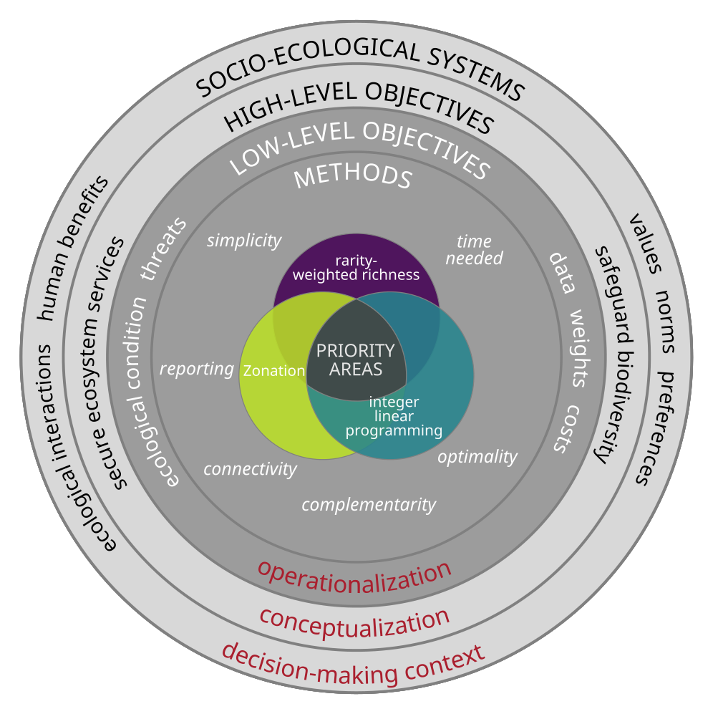

Figure 2.

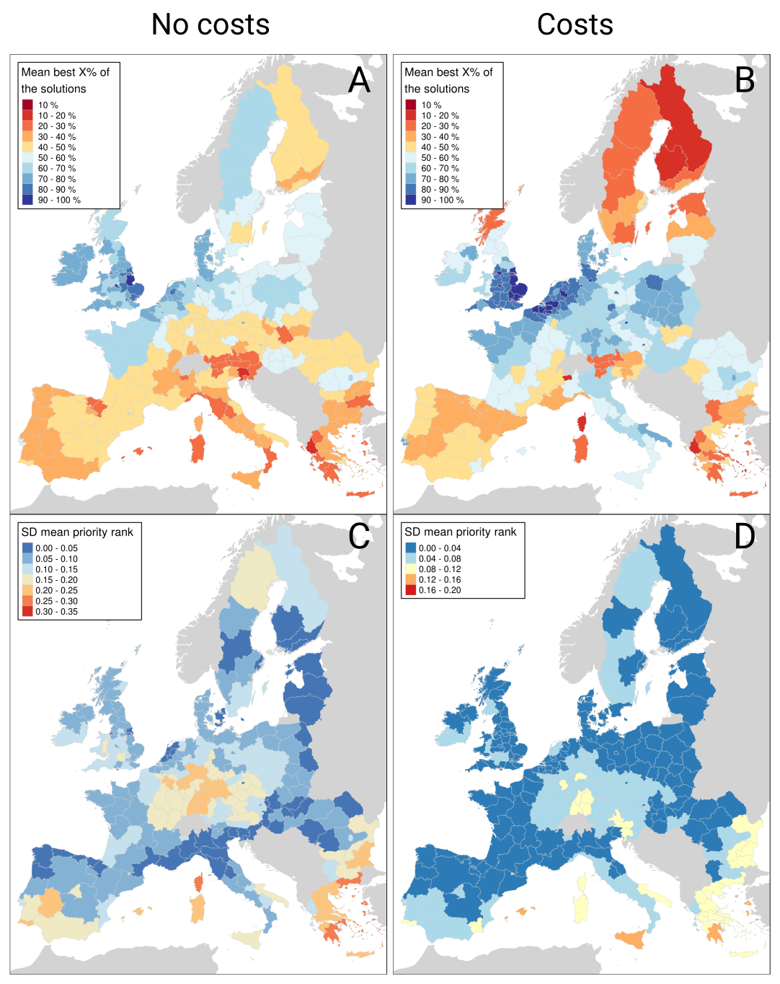

Figure 3.

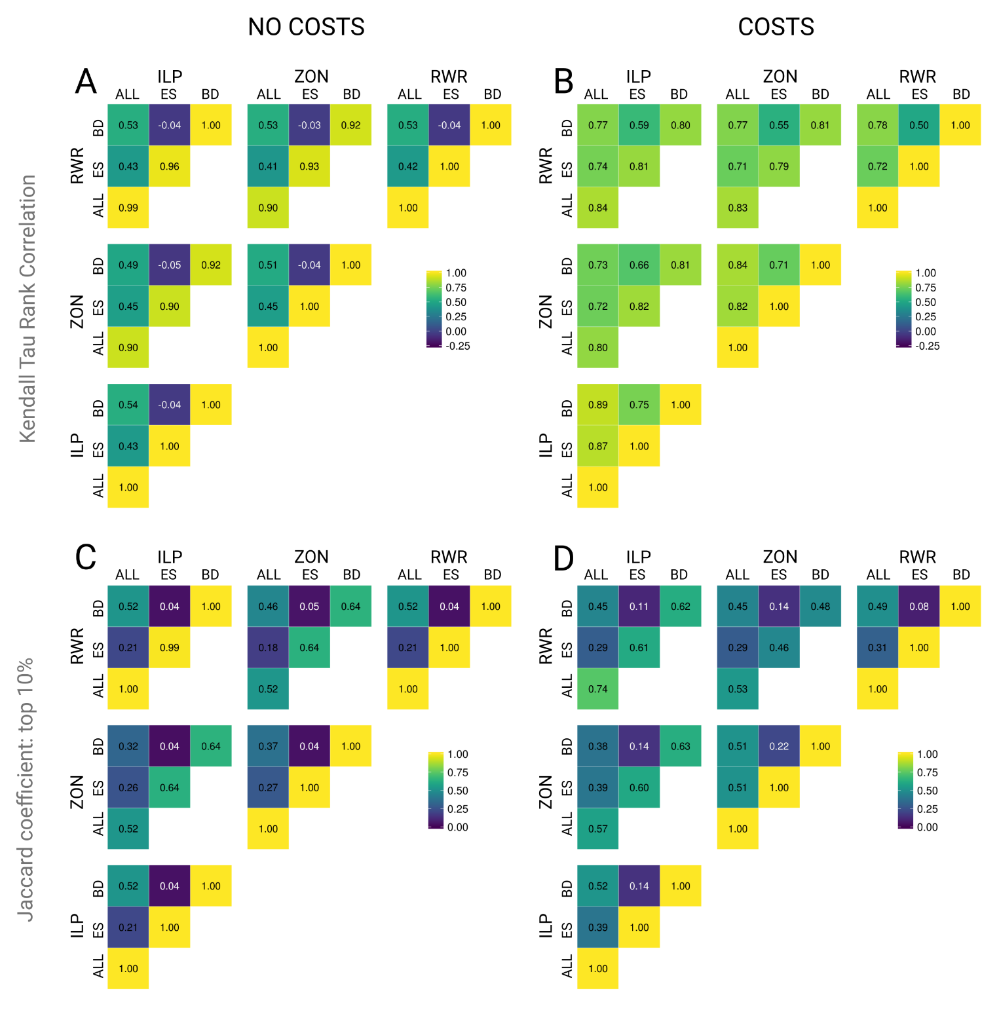

Figure 4.

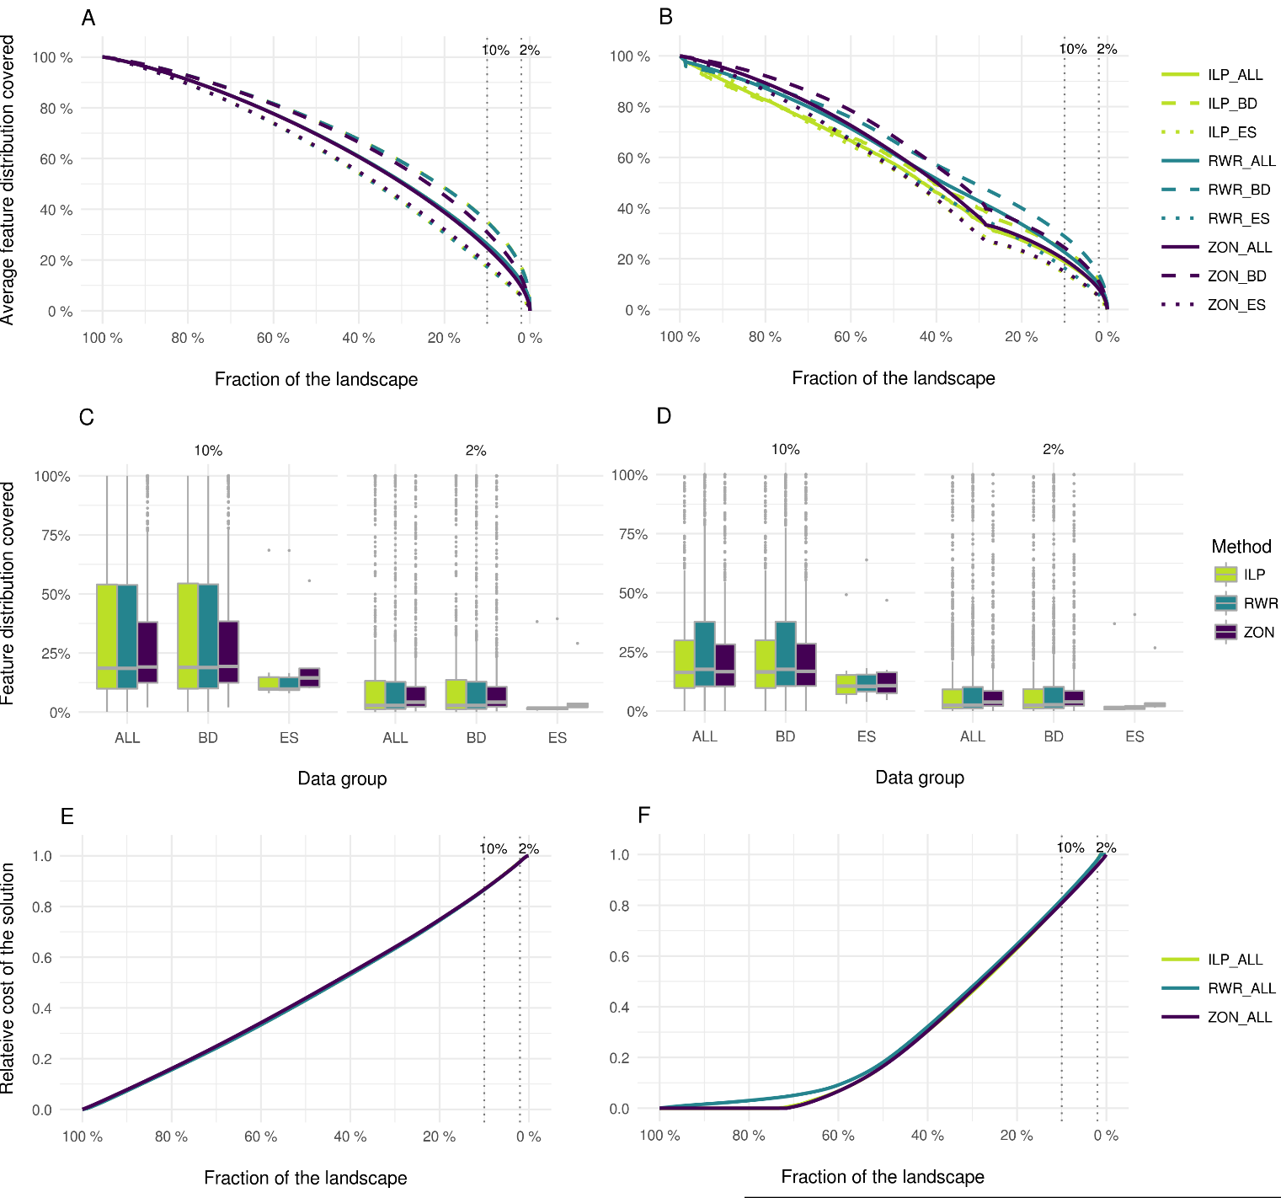

Figure 5.

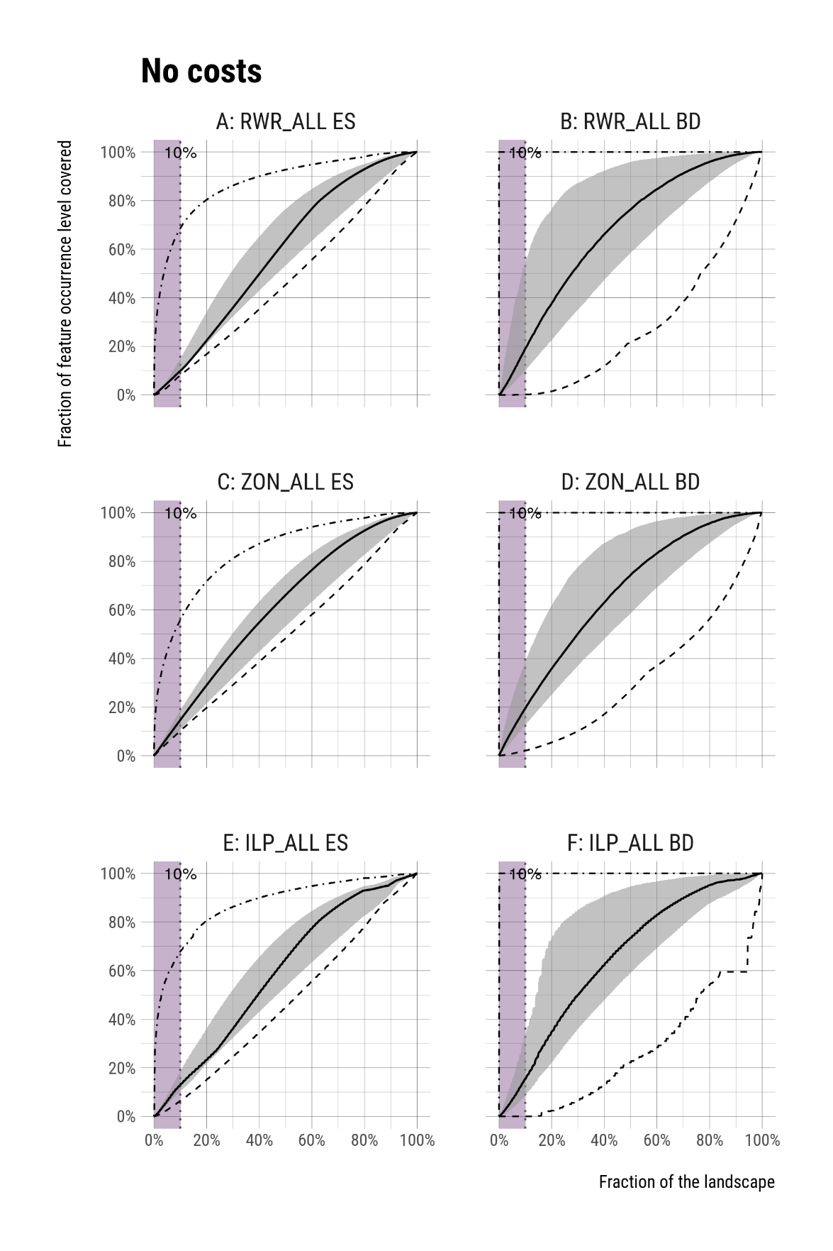

# Tables

**Table 1.** Spatially explicit modelled datasets used in the study. Temporal coverage refers to either a specific year of a range of years for which the model applies to.

**Dataset Description Unit Temporal Source  
 coverage**

**Ecosystem services**

Climate Response of terrestrial carbon balance to land Mg / C / ha 2006 Schulp et al.

regulation use change scenarios. (2008)

Erosion Protection of land cover against erosion in Ton / ha 2000 – 2030 Pérez-Soba   
prevention erosion prone areas. et al. (2010)

Flood Water retention capacity. Index (relative flood flows) 2007 – 2011 Stürck et al.  
regulation regulation of land use and (2014)

soil on river high flows)

Heritage: A cultural heritage index that is used to show Index 2000 – 2015 Tieskens et al.  
agricultural the spatial distribution of the overall cultural (2017)  
landscapes heritage index scores in agricultural land.

Heritage: A cultural heritage index that is used to show Index 2000 – 2015 Tieskens et al.  
forests the spatial distribution of the overall cultural (2017) heritage index scores in forests.

Pollination flows Unmanaged pollinators that live in suitable Index (the ratio between 2000 Serna-Chavez

natural and semi-natural habitats provide the proportion of benefiting et al. (2014)

pollination services especially to near areas located within the flow   
 croplands. area and the total benefiting

areas)

Tourism Supply of assets for tourism supported by Index 1999-2009 Van Berkel et al.

ecosystems. (2011)

Wild food Species richness of wild edible plants, Species richness of vascular 1999 – 2012 Schulp et al.   
provisioning mushrooms and game (supply) and demand plants (2014)

of wild food.

Wood High-resolution wood production maps for 1000 m3 / cell Average of Verkerk et al.  
production European forests. 2000-2010 (2015)

**Biodiversity features**

European Species-specific expert-based distribution Percentage of habitat in the 1997 – 2013 Thuiller et al

terrestrial models for 164 mammal, 404 bird, cell (primary + non-primary (2015)

vertebrates 83 amphibian, and 112 reptile species. habitat)

See Table S1 for a complete listing.

**Table 2.** Performancestatistics of variants RWR_ALL, ZON_ALL and ILP_ALL for the best 10% of the solutions (see also **Fig. 5**). Prioritizations are based on both feature groups (ALL), but statistics are also reported for each feature groups (ES and BD) separately. The values describe the percentage over all features in a given feature group.

**RWR** **ZON** **ILP**

**ALL** ES (ALL) BD (ALL) **ALL** ES (ALL) BD (ALL) **ALL** ES (ALL) BD (ALL)

**min** **0.1%** 8.0% 0.1% **2.0%** 10.1% 2.0% **0.0%** 6.4% 0.0%

**median** **18.5%** 9.8% 18.9% **19.1%** 14.5% 19.4% **15.3%** 12.8% 15.4%

**mean** **34.7%** 17.2% 34.9% **30.6%** 18.5% 30.8% **25.4%** 18.9% 25.5%

**max** **100.0%** 68.4% 100.0% **100.0%** 55.6% 100.0% **100.0%** 67.6% 100.0%

# Appendix

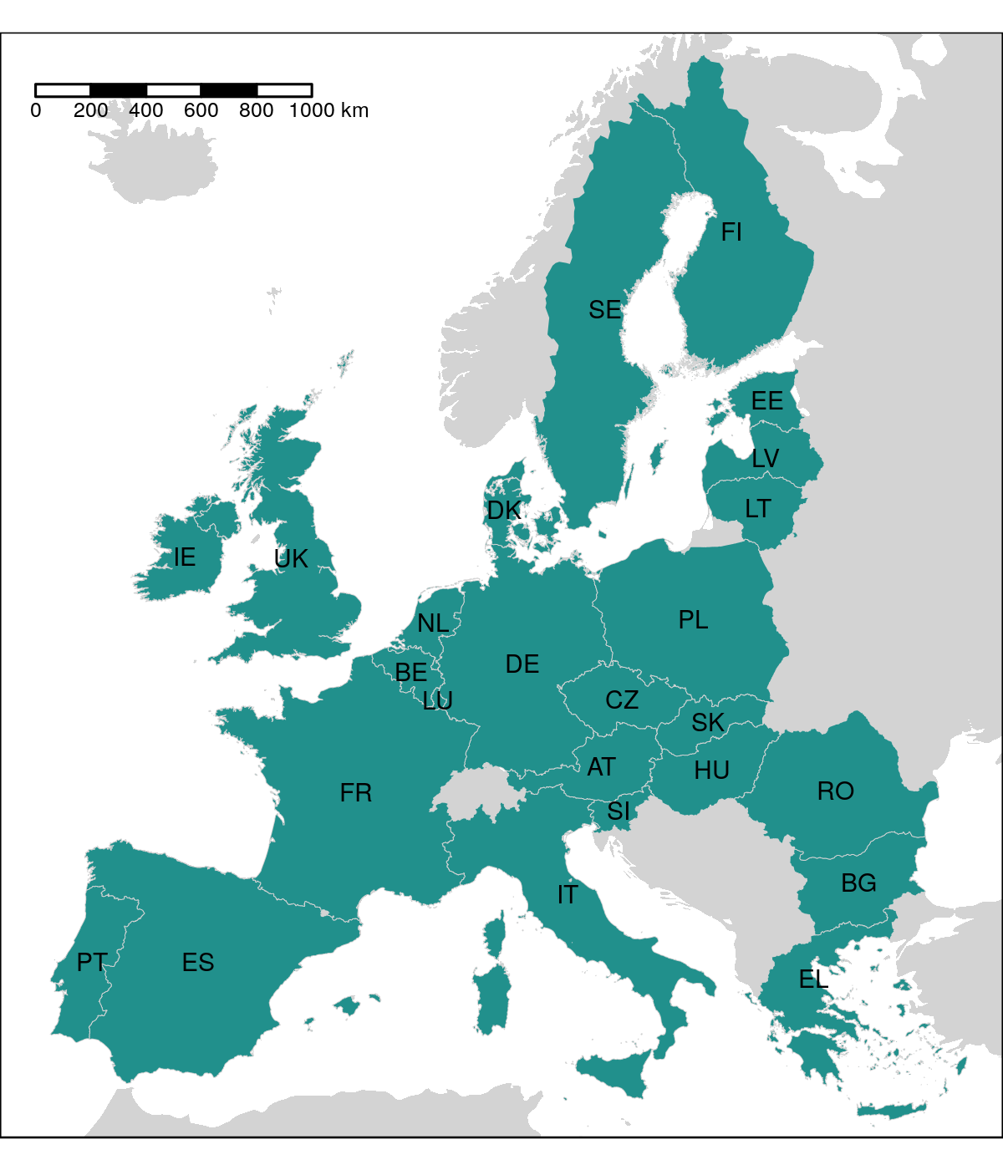

**Figure S1.** The 25 European countries included in the study.

Figure S2.

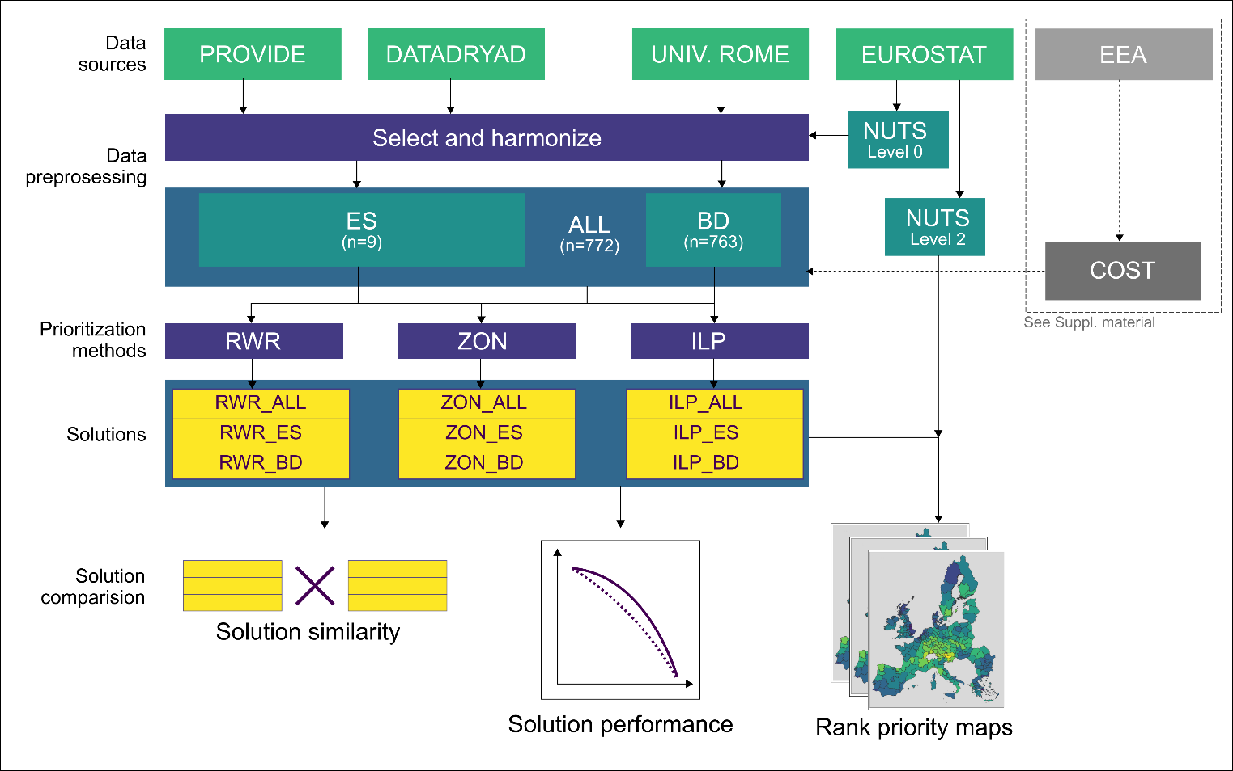

**Figure S2.** Schematics of the study workflow.

Table S1. Biodiversity features (n=759) used in the prioritization analyses.

|  |
| --- |
| **Amphibians** |
| Alytes cisternasii |
| Alytes dickhilleni |
| Alytes muletensis |
| Alytes obstetricans |
| Atylodes genei |
| Bombina bombina |
| Bombina pachypus |
| Bombina variegata |
| Bufo bufo |
| Calotriton arnoldi |
| Calotriton asper |
| Chioglossa lusitanica |
| Discoglossus galganoi |
| Discoglossus jeanneae |
| Discoglossus montalentii |
| Discoglossus pictus |
| Discoglossus sardus |
| Epidalea calamita |
| Euproctus montanus |
| Euproctus platycephalus |
| Hyla arborea |
| Hyla intermedia |
| Hyla meridionalis |
| Hyla sarda |
| Lissotriton boscai |
| Lissotriton helveticus |
| Lissotriton italicus |
| Lissotriton montandoni |
| Lissotriton vulgaris |
| Lyciasalamandra helverseni |
| Lyciasalamandra luschani |
| Mesotriton alpestris |
| Pelobates cultripes |
| Pelobates fuscus |
| Pelobates syriacus |
| Pelodytes ibericus |
| Pelodytes punctatus |
| Pelophylax bedriagae |
| Pelophylax bergeri |
| Pelophylax cerigensis |
| Pelophylax cretensis |
| Pelophylax epeirotcus |
| Pelophylax esculentus |
| Pelophylax grafi |
| Pelophylax hispanicus |
| Pelophylax kurtmuelleri |
| Pelophylax lessonae |
| Pelophylax perezi |
| Pelophylax ridibundus |
| Pleurodeles waltl |
| Proteus anguinus |
| Pseudepidalea balearica |
| Pseudepidalea sicula |
| Pseudepidalea variabilis |
| Pseudepidalea viridis |
| Rana arvalis |
| Rana dalmatina |
| Rana graeca |
| Rana iberica |
| Rana italica |
| Rana latastei |
| Rana pyrenaica |
| Rana temporaria |
| Salamandra atra |
| Salamandra corsica |
| Salamandra lanzai |
| Salamandra salamandra |
| Salamandrina perspicillata |
| Salamandrina terdigitata |
| Speleomantes ambrosii |
| Speleomantes flavus |
| Speleomantes imperialis |
| Speleomantes italicus |
| Speleomantes sarrabusensis |
| Speleomantes strinatii |
| Speleomantes supramontis |
| Triturus carnifex |
| Triturus cristatus |
| Triturus dobrogicus |
| Triturus karelinii |
| Triturus macedonicus |
| Triturus marmoratus |
| Triturus pygmaeus  **Birds** |
| Accipiter brevipes |
| Acrocephalus agricola |
| Acrocephalus arundinaceus |
| Acrocephalus dumetorum |
| Acrocephalus melanopogon |
| Acrocephalus paludicola |
| Acrocephalus palustris |
| Acrocephalus schoenobaenus |
| Acrocephalus scirpaceus |
| Actitis hypoleucos |
| Aegithalos caudatus |
| Aegolius funereus |
| Aegypius monachus |
| Alauda arvensis |
| Alca torda |
| Alcedo atthis |
| Alectoris barbara |
| Alectoris chukar |
| Alectoris graeca |
| Alectoris rufa |
| Anas acuta |
| Anas clypeata |
| Anas crecca |
| Anas penelope |
| Anas platyrhynchos |
| Anas querquedula |
| Anas strepera |
| Anser anser |
| Anser brachyrhynchus |
| Anser erythropus |
| Anser fabalis |
| Anthus campestris |
| Anthus cervinus |
| Anthus petrosus |
| Anthus pratensis |
| Anthus spinoletta |
| Anthus trivialis |
| Apus apus |
| Apus caffer |
| Apus melba |
| Apus pallidus |
| Aquila adalberti |
| Aquila chrysaetos |
| Aquila clanga |
| Aquila heliaca |
| Aquila pomarina |
| Ardea cinerea |
| Ardea purpurea |
| Ardeola ralloides |
| Arenaria interpres |
| Asio flammeus |
| Asio otus |
| Athene noctua |
| Aythya ferina |
| Aythya fuligula |
| Aythya marila |
| Aythya nyroca |
| Bombycilla garrulus |
| Bonasa bonasia |
| Botaurus stellaris |
| Branta bernicla |
| Branta leucopsis |
| Bubo bubo |
| Bubulcus ibis |
| Bucanetes githagineus |
| Bucephala clangula |
| Burhinus oedicnemus |
| Buteo buteo |
| Buteo lagopus |
| Buteo rufinus |
| Calandrella brachydactyla |
| Calandrella rufescens |
| Calcarius lapponicus |
| Calidris canutus |
| Calidris maritima |
| Calidris minuta |
| Calidris temminckii |
| Calonectris diomedea |
| Caprimulgus europaeus |
| Caprimulgus ruficollis |
| Carduelis cannabina |
| Carduelis carduelis |
| Carduelis chloris |
| Carduelis flammea |
| Carduelis flavirostris |
| Carduelis hornemanni |
| Carduelis spinus |
| Carpodacus erythrinus |
| Cepphus grylle |
| Cercotrichas galactote |
| Certhia familiaris |
| Cettia cetti |
| Charadrius alexandrinus |
| Charadrius dubius |
| Charadrius hiaticula |
| Charadrius morinellus |
| Chersophilus duponti |
| Chlidonias hybridus |
| Chlidonias leucopterus |
| Chlidonias niger |
| Ciconia ciconia |
| Ciconia nigra |
| Cinclus cinclus |
| Circaetus gallicus |
| Circus aeruginosus |
| Circus cyaneus |
| Circus macrourus |
| Circus pygargus |
| Cisticola juncidis |
| Clamator glandarius |
| Clangula hyemalis |
| Coccothraustes coccothraustes |
| Columba livia |
| Columba oenas |
| Coracias garrulus |
| Corvus corax |
| Corvus corone |
| Corvus frugilegus |
| Corvus monedula |
| Coturnix coturnix |
| Crex crex |
| Cuculus canorus |
| Cuculus saturatus |
| Cyanopica cyana cyanus |
| Cygnus cygnus |
| Cygnus olor |
| Delichon urbica |
| Dendrocopos leucotos |
| Dendrocopos major |
| Dendrocopos medius |
| Dendrocopos minor |
| Dendrocopos syriacus |
| Dryocopus martius |
| Egretta alba |
| Egretta garzetta |
| Elanus caeruleus |
| Emberiza aureola |
| Emberiza caesia |
| Emberiza cia |
| Emberiza cineracea |
| Emberiza cirlus |
| Emberiza citrinella |
| Emberiza hortulana |
| Emberiza melanocephala |
| Emberiza pusilla |
| Emberiza rustica |
| Emberiza schoeniclus |
| Eremophila alpestris |
| Erithacus rubecula |
| Falco biarmicus |
| Falco cherrug |
| Falco columbarius |
| Falco eleonorae |
| Falco naumanni |
| Falco peregrinus |
| Falco rusticolus |
| Falco subbuteo |
| Falco tinnunculus |
| Falco vespertinus |
| Ficedula albicollis |
| Ficedula hypoleuca |
| Ficedula parva |
| Ficedula semitorquata |
| Fratercula arctica |
| Fringilla montifringilla |
| Fulica atra |
| Fulica cristata |
| Fulmarus glacialis |
| Galerida cristata |
| Galerida theklae |
| Gallinago gallinago |
| Gallinago media |
| Gallinula chloropus |
| Garrulus glandarius |
| Gavia arctica |
| Gavia immer |
| Gavia stellata |
| Gelochelidon nilotica |
| Glareola nordmanni |
| Glareola pratincola |
| Glaucidium passerinum |
| Grus grus |
| Gypaetus barbatus |
| Gyps fulvus |
| Haematopus ostralegus |
| Halcyon smyrnensis |
| Haliaeetus albicilla |
| Hieraaetus fasciatus |
| Hieraaetus pennatus |
| Himantopus himantopus |
| Hippolais icterina |
| Hippolais olivetorum |
| Hippolais pallida |
| Hippolais polyglotta |
| Hirundo daurica |
| Hirundo rustica |
| Hoplopterus spinosus |
| Hydrobates pelagicus |
| Ixobrychus minutus |
| Jynx torquilla |
| Lagopus lagopus |
| Lagopus mutus |
| Lanius collurio |
| Lanius excubitor |
| Lanius meridionalis |
| Lanius minor |
| Lanius nubicus |
| Lanius senator |
| Larus argentatus |
| Larus audouinii |
| Larus cachinnans |
| Larus canus |
| Larus fuscus |
| Larus genei |
| Larus marinus |
| Larus melanocephalus |
| Larus minutus |
| Larus ridibundus |
| Limicola falcinellus |
| Limosa lapponica |
| Limosa limosa |
| Locustella fluviatilis |
| Locustella luscinioides |
| Locustella naevia |
| Loxia curvirostra |
| Loxia leucoptera |
| Loxia pytyopsittacus |
| Loxia scotica |
| Lullula arborea |
| Luscinia luscinia |
| Luscinia megarhynchos |
| Luscinia svecica |
| Lymnocryptes minimus |
| Marmaronetta angustirostris |
| Melanitta fusca |
| Melanitta nigra |
| Melanocorypha calandra |
| Mergus albellus |
| Mergus merganser |
| Mergus serrator |
| Merops apiaster |
| Miliaria calandra |
| Milvus migrans |
| Milvus milvus |
| Monticola saxatilis |
| Monticola solitarius |
| Montifringilla nivalis |
| Morus bassanus |
| Motacilla alba |
| Motacilla cinerea |
| Motacilla citreola |
| Motacilla flava |
| Muscicapa striata |
| Neophron percnopterus |
| Netta rufina |
| Nucifraga caryocatactes |
| Numenius arquata |
| Numenius phaeopus |
| Nyctea scandiaca |
| Nycticorax nycticorax |
| Oceanodroma castro |
| Oceanodroma leucorhoa |
| Oenanthe hispanica |
| Oenanthe isabellina |
| Oenanthe leucura |
| Oenanthe oenanthe |
| Oenanthe pleschanka |
| Oriolus oriolus |
| Otis tarda |
| Otus scops |
| Oxyura leucocephala |
| Pandion haliaetus |
| Panurus biarmicus |
| Parus caeruleus |
| Parus cinctus |
| Parus cristatus |
| Parus lugubris |
| Parus major |
| Parus montanus |
| Parus palustris |
| Passer domesticus |
| Passer hispaniolensis |
| Passer italiae |
| Passer montanus |
| Pelecanus crispus |
| Pelecanus onocrotalus |
| Perisoreus infaustus |
| Pernis apivorus |
| Petronia petronia |
| Phalaropus lobatus |
| Phalocrocorax carbo |
| Phalocrocorax pygmaeus |
| Phasianus colchicus |
| Philomachus pugnax |
| Phoenicopterus roseus |
| Phoenicurus ochruros |
| Phoenicurus phoenicurus |
| Phylloscopus bonelli |
| Phylloscopus borealis |
| Phylloscopus collybita |
| Phylloscopus sibilatrix |
| Phylloscopus trochiloides |
| Phylloscopus trochilus |
| Pica pica |
| Picoides tridactylus |
| Picus canus |
| Picus viridis |
| Pinicola enucleator |
| Platalea leucorodia |
| Plectrophenax nivalis |
| Plegadis falcinellus |
| Pluvialis apricaria |
| Podiceps auritus |
| Podiceps cristatus |
| Podiceps grisegena |
| Podiceps nigricollis |
| Porphyrio porphyrio |
| Porzana parva |
| Porzana porzana |
| Porzana pusilla |
| Prunella collaris |
| Prunella modularis |
| Pterocles alchata |
| Pterocles orientalis |
| Ptyonoprogne rupestris |
| Puffinus mauretanicus |
| Puffinus puffinus |
| Puffinus yelkouan |
| Pyrrhocorax graculus |
| Pyrrhocorax pyrrhocorax |
| Pyrrhula pyrrhula |
| Rallus aquaticus |
| Recurvirostra avosetta |
| Regulus ignicapillus |
| Regulus regulus |
| Remiz pendulinus |
| Riparia riparia |
| Rissa tridactyla |
| Saxicola rubetra |
| Saxicola torquata |
| Scolopax rusticola |
| Serinus citrinella |
| Serinus serinus |
| Sitta europaea |
| Sitta krueperi |
| Sitta neumayer |
| Sitta whiteheadi |
| Somateria mollissima |
| Stercorarius longicaudus |
| Stercorarius parasiticus |
| Stercorarius skua |
| Sterna albifrons |
| Sterna bengalensis |
| Sterna caspia |
| Sterna dougallii |
| Sterna hirundo |
| Sterna paradisaea |
| Sterna sandvicensis |
| Streptopelia decaocto |
| Streptopelia turtur |
| Strix aluco |
| Strix nebulosa |
| Strix uralensis |
| Sturnus roseus |
| Sturnus unicolor |
| Sturnus vulgaris |
| Surnia ulula |
| Sylvia atricapilla |
| Sylvia borin |
| Sylvia cantillans |
| Sylvia communis |
| Sylvia conspicillata |
| Sylvia curruca |
| Sylvia hortensis |
| Sylvia melanocephala |
| Sylvia nisoria |
| Sylvia rueppelli |
| Sylvia sarda |
| Sylvia undata |
| Tachybaptus ruficollis |
| Tadorna ferruginea |
| Tadorna tadorna |
| Tarsiger cyanurus |
| Tetrao urogallus |
| Tetrax tetrax |
| Tichodroma muraria |
| Tringa erythropus |
| Tringa glareola |
| Tringa nebularia |
| Tringa ochropus |
| Tringa stagnatilis |
| Tringa totanus |
| Turdus iliacus |
| Turdus merula |
| Turdus philomelos |
| Turdus pilaris |
| Turdus torquatus |
| Turdus viscivorus |
| Turnix sylvatica |
| Tyto alba |
| Upupa epops |
| Uria lomvia |
| Vanellus vanellus |
| Xenus cinereus |
| **Mammals** |
| Acomys minous |
| Alces alces |
| Alopex lagopus |
| Apodemus agrarius |
| Apodemus alpicola |
| Apodemus epimelas |
| Apodemus flavicollis |
| Apodemus mystacinus |
| Apodemus sylvaticus |
| Apodemus uralensis |
| Apodemus witherbyi |
| Arvicola amphibius |
| Arvicola sapidus |
| Arvicola scherman |
| Atelerix algirus |
| Barbastella barbastellus |
| Bison bonasus |
| Canis aureus |
| Capra ibex |
| Capra pyrenaica |
| Capreolus capreolus |
| Chionomys nivalis |
| Cricetulus migratorius |
| Cricetus cricetus |
| Crocidura leucodon |
| Crocidura pachyura |
| Crocidura russula |
| Crocidura sicula |
| Crocidura suaveolens |
| Crocidura zimmermanni |
| Dama dama |
| Dinaromys bogdanovi |
| Dryomys nitedula |
| Eliomys quercinus |
| Eptesicus bottae |
| Eptesicus nilsonii |
| Eptesicus serotinus |
| Erinaceus europaeus |
| Erinaceus roumanicus |
| Felis silvestris |
| Galemys pyrenaicus |
| Genetta genetta |
| Glis glis |
| Gulo gulo |
| Hystrix cristata |
| Lemmus lemmus |
| Lepus capensis |
| Lepus castroviejoi |
| Lepus corsicanus |
| Lepus europaeus |
| Lepus granatensis |
| Lepus timidus |
| Lutra lutra |
| Lynx pardinus |
| Martes foina |
| Martes martes |
| Meles meles |
| Meriones tristami |
| Mesocricetus newtoni |
| Micromys minutus |
| Microtus agrestis |
| Microtus arvalis |
| Microtus bavaricus |
| Microtus brachycercus |
| Microtus cabrerae |
| Microtus duodecimcostatus |
| Microtus felteni |
| Microtus gerbei |
| Microtus guentheri |
| Microtus levis |
| Microtus liechtesteini |
| Microtus lusitanicus |
| Microtus multiplex |
| Microtus oeconomus |
| Microtus savii |
| Microtus subterraneus |
| Microtus tatricus |
| Microtus thomasi |
| Miniopterus schreibersi |
| Mus macedonicus |
| Mus musculus |
| Mus spicilegus |
| Mus spretus |
| Muscardinus avellanarius |
| Mustela erminea |
| Mustela eversmanii |
| Mustela lutreola |
| Mustela nivalis |
| Mustela putorius |
| Myodes glareolus |
| Myodes rufocanus |
| Myodes rutilus |
| Myomimus roachi |
| Myopus schisticolor |
| Myotis alcathoe |
| Myotis aurascens |
| Myotis bechsteinii |
| Myotis blythii |
| Myotis brandtii |
| Myotis capaccinii |
| Myotis dasycneme |
| Myotis daubentonii |
| Myotis emarginatus |
| Myotis myotis |
| Myotis mystacinus |
| Myotis nattereri |
| Myotis punicus |
| Neomys anomalus |
| Neomys fodiens |
| Nyctalus lasiopterus |
| Nyctalus leisleri |
| Nyctalus noctula |
| Oryctolagus cuniculus |
| Ovis aries |
| Pipistrellus kuhlii |
| Pipistrellus nathusii |
| Pipistrellus pipistrellus |
| Pipistrellus pygmaeus |
| Pipistrellus savii |
| Plecotus auritus |
| Plecotus austriacus |
| Plecotus kolombatovici |
| Plecotus macrobullaris |
| Plecotus sardus |
| Pteromys volans |
| Rhinolophus blasii |
| Rhinolophus euryale |
| Rhinolophus ferrumequinum |
| Rhinolophus hipposideros |
| Rhinolophus mehelyi |
| Rupicapra rupicapra |
| Sciurus anomalus |
| Sciurus vulgaris |
| Sicista betulina |
| Sicista severtzovi |
| Sicista subtilis |
| Sorex alpinus |
| Sorex antinorii |
| Sorex araneus |
| Sorex caecutiens |
| Sorex coronatus |
| Sorex granarius |
| Sorex isodon |
| Sorex minutissimus |
| Sorex minutus |
| Sorex samniticus |
| Spalax graecus |
| Spalax leucodon |
| Spalax nehringi |
| Spermophilus citellus |
| Spermophilus suslicus |
| Suncus etruscus |
| Sus scrofa |
| Tadarida teniotis |
| Talpa caeca |
| Talpa europaea |
| Talpa levantis |
| Talpa occidentalis |
| Talpa romana |
| Talpa stankovici |
| Ursus arctos |
| Vespertilio murinus |
| Vormela peregusna |
| Vulpes vulpes |
| Ablepharus kitaibelii |
| Acanthodactylus erythrurus |
| **Reptiles** |
| Algyroides fitzingeri |
| Algyroides marchi |
| Algyroides moreoticus |
| Algyroides nigropunctatus |
| Anatolacerta anatolica |
| Anatolacerta oertzeni |
| Anguis cephallonica |
| Anguis fragilis |
| Archaeolacerta bedriagae |
| Blanus cinereus |
| Blanus strauchi |
| Chalcides bedriagai |
| Chalcides chalcides |
| Chalcides ocellatus |
| Chalcides striatus |
| Chamaeleo africanus |
| Chamaeleo chamaeleon |
| Coronella austriaca |
| Coronella girondica |
| Cyrtopodion kotschyi |
| Darevskia praticola |
| Dolichophis caspius |
| Dolichophis jugularis |
| Eirenis modestus |
| Elaphe quatuorlineata |
| Elaphe sauromates |
| Emys orbicularis |
| Emys trinacris |
| Eremias arguta |
| Eryx jaculus |
| Euleptes europaea |
| Eumeces schneideri |
| Hellenolacerta graeca |
| Hemidactylus turcicus |
| Hemorrhois hippocrepis |
| Hemorrhois nummifer |
| Hierophis gemonensis |
| Hierophis gyarosensis |
| Hierophis viridiflavus |
| Iberolacerta aranica |
| Iberolacerta aurelioi |
| Iberolacerta bonnali |
| Iberolacerta cyreni |
| Iberolacerta galani |
| Iberolacerta horvathi |
| Iberolacerta martinezricai |
| Iberolacerta monticola |
| Lacerta agilis |
| Lacerta bilineata |
| Lacerta schreiberi |
| Lacerta trilineata |
| Lacerta viridis |
| Laudakia stellio |
| Macroprotodon brevis |
| Macroprotodon cucullatus |
| Macroprotodon mauritanicus |
| Macrovipera schweizeri |
| Malpolon monspessulanus |
| Mauremys leprosa |
| Mauremys rivulata |
| Montivipera xanthina |
| Natrix maura |
| Natrix tesselleta |
| Ophiomorus punctatissimus |
| Ophisops elegans |
| Parvilacerta parva |
| Platyceps collaris |
| Platyceps najadum |
| Podarcis bocagei |
| Podarcis carbonelli |
| Podarcis erhardii |
| Podarcis filfolensis |
| Podarcis gaigeae |
| Podarcis hispanica |
| Podarcis lilfordi |
| Podarcis melisellensis |
| Podarcis milensis |
| Podarcis muralis |
| Podarcis peloponnesiaca |
| Podarcis pityusensis |
| Podarcis raffonei |
| Podarcis sicula |
| Podarcis taurica |
| Podarcis tiliguerta |
| Podarcis vaucheri |
| Podarcis wagleriana |
| Psammodromus hispanicus |
| Psammodromus jeanneae |
| Psammodromus manuelae |
| Pseudopus apodus |
| Rhinechis scalaris |
| Tarentola mauritanica |
| Telescopus fallax |
| Testudo graeca |
| Testudo hermanni |
| Testudo marginata |
| Timon lepidus |
| Trachylepis aurata |
| Trionyx triunguis |
| Typhlops vermicularis |
| Vipera ammodytes |
| Vipera aspis |
| Vipera berus |
| Vipera latastei |
| Vipera renardi |
| Vipera seoanei |
| Vipera ursinii |
| Zamenis lineatus |
| Zamenis longissimus |
| Zamenis situla |
|  |
|  |