**Comparing spatial prioritization methods for biodiversity conservation and ecosystem service supply in Europe**

**Joona Lehtomäki1\***, **Luigi Maiorano2** and **Peter verburg1**

1 Environmental Geography Group, Department of Earth Sciences, De Boelelaan 1105, 1081 HV Amsterdam, Vrije Universiteit Amsterdam, the Netherlands.

2 XXX

* Corresponding author

**Contact:** j.lehtomaki@vu.nl, tel. +31-20-59-87294  
ORCID: 0000-0002-7891-0843

XXX XXX

peter.verburg@vu.nl, tel. +31-20-59-83594

**Type of paper:** Environmental modelling and software, Research article

**Running title:** Spatial prioritization comparison

**Manuscript version:** 0.2 (see also associated NEWS.md)

**Manuscript statistics:** 236 words (abstract)  
178 words (main text)  
694 words (everything)  
7 references  
XX figures  
XX tables

**Abstract:**

Identifying priority areas that simultaneously supply ecosystem services and are important for biodiversity underlying the supply of ecosystem services is essential for well-informed decision-making on land use and conservation planning. Multiple methods for spatial prioritization of locations supplying individual or multiple ecosystem services, and for the balanced or optimal allocation of biodiversity conservation actions exist, but the benefits and disadvantages of using these methods are seldom explored. Furthermore, the technical complexity, data requirements and the transparency of the method parameterization further make a great difference in the usability of each method in practical work. Here, we compare a simple scoring method, heuristic prioritization software Zonation, and an exact spatial optimization method in prioritizing locations important for multiple ecosystem services and biodiversity at the European scale. Each method is used within a realistic, but hypothetical decision-making context. We show that for very simple analysis types, the scoring-type of approach performs very similarly to Zonation and the exact optimization method. However, more complex - and arguably more policy-relevant - analysis types can only be accommodated by the more complex methods. We demonstrate the practical implications of using each approach in operationalizing the concept ecosystem services and biodiversity conservation planning into more widespread practical use. We argue that the road forward in using planning methods is a combination of technical credibility, decision-making relevance, and effort in opening up the planning process to the stakeholders involved.

**Keywords:** spatial prioritization; ecosystem services; biodiversity conservation; Zonation; optimization; environmental decision-making

**Software and/or data availability:**TBA

# Highlights

* We compare three different spatial prioritization methods of identifying priority locations for both the supply of ecosystem services and biodiversity conservation on European scale.
* The prioritization results show that for a relatively simple prioritization analyses, all the methods perform similarly
* Priority areas for the selected ecosystem services are aggregated to central parts of Europe, whereas biodiversity priorities are found in the Mediterranean basin and Northern Fennoscandia.
* We provide information to guide the selection of a suitable approaches, including methods and the types of data needed, in operationalizing the spatial planning for ecosystem services and biodiversity.
* Importantly, our methods and results can help to characterize and quantify the potential trade-offs between ecosystem services supply and biodiversity conservation.

# 1. Introduction

Ecosystem services, activities or functions of ecosystems that provide benefit (or occasionally disbenefit) to humans (Mace et al., 2012), has quickly risen in popularity in guiding environmental management decisions. Ecosystems are thought to provide a broad spectrum of different services that directly or indirectly contribute to the human well-being on multiple spatiotemporal scales (REFS). Given the strong emphasis placed on ecosystem services especially in the national and international policy arenas (REFS), the operationalization of the concept of ecosystem services is still well underway. Part of this operationalization process is the development of methods and tools for spatial planning that integrates multiple objectives simultaneously in a transparent and cost-effective manner. Spatial planning and spatial support systems are widely studied and used in environmental context in land use, natural resource, urban and conservation planning (REFS). For practical relevance, spatial planning needs to be able to include ecological, economic and social factors relevant for whatever decision-making problem is at hand. Integrating spatial planning with decision-analytical methods has been done under the rubrics such as multi-criteria decision making (REFS), XXX (REFS) and XXX (REFS). Management decisions will increasingly need to account for both biodiversity conservation and the provision of ecosystem services (Goldman and Tallis, 2009) and therefore methods able to quantify the associated trade-offs are urgently needed (Cordingley et al., 2016). It is crucial, however, to be fully aware of the assumptions behind methods used to assess their suitability for the task.

In practice, spatial planning is useful for guiding environmental management only if the planning methods and the information they provide can been embedded into real-life management context. In the field of conservation science, systematic conservation planning (Margules and Pressey, 2000) has been perhaps to most influential framework combining aspects of spatial planning to implementation of biodiversity conservation (Kukkala and Moilanen, 2012). Within this broader decision-analytical framework, the more technical biogeographic-economic assessment of which areas are the most important for biodiversity and when and how particular actions should be implemented to achieving conservation goals, is called spatial conservation prioritization (SCP)(Ferrier and Wintle, 2009; Kukkala and Moilanen, 2012; Wilson et al., 2007). In addition to ecological effectiveness, socio-economic efficiency is a key aspect of SCP: how should limited resources be invested to maximize expected outcomes (the persistence of biodiversity)(Evans et al., 2015). While SCP was originally developed for designing more effective protected area networks, the underlying principles and methods developed based on them are suitable for prioritizing between a suite of different actions (REFS). For example, spatial conservation prioritization has been applied in context of natural resource extraction (Kareksela et al., 2013), habitat restoration (Thomson et al., 2009) and food production (Dobrovolski et al., 2014). Many SCP methods have also been implemented as software tools (REFS), increasing the uptake and usability of the methods and concepts in practice.  
  
Spatial prioritization methods have also been applied to prioritizing areas suitable for the provision of ecosystem services (Chan et al., 2006; Schröter et al., 2014), provision of ecosystem services and urban development (Casalegno et al., 2014) and both provision of ecosystem services and biodiversity conservation (Moilanen et al., 2011; Nin et al., 2016; Reyers et al., 2012). Spatial prioritization of ecosystem services provision is fundamentally different to spatial conservation prioritization of biodiversity, but the two share enough similarities for SCP methods to be useful for management concerning ecosystem services. The basic elements of a prioritization problem are the same for both biodiversity conservation and ecosystem services provision: quantitative and spatial features that need to be protected or secured, potential threats that features are facing, potential actions that can be taken to retain the features and mitigate threats, and information on the costs of the potential actions (Ferrier and Wintle, 2009; Luck et al., 2012). According to Luck et al. (2012), the prioritization of ecosystem services provision must additionally consider at least the availability of alternative meansof providing benefits supplied by services, the capacity of an ecosystem services to meet human demands, and the scaleof, and site dependencyin, the delivery of services. Furthermore, asymptotic benefit-functions often used in SCP (Arponen et al., 2005; Wilson et al., 2009b) are not suitable for all ecosystem services for which either linear or more complex relationships are more appropriate (Barbier et al., 2008; Luck et al., 2012). Emphasizing the relative importance of rare features over more common features (Moilanen et al., 2005; Williams et al., 1996) is another principle which may be more suitable for biodiversity rather than ecosystem services features.

One practical strength of adapting SCP methods in spatial prioritization of ecosystem services supply is that SCP has already seen wide operationalization and adaptation in real-life decision-making (Knight et al., 2009; Lehtomäki and Moilanen, 2013). Based on experiences from a broad array of applied projects and the existing literature on the applicability of methods and tools to practice, it is possible to assess the potential of SCP methods in the context of ecosystem services. In the broader context of providing decision-support tools capable of dealing with ecosystem services, there are multiple good reviews available assessing the technical and practical aspects of different software tools (e.g. Bagstad et al., 2013; Langemeyer et al., 2016). However, only few assessments explicitly consider explicitly consider spatial methods and combining both ecosystem provision and biodiversity conservation simultaneously.

A broad set of methods with variable complexity and flexibility are available for spatial prioritization. Relatively simple methods that sum the occurrence of biodiversity features (e.g. species) in a given area of interest have been popular exactly because of the simplicity of the approach (REFS). However, since most of these so-called “scoring” methods do not take into account complementarity, […], solutions produced are inefficient (Wilson et al., 2009a). Spatial conservation prioritization problems concerning the selection of an optimal set of areas based on some selection criteria are also solvable exactly using spatial optimization techniques such as integer linear programming (ILP) (Beyer et al., 2016). The advantage of ILP methods is that they produce a truly optimal solution or a quantitative estimate on the sub-optimality of the solution. The downside is that accounting for all the factors relevant for real-life prioritization problems quickly renders the optimization computationally infeasible (REFS), or require simplifications reducing the relevance of the solution (Moilanen, 2008). This is why heuristic methods have proven to be popular in spatial conservation prioritization: they are flexible enough to accommodate factors relevant for decision-making while retaining computational tractability (Moilanen and Ball, 2009). They cannot, however, guarantee the optimality of the solution and are typically on the same level of technical complexity as exact optimization methods.

Here, we compare three spatial prioritization methods that fall into the three categories of methods described above: rarity-weighted richness (RWR, scoring method), Zonation (heuristic), and ILP approach (exact optimization). We apply each of the methods on a prioritization problem constituting of 11 features describing ecosystem services capacity and 759 features of estimated extents of occurrence of tetrapods (amphibians, birds, mammal and reptiles) on European scale. While the prioritization results are indicative of true priority areas, we are more interested in the assumptions one needs to make in order to use each method, and the relative differences between the methods. This work contributes to the understanding of operational requirements of spatial planning integrating ecosystem services and biodiversity conservation, as well as developing operational instruments for such planning. We are interested in how the different methods used to identify important areas for ecosystem services and biodiversity are suited for operational planning and provide guidelines for doing so.

# 2. Material and methods

## 2.1 Datasets

* We use 11 features of ecosystem services capacity (group name: ES) and 759 features of biodiversity features (group name: BD). All datasets (n=770, group name: ALL) have originally been developed for different purposes, for a more detailed description of the data please refer to the original sources given in [Table 1](https://docs.google.com/spreadsheets/d/1niV9Oe8pavgskiq0ibMzPt6F_oJU3uTD3R2pY7RwyDU/edit#gid=0).
  + We aimed a selecting a plausible set of spatially explicit ecosystem service features.
* Our study area covers 26 EU member states (EU28 without Cyprus and Malta, **Figure 1**)
  + Countries involved were selected on data availability and EU membership.
  + The temporal coverage of the data varies from X to Y.
  + Ecosystem services data packaged for PROVIDE/VOLANTE project.
  + NUTS2 regions downloaded from Eurotstat.

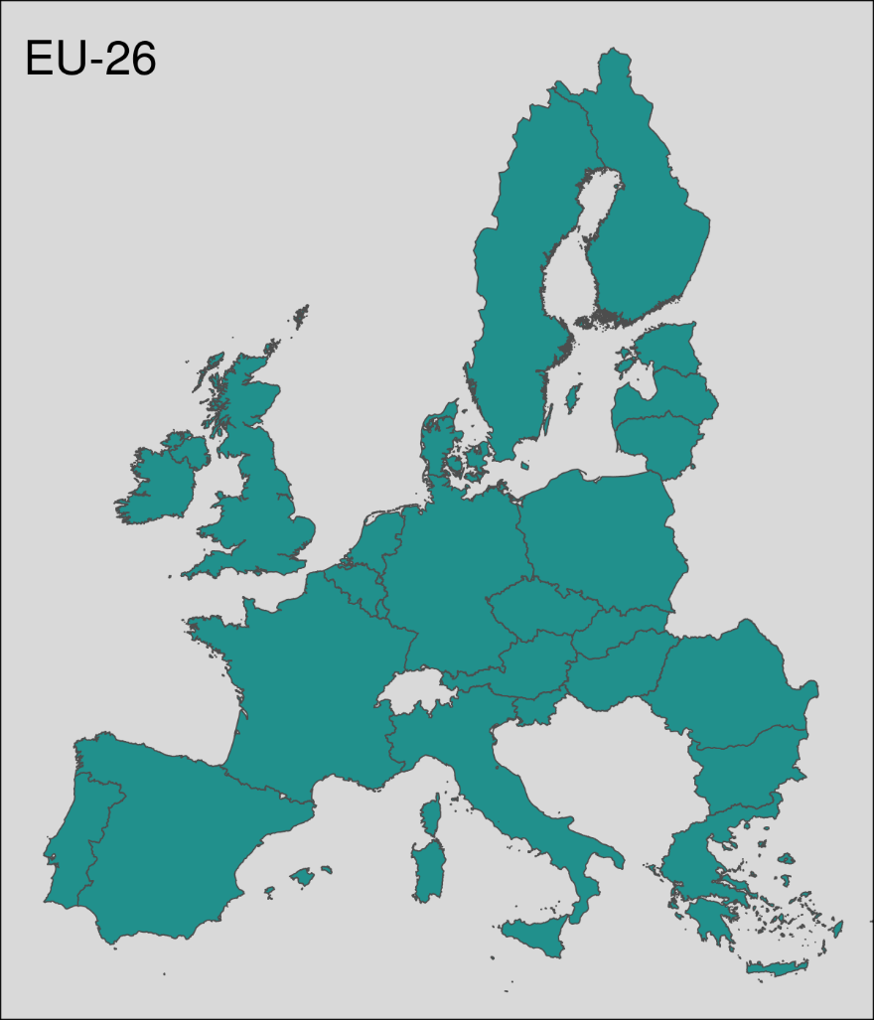

Figure 1. Area of interest spanning 26 EU Member States.

Table 1 Spatially explicit datasets used in the study

|  |  |  |  |  |
| --- | --- | --- | --- | --- |
| **Dataset** | **Description** | **Unit** | **Temporal coverage** | **Reference** |
| **Ecosystem services** | | | | |
| Megafauna habitat | Habitat suitability for European megafauna. | Index (the suitability of habitat for the natural recovery of European mammals in areas of agricultural abandonment) |  | Van der Zanden et al. (submitted) |
| Agricultural biodiversity | Species richness of farmland vertebrates and plants. | Predicted number of species / km2 |  | Overmars et al. (2014) |
| Climate  regulation | Response of terrestrial carbon balance to land use change scenarios. | Mg / C / ha | 2006 | Schulp et al.  (2008) |
| Erosion  prevention | Protection of land cover against erosion in erosion prone areas. | Tonnes / ha | 2000 - 2030 | Pérez-Soba et al. (2010) |
| Flood  regulation | Water retention capacity. | Index (relative flood regulation of land use and soil on river high flows) | 2007 - 2011 | Stürck et al.  (2014) |
| Heritage: agricultural landscapes | A cultural heritage index that is used to show the spatial distribution of the overall cultural heritage index scores in agricultural land. | Index | 2000 - 2015 | Tieskens et al.  (submitted) |
| Heritage: forest landscapes | A cultural heritage index that is used to show the spatial distribution of the overall cultural heritage index scores in forests. | Index | 2000 - 2015 | Tieskens et al.  (submitted) |
| Pollination flows | Unmanaged pollinators that live in suitable natural and semi-natural habitats provide pollination services especially to near croplands. | Index (the ratio between the proportion of benefiting areas located within the flow area and the total benefiting areas) | 2000 | Serna-Chavez et al. (2014) |
| Tourism | Supply of assets for tourism supported by ecosystems. | Index | 1999-2009 | Van Berkel et al. (2011) |
| Wild food provisioning | Species richness of wild edible plants, mushrooms and game (supply) and demand of wild food. | Species richness of vascular plants | 1999 - 2012 | Schulp et al.  (2014) |
| Wood  production | High-resolution wood production maps for European forests (average 2000-2010). | 1000m3 / pixel | Average of 2000-2010 | Verkerk et al.  (2015) |
| **Biodiversity features** | | | | |
| European vertebrate species | Species-specific expert-based distribution models for 164 mammal, 404 bird, 83 amphibian, and 112 reptile species. See Table S1 for a complete listing. | Percentage of habitat in the cell (primary + non-primary habitat) | 1997 - 2013 | Thuiller et al  (2015) |

## 2.2 Methods

* Data pre-processing
  + All data either originally in 1x1 km resolution, or rasterized into a common grid.
  + All data warped and/or projected into ETRS-LAEA (EPSG:3035) with matching extents.
  + We apply an occurrence level normalization on all datasets: each cell value is divided by the sum of all cell values. After the operation, the value in each cell will give the fraction of the overall occurrence level of that cell (i.e. values over all cells sum up to 1.0).
  + Data pre-processing implementation done with Python GDAL bindings (packages: NumPy, Scipy, rasterio).
* Prioritization methods
  + Three methods:
    1. Scoring (rarity-weighted richness, RWR)
       - Albuquerque and Beier (2015)
       - Note that this is slightly modified version of the original, which is based on presence/absence data, in which cells can only have a value of {0, 1}.
    2. Zonation (ZON)
       - Moilanen et al. (2014)
       - Cell-removal rule: additive benefit function.
    3. Exact optimization (ILP)
       - Beyer et al. (2016)
       - Using proprietary Gurobi solver
       - The hierarchical rank priority map is produced by solving maximum coverage problems with multiple area targets.
  + For implementation details, see **Figure S1**.
  + Weighting scheme used: the same aggregate weights assigned to all ES features and all BD features.
  + For each method, we created the following variants: All features (ALL, n=770), just ecosystem services (ES, n=11) and just biodiversity features (n=759).

## 2.3 Results comparison

* We aggregate all the prioritization results on NUTS2 regions.
* Quantitative comparisons between A) methods and B) datasets (ALL, ES, BD).
  + Jaccard’s index for the best 10% and worst 10% (**Table 2**)
  + Kendall’s Tau rank correlation (**Table 2**)
  + Map Comparison Statistic (MCS) (NUTS2 results) (**Table 2**)
  + Deviation from optimal solution (as given by the ILP) (**Figure 4**)
* Qualitative method comparison. Bagstad et al. (2013) provide a useful set of criteria against which methods and software tools can be assessed.
  + The fit of the underlying assumption/concepts with topic and research question
  + Quantification and uncertainty
  + Time requirements
  + Capacity for independent application
  + Level of development and documentation
  + Scalability
  + Generalizability
  + Nonmonetary and cultural perspectives
  + Affordability, insights, integration with existing environmental assessment

# 3. Results

## 3.1 Spatial patterns and similarity

* **Figure 2**: Prioritization rank maps for ALL variants (9 panels: 3 methods x 3 variants [ALL, ES, BD] by NUTS2 aggregations)
* **Figure 3**: Similarity dissimilarity between the complete set of analysis variants (ALL + ES + BD) as measured by A) Jaccard’s index, B) Kendall’s Tau rank correlation, and c) MCS.

## 3.2 Solution performance and optimality

* **Figure 4:** Solution performance comparison. Performance curves for ALL, ES and BD plotted based on the removal order given by ILP_ALL, ILP_ES and ILP_BD.

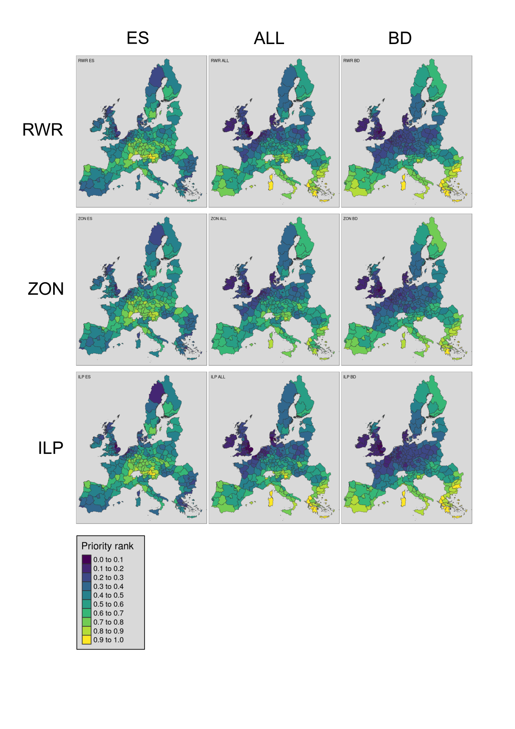

Figure 2. Rank priority maps for different methods (RWR, ZON and ILP) in columns, and for different datasets in rows (ALL, ES, BD).

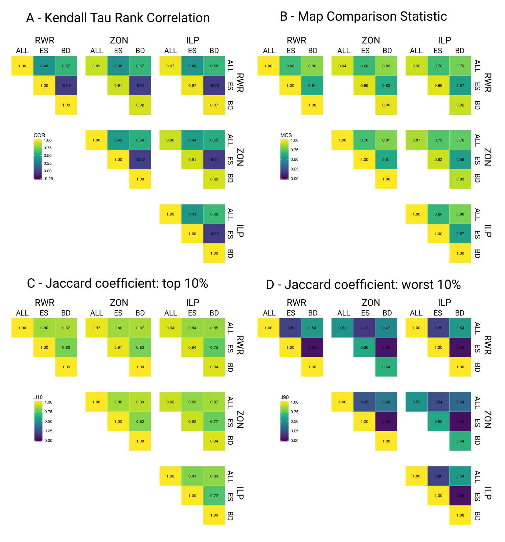

**Figure 3.** Similarity dissimilarity between the complete set of analysis variants (ALL + ES + BD) as measured by A) Kendall’s Tau rank correlation, B) MCS, and Jaccard’s coefficient between the best 10% (C) and the worst 10% (D) of the landscape.

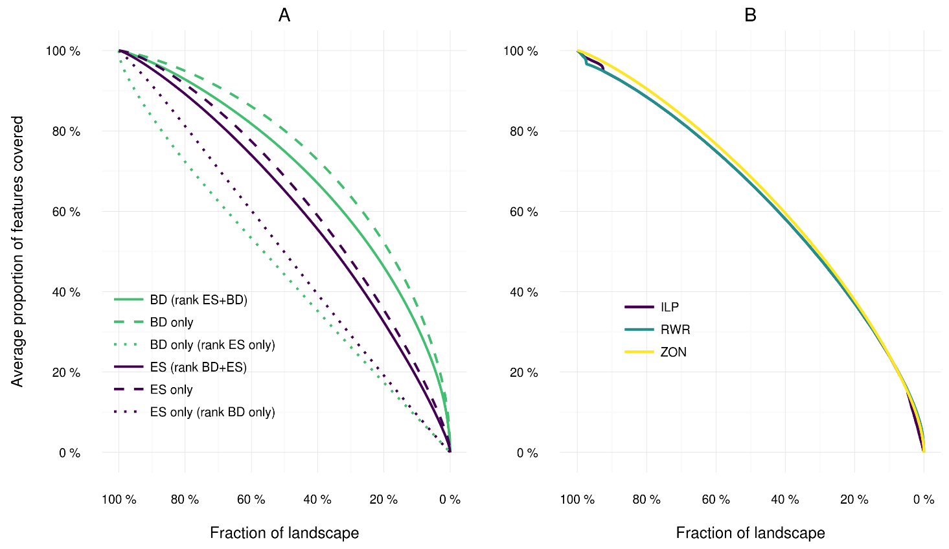

Figure 4. Performance curves for RWR_ALL (A), ZON_ALL (B) and ILP_ALL (C). XX curve is an average over all features, YY and ZZ are groups average for ES and BD respectively. Panel D show the average representation of features in RWR and ZON solutions when the rank order is taken from ILP (since it is guaranteed optimal).

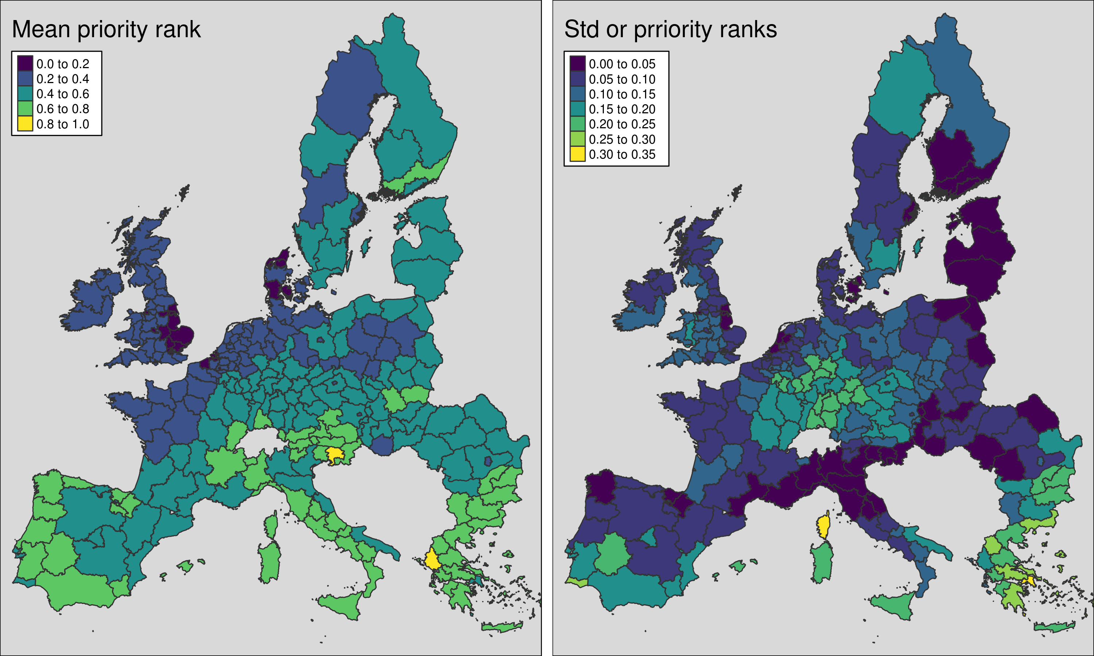

Figure 5. Mean priority rank and standard deviation of mean priority ranks between NUTS2-regions in the area of interest.

# 4. Discussion

## 4.1 Method performance

* Our results show that for a very simple type of prioritization problems, the more complex methods (ZON and ILP) do not produce significantly better results than the simpler scoring method (RWR). However, this is not very surprising given that all the algorithms are similar in their function.
* However, for more complex problems which most conservation prioritization problems typically are (Moilanen, 2008) , more complex methods are needed. This is particularly true if we aim at prioritizing actions instead of places as more complicated factors (costs, willingness to participate etc) must be accounted for.
  + RWR cannot be extended for example to account for connectivity and costs in a realistic manner
  + Zonation can do this
  + ILP could be implemented, particularly given the recent improvements both in software and hardware [(Beyer et al. 2016)](https://paperpile.com/c/Pgo1r9/2lNp).

## 4.2 Selecting the right tool

* Many prioritization methods designed with biodiversity features in mind give high emphasis on relative rarity of features. Furthermore, ways of accounting for spatial arrangement of features are predominantly done with the ecology of species mind (e.g. ecological connectivity).
* The extent to which spatial prioritization methods and tools are applicable also to the prioritization of areas important for the supply of ecosystem services depends on multiple factors. First, many spatial conservation prioritization methods have been developed primarily with biodiversity in mind (Wilson et al., 2009a). Some key features any many prioritization methods, such as placing higher value on rare features (Arponen et al., 2005) or ecological connectivity (Rudnick et al., 2012), do not necessarily make sense in context of ecosystem services.
* Ecosystem services require additional considerations (e.g. the availability of alternative meansof providing benefits supplied by services, human demand, and the scaleof, and site dependencyin, the delivery of services), which can be considerably different to those of species. In terms of selecting the suitable prioritization tool for the job, we recommend the following:
  1. Study the assumptions behind the tools you are about to use. Is it geared more towards species or ES?
  2. Embrace flexibility, but avoid complexity.

## 4.3 Integrated prioritization of biodiversity conservation and ecosystem services supply

* Trade-offs between ecosystem service provision and biodiversity conservation are most likely common. It does not necessarily follow that priority areas for the provision of ecosystem services are automatically priority areas also for biodiversity (Anderson et al., 2009; Thomas et al., 2012).
* In still remains unclear how exactly ecosystem services should best be incorporated into prioritization schemes that have been developed with biodiversity conservation in mind.
  + Complicating factors
    - Spatiotemporal scales
    - Supply/demand
    - Places/actions
* In addition to quantifying the differences between the different spatial prioritization methods, we also present the full implementation of the analysis that can be adjusted to other types of data.
* Operationalizing ecosystem services requires institutional adaptation, case-specific tailoring of methods, and deliberation among practitioners and stakeholders (Rinne and Primmer, 2015).

# 5. Conclusions

# 6. Acknowledgements

* OPERAs
* SURFsara
* Matt Strimas-Mackey for the prioritizr R package
* Beyer et al. (2016) for making the ILP implementation available.

# 7. References

Albuquerque, F.S., Beier, P., 2015. Rarity-Weighted Richness: A Simple and Reliable Alternative to Integer Programming and Heuristic Algorithms for Minimum Set and Maximum Coverage Problems in Conservation Planning. PLoS One 10, e0119905. doi:10.1371/journal.pone.0119905

Anderson, B.J., Armsworth, P.R., Eigenbrod, F., Thomas, C.D., Gillings, S., Heinemeyer, A., Roy, D.B., Gaston, K.J., 2009. Spatial covariance between biodiversity and other ecosystem service priorities. J. Appl. Ecol. 46, 888–896. doi:10.1111/j.1365-2664.2009.01666.x

Arponen, A., Heikkinen, R.K., Thomas, C.D., Moilanen, A., 2005. The Value of Biodiversity in Reserve Selection: Representation, Species Weighting, and Benefit Functions. Conserv. Biol. 19, 2009–2014. doi:10.1111/j.1523-1739.2005.00218.x

Bagstad, K.J., Semmens, D.J., Waage, S., Winthrop, R., 2013. A comparative assessment of decision-support tools for ecosystem services quantification and valuation. Ecosyst. Serv. 5, 27–39. doi:10.1016/j.ecoser.2013.07.004

Barbier, E.B., Koch, E.W., Silliman, B.R., Hacker, S.D., Wolanski, E., Primavera, J., Granek, E.F., Polasky, S., Aswani, S., Cramer, L. a, Stoms, D.M., Kennedy, C.J., Bael, D., Kappel, C. V, Perillo, G.M.E., Reed, D.J., 2008. Coastal Ecosystem – Based Ecological Functions and Values. Science (80-. ). 319, 321–323. doi:10.1126/science.1150349

Beyer, H.L., Dujardin, Y., Watts, M.E., Possingham, H.P., 2016. Solving conservation planning problems with integer linear programming. Ecol. Modell. 328, 14–22.

Casalegno, S., Bennie, J.J., Inger, R., Gaston, K.J., 2014. Regional scale prioritisation for key ecosystem services, renewable energy production and urban development. PLoS One 9. doi:10.1371/journal.pone.0107822

Chan, K.M.A., Shaw, M.R., Cameron, D.R., Underwood, E.C., Daily, G.C., 2006. Conservation Planning for Ecosystem Services. PLoS Biol. 4, e379. doi:10.1371/journal.pbio.0040379

Cordingley, J.E., Newton, A.C., Rose, R.J., Clarke, R.T., Bullock, J.M., 2016. Can landscape-scale approaches to conservation management resolve biodiversity-ecosystem service trade-offs? J. Appl. Ecol. 53, 96–105. doi:10.1111/1365-2664.12545

Dobrovolski, R., Loyola, R.D., Gustavo, A.B., Araújo, M.B., Da Fonseca, G.A.B., Diniz-Filho, J.A.F., Araújo, M.B., 2014. Globalizing Conservation Efforts to Save Species and Enhance Food Production. Bioscience XX, 1–7. doi:10.1093/biosci/biu064

Evans, M.C., Tulloch, A.I.T., Law, E.A., Raiter, K.G., Possingham, H.P., Wilson, K.A., 2015. Clear consideration of costs, condition and conservation benefits yields better planning outcomes. Biol. Conserv. 191, 716–727. doi:10.1016/j.biocon.2015.08.023

Ferrier, S., Wintle, B.A., 2009. Quantitative approaches to spatial conservation prioritization: matching the solution to the need, in: Moilanen, A., Wilson, K.A., Possingham, H.P. (Eds.), Spatial Conservation Prioritization: Quantitative Methods & Computational Tools. Oxford University Press, Oxford, p. 304.

Goldman, R.L., Tallis, H., 2009. A critical analysis of ecosystem services as a tool in conservation projects: The possible perils, the promises, and the partnerships. Ann. N. Y. Acad. Sci. 1162, 63–78. doi:10.1111/j.1749-6632.2009.04151.x

Kareksela, S., Moilanen, A., Tuominen, S., Kotiaho, J.S., 2013. Use of Inverse Spatial Conservation Prioritization to Avoid Biological Diversity Loss Outside Protected Areas. Conserv. Biol. 27, 1294–1303. doi:10.1111/cobi.12146

Knight, A.T., Cowling, R.M., Possingham, H.P., Wilson, K., 2009. From Theory to Practice: Designing and Situating Spatial Prioritization Approaches to Better Implement Conservation Action, in: Moilanen, A., Wilson, K., Possingham, H.P. (Eds.), Spatial Conservation Prioritization: Quantitative Methods & Computational Tools. Oxford University Press, Oxford, pp. 249–259.

Kukkala, A.S., Moilanen, A., 2012. Core concepts of spatial prioritisation in systematic conservation planning. Biol. Rev. 88, 443–464. doi:10.1111/brv.12008

Langemeyer, J., Haase, D., Elmqvist, T., Scheuer, S., Gómez-Baggethun, E., 2016. Bridging the gap between ecosystem service assessments and landuse planning through Multi-Criteria Decision Analysis (MCDA). Environ. Sci. Policy 62, 45–56. doi:10.1016/j.envsci.2016.02.013

Lehtomäki, J., Moilanen, A., 2013. Methods and workflow for spatial conservation prioritization using Zonation. Environ. Model. Softw. 47, 128–137. doi:10.1016/j.envsoft.2013.05.001

Luck, G.W., Chan, K.M., Klein, C.J., 2012. Identifying spatial priorities for protecting ecosystem services. F1000 Res. 1–16. doi:10.3410/f1000research.1-17.v1

Mace, G.M., Norris, K., Fitter, A.H., 2012. Biodiversity and ecosystem services: A multilayered relationship. Trends Ecol. Evol. 27, 19–25. doi:10.1016/j.tree.2011.08.006

Margules, C.R., Pressey, R.L., 2000. Systematic Conservation Planning. Nature 405, 243–253. doi:10.1038/35012251

Moilanen, A., 2008. Two paths to a suboptimal solution once more about optimality in reserve selection. Biol. Conserv. 141, 1919–1923. doi:10.1016/j.biocon.2008.04.018

Moilanen, A., Anderson, B.J., Eigenbrod, F., Heinemeyer, A., Roy, D.B., Gillings, S., Armsworth, P.R., Gaston, K.J., Thomas, C.D., 2011. Balancing alternative land uses in conservation prioritization. Ecol. Appl. 21, 1419–1426. doi:10.1890/10-1865.1

Moilanen, A., Ball, I.R., 2009. Heuristic and Approximate Optimization Methods for Spatial Conservation Prioritization, in: Moilanen, A., Wilson, K.A., Possingham, H.P. (Eds.), Spatial Conservation Prioritization: Quantitative Methods & Computational Tools. Oxford University Press, Oxford, pp. 58–69.

Moilanen, A., Franco, A.M.A., Early, R.I., Fox, R., Wintle, B.A., Thomas, C.D., 2005. Prioritizing multiple-use landscapes for conservation: methods for large multi-species planning problems. Proc. R. Soc. B Biol. Sci. 272, 1885–1891. doi:10.1098/rspb.2005.3164

Moilanen, A., Pouzols, F.M., Meller, L., Veach, V., Arponen, A., Leppänen, J., Kujala, H., 2014. Zonation spatial conservation planning methods and software v. 4, user manual. Helsinki.

Nin, M., Soutullo, A., Rodríguez-Gallego, L., Di Minin, E., 2016. Ecosystem services-based land planning for environmental impact avoidance. Ecosyst. Serv. 17, 172–184. doi:doi:10.1016/j.ecoser.2015.12.009

Reyers, B., O’Farrell, P.J., Nel, J.L., Wilson, K.A., O’Farrell, P.J., Nel, J.L., Wilson, K.A., 2012. Expanding the conservation toolbox: conservation planning of multifunctional landscapes. Landsc. Ecol. 27, 1121–1134. doi:10.1007/s10980-012-9761-0

Rinne, J., Primmer, E., 2015. A Case Study of Ecosystem Services in Urban Planning in Finland: Benefits, Rights and Responsibilities. J. Environ. Policy Plan. 7200, 1–20. doi:10.1080/1523908X.2015.1076721

Rudnick, D.A., Ryan, S.J., Beier, P., Cushman, S.A., Dieffenbach, F., Epps, C.W., Gerber, L.R., Hartter, J., Jenness, J.S., Kintsch, J., Merenlender, A.M., Perkl, R.M., Preziosi, D. V, Trombulak, S.C., 2012. The Role of Landscape Connectivity in Planning and Implementing Conservation and Restoration Priorities. Issues Ecol.

Schröter, M., Remme, R.P., Sumarga, E., Barton, D.N., Hein, L., 2014. Lessons learned for spatial modelling of ecosystem services in support of ecosystem accounting. Ecosyst. Serv. 13, 64–69. doi:10.1016/j.ecoser.2014.07.003

Thomas, C.D., Anderson, B.J., Moilanen, A., Eigenbrod, F., Heinemeyer, A., Quaife, T., Roy, D.B., Gillings, S., Armsworth, P.R., Gaston, K.J., 2012. Reconciling biodiversity and carbon conservation. Ecol. Lett. 16, 39–47. doi:10.1111/ele.12054

Thomson, J., Moilanen, A., Vesk, P.A., Bennett, A., Nally, R. Mac, MacNally, R.M., 2009. Where and when to revegetate: a quantitative method for scheduling landscape reconstruction. Ecol. Appl. 19, 817–828. doi:10.1890/08-0915.1

Williams, P., Gibbons, D., Margules, C., Rebelo, A., Humphries, C., Pressey, R., 1996. A Comparison of Richness Hotspots , Rarity Hotspots , and Complementary Areas for Conserving Diversity of British Birds. Conserv. Biol. 10, 155–174.

Wilson, K.A., Cabeza, M., Klein, C.J., 2009a. Fundamental concepts of spatial conservation prioritization, in: Moilanen, A.J., Wilson, K.A., Possingham, H.P. (Eds.), Spatial Conservation Prioritization: Quantitative Methods & Computational Tools. Oxford University Press, Oxford, pp. 16–27.

Wilson, K.A., Carwardine, J., Possingham, H.P., 2009b. Setting conservation priorities. Ann. N. Y. Acad. Sci. 1162, 237–264. doi:10.1111/j.1749-6632.2009.04149.x

Wilson, K.A., Underwood, E.C., Morrison, S.A., Klausmeyer, K.R., Murdoch, W.W., Reyers, B., Wardell-Johnson, G., Marquet, P.A., Rundel, P.W., McBride, M.F., Pressey, R.L., Bode, M., Hoekstra, J.M., Andelman, S.J., Looker, M., Rondinini, C., Kareiva, P.M., Shaw, M.R., Possingham, H.P., 2007. Conserving biodiversity efficiently: what to do, where, and when. PLoS Biol. 5, 12. doi:10.1371/journal.pbio.0050223

# 8. Supplementary information

**Figure S1:** Schematics of the processing steps for each method.

Table S1 Biodiversity features (n=759) used in the analyses.

|  |
| --- |
| **Amphibians** |
| Alytes cisternasii |
| Alytes dickhilleni |
| Alytes muletensis |
| Alytes obstetricans |
| Atylodes genei |
| Bombina bombina |
| Bombina pachypus |
| Bombina variegata |
| Bufo bufo |
| Calotriton arnoldi |
| Calotriton asper |
| Chioglossa lusitanica |
| Discoglossus galganoi |
| Discoglossus jeanneae |
| Discoglossus montalentii |
| Discoglossus pictus |
| Discoglossus sardus |
| Epidalea calamita |
| Euproctus montanus |
| Euproctus platycephalus |
| Hyla arborea |
| Hyla intermedia |
| Hyla meridionalis |
| Hyla sarda |
| Lissotriton boscai |
| Lissotriton helveticus |
| Lissotriton italicus |
| Lissotriton montandoni |
| Lissotriton vulgaris |
| Lyciasalamandra helverseni |
| Lyciasalamandra luschani |
| Mesotriton alpestris |
| Pelobates cultripes |
| Pelobates fuscus |
| Pelobates syriacus |
| Pelodytes ibericus |
| Pelodytes punctatus |
| Pelophylax bedriagae |
| Pelophylax bergeri |
| Pelophylax cerigensis |
| Pelophylax cretensis |
| Pelophylax epeiroticus |
| Pelophylax esculentus |
| Pelophylax grafi |
| Pelophylax hispanicus |
| Pelophylax kurtmuelleri |
| Pelophylax lessonae |
| Pelophylax perezi |
| Pelophylax ridibundus |
| Pleurodeles waltl |
| Proteus anguinus |
| Pseudepidalea balearica |
| Pseudepidalea sicula |
| Pseudepidalea variabilis |
| Pseudepidalea viridis |
| Rana arvalis |
| Rana dalmatina |
| Rana graeca |
| Rana iberica |
| Rana italica |
| Rana latastei |
| Rana pyrenaica |
| Rana temporaria |
| Salamandra atra |
| Salamandra corsica |
| Salamandra lanzai |
| Salamandra salamandra |
| Salamandrina perspicillata |
| Salamandrina terdigitata |
| Speleomantes ambrosii |
| Speleomantes flavus |
| Speleomantes imperialis |
| Speleomantes italicus |
| Speleomantes sarrabusensis |
| Speleomantes strinatii |
| Speleomantes supramontis |
| Triturus carnifex |
| Triturus cristatus |
| Triturus dobrogicus |
| Triturus karelinii |
| Triturus macedonicus |
| Triturus marmoratus |
| Triturus pygmaeus  **Birds** |
| Accipiter brevipes |
| Acrocephalus agricola |
| Acrocephalus arundinaceus |
| Acrocephalus dumetorum |
| Acrocephalus melanopogon |
| Acrocephalus paludicola |
| Acrocephalus palustris |
| Acrocephalus schoenobaenus |
| Acrocephalus scirpaceus |
| Actitis hypoleucos |
| Aegithalos caudatus |
| Aegolius funereus |
| Aegypius monachus |
| Alauda arvensis |
| Alca torda |
| Alcedo atthis |
| Alectoris barbara |
| Alectoris chukar |
| Alectoris graeca |
| Alectoris rufa |
| Anas acuta |
| Anas clypeata |
| Anas crecca |
| Anas penelope |
| Anas platyrhynchos |
| Anas querquedula |
| Anas strepera |
| Anser anser |
| Anser brachyrhynchus |
| Anser erythropus |
| Anser fabalis |
| Anthus campestris |
| Anthus cervinus |
| Anthus petrosus |
| Anthus pratensis |
| Anthus spinoletta |
| Anthus trivialis |
| Apus apus |
| Apus caffer |
| Apus melba |
| Apus pallidus |
| Aquila adalberti |
| Aquila chrysaetos |
| Aquila clanga |
| Aquila heliaca |
| Aquila pomarina |
| Ardea cinerea |
| Ardea purpurea |
| Ardeola ralloides |
| Arenaria interpres |
| Asio flammeus |
| Asio otus |
| Athene noctua |
| Aythya ferina |
| Aythya fuligula |
| Aythya marila |
| Aythya nyroca |
| Bombycilla garrulus |
| Bonasa bonasia |
| Botaurus stellaris |
| Branta bernicla |
| Branta leucopsis |
| Bubo bubo |
| Bubulcus ibis |
| Bucanetes githagineus |
| Bucephala clangula |
| Burhinus oedicnemus |
| Buteo buteo |
| Buteo lagopus |
| Buteo rufinus |
| Calandrella brachydactyla |
| Calandrella rufescens |
| Calcarius lapponicus |
| Calidris canutus |
| Calidris maritima |
| Calidris minuta |
| Calidris temminckii |
| Calonectris diomedea |
| Caprimulgus europaeus |
| Caprimulgus ruficollis |
| Carduelis cannabina |
| Carduelis carduelis |
| Carduelis chloris |
| Carduelis flammea |
| Carduelis flavirostris |
| Carduelis hornemanni |
| Carduelis spinus |
| Carpodacus erythrinus |
| Cepphus grylle |
| Cercotrichas galactote |
| Certhia familiaris |
| Cettia cetti |
| Charadrius alexandrinus |
| Charadrius dubius |
| Charadrius hiaticula |
| Charadrius morinellus |
| Chersophilus duponti |
| Chlidonias hybridus |
| Chlidonias leucopterus |
| Chlidonias niger |
| Ciconia ciconia |
| Ciconia nigra |
| Cinclus cinclus |
| Circaetus gallicus |
| Circus aeruginosus |
| Circus cyaneus |
| Circus macrourus |
| Circus pygargus |
| Cisticola juncidis |
| Clamator glandarius |
| Clangula hyemalis |
| Coccothraustes coccothraustes |
| Columba livia |
| Columba oenas |
| Coracias garrulus |
| Corvus corax |
| Corvus corone |
| Corvus frugilegus |
| Corvus monedula |
| Coturnix coturnix |
| Crex crex |
| Cuculus canorus |
| Cuculus saturatus |
| Cyanopica cyana cyanus |
| Cygnus cygnus |
| Cygnus olor |
| Delichon urbica |
| Dendrocopos leucotos |
| Dendrocopos major |
| Dendrocopos medius |
| Dendrocopos minor |
| Dendrocopos syriacus |
| Dryocopus martius |
| Egretta alba |
| Egretta garzetta |
| Elanus caeruleus |
| Emberiza aureola |
| Emberiza caesia |
| Emberiza cia |
| Emberiza cineracea |
| Emberiza cirlus |
| Emberiza citrinella |
| Emberiza hortulana |
| Emberiza melanocephala |
| Emberiza pusilla |
| Emberiza rustica |
| Emberiza schoeniclus |
| Eremophila alpestris |
| Erithacus rubecula |
| Falco biarmicus |
| Falco cherrug |
| Falco columbarius |
| Falco eleonorae |
| Falco naumanni |
| Falco peregrinus |
| Falco rusticolus |
| Falco subbuteo |
| Falco tinnunculus |
| Falco vespertinus |
| Ficedula albicollis |
| Ficedula hypoleuca |
| Ficedula parva |
| Ficedula semitorquata |
| Fratercula arctica |
| Fringilla montifringilla |
| Fulica atra |
| Fulica cristata |
| Fulmarus glacialis |
| Galerida cristata |
| Galerida theklae |
| Gallinago gallinago |
| Gallinago media |
| Gallinula chloropus |
| Garrulus glandarius |
| Gavia arctica |
| Gavia immer |
| Gavia stellata |
| Gelochelidon nilotica |
| Glareola nordmanni |
| Glareola pratincola |
| Glaucidium passerinum |
| Grus grus |
| Gypaetus barbatus |
| Gyps fulvus |
| Haematopus ostralegus |
| Halcyon smyrnensis |
| Haliaeetus albicilla |
| Hieraaetus fasciatus |
| Hieraaetus pennatus |
| Himantopus himantopus |
| Hippolais icterina |
| Hippolais olivetorum |
| Hippolais pallida |
| Hippolais polyglotta |
| Hirundo daurica |
| Hirundo rustica |
| Hoplopterus spinosus |
| Hydrobates pelagicus |
| Ixobrychus minutus |
| Jynx torquilla |
| Lagopus lagopus |
| Lagopus mutus |
| Lanius collurio |
| Lanius excubitor |
| Lanius meridionalis |
| Lanius minor |
| Lanius nubicus |
| Lanius senator |
| Larus argentatus |
| Larus audouinii |
| Larus cachinnans |
| Larus canus |
| Larus fuscus |
| Larus genei |
| Larus marinus |
| Larus melanocephalus |
| Larus minutus |
| Larus ridibundus |
| Limicola falcinellus |
| Limosa lapponica |
| Limosa limosa |
| Locustella fluviatilis |
| Locustella luscinioides |
| Locustella naevia |
| Loxia curvirostra |
| Loxia leucoptera |
| Loxia pytyopsittacus |
| Loxia scotica |
| Lullula arborea |
| Luscinia luscinia |
| Luscinia megarhynchos |
| Luscinia svecica |
| Lymnocryptes minimus |
| Marmaronetta angustirostris |
| Melanitta fusca |
| Melanitta nigra |
| Melanocorypha calandra |
| Mergus albellus |
| Mergus merganser |
| Mergus serrator |
| Merops apiaster |
| Miliaria calandra |
| Milvus migrans |
| Milvus milvus |
| Monticola saxatilis |
| Monticola solitarius |
| Montifringilla nivalis |
| Morus bassanus |
| Motacilla alba |
| Motacilla cinerea |
| Motacilla citreola |
| Motacilla flava |
| Muscicapa striata |
| Neophron percnopterus |
| Netta rufina |
| Nucifraga caryocatactes |
| Numenius arquata |
| Numenius phaeopus |
| Nyctea scandiaca |
| Nycticorax nycticorax |
| Oceanodroma castro |
| Oceanodroma leucorhoa |
| Oenanthe hispanica |
| Oenanthe isabellina |
| Oenanthe leucura |
| Oenanthe oenanthe |
| Oenanthe pleschanka |
| Oriolus oriolus |
| Otis tarda |
| Otus scops |
| Oxyura leucocephala |
| Pandion haliaetus |
| Panurus biarmicus |
| Parus caeruleus |
| Parus cinctus |
| Parus cristatus |
| Parus lugubris |
| Parus major |
| Parus montanus |
| Parus palustris |
| Passer domesticus |
| Passer hispaniolensis |
| Passer italiae |
| Passer montanus |
| Pelecanus crispus |
| Pelecanus onocrotalus |
| Perisoreus infaustus |
| Pernis apivorus |
| Petronia petronia |
| Phalaropus lobatus |
| Phalocrocorax carbo |
| Phalocrocorax pygmaeus |
| Phasianus colchicus |
| Philomachus pugnax |
| Phoenicopterus roseus |
| Phoenicurus ochruros |
| Phoenicurus phoenicurus |
| Phylloscopus bonelli |
| Phylloscopus borealis |
| Phylloscopus collybita |
| Phylloscopus sibilatrix |
| Phylloscopus trochiloides |
| Phylloscopus trochilus |
| Pica pica |
| Picoides tridactylus |
| Picus canus |
| Picus viridis |
| Pinicola enucleator |
| Platalea leucorodia |
| Plectrophenax nivalis |
| Plegadis falcinellus |
| Pluvialis apricaria |
| Podiceps auritus |
| Podiceps cristatus |
| Podiceps grisegena |
| Podiceps nigricollis |
| Porphyrio porphyrio |
| Porzana parva |
| Porzana porzana |
| Porzana pusilla |
| Prunella collaris |
| Prunella modularis |
| Pterocles alchata |
| Pterocles orientalis |
| Ptyonoprogne rupestris |
| Puffinus mauretanicus |
| Puffinus puffinus |
| Puffinus yelkouan |
| Pyrrhocorax graculus |
| Pyrrhocorax pyrrhocorax |
| Pyrrhula pyrrhula |
| Rallus aquaticus |
| Recurvirostra avosetta |
| Regulus ignicapillus |
| Regulus regulus |
| Remiz pendulinus |
| Riparia riparia |
| Rissa tridactyla |
| Saxicola rubetra |
| Saxicola torquata |
| Scolopax rusticola |
| Serinus citrinella |
| Serinus serinus |
| Sitta europaea |
| Sitta krueperi |
| Sitta neumayer |
| Sitta whiteheadi |
| Somateria mollissima |
| Stercorarius longicaudus |
| Stercorarius parasiticus |
| Stercorarius skua |
| Sterna albifrons |
| Sterna bengalensis |
| Sterna caspia |
| Sterna dougallii |
| Sterna hirundo |
| Sterna paradisaea |
| Sterna sandvicensis |
| Streptopelia decaocto |
| Streptopelia turtur |
| Strix aluco |
| Strix nebulosa |
| Strix uralensis |
| Sturnus roseus |
| Sturnus unicolor |
| Sturnus vulgaris |
| Surnia ulula |
| Sylvia atricapilla |
| Sylvia borin |
| Sylvia cantillans |
| Sylvia communis |
| Sylvia conspicillata |
| Sylvia curruca |
| Sylvia hortensis |
| Sylvia melanocephala |
| Sylvia nisoria |
| Sylvia rueppelli |
| Sylvia sarda |
| Sylvia undata |
| Tachybaptus ruficollis |
| Tadorna ferruginea |
| Tadorna tadorna |
| Tarsiger cyanurus |
| Tetrao urogallus |
| Tetrax tetrax |
| Tichodroma muraria |
| Tringa erythropus |
| Tringa glareola |
| Tringa nebularia |
| Tringa ochropus |
| Tringa stagnatilis |
| Tringa totanus |
| Turdus iliacus |
| Turdus merula |
| Turdus philomelos |
| Turdus pilaris |
| Turdus torquatus |
| Turdus viscivorus |
| Turnix sylvatica |
| Tyto alba |
| Upupa epops |
| Uria lomvia |
| Vanellus vanellus |
| Xenus cinereus |
| **Mammals** |
| Acomys minous |
| Alces alces |
| Alopex lagopus |
| Apodemus agrarius |
| Apodemus alpicola |
| Apodemus epimelas |
| Apodemus flavicollis |
| Apodemus mystacinus |
| Apodemus sylvaticus |
| Apodemus uralensis |
| Apodemus witherbyi |
| Arvicola amphibius |
| Arvicola sapidus |
| Arvicola scherman |
| Atelerix algirus |
| Barbastella barbastellus |
| Bison bonasus |
| Canis aureus |
| Capra ibex |
| Capra pyrenaica |
| Capreolus capreolus |
| Chionomys nivalis |
| Cricetulus migratorius |
| Cricetus cricetus |
| Crocidura leucodon |
| Crocidura pachyura |
| Crocidura russula |
| Crocidura sicula |
| Crocidura suaveolens |
| Crocidura zimmermanni |
| Dama dama |
| Dinaromys bogdanovi |
| Dryomys nitedula |
| Eliomys quercinus |
| Eptesicus bottae |
| Eptesicus nilsonii |
| Eptesicus serotinus |
| Erinaceus europaeus |
| Erinaceus roumanicus |
| Felis silvestris |
| Galemys pyrenaicus |
| Genetta genetta |
| Glis glis |
| Gulo gulo |
| Hystrix cristata |
| Lemmus lemmus |
| Lepus capensis |
| Lepus castroviejoi |
| Lepus corsicanus |
| Lepus europaeus |
| Lepus granatensis |
| Lepus timidus |
| Lutra lutra |
| Lynx pardinus |
| Martes foina |
| Martes martes |
| Meles meles |
| Meriones tristami |
| Mesocricetus newtoni |
| Micromys minutus |
| Microtus agrestis |
| Microtus arvalis |
| Microtus bavaricus |
| Microtus brachycercus |
| Microtus cabrerae |
| Microtus duodecimcostatus |
| Microtus felteni |
| Microtus gerbei |
| Microtus guentheri |
| Microtus levis |
| Microtus liechtesteini |
| Microtus lusitanicus |
| Microtus multiplex |
| Microtus oeconomus |
| Microtus savii |
| Microtus subterraneus |
| Microtus tatricus |
| Microtus thomasi |
| Miniopterus schreibersi |
| Mus macedonicus |
| Mus musculus |
| Mus spicilegus |
| Mus spretus |
| Muscardinus avellanarius |
| Mustela erminea |
| Mustela eversmanii |
| Mustela lutreola |
| Mustela nivalis |
| Mustela putorius |
| Myodes glareolus |
| Myodes rufocanus |
| Myodes rutilus |
| Myomimus roachi |
| Myopus schisticolor |
| Myotis alcathoe |
| Myotis aurascens |
| Myotis bechsteinii |
| Myotis blythii |
| Myotis brandtii |
| Myotis capaccinii |
| Myotis dasycneme |
| Myotis daubentonii |
| Myotis emarginatus |
| Myotis myotis |
| Myotis mystacinus |
| Myotis nattereri |
| Myotis punicus |
| Neomys anomalus |
| Neomys fodiens |
| Nyctalus lasiopterus |
| Nyctalus leisleri |
| Nyctalus noctula |
| Oryctolagus cuniculus |
| Ovis aries |
| Pipistrellus kuhlii |
| Pipistrellus nathusii |
| Pipistrellus pipistrellus |
| Pipistrellus pygmaeus |
| Pipistrellus savii |
| Plecotus auritus |
| Plecotus austriacus |
| Plecotus kolombatovici |
| Plecotus macrobullaris |
| Plecotus sardus |
| Pteromys volans |
| Rhinolophus blasii |
| Rhinolophus euryale |
| Rhinolophus ferrumequinum |
| Rhinolophus hipposideros |
| Rhinolophus mehelyi |
| Rupicapra rupicapra |
| Sciurus anomalus |
| Sciurus vulgaris |
| Sicista betulina |
| Sicista severtzovi |
| Sicista subtilis |
| Sorex alpinus |
| Sorex antinorii |
| Sorex araneus |
| Sorex caecutiens |
| Sorex coronatus |
| Sorex granarius |
| Sorex isodon |
| Sorex minutissimus |
| Sorex minutus |
| Sorex samniticus |
| Spalax graecus |
| Spalax leucodon |
| Spalax nehringi |
| Spermophilus citellus |
| Spermophilus suslicus |
| Suncus etruscus |
| Sus scrofa |
| Tadarida teniotis |
| Talpa caeca |
| Talpa europaea |
| Talpa levantis |
| Talpa occidentalis |
| Talpa romana |
| Talpa stankovici |
| Ursus arctos |
| Vespertilio murinus |
| Vormela peregusna |
| Vulpes vulpes |
| Ablepharus kitaibelii |
| Acanthodactylus erythrurus |
| **Reptiles** |
| Algyroides fitzingeri |
| Algyroides marchi |
| Algyroides moreoticus |
| Algyroides nigropunctatus |
| Anatolacerta anatolica |
| Anatolacerta oertzeni |
| Anguis cephallonica |
| Anguis fragilis |
| Archaeolacerta bedriagae |
| Blanus cinereus |
| Blanus strauchi |
| Chalcides bedriagai |
| Chalcides chalcides |
| Chalcides ocellatus |
| Chalcides striatus |
| Chamaeleo africanus |
| Chamaeleo chamaeleon |
| Coronella austriaca |
| Coronella girondica |
| Cyrtopodion kotschyi |
| Darevskia praticola |
| Dolichophis caspius |
| Dolichophis jugularis |
| Eirenis modestus |
| Elaphe quatuorlineata |
| Elaphe sauromates |
| Emys orbicularis |
| Emys trinacris |
| Eremias arguta |
| Eryx jaculus |
| Euleptes europaea |
| Eumeces schneideri |
| Hellenolacerta graeca |
| Hemidactylus turcicus |
| Hemorrhois hippocrepis |
| Hemorrhois nummifer |
| Hierophis gemonensis |
| Hierophis gyarosensis |
| Hierophis viridiflavus |
| Iberolacerta aranica |
| Iberolacerta aurelioi |
| Iberolacerta bonnali |
| Iberolacerta cyreni |
| Iberolacerta galani |
| Iberolacerta horvathi |
| Iberolacerta martinezricai |
| Iberolacerta monticola |
| Lacerta agilis |
| Lacerta bilineata |
| Lacerta schreiberi |
| Lacerta trilineata |
| Lacerta viridis |
| Laudakia stellio |
| Macroprotodon brevis |
| Macroprotodon cucullatus |
| Macroprotodon mauritanicus |
| Macrovipera schweizeri |
| Malpolon monspessulanus |
| Mauremys leprosa |
| Mauremys rivulata |
| Montivipera xanthina |
| Natrix maura |
| Natrix tesselleta |
| Ophiomorus punctatissimus |
| Ophisops elegans |
| Parvilacerta parva |
| Platyceps collaris |
| Platyceps najadum |
| Podarcis bocagei |
| Podarcis carbonelli |
| Podarcis erhardii |
| Podarcis filfolensis |
| Podarcis gaigeae |
| Podarcis hispanica |
| Podarcis lilfordi |
| Podarcis melisellensis |
| Podarcis milensis |
| Podarcis muralis |
| Podarcis peloponnesiaca |
| Podarcis pityusensis |
| Podarcis raffonei |
| Podarcis sicula |
| Podarcis taurica |
| Podarcis tiliguerta |
| Podarcis vaucheri |
| Podarcis wagleriana |
| Psammodromus hispanicus |
| Psammodromus jeanneae |
| Psammodromus manuelae |
| Pseudopus apodus |
| Rhinechis scalaris |
| Tarentola mauritanica |
| Telescopus fallax |
| Testudo graeca |
| Testudo hermanni |
| Testudo marginata |
| Timon lepidus |
| Trachylepis aurata |
| Trionyx triunguis |
| Typhlops vermicularis |
| Vipera ammodytes |
| Vipera aspis |
| Vipera berus |
| Vipera latastei |
| Vipera renardi |
| Vipera seoanei |
| Vipera ursinii |
| Zamenis lineatus |
| Zamenis longissimus |
| Zamenis situla |
|  |
|  |