**Comparing spatial prioritization methods for biodiversity conservation and ecosystem service supply in Europe – Electronic Supplementary Material**

**Joona Lehtomäki1\***, **Luigi Maiorano2** and **Peter verburg1**

# Including a proxy of costs into the prioritization

## Cost data

To approximate the cost of the prioritization, we created an index based on spatially explicit population density data acquired from the European Environment Agency (**REF**). We first translated the population density data to the same geospatial extent and CRS as the BD and ES features, log-transformed the data, and finally smoothed the resulting raster using a single-pass median filter as implemented in SciPy (version 0.18.1, Jones et al. 2001) (**Fig. S2**).

## Implementing costs in the different prioritization methods

In the following sections, we describe how costs were technically included in each of the three prioritization methods.

### RWR

To our knowledge, there is no published conceptualization and/or implementation of RWR which would also account for costs as part of prioritization. Here, we use a simple cost-derived penalty to adjust RWR score. We processed all the prioritization features as in the non-cost version of our RWR implementation up until the ranking and normalization phase. Before this phase, we performed occurrence level normalization (see equation 3 in the main text) also on the cost index feature, after which we subtracted it from the RWR score feature. After penalizing the RWR score feature with the cost index, the resulting score is ranked and rescaled into range [0, 1] to produce the final priority rank map.

[ADD MATHEMATICAL NOTATION?]

### ZON

Zonation is capable of accounting for costs in two ways: as an actual cost layer and as a negatively weighted prioritization features. Former has more drastic effect on the prioritization outcome (Moilanen et al. 2014), and to retain as much similarity to RWR and ILP, we chose to use the latter option to represent costs in Zonation. Thus, the cost index feature was entered into the prioritization with negative weight equal to the aggregate weight of each of the feature groups (i.e. -1).

### ILP

We extended the non-costs formulated of the optimization problem as a multi-objective problem in which we set two objectives: maximize the representation levels of all (occurrence normalized features) while minimizing the cost with the constraint of keeping the number of selected cells below a given (area target) threshold.

[ADD MATHEMATICAL NOTATION]

## Results

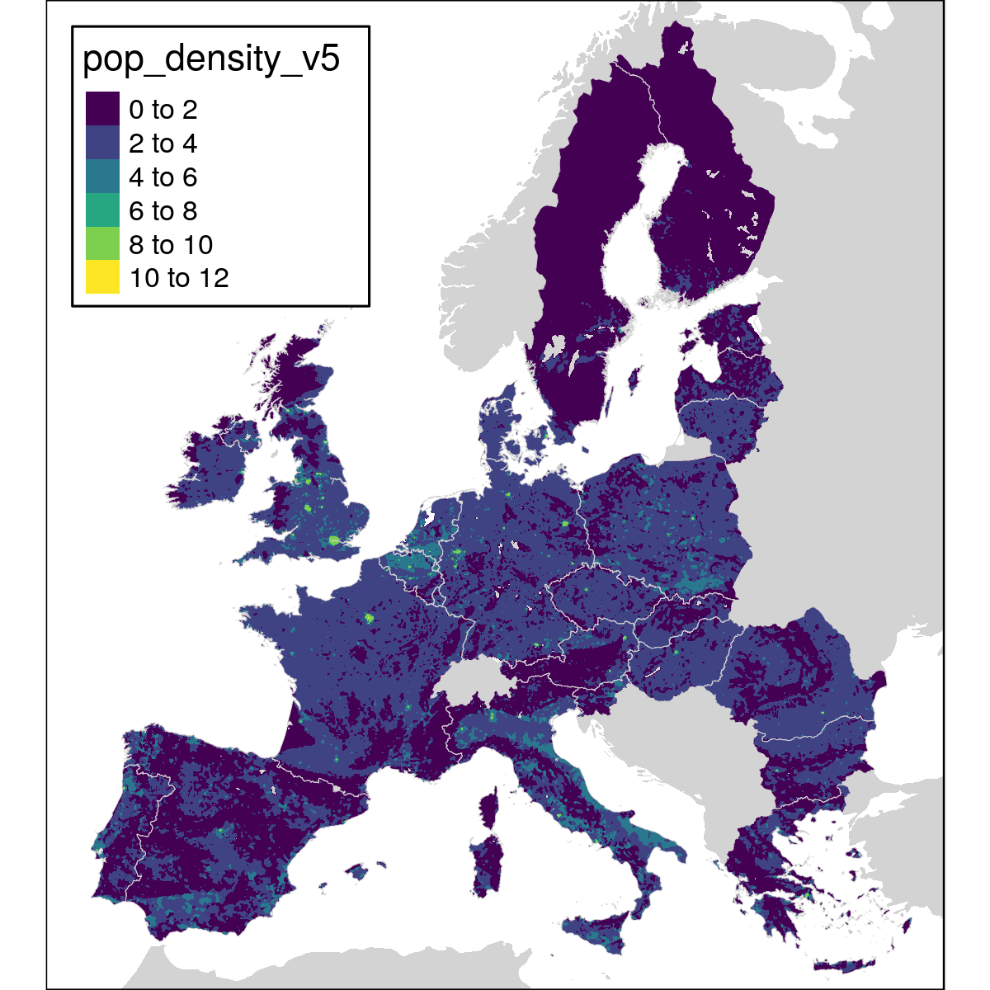

Cost index

**Figure S1.** The cost index feature used in the prioritization. Index is a smoothed and log-transformed version of the population density estimate for Europe.

Figure S3.

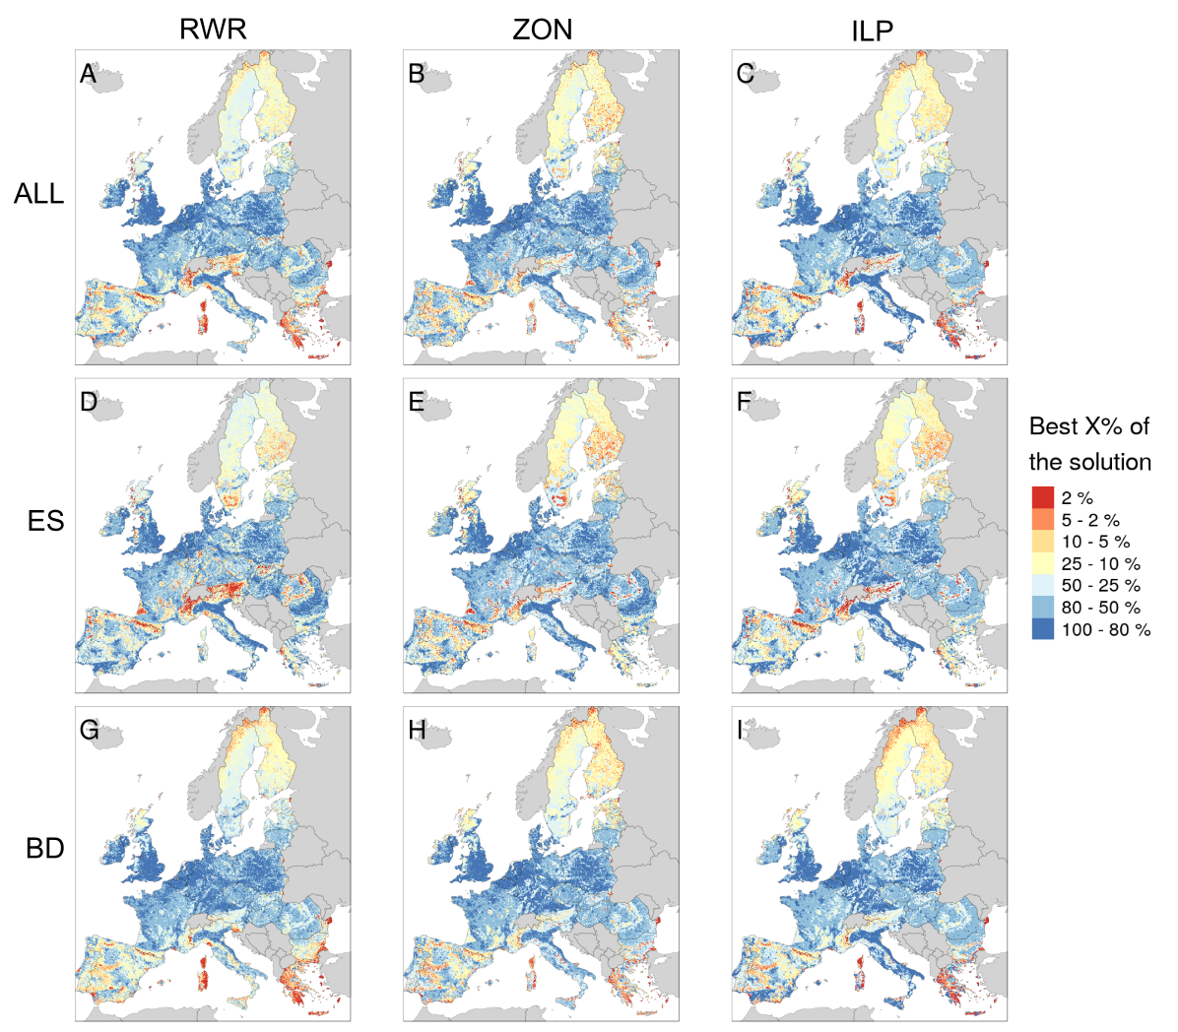

**Figure S2.** Priority rank maps (spatial solutions) for the nine analysis variants in the study including the effects of cost. The maps are grouped by method used (RWR, ZON and ILP) in columns, and by data groups (ALL, ES, BD) in rows. The color scale indicates rank priorities from the lowest 20% (in blue) to the highest 2% (in red).

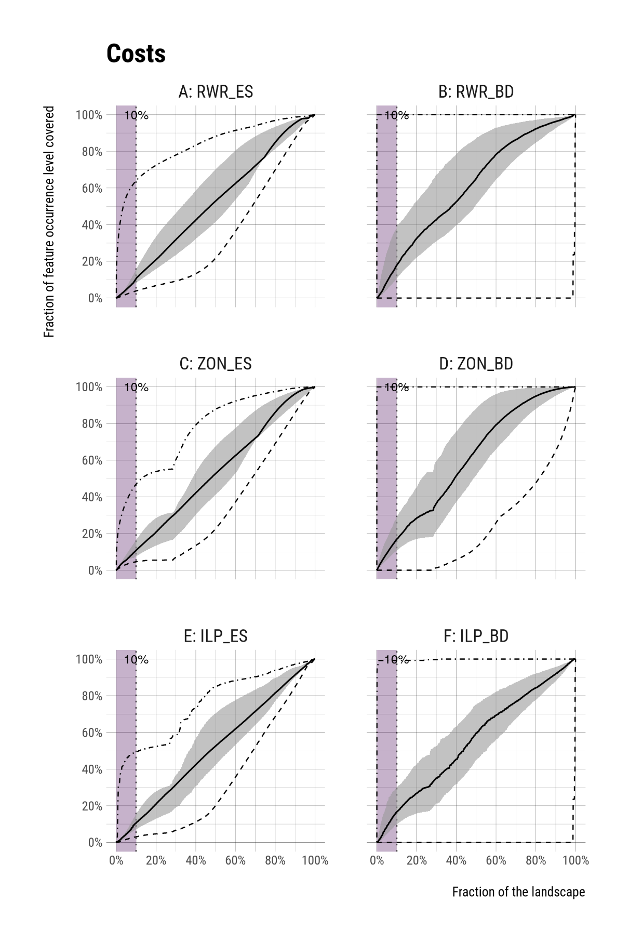

**Figure S3.** The performance of different spatial prioritization methods per feature group when including costs in the prioritization. Solid lines show the median value of how much a given fraction of the landscape (x-axis) covers of the feature occurrence levels (y-axis) in a given feature group. The grey shaded area is delineated by upper (75%) and lower (25%) quartiles and hence show the performance distribution of 50% of features within the group. Dashed line indicates the minimum and dot-dashed line the maximum over all features within the group. Panels show feature-group performance per spatial prioritization methods used: RWR (**A** and **B**), ZON (**C** and **D**), and ILP (**E** and **F**). The vertical dotted line and purple shading indicate the top 10% fraction of the solution.

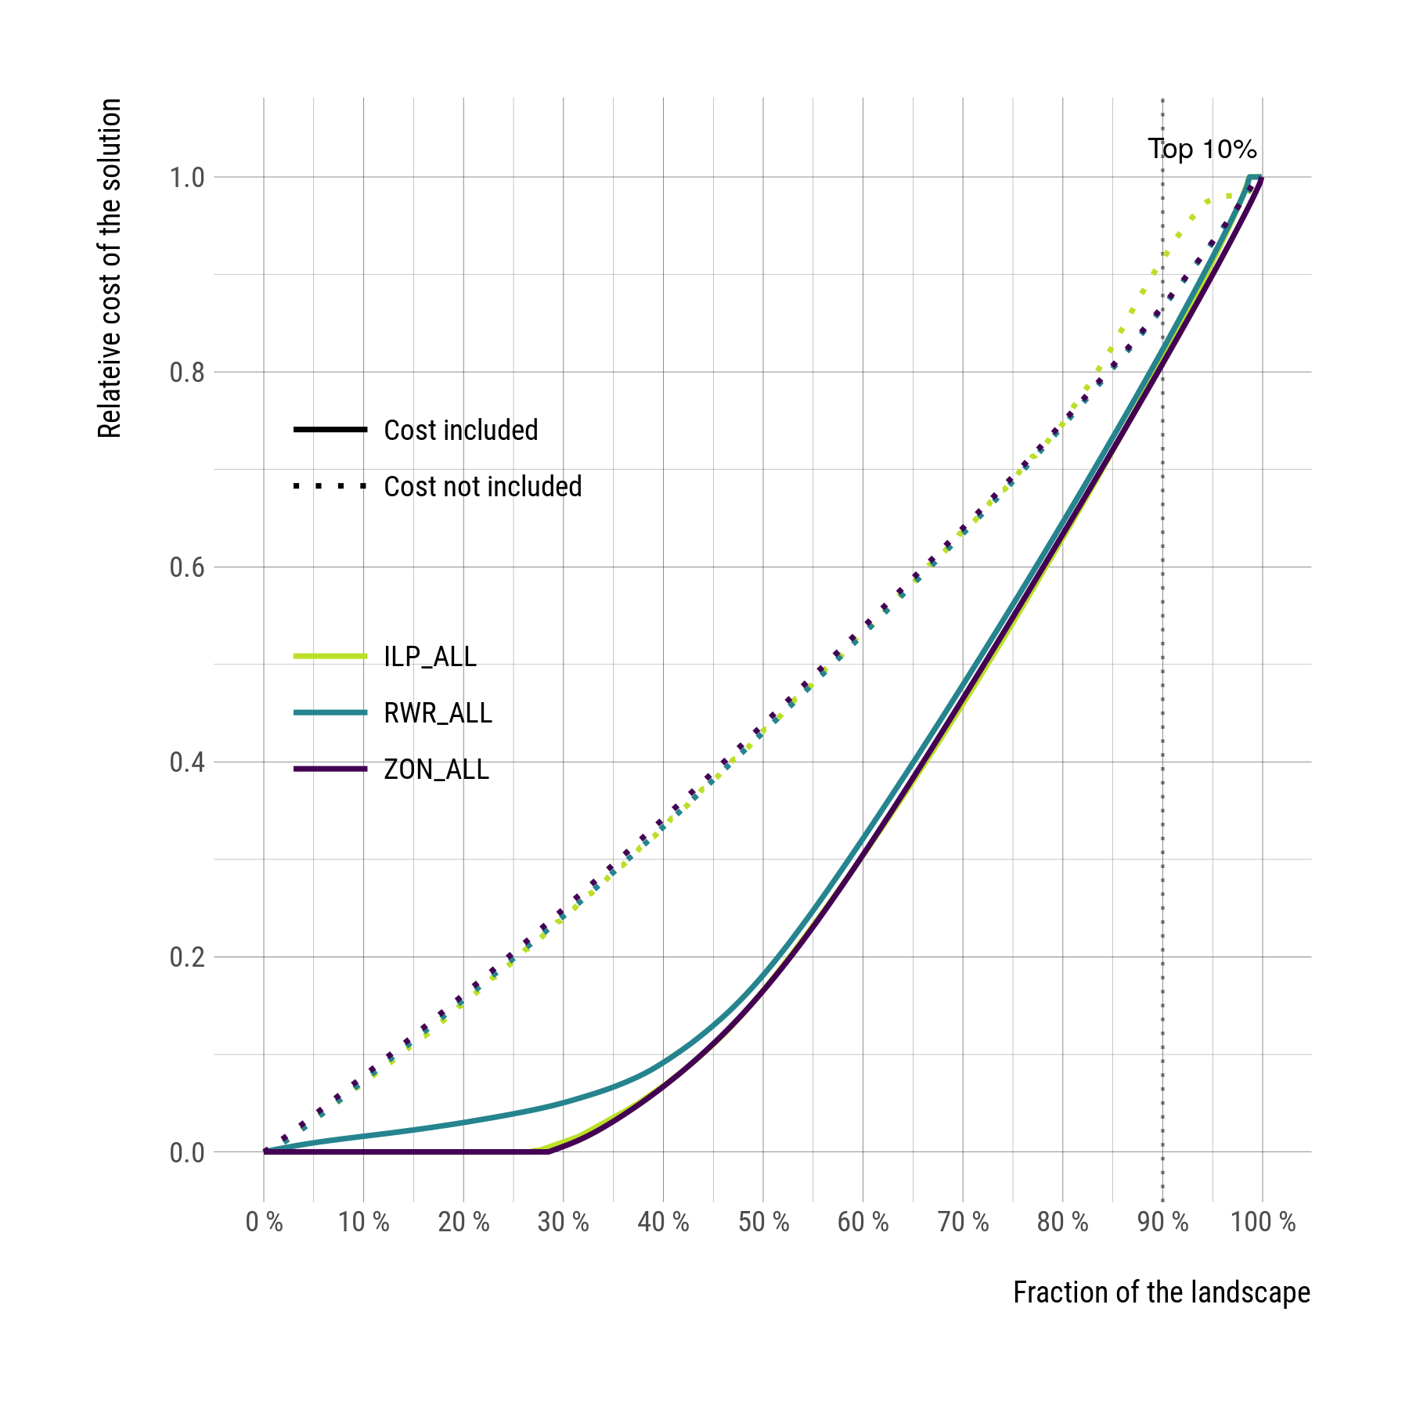o

**Figure S4.** Cost of different prioritization solutions. Curves show the relative cost of a given fraction of the landscape per prioritization method: ILP (lime green), RWR (turquoise) and ZON (purple). Dotted lines show the cost from solutions in which costs are not part of the prioritization, solid lines where costs are part of prioritization.

# References

Jones E, Oliphant T, Peterson P (2001) SciPy: Open source scientific tools for Python.

Moilanen A, Pouzols FM, Meller L, et al (2014) Zonation spatial conservation planning methods and software v. 4, user manual. Helsinki