January 10, 2022

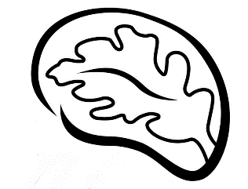

`r first_name`

`r last_name`

`r street_address`

`r city`

,

`r state`

`r zipp`

RE: Feedback for Tennessee Alzheimer’s Project Baseline Visit

`r enroll_date`

Dear

`r salutation`

`r last_name`

,

Thank you for your recent participation in the **Tennessee Alzheimer’s Project** and completion of your Baseline visit on

`r enroll_date`

. As you know, we offer to share results from your laboratory work, your memory test, and your heart scan. Your research visit results are summarized below.

**Vital Signs**

*These values are recommended by Vanderbilt University; **Bold** values are outside this range

**Fasting Blood Work Results**

*These values are recommended by Vanderbilt University; **Bold** values are outside this range

**Heart Test Results**

You underwent heart testing, which was read by a board-certified cardiologist. Results were as follows:

`r lv`

left ventricular diastolic function

`r val`

valvular abnormality

**Memory Testing Results**

During your visit, you completed a series of paper and pencil tests and puzzles that measured different cognitive activities, such as memory, language, attention, planning, multi-tasking, and spatial abilities. Your performance was compared to other

`r gender`

who are your same age with similar education background. Below is a graph of your results:

`r decline`

`r gds`

`r brain_intro1`

`r brain_intro2`

`r brain_ic`

`r brain_c`

Per your request, we have sent the results summarized above to your treating physician(s). If you have any questions about the results above, we strongly encourage you to discuss them with your health care provider(s).

We greatly appreciate your participation in the Tennessee Alzheimer’s Project and your continued support of our research activities. If you have any questions about your participation in the study, please do not hesitate to contact us at 615-336-3388.

We look forward to seeing you at your next visit in

`r date_ty`

.

Warm regards,

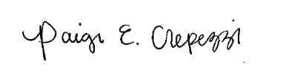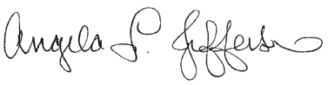 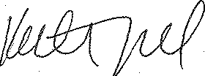

Angela L. Jefferson, PhD Katherine A. Gifford, PsyD Paige E. Crepezzi, BSN, RN

Principal Investigator Study Neuropsychologist Research Nurse Specialist

cc:

`r first_name_physician1`

`r last_name_physician1`

,

`r credentials1`

`r street_address_physician1`

`r city_physician1`

`r state_physician1`

`r zip_physician1`

`r first_name_physician2`

`r last_name_physician2`

`r street_address_physician2`

`r city_physician2`

`r state_physician2`

`r zip_physician2`

`r first_name_physician3`

`r last_name_physician3`

`r street_address_physician3`

`r city_physician3`

`r state_physician3`

`r zip_physician3`