February 22, 2022

`r first_name`

`r last_name`

`r street_address`

`r city`

,

`r state`

`r zipp`

RE: **Incidental Bloodwork Finding**

Dear

`r salutation`

`r last_name`

,

As part of your involvement with the Vanderbilt Memory and Aging Project, you underwent a Bloodwork examination on

`r bld_date_time`

. During your recent partial feedback session held on

`r enroll_date`

on the telephone, the following research visit results were summarized.

*These values are recommended by Vanderbilt University; **Bold** values are outside this range

If you have any questions about the results above, we strongly encourage you to discuss them with your health care provider(s).

We greatly appreciate your participation in the Memory & Aging Project and your continued support of our research activities. If you have any questions about your participation in the study, please do not hesitate to contact us at 615-347-6937.

Warm regards,

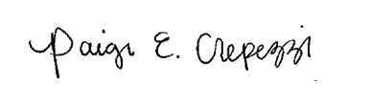

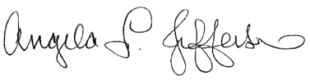 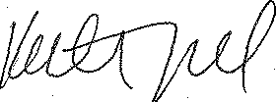

Angela L. Jefferson, PhD Katherine A. Gifford, PsyD Paige E. Crepezzi,, BSN, RN

Memory & Aging Project Memory & Aging Project Memory & Aging Project

Principal Investigator Study Neuropsychologist Research Nurse Specialist