April 13, 2022

`r first_name`

`r last_name`

`r street_address`

`r city`

,

`r state`

`r zipp`

RE: **Incidental Brain MRI Finding**

Dear

`r salutation`

`r last_name`

,

`r brain_incidental_ptp`

.

Sincerely,

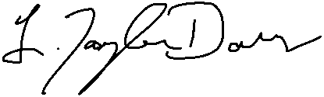   
L. Taylor Davis, MD