February 22, 2022

`r first_name`

`r last_name`

`r street_address`

`r city`

,

`r state`

`r zipp`

RE: **Incidental Echocardiogram** **Finding**

Dear

`r salutation`

`r last_name`

,

As part of your involvement with the Vanderbilt Memory and Aging Project, you underwent a echocardiogram examination on

`r echo_date_time`

. Upon examination, I report

`r echo_find_notes`

`r echo_comments`

Sincerely,

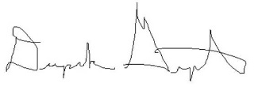   
Deepak Gupta, MD