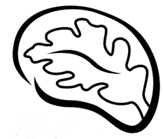Patient Name:

`r first_name`

`r last_name`

Date of Birth:

`r dob`

April 21, 2022

**`r first_name_physician`**

`r last_name_physician`

**,**

`r credentials`

`r street_address_physician`

**`r city_physician`**

**,**

`r state_physician`

**`r zip_physician`**

**RE: Incidental Echocardiogram Finding for**

`r first_name`

**, DOB**

`r dob`

Dear Dr.

`r last_name_physician`

**,**

As part of your patient’s involvement with the Tennessee Alzheimer’s Project,

`r pronoun`

underwent an echocardiogram examination on

`r echo_date_time`

. Upon examination, I report

`r echo_phys`

Sincerely,

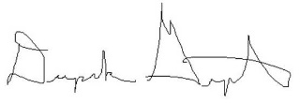  
Deepak Gupta, MD