

January 6, 2022

`r first_name`

`r last_name`

`r street_address`

`r city`

,

`r state`

`r zipp`

RE: **Feedback for Vanderbilt Memory & Aging Project**

`r Epoch`

**Visit**

`r fu_date_c`

Dear

`r salutation`

`r last_name`

,

Thank you for your recent participation in the **Vanderbilt Memory & Aging Project (VMAP) Study** and completion of your Enrollment visit on

`r fu_date_c`

. As you know, we offer to share results from your laboratory work, your memory test, and your heart scan. Your research visit results are summarized below.

**Vital Signs**

*Values are recommended by Vanderbilt Medical Center; **Bold** values are outside this range

**Fasting Blood Work Results**

*Values are recommended by Vanderbilt Medical Center; **Bold** values are outside this range

**Heart Test Results**

You underwent heart testing, which was read by a board-certified cardiologist.

Your **current enrollment visit results on**

`r enroll_date`

were as follows:

`r lv_c`

left ventricular diastolic function

`r val_c`

valvular abnormality

`r lung_c`

`r brain_intro1`

`r brain_intro2`

`r brain_ic`

`r brain_c`

**Memory Testing Results**

During your visit, you completed a series of paper and pencil tests and puzzles that measured different cognitive activities, such as memory, language, attention, planning, multi-tasking, and spatial abilities. Your performance was compared to other

`r gender`

who are your same age with similar education background. Below is a graph of your results:

`r decline`

`r gds`

Per your request, we have sent the results above to the following treating physician(s) for you:

`r first_name_physician1`

`r last_name_physician1`

,

`r credentials1`

`r street_address_physician1`

`r city_physician1`

`r state_physician1`

`r zip_physician1`

`r first_name_physician2`

`r last_name_physician2`

`r street_address_physician2`

`r city_physician2`

`r state_physician2`

`r zip_physician2`

`r first_name_physician3`

`r last_name_physician3`

`r street_address_physician3`

`r city_physician3`

`r state_physician3`

`r zip_physician3`

If you have any questions about the results above, we strongly encourage you to discuss them with your health care provider(s).

We greatly appreciate your participation in the Memory & Aging Project and your continued support of our research activities. If you have any questions about your participation in the study, please do not hesitate to contact us at 615-347-6937.

We look forward to seeing you at your next visit in

`r date_ty`

.

Warm regards,

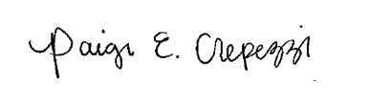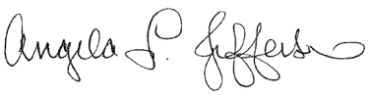 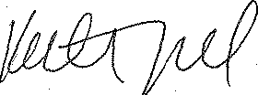

Angela L. Jefferson, PhD Katherine A. Gifford, PsyD Paige E. Crepezzi, BSN, RN

Principal Investigator Study Neuropsychologist Research Nurse Specialist

cc:

`r first_name_physician1`

`r last_name_physician1`

,

`r credentials1`

`r street_address_physician1`

`r city_physician1`

`r state_physician1`

`r zip_physician1`

`r first_name_physician2`

`r last_name_physician2`

`r street_address_physician2`

`r city_physician2`

`r state_physician2`

`r zip_physician2`

`r first_name_physician3`

`r last_name_physician3`

`r street_address_physician3`

`r city_physician3`

`r state_physician3`

`r zip_physician3`