Patient Name:

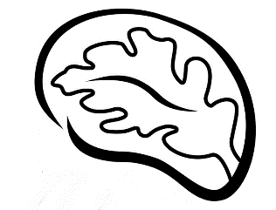

`r first_name`

`r last_name`

Date of Birth:

`r dob`

April 28, 2022

**`r first_name_physician`**

`r last_name_physician`

**,**

`r credentials`

`r street_address_physician`

**`r city_physician`**

**,**

`r state_physician`

**`r zip_physician`**

RE: **Clinical Research Results** **for**

`r first_name`

`r last_name`

, DOB

**`r dob`**

Dear Dr.

`r last_name_physician`

,

Your patient,

`r first_name`

`r last_name`

, is a recent research participant in the *Tennessee Alzheimer’s Project* and completed a baseline visit on

`r enroll_date`

. This study, funded by the National Institutes of Health,investigates brain aging in older adults. The study involves a fasting blood draw, neuropsychological evaluation, and echocardiogram at Vanderbilt University Medical Center.

Participants may request their laboratory, neuropsychological, and echocardiogram results be released to their physician(s).

`r salutation`

`r last_name`

has provided permission for us to release

`r pronoun_poss`

results to you. Enclosed, you will find a copy of the **Release of Medical Information Form** signed by your patient. For your records,

`r salutation`

`r last_name`

’s laboratory, neuropsychological, and heart test results from

`r pronoun_poss`

initial baseline visit on

`r enroll_date`

are summarized below:

**Vital Signs**

*These values are recommended by Vanderbilt University; **Bold** values are outside this range

**Fasting Blood Work Results**

*These values are recommended by Vanderbilt University; **Bold** values are outside this range

**Heart Test Results**

`r salutation`

`r last_name`

completed heart testing, which was read by a board-certified cardiologist. Results are as follows:

`r lv`

left ventricular diastolic function

`r val`

valvular abnormality

**Memory Test Results**

During

`r salutation`

`r last_name`

’s visit,

`r pronoun`

completed a series of paper and pencil tests and puzzles that assess different cognitive activities, such as memory, language, attention, planning, multi-tasking, and spatial abilities.

`r pronoun_poss_cap`

performance was compared to other

`r gender`

who are of

`r pronoun_poss`

same age and similar education background. Below is a summary of results:

`r decline_phys`

`r gds_phys`

`r brain_intro1`

`r brain_intro2`

`r brain_ic_phys`

`r brain_c_phys`

Please note that while we provide the same results summary listed above to our research participants, we *do not* discuss clinical implications of the blood work or cardiac imaging results with our research participants. Our study doctors only offer brief feedback about the neuropsychological test results. We encourage participants to discuss the laboratory and cardiac imaging results with their treating physicians.

Should you have any questions regarding the content of this letter, please feel free to contact the study team at 615-336-3388. Also, if you have additional older adult patients in your practice who might benefit from a memory diagnostic workup, please have them contact our clinic to schedule an appointment at 615-936-0060. We have enclosed copies of our memory loss workup brochures for more information.

Sincerely,

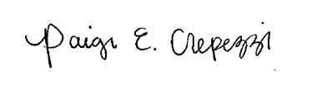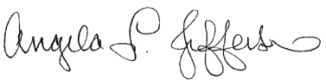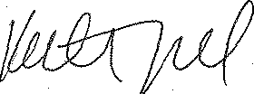

Angela L. Jefferson, PhD Katherine A. Gifford, PsyD Paige E. Crepezzi, BSN, RN

Principal Investigator Study Neuropsychologist Research Nurse Specialist