Patient Name:

`r first_name`

`r last_name`

Date of Birth:

`r dob`

February 22, 2022

**`r first_name_physician`**

`r last_name_physician`

**,**

`r credentials`

`r street_address_physician`

**`r city_physician`**

**,**

`r state_physician`

**`r zip_physician`**

RE: **Incidental Bloodwork Finding**

Dear Dr.

`r last_name_physician`

,

Your patient,

`r first_name`

`r last_name`

, was a recent research participant in the *Vanderbilt Memory & Aging Project*, completing a visit on

`r enroll_date`

. This study, funded by the National Institutes of Health,investigates the relationship between heart health and brain aging in older adults. The study visit involves a fasting blood draw, neuropsychological evaluation, and echocardiogram completed at the Vanderbilt University Medical Center.

Participants may elect to have their laboratory, neuropsychological, and echocardiogram results released to their treating physician(s).

`r salutation`

`r last_name`

has provided permission for us to release

`r pronoun_poss`

results to you. Enclosed, you will find a copy of the **Release of Medical Information Form** signed by your patient. For your records, please find a summary of

`r salutation`

`r last_name`

’s laboratory, neuropsychological, and heart test results from

`r pronoun_poss`

initial enrollment visit on

`r enroll_date`

. When the remainder of

`r pronoun_poss`

test results are available, you will be sent a summary of those results:

*These values are recommended by Vanderbilt University; **Bold** values are outside this range

Please note that while we provide the same results summary listed above to our research participants, we *do not* discuss clinical implications of the blood work with our research participants. We encourage participants to discuss the laboratory results with their treating physicians.

Should you have any questions regarding the content of this letter, please feel free to contact the study team (615-347-6937).

Warm regards,

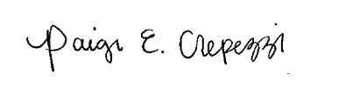

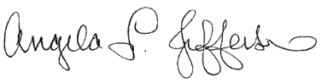 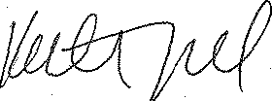

Angela L. Jefferson, PhD Katherine A. Gifford, PsyD Paige E. Crepezzi, BSN, RN

Memory & Aging Project Memory & Aging Project Memory & Aging Project

Principal Investigator Study Neuropsychologist Research Nurse Specialist