Patient Name:

`r first_name`

`r last_name`

Date of Birth:

`r dob`

April 13, 2022

**`r first_name_physician`**

`r last_name_physician`

**,**

`r credentials`

`r street_address_physician`

**`r city_physician`**

**,**

`r state_physician`

**`r zip_physician`**

RE: **Incidental Brain MRI Finding**

Dear Dr.

`r last_name_physician`

**,**

`r brain_incidental_physician`

.

Sincerely,

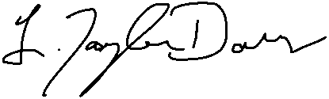  
L.Taylor Davis, MD