April 25, 2022

`r proxy_first_name`

`r proxy_last_name`

`r proxy_address`

`r proxy_city`

,

`r proxy_state`

`r proxy_zip`

RE: Tennessee Alzheimer’s Project

**`r Epoch`**

Visit –

**`r visit1_date`**

at

**`r visit1_time`**

**`r day2`**

Dear

`r proxy_salutation`

`r proxy_last_name`

,

Thank you for being the **Tennessee Alzheimer’s Project Study Partner** for

`r first_name`

.

`r pronoun_poss_cap`

`r Epoc`

visit is scheduled for

**`r visit1_date`**

at

**`r visit1_time`**

and will last approximately

**`r visit1_hours`**

hours.

`r pronoun_poss_cap`

second visit is scheduled for

**`r visit2_date`**

at

**`r visit2_time`**

and will last approximately

**`r visit2_hours`**

hours.

`r p_req`

We have enclosed several important documents for the visit:

1. **Location and Directions.**

`r location_day1_prox`

`r location_day1_prox_extra`

`r location_day2_3_prox`



`r t_need_proxy`

`r hotel_proxy`



You will be asked to wear a mask throughout

`r pronoun_poss`

visit; if you do not have a mask, one will be provided.

1. **Study Itinerary and Visit Instructions.** We have included a study itinerary with a schedule and instructions for how to prepare for

`r pronoun_poss`

1. visits. **It is important that everyone carefully read the visit day instructions and closely follow them**.
2. **Consent Statement.** This document describes the **Tennessee Alzheimer’s Project.** You and

`r first_name`

1. will sign this document again at each visit. Please read the form thoroughly. If you have questions, please let us know.

If you have any questions, you may reach us at **615-336-3388**. We look forward to

`r first_name`

’s visit on

`r visit1_date`

at

`r visit1_time`

, and thank you both for your contribution to our research efforts.

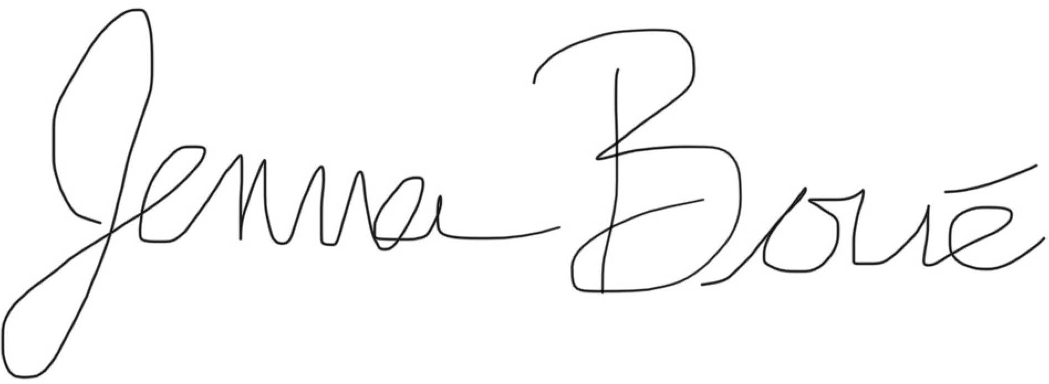Sincerely,

Jenna Boue

P20 Program Manager

Vanderbilt Memory & Alzheimer’s Center Phone: 615-336-3388

Email: [jenna.boue@vumc.org](mailto:jenna.boue@vumc.org)

**Day 1**

**`r Epoch`**

Visit Agenda for

`r first_name`

Day 1:

**`r visit1_date`**

at

**`r visit1_time`**

**Preparing for the Study Visit:**

If

`r pronoun`

wears reading glasses or hearing aids, please be sure to bring these items to the appointment.

**Study Visit Itinerary – Day 1:**

**Day 2**

**`r Epoch`**

Visit Agenda for

**`r first_name`**

Day 2:

**`r visit2_date`**

at

**`r visit2_time`**

**Preparing for the Study Visit:**

Participation in our study requires a fasting blood draw upon arrival to the study visit.

`r first_name`

**should not eat or drink anything other than water after midnight on the evening before the visit**. Regularly scheduled medication may be taken the morning of the visit. If

`r pronoun`

takes insulin, please call 615-347-6937 prior to fasting. We encourage

`r pronoun_obj`

to drink plenty of water during

`r pronoun_poss`

fasting period. Being well hydrated will help to make the blood draw more comfortable. We will provide breakfast immediately after blood work is finished.

Please adhere to the following guidelines in preparation for

`r pronoun_poss`

visit:

1. If

`r pronoun`

wears a wedding ring or other jewelry,

`r pronoun`

1. will have to remove them before the MRI scans.

`r pronoun_cap`

may need to remove any wigs, hairpieces, or hair extensions before

`r pronoun_poss`

1. MRI scans. If possible, please leave these items at home.

`r pronoun_cap`

1. should not wear any tinted hair wax or dry shampoo, as these may pose a safety concern during the MRI.
2. Please remove any nail polish or artificial nails prior to

`r pronoun_poss`

1. visit.
2. No lotions, perfumes, or scented deodorants may be worn during

`r pronoun_poss`

visit.

If

`r pronoun`

**wears reading glasses or hearing aids, please be sure to bring these items to the appointment.**

**Study Visit Itinerary – Day 2:**