July 14, 2022

`r proxy_first_name`

`r proxy_last_name`

`r proxy_address`

`r proxy_city`

,

`r proxy_state`

`r proxy_zip`

RE: Tennessee Alzheimer’s Project

**`r Epoch`**

Visit –

**`r visit1_date`**

at

**`r visit1_time`**

,

**`r day2`**

, and

**`r day3`**

Dear

`r proxy_salutation`

`r proxy_last_name`

,

Thank you for being the **Tennessee Alzheimer’s Project Study Partner** for

`r first_name`

.

`r pronoun_poss_cap`

`r Epoc`

visit is scheduled for

**`r visit1_date`**

at

**`r visit1_time`**

and will last approximately

**`r visit1_hours`**

**hours**.

`r pronoun_poss_cap`

second visit is scheduled for

**`r visit2_date`**

at

**`r visit2_time`**

and will last approximately

**`r visit2_hours`**

**hours**.

`r pronoun_poss_cap`

third visit is scheduled for

**`r visit3_date`**

at

**`r visit3_time`**

and will last approximately

**`r visit3_hours`**

hours.

`r p_req`

We have enclosed several important documents for

`r pronoun_poss`

visit:

1. **Location and Directions.**

`r location_day1_prox`

`r location_day1_prox_extra`

`r location_day2_3_prox`



`r t_need_proxy`

`r hotel_proxy`



You will be asked to wear a mask throughout

`r pronoun_poss`

visit. If you do not have a mask, one will be provided.

1. **Study Itinerary and Visit Instructions.** We have included a study itinerary with a schedule and instructions for how to prepare for

`r pronoun_poss`

1. visits. **It is important that everyone carefully read the visit day instructions and closely follow them**.
2. **Consent Statement.** This document describes the **Tennessee Alzheimer’s Project.** You and

`r first_name`

1. will sign this document again at each visit. Please read the form thoroughly. If you have questions, please let us know.
2. **Questionnaires.** Prior to your appointment, you will receive information about completing questionnaires ahead of your visit. A “Questionnaire Information Sheet” is enclosed and includes information about completing the questionnaires.

If you have any questions, you may reach us at **615-336-3388**. We look forward to

`r first_name`

’s visit on

`r visit1_date`

at

`r visit1_time`

, and thank you both for your contribution to our research efforts.

Sincerely,

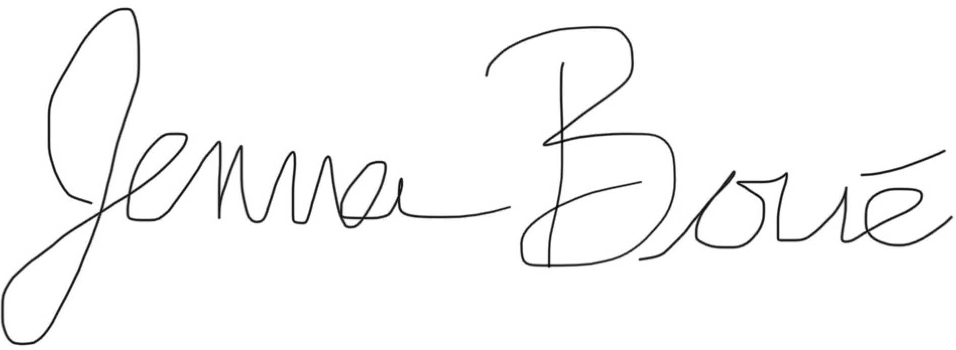

Jenna Boue

P20 Program Manager

Vanderbilt Memory & Alzheimer’s Center Phone: 615-336-3388

Email: [jenna.boue@vumc.org](mailto:jenna.boue@vumc.org)

**Day 1**

**`r Epoch`**

Visit Agenda for

`r first_name`

`r last_name`

Day 1:

**`r visit1_date`**

at

**`r visit1_time`**

**Preparing for the Study Visit:**

If

`r pronoun`

wears reading glasses or hearing aids, please be sure to bring these items to the appointment.

**Study Visit Itinerary – Day 1:**

**Day 2**

**`r Epoch`**

Visit Agenda for

**`r first_name`**

`r last_name`

Day 2:

**`r visit2_date`**

at

**`r visit2_time`**

**Preparing for the Study Visit:**

Please adhere to the following guidelines in preparation for

`r pronoun_poss`

visit:

1. If

`r pronoun`

wears a wedding ring or other jewelry,

`r pronoun`

1. will have to remove them before the MRI scans.

`r pronoun_cap`

may need to remove any wigs, hairpieces, or hair extensions before

`r pronoun_poss`

1. MRI scans. If possible, please leave these items at home.

`r pronoun_cap`

1. should not wear any tinted hair wax or dry shampoo, as these may pose a safety concern during the MRI.
2. Please remove any nail polish or artificial nails prior to

`r pronoun_poss`

1. visit.
2. No lotions, perfumes, or scented deodorants may be worn during

`r pronoun_poss`

visit.

If

`r pronoun`

**wears reading glasses or hearing aids, please be sure to bring these items to the appointment.**

**Study Visit Itinerary – Day 2:**

**Day 3**

**`r Epoch`**

Visit Agenda for

**`r first_name`**

`r last_name`

Day 3:

**`r visit3_date`**

at

**`r visit3_time`**

**Preparing for the Study Visit:**

Participation in our study requires a fasting blood draw upon arrival of the study visits.

`r first_name`

**should not eat or drink anything other than water after midnight on the evening before the visit**. Regularly scheduled medications may be taken the morning of the visit. If she takes insulin, please call 615-336- 3388 prior to fasting. We encourage her to drink plenty of water during her fasting period. Being well hydrated will help to make the blood draw more comfortable. We will provide breakfast immediately after blood work is finished.

**If she wears reading glasses or hearing aids, please be sure to bring these items to the appointment.**

**Preparing for the Visit:** Please carefully read and follow the instructions below to prepare for

`r first_name`

’s lumbar puncture (LP).

`r first_name`

should not eat or drink anything other than water after midnight on the evening before

`r pronoun_poss`

1. **visit.**

`r pronoun_cap`

1. may take

`r pronoun_poss`

* 1. regularly scheduled medications the morning of the visit. We will provide breakfast at the end of the visit.

`r first_name`

should drink plenty of water the night before and morning of

`r pronoun_poss`

1. **appointment**. We recommend drinking **at least eight glasses of water** the day before the visit. One possible side effect is a headache, which can often be avoided by staying well hydrated.
2. If

`r first_name`

1. **is taking prescription blood thinners** (e.g., Plavix, Warfarin, Pradaxa, Coumadin),

`r pronoun`

1. should not participate in the lumbar puncture. If

`r pronoun`

* 1. is taking one of these medications, please call us as soon as possible (615-336-3388).

1. If

`r first_name`

has been prescribed aspirin that is greater than 325 mg by

`r pronoun_poss`

1. **doctor** for a medical reason, please follow these instructions after consulting with

`r pronoun_poss`

* 1. doctor:
     1. Stop taking the aspirin one week before the LP and restart it the day after the LP.

1. If

`r first_name`

is taking aspirin greater than 325 mg on

`r pronoun_poss`

* 1. **own** for general health, please follow these instructions:
     1. Stop taking the aspirin one week before the LP and restart it the day after the LP.

We will provide scrubs for

`r first_name`

to wear throughout

`r pronoun_poss`

visit.

**Study Visit Itinerary – Day 3:**

# After the Visit:

Please have

`r first_name`

follow these guidelines after

`r pronoun_poss`

visit:

1. No heavy lifting or vigorous exercise for 24 hours after the LP. This will reduce the risk of low back soreness or headache.
2. Stay well hydrated during the 24 hours after the LP. This will also help avoid a headache.

The day after the visit, a study coordinator will call you to see how

`r first_name`

is doing. You may also reach a team member at any time by calling or texting 615-336-3388.