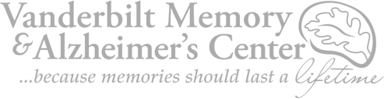

1207 17th Avenue South | 2nd Floor, Suite 204 | Nashville, TN 37212

January 18, 2022

Dear

**`r first_name`**

**`r last_name`**

**’s Family,**

On behalf of our entire research team, we were very saddened to learn of the death of

`r salutation`

`r last_name`

. We are writing to express our sincerest condolences. We are grateful for

`r salutation`

`r last_name`

's participation in the Tennessee Alzheimer’s Project over the last

`r enroll_length`

and for allowing us to learn from

`r pronoun_obj`

.

`r pronoun_poss_cap`

contribution to our research program has been instrumental in our understanding of the aging brain and risk factors for Alzheimer's disease, which will enable us to help others facing this illness in the future.

Our thoughts are with you and your family during this difficult time.

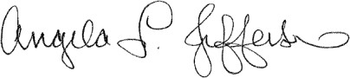**Sincerely,**

**[INSERT SIGNATURE]**

**[NAME] Angela L. Jefferson, PhD**

**[Title] Director and Principal Investigator,**

**[EMAIL] Vanderbilt Alzheimer’s Disease**

**[Phone] Research Center Professor of Neurology**

[www.vanderbiltalzheimers.com](http://www.vanderbiltalzheimers.com/) | tel 615.336.3388 | fax 615.875.2727