Patient Name: FIRST LAST [first_name last_name]

Date of Birth: MM/DD/YYYY [dob]

DATE **[current date]**

**Physician Name [feedback_incidental_stat_blood_physician1_first_name //last_name]**

**Street [feedback_incidental_stat_blood_physician1_street_address]**

City, State, Zip **[feedback_incidental_stat_blood_physician1_city //state //zip]**

**RE: Incidental Bloodwork Finding for**

`r first_name`

**, DOB**

`r dob`

Dear Dr. XX [**[feedback_incidental_stat_blood_physician1_**salutation //last_name],

Your patient, Participant Name [first_name last_name], was a recent research participant in the *Vanderbilt* *Memory & Aging Project*, completing a visit on MM/DD/YYYY [vf_wrapup_date_time]. This study, funded by the National Institutes of Health,investigates the association between heart health and brain aging in older adults. The study visit involves a fasting blood draw, neuropsychological evaluation, and echocardiogram completed at the Vanderbilt University Medical Center.

Participants may elect to have their laboratory, neuropsychological, and echocardiogram results released to their treating physician(s). Mr./Mrs. LastName [salutation last_name] has provided permission for us to release his/her results to you. Enclosed, you will find a copy of the **Release of Medical Information Form** signed by your patient. For your records, please find a summary of Mr./Mrs. LastName’s [salutation last_name] laboratory results from his/her initial enrollment visit, follow-up visits, and the current visit on MM/DD/YYYY [vf_consent_date_time]. When the remainder of his/her test results are available, you will be sent a summary of those results:

**[vf_consent_date_time - EPOCH x/x, x-2, x-1, x]**

|  |  |  |  |  |  |  |
| --- | --- | --- | --- | --- | --- | --- |
| **Test** | | **Enrollment Results XX/XX/XXXX** | **5-Year Results XX/XX/XXXX** | **7-Year Results XX/XX/XXXX** | **9-Year Results**  **XX/XX/XXXX** | **Normal Range/**  **Cut-off\*** |
|  |  | **ix/x** | **ix-2** | **ix-1** | **ix** | irange |

*These values are recommended by Vanderbilt University; **Bold** values are outside this range

i = {bld_c_glucose, bld_c_chol, bld_c_trig, bld_c_hdlc, bld_c_ldlc, bld_c_crp, bld_c_tsh, bld_c_insulin, bld_c_hgba1c}

Please note that while we provide the same results summary listed above to our research participants, we *do not* discuss clinical implications of the blood work with our research participants. We encourage participants to discuss the laboratory results with their treating physicians.

Should you have any questions regarding the content of this letter, please feel free to contact the study team (615-347-6937).

Warm regards,

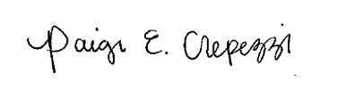

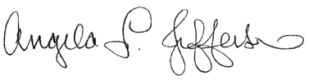 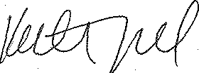

Angela L. Jefferson, PhD Katherine A. Gifford, PsyD Paige E. Crepezzi, BSN, RN

Memory & Aging Project Memory & Aging Project Memory & Aging Project

Principal Investigator Study Neuropsychologist Research Nurse Specialist