February 22, 2022

`r first_name`

`r last_name`

`r street_address`

`r city`

,

`r state`

`r zipp`

RE: **Incidental Brain MRI Finding**

Dear Mr./Mrs. Last Name [salutation last_name],

As part of your involvement with the Vanderbilt Memory and Aging Project, you underwent a Brain MRI examination on MM/DD/YYYY. Upon examination, I report *[insert incidental findings here]*. I recommend *[insert clinician’s recommendation(s) here].* [brain_relay_ptp]

Sincerely,

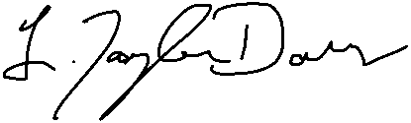   
L. Taylor Davis, MD