February 22, 2022

`r first_name`

`r last_name`

`r street_address`

`r city`

,

`r state`

`r zipp`

RE: **Incidental Heart MRI Finding**

Dear

`r salutation`

`r last_name`

,

As part of your involvement with the Vanderbilt Memory and Aging Project, you underwent a Heart MRI examination on

`r bld_date_time`

. Upon examination, I report *[insert incidental findings here]*. I recommend *[insert clinician’s recommendation(s) here].* [extracardiac_incidental_letter_particpant]

Sincerely,

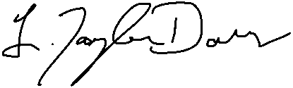   
L. Taylor Davis, MD