April 20, 2022

`r first_name`

`r last_name`

`r street_address`

`r city`

,

`r state`

`r zipp`

RE: **Incidental Bloodwork Finding**

Dear

`r salutation`

`r last_name`

,

As part of your involvement with the Tennessee Alzheimer’s Project, you underwent a Bloodwork examination on

`r bld_date_time`

. During your recent partial feedback session held on XXXXXXX on the telephone, the following research visit results were summarized.

*These values are recommended by Vanderbilt University; **Bold** values are outside this range

If you have any questions about the results above, we strongly encourage you to discuss them with your health care provider(s).

We greatly appreciate your participation in the Tennessee Alzheimer’s Project and your continued support of our research activities. If you have any questions about your participation in the study, please do not hesitate to contact us at 615-336-3388.

Warm regards,

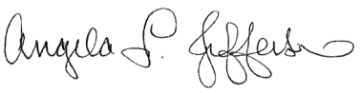 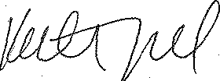 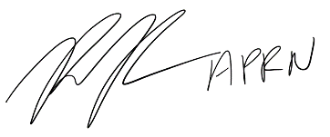

Angela L. Jefferson, PhD Katherine A. Gifford, PsyD Raymond Romano, PhD, MPH

Tennessee Alzheimer’s Project Tennessee Alzheimer’s Project Tennessee Alzheimer’s Project

Principal Investigator Study Neuropsychologist Research Nurse Specialist