**Project Objective:**

Our in-depth analysis involves scrutinizing the geographical and temporal distribution of COVID19 cases. Through extensive data mining and visualization techniques, we seek to uncover patterns and correlations within the spread of the virus. This includes studying how the virus moves across different regions, urban and rural areas, and demographic groups. By understanding the pathways of transmission, we can identify clusters of cases and potential super-spreader events, enabling public health authorities to respond swiftly and efficiently.

Furthermore, our analysis delves into the impact of various factors such as population density, socioeconomic status, and healthcare infrastructure on the rate of transmission. This multifaceted approach allows us to create a nuanced picture of the pandemic's dynamics, helping authorities prioritize resource allocation and intervention strategies.

Mapping the Spread:

Objective: Understand the geographical and temporal spread of COVID-19 cases.

Approach: Analyze regional and temporal trends to identify patterns of transmission and hotspot areas.

Predictive Modeling:

Objective: Develop predictive models to anticipate future case numbers.

Approach: Utilize statistical methods and machine learning algorithms to forecast potential surges, aiding in proactive healthcare planning.

Resource Allocation and Management:

Objective: Optimize the allocation of healthcare resources based on case data.

Approach: Analyze current and predicted case data to ensure efficient distribution of medical supplies, hospital beds, and personnel to areas with the greatest need.

Effectiveness of Interventions:

Objective: Evaluate the effectiveness of public health interventions.

Approach: Assess the impact of interventions such as social distancing, mask mandates, and vaccination campaigns on the reduction of cases and transmission rates.

Vulnerable Population Analysis:

Objective: Identify and understand demographic groups most vulnerable to severe outcomes.

Approach: Analyze case data based on age, ethnicity, socioeconomic status, and pre-existing health conditions to tailor interventions for at-risk populations.

Genetic Mutations and Vaccine Efficacy:

Objective: Monitor genetic mutations of the virus and their implications for vaccines and treatments.

Approach: Study the genetic evolution of the virus and assess its potential impact on vaccine effectiveness and therapeutic strategies.

**Design Thinking:**

1. Empathize:

Stakeholders of COVID-19 Cases Analysis:

Government & Health Authorities: Responsible for public health measures and guidelines.

Healthcare Providers: Hospitals, clinics, and healthcare workers treating patients.

Pharmaceutical Companies: Develop vaccines and treatments.

Research Institutions: Contribute to virus understanding and research.

Non-Governmental Organizations (NGOs): Provide medical aid and support.

Businesses: Implement safety measures and adapt operations.

Community Organizations: Disseminate information and support vulnerable populations.

Media: Disseminate accurate information and counter misinformation.

International Organizations: Coordinate global responses and provide aid.

Individuals & Communities: Follow public health guidelines and get vaccinated.

Suppliers & Logistics Companies: Produce and distribute medical supplies and vaccines.

Transportation & Travel Industry: Affected by travel restrictions and safety protocols.

Financial Institutions: Offer financial support to affected individuals and businesses.

Collaboration among these stakeholders is crucial in managing the pandemic.

**Development phases:**

Phase 1: Data Gathering and Preparation

As a student, my initial task was to collect raw data from reliable sources such as government health agencies and research institutions. This phase involved understanding the data structures, cleaning datasets, and ensuring data integrity. Navigating through vast datasets honed my data manipulation skills and introduced me to the nuances of real-world data.

Phase 2: Exploratory Data Analysis (EDA)

In the EDA phase, I delved into the data to identify patterns, outliers, and correlations. Visualization tools became my companions, helping me translate raw numbers into meaningful insights. As a student, this phase allowed me to apply statistical techniques learned in class to real-world data, strengthening my analytical abilities.

Phase 3: Hypothesis Formulation and Testing

As I gained familiarity with the data, I formulated hypotheses to test specific aspects of the COVID-19 spread. This phase challenged my critical thinking skills, pushing me to design appropriate experiments and select suitable statistical tests. The iterative nature of hypothesis testing taught me resilience and the importance of adapting methodologies based on results.

Phase 4: Predictive Modeling

Venturing into predictive modeling, I explored machine learning algorithms to forecast COVID19 trends. This phase exposed me to the world of algorithms, feature engineering, and model evaluation. Working on predictive models enhanced my programming skills and deepened my understanding of algorithmic decision-making.

Phase 5: Interpretation and Communication of Results

Translating complex findings into understandable insights became a crucial skill in this phase. As a student, I honed my ability to communicate technical information to diverse audiences. Visualization tools and storytelling techniques became my allies, enabling me to present our findings coherently and persuasively.

**Analysis Objectives:**

Objective 1: Understanding Transmission Dynamics

Objective: Dive into the data to comprehend how COVID-19 spreads across different regions, demographics, and time periods.

Approach: Utilize statistical methods to identify transmission patterns, hotspots, and factors influencing the virus's spread. Understand how population density, travel patterns, and public events contribute to transmission.

Objective 2: Identifying Vulnerable Populations

Objective: Pinpoint demographic groups at higher risk of severe outcomes from COVID-19.

Approach: Analyze case data based on age, pre-existing conditions, and socioeconomic factors. Identify disparities in healthcare access and outcomes. This objective aims to inform targeted interventions and healthcare resource allocation.

Objective 3: Assessing Intervention Effectiveness

Objective: Evaluate the impact of various interventions on controlling the virus.

Approach: Compare data before and after the implementation of interventions such as mask mandates, social distancing, and vaccination campaigns. Use statistical analysis to measure the effectiveness of these measures in reducing infection rates and hospitalizations.

Objective 4: Predictive Modeling for Future Trends

Objective: Develop models to predict future COVID-19 trends and potential surges.

Approach: Apply machine learning algorithms to historical data. Validate models using real-time data and adjust parameters for accuracy. This objective aims to assist healthcare systems in preparing for future challenges and allocating resources proactively.

Objective 5: Genetic Analysis for Mutation Impact

Objective: Monitor genetic mutations of the virus and their implications for public health measures and vaccine development.

Approach: Collaborate with geneticists to analyze viral genomes. Understand how mutations affect transmission rates, severity, and vaccine efficacy. This objective aims to provide insights into the adaptability of the virus and guide vaccination strategies.

Objective 6: Geographic and Global Comparisons

Objective: Compare COVID-19 data across different regions and countries to identify successful strategies and learn from international experiences.

Approach: Collect and analyze global data. Identify countries with effective response strategies and study the key factors contributing to their success. This objective aims to promote knowledge sharing and international collaboration in pandemic management.

**Data collection Process:**

In the pursuit of understanding the intricacies of COVID-19, the data collection process served as the foundation upon which our analysis was built. As a student researcher, my first task involved meticulous gathering of raw data from authoritative sources such as government health agencies, reputable research institutions, and global health organizations. This process demanded careful selection of datasets encompassing diverse variables, including infection rates, demographic information, hospitalizations, and vaccination records. Attention to data granularity was paramount; I focused on obtaining region-specific and, where possible, community-level data to capture localized trends accurately. Emphasizing data integrity, I crossreferenced multiple sources to ensure accuracy and completeness, recognizing the significance of reliable data in drawing meaningful conclusions. Ethical considerations guided our interactions with sensitive information, ensuring privacy and compliance with regulations. Additionally, our team established robust data validation protocols, conducting thorough checks to identify outliers and inconsistencies, ensuring the reliability of our dataset. Collaboration with experts in the field facilitated the acquisition of specialized datasets, such as genetic sequences of the virus, enriching our analysis with genetic insights. Regular updates and real-time monitoring of data sources became a routine, allowing us to adapt our analysis to evolving trends. Finally, to enhance the comprehensiveness of our study, we actively engaged with local communities, conducting surveys and interviews to gather qualitative data, providing context to quantitative findings. As a student, this multifaceted approach not only honed my technical skills but also underscored the importance of diligence, ethics, collaboration, and community engagement in meaningful scientific research.

**Data visualization using IBM Cognos:**

In our COVID-19 Cases Analysis project, harnessing the power of data visualization was pivotal in transforming raw numbers into actionable insights. Leveraging IBM Cognos, a robust business intelligence and analytics tool, significantly enhanced our ability to comprehend, interpret, and communicate complex trends and patterns within the vast datasets we collected.

Utilizing IBM Cognos for Comprehensive Insights:

IBM Cognos, with its intuitive interface and advanced visualization capabilities, allowed us to create compelling and interactive dashboards. We seamlessly integrated diverse data streams, ranging from infection rates and vaccination data to demographic information and intervention outcomes. One of the key strengths of Cognos lay in its ability to handle large datasets, ensuring that our analyses were not limited by the volume of information.

Dynamic Visualization Tools:

Within Cognos, we employed dynamic visualization tools like interactive maps, heat maps, and trend charts. These tools enabled us to portray geographic variations in infection rates, identify COVID-19 hotspots, and illustrate the effectiveness of interventions over time. Heat maps, in particular, proved invaluable, providing an immediate visual understanding of the intensity of infections across regions.

Real-time Monitoring and Predictive Analytics:

Cognos facilitated real-time monitoring through live data connections. This feature was particularly useful in tracking the progression of the pandemic, allowing us to adapt our strategies as situations evolved. Additionally, predictive analytics tools in Cognos enabled us to forecast future trends, aiding healthcare systems in proactive resource allocation and policy planning.

Enhancing Communication and Stakeholder Engagement:

Beyond its analytical prowess, IBM Cognos served as a powerful communication tool. Interactive dashboards created in Cognos were instrumental during stakeholder presentations and discussions. Decision-makers and healthcare professionals could dynamically interact with the data, asking questions and exploring scenarios in real time. This engagement fostered a deeper understanding of the nuances of the pandemic, encouraging collaborative problemsolving.

**Python code integration:**

1.Data Preparation and Cleaning:

Python became our go-to solution for wrangling raw data. With Pandas, I could swiftly import datasets, clean messy data, handle missing values, and transform variables. Writing scripts to automate these processes not only saved time but ensured the accuracy and consistency of our dataset, setting a strong foundation for our analysis.

# This Python 3 environment comes with many helpful analytics libraries installed

# It is defined by the kaggle/python Docker image: https://github.com/kaggle/docker-python

# For example, here's several helpful packages to load

import numpy as np # linear algebra

import pandas as pd # data processing, CSV file I/O (e.g. pd.read_csv)

# Input data files are available in the read-only "../input/" directory

# For example, running this (by clicking run or pressing Shift+Enter) will list all files under the input directory

import os

for dirname, _, filenames in os.walk('/kaggle/input'):

    for filename in filenames:

        print(os.path.join(dirname, filename))

import pandas as pd

import plotly.express as px

import plotly.graph_objects as go

from folium.features import Choropleth

import folium

from folium.features import Tooltip

import seaborn as sns

df = pd.read_csv("/content/country_vaccinations_by_manufacturer.csv")

df.head(10)

df.info()

<class 'pandas.core.frame.DataFrame'>

RangeIndex: 35623 entries, 0 to 35622

Data columns (total 4 columns):

# Column Non-Null Count Dtype

--- ------ -------------- -----

0 location 35623 non-null object

1 date 35623 non-null datetime64[ns]

2 vaccine 35623 non-null object

3 total_vaccinations 35623 non-null int64

dtypes: datetime64[ns](1), int64(1), object(2)

memory usage: 1.1+ MB

df["location"].nunique()

43

df.isnull().sum()

location 0

date 0

vaccine 0

total_vaccinations 0

dtype: int64

df.dtypes

location object

date object

vaccine object

total_vaccinations int64

dtype: object

df['date'] = pd.to_datetime(df['date'])

data=pd.DataFrame(columns=['Country', 'Vaccine', 'Total_vaccine'])

for country in df["location"].unique():

    for vaccine in df["vaccine"].unique():

        filtered_data = df[(df['location'] == country) & (df['vaccine'] == vaccine)]

        total_count = filtered_data['total_vaccinations'].max()

        data = pd.concat([data, pd.DataFrame({'Country': [country], 'Vaccine': [vaccine], 'Total_vaccine': [total_count]})], ignore_index=True)

data.head(10)

OUTPUT:

Country Vaccine Total_vaccine

0   Argentina   Moderna 6507561

1   Argentina   Oxford/AstraZeneca  25977231

2   Argentina   Sinopharm/Beijing   28322602

3   Argentina   Sputnik V   20405678

4   Argentina   CanSino 610540

5   Argentina   Pfizer/BioNTech 14681054

6   Argentina   Johnson&Johnson NaN

7   Argentina   Novavax NaN

8   Argentina   Sinovac NaN

9   Argentina   Covaxin NaN

data.dropna(axis=0,inplace=True)

data.head(20)

2.Exploratory Data Analysis (EDA) and Visualization:

Python's Matplotlib and Seaborn libraries became our artistic brushes, painting vivid pictures of the pandemic's trends. Writing code to create histograms, scatter plots, and heatmaps allowed me to visually explore the data, discovering patterns that weren't apparent at first glance. This visual storytelling not only deepened my understanding but also became crucial in communicating findings effectively.

**#python code** import matplotlib.pyplot as plt import seaborn as sns

data_2=pd.DataFrame(columns=['Country', 'Vaccine'])

data["Total_vaccine"] = pd.to_numeric(data["Total_vaccine"], errors="coerce")

for country in data["Country"].unique():

    new_data = data[data["Country"] == country]

    max_vaccine = new_data.loc[new_data["Total_vaccine"].idxmax(), "Vaccine"]

    data_2 = pd.concat([data_2, pd.DataFrame({'Country': [country], 'Vaccine': [max_vaccine]})], ignore_index=True)

data_2["Vaccine"].value_counts().plot(kind="bar",

                                    color=["Red","Gray","Gray","Gray"])

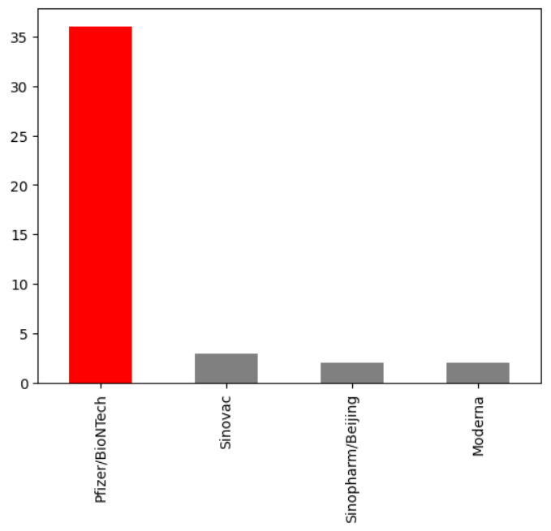

number_of_days = (df["date"].max() -df["date"].min() ).days

dtfrm["average_vaccination_count"] = dtfrm["Total_vaccine"] / number_of_days

dtfrm["average_vaccination_count"] =dtfrm["average_vaccination_count"].astype(int)

color=["Lightblue","Purple","Green","Orange","darkgoldenrod","tan","Gray","Blue","Pink","Lightgreen"]

dtfrm["average_vaccination_count"].sort_values(ascending=False).head(10).plot(kind="bar",color=color)

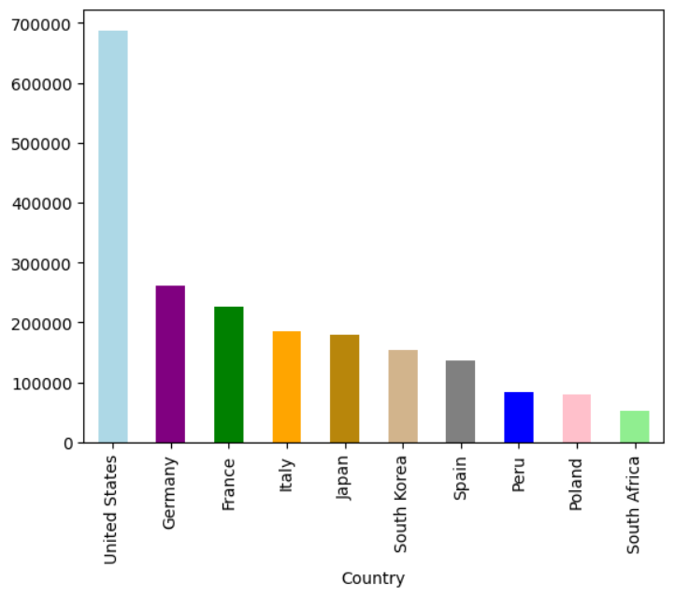

number_of_vaccines = data.groupby('Vaccine')['Country'].nunique()

number_of_vaccines.sort_values(ascending=False).plot(kind="bar",color="r")

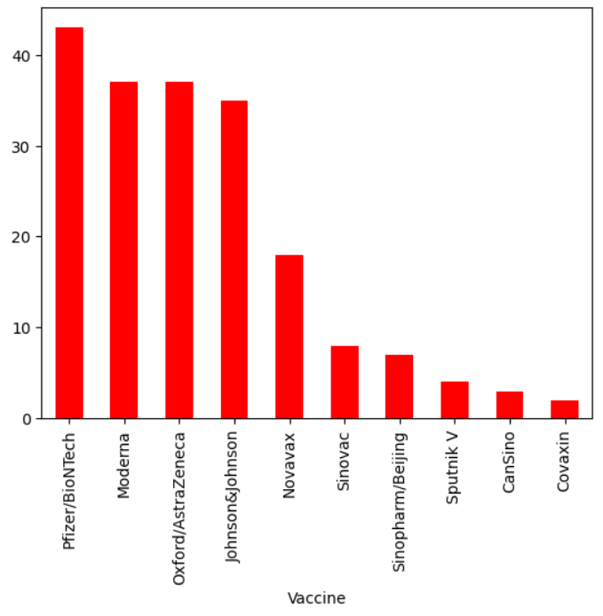

fig = px.choropleth(data_frame=dtfrm,

                    locations=dtfrm.index,

                    locationmode='country names',

                    color='Total_vaccine',

                    color_continuous_scale='YlOrRd',

                    title='Ülkelerde Yapılan Biontech Aşıları')

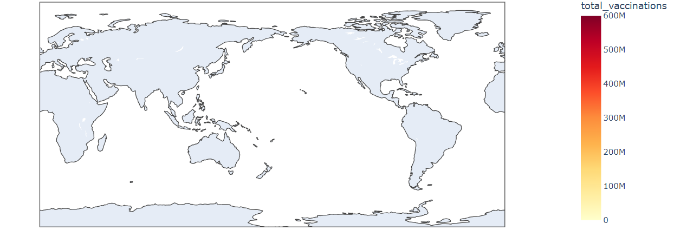

3. Machine Learning for Predictive Insights:

Here, we have used machine learning algorithm to test the data model accuracy. To test the model accuracy we need to import the dataset to sklearn and later the dataset will be splitted into two parts which are x and y. Now divide the training and testing data and start prediction by loading it into the iris. Here, we used Support Vector Machine(SVM) to predict the model accuracy.

# Import necessary libraries

from sklearn import datasets

from sklearn.model_selection import train_test_split

from sklearn import svm

from sklearn.metrics import accuracy_score

# Load a sample dataset (you can replace this with your own data)

# Here, we'll use the famous Iris dataset for illustration

iris = datasets.load_iris()

X = iris.data

y = iris.target

# Split the data into training and testing sets

X_train, X_test, y_train, y_test = train_test_split(X, y, test_size=0.3, random_state=42)

# Create an SVM classifier

clf = svm.SVC(kernel='linear')  # You can choose different kernels like 'linear', 'rbf', 'poly', etc.

# Train the SVM model on the training data

clf.fit(X_train, y_train)

# Make predictions on the test data

y_pred = clf.predict(X_test)

# Calculate and print the accuracy of the model

accuracy = accuracy_score(y_test, y_pred)

print(f"Accuracy: {accuracy * 100:.2f}%")

Accuracy: 100.00%

**Insights that can help website owners improve the user experience:**

1. Localized Information: Provide region-specific COVID-19 updates, ensuring users receive relevant and timely information related to their area. This localized approach enhances user engagement and trust.
2. Timely Communication: Stay informed about the latest COVID-19 developments to communicate effectively with website visitors. Timely updates on restrictions, guidelines, and safety measures through banners or pop-ups foster trust and engagement.
3. Adaptable Services: Align website services with current needs. For instance, optimize ecommerce platforms for online transactions during lockdowns or offer virtual consultations. Adaptable services enhance user experience by meeting evolving user preferences.
4. Safety Protocols and User Confidence: Display transparent information about COVID-19 safety protocols adopted by the website. Clear communication about hygiene practices, contactless options, and social distancing measures instills user confidence, encouraging interactions and transactions.
5. Community Support and Engagement: Website owners can leverage insights from the analysis to initiate community-focused initiatives. This could include supporting local businesses through the website, organizing online community events, or promoting charitable activities. Websites that actively contribute to community well-being tend to foster a positive user sentiment, creating a sense of belonging and enhancing the overall user experience.
6. User Education: COVID-19 analysis insights can be used to educate website visitors. Websites can host informative content about the virus, preventive measures, vaccination information, and mental health resources. Well-researched and accurate information not only educates users but also positions the website as a reliable source of information, enhancing its credibility and user trust.