

VILNIUS UNIVERSITY
ŠIAULIAI ACADEMY
BACHELOR PROGRAMME SOFTWARE ENGINEERING
Student – Maksim Hrybok
Programming Project: Utilization of Open Data

1. Task Description
Project Goals
The goal of this project is to develop a web-based "Eurostat Education Analyzer". The application acts as an interface between the user and the Eurostat API. It aims to:
- Dynamically retrieve live data regarding student enrollment in Tertiary Education (Universities).
- Allow users to filter data by Year, Field of Education (e.g., ICT, Engineering, Arts), and Country.
- Process the hierarchical JSON data into a flat, readable format.
- Present the results in a ranked HTML table to identify which countries have the highest student numbers in selected fields.
Open Data Source
- Source Name: Eurostat (European Commission)
- Dataset Code: educ_uoe_enrt03
- Dataset Title: Students enrolled in tertiary education by education level, programme orientation, sex, and field of education.
- Link: https://ec.europa.eu/eurostat/databrowser/view/educ_uoe_enrt03/default/table?lang=en
2. Project Architecture and Structure
Programming Language Justification
PHP was chosen for this project for the following reasons:
- Backend Data Processing: PHP is highly efficient at handling server-side API requests using file_get_contents or cURL.
- JSON Handling: The project relies heavily on parsing nested JSON structures. PHP’s native json_decode() function converts Eurostat's complex JSON-STAT format into associative arrays quickly and reliably.
- Dynamic HTML Generation: PHP allows for the seamless embedding of logic within HTML, enabling the rapid rendering of data tables without requiring complex frontend JavaScript frameworks.
Program Structure
The project is implemented using Object-Oriented Programming (OOP) principles to ensure modularity and clean code. The entire solution is contained in index.php but is logically divided into three distinct classes:
- Class EurostatConfig:
  - Purpose: Acts as a data dictionary. It stores static configurations such as the list of Country Codes (EU, EFTA, Candidate countries) and ISCED-F13 Field Codes.
  - Role: Decouples configuration data from business logic.
- Class EurostatFetcher:
  - Purpose: Handles the connection to the Eurostat REST API.
  - Role: It constructs the dynamic URL query string (using http_build_query) based on user filters (Year, Field, Countries) and executes the GET request.
- Class DataProcessor:
  - Purpose: Responsible for parsing the raw JSON-STAT response.
  - Role: It maps "Country Indices" (e.g., "0", "1") to "Country Labels" (e.g., "Austria", "Belgium") and extracts the corresponding student counts. It also handles sorting the final array.
- Main Controller & View:
  - Purpose: Handles the user input ($_GET request), instantiates the classes, and renders the HTML form and result table.
Algorithm (Data Processing Logic)
The data flow follows a linear Request-Process-Response model:
- User Input: The user selects a Year, a Field of Study, and specific Countries via the HTML form.
- Data Acquisition:
  - The EurostatFetcher receives parameters.
  - Constructs URL: BASE_URL + ?iscedf13=[FIELD]&time=[YEAR]&geo=[COUNTRY_1]&geo=[COUNTRY_2]...
  - Sends HTTP GET Request to Eurostat.
- Validation:
  - IF response is failure
$$→$$
Throw Exception (Error Message).
  - IF response is success
$$→$$
Decode JSON to Array.
- Processing:
  - Extract dimension.geo.category.index (Country IDs).
  - Extract dimension.geo.category.label (Country Names).
  - Extract value (Student Counts).
  - Loop through IDs
$$→$$
Match with Name and Value.
- Aggregation & Sorting:
  - Create a clean list of objects: [{code: 'DE', name: 'Germany', count: 800000}, ...].
  - Sort list Descending by count.
- Result Presentation:
  - Render HTML Table rows (<tr>) using a foreach loop.

3. Result Examples

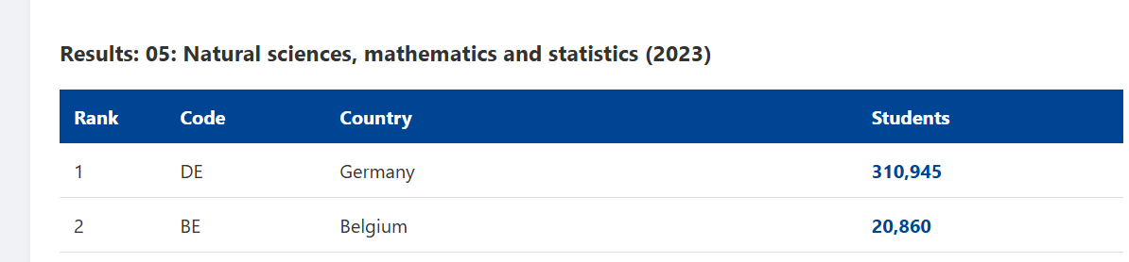

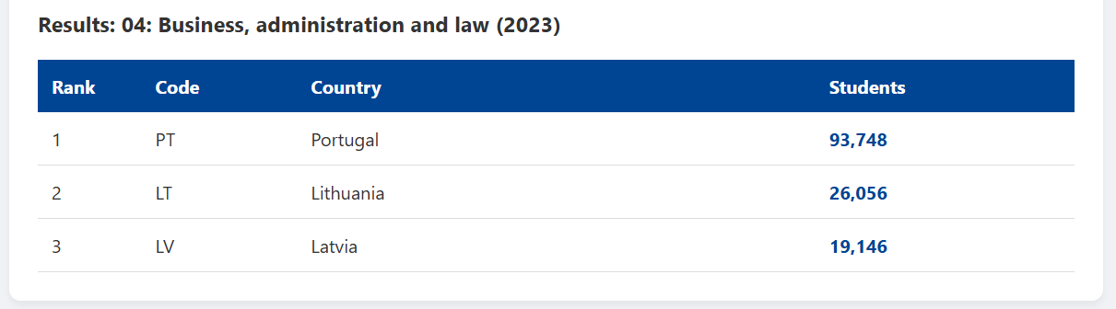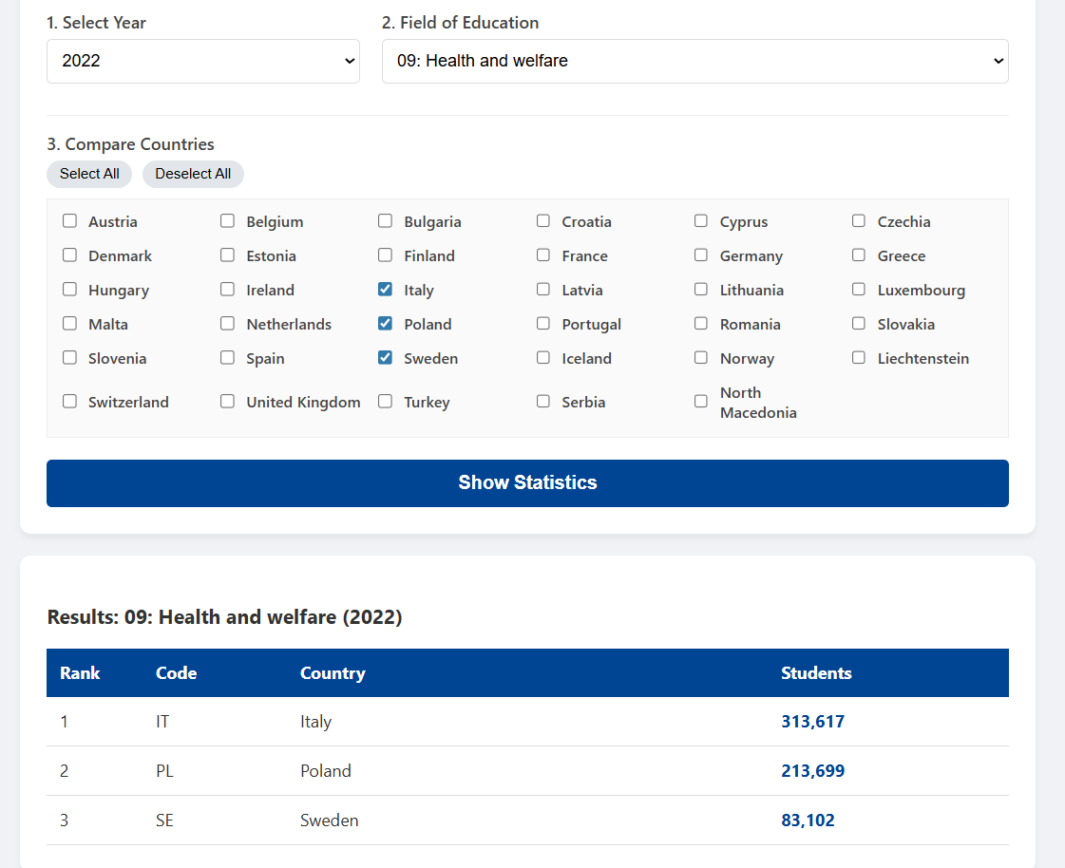

Student : Maksim Hrybok
Šiauliai, 2025

