project 3

Combining Multiple Behaviors

CS-521 Robotics

Vatsal Thakar (012190256)

**Introduction**

The goal of the assignment was to combine multiple behaviours and reach the goal position. The programme was made on top of the pilot navigator module which I made for project 2.

**X=6 Y=6**

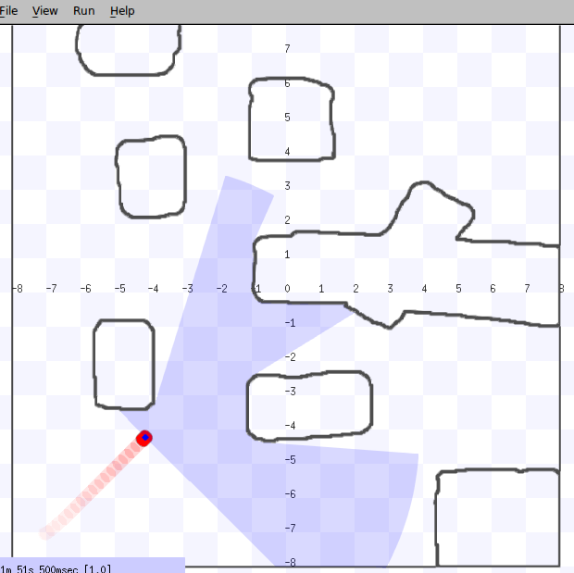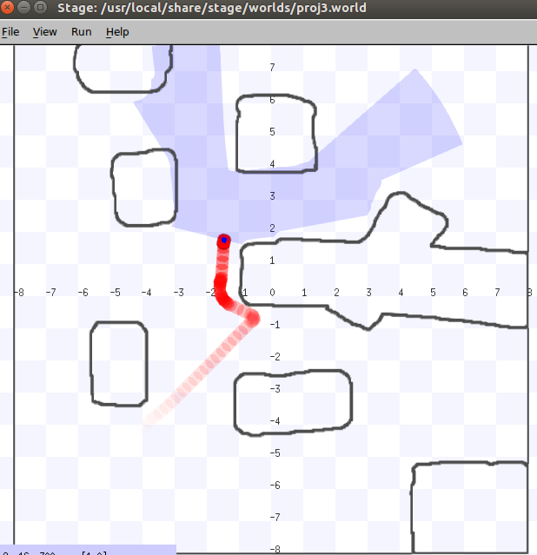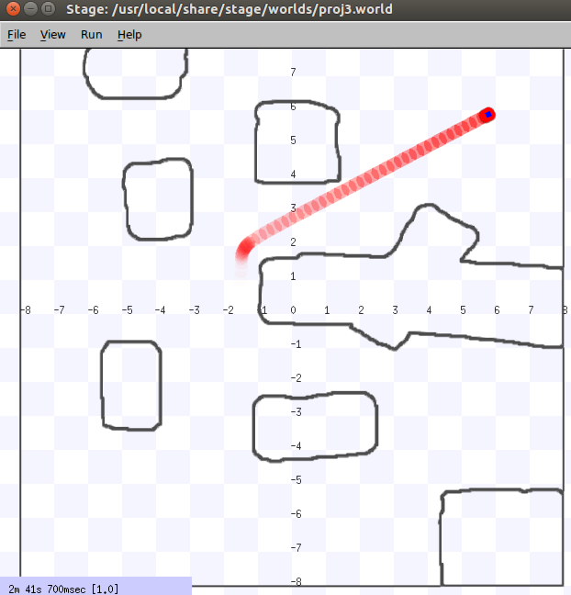

**X=-4 Y=5**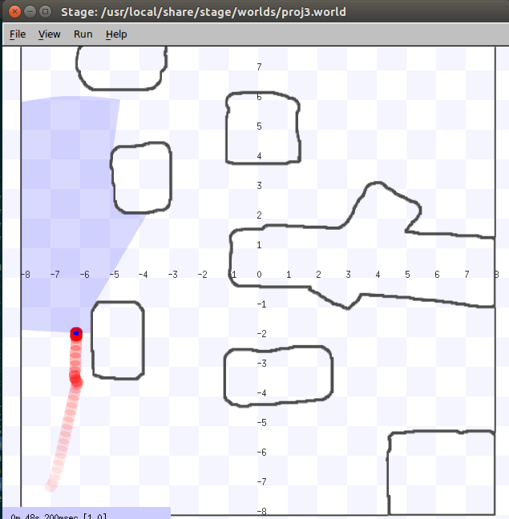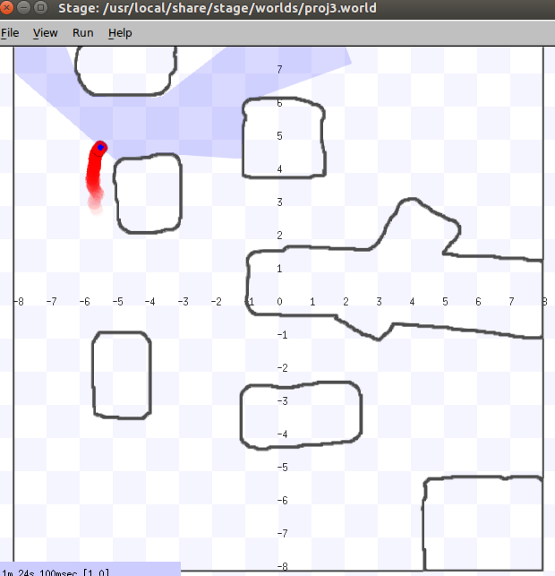

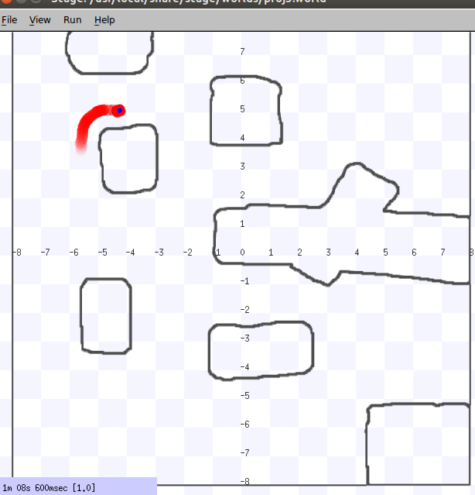

**X=6 Y=3**

