Project 4

Path planning and navigation

CS 521-Robotics

Vatsal Thakar(012190256)

**A discussion of issues you ran into in getting your robot's behavior to work properly, particularly, when robot moves through doorways. Another issue you may run into is the obstacle avoidance behavior knocking the robot off its path, and then the robot having difficulty picking back up the path. If so, please discuss how you handled this issue. Finally, a discussion on the set up of your grid map, such as obstacle growth, etc**

While developing this project , I had faced many issues.To reach the final solution I had divided whole problem into subproblems.The first problem i faced was propagating the wavefront as the file wasn’t putting the robot and goal position to their right places.After solving that I met with the second hurdle which was to generate a path from robot’s starting position to goal position.After solving that I had to solve the third issue which is a major one and took lot of time to solve and that is to convert array index to coordinate values on the map and vice-versa.This was the hardest one as I had to find the exact array index for a particular point.Fourth problem was too many subgoals as wavefront generates too many waypoints so I had to remove some of them through path relaxation.

One of the major problem was obstacle growth.The reason it was major Is because growing obstacle in triple size would close any path between doorways and if the obstacle is grown in small size than there were chances that robot would hit the obstacle.So I finally used double pixel for obstacles as it wasn’t blocking the path between doorways.

**Path planner result: For each goal position, you should document the final series of waypoints that are generated by your path planner. To represent them on the hospital_section map, you can use the functions in the inputMap.cc to mark the waypoints on the map and include them in your report.**

|  |  |  |  |
| --- | --- | --- | --- |
| **( 7.5, 5.5)** | **(8.5, -4)** | **(-18.5, 7)** | **(-9, -4)** |
| [-10.5714, 3]  [-10.5714, 3]  [-10.2857, 4]  [-9.85714, 4]  [-9.42857, 4]  [-9, 4]  [-8.57143, 4]  [-8.14286, 4]  [-7.71429, 4]  [-7.28571, 4]  [-6.85714, 4]  [-6.42857, 4]  [-6, 4]  [-5.57143, 4]  [-5.14286, 4]  [-4.71429, 4]  [-4.57143, 4]  [-4.14286, 4]  [-3.71429, 4]  [-3.28571, 4]  [-2.85714, 4]  [-2.42857, 4]  [-2, 4]  [-1.57143, 4]  [-1.14286, 4]  [-0.714286, 4]  [-0.285714, 4]  [0.142857, 4]  [0.571429, 4]  [1, 4]  [1.42857, 4]  [1.85714, 4]  [2.28571, 4]  [2.71429, 4]  [3.14286, 4]  [3.57143, 4]  [4, 4]  [4.42857, 4]  [4.85714, 4]  [5.28571, 4]  [5.71429, 4]  [6.14286, 4]  [6.28571, 4]  [6.57143, 4]  [6.57143, 5]  [6.57143, 5]  [6.71429, 5] | [-10.4286, 3]  [-10.1429, 3]  [-9.71429, 3]  [-9.28571, 3]  [-8.85714, 3]  [-8.42857, 3]  [-8, 3]  [-7.57143, 3]  [-7.14286, 3]  [-6.71429, 3]  [-6.28571, 3]  [-5.85714, 3]  [-5.42857, 3]  [-5, 3]  [-4.71429, 3]  [-4.28571, 3]  [-3.85714, 3]  [-3.42857, 3]  [-3, 3]  [-2.57143, 3]  [-2.14286, 3]  [-1.71429, 3]  [-1.28571, 3]  [-0.857143, 3]  [-0.428571, 3]  [0, 3]  [0.428571, 3]  [0.857143, 3]  [1.28571, 3]  [1.71429, 3]  [2.14286, 3]  [2.42857, 3]  [2.71429, 3]  [2.71429, 2]  [2.85714, 2]  [3, 2]  [3, 1]  [3, 1]  [3, 0]  [3, 0]  [3, -1]  [3, -1]  [3, -1]  [3, -2]  [3, -2]  [3, -3]  [3, -3]  [3.42857, -3]  [3.85714, -3]  [4.28571, -3]  [4.71429, -3]  [5.14286, -3]  [5.57143, -3]  [5.85714, -3]  [6.28571, -3]  [6.71429, -3]  [7.14286, -3]  [7.28571, -4]  [7.71429, -4] | [-10.5714, 3]  [-10.5714, 3]  [-10.5714, 4]  [-11, 4]  [-11.4286, 4]  [-11.8571, 4]  [-12.2857, 4]  [-12.7143, 4]  [-13.1429, 4]  [-13.5714, 4]  [-14, 4]  [-14.4286, 4]  [-14.8571, 4]  [-15.2857, 4]  [-15.7143, 4]  [-16.1429, 4]  [-16.5714, 4]  [-16.8571, 4]  [-17.1429, 4]  [-17.1429, 5]  [-17.1429, 5]  [-17.1429, 5]  [-17.1429, 6]  [-17.1429, 6]  [-17.1429, 7]  [-17.1429, 7]  [-17.2857, 7]  [-17.7143, 7] | [-10.5714, 3]  [-10.7143, 3]  [-11, 3]  [-11, 2]  [-11, 2]  [-11, 1]  [-11, 1]  [-11, 0]  [-11, 0]  [-11, 0]  [-10.5714, 0]  [-10.1429, 0]  [-9.71429, 0]  [-9.28571, 0]  [-8.85714, 0]  [-8.42857, 0]  [-8.28571, -1]  [-8.14286, -1]  [-8.14286, -1]  [-7.85714, -2]  [-7.85714, -2]  [-7.85714, -2]  [-7.85714, -3]  [-7.85714, -3]  [-8, -4]  [-8.42857, -4]  [-8.85714, -4] |

**4 screen dumps of your robot moving along the 4 goal points mentioned above. Be sure to**

**turn on the robot trace. You just need to include the screen dumps inside your project**

**report, there's no need to include the images separately in your submission.**

**Point (7.5, 5.5)** 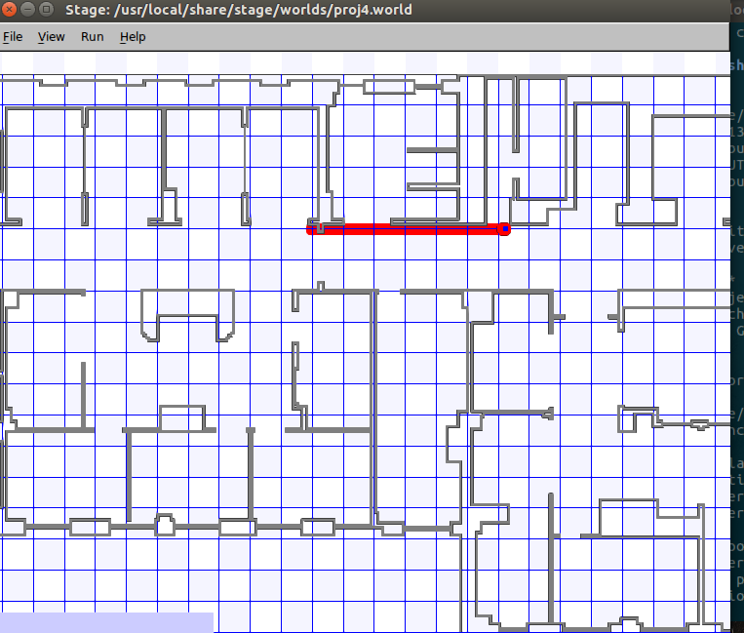

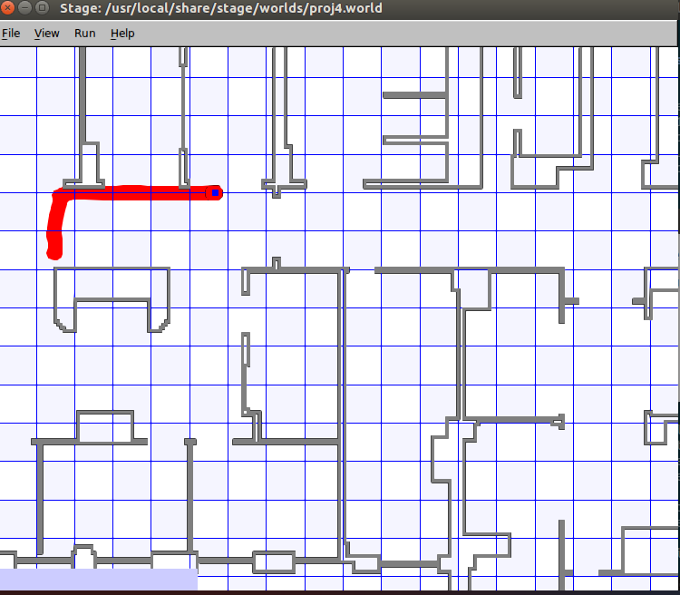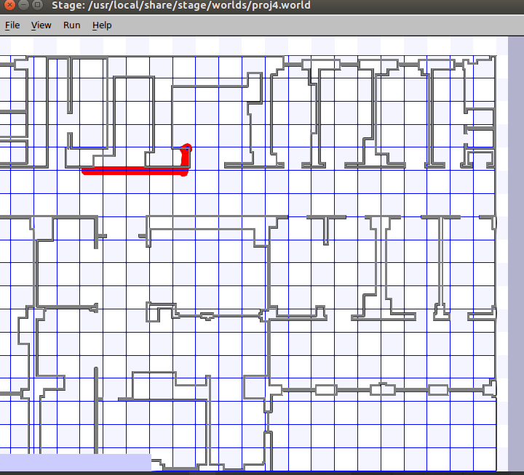

**Point (8.5, -4)**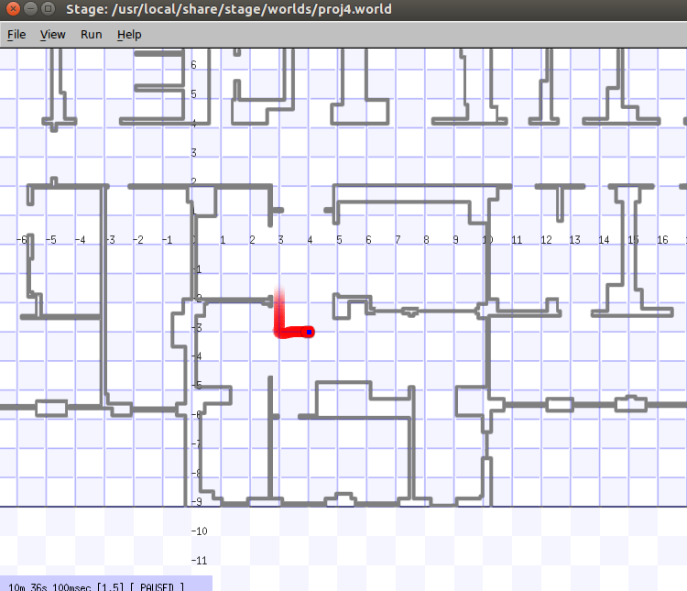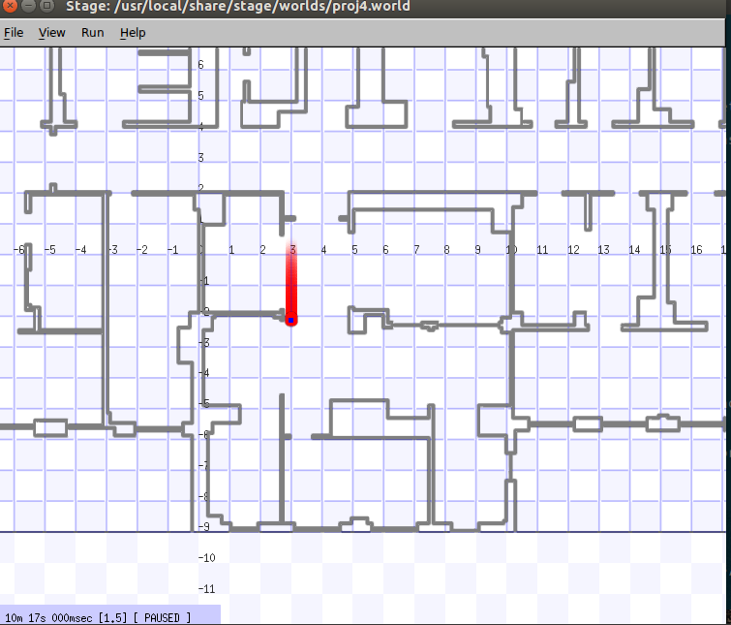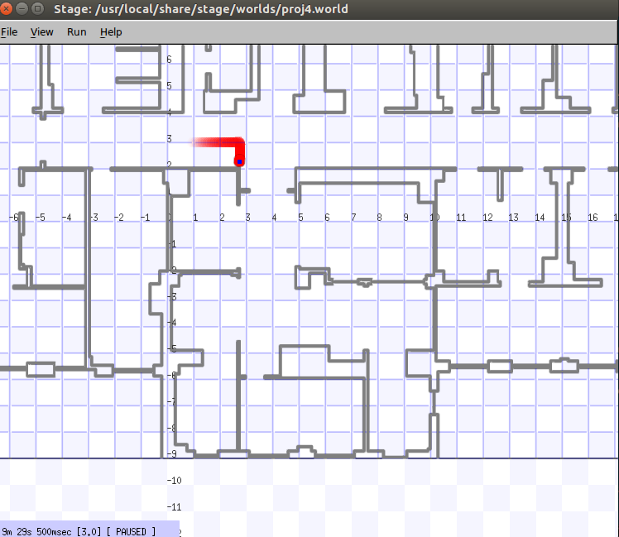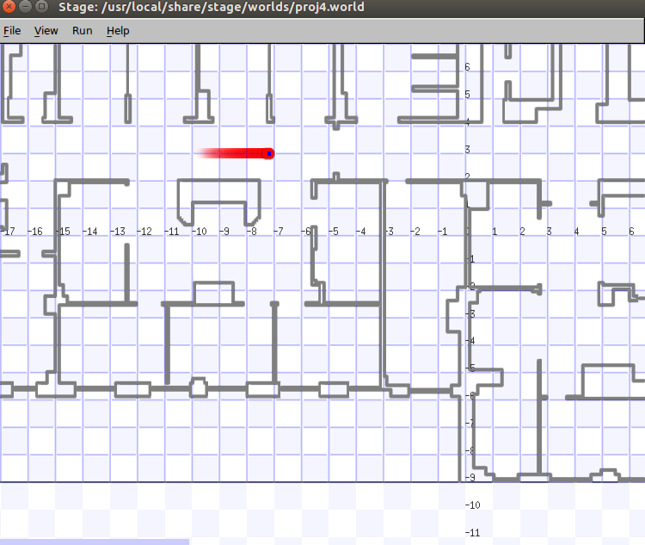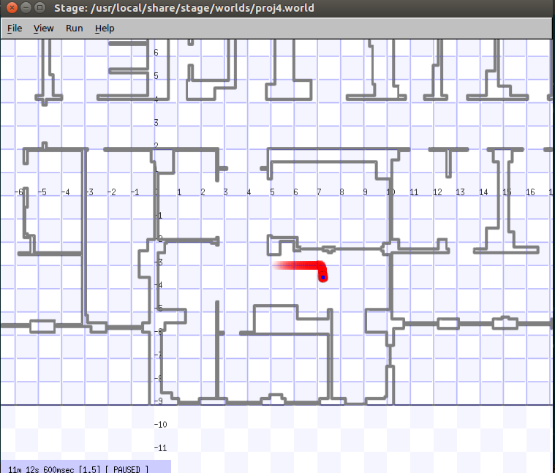

**Point(-18.5, 7)** 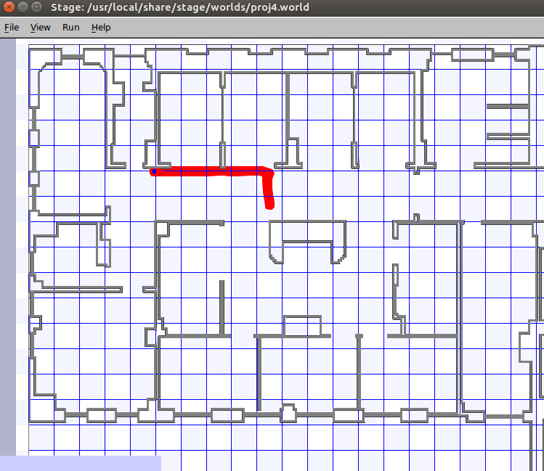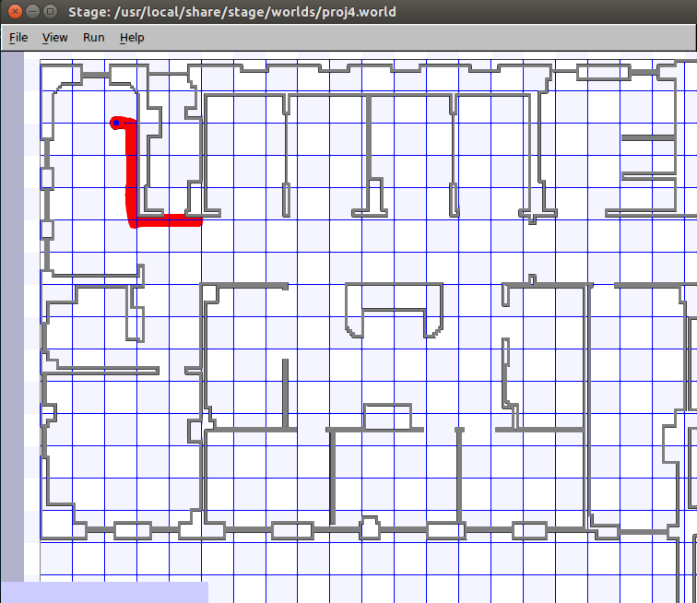

**Point(-9, -4)**