

Лабораторная работа №17
Вариант №4

Выполнила:
Пашина Валентина Петровна

г. Улан-Удэ
2026 г.
Главное меню
Листинг код XAML:
<Window x:Class="LR170101.MainWindow"
xmlns="http://schemas.microsoft.com/winfx/2006/xaml/presentation"
xmlns:x="http://schemas.microsoft.com/winfx/2006/xaml"
xmlns:d="http://schemas.microsoft.com/expression/blend/2008"
xmlns:mc="http://schemas.openxmlformats.org/markup-compatibility/2006"
xmlns:local="clr-namespace:LR170101"
mc:Ignorable="d"
Title="MainWindow" Height="450" Width="800">
<Grid>
<Button Content="Пример 1" HorizontalAlignment="Left" Margin="38,62,0,0" VerticalAlignment="Top" Click="Button_Click" Height="35" Width="242"/>
<Button Content="Пример 2" HorizontalAlignment="Left" Margin="305,62,0,0" VerticalAlignment="Top" Click="Button_Click_1" Height="35" Width="242"/>
<Button Content="Пример 3" HorizontalAlignment="Left" Margin="38,113,0,0" VerticalAlignment="Top" Click="Button_Click_2" Height="35" Width="242"/>
<Button Content="Пример 4" HorizontalAlignment="Left" Margin="305,113,0,0" VerticalAlignment="Top" Click="Button_Click_3" Height="35" Width="242"/>
<Button Content="Пример 5" HorizontalAlignment="Left" Margin="38,167,0,0" VerticalAlignment="Top" Click="Button_Click_4" Height="33" Width="242"/>
<Button Content="Пример 6" HorizontalAlignment="Left" Height="33" Margin="305,167,0,0" VerticalAlignment="Top" Width="242" Click="Button_Click_5"/>
<Button Content="Задание 1" HorizontalAlignment="Left" Margin="38,277,0,0" VerticalAlignment="Top" Click="Button_Click_6" Height="38" Width="242"/>
<Button Content="Задание 2" HorizontalAlignment="Left" Margin="305,277,0,0" VerticalAlignment="Top" Click="Button_Click_7" Height="38" Width="242"/>

</Grid>
</Window>
CS:
using System;
using System.Collections.Generic;
using System.Linq;
using System.Text;
using System.Threading.Tasks;
using System.Windows;
using System.Windows.Controls;
using System.Windows.Data;
using System.Windows.Documents;
using System.Windows.Input;
using System.Windows.Media;
using System.Windows.Media.Imaging;
using System.Windows.Navigation;
using System.Windows.Shapes;

namespace LR170101
{

public partial class MainWindow : Window
{
public MainWindow()
{
InitializeComponent();
}

private void Button_Click(object sender, RoutedEventArgs e)
{
Window1 Window1 = new Window1();
Window1.Show();
}

private void Button_Click_1(object sender, RoutedEventArgs e)
{
Primer2 Primer2 = new Primer2();
Primer2.Show();
}

private void Button_Click_2(object sender, RoutedEventArgs e)
{
Window2 Window2 = new Window2();
Window2.Show();
}

private void Button_Click_3(object sender, RoutedEventArgs e)
{

Window3 Window3 = new Window3();
Window3.Show();
}

private void Button_Click_4(object sender, RoutedEventArgs e)
{
Window4 Window4 = new Window4();
Window4.Show();
}

private void Button_Click_5(object sender, RoutedEventArgs e)
{
Window5 Window5 = new Window5();
Window5.Show();
}

private void Button_Click_6(object sender, RoutedEventArgs e)
{
Zadanie1 Zadanie1 = new Zadanie1();
Zadanie1.Show();
}

private void Button_Click_7(object sender, RoutedEventArgs e)
{
Zadanie2 Zadanie2 = new Zadanie2();
Zadanie2.Show();
}
}
}
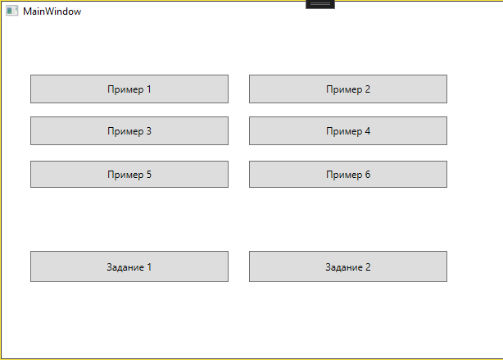
Рис.1 «Результат»

Пример 1
Листинг код:
<Window x:Class="LR170101.Window1"
xmlns="http://schemas.microsoft.com/winfx/2006/xaml/presentation"
xmlns:x="http://schemas.microsoft.com/winfx/2006/xaml"
xmlns:d="http://schemas.microsoft.com/expression/blend/2008"
xmlns:mc="http://schemas.openxmlformats.org/markup-compatibility/2006"
xmlns:local="clr-namespace:LR170101"
mc:Ignorable="d"
Title="Window1" Height="450" Width="800">
<StackPanel HorizontalAlignment="Center" VerticalAlignment="Center">
<StackPanel.RenderTransform>
<RotateTransform Angle="30" CenterX="0" CenterY="0" />
</StackPanel.RenderTransform>

<Button Content="Обычная кнопка" />
<TextBox Text="Текстовое поле" />
<StackPanel Orientation="Horizontal">
<CheckBox Content="Красный" />
<CheckBox Content="Зеленый" />
<CheckBox Content="Синий" />
</StackPanel>
<Rectangle Width="200" Height="30" Fill="Wheat" Stroke="Brown"
StrokeThickness="2" RadiusX="15" RadiusY="15" />
</StackPanel>
</Window>
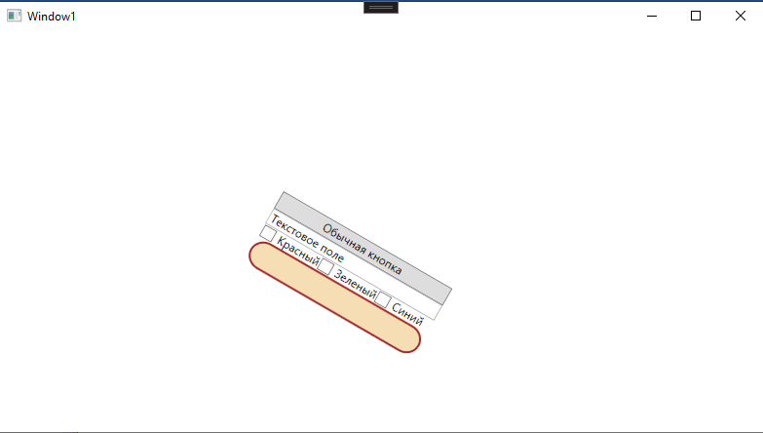
Рис.2 «Результат»

Пример 2
Листинг код:
<Window x:Class="LR170101.Primer2"
xmlns="http://schemas.microsoft.com/winfx/2006/xaml/presentation"
xmlns:x="http://schemas.microsoft.com/winfx/2006/xaml"
xmlns:d="http://schemas.microsoft.com/expression/blend/2008"
xmlns:mc="http://schemas.openxmlformats.org/markup-compatibility/2006"
xmlns:local="clr-namespace:LR170101"
mc:Ignorable="d"
Title="Primer2" Height="450" Width="800">
<StackPanel HorizontalAlignment="Center" VerticalAlignment="Center" Height="89" Width="212">
<StackPanel.RenderTransform>
<ScaleTransform ScaleX="2" ScaleY="0.8" CenterX="100" CenterY="100" />
</StackPanel.RenderTransform>
<Button Content="Обычная кнопка" />
<TextBox Text="Текстовое поле" />
<StackPanel Orientation="Horizontal">
<CheckBox Content="Красный" />
<CheckBox Content="Зеленый" />
<CheckBox Content="Синий" />
</StackPanel>
<Rectangle Width="200" Height="30" Fill="Wheat" Stroke="Brown"
StrokeThickness="2" RadiusX="15" RadiusY="15" />
</StackPanel>
</Window>
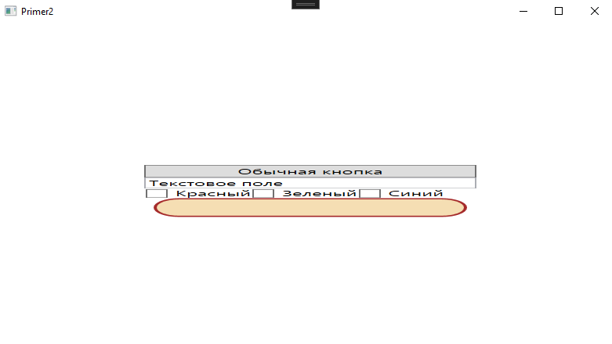
Рис.3 «Результат»

Пример 3
Листинг код:
<Window x:Class="LR170101.Window2"
xmlns="http://schemas.microsoft.com/winfx/2006/xaml/presentation"
xmlns:x="http://schemas.microsoft.com/winfx/2006/xaml"
xmlns:d="http://schemas.microsoft.com/expression/blend/2008"
xmlns:mc="http://schemas.openxmlformats.org/markup-compatibility/2006"
xmlns:local="clr-namespace:LR170101"
mc:Ignorable="d"
Title="Window2" Height="450" Width="800">
<StackPanel HorizontalAlignment="Center" VerticalAlignment="Center">
<StackPanel.RenderTransform>
<SkewTransform AngleX="20" AngleY="20" CenterX="100" CenterY="100" />
</StackPanel.RenderTransform>

<Button Content="Обычная кнопка" />
<TextBox Text="Текстовое поле" />
<StackPanel Orientation="Horizontal">
<CheckBox Content="Красный" />
<CheckBox Content="Зеленый" />
<CheckBox Content="Синий" />
</StackPanel>
<Rectangle Width="200" Height="30" Fill="Wheat" Stroke="Brown"
StrokeThickness="2" RadiusX="15" RadiusY="15" />
</StackPanel>
</Window>
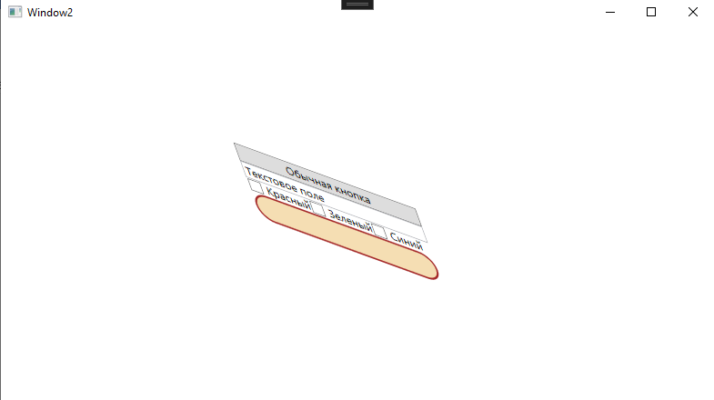
Рис.4 «Результат»

Пример 4
Листинг код:
<Window x:Class="LR170101.Window3"
xmlns="http://schemas.microsoft.com/winfx/2006/xaml/presentation"
xmlns:x="http://schemas.microsoft.com/winfx/2006/xaml"
xmlns:d="http://schemas.microsoft.com/expression/blend/2008"
xmlns:mc="http://schemas.openxmlformats.org/markup-compatibility/2006"
xmlns:local="clr-namespace:LR170101"
mc:Ignorable="d"
Title="Window3" Height="450" Width="800">
<StackPanel HorizontalAlignment="Center" VerticalAlignment="Center">
<StackPanel.RenderTransform>
<TranslateTransform X="100" Y="100" />
</StackPanel.RenderTransform>

<Button Content="Обычная кнопка" />
<TextBox Text="Текстовое поле" />
<StackPanel Orientation="Horizontal">
<CheckBox Content="Красный" />
<CheckBox Content="Зеленый" />
<CheckBox Content="Синий" />
</StackPanel>
<Rectangle Width="200" Height="30" Fill="Wheat" Stroke="Brown"
StrokeThickness="2" RadiusX="15" RadiusY="15" />
</StackPanel>
</Window>
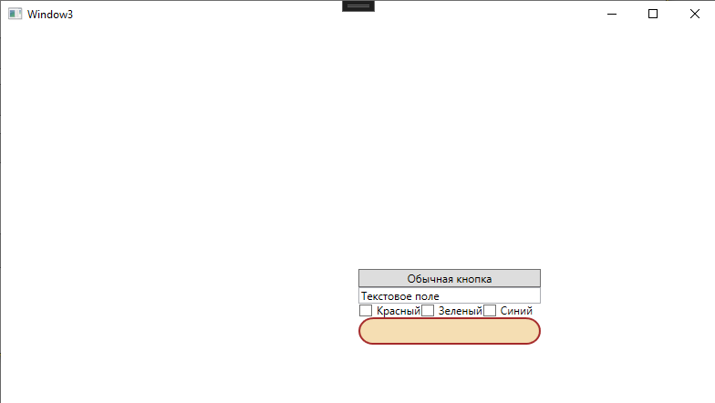
Рис.5 «Результат»

Пример 5
Листинг код:
<Window x:Class="LR170101.Window4"
xmlns="http://schemas.microsoft.com/winfx/2006/xaml/presentation"
xmlns:x="http://schemas.microsoft.com/winfx/2006/xaml"
xmlns:d="http://schemas.microsoft.com/expression/blend/2008"
xmlns:mc="http://schemas.openxmlformats.org/markup-compatibility/2006"
xmlns:local="clr-namespace:LR170101"
mc:Ignorable="d"
Title="Window4" Height="450" Width="800">
<StackPanel HorizontalAlignment="Center" VerticalAlignment="Center">
<StackPanel.RenderTransform>
<TransformGroup>
<RotateTransform Angle="30" />
<ScaleTransform ScaleX="2" ScaleY="0.8" />
<TranslateTransform X="-200" Y="-100" />
</TransformGroup>
</StackPanel.RenderTransform>

<Button Content="Обычная кнопка" />
<TextBox Text="Текстовое поле" />
<StackPanel Orientation="Horizontal">
<CheckBox Content="Красный" />
<CheckBox Content="Зеленый" />
<CheckBox Content="Синий" />
</StackPanel>
<Rectangle Width="200" Height="30" Fill="Wheat" Stroke="Brown"
StrokeThickness="2" RadiusX="15" RadiusY="15" />
</StackPanel>
</Window>
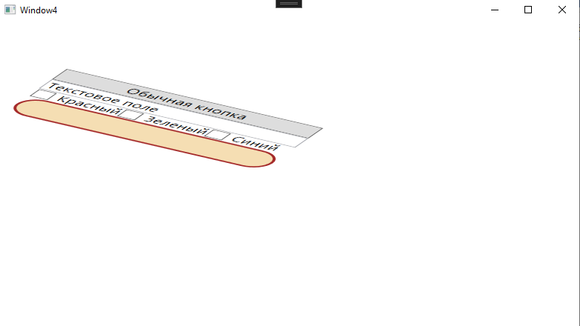
Рис.6 «Результат»

Пример 6
Листинг код:
<Window x:Class="LR170101.Window5"
xmlns="http://schemas.microsoft.com/winfx/2006/xaml/presentation"
xmlns:x="http://schemas.microsoft.com/winfx/2006/xaml"
xmlns:d="http://schemas.microsoft.com/expression/blend/2008"
xmlns:mc="http://schemas.openxmlformats.org/markup-compatibility/2006"
xmlns:local="clr-namespace:LR170101"
mc:Ignorable="d"
Title="Window5" Height="450" Width="800">
<StackPanel HorizontalAlignment="Center" VerticalAlignment="Center">
<StackPanel.RenderTransform>
<RotateTransform Angle="30" CenterX="0" CenterY="0" />
</StackPanel.RenderTransform>

<Button Content="Обычная кнопка"
RenderTransformOrigin="0.5,0.5">
<Button.RenderTransform>
<RotateTransform x:Name="AnimatedRotation" Angle="0" />
</Button.RenderTransform>

<Button.Triggers>
<EventTrigger RoutedEvent="Button.MouseEnter">
<BeginStoryboard>
<Storyboard>
<DoubleAnimation
Storyboard.TargetProperty="RenderTransform.Angle"
From="0" To="360" Duration="0:0:1" />
</Storyboard>
</BeginStoryboard>
</EventTrigger>
</Button.Triggers>
</Button>
<TextBox Text="Текстовое поле" />
<StackPanel Orientation="Horizontal">
<CheckBox Content="Красный" />
<CheckBox Content="Зеленый" />
<CheckBox Content="Синий" />
</StackPanel>
<Rectangle Width="200" Height="30" Fill="Wheat" Stroke="Brown"
StrokeThickness="2" RadiusX="15" RadiusY="15" />
</StackPanel>
</Window>
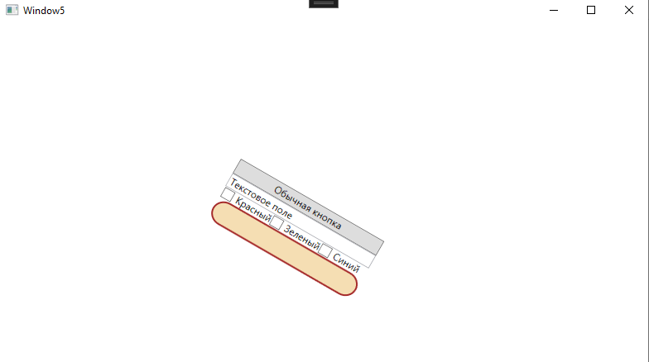
Рис.7 «Результат»

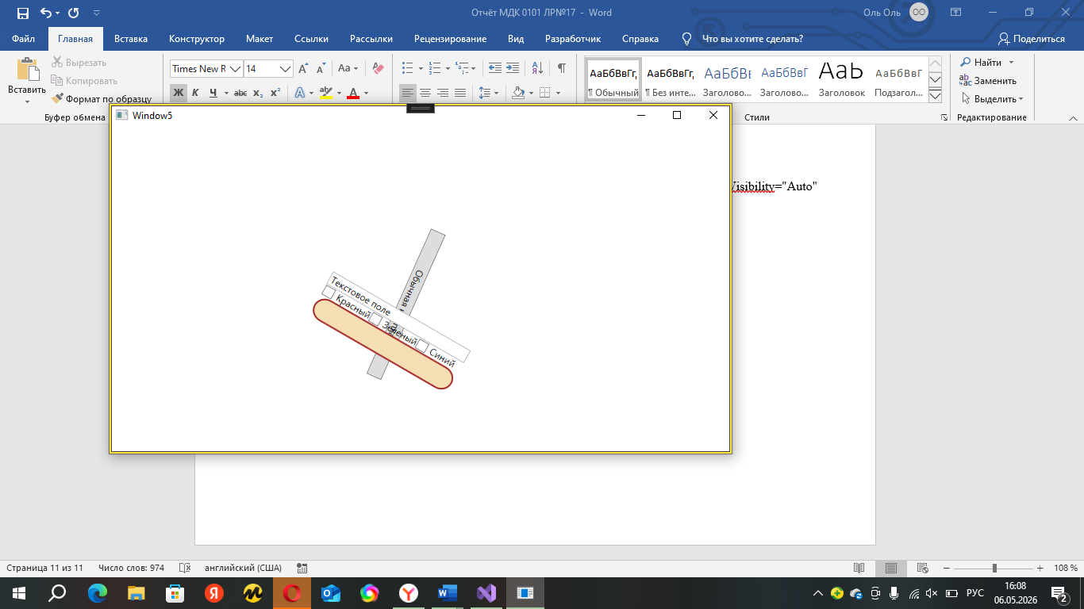
Рис.8 «Результат»

Задание 1
Листинг код:
Задание 2
Листинг код XAML:
<Window x:Class="LR170101.Zadanie2"
xmlns="http://schemas.microsoft.com/winfx/2006/xaml/presentation"
xmlns:x="http://schemas.microsoft.com/winfx/2006/xaml"
Title="Текстовый редактор" Height="550" Width="800"
WindowStartupLocation="CenterScreen">

<Grid>
<Grid.RowDefinitions>
<RowDefinition Height="Auto"/>
<RowDefinition Height="*"/>
</Grid.RowDefinitions>

<StackPanel Grid.Row="0" Orientation="Horizontal" Margin="10" HorizontalAlignment="Center">
<Button x:Name="CopyButton" Width="100" Height="30" Margin="5" Content="Копировать"/>
<Button x:Name="CutButton" Width="100" Height="30" Margin="5" Content="Вырезать"/>
<Button x:Name="PasteButton" Width="100" Height="30" Margin="5" Content="Вставить"/>
</StackPanel>

<Canvas Grid.Row="1" Margin="10">

<Border x:Name="Block1" Width="200" Height="120" Canvas.Left="50" Canvas.Top="280" Background="LightBlue" BorderBrush="Blue" BorderThickness="2" CornerRadius="8">
<Border.Style>
<Style TargetType="Border">
<Style.Triggers>
<Trigger Property="IsKeyboardFocusWithin" Value="True">
<Trigger.EnterActions>
<BeginStoryboard>
<Storyboard>
<DoubleAnimation Storyboard.TargetProperty="(Canvas.Left)" Duration="0:0:0.3" To="300"/>
<DoubleAnimation Storyboard.TargetProperty="(Canvas.Top)" Duration="0:0:0.3" To="150"/>
</Storyboard>
</BeginStoryboard>
</Trigger.EnterActions>
<Trigger.ExitActions>
<BeginStoryboard>
<Storyboard>
<DoubleAnimation Storyboard.TargetProperty="(Canvas.Left)" Duration="0:0:0.3" To="50"/>
<DoubleAnimation Storyboard.TargetProperty="(Canvas.Top)" Duration="0:0:0.3" To="280"/>
</Storyboard>
</BeginStoryboard>
</Trigger.ExitActions>
</Trigger>
</Style.Triggers>
</Style>
</Border.Style>
<TextBox TextWrapping="Wrap" AcceptsReturn="True" VerticalScrollBarVisibility="Auto" Margin="5" FontSize="12"/>
</Border>

<Border x:Name="Block2" Width="200" Height="120" Canvas.Left="280" Canvas.Top="320" Background="LightGreen" BorderBrush="Green" BorderThickness="2" CornerRadius="8">
<Border.Style>
<Style TargetType="Border">
<Style.Triggers>
<Trigger Property="IsKeyboardFocusWithin" Value="True">
<Trigger.EnterActions>
<BeginStoryboard>
<Storyboard>
<DoubleAnimation Storyboard.TargetProperty="(Canvas.Left)" Duration="0:0:0.3" To="300"/>
<DoubleAnimation Storyboard.TargetProperty="(Canvas.Top)" Duration="0:0:0.3" To="150"/>
</Storyboard>
</BeginStoryboard>
</Trigger.EnterActions>
<Trigger.ExitActions>
<BeginStoryboard>
<Storyboard>
<DoubleAnimation Storyboard.TargetProperty="(Canvas.Left)" Duration="0:0:0.3" To="280"/>
<DoubleAnimation Storyboard.TargetProperty="(Canvas.Top)" Duration="0:0:0.3" To="320"/>
</Storyboard>
</BeginStoryboard>
</Trigger.ExitActions>
</Trigger>
</Style.Triggers>
</Style>
</Border.Style>
<TextBox TextWrapping="Wrap" AcceptsReturn="True" VerticalScrollBarVisibility="Auto" Margin="5" FontSize="12"/>
</Border>

<Border x:Name="Block3" Width="200" Height="120" Canvas.Left="510" Canvas.Top="280" Background="LightCoral" BorderBrush="Red" BorderThickness="2" CornerRadius="8">
<Border.Style>
<Style TargetType="Border">
<Style.Triggers>
<Trigger Property="IsKeyboardFocusWithin" Value="True">
<Trigger.EnterActions>
<BeginStoryboard>
<Storyboard>
<DoubleAnimation Storyboard.TargetProperty="(Canvas.Left)" Duration="0:0:0.3" To="300"/>
<DoubleAnimation Storyboard.TargetProperty="(Canvas.Top)" Duration="0:0:0.3" To="150"/>
</Storyboard>
</BeginStoryboard>
</Trigger.EnterActions>
<Trigger.ExitActions>
<BeginStoryboard>
<Storyboard>
<DoubleAnimation Storyboard.TargetProperty="(Canvas.Left)" Duration="0:0:0.3" To="510"/>
<DoubleAnimation Storyboard.TargetProperty="(Canvas.Top)" Duration="0:0:0.3" To="280"/>
</Storyboard>
</BeginStoryboard>
</Trigger.ExitActions>
</Trigger>
</Style.Triggers>
</Style>
</Border.Style>
<TextBox TextWrapping="Wrap" AcceptsReturn="True" VerticalScrollBarVisibility="Auto" Margin="5" FontSize="12"/>
</Border>

<Border x:Name="Block4" Width="200" Height="120" Canvas.Left="160" Canvas.Top="360" Background="LightYellow" BorderBrush="Gold" BorderThickness="2" CornerRadius="8">
<Border.Style>
<Style TargetType="Border">
<Style.Triggers>
<Trigger Property="IsKeyboardFocusWithin" Value="True">
<Trigger.EnterActions>
<BeginStoryboard>
<Storyboard>
<DoubleAnimation Storyboard.TargetProperty="(Canvas.Left)" Duration="0:0:0.3" To="300"/>
<DoubleAnimation Storyboard.TargetProperty="(Canvas.Top)" Duration="0:0:0.3" To="150"/>
</Storyboard>
</BeginStoryboard>
</Trigger.EnterActions>
<Trigger.ExitActions>
<BeginStoryboard>
<Storyboard>
<DoubleAnimation Storyboard.TargetProperty="(Canvas.Left)" Duration="0:0:0.3" To="160"/>
<DoubleAnimation Storyboard.TargetProperty="(Canvas.Top)" Duration="0:0:0.3" To="360"/>
</Storyboard>
</BeginStoryboard>
</Trigger.ExitActions>
</Trigger>
</Style.Triggers>
</Style>
</Border.Style>
<TextBox TextWrapping="Wrap" AcceptsReturn="True" VerticalScrollBarVisibility="Auto" Margin="5" FontSize="12"/>
</Border>

<Border x:Name="Block5" Width="200" Height="120" Canvas.Left="420" Canvas.Top="360" Background="LightGray" BorderBrush="Gray" BorderThickness="2" CornerRadius="8">
<Border.Style>
<Style TargetType="Border">
<Style.Triggers>
<Trigger Property="IsKeyboardFocusWithin" Value="True">
<Trigger.EnterActions>
<BeginStoryboard>
<Storyboard>
<DoubleAnimation Storyboard.TargetProperty="(Canvas.Left)" Duration="0:0:0.3" To="300"/>
<DoubleAnimation Storyboard.TargetProperty="(Canvas.Top)" Duration="0:0:0.3" To="150"/>
</Storyboard>
</BeginStoryboard>
</Trigger.EnterActions>
<Trigger.ExitActions>
<BeginStoryboard>
<Storyboard>
<DoubleAnimation Storyboard.TargetProperty="(Canvas.Left)" Duration="0:0:0.3" To="420"/>
<DoubleAnimation Storyboard.TargetProperty="(Canvas.Top)" Duration="0:0:0.3" To="360"/>
</Storyboard>
</BeginStoryboard>
</Trigger.ExitActions>
</Trigger>
</Style.Triggers>
</Style>
</Border.Style>
<TextBox TextWrapping="Wrap" AcceptsReturn="True" VerticalScrollBarVisibility="Auto" Margin="5" FontSize="12"/>
</Border>

</Canvas>
</Grid>
</Window>
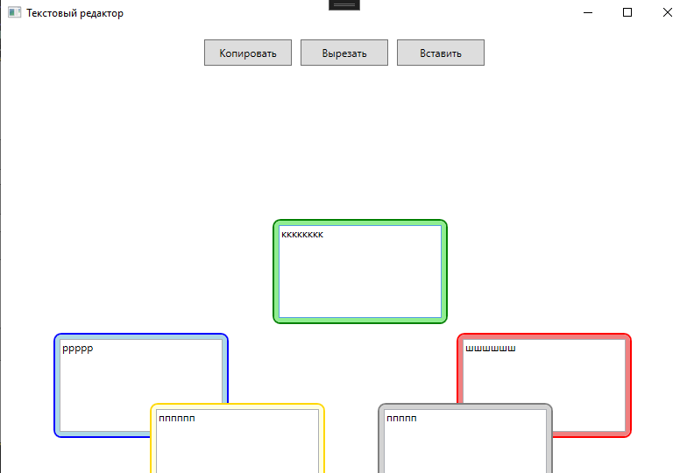
Рис.10 «Результат»

