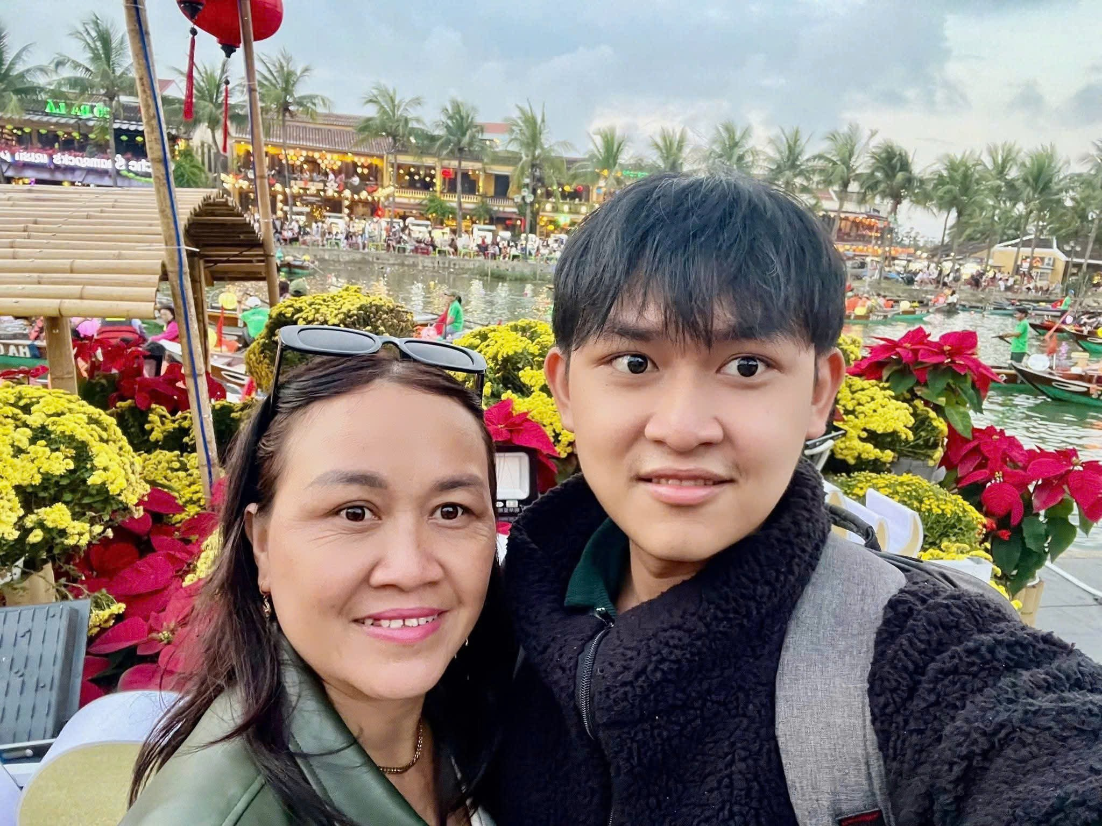
Last Tet holiday, I had a memorable trip to Hoi An with my family. In early February 2026, the ancient town was very beautiful with yellow flowers and thousands of red lanterns. Because it was the New Year, the streets were crowded and busy with many tourists.
My mother and I took many wonderful photos with the fresh flowers to keep our memories. We also visited the ancient Bridge Pagoda and listened to traditional Bai Choi singing. After that, we enjoyed a delicious bowl of Cao Lau, a well-known local dish. It was a relaxing getaway, and I felt truly at peace with my family. It was the ideal start to a new year!

