Lab 10

Houston McDaniel

1.) The SSIDs of the access points issuing most of the beacon frames are “30 Munroe St” and “linksys12”. See below screenshot.



2.) These access points are using channel 6. See below screenshots.

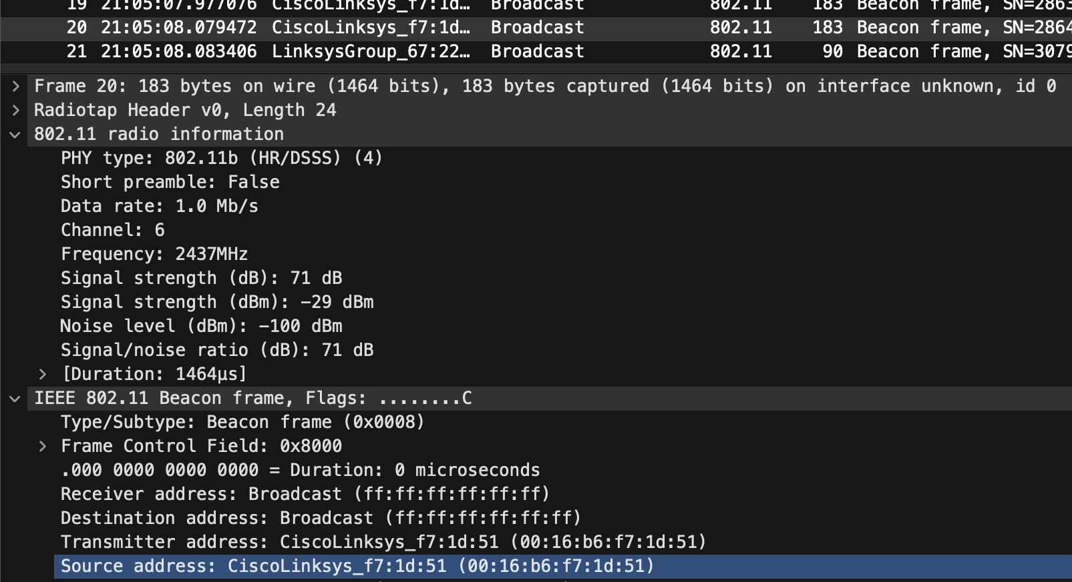

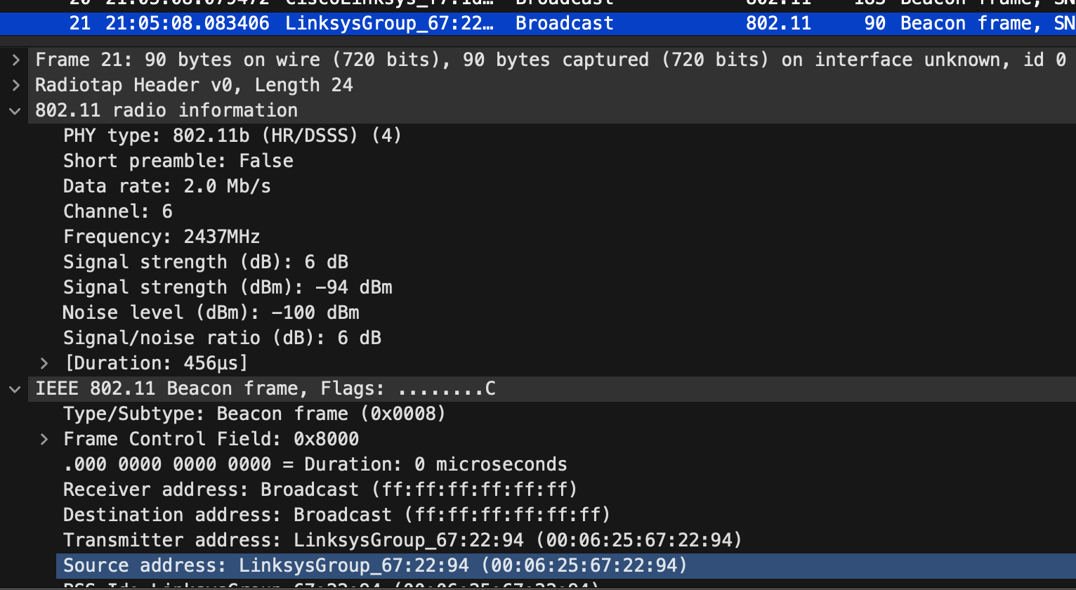

3.) The interval between beacon frames is .1024 seconds.

4.) The source MAC address of the frame is 00:16:b6:f7:1d:51 (CiscoLinksys_f7:1d:51). See below screenshot.

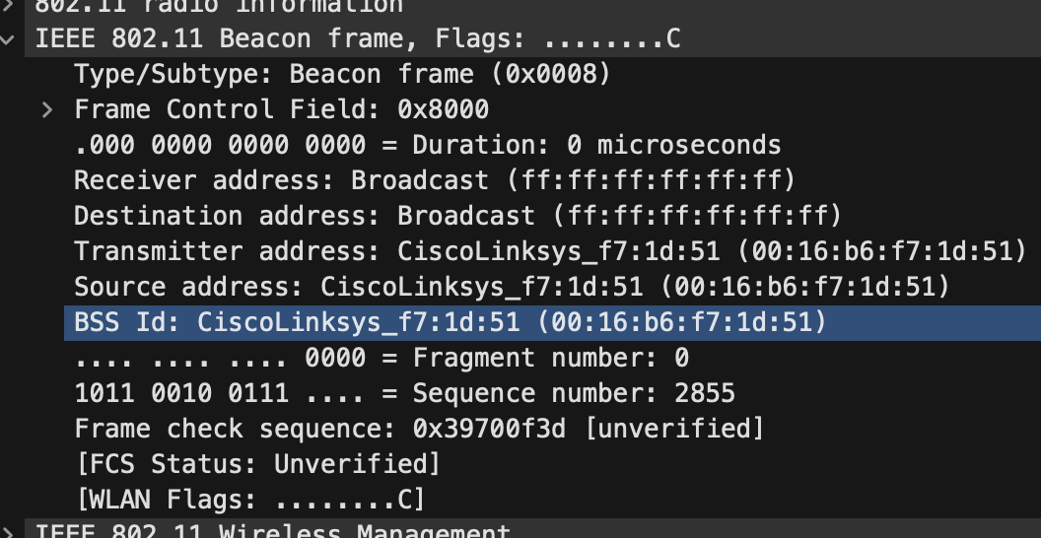

5.) The destination MAC address is ff:ff:ff:ff:ff:ff (Broadcast). See above screenshot.

6.) The MAC BSS ID on 30 Munroe St’s beacon frame is 00:16:b6:f7:1d:51 (CiscoLinksys_f7:1d:51). See above screenshot.

7.) The supported rates are 1(B), 2(B), 5.5(B), 11(B), 6(B), 0, 12(B), 18, 24(B), 36, 48, and 54 Mbit/second. See below screenshot.

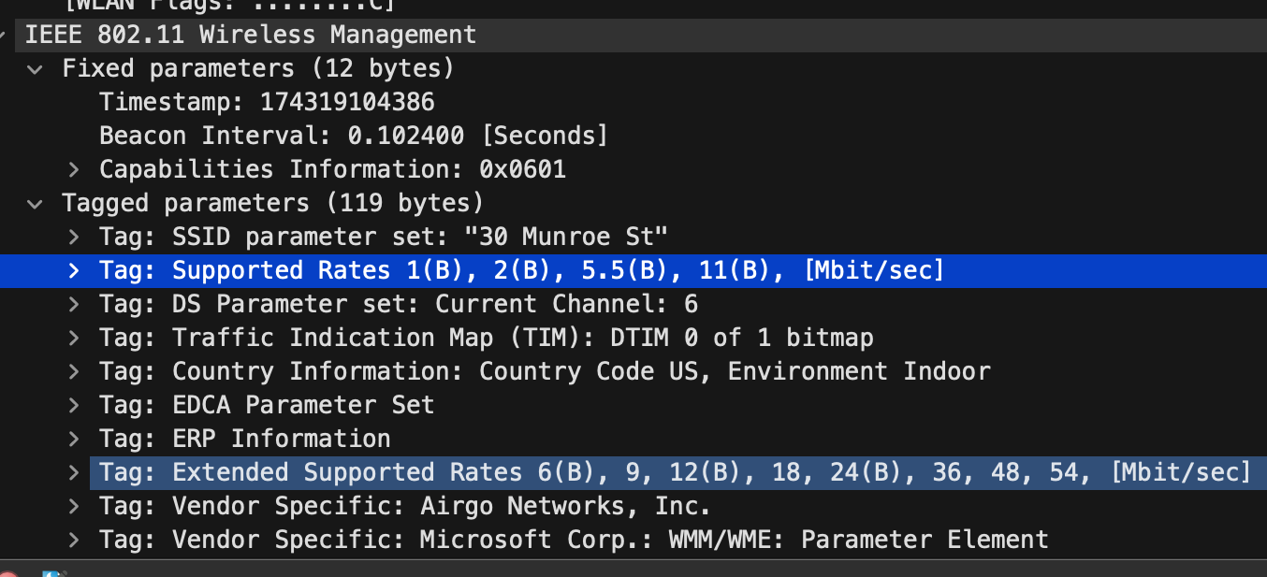

8.) Three MAC address fields are the Receiver address, Transmitter address, and Destination address. The wireless host’s MAC address is 00:13:02:d1:b6:4f, the access point’s MAC address is 00:16:b6:f7:1d:51, and the first hop router’s MAC address (the destination address) is 00:16:b6:f4:eb:a8. The sender and recipient’s IP addresses are 192.168.1.109 and 128.119.245.12 respectively. See below screenshot.

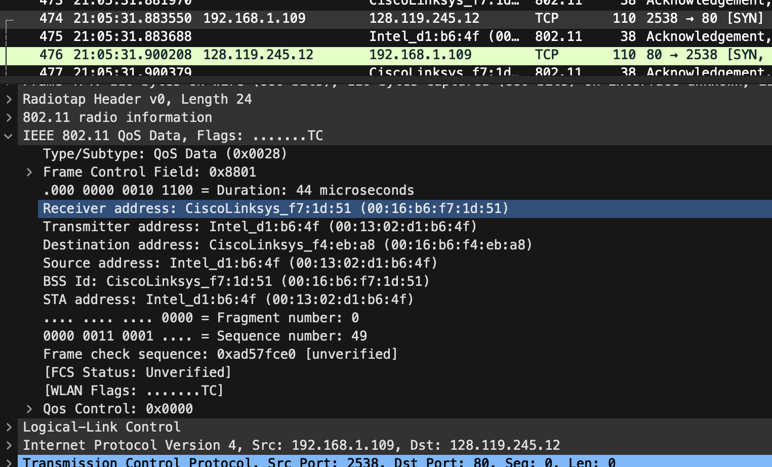

9.) The destination IP address corresponds to the destination web server.

10.) Three MAC address fields are the Receiver address, Transmitter address and Destination address. The MAC address corresponding to the host is the destination address, 91:2a:b0:49:b6:4f. The MAC address corresponding to the access point is the BSS ID, 00:16:b6:f7:1d:51. The MAC address corresponding to the first hop router is the source address, 00:16:b6:f4:eb:a8.

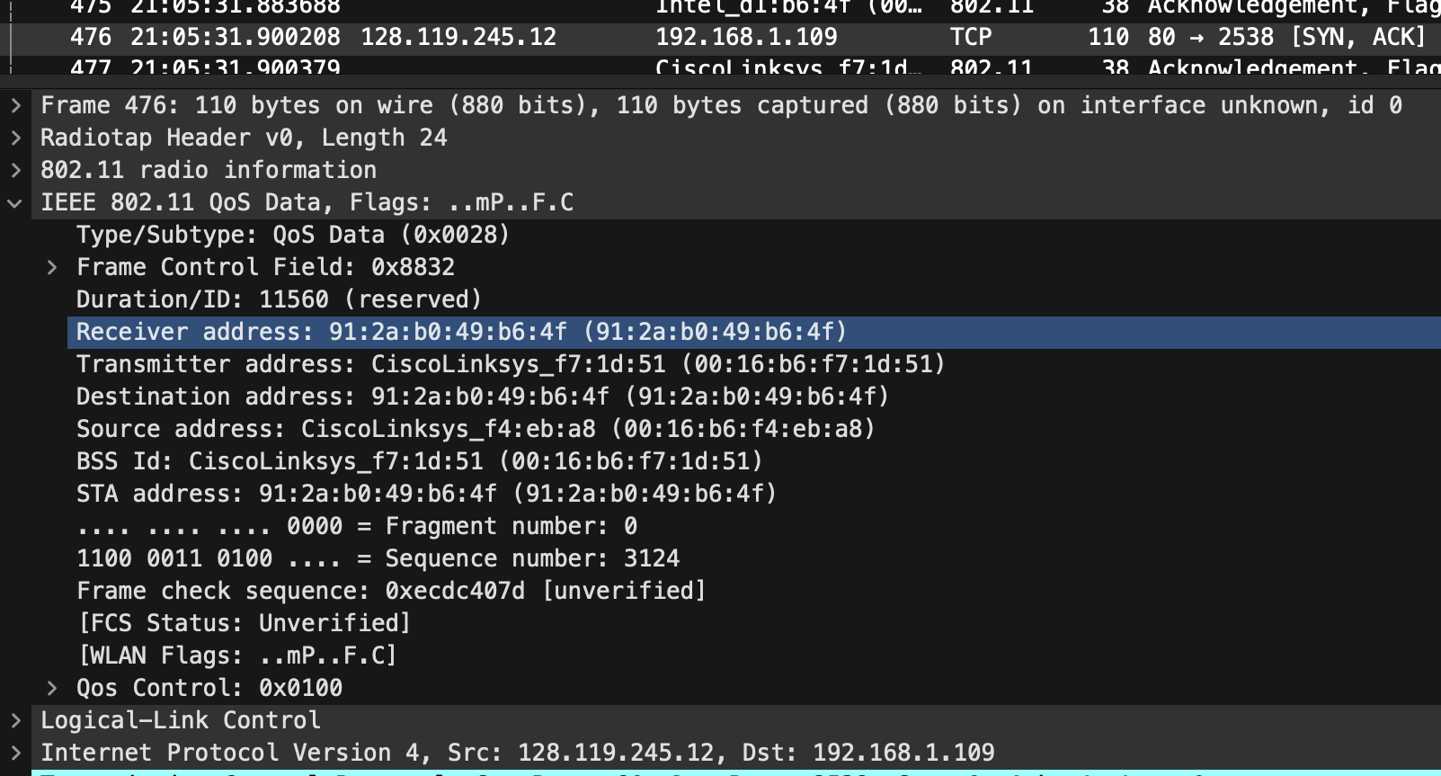

11.) The host sends a DHCP release frame and a Deauthentication frame. See below screenshot.



12.) Open system authentication is being requested. See below screenshot.

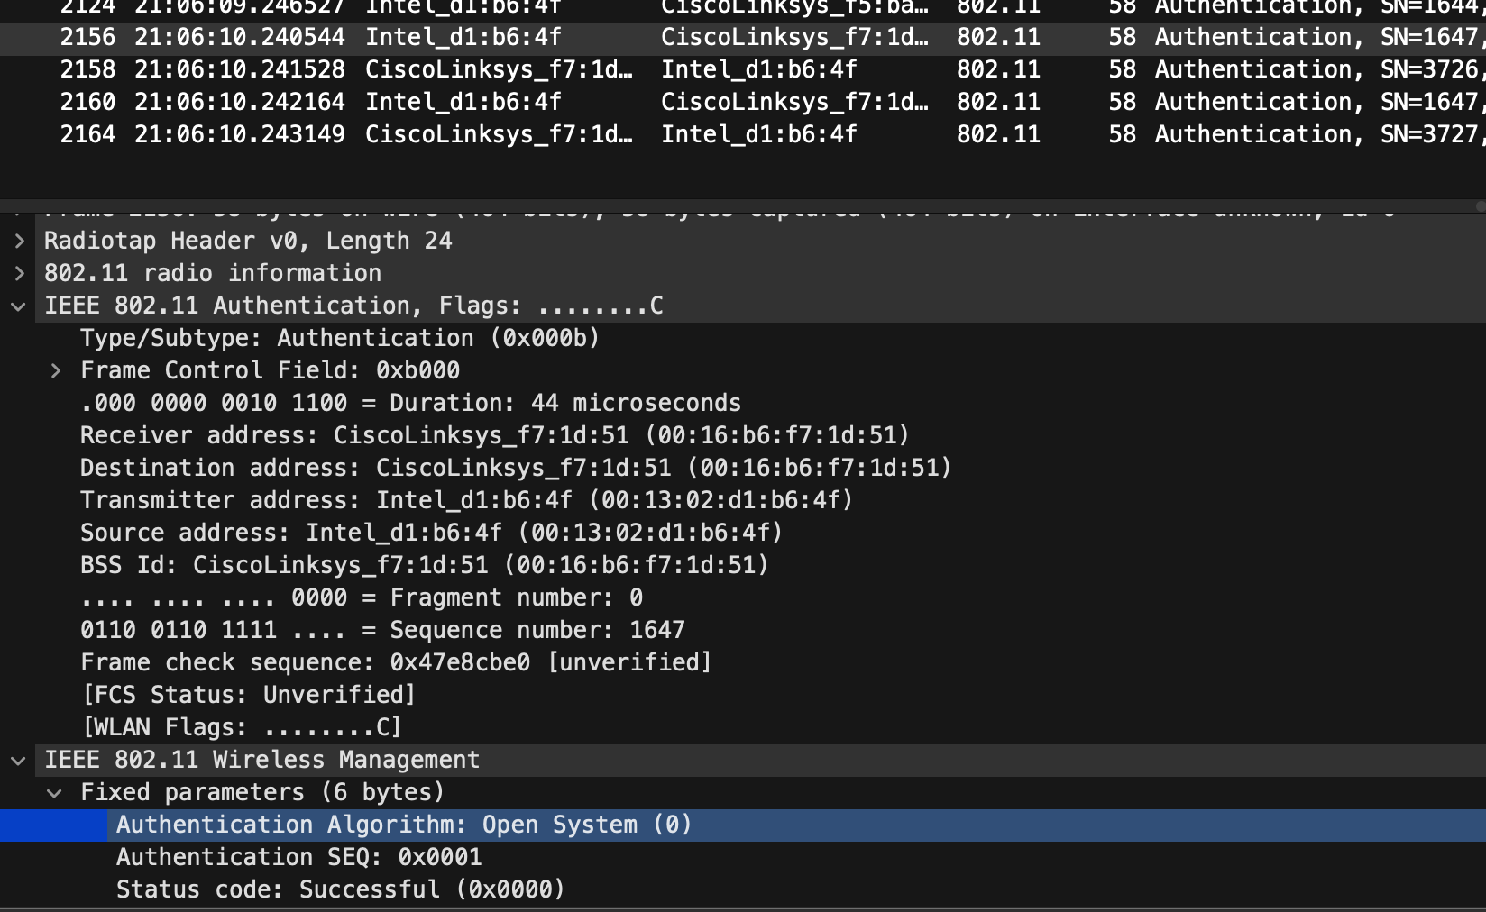

13.) The Authentication SEQ value is 1. See above screenshot.

14.) The AP accepts. See below screenshot.

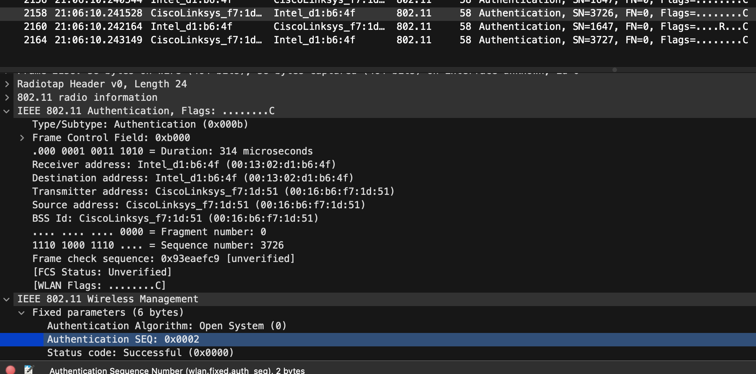

15.) The Authentication SEQ value is 2. See above screenshot.

16.) The supported rates are 1(B), 2(B), 5.5(B), 11(B), 6(B), 9, 12(B), and 18 Mbit/second.

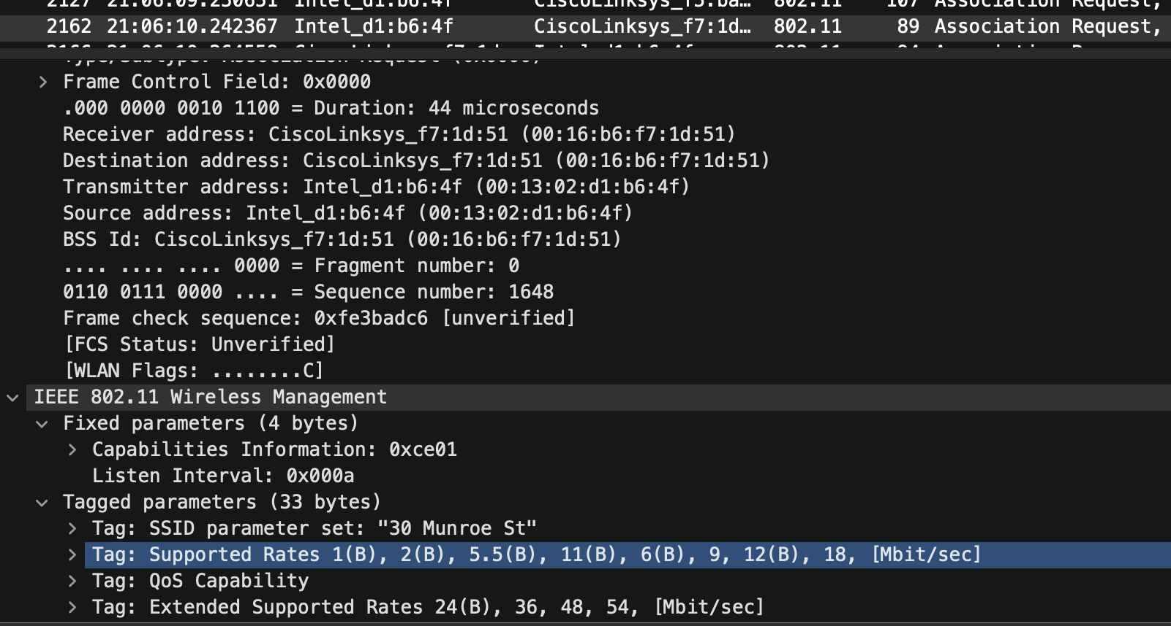

17.) The response indicates successful association.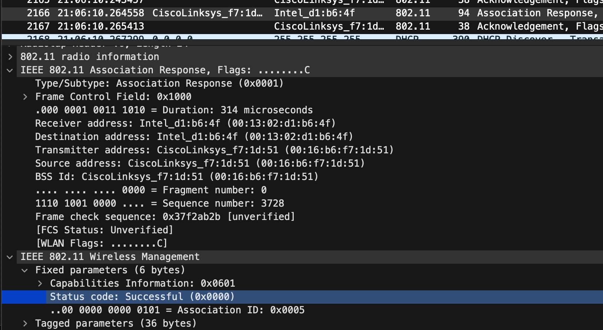

18.) Yes, the highest rate offered by the request and response is 54 Mbit/second.