
Travlr Getaways
CS 465 Project Software Design Document
Version 1.0
Prepared by Vonatarius Valerion

Table of Contents
- Document Revision History
- Executive Summary
- Design Constraints
- System Architecture View
- Component Diagram
- Sequence Diagram
- Class Diagram
- API Endpoints
- The User Interface

Document Revision History
Version | Date | Author | Comments
1.0 | 06/22/26 | Vonatarius Valerion | Completed final design document, API documentation, sequence diagram, class diagram, and user interface summary for the Travlr Getaways full stack project.

Executive Summary
Travlr Getaways is built as a full stack web application that uses the MEAN stack. MongoDB stores the trip and user data, Express and Node.js provide the server, API routes, and controller logic, and Angular provides the administrator single page application. This architecture fits the client requirement because the public website can display travel packages to customers while the administrator side gives Travlr staff a controlled way to manage trip packages, pricing, dates, images, and descriptions.
The customer facing side of the application uses Express routing, controller files, Handlebars views, static assets, and JSON based trip data so visitors can browse travel packages through a traditional web page flow. The administrator SPA is separate from the public website and uses Angular components, services, routing, forms, and HTTP calls to communicate with the REST API. Security is handled by requiring an administrator login and using a token with protected API endpoints for actions that change trip data.

Design Constraints
The main design constraints are the required use of the MEAN stack, the existing Travlr Getaways wireframe, the need for both a public website and an admin only SPA, and the requirement to store and retrieve trip data through MongoDB. These constraints shaped the application structure by separating the Express public site from the Angular admin project while still allowing both sides to share the same backend API and database.
Another constraint is security. Public users should be able to view trip information, but trip creation, editing, and deletion should only be available to authenticated administrators. This means the application needs form validation, server side validation, password hashing, token generation, authorization headers, protected routes, and controlled error responses. The design also needs to stay simple enough to test locally, so API endpoints, seed scripts, and README testing notes were included to support repeatable testing.

System Architecture View

Component Diagram
The component diagram on page 3 of the original template shows three major areas: the client, the server, and the database. The client contains the browser, the customer traveler portfolio, and the administrator SPA. The server contains the Express and Node application, authentication service, API routes, controllers, and the Mongoose object data model. The database layer contains MongoDB, which stores the Travlr data used by the application.
The browser sends requests to the Express server. For public pages, the server returns rendered Handlebars views and static files. For administrator functions, the Angular SPA uses HTTP requests to call the REST endpoints under /api. The API controller then uses Mongoose to read or update MongoDB. This separation keeps the interface, business logic, and data storage in different layers, which makes the application easier to maintain and test.

Sequence Diagram
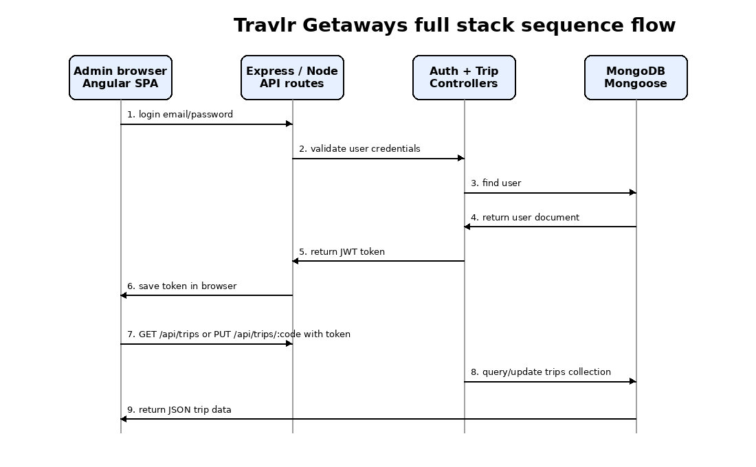
The sequence diagram shows the main flow between the administrator browser, the Express and Node API layer, the controller layer, and MongoDB. For sign in, the Angular login form sends the administrator email and password to the /api/login endpoint. The authentication controller finds the user in MongoDB, verifies the password hash, and returns a signed token when the credentials are valid. The SPA stores the token locally and uses it in the Authorization header for protected requests.
For trips, the SPA calls GET /api/trips to display the trip list and GET /api/trips/:tripCode when an administrator opens an edit screen. When the administrator saves changes, the SPA sends a PUT request to /api/trips/:tripCode with the token and updated trip data. The API route checks the token first, then the trip controller validates the request body, updates the matching document through Mongoose, and returns the updated JSON response to the SPA. This flow shows how the presentation tier, server tier, controller/model tier, and database tier work together.

Class Diagram
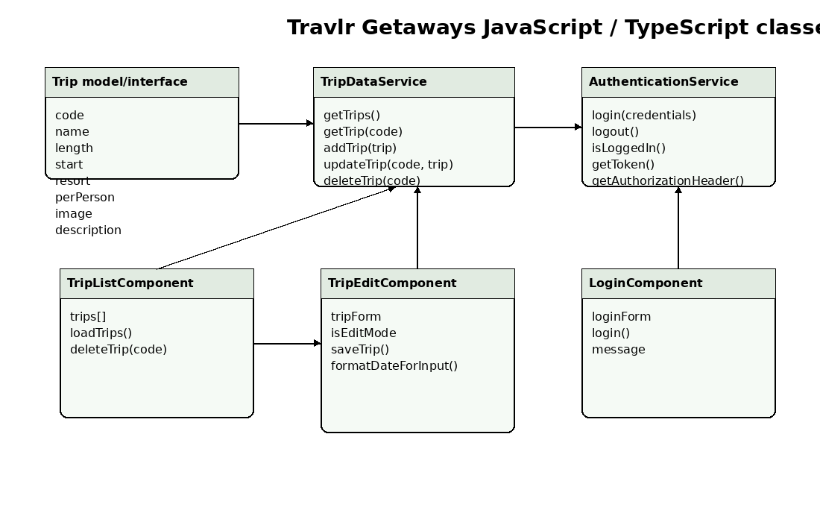
The class diagram represents the main JavaScript and TypeScript classes used by the admin side of the application. The Trip interface defines the trip fields used across the Angular project, including code, name, length, start date, resort, price per person, image, and description. TripDataService is responsible for all trip related HTTP requests, including retrieving all trips, retrieving one trip by code, adding a trip, updating a trip, and deleting a trip.
TripListComponent displays the trip collection and calls the service when trips need to load or delete. TripEditComponent owns the reactive form used for adding and updating trips. LoginComponent handles the administrator login form. AuthenticationService manages the login request, token storage, logout behavior, login state, and authorization header used by protected API calls. Together, these classes keep the SPA organized by separating UI behavior from API communication and authentication logic.

API Endpoints
The REST API exposes endpoints for administrator authentication and trip management. Public reads are available for viewing trip data, while create, update, and delete actions require a valid bearer token from the admin login process.
Method | Purpose | URL | Notes
POST | Register administrator user | /api/register | Creates a user account and returns a token. Mainly used for setup or testing.
POST | Authenticate administrator | /api/login | Checks email and password, then returns a JWT style bearer token.
GET | Retrieve all trips | /api/trips | Returns the full list of trip documents sorted by start date.
POST | Add a new trip | /api/trips | Protected endpoint. Requires bearer token and a complete trip payload.
GET | Retrieve one trip | /api/trips/:tripCode | Returns one trip document based on the trip code in the URL.
PUT | Update one trip | /api/trips/:tripCode | Protected endpoint. Validates fields and updates the matching trip document.
DELETE | Delete one trip | /api/trips/:tripCode | Protected endpoint. Deletes the matching trip document.

The User Interface
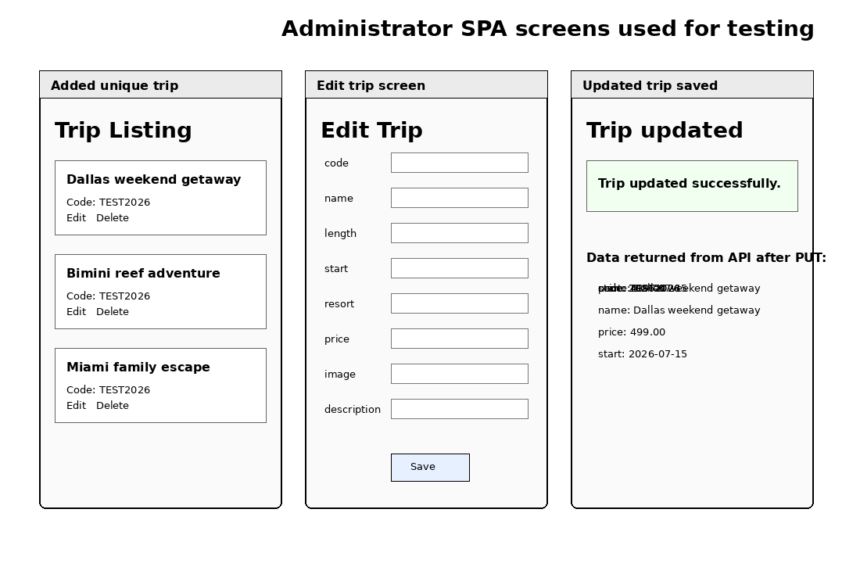
The Angular project is organized around standalone components, routes, services, guards, and models. The app component provides the main shell and navigation. The login component handles administrator access. The trips folder contains the trip list, trip card, and trip edit components. The services folder contains the trip data service and authentication service, while the guard prevents unauthenticated users from opening protected admin routes.
The Express project is organized differently because it focuses on server side routing and data handling. The app_server folder supports the customer facing pages through routes, views, and controllers. The app_api folder supports REST endpoints through API routes, controllers, Mongoose models, and seed scripts. Angular focuses on the browser experience, component state, and form interaction, while Express focuses on requests, responses, and database communication.
The SPA provides richer functionality than a simple web page because it can change views without reloading the whole site, validate form fields before submission, show messages after API calls, use route guards, and reuse services across multiple screens. Testing focused on confirming that the SPA could GET trip data from the API, open an individual trip for editing, send a PUT request with updated values, and then reload the trip list to confirm the database returned the new data. Security testing also confirmed that protected add, update, and delete requests require the Authorization header.

