### **Tates Museum - warehouse design**

Business process

Designed for **donation** business process described in ‘*Specification of business process in Tate’s Museum*’

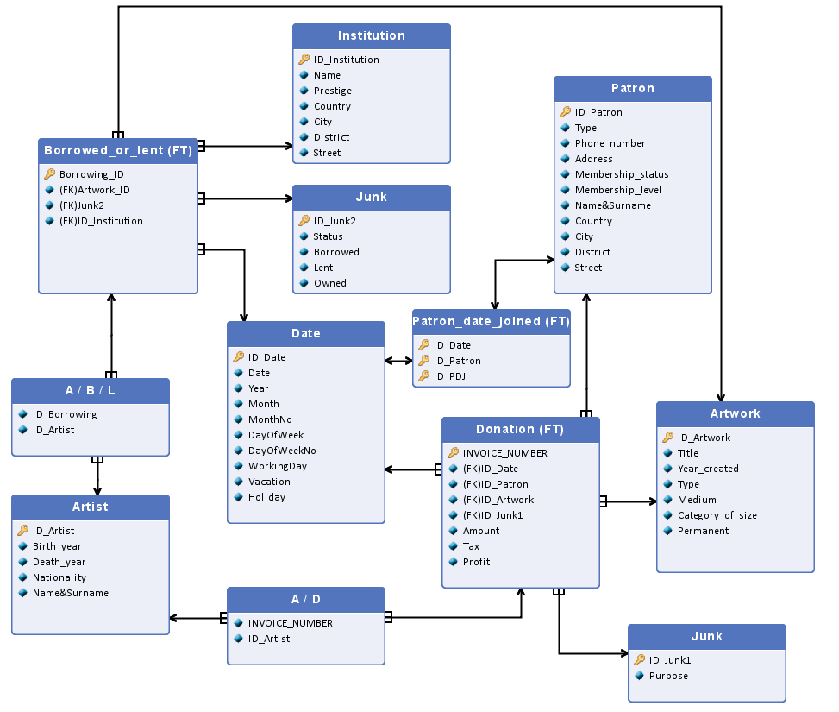

### 

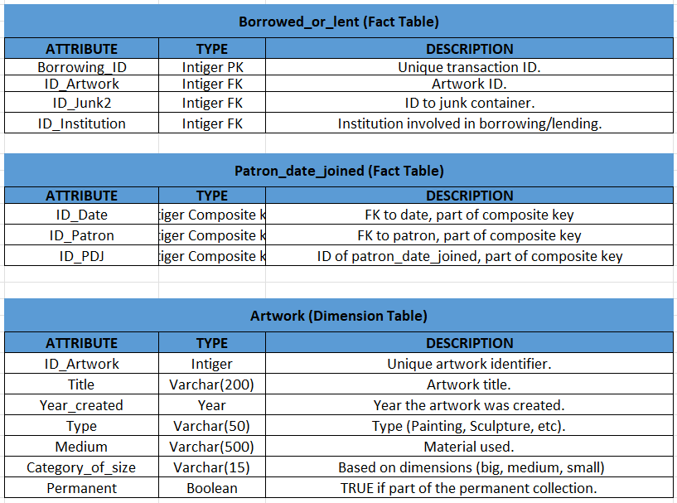

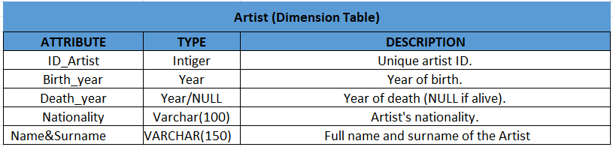

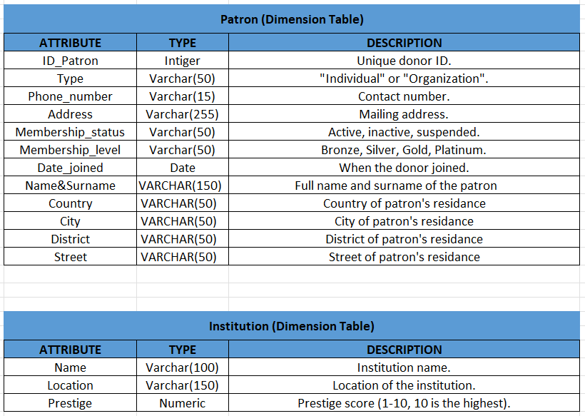

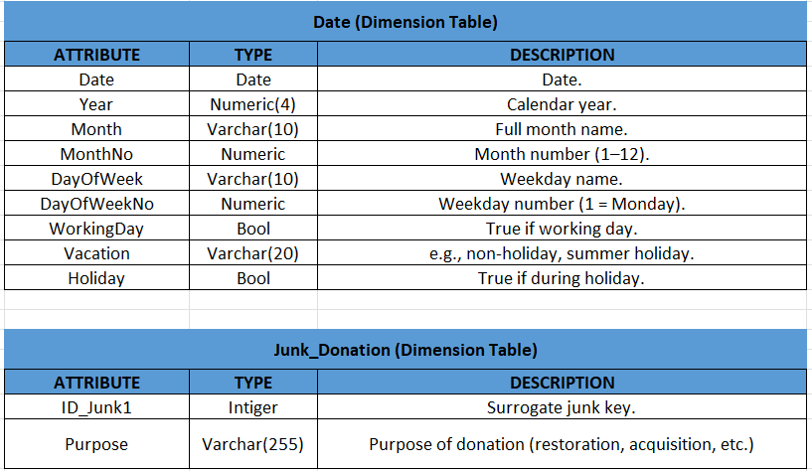

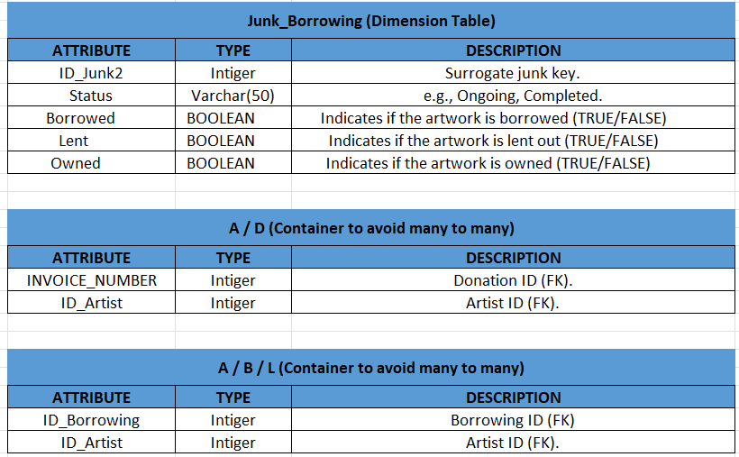

## **Fact Definitions**

### **Fact 1: Donation Fact**

**Description**:  
 A donation of a specified amount by a specified patron for a specific artwork, made on a given day, with a defined purpose, linked to the artwork’s ownership and exhibition status.

**Fact Table: Donation**

**Granularity**:

* A specific donation (INVOICE_NUMBER)
* A specific date of donation
* A specific patron
* A specific artwork
* A specific purpose of the donation
* Artwork ownership/exhibition status (borrowed/lent/owned)

Measures and Aggregation Functions:

* Number of donation facts – COUNT(1)
* Total amount donated – SUM(Amount)
* Tax – SUM(Tax)
* Profit – SUM(Profit)
* Number of distinct donors – DISTINCT COUNT(ID_Patron)

### **Fact 2: Borrowing/Lending Fact**

**Description**:  
 A transaction in which an artwork is borrowed, lent, or confirmed as owned by the museum

**Fact Table: Borrowed_or_Lent**

**Granularity**:

* A specific borrowing/lending transaction
* A specific artwork
* A specific institution
* A specific loan status (ongoing/completed, borrowed/lent/owned)

Measures and Aggregation Functions:

* Number of borrowing/lending facts – COUNT(1)
* Number of artworks lent – SUM(Lent)
* Number of artworks owned – SUM(Owned)

## Dimension Definitions

### Dimensions for Fact 1: Donation

| **DIMENSION / ATTRIBUTE** | **TABLE.COLUMN** | **TYPE** |
| --- | --- | --- |
| Donation Number | Donation.INVOICE_NUMBER | Degenerate dimension |
| Artwork | Artwork | Dimension |
| Title | Artwork.Title | Dimension attribute |
| Year created | Artwork.Year_created | Dimension attribute |
| Type | Artwork.Type | Dimension attribute |
| Medium | Artwork.Medium | Dimension attribute |
| Category_of_size | Artwork.Category_of_size | Dimension attribute |
| Permanent | Artwork.Permanent | Dimension attribute |
| Artwork ID | Artwork.ID_Artwork | Surrogate key |

|  |  |  |
| --- | --- | --- |
| Patron | Patron | Dimension |
| Type | Patron.Type | Dimension attribute |
| Phone number | Patron.Phone Number | Dimension attribute |
| Address | Patron.Address | Dimension attribute |
| Membership status | Patron.Membership_status | Dimension attribute |
| Membership level | Patron.Membership_level | Dimension attribute |
| Date joined | Patron.Date_joined | Dimension attribute |
| Name | Patron.Name&Surname | Dimension attribute |
| Country | Patron.Country | Dimension attribute |
| City | Patron.City | Dimension attribute |
| District | Patron.District | Dimension attribute |
| Street | Patron.Street | Dimension attribute |
| Patron ID | Patron.ID_Patron | Surrogate key |
|  |  |  |

|  |  |  |
| --- | --- | --- |
| Date of Donation | Date | Dimension |
| Year | Date.Year | Dimension attribute |
| Month | Date.Month | Dimension attribute |
| MonthNo | Date.MonthNo | Dimension attribute |
| Day of Week | Date.DayOfWeek | Dimension attribute |
| Working Day | Date.WorkingDay | Dimension attribute |
| Holiday | Date.Holiday | Dimension attribute |
| Date ID | Date.ID_Date | Surrogate key |

|  |  |  |
| --- | --- | --- |
| Donation Purpose | Junk | Junk Dimension |
| Purpose | Junk.Purpose | Dimension attribute |
| Junk1 ID | Donation.ID_Junk1 | Surrogate key |
| Artist | Artist | Dimension |
| ID_Artist | Artist.ID_Artist | Surogate key |
| Birth year | Artist.Birth_year | Dimension attribute |
| Death year | Atrist.Death_ year | Dimension attribute |
| Nationality | Atrist.Nationality | Dimension attribute |
| Name | Atrist.Name&Surname | Dimension attribute |

Dimension Definitions for Fact 2: Borrowed_or_lent

| **DIMENSION / ATTRIBUTE** | **TABLE.COLUMN** | **TYPE** |
| --- | --- | --- |

| Artwork | Artwork | Dimension |
| --- | --- | --- |

| Title | Artwork.Title | Dimension attribute |
| --- | --- | --- |

| Year created | Artwork.Year_created | Dimension attribute |
| --- | --- | --- |

| Type | Artwork.Type | Dimension attribute |
| --- | --- | --- |

| Medium | Artwork.Medium | Dimension attribute |
| --- | --- | --- |

| Dimensions | Artwork.Dimensions | Dimension attribute |
| --- | --- | --- |

| Permanent | Artwork.Permanent | Dimension attribute |
| --- | --- | --- |

| Artwork ID | Borrowed_or_lent.ID_Artwork | Surrogate key |
| --- | --- | --- |

| Institution | Institution | Dimension |
| --- | --- | --- |

| Name | Institution.Name | Dimension  attribute |
| --- | --- | --- |

| Location | Institution.Location | Dimension  attribute |
| --- | --- | --- |

| Prestige | Institution.Prestige | Dimension attribute |
| --- | --- | --- |

| Institution ID | Borrowed_or_lent.ID_Institution | **Surrogate key** |
| --- | --- | --- |
| Borrowing Status | Junk (Status) | Junk Dimension |
| Status | Junk.Status | Dimension attribute |
| Junk2 ID | Borrowed_or_lent.ID_Junk2 | Surrogate key |

|  |  |  |
| --- | --- | --- |
| Borrow Date | Date | Dimension |
| Year | Date.Year | Dimension attribute |
| Month | Date.Month | Dimension attribute |
| Working Day | Date.WorkingDay | Dimension attribute |
| Borrow Date ID | Borrowed_or_lent.ID_StartDate | Surrogate key |
| Lent Date | Date | Dimension |
| Year | Date.Year | Dimension attribute |
| Month | Date.Month | Dimension attribute |
| Working Day | Date.WorkingDay | Dimension attribute |
| Lent Date ID | Borrowed_or_lent.ID_StartDate | Surrogate key |
| Artist | Artist | Dimension |
| ID_Artist | Artist.ID_Artist | Surogate key |
| Birth year | Artist.Birth_year | Dimension attribute |
| Death year | Atrist.Death_ year | Dimension attribute |
| Nationality | Atrist.Nationality | Dimension attribute |
| Name | Atrist.Name&Surname | Dimension attribute |

# 

# 

# 

# **Checking the feasibility of queries based on the multidimensional model**

**1. Why was there an increase / decrease in donations this month?**

Measure: Total amount of donations – SUM(Amount)

Dimension: Date (dimension attributes: Month, Year)

Dimension: Donation Purpose (from Junk)

Dimension: Artwork (dimension attributes: Title, Type)

**2. Compare the total donations amount this month to the previous month.**

Measure: Total amount of donations – SUM(Amount)

Dimension: Date (dimension attributes: Month, Year)

**3. Have we got new patrons this month?**

Measure: Number of new patrons – COUNT(ID_Patron)

Dimension: Patron (dimension attribute: Date_joined)

Dimension: Date (dimension attributes: Month, Year)

**4. Who is the biggest patron this month?**

Measure: Total amount of donations – SUM(Amount)

Dimension: Patron (dimension attributes: Name, Surname)

Dimension: Date (dimension attributes: Month, Year)

**5. Which borrowed artwork earned the most?**

Measure: Total amount of donations – SUM(Amount)

Dimension: Artwork (dimension attributes: Title)

Dimension: Borrowed_or_Lent (dimension attributes: Borrowed = TRUE)

Join Condition: Artwork must be marked as borrowed in Borrowed_or_Lent during the donation period

**6. How much money came from donations for borrowed artworks?**

Measure: Total amount of donations – SUM(Amount)

Dimension: Artwork (with FK to Borrowed_or_Lent)

Dimension: Borrowed_or_Lent (attribute: Borrowed = TRUE)

**7. How Does Borrowing/Lending Art Influence Donations?**

Measure: Total amount of donations – SUM(Amount)

Dimension: Borrowed_or_Lent (attributes: Borrowed, Lent, Owned)

Dimension: Date (dimension attributes: Year, Month)

**8. How do donation amounts change when the museum exhibits borrowed artwork compared to its permanent collection?**

Measure: Total amount of donations – SUM(Amount)

Dimension: Artwork (attribute: Permanent)

Dimension: Borrowed_or_Lent (attribute: Borrowed = TRUE)

Dimension: Date (dimension attributes: Month, Year)

**9. Do donors contribute more when an artwork is on temporary loan rather than part of the museum's own collection?**

Measure: Total amount of donations – SUM(Amount)

Dimension: Artwork (attribute: Permanent = FALSE)

Dimension: Borrowed_or_Lent (attribute: Borrowed = TRUE)

Dimension: Date (dimension attributes: Month, Year)

**10. How does the prestige of the lending institution affect the frequency of donations?**

Measure: Number of donation facts – COUNT(1)

Dimension: Institution (attribute: Prestige)

**11. Does lending out the museum’s own artwork to other institutions attract new patrons this year in comparison to last year?**

Measure: Number of new patrons – COUNT(ID_Patron)

Dimension: Date (attribute: Year)

Dimension: Borrowed_or_Lent (attribute: Lent = TRUE)

**12. How does the prestige of the institution that we lend out affect the total amount of donations?**

Measure: Total amount of donations – SUM(Amount)

Dimension: Institution (attribute: Prestige)

Dimension: Borrowed_or_Lent (attribute: Lent = TRUE)

# 

### **TABLE NAME: DONATION**

| **COLUMN** | **SOURCE** |
| --- | --- |
| INVOICE_NUMBER | Unique donation identifier. Taken from donations.csv. |
| ID_Date | ID_Date surrogate key - generated by the database, when donation is made. |
| ID_Patron | Foreign key to Patron. Taken from ID_Patron in donations.csv. |
| ID_Artwork | Foreign key to Artwork. Taken from ID_Artwork in artwork.csv. |
| ID_Junk1 | Foreign key to Junk, taken from donations.csv. |
| Amount | Taken from donations.csv. |
| Tax | Taken from tax.csv. |
| Profit | Calculated as amount after subtracting tax. |

# 

### **TABLE NAME: PATRON**

| **COLUMN** | **SOURCE** |
| --- | --- |
| ID_Patron | ID_Patron surrogate key - generated by the database |
| Type | From patron.csv. |
| Phone_number | From patron.csv. |
| Address | From patron.csv. |
| Membership_status | From patron.csv. |
| Membership_level | From patron.csv. |
| Date_joined | From patron.csv. |
| Name | From patron.csv. |
| Surname | From patron.csv. |

# 

### **TABLE NAME: ARTWORK**

| **COLUMN** | **SOURCE** |
| --- | --- |
| ID_Artwork | ID_Artwork surrogate key - generated by the database |
| Title | From artwork.csv. |
| Year_created | From artwork.csv. |
| Type | From artwork.csv. |
| Medium | From artwork.csv. |
| Dimensions | From artwork.csv. |
| Permanent | From artwork.csv. |

# 

### **TABLE NAME: ARTIST**

| **COLUMN** | **SOURCE** |
| --- | --- |
| ID_Artist | ID_Artwork surrogate key - generated by the database |
| Birth_year | From artist.csv. |
| Death_year | From artist.csv. |
| Nationality | From artist.csv. |
| Name | From artist.csv. |
| Surname | From artist.csv. |

# 

### **TABLE NAME: INSTITUTION**

| **COLUMN** | **SOURCE** |
| --- | --- |
| ID_Institution | ID_Institution surrogate key - generated by the database |
| Name | From Borrowed_or_lend.csv. |
| Location | From Borrowed_or_lend.csv. |
| Prestige | From Borrowed_or_lend.csv. |

### **TABLE NAME: BORROWED_OR_LENT**

| **COLUMN** | **SOURCE** |
| --- | --- |
| Borrowing_ID | Borrowing_ID surrogate key - generated by the database |
| ID_Artwork | Foreign key to Artwork. Taken from Artwork_ID. |
| Borrowed | From Borrowed_or_lend.csv. |
| Lent | From Borrowed_or_lend.csv. |
| Owned | From Borrowed_or_lend.csv. |
| ID_Junk2 | From Borrowed_or_lend.csv. |
| ID_Institution | Foreign key to Institution. From Borrowed_or_lend.csv. |

# 

### **TABLE NAME: DATE**

| **COLUMN** | **SOURCE** |
| --- | --- |
| ID_Date | ID_Date surrogate key - generated by the database |
| Date | Standard date format (e.g., 2025-04-01). Generated by the database. |
| Year, Month, MonthNo | Extracted from Date. |
| DayOfWeek, DayOfWeekNo | Extracted from Date. |
| WorkingDay | Extracted from Date.. |
| Vacation | Extracted from Date. |
| Holiday | Extracted from Date. |