Pre-requisites:

How to manage your automation project in GitHub

1. Register your GitHub account and upload your automation project into the GitHub repositories
2. Create repository in GitHub

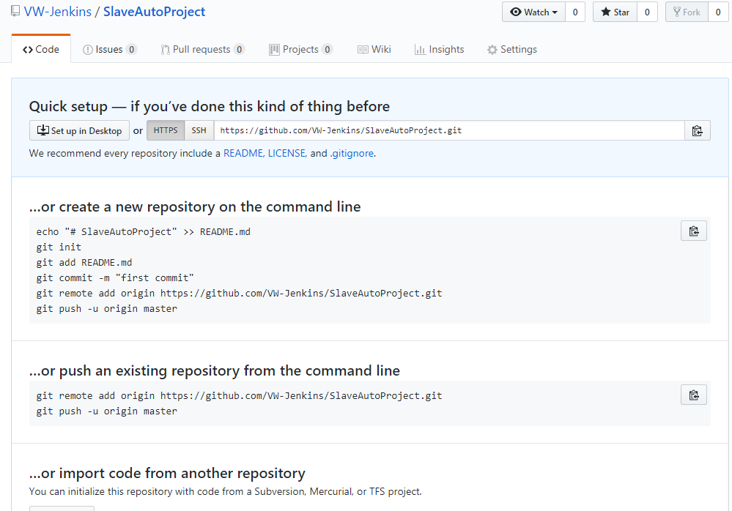

1. Install github in your local machine and co to your project folder -> Git bash
2. Run below command

Git init

Git add \*

Git commit –m “How to config selenium project”

Git remote add origin <https://github.com/VW-Jenkins/SlaveAutoProject.git>

Git push –u origin master

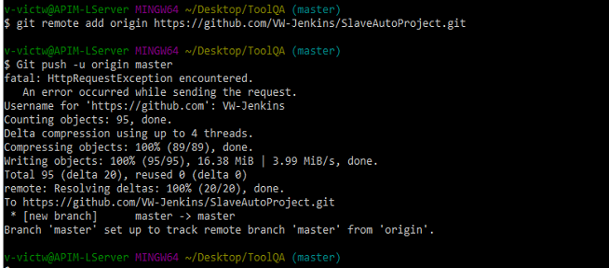

1. Go to the GitHub repositories, check your project

How to create and configure Jenkins Job?

1. Create job with Freestyle project

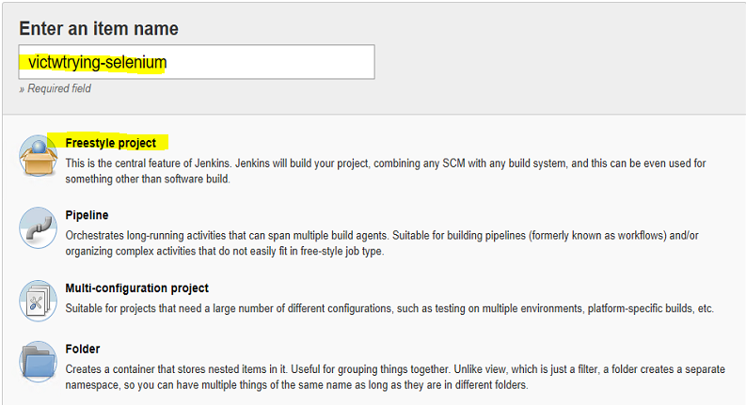

1. General
   1. Input the description
   2. Check the GitHub project and input the project URL. Go to GitHub open the relate repository copy the URL in the site

e.g. <https://github.com/VW-Jenkins/SlaveAutoProject>

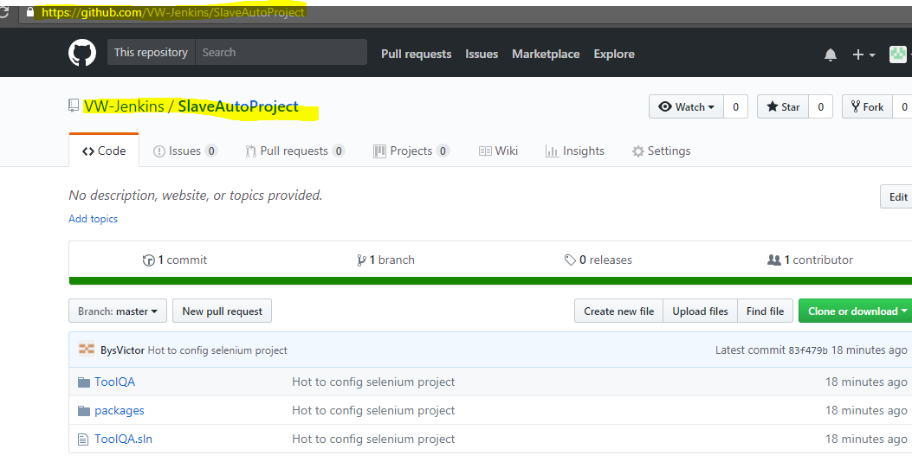

1. Source Code Management

Pre-requisites,

Go to Jenkins home -> Manage Jenkins -> Manage Plugins -> make sure u are installed the “GitHub” Plugins

Go to the Jenkins home -> Management Jenkins -> Global Tool Configuration -> go to Git section-> configure Git

The “Path to Git executable” -> must use your local git.exe oath

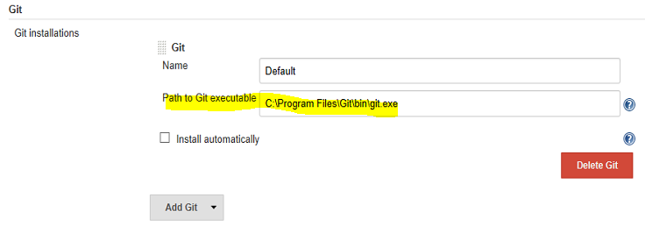

* 1. Check the “Git”
  2. Input the repository url: <https://github.com/VW-Jenkins/SlaveAutoProject.git>
  3. Credentials -> Add -> Jenkins -> Username with password -> Input your github name and pwd

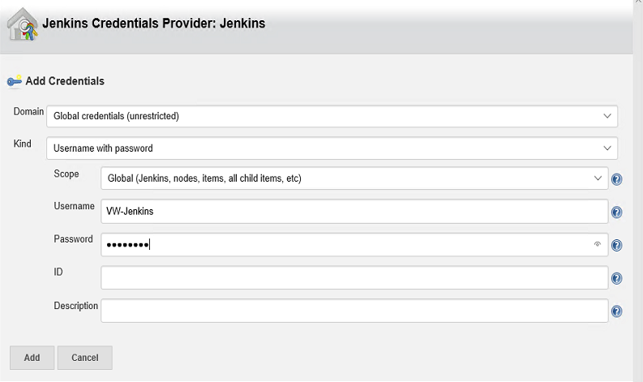

* 1. Repository browser: “gitweb”
  2. Repository browser url: input the git repository url e.g. <https://github.com/VW-Jenkins/SlaveAutoProject>

After configure you should see snapshot like below:

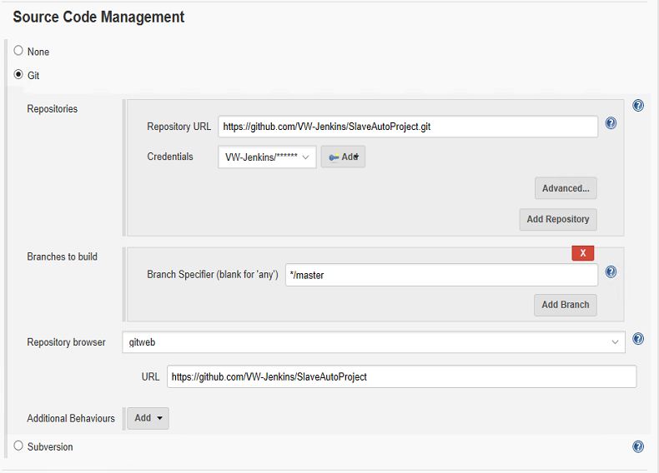

1. Build Triggers
   1. Select the build periodically

(MINUTE (0-59), HOUR (0-23), DAY (1-31), MONTH (1-12), DAY OF THE WEEK (0-6))

If you want run build at 12, 20 clock, you should input below value:

0 12, 20 \* \* \*

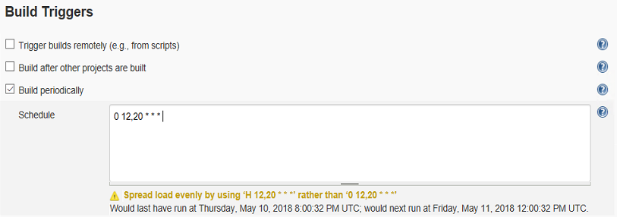

1. Build
   1. Click the “Add build step”, if no “Build a Visual Studio project or solution using MSBuild” and “Run unit tests with VSTest.console” option, please install related Plugins

Jenkins home -> Manage Jenkins -> Manage Plugins

Build a Visual Studio project or solution using MSBuild -> MSBuild Plugin

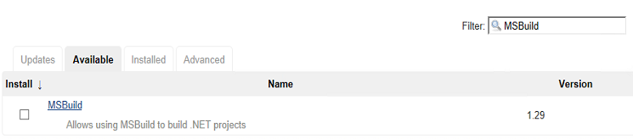

Run unit tests with VSTest.console -> VSTest Runner

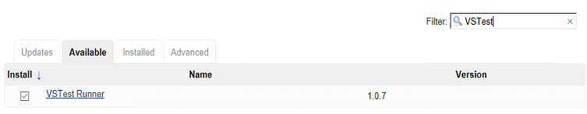

1.0.7 has bug, no matter what path used, always cannot found it. Maybe need 1.0.4



* 1. Go to the Jenkins home -> Manage Jenkins -> Global Tool Configuration -> MS Build Add MSBuild.exe path (C:\Windows\Microsoft.NET\Framework\v4.0.30319\MSBuild.exe)

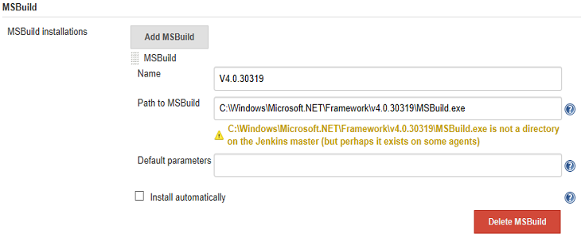

* 1. Go to the Jenkins home->Manage Jenkins -> Global Tool Configuration-> VSTest -> Add

Path to VSTest:

C:\Program Files (x86)\Microsoft Visual Studio\2017\Professional\Common7\IDE\CommonExtensions\Microsoft\TestWindow\vstest.console.exe

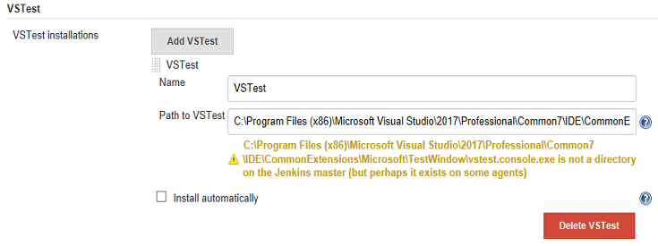

* 1. Go to Job configure section configure

MS Build File need go to Jenkins workspace to find the project file

(D:\Software\Jenkins\workspace\victwtrying-selenium\ToolQA.sln)

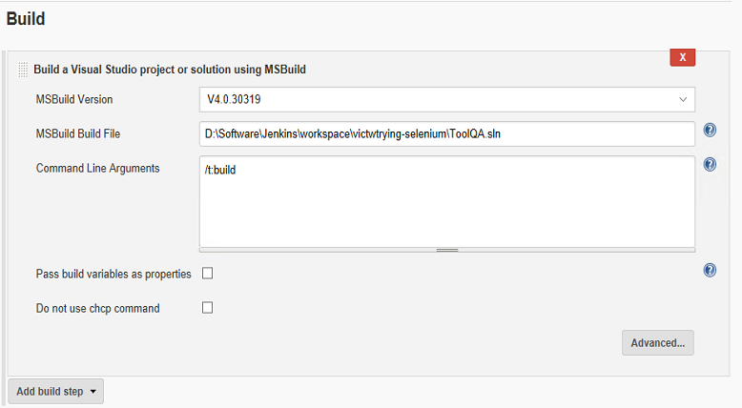

VSTest.console need config test file path: .\ToolQA\bin\Debug\ToolQA.exe

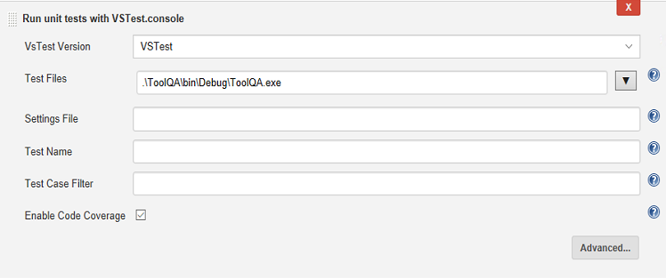

* 1. Build the Jenkins project, make sure all things run successfully (make sure u are install the firefox browser(related browser) in your test machine).

1. Post-build Actions

After you build and run the automation cases, I guess you want to send email to the test team to analytics test result.

Jenkins have this function, so we need configure the [Post-build actions]

Go to Jenkins home -> Your Job -> Configure -> Go to Post-Build actions section -> Add post-build action -> E-mail Notification.

Before your input the recipients, first u need configure the E-mail’s server

Go to the Jenkins Home -> Manage Jenkins -> Configure System -> E-mail Notification

Input below info for configure email server:

SMTP server: smtp.gmail.com

Default user e-mail suffix: @gamil.com

Use SMTP authentication: checked

Username: yours Gmail (E.g. [Aaptvictorwang@gmail.com](mailto:Aaptvictorwang@gmail.com))

Password: Gmail password (e.g. password~1)

Use SSL: checked

SMTP post: 465

Charset: UTF-8

Other field make default.

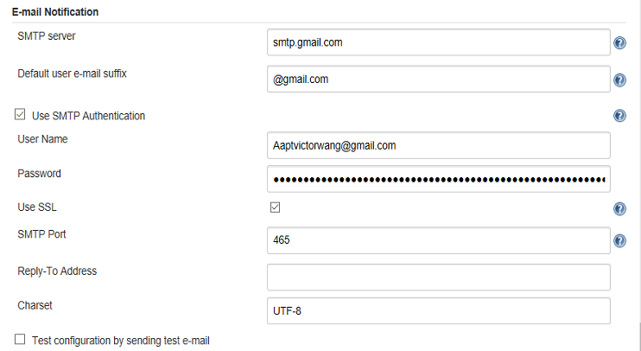

Then go to the Job’s configure blade, input your Recipients.

Here can input un-Gmail, e.g. [v-victw@microsoft.com](mailto:v-victw@microsoft.com)

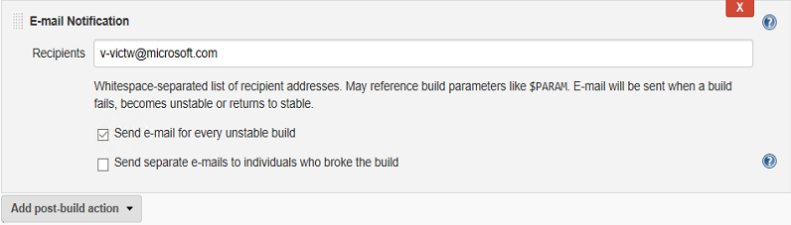

Save and run build, you will get the email in your Recipients

Above E-mail Notification, only send email when build/run failed, or unstable. However, sometime user want to get result for every build. Its need other plugin: Email Extension Plugin

Extra – email notification plugins docs: <https://wiki.jenkins.io/display/JENKINS/Email-ext+plugin>

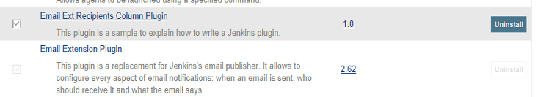

Before use in job, u need go to Jenkins home -> Manage Jenkins -> Configure System -> Go to the “Extended E-mail Notification” section.

Most field the same with E-mail notification, here only need notice the default trigger. Select trigger, which you need. (E.g. Always)

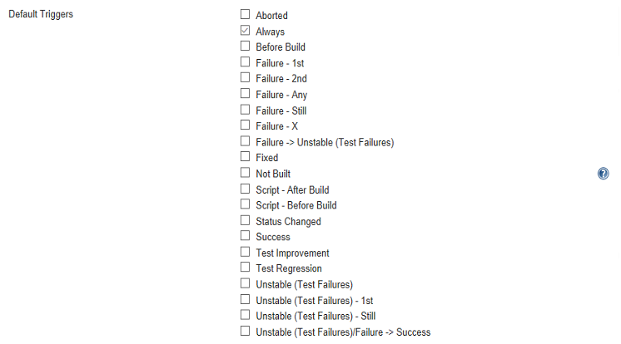

Then go to the Job -> Configure -> Editable Email Notification -> Advanced configure -> Always -> Add send to -> Input your email into the “recipient list” (E.g. [v-victw@microsoft.com](mailto:v-victw@microsoft.com))

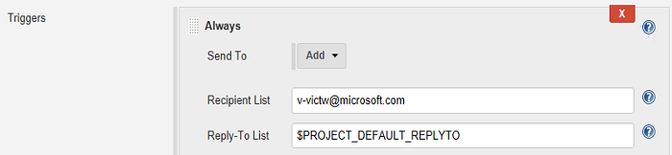

Then, save and run build, now you can got email for every build.