Original Jenkins docs url: <https://yakiloo.com/setup-jenkins-and-windows/>

Pre-requisites:

Run Jenkins in Window machine, you’ll need to install the Java stuff

Download with below link: <https://www.java.com/en/download/manual.jsp>

Download Jenkins:

Jenkins: <https://jenkins.io/>

\*War file: <http://mirrors.jenkins-ci.org/war/latest/jenkins.war>

Installing Jenkins as a Windows Service

If u donot set the environment variable, u run the java -jar jenkins.war it will be auto install the Jenkins under “C:\Users\[[UserName](http://en.wikipedia.org/wiki/User_%28computing%29)]\.jenkins”. it’s not good and generate some dirty data. So please see the environment variable more better.

JENLINS\_HOME: D:\Software\Jenkins\.jenkins

Snapshot see:

System Properties 
Compute 
Environment Variables 
You must be logged on as an 
User variables for V•victw 
M&ual éfects, processor 
Variable 
OneOrive 
Path 
Desktop setti-gs r&edto 
Recovery 
System "tam i 
variable 
Variable 
cc Spec 
Path 
Ubuntu environment you can 
n this article Ill be creating a 
Value 
• MongoDB - Introduc 
x 
Micros oft\WindowsApp5; 
Value 
Files 

When u run the above command, again Jenkins will look for this Environment Variable and automatically know to run there.

After install successfully, u will see snapshot like below:

Jenkins initial setup is required. An admin user has been created and a password generated. 
Please use the following password to proceed to installation: 
cøf19a27b7S74791a9d541bgesc42321 
This may also be found at: D: 
"ay €2, 2818 8:11:26 AN .mode1.UpdateSite updateOata 
INFO: Obtained the latest update center data file for UpdateS0unce default 
hay 02, 2e18 8:11:26 AM jenkins.1nitReactorRunnerS1 onAttained 
INFO: Completed initialization 
"ay 02, 2818 8:11:26 AM hudson.uebAppNain$3 run 
INFO: Jenkins is fully up and running 

Then open up a browser and browse to your new running Jenkins’s home page at “<http://localhost:8080>”

Then login local site and click -> Manage Jenkins -> “Install as Windows Service” -> Click Install -> Yes

After install the windows service, u can go to the “window service” check it.

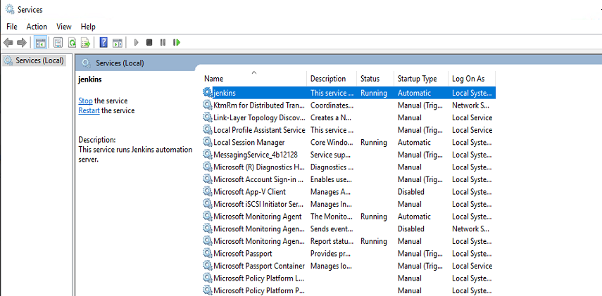

If u want to stop / run Jenkins server. Please run below command:

Open Console/Command line --> Go to your Jenkins installation directory. Execute the following commands respectively:

**to stop:**

jenkins.exe stop

**to start:**

jenkins.exe start

**to restart:**

jenkins.exe restart

Configure Jenkins Slave:

Original Jenkins slave url: <https://wiki.jenkins.io/display/JENKINS/Step+by+step+guide+to+set+up+master+and+slave+machines+on+Windows>

* Go to the master machine go to the Manage Jenkins -> Manage Nodes -> New Node (permanent Agent)

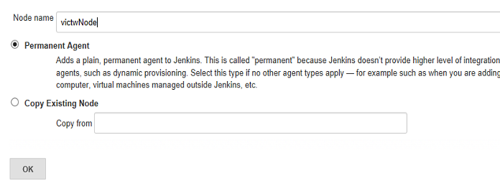

* Click Ok, u will go to below snapshot:

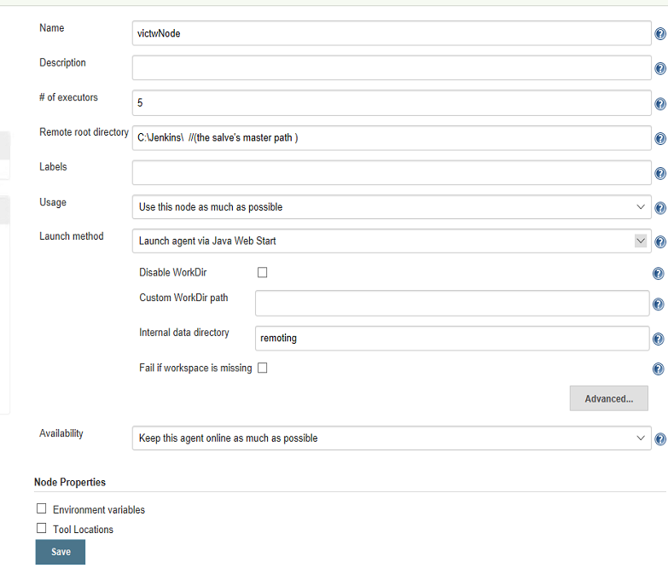

\*Note: about the **Launch Method** if do not have the *Launch slave agents via Java Web Start* in dropdown, please go to Manage Jenkins-> Configure Global Security -> Able the JNLP for Agents. Details see below:

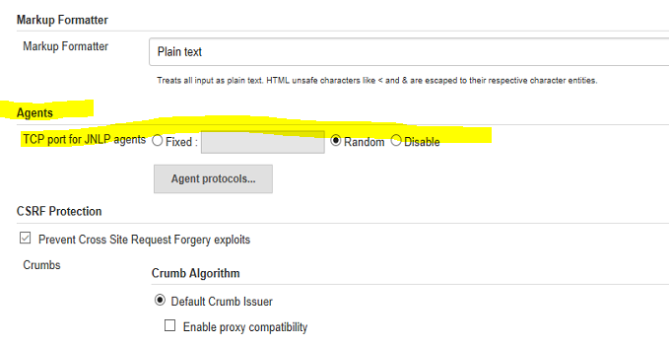

* Now u need to connect your salve machine, then do below steps
  + Open a browser on the **slave machine** and go to the **Jenkins master server** url (<http://10.138.68.138:8080/> ).

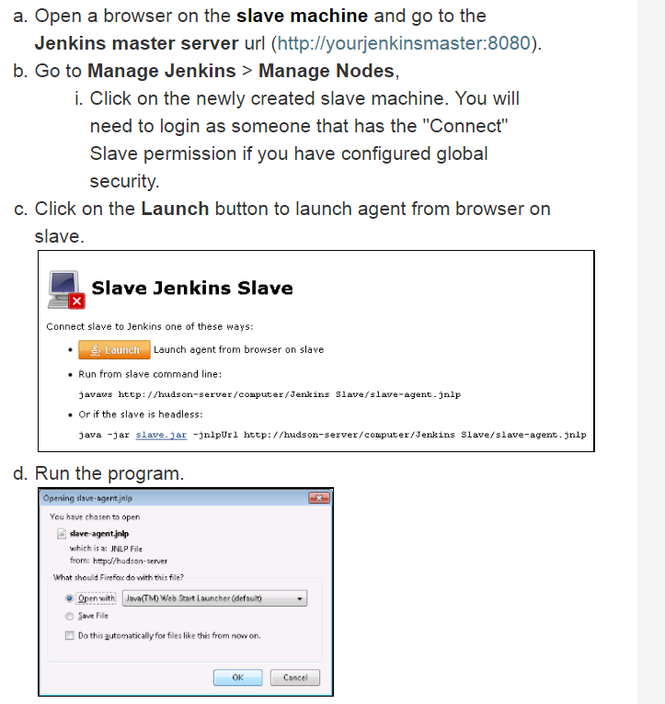

* + If u do not see run the program, please install the JAVA staff in the slave machine

<https://www.java.com/en/download/manual.jsp>

\*Note: Win 8.1 and win10 seems have lunch bug for slave, so please fellow below steps:

1. Run cmd with admin
2. Go to the slave-agent.jnlp folder, directly run it
3. Then click file - > install service

Home 
Quick 
Downloads 
Documents 
[e Pictures 
Share View 
This PC Temporary Storage (D:) 
Name 
Slave 
- slave-agent.jnlp 
Software 
Jenkins 
v Search Jenkins 
modified 
Type 
5/7/2018 7:28 AM 
File folder 
5/7/2018 7:27 AM 
'NLP File 
o 
c:] 
Administrator: Command Prompt 
Microsoft [Version Id.e.Ib29Y.3JI] 
(c) 2817 Microsoft Corporation. All rights reserved. 
D: Software 
O: Jenkins 
Slave 
O: Jenkins>sl ave- agent. jnlp 
D: Jenkins>_ 
x 

* + Then install salve agent Windows service with below snapshot:

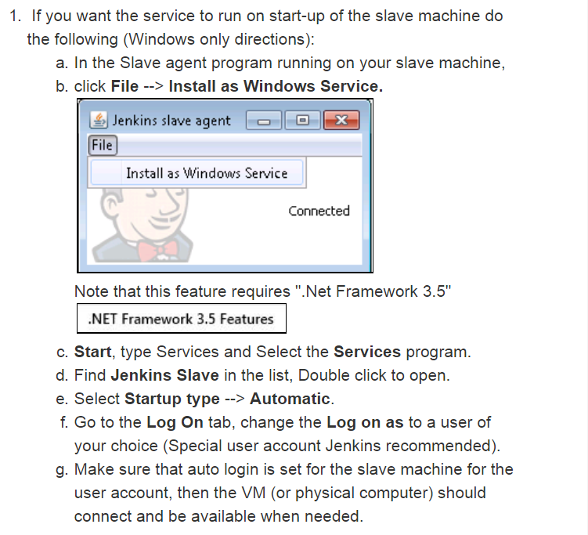

After install, you will see the below two machines:

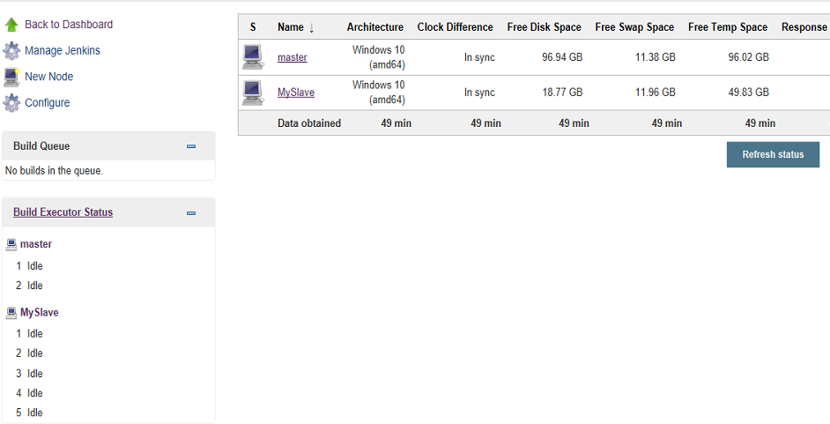

**Why need Jenkins slave?**

<http://www.360doc.com/content/14/1016/10/10058718_417365916.shtml>

You can configure run your project in which machine: Job-> General -> restrict where this project can be run -> Label expression -> Input your label.

