**About The Battle for Midway**

The Battle for Midway is a somewhat modernized game modeled after the ‘Midway Campaign’ game released by Avalon Hill in the early 80’s. While limited to ASCII text, the game did an excellent job putting you into the position of Admiral Chester Nimitz, RADM Fletcher, and RADM Spruance leading numerically inferior and far less experienced carrier forces against the far more impressive, at least on paper, Kidō Butai ("Mobile Force") of the Japanese. After the Doolittle raid, Admiral Yamamoto, to eliminate the United States as a threat in the Pacific had set up a complicated plan to invade the Aleutians as a diversion while sending a massive invasion fleet led by the experienced and battle hardened Kidō Butai that had attacked Pearl Harbor. The Japanese force was slightly diminished due to losses during the Battle of the Coral Sea, but they believed the United States only had two fleet carriers in the entire Pacific. This was incorrect, however, as the Yorktown, despite suffering apparent catastrophic damage during the Battle of the Coral Sea was rapidly repaired by a tireless damage control team in more rapid fashion than the Japanese could have believed. Furthermore, the United States had broken the Japanese naval codes allowing them to determine that Midway, not the Aleutian Islands was Yamamoto’s real target.

While not expecting it, Yamamoto did consider the possibility of United States carriers being in the theater. He ordered Admiral Nagumo commanding the Kidō Butai to keep two of his carriers in reserve for strikes against American carriers should they make an appearance. In the actual battle, Nagumo, PBY’s were spotted overhead the morning of the 3rd, so it was no surprise when a strike from Midway attacked his fleet before his first strike could hit the airfield on Eastern Midway Island. Midway had time to launch all of her fighters, but they were comprised of outdated Buffalo F2A as well as the not exactly superb F4F wildcat numbering 24 in total versus the nimble and superior A6M zero. The United States lost 2 of the F4F’s and the 13 of the Buffaloes were slaughtered. Many of the American pilots had not faced the zero and survivors were stunned at how inferior their planes were wanting both of them retired, not just the F2A which mostly served as a trainer. While the Japanese devastated Midway’s infrastructure, power, and fuel facilities, they failed to significantly damage the air field while having over 20% of their attack planes lost or out of service after the attack. The strike from Midway failed to inflict significant damage on the Japanese fleet; even a number of B-17’s dropping numerous large bombs failed to score hits as their high-altitude bombs left the Japanese carriers ample time for evasive maneuvers. Nagumo set out to rearm his carrier attack forces for a follow-up attack on Midway. Before that could be completed, one of his PBY’s, coincidentally the only one to have mechanical issues delaying her launch by at least half an hour found the US carrier fleet to the Northeast. This led to Nagumo’s dilemma. He had to coordinate landing his returning strike, yet again rearming his planes, or launching planes with sub-optimally armed for a carrier strike. He chose to recover his strike, rearm, and make a massive strike on whatever US forces where to the Northeast.

Unfortunately for Nagumo, the rest of the day his fleet would be largely occupied dealing with attacks from United States planes. Aside from the strike from Midway, US fliers, inexperienced US fliers, failing to organize into a consolidated attack showed up in small waves that generally prevented the Japanese from launching their strike despite most of them failing to score any hits on Japanese forces for most of the day. TBD pilots had generally thought well of their plane up until this battle, and they had managed to perform fairly well in the Coral Sea due to optimum conditions and an ability to bracket Japanese carriers, but at Midway TBD’s showed up in isolated squadrons having to approach carriers behind massive walls of AA and they were butchered, generally before they could get close enough to drop their torpedoes. Dropped from one side at a distance, the torpedoes were not difficult for Japanese carriers to dodge, and unbeknownst to most of those TBD pilots, their torpedoes most often did not explode if they did manage a hit. Despite this, most TBD squadrons that day pushed on against overwhelming odds. No torpedo hits were scored on Japanese carriers, but these brave TBD crews won the war by giving up their lives. Each time a TBD squadron showed up, they forced the Japanese to go into evasive maneuvers and delayed their attack on the US fleet. The USS Hornet, with perhaps the least experienced flight crew and fighter complement having been pulled straight out of training into serving as the platform for the Doolittle raid, launched their strike far out to the west as the United States did not know if the Japanese had four carriers in one group or two separate groups with one farther behind. As a result, their first launch led to the infamous Flight to Nowhere, but LCDR Waldron, refusing to follow orders that were clearly leading them away from the carriers took his TBD’s and broke off to the south. His squadron arrived yet again just in time to force the Japanese onto defense yet again. The entire squadron was annihilated including LCDR Waldron, though one pilot, Ensign George gay managed to survive by hiding under a seat cushion in sight of Japanese forces on all sides. Waldron’s move, though, saved the United States that day as Japanese combat air patrols, suffering from poor radio communication systems, failed to properly maintain high- and low-level patrols with most of their planes greedily chasing down TBD’s for more kills. This would provide the United States the opportunity it needed.

While the Japanese were busy defending from TBD attacks taking evasive action to avoid torpedoes, LCMDR McClusky’s squadron of scout bombers in VF-6 had arrived at where the Japanese carrier fleet had been only to find them missing (they had moved to the Northwest). Faced with the decision to divert to Midway to refuel or return to the Enterprise, McClusky astutely noticed the IJN Arashi, a Japanese destroyed steaming north at flank speed which he correctly surmised was towards the Japanese fleet – his decision to follow that destroyer was later called by Nimitz the most important decision of the entire battle. In another moment of benevolence, earlier that morning the USS Nautilus had attempting to attack the Japanese fleet and the Arashi had been sent to attempt to hunt her down. They came upon the Japanese fleet with much of its fighter cover at sea level after chasing the TBD’s. There was confusion over target assignment with most bombers going after Kaga but Lt. Richard Best and his two wingmen diverted in time to attack the Akagi. The Kaga took 4 hits and was a burning wreck. The Akagi, though seemingly better off would later explode as gas vapors would spread and find an ignition source. In another favorable moment for the United States, just as McClusky’s flight group arrived in the Southwest, the Yorktown’s squadron of SBD’s arrived to the Northeast – a matter of absolute failure to coordinate leading to a perfect bracketing of the fleet. The Yorktown fliers pummeled the Soryu leaving her a burning wreck. Unfortunately, Hiryu was just over the horizon. She launched a strike which followed the American pilots back to Yorktown where they disabled her. She was rapidly repaired but a subsequent strike caused more significant damage before a joint strike by Yorktown and Enterprise bombers left Hiryu ablaze – Lt. Richard Best again scoring one of the four hits that doomed her. All four Japanese carriers were then, ironically, sunk by torpedoes… Japanese torpedoes before the fleet retreated back towards Japan. Yorktown almost pulled another miraculous recovery, but the IJN I-168, an intrepid submarine managed to put two torpedoes into the Yorktown followed by a third into the destroyer USS Hammann that had been tending to her – leading to the loss of 80 lives.

As good as the original game is, it did seem to favor some misperceptions that are also seen in the 1976 film Midway – that armed planes on the deck led to great explosions that put the carriers out of action. Most historians now seem to favor fuel vapors building up in the hangars and poor damage control practices exacerbating Japanese losses. I have remodeled that game to focus less on the planes on deck though there are still explosions, and the United States has an even more dramatic edge in damage control than provided in the original game. While the player may not know it, the Japanese carriers do follow Yamamoto’s orders on way in with half the fleet armed for ground attack. If the Japanese fleet discovers the US carriers, they will rearm potentially leading to a delay. Another factor the original game did not consider is the US having radar. I have incorporated potential contact spotting by submarines and radar in addition to PBY scout planes. If a contact is spotted on radar, it is not identified, but can provide a player clues. Of more import, if the Japanese launch a strike, you will be warned of approaching bogies by the radar crew… well, most of the time – there is some chance they will consider it a weather anomaly or friendly planes and not report it – as tended to happen in the early days of radar. I have also added in visual spotting of adjacent forces as it only makes common sense. In a future version, I probably will allow you to launch scout strikes to go where you THINK the Japanese fleet is… at a slightly greater risk of planes splashing (especially if they are from the Hornet). I also plan on adding in the B-17’s from Midway as an option to harass the Japanese periodically until they put Midway airfield out of operation or destroy them on the ground. The game does not currently delay Japanese flight operations if the US attacks, but requiring decisions on whether to launch or continue evasion and forcing you to turn into the wind for launching strikes might be added in a future version. I did give the Yorktown fighters a significant edge as compared to other US fighter squadrons based on LCMDR Jimmy Thach of Yorktown’s VF-3 successfully implementing what would later become known as the “Thach weave” – a tactic where F4F’s, rather than attempting to outturn the far nimbler Zero’s would weave back and forth with their wingman so that either could shoot any zero off the tail of the other. While far nimbler, the A6M Zero lacked a self-sealing gas tank and was not hard to shoot down if you could get it in front of your plane. This doctrine would later be taught to all F4F squadrons along with some other tactics to help somewhat even the playing field, but at Midway, only Thach’s group was using this tactic.

The original game also included an escort carrier, the Zuiho, in the Japanese troop transport group. I have not only kept this in, but this carrier now will actively go to war at times. In addition to performing CAP for the transports against air attacks, she will venture out with a strike force of her own if the situation calls for it – say no other carriers are around (or still afloat) – and there is a target in range.

While I have not yet implemented multi-level CAP which might be more complicated than the game needs, I did add some more CAP and squadron diversion logic. There are limits on how many planes can divert to a carrier, though diversions to Midway face no such limit as there is no space limit there. Much as in real life, the TBD squadron’s are almost a wasted effort in this game, though they do occasionally score some devastating hits, but more importantly, CAP has a recovery time in this game – if subsequent waves show up in sequence, Japanese fighter cover can be inadequate.

Avalon Hill put out their source code, but it is very difficult to read. If anyone is interested in some guidance on modifying that code or collaborating on this version, feel free to reach out to me: [VWilcox2000@hotmail.com](mailto:VWilcox2000@hotmail.com). I just decided to build this because I love the original game but it is hard to play on any of the emulators out there. God bless the heroes of that battle and the men and women of the US Navy.

LCMDR Jimmy Hatch

|  |  |
| --- | --- |
| John Thach - Wikipedia |  |

Instructional video on his tactic: <https://www.youtube.com/watch?v=C_iW1T3yg80>

RADM C. Wade McClusky

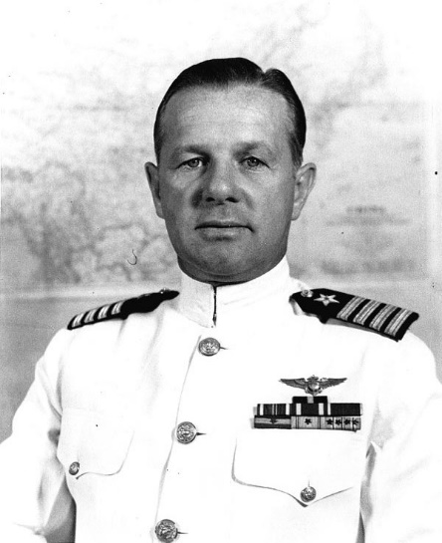

LCMDR Richard Halsey Best

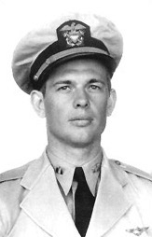

LCMDR Best scored hits on two different carriers during the Midway campaign, an amazing feat. His oxygen rebreather malfunctioned, but despite breathing caustic fumes he pushed on to achieve his successful attack later suffering disability due to lung injuries.

CAP Richard E. Fleming, USMCR

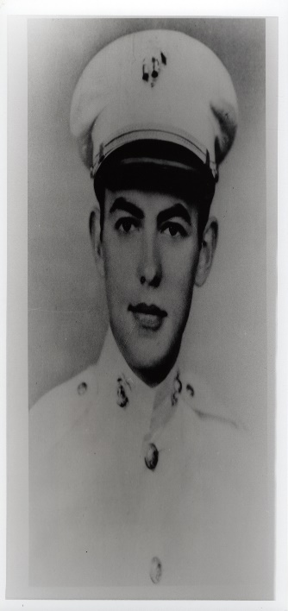

Taking over for his squadron after losing his commander and part of an ill fated bombing run where inexperienced pilots glide bombed rather than dive bombing and set ablaze by anti-aircraft fire, Captain Fleming aimed his plane at an enemy battleship just missing the infrastructure and dousing the bridge in splash. He was post-humorously awarded the Medal of Honor.

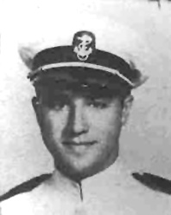 <https://www.findagrave.com/memorial/173743212/wesley-frank-osmus>

Ensign Wesley Frank Osmus – part of LCMD Waldron’s TBD Squadron

Murdered by Japanese sailors after recovering him from the water at the order of their captain.

<https://www.findagrave.com/memorial/56118326/wesley-f-osmus>

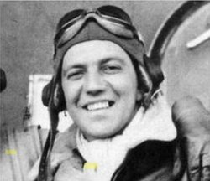 <https://www.findagrave.com/memorial/204858226/bruno-peter-gaido>

Petty Officer Bruno Peter Gaido – in the Marshall and Gilbert Islands, with a Japanese Bomber attempting to ram the USS Enterprise, he ran to a parked SBD and continuously fired her twin .03 cal’s into the bomber even as the bomber which veered off crashing into the sea with its wing slicing the SBD a few feet behind Gaido on its way. Gaido put the fire out and then disappeared fearing disciplinary action. Instead, VADM Halsey ordered him found and promoted him to Aviation Machinist’s Mate First Class. He was subsequently the gunner for…

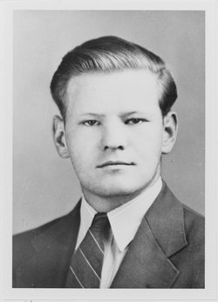 <https://www.findagrave.com/memorial/56127242/frank-woodrow-o_flaherty>

Ensign Frank Woodrow O’Flaherty – part of VS-6 group of SBD’s that destroyed the KAGA. Having taken a circuitous route looking for the Japanese fleet, their SBD exhausted its fuel and they went down. Neither Gaido of O’Flaherty were seen and presumed lost in action. After the war, it was found that they had been recovered by Japanese enraged at the loss of their carriers who took retribution on them by tying heavy fuel cans to them and tossing them into the sea to drown.

More links to learn more about this amazing battle:

The Battle of Midway 1942: Told from the American Perspective: <https://www.youtube.com/watch?v=Bd8_vO5zrjo&t=668s>

The Battle of Midway 1942: Told from the Japanese Perspective: <https://www.youtube.com/watch?v=Bd8_vO5zrjo>

How did the US Navy win the Battle of Midway? <https://www.youtube.com/watch?v=wyFZ3cJRrcg&t=12s>

Battle 360: Battle of midway Leads to WWII Victory (S1, E2) <https://www.youtube.com/watch?v=Xtgggq1l8o4>

History Buffs: Midway Part One <https://www.youtube.com/watch?v=4qQim09n6mY&t=4s>

Midway Pilots – Prisoners of the Japanese <https://www.youtube.com/watch?v=5VmyQdVS5uw> (US pilots “rescued” by Japanese murdered)

The Battle of Midway Nagumo’s Dilemma, the Mistake that Lost the Battle? <https://www.youtube.com/watch?v=20JqGZva2is>

World War II: The Battle of Midway | Full Movie (Feature Documentary) <https://www.youtube.com/watch?v=TZH-K0theTg>

Midway: Why did the Japanese Lose? <https://www.youtube.com/watch?v=oiBhGhROP5o>

Github link for the current version: <https://github.com/VWilcox2000/Midway>