Assignment - 2

Machine Learning (CS 5710) CRN: 22002

Vinay Kumar Camarushi

700740428

GitHub Link: https://github.com/VXC04280/In_Class_Programming_Assignment_2

**Question – 1)**

**Use a python code to display the following star pattern using the for loop**

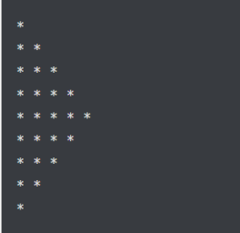

Solution :

* Here we used to nested for loops to print the given star pattern.
* The first nested loop is used to print the upper part of the star pattern and the lower for loop is used to print the lower part of the string.
* The first for loop in both the parts are used to loop over the number of rows in the pattern.
* The Second for loop is used to loop over the number of elements of the rows based on the iterable of the first for loop.

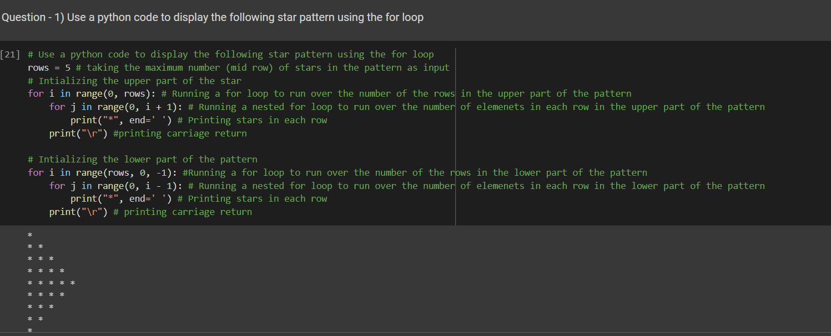

**Question – 2)**

**Use looping to output the elements from a provided list present at odd indexes.**

**my_list = [10, 20, 30, 40, 50, 60, 70, 80, 90, 100]**

* Here the input list is stored in my_list
* Created an empty list for storing the output
* We ran a for loop to check if the index is even or odd.
* If the index is odd, we appended the list elements to the output_list
* At last we printed the output_list

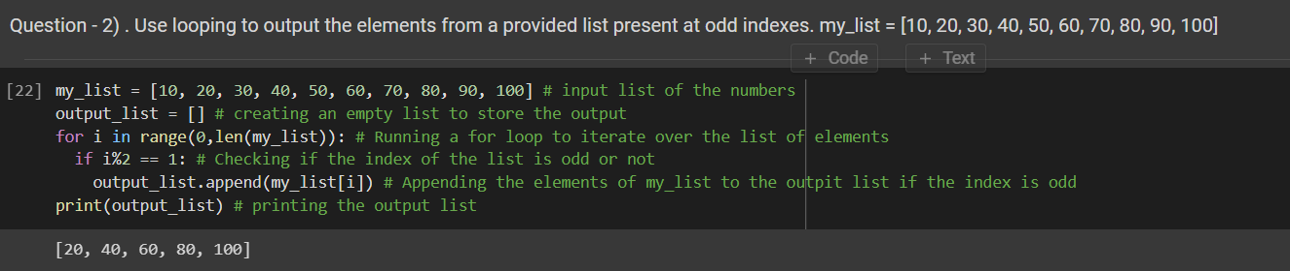

**Question – 3)**

Write a code that appends the type of elements from a given list.

Input x = [23, ‘Python’, 23.98]

Expected output [23, 'Python', 23.98] [class<’int’>,class<’str’> ,class<’int’> ]

* Here the input list is stored in x
* Created an empty list for storing the output
* We ran a for loop to iterate over the loop to get the type of the index.
* We appended the type of the list elements to the output_list
* At last we printed the output_list

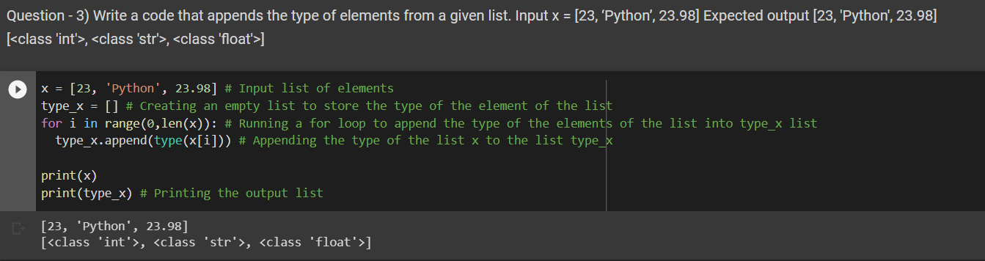

**Question – 4)**

Write a function that takes a list and returns a new list with unique items of the first list. Sample List: [1,2,3,3,3,3,4,5] Unique List: [1, 2, 3, 4, 5]

* Here the input list is stored in input_list
* Created a function to get the unique elements of the list.
* In the method, we convert the input list to a set and then type cast the set as a list again.
* We return the list from the given method.
* When the function is called the output is stored in the variable output_list
* Output_list is printed.

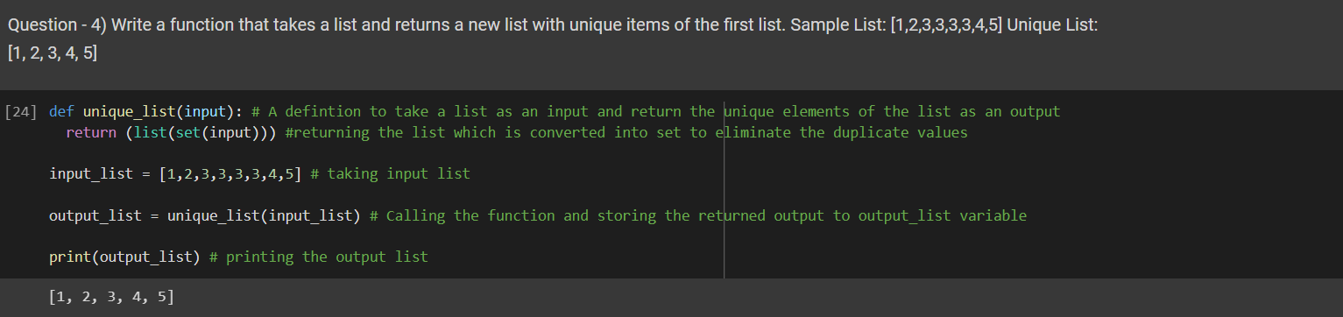

**Question – 5)**

**Write a function that accepts a string and calculate the number of upper-case letters and lower-case letters.**

**Input String: 'The quick Brow Fox'**

**Expected Output:**

**No. of Upper-case characters: 3**

**No. of Lower-case Characters: 12**

* Here the input string is stored in input_string and pass it to the definition to get the output.
* Created a function to get the no. of uppercase and lowercase letters
* In the method, we iterate over the string and check if the character is lowercase or uppercase.
* If the character is uppercase, then the upper counter will be incremented.
* If the character is lowercase, then the lower counter will be incremented.
* We print the statements as per the given question.

