
HOUSE OF PRACTICE
ROUND ONE
FINANCIAL TRANSACTION CYBERSECURITY
ANALYSIS
Victor Xorse
Full Name Victor Xorse
Selected Track Cybersecurity
Project Title Transaction Threat Detection and Fraud Risk
Assessment
Primary Work Link Self-contained submission

Executive Summary
I treated the fictional transaction dataset as a fraud and anomaly
detection exercise. I first checked the data for quality issues, then
compared risk scores with transaction amounts, frequency, device
changes, failed attempts, channels, and locations. The goal was to
identify patterns that would justify further investigation, not to label
customers as fraudsters/threat actors.
Transactions with risk scores of 80 or above made up 20.5% of the
dataset, with 237 of these transactions still recorded as successful.
This suggests a gap between risk detection and transaction
prevention. High-risk activity should trigger controls such as
additional authentication or review.
Transaction velocity, failed attempts, and device changes were the
strongest supporting indicators. CUST0099 also stood out due to
repeated high-risk activity across different devices, channels,
regions, and failed attempts. I would treat this as an investigation
lead rather than proof of compromise.
The analysis has limitations because the dataset is fictional and has
no confirmed fraud labels. Missing fields such as IP addresses,
authentication details, beneficiary history, and confirmed outcomes
also limit the investigation.
I recommend layered controls that combine risk scores with velocity
limits, device alerts, step-up authentication, temporary holds, and
analyst review. The next step would be to test these controls against
confirmed fraud and legitimate transactions to measure false
positives, missed attacks, and response time.

1. Purpose and Scope
The purpose of this analysis was to examine fictional financial transactions for
signs of potentially suspicious activity and to suggest practical controls that
could help a security team prioritise investigations.
2. Data Review
The dataset contains 1,500 transactions. I reviewed the structure, timestamps,
transaction outcomes, risk scores and behavioural fields before looking for
patterns.
The main fields used were amount, transaction type, channel, region, device ID,
status, one-hour transaction velocity, device changes, failed attempts and risk
score.
3. Analysis Method
I checked the data for missing values and inconsistent field types.
I grouped transactions by risk level and examined the high-risk group in more detail.
I compared risk with behavioural indicators rather than relying on risk score alone.
I reviewed patterns by customer, channel and region.
I separated investigation leads from conclusions about actual fraud.
4. Findings
308 transactions, or 20.5%, had a risk score of 80 or higher.
237 high-risk transactions were successful, with a combined value of GHS 55,282.48.
CUST0099 showed repeated high-risk activity and deserves account-level review.
Velocity, failed attempts and device changes provided useful supporting context.
Missing data reduces confidence in some automated detection rules.
5. Security Recommendations
Use step-up authentication for high-risk transactions.
Monitor transaction velocity and repeated failed attempts.
Alert on unusual device changes, especially when combined with other
risk signals.Prioritise repeated suspicious behaviour at account level.
Keep an audit trail that allows analysts to reconstruct the event.
Measure detection performance using confirmed legitimate and
fraudulent cases.
6. Limitations

This is fictional data and contains no confirmed fraud outcome. The analysis therefore
identifies risk patterns rather than proving malicious activity. Missing fields and the short
observation period also limit the conclusions.
7. Evidence
The following pages contain the supporting charts, transaction examples and investigation
logic used to reach the findings.

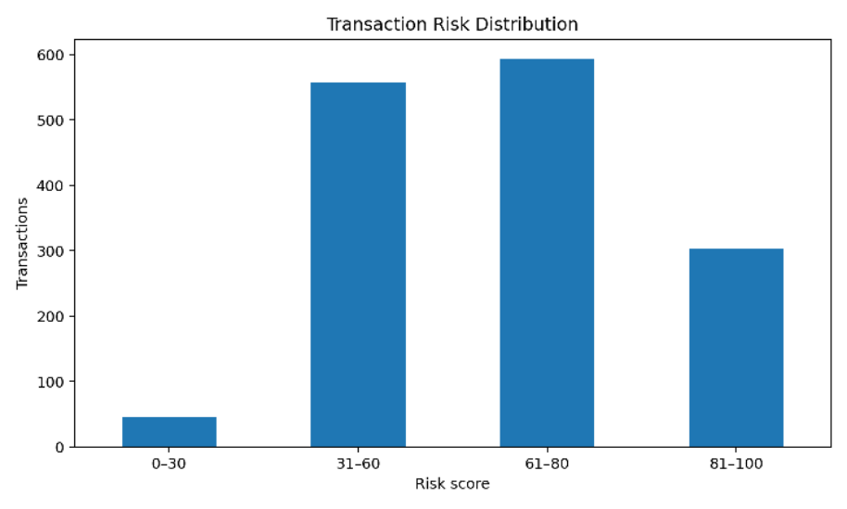
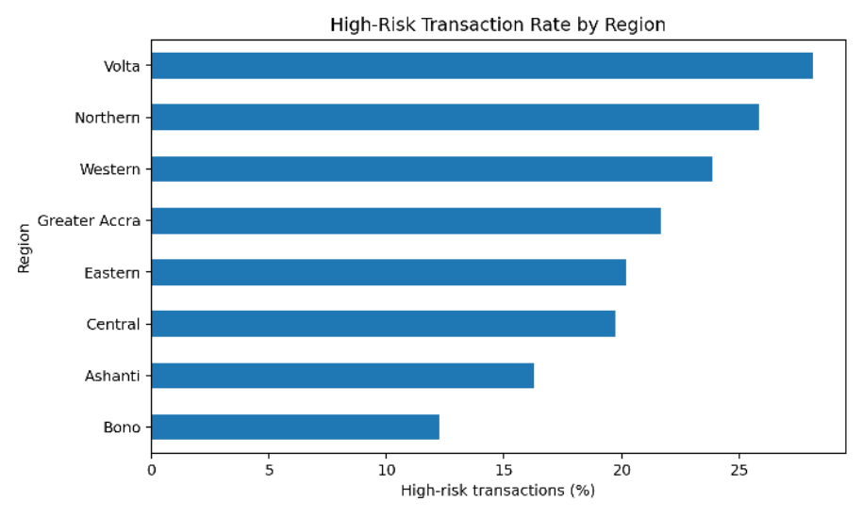
8. Risk Distribution
Risk score distribution across the supplied transactions. Scores of 80 and above were treated
as the main investigation group.
9. Regional View
Share of transactions in each region that fall into the high-risk group.

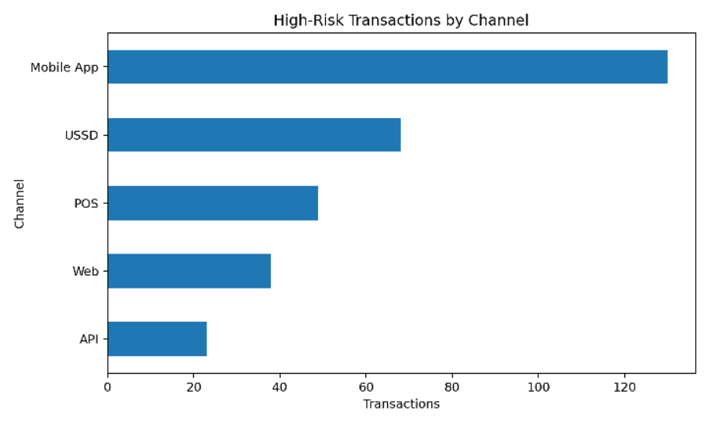
10. Channel View
Number of high-risk transactions by transaction channel.
11. Example High-Risk Transactions
Transacti | Customer | Amount | Type | Channel | Status | Velocity | Risk
on GHS
TXN0002 | CUST021 | 498.63 | Cash-Out | USSD | SUCCESS | 5 | 99.0
33 0
TXN0002 | CUST015 | 440.19 | Bill | Mobile | FAILED | 4 | 99.0

67 | 2 | Payment | App

TXN0002 | CUST029 | 364.62 | Cash-In | USSD | REVERSE | 5 | 99.0

46 | 4 | D

TXN0011 | CUST016 | 355.49 | Bank | Mobile | SUCCESS | 5 | 99.0

66 | 1 | Transfer | App

TXN0004 | CUST004 | 328.31 | P2P | Mobile | FAILED | 4 | 99.0

08 | 9 | Transfer | App

TXN0001 | CUST029 | 256.47 | Bank | Web | SUCCESS | 5 | 99.0

49 | 4 | Transfer

TXN0001 | CUST020 | 242.55 | Cash-In | Mobile | SUCCESS | 5 | 99.0

96 | 5 | App

TXN0008 | CUST022 | 242.04 | P2P | POS | FAILED | 5 | 99.0

25 | 5 | Transfer

TXN0003 73 | CUST018 2 | 232.38 | Bill  Payment | Web | SUCCESS | 4 | 99.0
TXN0012 65 | CUST006 2 | 191.16 | P2P  Transfer | POS | FAILED | 5 | 99.0
12. Investigation Logic
Risk score 80+ is an investigation trigger, not a verdict.
Increase priority when high risk is combined with high velocity, device changes or
repeated failed attempts.
Repeated high-risk activity from the same customer should be reviewed as one case.
Successful high-risk transactions should be checked for possible control gaps.
Missing critical fields should be handled explicitly rather than silently ignored.
13. Customer Case: CUST0099
CUST0099 is one of the clearest investigation leads in the dataset. The account
appears repeatedly in high-risk records and shows several risk signals at the same
time. The mix of channels, regions, velocity, failed attempts and device changes is
enough to justify review. It would not be appropriate to call the account
compromised without additional evidence.
14. Problems and Limitations
The dataset is fictional.
There is no confirmed fraud label.
Some important fields contain missing values.
No IP, authentication, beneficiary or precise location data is available.
The observation period is too short to establish a strong long-term customer baseline.
15. AI / External Tools
NotebookLM was used to assist with the analysis of the supplied
transaction sheet. It helped review the dataset, identify relevant patterns
and risk indicators, and support the interpretation of transaction
behaviour.
If I had another 72 hours, I would…
build a small detection pipeline, test the rules against confirmed legitimate and
fraudulent examples, measure false positives and missed attacks, and add
customer and device baselines so the system can distinguish unusual behaviour
from genuinely risky behaviour.

