VYVA x Red Cross

Admin Console User Manual
Reference guide for admins using the VYVA operations console

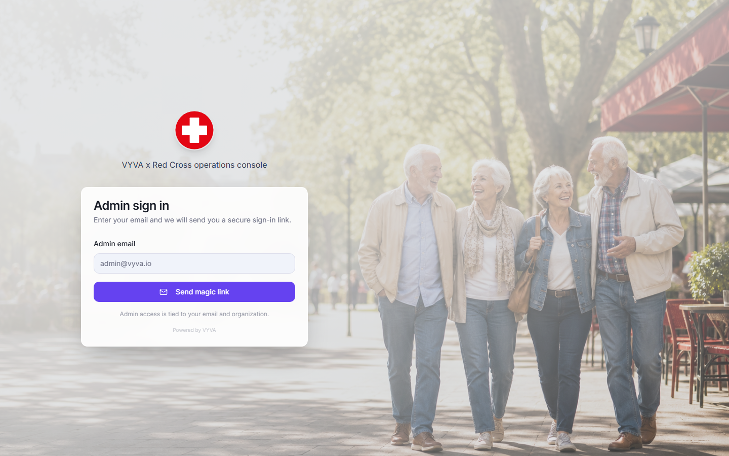
Sign-in page shown with sanitized placeholder data.
Audience | Organization admins responsible for client operations, follow-up, and console management.
Language | English only.
Data policy | Screenshots use sanitized demo data or sanitized UI examples. Do not copy real client details into training materials.
Scope | Feature guide only. This document does not change console links, routes, email templates, or permissions.

Contents
Getting started
Sign in with a magic link
Console layout and organization context
Roles and language setting
Main workflows
Today dashboard
Clients list
Add User intake
CSV and API onboarding reference
Client profile
Edit profile
Notes
Care coverage
Health, medications, sensors, and health plan
Risk and follow-up
Risk queue
Prepare call workflow
Sensors and alerts
Check-ins
Medication monitoring
Brain Coach sessions
Management
Campaigns wizard
Emergency Contacts and Care Providers
Team access
Settings and organization management
Reports
Appendix
Role capability matrix
Common errors
Safe data handling
Glossary

Getting started

Sign in with a magic link
Purpose | Gives admins secure access without storing a console password in the app.
Use when | Use this every time you need to open the console from a new browser, after signing out, or after a session expires.
Admin edits | Admins cannot edit anything from the sign-in page. Access depends on the email and organization record.
Expected result | The console opens to the Today dashboard with the correct organization selected.
Common mistakes | Using an unregistered email, opening an expired link, or requesting too many links too quickly.

How to use
- Open the console sign-in page provided by your organization.
- Enter your admin email exactly as registered for your organization.
- Select Send magic link and check your inbox for the secure sign-in email.
- Open the link in the same browser you will use for the console.
Admin-only behavior
Magic-link access is tied to an authorized staff email and organization membership. Operators can sign in but do not receive admin-only controls.

Sign-in screen with organization-neutral placeholder email.

Console layout and organization context
Purpose | Explains the stable navigation model used across the console.
Use when | Use this when orienting a new admin or confirming which organization data you are viewing.
Admin edits | Admins can act inside their organization. Platform admins can also create and switch organizations when that control is available.
Expected result | Each page opens in the current organization context, so lists, profiles, and reports stay scoped correctly.
Common mistakes | Working in the wrong organization context or assuming sidebar counts are global.

How to use
- Use the left sidebar to move between Main, Follow-up, and Management areas.
- Check the top bar for the current organization and system status.
- Use the sidebar footer to confirm the signed-in account and role label.
- If you manage more than one organization, change context only from Settings when permitted.
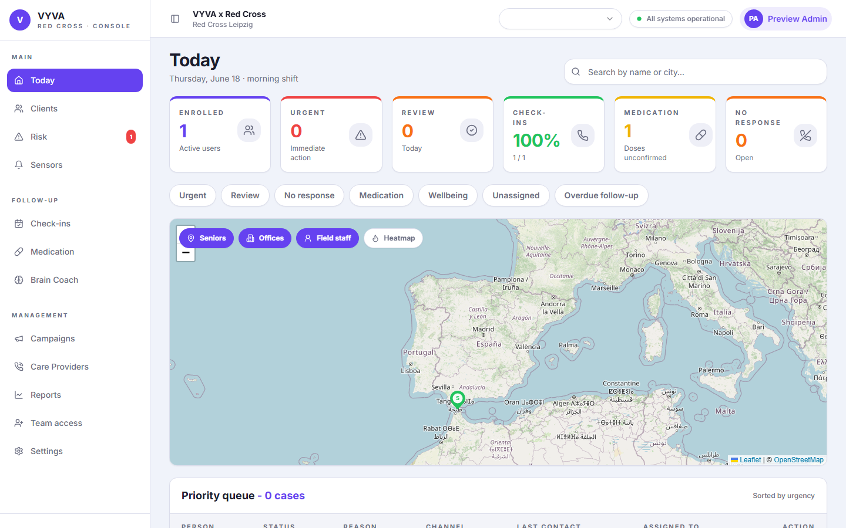
Today dashboard showing sidebar groups, organization context, and operational status.

Roles and language setting
Purpose | Clarifies who can see and change admin controls and how language is handled after sign-in.
Use when | Use this when a staff member cannot see a button, form, or management area.
Admin edits | Admins manage client intake, follow-up, campaigns, team access, and settings. Operators primarily review assigned operational work.
Expected result | The visible controls match the signed-in user role and organization permissions.
Common mistakes | Expecting operator accounts to see admin-only buttons or changing personal language instead of the organization default.

How to use
- Check the role label in the lower-left account card.
- Use Team access to invite or adjust organization staff roles when you have permission.
- Use Settings to change your own display language after signing in.
- Keep organization default language aligned with the branch, such as Spanish for Zamora or German for Leipzig.
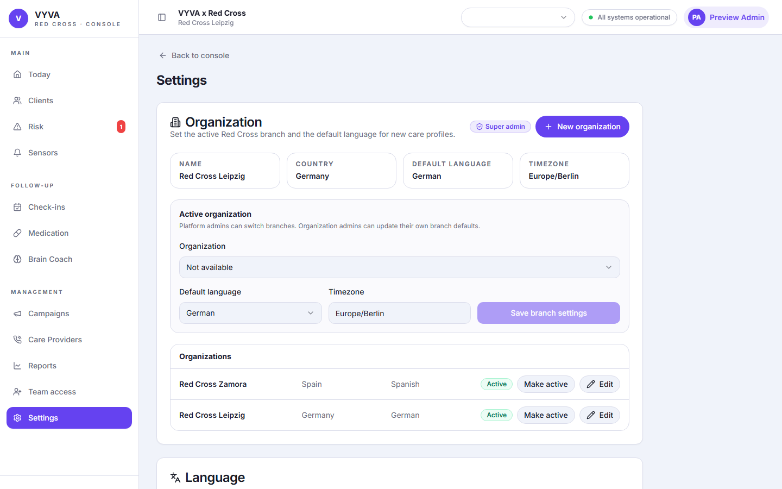
Settings page where language and organization-related controls are managed after sign-in.

Main workflows

Today dashboard
Purpose | Provides the daily operational view: counts, map, priority queue, and fast filters.
Use when | Use at the start of a shift and whenever you need a quick picture of current work.
Admin edits | Admins can open profiles, prepare calls, and follow up based on the queue. Dashboard counts are read from current operational data.
Expected result | The admin knows what needs attention now and where clients or teams are clustered.
Common mistakes | Treating dashboard counts as historical reports or ignoring organization context.

How to use
- Review the top summary cards for enrolled clients, urgent cases, reviews, check-ins, medication, and no-response items.
- Use the search field for a person or city.
- Toggle map layers for seniors, offices, field staff, or heatmap views.
- Open a queue item to continue into the risk or profile workflow.

Today dashboard with daily cards, filters, and map view.

Clients list
Purpose | Central list for finding clients, adding new users, and opening profiles.
Use when | Use when onboarding a client, searching for a profile, or validating care coverage.
Admin edits | Admins can add users, edit profiles, and assign care providers. Operators can review accessible client information without admin edit controls.
Expected result | The correct client profile opens and any admin edits remain organization-scoped.
Common mistakes | Adding duplicate clients because the phone number was not checked first.

How to use
- Open Clients from the Main sidebar group.
- Search by name, phone, or city.
- Use filters and list actions to narrow the operational set.
- Open a profile to review or update details.
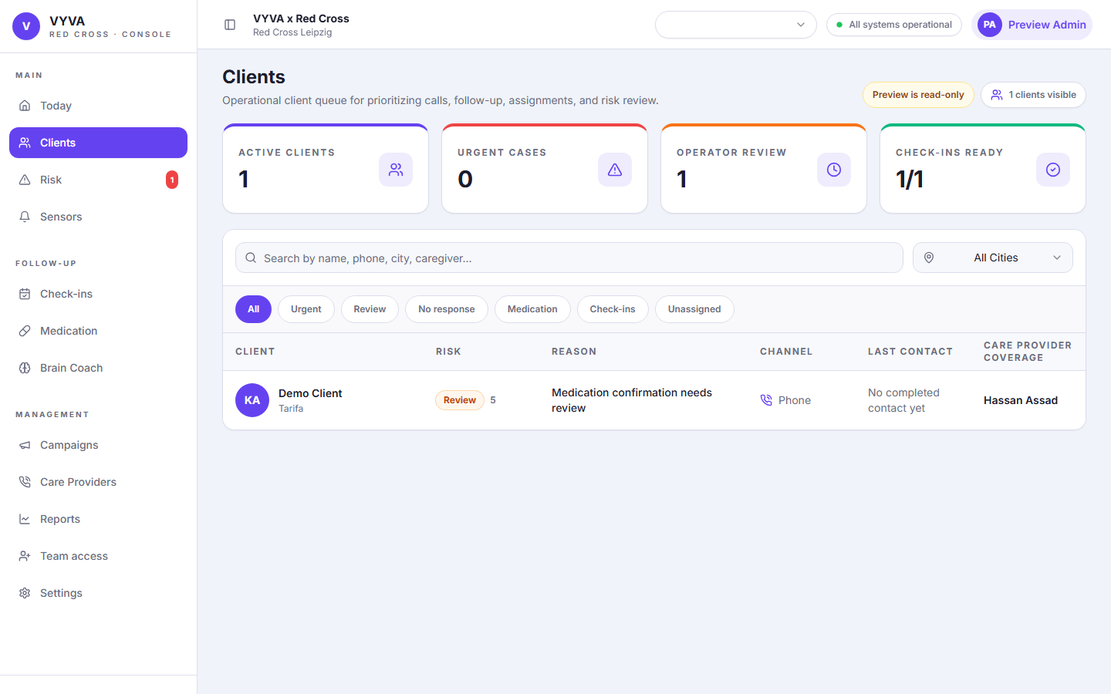
Clients list with sanitized demo profiles.

Add User intake
Purpose | Creates a new client profile from the same fields used by onboarding intake.
Use when | Use when one client needs to be added manually instead of through CSV or API onboarding.
Admin edits | Admins can create the user and submit health, medications, caregivers, consent, check-ins, and Brain Coach data in one save.
Expected result | The new profile exists in Clients, uses the active organization defaults, and opens automatically after save.
Common mistakes | Leaving required names blank, entering a phone number that cannot be normalized, or adding medication rows without names.

How to use
- Open Clients and select Add User or Add one by one.
- Enter first name and last name. These are mandatory.
- Add optional intake details: phone, date of birth, gender, language, address, care safety notes, health conditions, mobility needs, medications, caregivers, consent, check-ins, and Brain Coach settings.
- Fix validation messages for phone format, date format, medication names, and preferred times.
- Save the profile. The console opens the new client profile after creation.
Mandatory fields
First name and last name are mandatory. Other onboarding-aligned fields remain optional but are validated when filled.
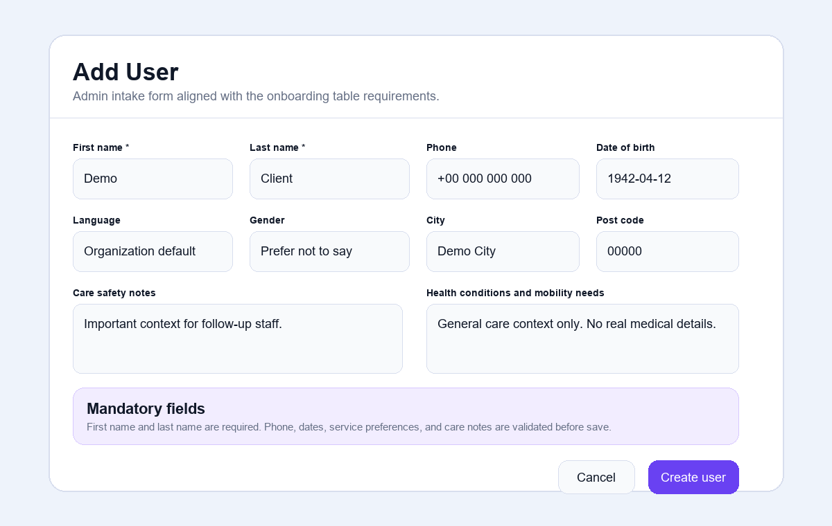
Sanitized Add User dialog example aligned with onboarding intake fields.

CSV and API onboarding reference
Purpose | Keeps bulk onboarding and manual intake aligned around the same client data model.
Use when | Use when preparing a spreadsheet upload or API feed from an external intake source.
Admin edits | Admins can review imported profiles and correct profile-level information. Bulk import setup may require platform support depending on deployment.
Expected result | Imported records map to the same profile sections shown in the console.
Common mistakes | Mixing campaign/call metadata with onboarding data or using inconsistent medication times.

How to use
- Use the onboarding template fields as the source of truth for person, address, care notes, health, medications, caregivers, consent, check-ins, and Brain Coach information.
- Avoid webhook-only call metadata in manual forms; those fields are not part of client intake.
- Validate phone and preferred-time formats before uploading or sending API data.
- Review created records in Clients after import.

Client profile
Purpose | Single operational record for a client: contact details, risks, care coverage, services, health, medications, sensors, timeline, and notes.
Use when | Use whenever you need context before a call, follow-up, medication review, sensor review, or care-provider assignment.
Admin edits | Admins can edit profile details, add notes, manage care coverage, update services, medications, sensors, and care plan content when permissions allow.
Expected result | All major operational context is visible before the admin takes action.
Common mistakes | Calling without checking recent alerts or assuming an old care note is still current.

How to use
- Open a client from Clients, Today, Risk Queue, or a follow-up list.
- Review the header for preferred channel, phone number, urgency, and key alerts.
- Scan Key data and Care notes before taking action.
- Use profile cards to review services, health plan, care coverage, medications, sensors, and timeline activity.
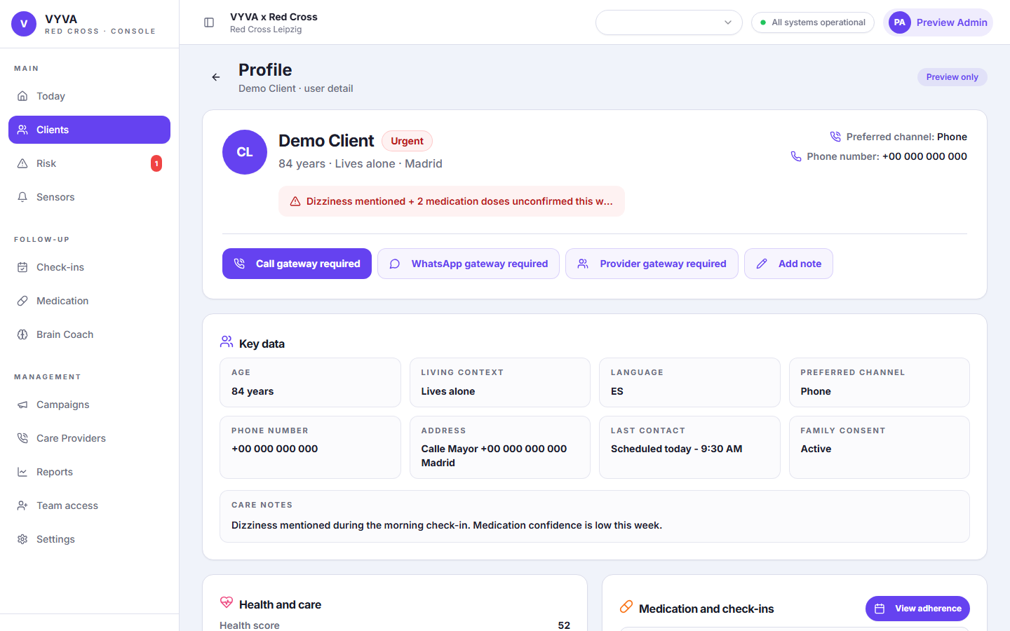
Client profile with sanitized contact details and operational context.

Edit profile
Purpose | Updates core client demographics, contact details, language, address, consent, and care notes.
Use when | Use after receiving corrected information from the client, family contact, Red Cross staff, or onboarding source.
Admin edits | Admins can edit profile data when the profile is not preview-only and the backend confirms edit permission.
Expected result | The client profile reflects the updated details without changing unrelated service settings.
Common mistakes | Changing language or channel without confirming client preference.

How to use
- Open the client profile and select the edit profile control when visible.
- Update only the fields you can verify.
- Keep care notes operational and concise.
- Save and confirm the profile header or key data card reflects the change.
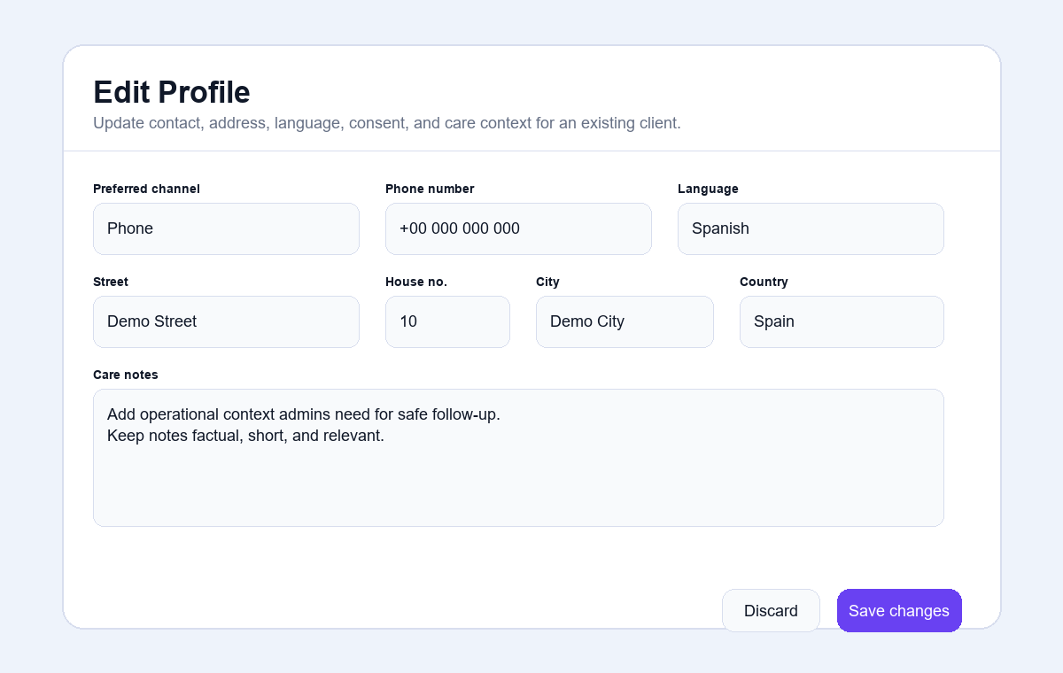
Sanitized Edit Profile dialog example.

Notes
Purpose | Captures short operational notes on the client timeline.
Use when | Use after a call, care-provider contact, manual review, or important profile update.
Admin edits | Admins can add notes to the profile. Notes should not be used for broad document storage or unsupported medical claims.
Expected result | The note is saved against the client profile and visible to authorized console users.
Common mistakes | Writing speculative, overly personal, or unnecessary sensitive details.

How to use
- Open the client profile and select Add note.
- Choose the note type or context if prompted.
- Write a concise, factual note with the action taken and next step.
- Save and confirm the note appears in the profile timeline.
Safe note writing
Use objective language. Record what happened, who acted, and what should happen next.
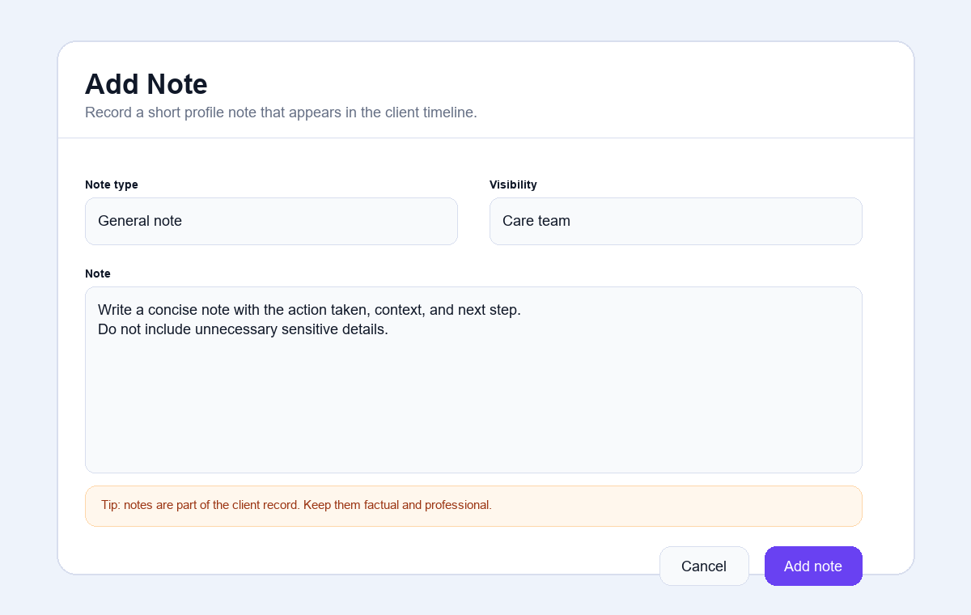
Sanitized Add Note dialog example.

Care coverage
Purpose | Shows emergency contacts and Red Cross staff connected to the client.
Use when | Use to confirm who can be contacted or assigned when the client needs support.
Admin edits | Admins can link emergency contacts and care providers. Only one primary should exist per provider type.
Expected result | Care coverage shows the right contact number, staff role, and linked clients.
Common mistakes | Creating duplicate contacts instead of linking an existing contact.

How to use
- Open the client profile and scroll to Care coverage.
- Check the primary emergency contact and primary Red Cross staff card.
- Use the add or assign control to link a provider when permitted.
- Confirm whether the provider is primary and what role they hold.
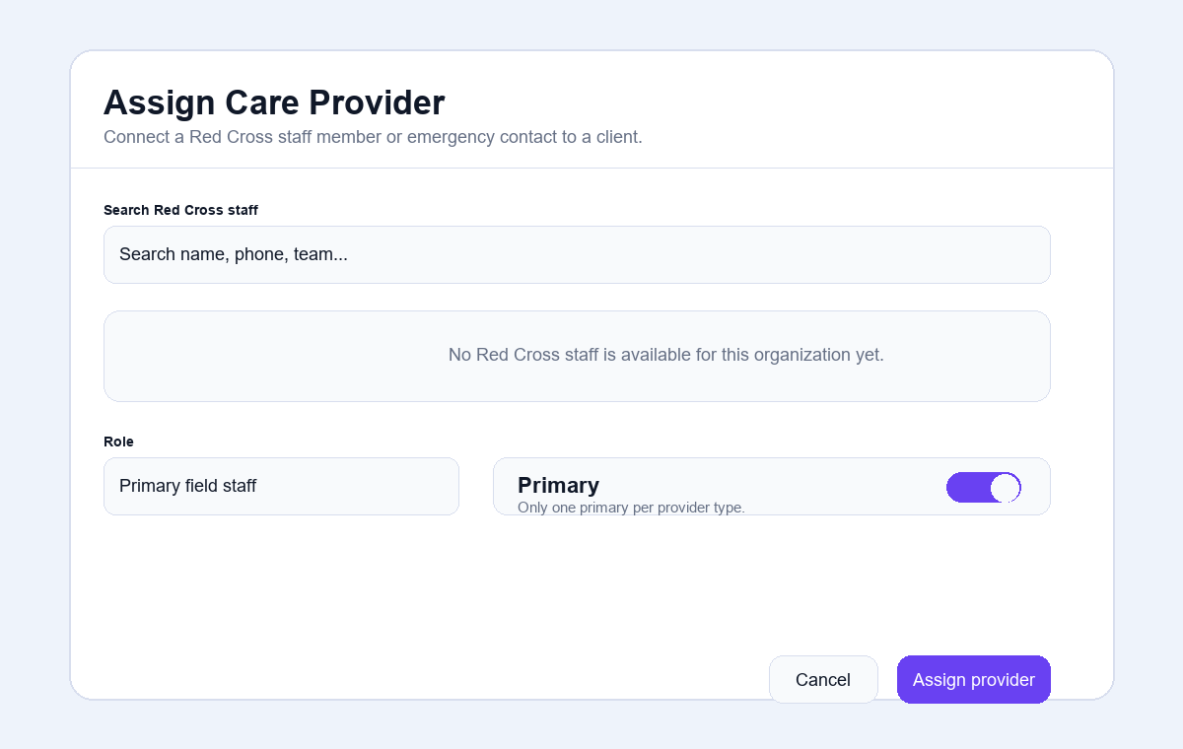
Sanitized Assign Care Provider dialog example.

Health, medications, sensors, and health plan
Purpose | Keeps clinical-adjacent operational data in structured cards while avoiding unnecessary detail in queues.
Use when | Use when reviewing adherence, device status, service settings, or care-plan guidance.
Admin edits | Admins can update medications, sensors, check-ins, Brain Coach, and health plan settings when enabled for the profile.
Expected result | The profile reflects the current monitoring setup and gives staff practical next actions.
Common mistakes | Entering device IDs in the wrong field, leaving medication rows incomplete, or using the health plan as free-text storage.

How to use
- Review Health and care for score, plan, safety notes, and status signals.
- Review Medication and check-ins for reminders, dose confirmation, and service preferences.
- Use Sensors to confirm linked devices and alert status.
- Use Health plan to review generated goals, daily guidance, monitor signals, escalation triggers, and caregiver guidance.
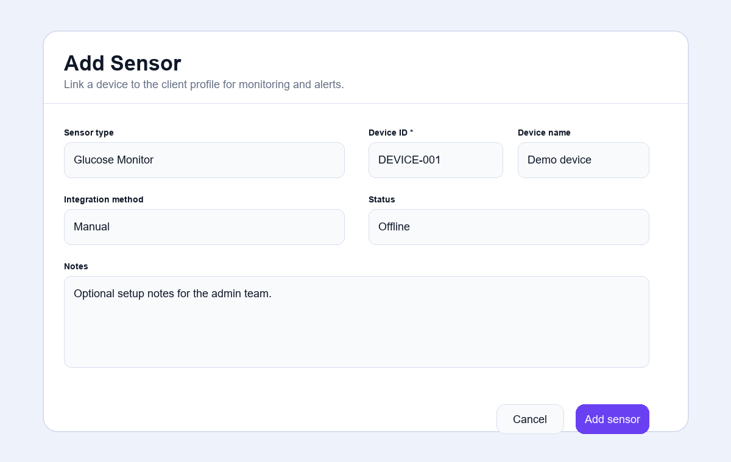
Sanitized Add Sensor dialog example.

Risk and follow-up

Risk queue
Purpose | Prioritizes clients needing review based on operational risk, alerts, missed responses, and monitoring signals.
Use when | Use during shift triage and before outreach.
Admin edits | Admins can prepare calls, update notes, and coordinate follow-up. Operators can work visible queue items according to role permissions.
Expected result | The most important cases are reviewed first with enough context to act safely.
Common mistakes | Treating risk score alone as the full decision or skipping profile review before contacting someone.

How to use
- Open Risk from the Main sidebar group.
- Review urgency, reason, channel, last contact, and assigned staff.
- Use filters to focus on urgent, review, no-response, medication, wellbeing, unassigned, or overdue cases.
- Open a case or prepare a call before outreach.
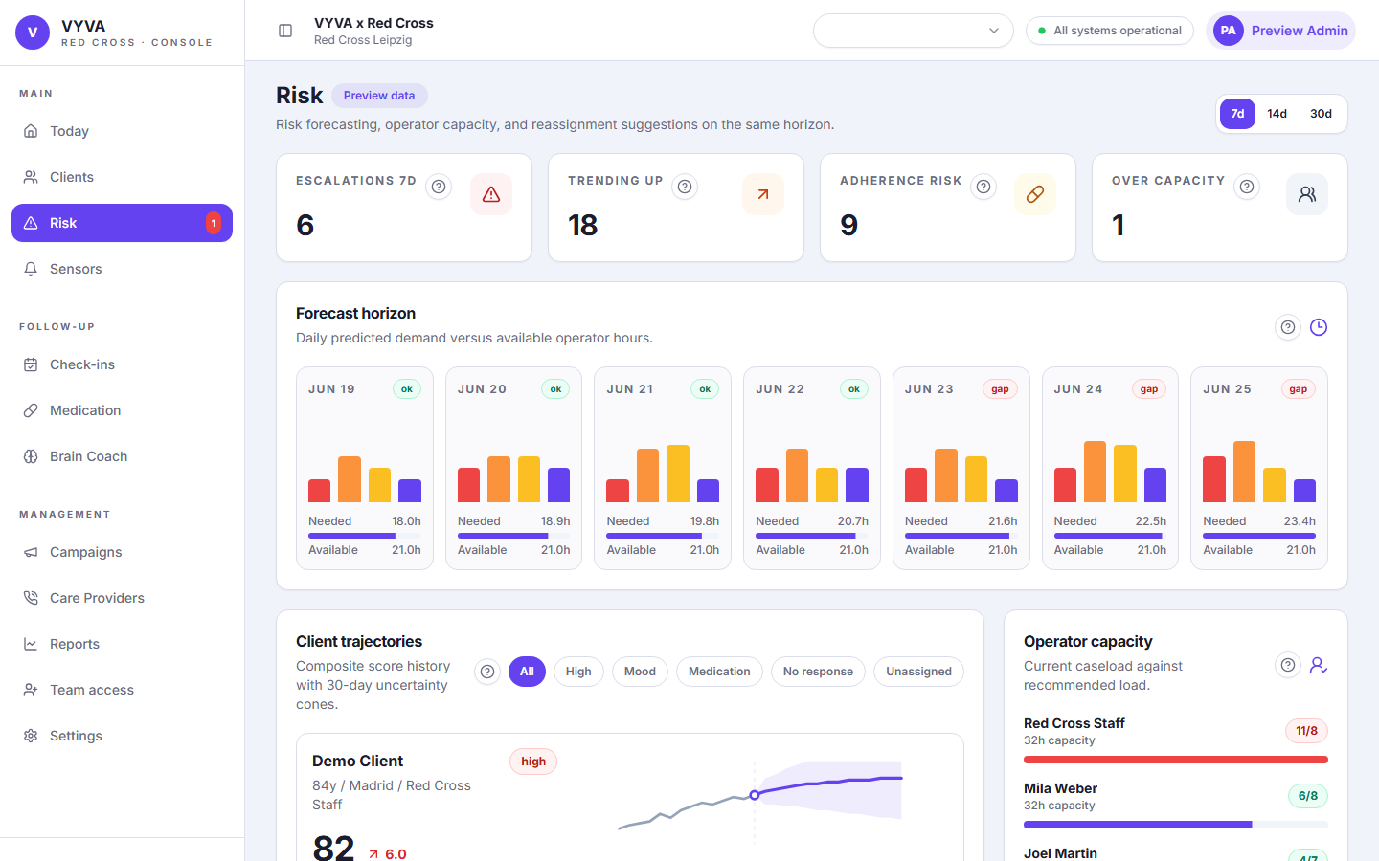
Risk queue with sanitized demo data.

Prepare call workflow
Purpose | Provides a guided pre-call brief so staff can contact the client with context.
Use when | Use before calling a client from Risk Queue or Today.
Admin edits | Admins can use profile actions after the call to add notes, update care coverage, or adjust services.
Expected result | The caller has a short, relevant brief and avoids repeating unnecessary questions.
Common mistakes | Reading the script without checking current profile context or missing the recommended questions.

How to use
- Open the case and select Prepare call when available.
- Read the summary, risk signals, recommended questions, and suggested opening.
- Confirm preferred channel and phone number.
- Document the result through notes or profile updates after the call.
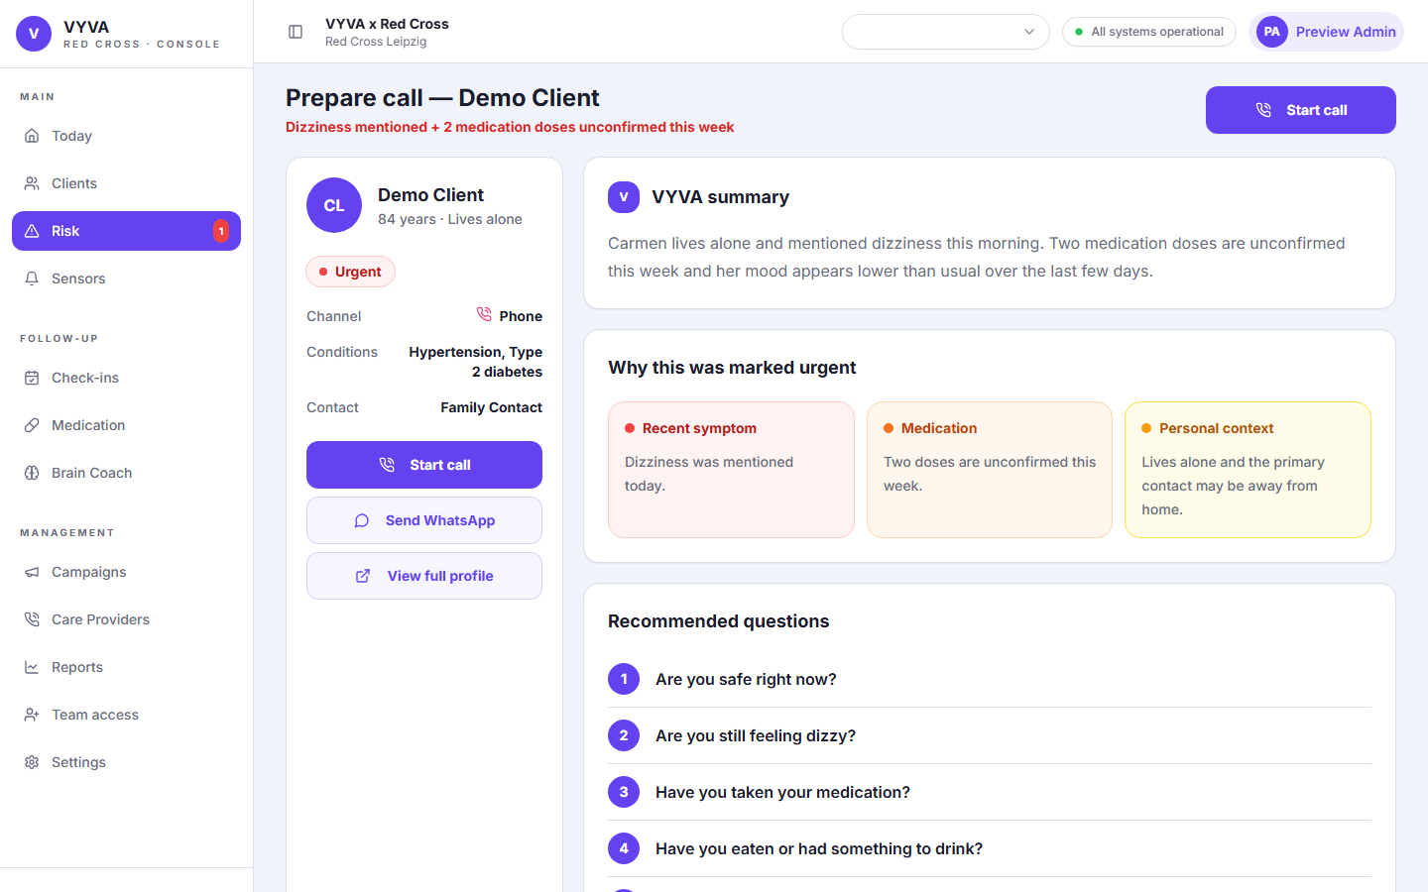
Prepare-call view with sanitized client context.

Sensors and alerts
Purpose | Monitors linked devices and alert conditions across clients.
Use when | Use when reviewing device status, manual integration notes, or client-specific alert signals.
Admin edits | Admins can add sensors, edit integration method, set status, and document sensor notes.
Expected result | Sensor status is visible on the profile and contributes to follow-up context where supported.
Common mistakes | Using a numeric code or HTTP status as a device ID when the field expects a real device identifier.

How to use
- Open Sensors from the Main sidebar group.
- Review device status, alert counts, and client links.
- Open a client profile to investigate alerts in context.
- Add or edit a sensor from the profile when admin controls are available.
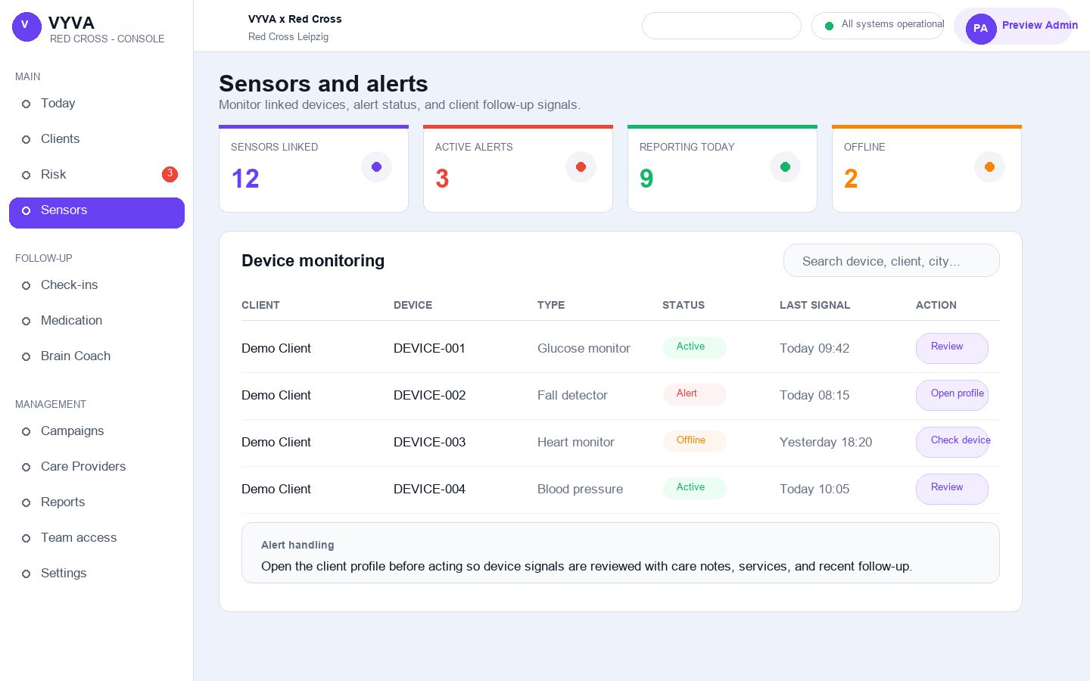
Sensors view in demo mode.

Check-ins
Purpose | Tracks scheduled wellbeing or safety check-ins and their status.
Use when | Use to review enabled check-ins, missed check-ins, preferred times, and assigned follow-up work.
Admin edits | Admins can create or edit check-in schedules from the profile when permitted.
Expected result | Check-in status and preferred time remain aligned with the client profile.
Common mistakes | Entering invalid preferred times or changing cadence without confirming the client preference.

How to use
- Open Check-ins from the Follow-up sidebar group.
- Use filters to find missed, due, disabled, or assigned check-ins.
- Open the client profile to update service preferences or add notes.
- Coordinate staff action when a check-in is overdue or unanswered.
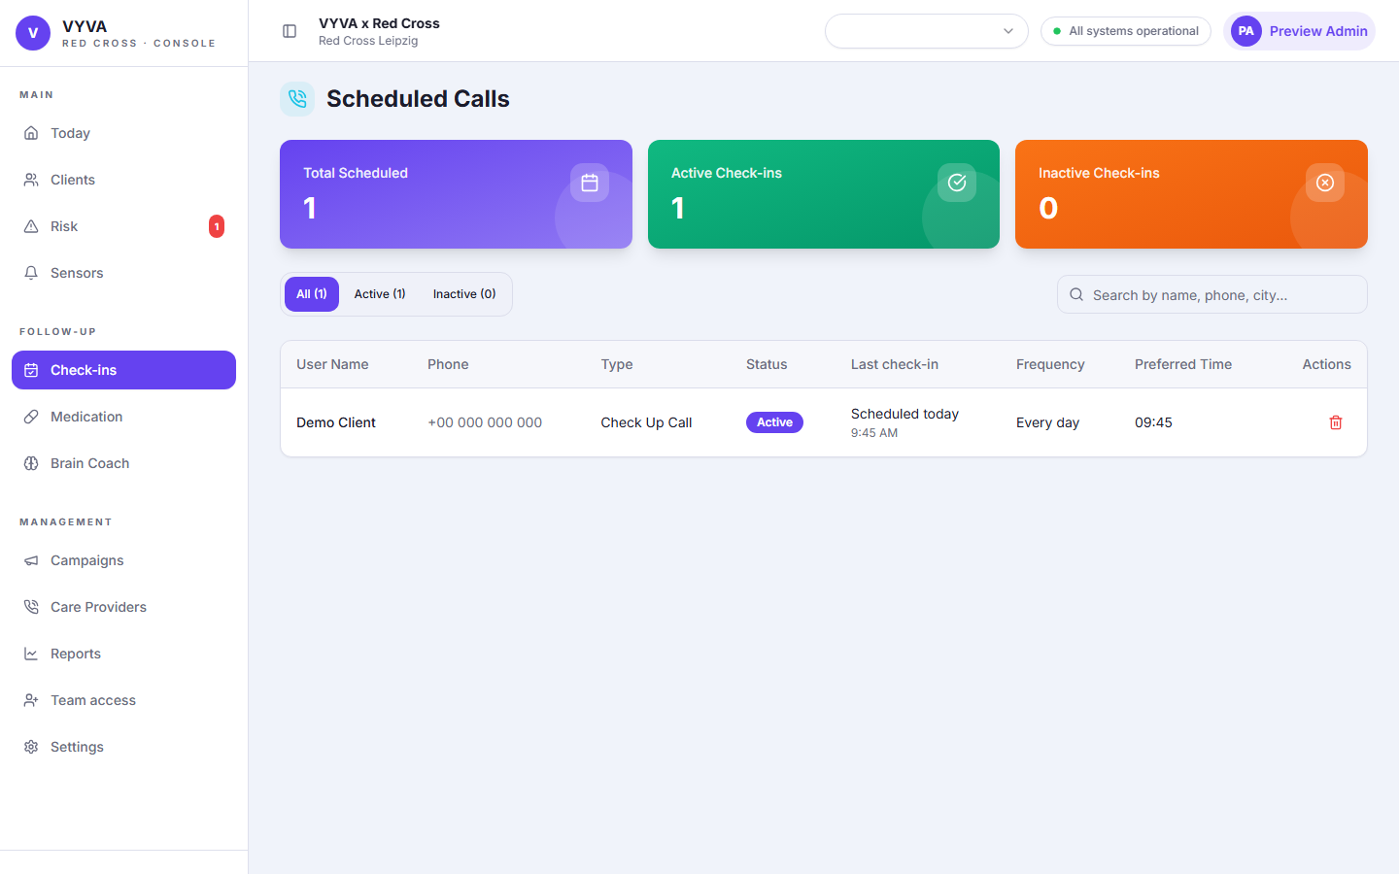
Check-in monitoring page with sanitized demo data.

Medication monitoring
Purpose | Reviews medication reminder status and dose confirmation patterns.
Use when | Use when medication cards, dashboard counts, or risk reasons show unconfirmed doses.
Admin edits | Admins can edit medication names, reminder settings, times, and notes from the profile.
Expected result | Medication follow-up is visible and connected to profile context.
Common mistakes | Saving medication rows without a name or using an invalid time format.

How to use
- Open Medication from the Follow-up sidebar group.
- Review adherence status, unconfirmed doses, reminder status, and timing.
- Open the client profile to edit medication rows or add a note.
- Escalate operationally according to your organization policy if missed confirmations repeat.
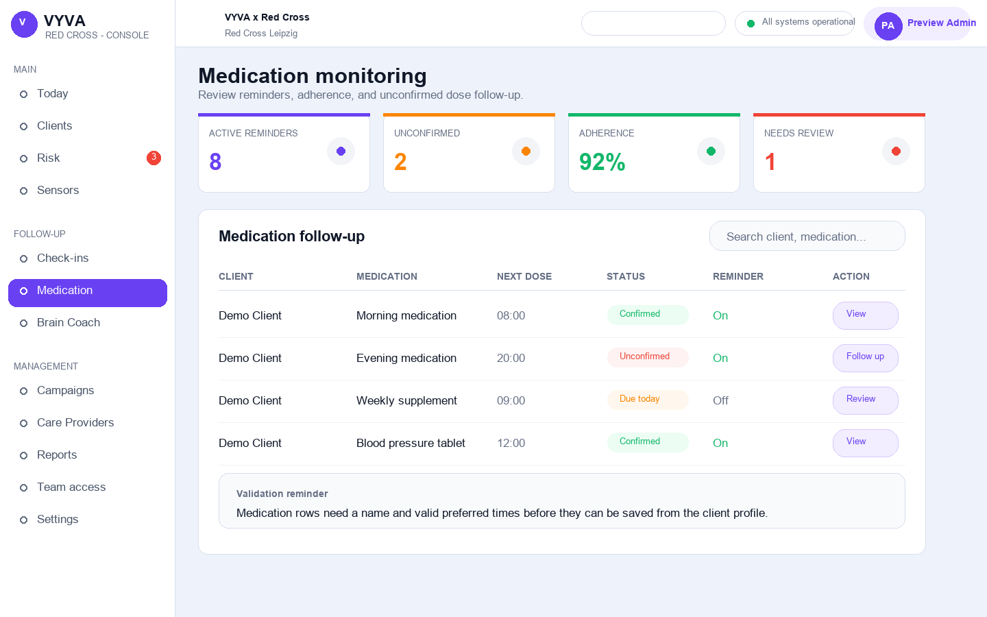
Medication monitoring page in demo mode.

Brain Coach sessions
Purpose | Tracks Brain Coach service status, cadence, preferred time, and recent sessions.
Use when | Use when reviewing cognitive support activity or service preferences.
Admin edits | Admins can edit Brain Coach settings from the profile when permitted.
Expected result | The service cadence and preferred contact time match the client record.
Common mistakes | Changing Brain Coach frequency without checking language and contact preferences.

How to use
- Open Brain Coach from the Follow-up sidebar group.
- Review active/inactive status, cadence, preferred time, and session indicators.
- Open the profile to edit service settings when admin controls are available.
- Document meaningful changes in the profile timeline.
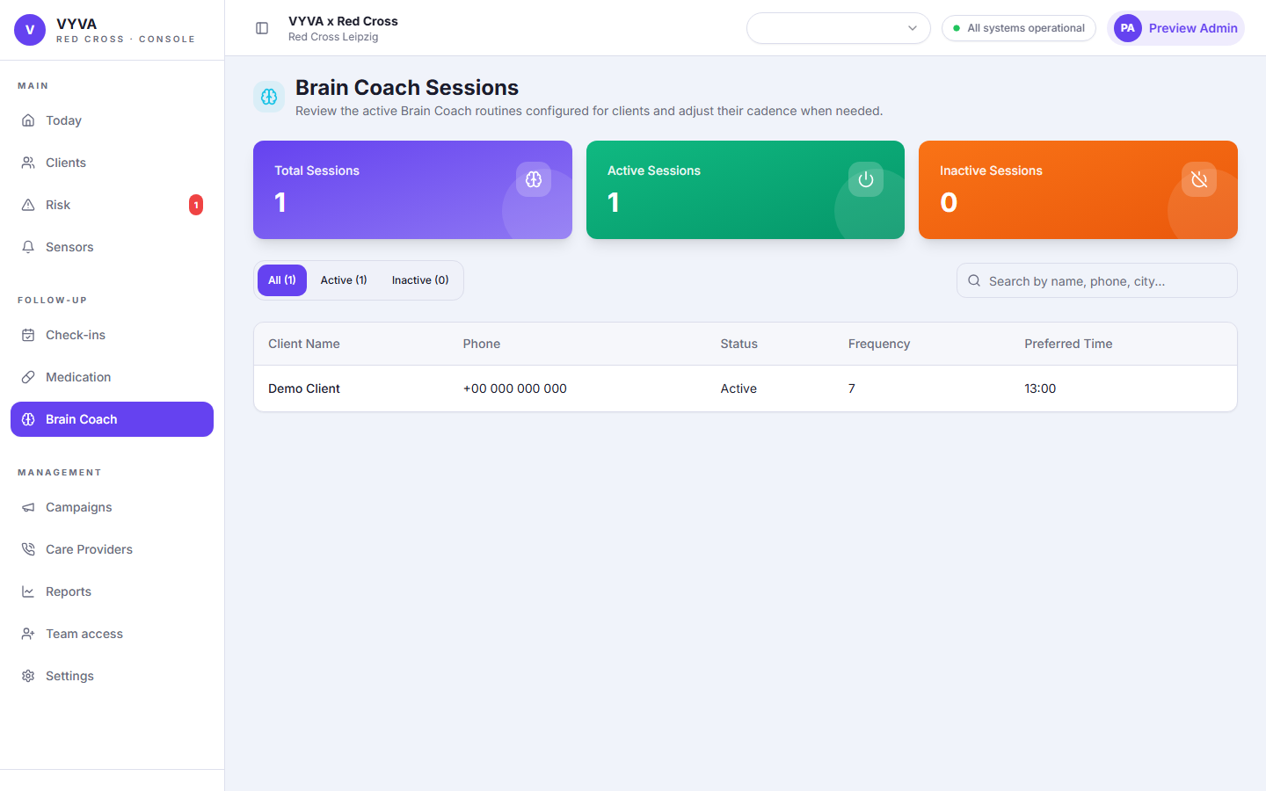
Brain Coach monitoring page with sanitized demo data.

Management

Campaigns wizard
Purpose | Creates campaign drafts using the corrected flow: Script, Audience, Channel, Schedule.
Use when | Use when planning outreach campaigns for selected client groups.
Admin edits | Admins can manage campaigns. Voice calls are the only channel currently previewed or queued by the backend; other channels are saved as planning metadata.
Expected result | The campaign payload stores script, audience source, selected channels, schedule, and voice settings.
Common mistakes | Expecting WhatsApp, email, or SMS to send automatically, leaving script empty, selecting no channel, or skipping schedule date/time.

How to use
- Open Campaigns from Management.
- Start Create Campaign when the action is available.
- Step 1: choose an existing template and edit it, or create a campaign-only AI draft.
- Step 2: choose existing audience, define criteria, or upload a simple list.
- Step 3: select one or more channels: Voice calls, WhatsApp, Email, or SMS.
- Step 4: pick date, time, frequency, and voice-only advanced settings.
- Save the draft or queue/schedule voice-call execution when available.
Channel behavior
Only voice-call delivery is currently executable. WhatsApp, email, and SMS selections are saved for planning until delivery jobs are added.
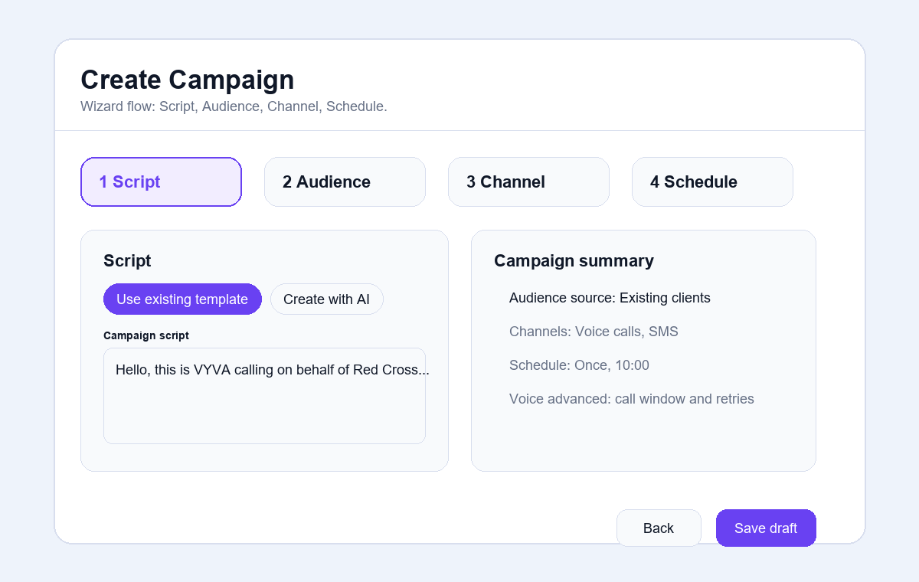
Sanitized Campaign wizard example with the correct step order.

Emergency Contacts and Care Providers
Purpose | Manages personal emergency contacts and Red Cross staff assignments linked to clients.
Use when | Use when updating family support, assigning field staff, or auditing care coverage.
Admin edits | Admins can add emergency contacts and manage assignments. Preview/demo mode may disable writes.
Expected result | Contacts show relationship or role, phone number, source, linked clients, and assignments.
Common mistakes | Confusing emergency contacts with Red Cross staff or creating duplicate provider records.

How to use
- Open Care Providers from Management.
- Search by contact, phone, client, or city.
- Add or edit emergency contacts when the action is enabled.
- Use the client profile to link providers and set primary roles.
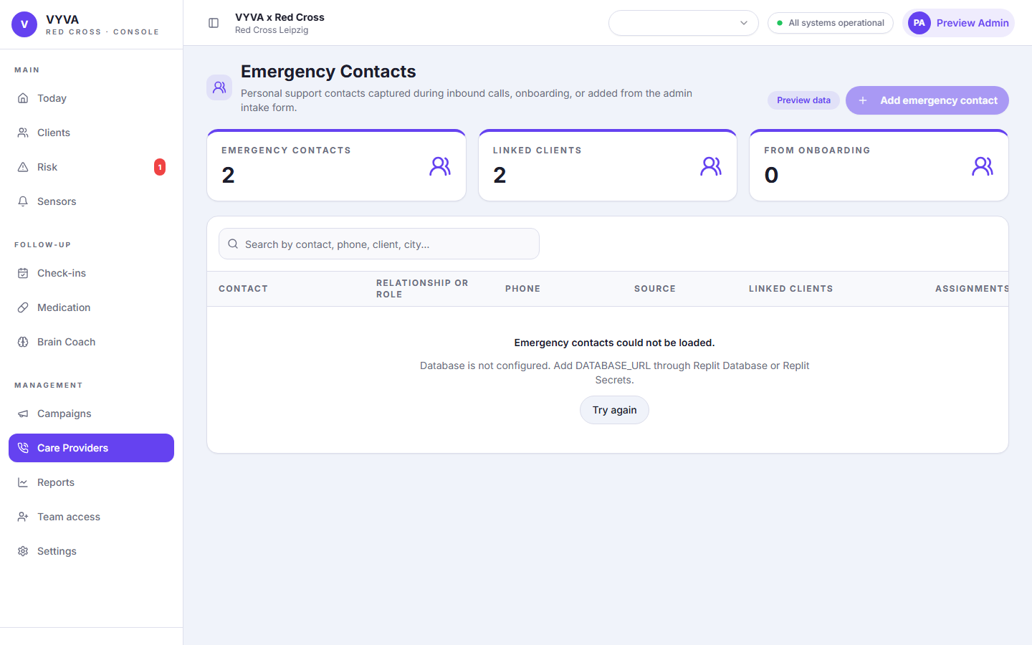
Emergency Contacts and Care Providers management page with sanitized demo data.

Team access
Purpose | Invites staff members to the console and controls whether they are admins or operators.
Use when | Use when adding a console user for an organization.
Admin edits | Admins and platform admins can manage team access. Platform-wide superadmins are managed outside the console.
Expected result | The invited staff member can sign in with the correct role after accepting access.
Common mistakes | Inviting the wrong email, using admin role when operator is enough, or expecting platform admin creation inside this page.

How to use
- Open Team access from Management.
- Enter the staff email address.
- Choose Admin or Operator role.
- Optionally set a temporary password only when your organization uses that fallback.
- Send the invite and confirm the member appears in Current team members.
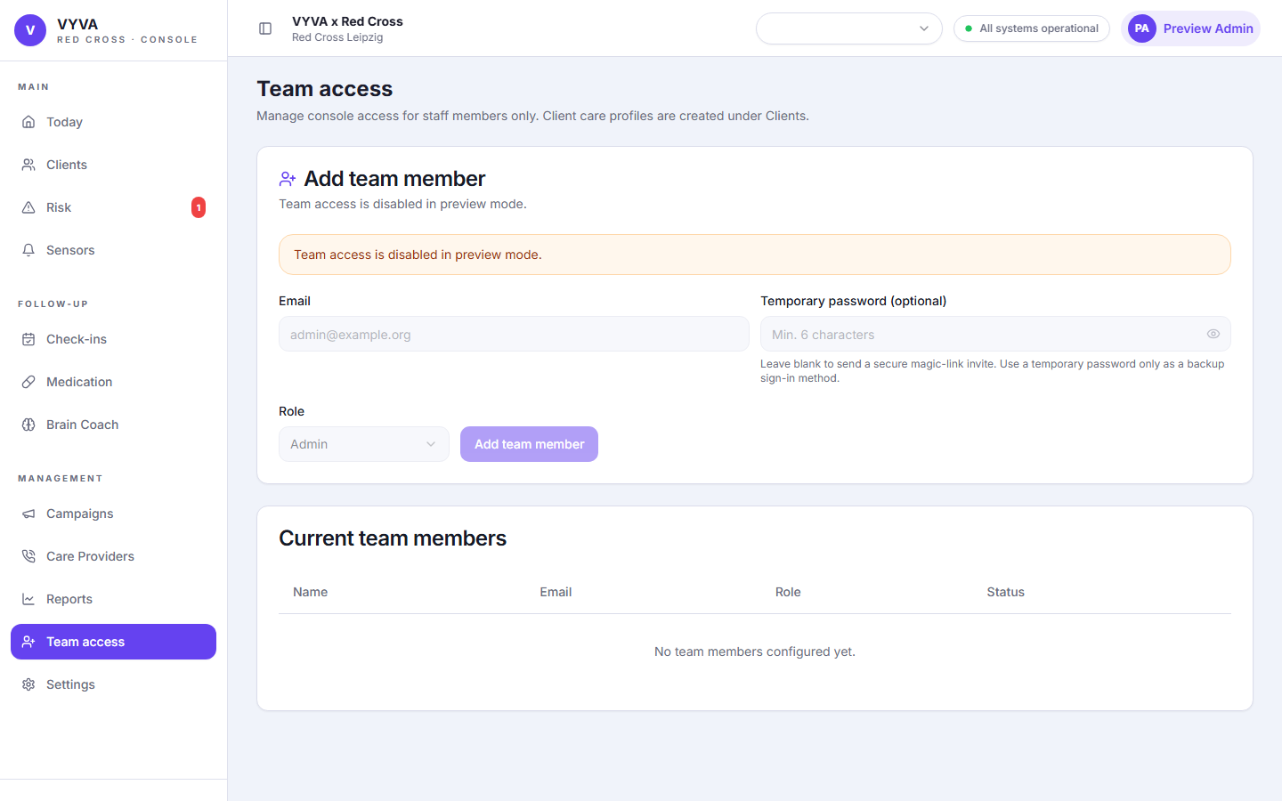
Team access page in demo mode.

Settings and organization management
Purpose | Controls personal display language, organization defaults, and platform-admin organization tools when available.
Use when | Use when validating organization name, default language, timezone, country, or admin account display settings.
Admin edits | Admins manage current organization settings. Platform admins can access broader organization-management controls.
Expected result | The console uses the correct country, timezone, default language, and active organization context.
Common mistakes | Changing personal language when the organization default needs updating, or working in the wrong active organization.

How to use
- Open Settings from Management.
- Review the active organization card and defaults.
- Change your personal display language if needed after sign-in.
- Platform admins can create, activate, or switch organizations where the deployment allows it.
- Save changes and verify the top-bar organization context updates as expected.

Settings page with language and organization controls.

Reports
Purpose | Shows predictive insights and operational analytics where underlying data is available.
Use when | Use to review aggregate trends rather than individual profile actions.
Admin edits | Admins can view reports when data is available. Report generation depends on configured data sources and nightly jobs.
Expected result | Admins understand aggregate risk and operational patterns.
Common mistakes | Treating a missing report table as missing client data, or using reports for individual emergency action.

How to use
- Open Reports from Management.
- Choose the available report window or filters.
- Review warnings if data tables are unavailable or still generating.
- Use client-level pages for direct follow-up actions.
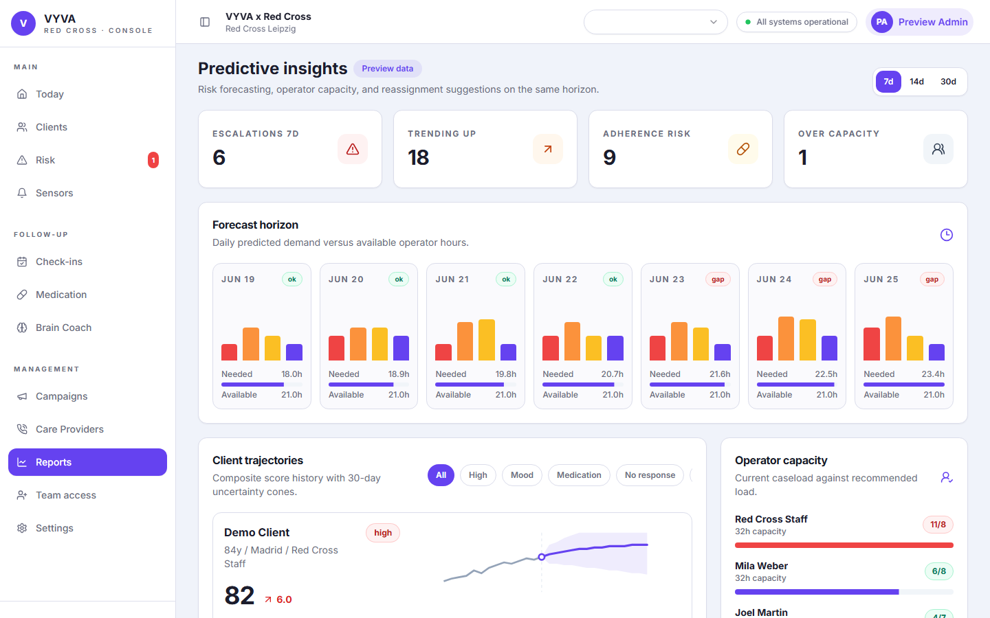
Reports/predictive insights page in demo mode.

Appendix

Role capability matrix
Capability | Operator | Admin | Platform admin
View assigned operational pages | Yes | Yes | Yes
Add or edit client profiles | No | Yes | Yes
Add notes to profile | Limited by permission | Yes | Yes
Manage medications, services, sensors, care plan | No | Yes | Yes
Create or manage campaigns | No | Yes | Yes
Manage emergency contacts and care providers | No | Yes | Yes
Invite team members | No | Yes | Yes
Create or switch organizations | No | No | Yes

Common errors
Invalid session | The browser no longer has a valid session token, or the backend cannot verify it. Sign out and request a fresh magic link.
Too many attempts | Magic-link requests may be rate limited by the auth provider. Wait before trying again and avoid repeated clicks.
Access disabled | The account may be an operator or may not be linked to the active organization. Check Team access and Settings.
Could not load data | Usually means the backend, database, or API source is unavailable for that feature. Retry after confirming system status.
Validation error | Fix required names, phone format, date format, medication names, and preferred-time format before saving.
Preview only | Demo/preview mode intentionally disables write actions and is safe for training screenshots.

Safe data handling
- Use sanitized demo data in manuals, training decks, tickets, and public screenshots.
- Do not include real names, phone numbers, addresses, medical details, or emails in shared documentation.
- Keep notes factual and operational. Avoid speculation or unnecessary sensitive details.
- Confirm organization context before exporting, importing, or updating records.
- Use the minimum role needed for each staff member.
Training material rule
Screenshots in this manual are sanitized. Repeat that standard whenever preparing training or support material.

Glossary
Client | A person receiving services or follow-up through the console.
Care coverage | Emergency contacts and Red Cross staff assigned to a client.
Check-in | Scheduled wellbeing, safety, or status contact with a client.
Brain Coach | Service cadence and session tracking for cognitive-support interactions.
Campaign | Planned outreach using a script, audience, selected channels, and schedule.
Risk queue | Prioritized operational list of clients needing review or action.
Platform admin | Higher-level admin who can manage organization-level setup beyond a single branch.

Addendum: Check-in adherence updates
Version: 2026-06-18.2 | Audience: organization admins | Scope: current console behavior

Check-in adherence
The console now includes a dedicated Check-in adherence view for each client with scheduled check-in calls. Admins use it to understand whether calls were completed, missed, not yet logged, or still upcoming within the selected week.

How to use it
- Open the client profile.
- In the Medication and Check-ins area, select View adherence for the check-in service when available.
- Review the weekly status totals: Completed, Missed, No result logged, and Upcoming.
- Use Previous and Next to move between weeks. The view does not move beyond the current week.
- Select Back to profile to return to the client profile.

What admins can edit
The adherence calendar is a read-only status view. Admins change the scheduled check-in setup from the client profile or from the Check-ins monitoring workflow.

Last check-in status on the profile
The client profile's Last contact / last check-in value can now include a status label when the latest check-in outcome is available. This helps admins quickly see whether the most recent check-in was completed, missed, or still unresolved before opening the full adherence calendar.

Common mistakes
- If no scheduled call exists, the adherence page shows an empty-state message instead of weekly results.
- A past scheduled call without a logged outcome appears as No result logged.
- The page reflects check-in data only; unrelated notes or manual outreach may not change adherence status unless recorded as a check-in result.

Screenshot note
This same-day update documents the new feature immediately. Refresh screenshots during the next scheduled manual capture pass with sanitized demo data.

