Bank_problem.R
Yash Vora
Wed Feb 27 15:57:07 2019
#Importing Libraries
library(tidyverse)
## Loading tidyverse: ggplot2
## Loading tidyverse: tibble
## Loading tidyverse: tidyr
## Loading tidyverse: readr
## Loading tidyverse: purrr
## Loading tidyverse: dplyr
## Warning: package 'purrr' was built under R version 3.4.4
## Conflicts with tidy packages ----------------------------------------------
## filter(): dplyr, stats
## lag(): dplyr, stats
library(rockchalk)
## Warning: package 'rockchalk' was built under R version 3.4.4
##
## Attaching package: 'rockchalk'
## The following object is masked from 'package:dplyr':
##
## summarize
library(caret)
## Warning: package 'caret' was built under R version 3.4.4
## Loading required package: lattice
##
## Attaching package: 'caret'
## The following object is masked from 'package:purrr':
##
## lift
#Importing Dataset
training_set <- read.csv('bank-full.csv', sep = ';')
test_set <- read.csv('bank.csv', sep = ';')
dataset <- rbind(training_set, test_set)
#Data Preprocessing
summary(dataset)
## age job marital education
## Min. :18.00 blue-collar:10678 divorced: 5735 primary : 7529
## 1st Qu.:33.00 management :10427 married :30011 secondary:25508
## Median :39.00 technician : 8365 single :13986 tertiary :14651
## Mean :40.96 admin. : 5649 unknown : 2044
## 3rd Qu.:48.00 services : 4571
## Max. :95.00 retired : 2494
## (Other) : 7548
## default balance housing loan contact
## no :48841 Min. : -8019 no :22043 no :41797 cellular :32181
## yes: 891 1st Qu.: 72 yes:27689 yes: 7935 telephone: 3207
## Median : 448 unknown :14344
## Mean : 1368
## 3rd Qu.: 1431
## Max. :102127
##
## day month duration campaign
## Min. : 1.00 may :15164 Min. : 0.0 Min. : 1.000
## 1st Qu.: 8.00 jul : 7601 1st Qu.: 103.0 1st Qu.: 1.000
## Median :16.00 aug : 6880 Median : 180.0 Median : 2.000
## Mean :15.82 jun : 5872 Mean : 258.7 Mean : 2.767
## 3rd Qu.:21.00 nov : 4359 3rd Qu.: 320.0 3rd Qu.: 3.000
## Max. :31.00 apr : 3225 Max. :4918.0 Max. :63.000
## (Other): 6631
## pdays previous poutcome y
## Min. : -1.00 Min. : 0.0000 failure: 5391 no :43922
## 1st Qu.: -1.00 1st Qu.: 0.0000 other : 2037 yes: 5810
## Median : -1.00 Median : 0.0000 success: 1640
## Mean : 40.16 Mean : 0.5769 unknown:40664
## 3rd Qu.: -1.00 3rd Qu.: 0.0000
## Max. :871.00 Max. :275.0000
##
# Quick Data exploration (Missing values)
library(DataExplorer)
## Warning: package 'DataExplorer' was built under R version 3.4.4
#Plot missing values
plot_missing(dataset)
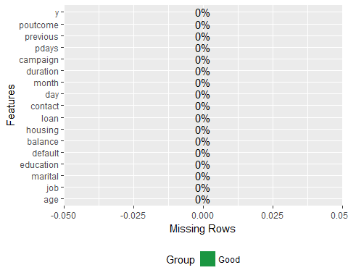
#Continuous variables
plot_histogram(dataset)
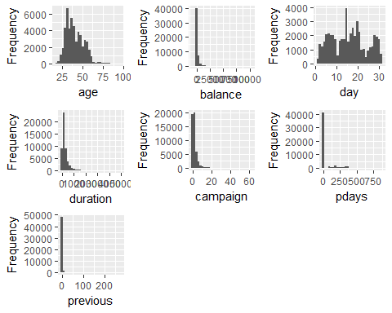
#Categorical Variables
plot_bar(dataset)
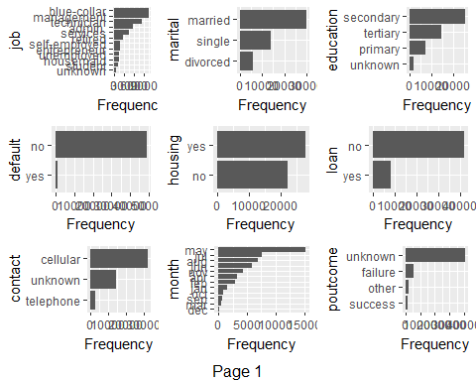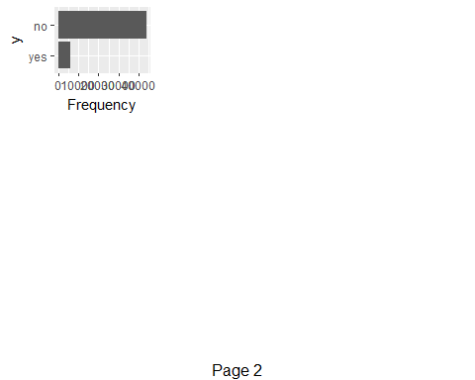
#Encoding Categorical Data
#Combining levels with similar proportions to avoid redundancy
round(prop.table(table(dataset$job,dataset$y),1)*100,1)
##
## no yes
## admin. 87.8 12.2
## blue-collar 92.7 7.3
## entrepreneur 91.7 8.3
## housemaid 90.9 9.1
## management 86.3 13.7
## retired 77.1 22.9
## self-employed 88.3 11.7
## services 91.1 8.9
## student 71.8 28.2
## technician 89.0 11.0
## unemployed 85.0 15.0
## unknown 87.4 12.6
dataset$job = combineLevels(dataset$job, levs = c("self-employed","unknown","technician"), newLabel = "job_1")
## The original levels admin. blue-collar entrepreneur housemaid management retired self-employed services student technician unemployed unknown
## have been replaced by admin. blue-collar entrepreneur housemaid management retired services student unemployed job_1
dataset$job = combineLevels(dataset$job, levs = c("services","housemaid","entrepreneur", "blue-collar"),
newLabel = "job_2")
## The original levels admin. blue-collar entrepreneur housemaid management retired services student unemployed job_1
## have been replaced by admin. management retired student unemployed job_1 job_2
dataset$job = combineLevels(dataset$job, levs = c("management", "admin."), newLabel = "job_3")
## The original levels admin. management retired student unemployed job_1 job_2
## have been replaced by retired student unemployed job_1 job_2 job_3
dataset$job = combineLevels(dataset$job, levs = c("student"), newLabel = "job_4")
## The original levels retired student unemployed job_1 job_2 job_3
## have been replaced by retired unemployed job_1 job_2 job_3 job_4
dataset$job = combineLevels(dataset$job, levs = c("retired"), newLabel = "job_5")
## The original levels retired unemployed job_1 job_2 job_3 job_4
## have been replaced by unemployed job_1 job_2 job_3 job_4 job_5
dataset$job = combineLevels(dataset$job, levs = c("unemployed"), newLabel = "job_6")
## The original levels unemployed job_1 job_2 job_3 job_4 job_5
## have been replaced by job_1 job_2 job_3 job_4 job_5 job_6
dataset$job = factor(dataset$job,
levels = c("job_1", "job_2", "job_3", "job_4", "job_5", "job_6"),
labels = c(1, 2,3,4,5,6))
table(dataset$marital)
##
## divorced married single
## 5735 30011 13986
dataset$marital = factor(dataset$marital,
levels = c("divorced", "married", "single"),
labels = c(1, 2, 3))
table(dataset$education)
##
## primary secondary tertiary unknown
## 7529 25508 14651 2044
dataset$education = factor(dataset$education,
levels = c("primary", "secondary", "tertiary", "unknown"),
labels = c(1,2,3,4))
dataset$default = factor(dataset$default,
levels = c("no", "yes"),
labels = c(0,1))
dataset$housing = factor(dataset$housing,
levels = c("no", "yes"),
labels = c(0,1))
dataset$loan = factor(dataset$loan,
levels = c("no", "yes"),
labels = c(0,1))
table(dataset$contact)
##
## cellular telephone unknown
## 32181 3207 14344
dataset$contact = factor(dataset$contact,
levels = c("cellular", "telephone", "unknown"),
labels = c(1,2,3))
table(dataset$month)
##
## apr aug dec feb jan jul jun mar may nov oct sep
## 3225 6880 234 2871 1551 7601 5872 526 15164 4359 818 631
#Combining levels with similar count to avoid redundancy
round(prop.table(table(dataset$month,dataset$y),1)*100,1)
##
## no yes
## apr 80.4 19.6
## aug 88.9 11.1
## dec 53.4 46.6
## feb 83.3 16.7
## jan 89.8 10.2
## jul 90.9 9.1
## jun 89.8 10.2
## mar 48.9 51.1
## may 93.3 6.7
## nov 89.9 10.1
## oct 56.0 44.0
## sep 54.7 45.3
dataset$month = combineLevels(dataset$month, levs = c("dec", "sep", "oct"), newLabel = "month1")
## The original levels apr aug dec feb jan jul jun mar may nov oct sep
## have been replaced by apr aug feb jan jul jun mar may nov month1
dataset$month = combineLevels(dataset$month, levs = c("aug","jan", "jun", "jul", "nov"), newLabel = "month2")
## The original levels apr aug feb jan jul jun mar may nov month1
## have been replaced by apr feb mar may month1 month2
dataset$month = combineLevels(dataset$month, levs = c("mar"), newLabel = "month3")
## The original levels apr feb mar may month1 month2
## have been replaced by apr feb may month1 month2 month3
dataset$month = combineLevels(dataset$month, levs = c("apr"), newLabel = "month4")
## The original levels apr feb may month1 month2 month3
## have been replaced by feb may month1 month2 month3 month4
dataset$month = combineLevels(dataset$month, levs = c("feb"), newLabel = "month5")
## The original levels feb may month1 month2 month3 month4
## have been replaced by may month1 month2 month3 month4 month5
dataset$month = combineLevels(dataset$month, levs = c("may"), newLabel = "month6")
## The original levels may month1 month2 month3 month4 month5
## have been replaced by month1 month2 month3 month4 month5 month6
dataset$month = factor(dataset$month,
levels = c("month1", "month2", "month3", "month4", "month5", "month6"),
labels = c(1,2,3,4,5,6))
dataset$poutcome = factor(dataset$poutcome,
levels = c("failure", "other", "success", "unknown"),
labels= c(1,2,3,4))
dataset$y = factor(dataset$y,
levels = c("no", "yes"),
labels = c(0,1))
# Duration is not counted to create a more realistic model
dataset = dataset[-12]
#Splitting dataset
library(caTools)
set.seed(123)
split = sample.split(dataset$y, SplitRatio = 0.80)
training_set = subset(dataset, split == TRUE)
test_set = subset(dataset, split == FALSE)
# Fitting Random Forest Classification to the Training set
library(randomForest)
## randomForest 4.6-12
## Type rfNews() to see new features/changes/bug fixes.
##
## Attaching package: 'randomForest'
## The following object is masked from 'package:dplyr':
##
## combine
## The following object is masked from 'package:ggplot2':
##
## margin
set.seed(123)
classifier = randomForest(x = training_set[-16],
y = training_set$y,
ntree = 100)
# Predicting the Test set results
y_pred = predict(classifier, newdata = test_set[-16])
confusionMatrix(y_pred, test_set$y)
## Confusion Matrix and Statistics
##
## Reference
## Prediction 0 1
## 0 8664 866
## 1 120 296
##
## Accuracy : 0.9009
## 95% CI : (0.8948, 0.9067)
## No Information Rate : 0.8832
## P-Value [Acc > NIR] : 1.056e-08
##
## Kappa : 0.3341
## Mcnemar's Test P-Value : < 2.2e-16
##
## Sensitivity : 0.9863
## Specificity : 0.2547
## Pos Pred Value : 0.9091
## Neg Pred Value : 0.7115
## Prevalence : 0.8832
## Detection Rate : 0.8711
## Detection Prevalence : 0.9582
## Balanced Accuracy : 0.6205
##
## 'Positive' Class : 0
##
varImp(classifier)
## Overall
## age 851.39329
## job 309.68680
## marital 169.78330
## education 219.45916
## default 18.12773
## balance 987.63118
## housing 151.50122
## loan 70.73018
## contact 146.60927
## day 739.08880
## month 597.57470
## campaign 341.34502
## pdays 447.83779
## previous 222.05373
## poutcome 538.18621
#Therefore, a supervised model has been created to predict term deposit product with an accuracy of 91%.

