

Cloud Landing Zone
Solution Architecture Document
Northwind Systems — Enterprise Technology

Document Version: 1.0 (Draft)
August 2026
Classification: Internal Use Only

Table of Contents

Table of Contents 2
1. Architecture Overview 3
1.1 Purpose and Scope 3
1.1.1 In Scope 3
1.1.2 Out of Scope 3
1.2 Conceptual Diagram 3
2. Cost-Benefit Analysis 4
2.1 Estimated Monthly Platform Cost 4
2.2 Benefit Comparison by Landing Zone Area 4

1. Architecture Overview
This section describes the conceptual design of the Northwind Systems cloud landing zone, a governed multi-subscription environment built to host platform services, application workloads, and data & analytics estates in a consistent, compliant manner.

1.1 Purpose and Scope
The landing zone establishes the foundational subscriptions, networking topology, identity boundaries, and governance guardrails required before any workload is onboarded. It is intended for use by platform engineering, security, and application delivery teams.

1.1.1 In Scope
Management group hierarchy, hub-and-spoke networking, centralized identity and security services, and policy-driven governance across all subscriptions.

1.1.2 Out of Scope
Application-level architecture, data models, and workload-specific CI/CD pipelines are covered in separate solution-level design documents.

1.2 Conceptual Diagram
Figure 1 illustrates the high-level landing zone topology, showing the platform, application, and governance layers and their relationships to on-premises and internet boundaries.
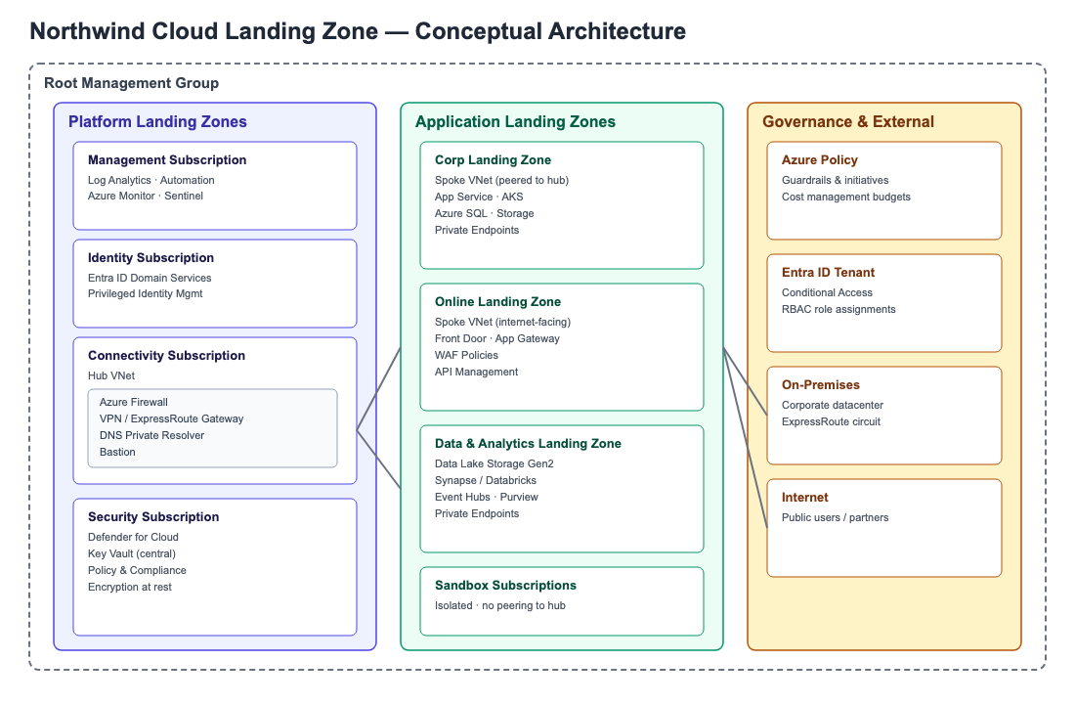
Figure 1 — Northwind Cloud Landing Zone conceptual architecture (illustrative)

2. Cost-Benefit Analysis
This section summarizes the estimated cost of the landing zone platform services and the qualitative and quantitative benefits expected from adopting the proposed architecture.

2.1 Estimated Monthly Platform Cost
Indicative monthly run cost for shared platform services (illustrative figures).
Service | Estimated Monthly Cost (USD)
Azure Firewall (hub) | $1,250
VPN / ExpressRoute Gateway | $450
Log Analytics / Sentinel | $900
Key Vault (central) | $120
Total | $2,720

2.2 Benefit Comparison by Landing Zone Area
Key benefits and associated estimated annual value per platform area.
Area | Key Benefits | Annual Value (USD)
Security & Governance | - Centralized policy enforcement  - Reduced audit and compliance effort  - Faster incident detection via Sentinel | $185,000
Networking | - Single hub for shared connectivity  - Simplified peering and routing | $96,500
Operational Efficiency | - Standardized subscription vending  - Reduced onboarding time for new workloads  - Fewer manual configuration errors | $140,000

