## Flexbox Layout

### Task 1. Stepper Input



### Task 2. Site Header



### Task 3. Side Bar

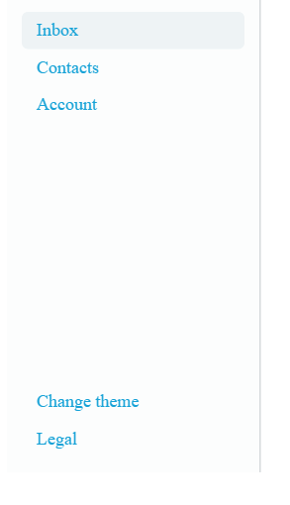

### Task 4. Center

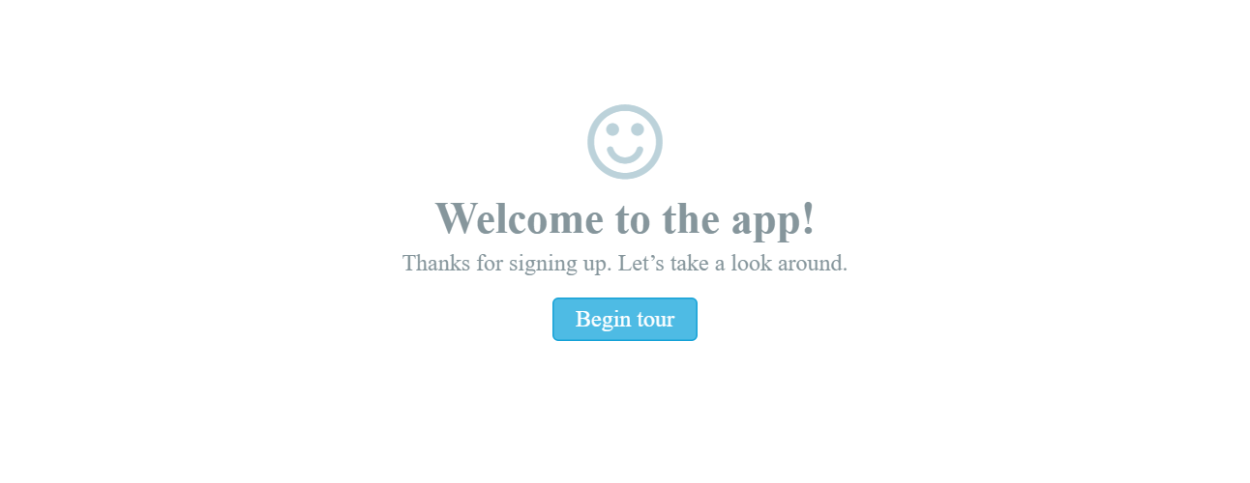

### Task 5. Feature List

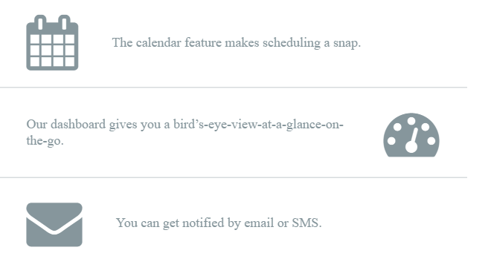

### Task 6. Six Elements

1 wide screen



2 middle screen



3 less then middle screen



4 small screen

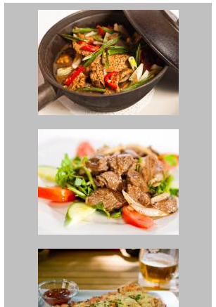

### Task 7. Creating Equal Height Columns

### 

### Task 8. Navigation

1 small screen (<992)

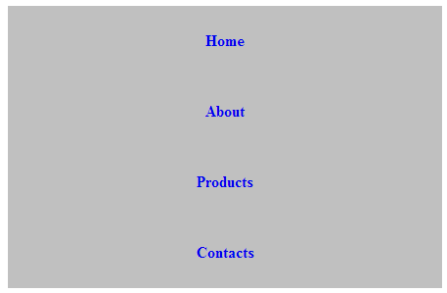

2 middle screen (<1200)



3 wide screen (>=1200)



### Task 9. Layout 3 columns

1 small screen (<992)

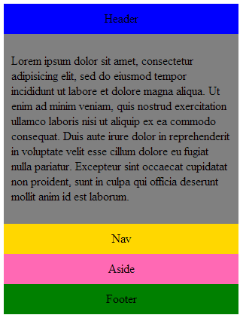

2 middle screen (<1200)

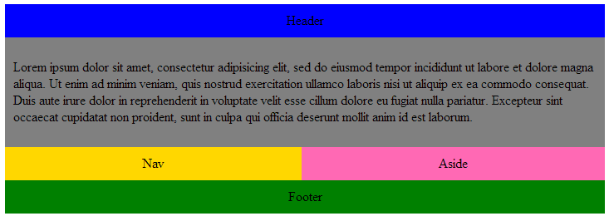

3 wide screen (>= 1200)

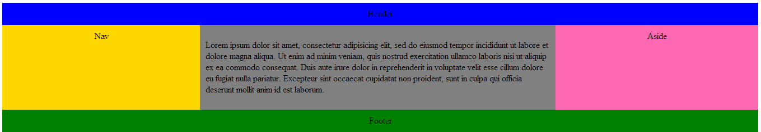

### Task 10. Form Elements



### Task 11. Sticky Footer

