Invincible Beat-em Up Brawler Game

Invincible: Unstoppable Duo

Invincible Unstoppable Duo is a beat-em up game similar to Streets of Rage or Marvel Cosmic Invasion where you go to the different sections of the Invincible world and beat up different types of bad-guys as the difficulty goes up, it’s also like a Arcade-Game where you get to fight different bosses.

Initial Plan:
The game is a local 2Player couch co-op that two players get to play together.
One man plays as Invincible and the other player plays as Atom Eve.

Both players have different abilities and different play styles and skill trees to consider. Each character can also do different combos.

The game will consist of total of 10 levels and each 3 levels have a boss fight.

Different stages, different enemy types and different difficulties

Alpha version:

Alpha version will contain no more than just 2 levels, one is a street patrol level and the other one is a boss fight of Immortal.

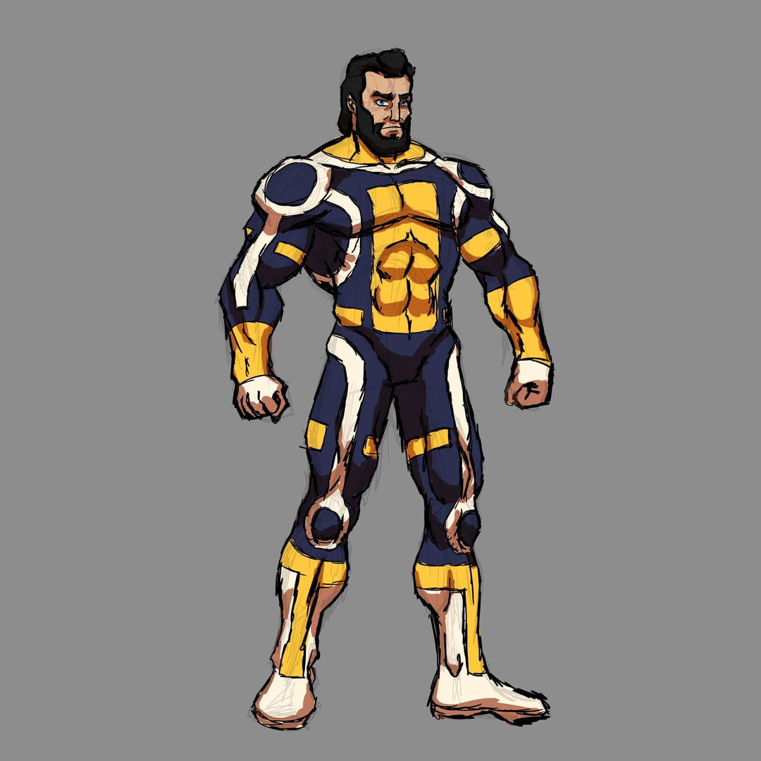
“WHERE IS OMNI-MAN?! WHERE IS HE?!” -Immortal

The gameplay will have the maximum depth possible but everything will go very short.

Introducing the playable Characters below:
INVINCIBLE:

Real name: Mark Grayson

Parameters:

HP 150
Damage Roll 15-22
Damage Reduction 5



Invincible is the first Playable Character and he has two different Play styles two give some depth into his character and doesn’t make the player bored.

He has 2 different skill trees which the Player has access to both to make a whole build out of him.
However, because of the alpha version, each skill tree only has 3 nodes.

One tree is about his brawling style.
The other tree is about being defensive and losing his HP to deal damage.

Skill Tree:

ATOM EVE:

Real name: Samantha Eve Wilkins

Parameters:

HP 100
Damage Roll 17-27
Damage Reduction 3



Atom Eve is the second playable character and she also has 2 different play styles that one revolves around being the team’s damage and the other one is focused around healing and defending Invincible.

Much like Invincible she also has only 2 skill trees, each having only 3 nodes first. His first skill tree increases the range of her attacks so that she can stand back and fight, in addition unlike Invincible she gain access to a Dodge roll so completely avoid attacks.

The other tree she can heal her and Invincible, shield her teammate and also reviving herself or Invincible.

Combo Strings:
Using Keyboard with WASD and HJKL buttons or the controller, the players can trigger a set of combos which will be displayed in the movie list.

Invincible will be able to combo using button strings like:
Light → Heavy → Light

While Atom Eve has motion inputs to make special moves like:
Down → Forward → Heavy

Summary of both characters:
In the start of the first level, each player gains 4 skill points, so that they can still get creative with making a build while also not having access to all of the skill nodes, which will defeat the purpose of adding depth to the gameplay.

The game already ends with defeating Immortal so in the Alpha build, the player cannot really get the most out of the gameplay but rather a fraction of it.

If we get more time, we can increase the game’s depth and make more content like a survival mode.

