Dear Grader of this assignment:

1. I work on Mac, I am not sure about your grading environment. If you open it correctly, it should look like this: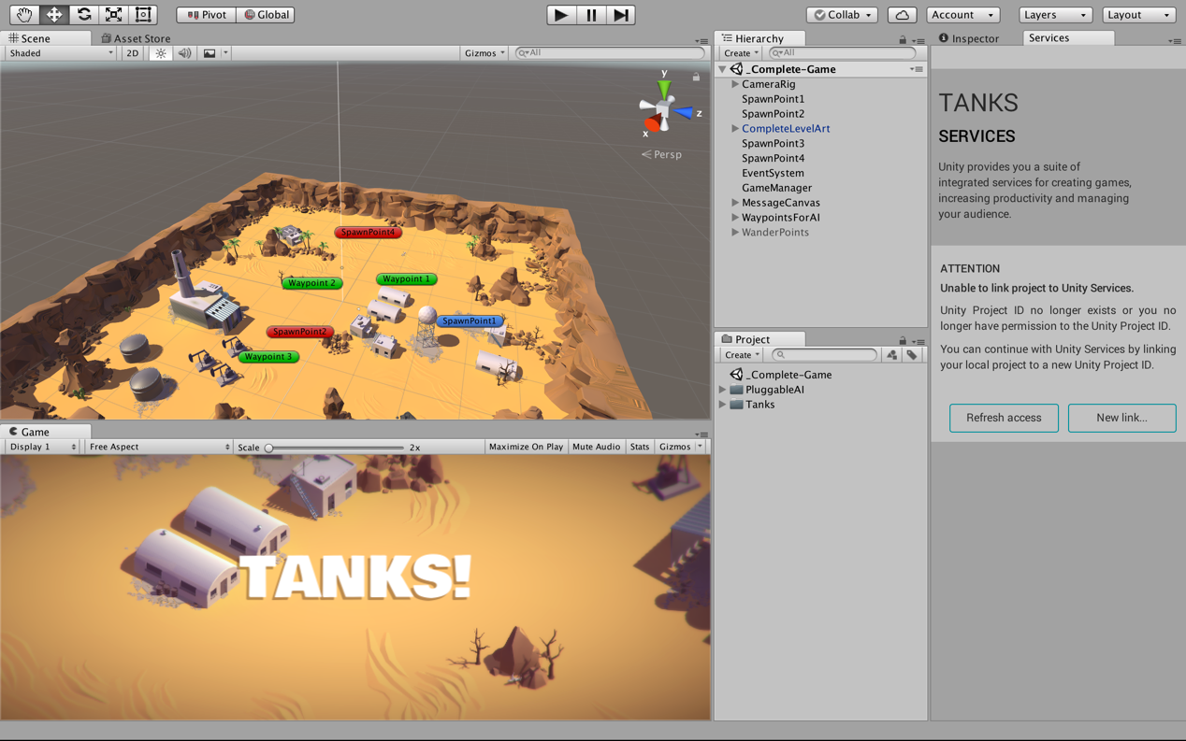
2. If you want to check the scripts, they are all located in Assets/PluggableAI/Scripts/;
3. If you want to check about the Finite State Machine I implemented, go to Assets/PluggableAI/Scripts/ScriptableObjects,I categorized all the states, decisions and actions
4. Known bug: when player(the blue one)gets too close to the enemies, no matter what kind of enemy it is, they all stop functioning before you get away from them. You can deduct my mark accordingly.