PSGAN LOG

1. Dataset
   1. In this paper, the author says the dataset consists of 69 kinds of costume on “several continuous actions”, which is further divided into 600 poses with 20 keypoints. These images are generated using Unity. The clothes of size 256x256 they use are from a dataset called DeepFashion maintained by CUHK. Finally the skeletons are generated by OpenPose from the character images.
      1. OpenPose cannot be installed:
         1. Prerequisites failed to satisfy?
         2. Install Caffe and its prerequisites to see if that helps
         3. If problem persists, try to do everything again in Windows, and capture images from the Unity scene
      2. Another way of doing this:
         1. Try to apply .bvh motion into a character and then output each frame
      3. Do everything again on Ubuntu
         1. Ubuntu successfully installed
         2. Openpose cloned to VM repository
         3. Install all the prerequisites for OpenPose
            1. Fail to install CUDA due to “insufficient space”
            2. Insufficient process power: need a Nvidia GPU or CPU with 8GB free memory
            3. <https://www.mesa3d.org/llvmpipe.html> This is the graphics library used by the VM to render graphics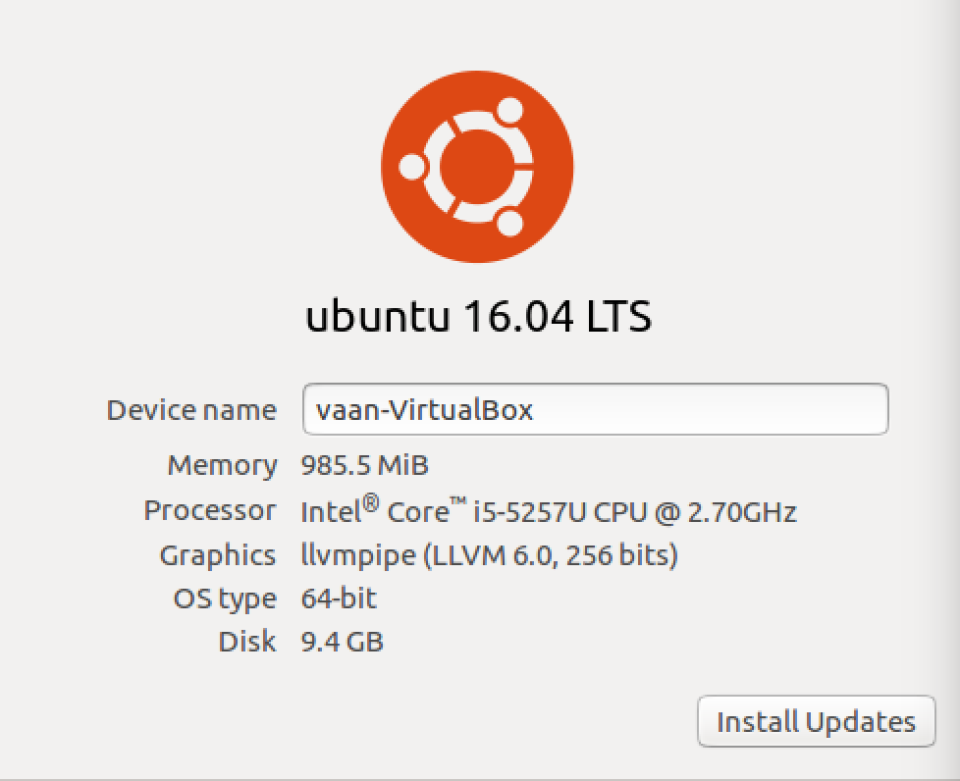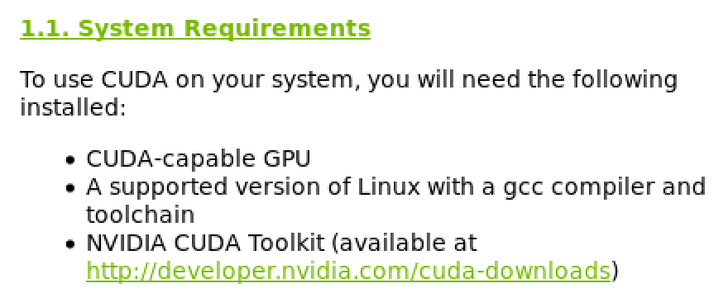
         4. Try to do it in CPU-only mode
      4. Running on Windows: Unable to download models; Error: Fatal: Unknown error
         1. Now we can run the OpenPose demo on Windows and save the keypoints output using the --write_images flag; for more information go check flags.hpp in include/openpose
      5. Given that OpenPose can be run on Windows and we managed to generate dataset we want via Unity and OpenPose, we need to setup the environment on department GPU and run StyleGAN on it.
         1. Run python train.py directly: syntax error in init.py in dnnlib
            1. I check the system, only the requirement of tensorflow version 1.10.0 is not satisfied(now 1.8.0), and cuDNN is not installed. Besides that, everything is up to date.
            2. Run with python3!!!
            3. Said network unreachable when I try to download dataset or other pacakges from the Internet.
            4. Now created an empty directory that has the same name as specified in the code
            5. Error message as of 10pm, March 20

File "train.py", line 191, in <module>

main()

File "train.py", line 186, in main

dnnlib.submit_run(**kwargs)

File"/data/d0/y16/cshuang6/styleGAN/dnnlib/submission/submit.py", line 290, in submit_run

run_wrapper(submit_config)

File"/data/d0/y16/cshuang6/styleGAN/dnnlib/submission/submit.py", line 242, in run_wrapper util.call_func_by_name(func_name=submit_config.run_func_name, submit_config=submit_config, **submit_config.run_func_kwargs)

File "/data/d0/y16/cshuang6/styleGAN/dnnlib/util.py", line 257, in call_func_by_name

return func_obj(*args, **kwargs) File"/data/d0/y16/cshuang6/styleGAN/training/training_loop.py", line 146, in training_loop

training_set = dataset.load_dataset(data_dir=config.data_dir, verbose=True, **dataset_args)

File "/data/d0/y16/cshuang6/styleGAN/training/dataset.py", line 234, in load_dataset

dataset = dnnlib.util.get_obj_by_name(class_name)(**adjusted_kwargs)

File "/data/d0/y16/cshuang6/styleGAN/training/dataset.py", line 70, in __init__

assert os.path.isdir(self.tfrecord_dir)

AssertionError

* + - * 1. Look into training_loop.py in training folder
        2. We need .tfrecords files as datasets according to source code; How to convert existing images to tfrecords?
        3. Use dataset-tool.py to convert images to tfrecords. But new error occurred:

Creating the run dir: results/00013-sgan-bedroom-1gpu

Copying files to the run dir

dnnlib: Running training.training_loop.training_loop() on localhost...

Streaming data using training.dataset.TFRecordDataset...

Dataset shape = [3, 256, 256]

Dynamic range = [0, 255]

Label size = 0

Constructing networks...

Traceback (most recent call last):

File "train.py", line 191, in <module>

main()

File "train.py", line 186, in main

dnnlib.submit_run(**kwargs)

File "/data/d0/y16/cshuang6/styleGAN/dnnlib/submission/submit.py", line 290, in submit_run

run_wrapper(submit_config)

File "/data/d0/y16/cshuang6/styleGAN/dnnlib/submission/submit.py", line 242, in run_wrapper

util.call_func_by_name(func_name=submit_config.run_func_name, submit_config=submit_config, **submit_config.run_func_kwargs)

File "/data/d0/y16/cshuang6/styleGAN/dnnlib/util.py", line 257, in call_func_by_name

return func_obj(*args, **kwargs)

File "/data/d0/y16/cshuang6/styleGAN/training/training_loop.py", line 156, in training_loop

G = tflib.Network('G', num_channels=training_set.shape[0], resolution=training_set.shape[1], label_size=training_set.label_size, **G_args)

File "/data/d0/y16/cshuang6/styleGAN/dnnlib/tflib/network.py", line 98, in __init__

self._init_graph()

File "/data/d0/y16/cshuang6/styleGAN/dnnlib/tflib/network.py", line 155, in _init_graph

out_expr = self._build_func(*self.input_templates, **build_kwargs)

File "/data/d0/y16/cshuang6/styleGAN/training/networks_stylegan.py", line 334, in G_style

components.synthesis = tflib.Network('G_synthesis', func_name=G_synthesis, **kwargs)

File "/data/d0/y16/cshuang6/styleGAN/dnnlib/tflib/network.py", line 98, in __init__

self._init_graph()

File "/data/d0/y16/cshuang6/styleGAN/dnnlib/tflib/network.py", line 185, in _init_graph

self.trainables = OrderedDict((name, var) for name, var in self.vars.items() if var.trainable)

File "/data/d0/y16/cshuang6/styleGAN/dnnlib/tflib/network.py", line 185, in <genexpr>

self.trainables = OrderedDict((name, var) for name, var in self.vars.items() if var.trainable)

AttributeError: 'Variable' object has no attribute 'trainable'

1. Understanding the code: