Assignment 1 MSS Product Backlog with Acceptance Criteria
Student ID:35844851
Student Name:Vaasu Goyal
Part A: Product Backlog for the MSS
ID | Backlog Items | Type of Item | Priority | Estimate  (Story Points) | Sprint | Assigned to
US001 | As a patient, I want to book a telehealth consultation with my obstetrician, so that I can receive care without travelling to a clinic | User story | M | 8 | 1 | Vaasu Goyal
US002 | As a doctor, I want to access a patient's full clinical record during a telehealth consultation, so that I can make informed care decisions | User story | M | 13 | 1 | Vaasu Goyal
US003 | As a hospital administrator, I want to manage and update appointment scheduling, so that clinics run efficiently | User story | M | 5 | 1 | Vaasu Goyal
US004 | As a pharmacy staff member, I want to receive and process e-prescriptions through MSS, so that patients get medications without a paper script | User story | M | 8 | 1 | Vaasu Goyal
US005 | As a doctor, I want to receive an automatic alert when a patient's lab result is abnormal, so that I can act quickly | User story | S | 8 | 1 | Vaasu Goyal
US006 | As a security and compliance officer, I want all user logins to require multi-factor authentication, so that patient data across all roles stays protected | User story | M | 5 | 2 | Vaasu Goyal
US007 | As a technical architect, I want the API Gateway integrated with the existing EHR system, so that clinicians can retrieve patient records in real time | User story | M | 8 | 2 | Josephine Nakato
US008 | As a technical architect, I want to investigate the SaaS vendor's video conferencing SDK compatibility with MSS, so that we confirm a reliable telehealth integration before development | User story | M | 3 | 2 | Vaasu Goyal
US009 | As a patient, I want to register and create a secure MSS account, so that I can access the platform | User story | M | 5 | 2 | Vaasu Goyal
US010 | As a patient, I want to log in securely with MFA, so that my health data stays protected | User story | M | 3 | 3 | Vaasu Goyal
US011 | As an expectant mother, I want to view my lab/pathology results in the app, so that I stay informed without waiting for a phone call | User story | C | 5 | 3 | Josephine Nakato
US012 | As a hospital administrator, I want to generate billing and claims records from completed consultations, so that MSI processes payments accurately | User story | S | 8 | 3 | Vaasu Goyal
US013 | As a pharmacy staff member, I want to track medication inventory linked to prescriptions, so that stock stays accurate | User story | C | 5 | 3 | Vaasu Goyal
US014 | As a hospital administrator, I want the double-booking edge case in the scheduling module fixed, so that patients and clinicians are never booked into conflicting slots | User story | M | 2 | 4 | Vaasu Goyal
US015 | As a patient, I want to reschedule or cancel my own telehealth appointment, so that I have flexibility if plans change | User story | S | 5 | 4 | Vaasu Goyal
US016 | As a patient, I want to receive automated appointment reminder notifications, so that I don't miss consultations | User story | S | 3 | 4 | Vaasu Goyal
US017 | As a doctor, I want to add and update clinical notes after a consultation, so that patient records stay current | User story | M | 5 | 4 | Vaasu Goyal
US018 | As a midwife, I want to view my upcoming patient consultation schedule, so that I can prepare for each appointment | User story | S | 3 | 5 | Vaasu Goyal
US019 | As an obstetrician, I want to review a patient's pregnancy history before a consultation, so that I provide informed care | User story | M | 5 | 5 | Vaasu Goyal
US020 | As a hospital administrator, I want to view a daily clinician schedule overview, so that I can manage clinic operations | User story | S | 3 | 5 | Vaasu Goyal
US021 | As a hospital administrator, I want to reschedule or cancel appointments on behalf of patients, so that I can handle patient requests | User story | C | 3 | 5 | Vaasu Goyal
US022 | As a telehealth provider, I want to join a virtual consultation via the MSS video link, so that I can deliver remote care | User story | M | 8 | 6 | Vaasu Goyal
US023 | As a telehealth provider, I want video consultation sessions to maintain under 2-second latency, so that I can conduct sessions without disruptive delays | User story | M | 8 | 6 | Vaasu Goyal
US024 | As a patient, I want to complete an entire telehealth consultation journey from booking through clinical follow-up in one platform, so that I receive continuous, coordinated maternity care | User story | M | 13 | 6 | Vaasu Goyal
US025 | As a patient, I want a secure, end-to-end experience for registering, logging in, and managing my account, so that I can safely access all MSS services | User story | M | 13 | 6 | Fatuma Namisango
T001 | MSS Vision Board | Task | M | 3 | 1 | Vaasu Goyal
T002 | MSS Lean Canvas | Task | M | 3 | 1 | Vaasu Goyal
T003 | MSS Project Charter | Task | M | 3 | 1 | Vaasu Goyal
T004 | MSS Product Roadmap | Task | M | 3 | 1 | Vaasu Goyal
T005 | MSS Product Backlog | Task | M | 3 | 1 | Vaasu Goyal
T006 | Sprint Backlog | Task | M | 3 | 1 | Vaasu Goyal
T007 | Product and Sprint Backlog in Azure Devops | Task | M | 3 | 1 | Vaasu  Goyal

Part B: Acceptance Criteria
US001: As a patient I want to book a telehealth consultation with my obstetrician. So that I can receive care without travelling to a clinic.
Acceptance Criteria | Scenario 1: Successful booking  - Given the patient is logged into MSS with MFA verified  - When they select an available time slot with their assigned obstetrician and confirm  - Then the booking is confirmed and added to both the patient's and clinician's schedules  Scenario 2: Reminder sent  - Given a booking has been confirmed  - When the appointment time approaches  - Then the system sends a reminder notification to the patient  Scenario 3: Slot already taken  - Given the patient attempts to book a time slot that is no longer available  - When they submit the booking request  - Then the system rejects the booking and displays alternative available times
US002: As a doctor I want to access a patient's full clinical record during a telehealth consultation So that I can make informed care decisions in real time.
Acceptance Criteria | Scenario 1: Successful EHR retrieval  - Given the doctor is authenticated via MFA and has opened an active telehealth session  - When the session loads  - Then the API Gateway retrieves the patient's EHR data within the session view  Scenario 2: Clinical notes saved  - Given the doctor has entered clinical notes during the consultation  - When they save the notes  - Then the update is routed through the Healthcare Service Bus to the patient's EHR  Scenario 3: Unauthorised access denied  - Given the doctor is not authorised to view a specific patient's record  - When they attempt to access it  - Then the Security Gateway denies the request and logs the attempt
US003: As a hospital administrator I want to manage and update appointment scheduling So that clinics run efficiently with minimal double-bookings.
Acceptance Criteria | Scenario 1: Double-booking prevented  - Given the administrator is managing the scheduling calendar  - When they attempt to book two patients into the same clinician time slot  - Then the system prevents the double-booking and flags the conflict  Scenario 2: Slot released on cancellation  - Given a patient cancels an existing appointment  - When the administrator processes the cancellation  - Then the freed time slot becomes available for other patients in real time.
US004: As a pharmacy staff member I want to receive and process e-prescriptions directly through MSS So that patients can get medications dispensed without a paper script.
Acceptance Criteria | Scenario 1: Prescription appears for pharmacy  - Given a doctor has issued an e-prescription for a patient  - When the pharmacy staff member opens their MSS dashboard  - Then the prescription appears with patient details and medication instructions  Scenario 2: Dispense triggers notification  - Given a pharmacy staff member marks a prescription as dispensed  - When they submit the update  - Then an event is generated on the Event Queue to update medication records and notify the patient
US005: As a doctor I want to receive an automatic alert when a patient's lab result is abnormal So that I can act quickly on critical health issues.
Acceptance Criteria | Scenario 1: Alert generated  - Given a lab result is received for a patient  - When the result falls outside the normal threshold range  - Then the system automatically generates an alert to the assigned doctor  Scenario 2: Alert flagged as high priority  - Given an alert has been generated for an abnormal result  - When the doctor views their dashboard  - Then the alert is clearly flagged as high priority

Project Board
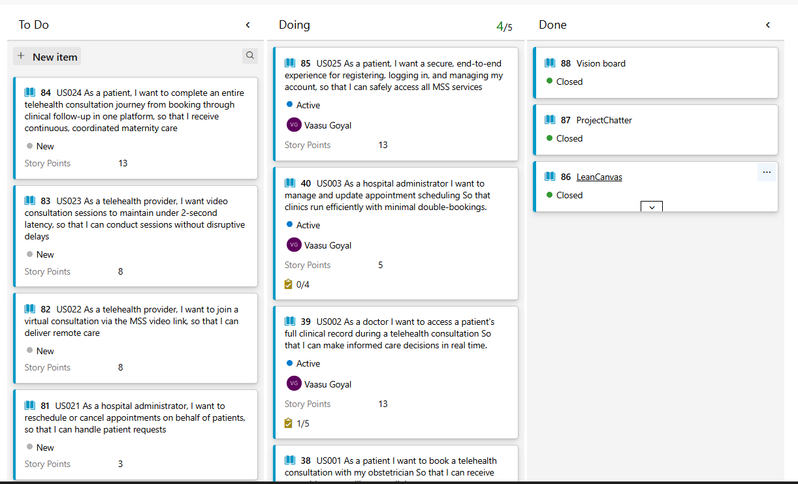

Project Backlog - With 25 user stories.

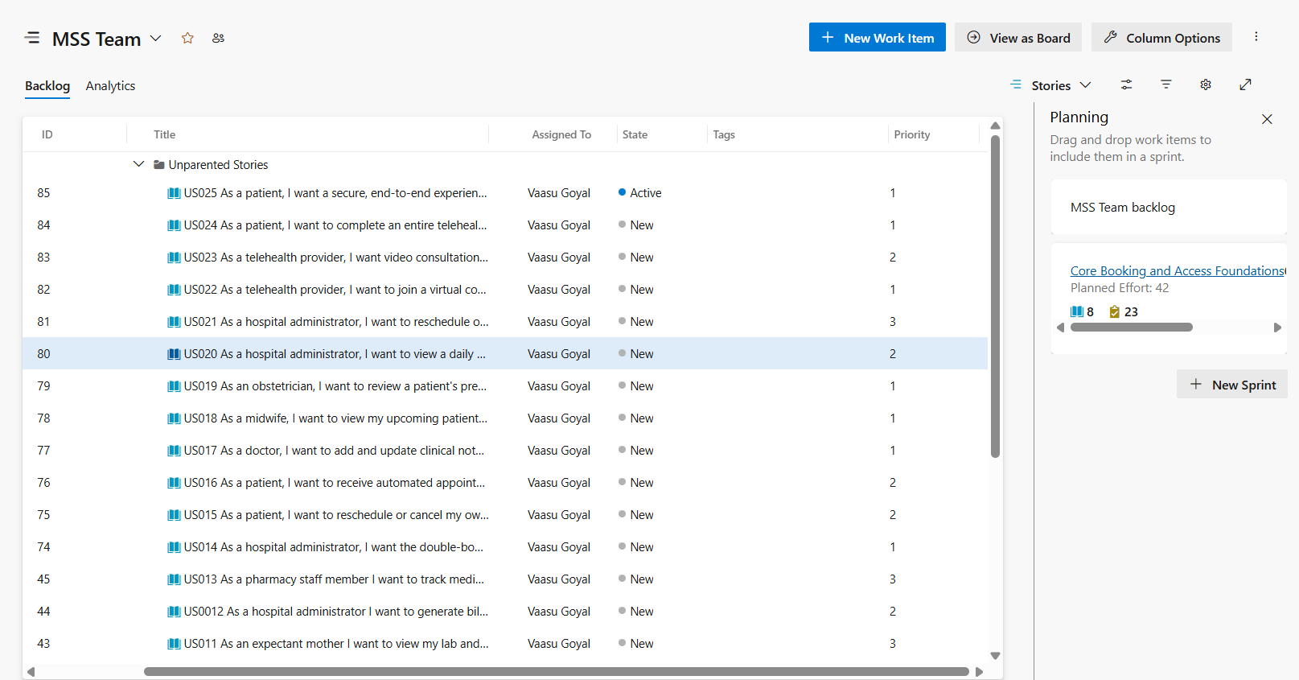

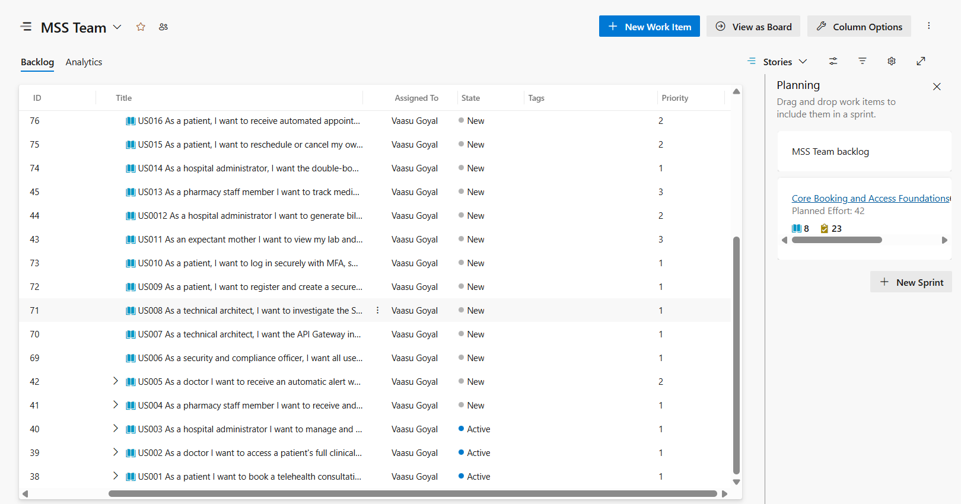

Acceptance Criteria
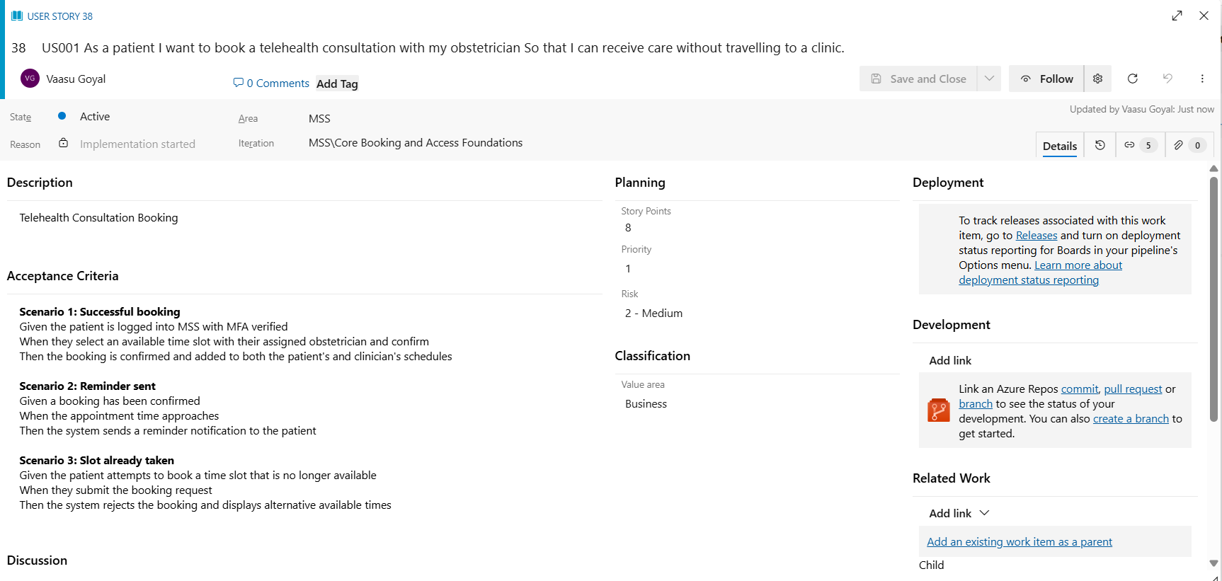

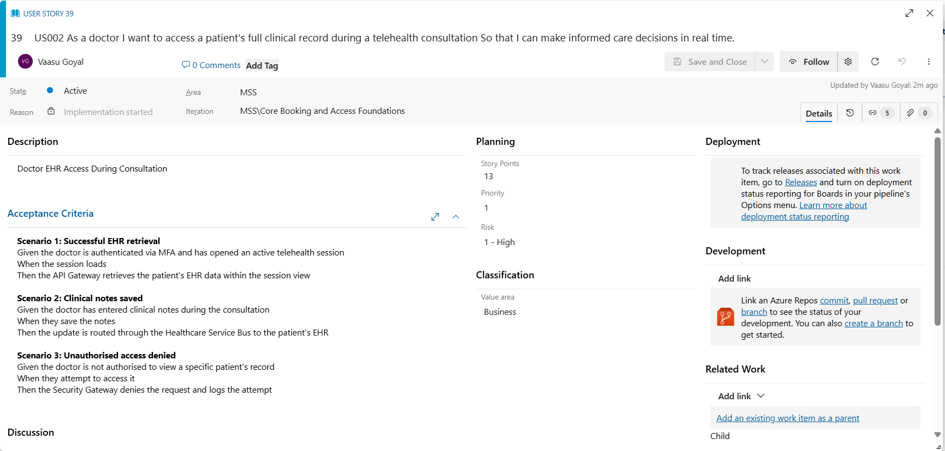

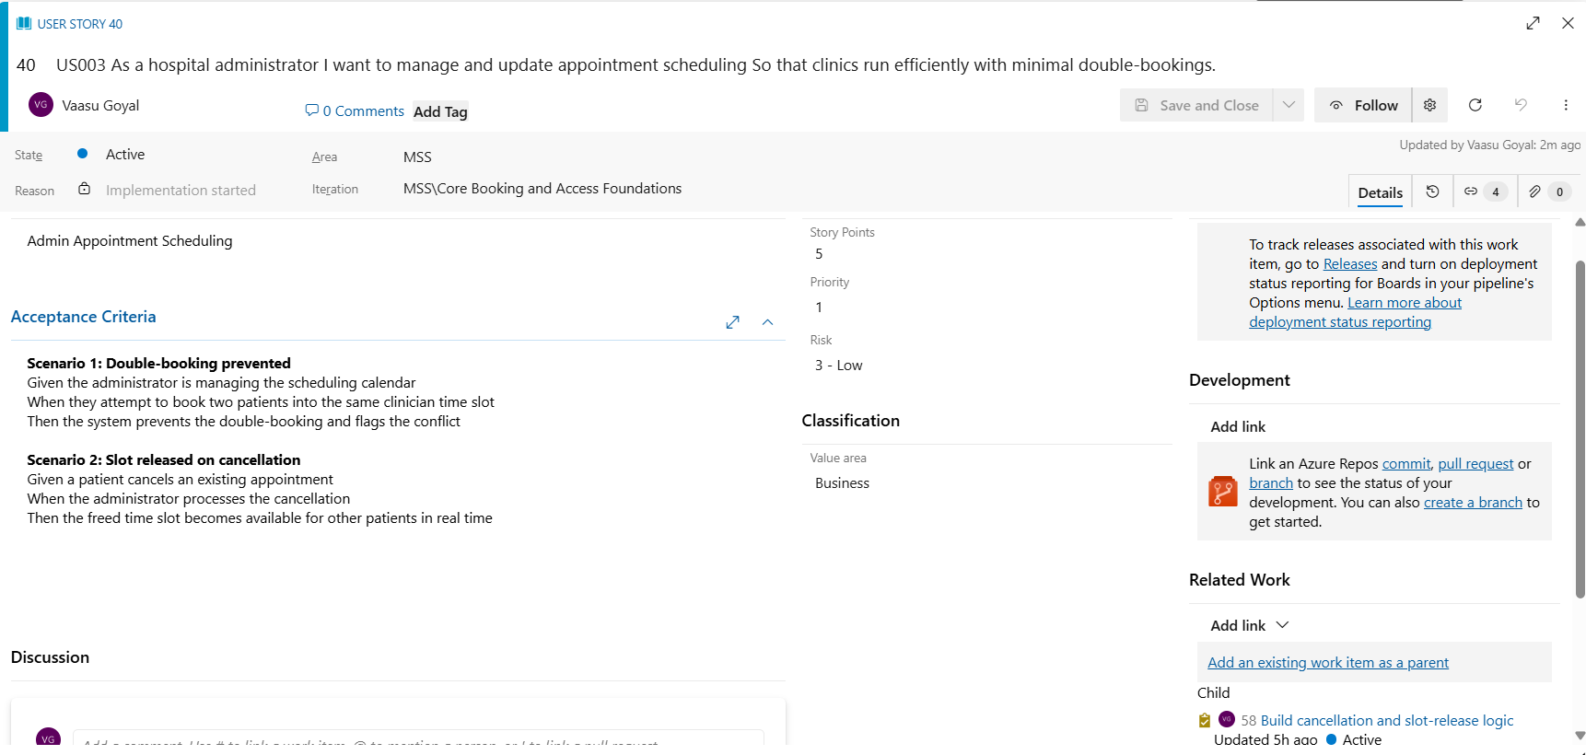

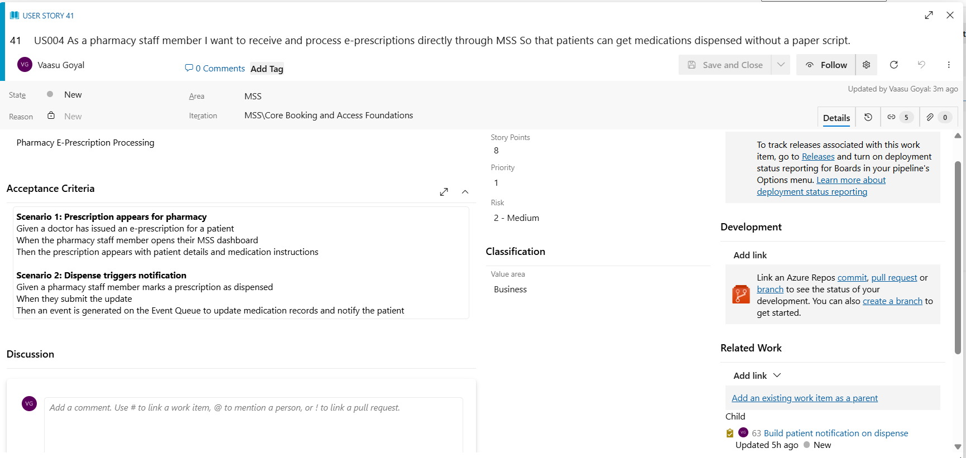

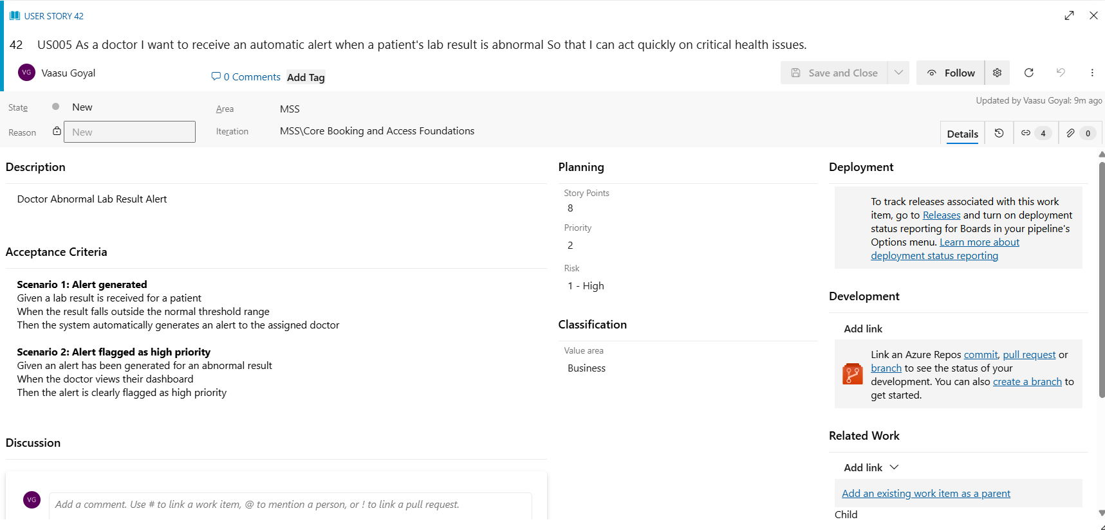

Sprint Board
Sprint 1 - Assigning different roles
