Assignment 1 MSS Project Sprint Planning
Student ID:35844851
Student Name:Vaasu Goyal
Sprint 1 Backlog
Sprint Goal: Deliver the foundational booking, clinical access, scheduling, prescription, and alerting workflows that the four core MSS services depend on.
ID | User Story | Effort Estimate (Story Points) | Tasks | Assigned to | Status
US001 | As a patient I want to book a telehealth consultation with my obstetrician So that I can receive care without travelling to a clinic. | 8 | Build appointment slot selection UI | Vaasu Goyal | Done
US001 |  | 8 | Implement MFA login check before booking | Josephine Nakato | To Do
US001 |  | 8 | Build server-side endpoint to create and store booking | Vaasu Goyal | To Do
US001 |  | 8 | Build booking confirmation and reminder notification service | Vaasu Goyal | To Do
US001 |  | 8 | Test booking conflict handling and edge cases | Fatuma Namisango | To Do
US001 |  | 8 | Configure API Gateway request for EHR retrieval | Josephine Nakato | To Do
US002 | As a doctor I want to access a patient's full clinical record during a telehealth consultation So that I can make informed care decisions in real time. | 13 | Build clinical notes entry UI for doctor | Vaasu Goyal | Active
US002 |  | 13 | Implement save-to-HCB integration for clinical notes | Josephine Nakato | To Do
US002 |  | 13 | Implement Security Gateway access-denial logging | Josephine Nakato | Active
US002 |  | 13 | Test end-to-end EHR retrieval during a live session | Fatuma Namisango | To Do
US002 |  | 13 | Build scheduling calendar interface | Vaasu Goyal | To Do
US003 | As a hospital administrator I want to manage and update appointment scheduling So that clinics run efficiently with minimal double-bookings. | 8 | Implement double-booking conflict detection | Josephine Nakato | To Do
US003 |  | 8 | Build cancellation and slot-release logic | Vaasu Goyal | Active
US003 |  | 8 | Test scheduling calendar with concurrent admin users | Fatuma Namisango | To Do
US003 |  | 8 | Build pharmacy dashboard prescription view | Vaasu Goyal | To Do
US003 |  | 8 | Implement dispense-status update logic | Josephine Nakato | To Do
US004 | As a pharmacy staff member I want to receive and process e-prescriptions directly through MSS So that patients can get medications dispensed without a paper script. | 8 | Implement Event Queue trigger on dispense | Josephine Nakato | Active
US004 |  | 8 | Build patient notification on dispense | Vaasu Goyal | To Do
US004 |  | 8 | Test end-to-end e-prescription flow | Fatuma Namisango | To Do
US004 |  | 8 | Build lab result threshold-check logic | Vaasu Goyal | Active
US004 |  | 8 | Implement automated alert notification service to doctor | Josephine Nakato | To Do
US005 | As a doctor I want to receive an automatic alert when a patient's lab result is abnormal So that I can act quickly on critical health issues. | 8 | Integrate alert with Event Queue | Josephine Nakato | Active
US005 |  | 8 | Test alert delivery timing and accuracy | Fatuma Namisango | To Do
US005 |  | 8 | Build appointment slot selection UI | Vaasu Goyal | To Do
US005 |  | 8 | Implement MFA login check before booking | Josephine Nakato | To Do
US005 |  | 8 | Build server-side endpoint to create and store booking | Vaasu Goyal | To Do
 |  |  | Build booking confirmation and reminder notification service | Vaasu Goyal | To Do
T001 | MSS Vision Board | 3 | Defined the MSS product vision — the why, who, what, and how of the platform, aligning maternity service delivery with WA Health's regional access goals. | Vaasu Goyal | Done
T002 | MSS Lean Canvas | 3 | Validated the MSS product idea using the Lean Canvas — mapped problem, solution, unique value proposition, customer segments, and cost/revenue structure for the maternity SaaS platform | Vaasu Goyal | Done
T003 | MSS Project Charter | 3 | Developed the full MSS Project Charter — business case, scope, cost estimate (NPV/ROI/Payback), timeline, stakeholders, ethical considerations, assumptions/risks, and sign-off, covering all three sub-projects. | Vaasu Goyal | Done
T004 | MSS Product Roadmap | 3 | Defined the MSS Now/Next/Later product roadmap, aligning backlog priorities with themes across the Creation, Integration, and Upgrade phases. | Vaasu Goyal | Done
T005 | MSS Product Backlog | 3 | Created a prioritised, 25-item MSS product backlog covering all system users, using MoSCoW prioritisation and Fibonacci story point estimation across six sprints. | Vaasu Goyal | Done
T006 | Sprint Backlog | 3 | Developed the Sprint 1 backlog for the five highest-priority MSS user stories, breaking each into development tasks with effort estimates and team assignments. | Vaasu Goyal | Done
T007 | Product and Sprint Backlog in Azure Devops | 3 | Implemented the full MSS product backlog and Sprint 1 backlog in Azure DevOps, including user stories, acceptance criteria, planning fields, task breakdowns, and team assignments, shared with the Unit Coordinator and Tutor. | Vaasu Goyal | Doing

Sprints Backlogs:

Sprint 1

Note: Azure DevOps Priority field uses numeric values (1 = Must have, 2 = Should have, 3 = Could have), consistent with the MoSCoW prioritisation technique used throughout this backlog. This differs from the M/S/C letter notation used in the Word document tables for readability.

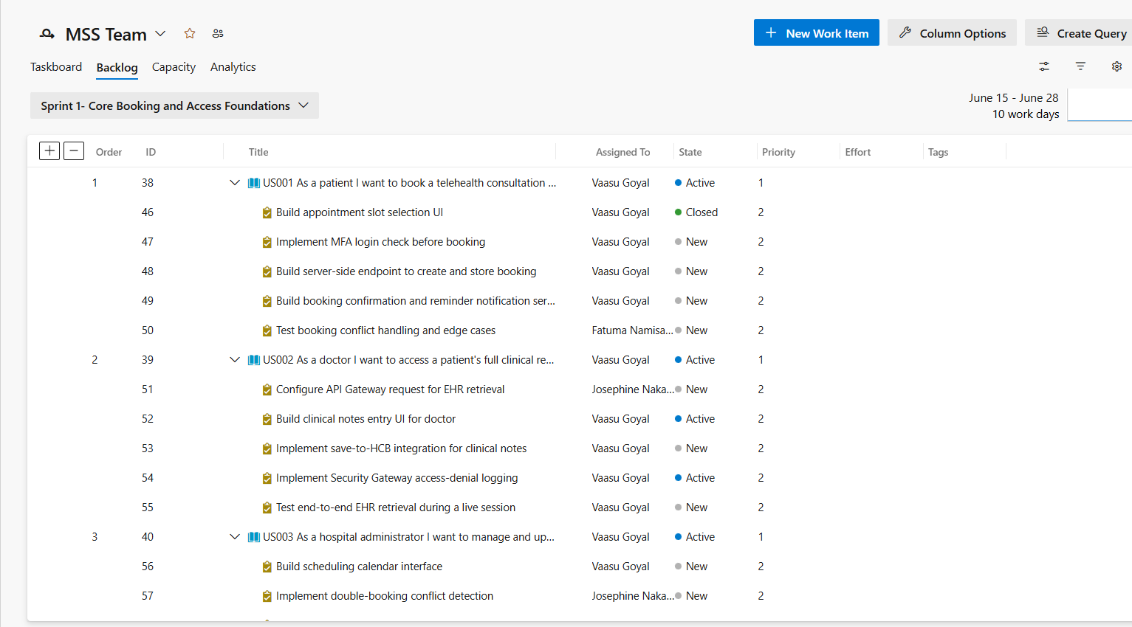

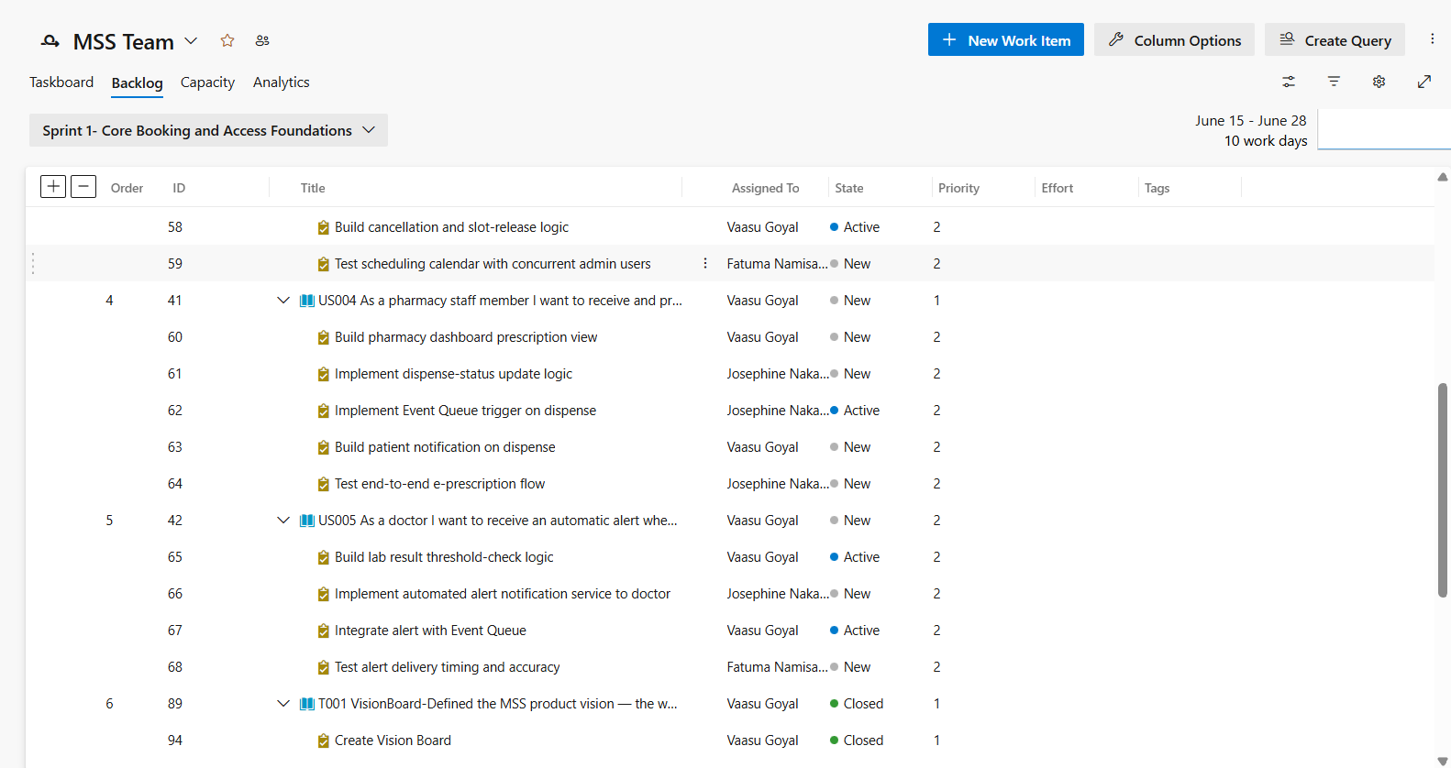

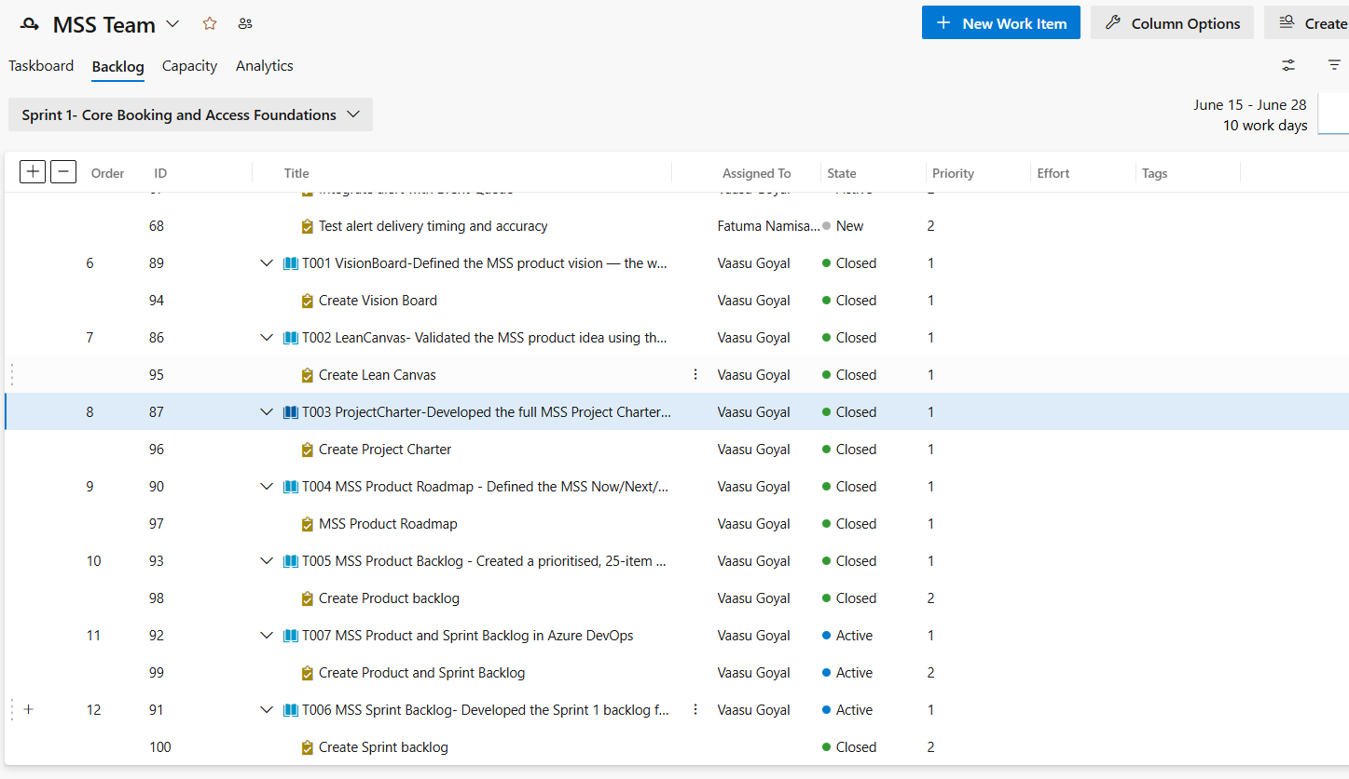

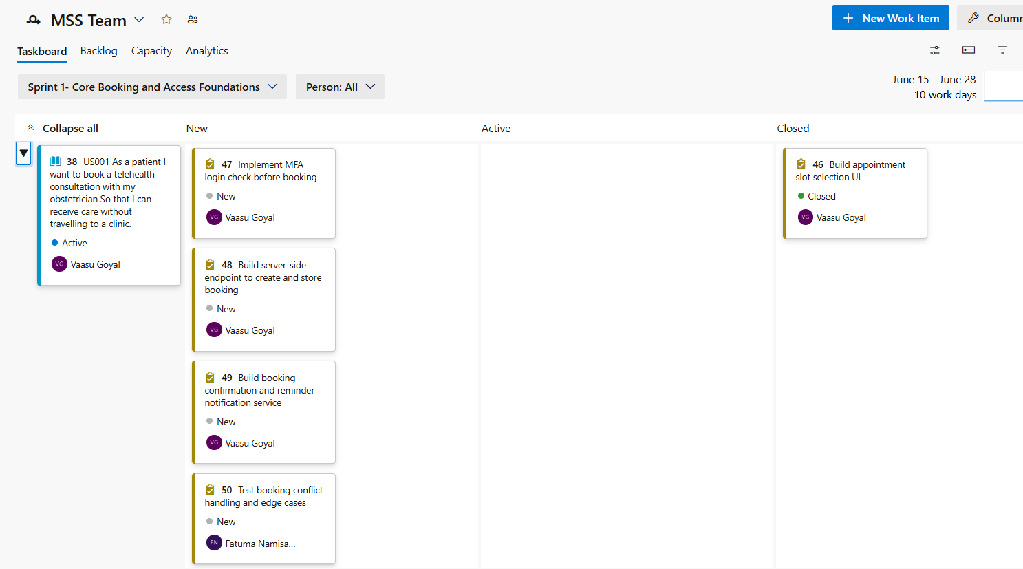

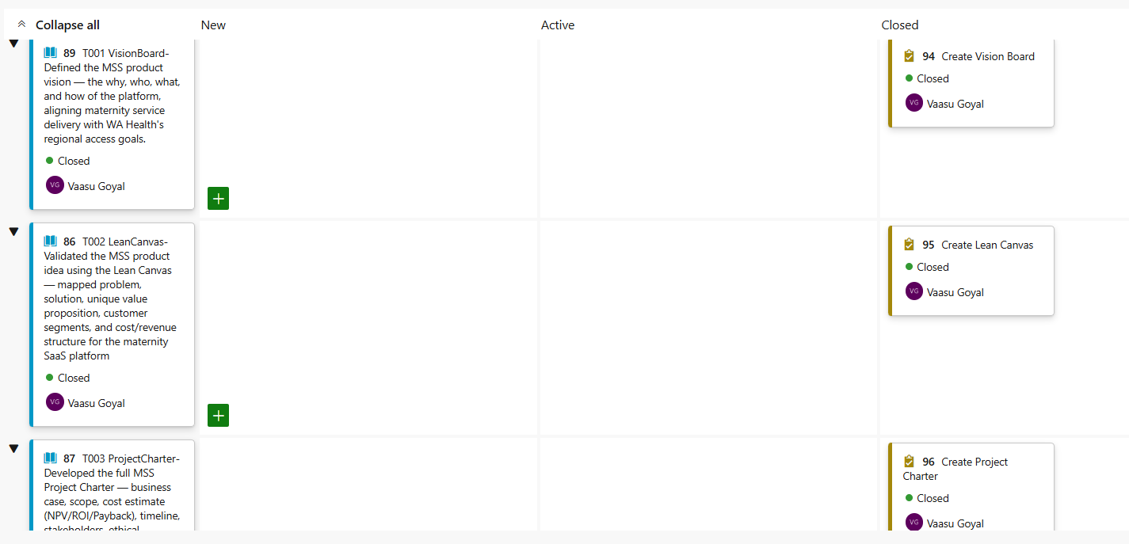

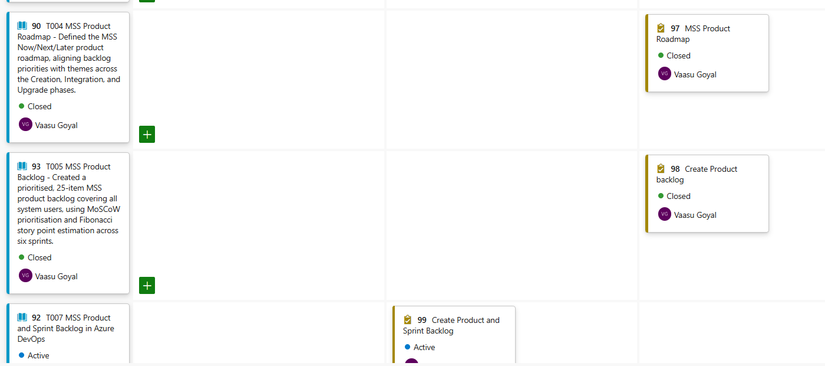

Sprint 2

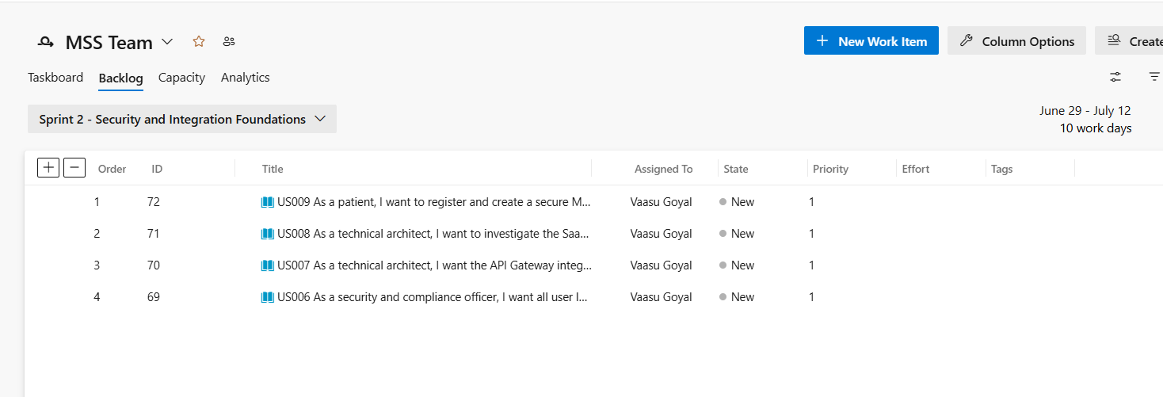

Sprint 3

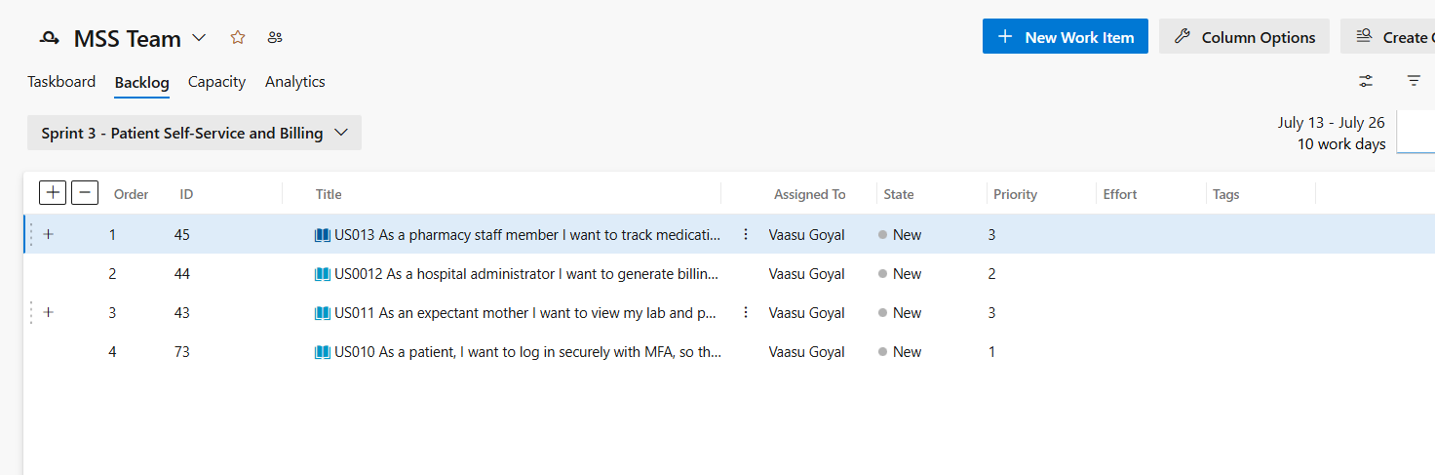

Sprint 4
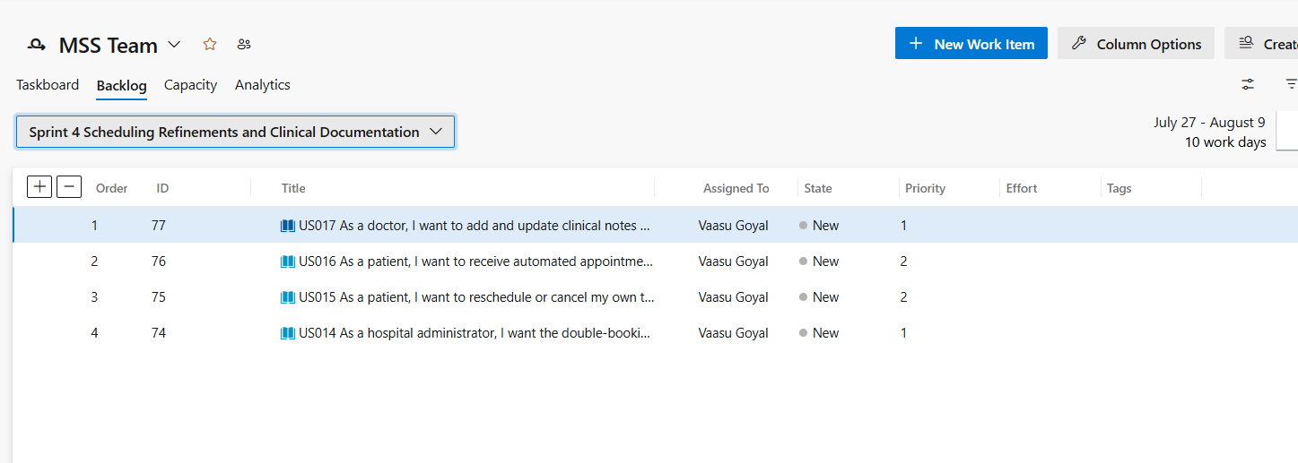

Sprint 5

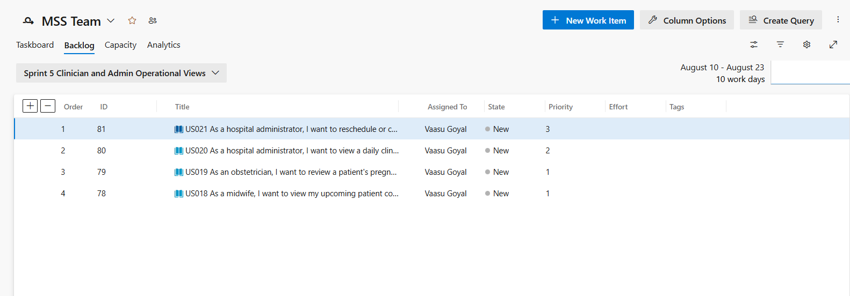

Sprint 6
