Abstract— Nowadays with almost any written text being analyzed for information of some kind or a pattern which helps us in prediction of our target output NLP techniques have been at the forefront of simplifying textual data. Sentiment analysis or opinion mining is the computational study of people’s opinions, sentiments, emotions, appraisals, and attitudes towards entities such as products, services, organizations, individuals, issues etc. Deep neural networks have been implemented for this analysis in recent years but Convolutional Neural Networks (CNNs), Long Short-Term Memory (LSTM) and Gated Recurrent Units (GRU) have been more efficient and accurate over Deep Neural Networks (DNNs) across a wide variety of tasks. CNNs, LSTMs, GRUs and DNNs are similar in their modelling capabilities, as CNNs are good at reducing frequency variations, LSTMs are good at temporal modelling, and DNNs are appropriate for mapping features to a more separable space. In this project, we see how various NLP techniques in collaboration with these Neural networks help predict sentiment in Movie Reviews.
Survey of how different NLP techniques affect the prediction of Sentiment using Deep Learning (October 2018)
Vaasu Gupta, Fellow, IEEE, Second B. Author, and Third C. Author, Jr., Member, IEEE

Index Terms - Sentiment analysis; recurrent neural network; deep neural network; convolutional neural network; long short term memory; gated recurrent unit

INTRODUCTION

A) Sentiment Analysis

Sentiment analysis or opinion mining is the computational study of people’s opinions, sentiments, emotions, appraisals, and attitudes towards entities such as products, services, organizations, individuals, issues, events, topics, and their attributes [1]. Sentiment analysis provide the comprehension information related to public views, as it analyzes different tweets and reviews. It is a verified tool for the prediction of many significant events such as box office performance of movies and general elections [2]. Public reviews are used to evaluate a certain entity, i.e., person, product or location and might be found on different websites like Amazon and Yelp. The opinions can be categorized into negative, positive or neutral. The purpose of sentiment analysis is to automatically determine the expressive direction of user reviews [3]. The demand of sentiment analysis is raised due to increase requirement of analyzing and structuring hidden information which comes from the social media in the form of unstructured data [4].

B) NLP in Sentiment Analysis

People often consider sentiment as the most important value of the opinionated users express via social media. Although, in real life emotions provide a purer set of data that address consumer choices and, in many cases, even determines their decisions. Due to this, Natural Language Processing for sentiment analysis focused on emotions is extremely useful. NLP for sentiment analysis in combination with a powerful social media monitoring strategy, organizations can analyze customer demand and act accordingly to improve customer experience, quickly resolve customer issues and change their market position.

But, without NLP and access to a balanced corpus, it is hard to discover and collect insight necessary for driving business decisions. NLP makes speech analysis easier. For example, if a customer sends an email about a problem they’re experiencing with a product or service, a NLP system would recognize the emotion (angry, disappointed, annoyed) and mark it for a quick automatic response or forward the email to the right person.

C) Deep Neural Networks

Deep Learning was firstly proposed by G.E. Hinton in
2006 and is the part of machine learning process which refers
to Deep Neural Network [5]. Neural network is influenced
by human brain and it contains several neurons that make
an impressive network. Deep learning networks are capable
for providing training to both supervised and unsupervised
categories [6]. Deep learning includes many networks such as CNN (Convolutional Neural Networks), RNN (Recurrent Neural Networks), Recursive Neural Networks, DBN (Deep Belief Networks) and many more. Neural networks are very beneficial in text generation, vector representation, word representation estimation, sentence classification, sentence modelling and feature presentation. [7].

1) Applications of Deep Learning:

Automatic Machine Translation
This is a problem where when given some words, phrase or sentence in a language, it will automatically translate it into another language.
Automatic machine translation has been around for some time, but deep learning is achieving better results in two specific areas:
- Automatic Translation of Text
- Automatic Translation of Images
Text translation can be performed without any pre-processing of the sequence, allowing the algorithm to learn the dependencies between words and their mapping to a new language.
Automatic Text Generation
This is a problem, where a corpus of textual data is learned by the network and from this model new text is generated, word-by-word or character-by-character.
The model is capable of learning how to spell, punctuate, form sentences and even capture the style of the text in the corpus. Large recurrent neural networks are used to learn the relationship between items in the sequences of input strings and then generate text.

Automatic Handwriting Generation
This is a problem where when given a corpus of handwriting examples, we have to generate a new handwriting for any given word or phrase.
The handwriting is then provided as a sequence of coordinates used by a pen when the handwriting samples were created. From this corpus, the relationship between the pen movement and the letters is learned and new examples can be generated ad hoc.
D) Predicting Sentiment using Deep Neural Networks
Recently, deep learning algorithms have shown impressive performance in natural language processing applications including sentiment analysis across multiple datasets [8]. These models do not need to be provided with pre-defined features hand-picked by an engineer, but they can learn sophisticated features from the dataset by themselves. Although each single unit in these neural networks is fairly simple, by stacking layers of non-linear units at the back of each other, these models are capable of learning highly sophisticated decision boundaries. Words are represented in
a high dimensional vector space, and the feature extraction is left to the neural network [9]. As a result, these models can map words with similar semantic and syntactic properties to nearby locations in their coordinate system, in a way which is reminiscent of understanding the meaning of words. Architectures like Recursive Neural Networks are also capable of efficiently understanding the structure of the sentences [10]. These characteristics make deep learning models a natural fit for a task like sentiment analysis.
E) NLP techniques used for text simplification
Lot of NLP libraries are available on open CV related to NLP. Some of the most popular ones are NLTK, Stanford’s NLP toolkit, TextBlob and SpaCy. These libraries can be used to perform functions like segmentation, POS tagging, stemming etc. To run textual data on neural networks many techniques can be involved like finding Tfidf, N-Grams, word embeddings. All techniques though can be implemented on neural networks after certain simplification. One such approach follows these steps:
- Segmentation
- Regular Expression (To keep only characters)
- Stemming / lemmatization
- Removing stop words
This approach when used will give us a clean corpus which we can then appropriately convert to a form suitable for a neural network input.

Literary Survey

- Du, T. (2009). Deep Learning for Natural Language Processing.

This study aims to serve as an entry point to applying different deep learning techniques and models for Natural Language Processing and other related fields. It discusses a great deal about neural networks such as Auto-encoder and Deep Boltzmann Machines which uses layerwise greedy unsupervised pre-training to perform crucial functions such as dimensionality reduction or data compression. It highlights the use of deep learning methods in NLP applications such as word embeddings and how it can benefit from transfer learning to surpass the state-of-the-art on most of the NLP related tasks which is much faster than general predictors.

It also referenced the work of Collobert et al. (Collobert and Weston 2008; Collobert, Weston et al. 2011) which proposed a deep neural network model trained in an end-to-end fashion. Backpropagation is used to automatically train the features of the DNN relevant to the to the task. In the proposed architecture, the first layer was used in extracting features for each word and the second layer extracted features from the sentence. The layers that followed were classical NN layers. This architecture reported a per-word error rate as low as 14.30%, POS error rate of 2.91% and 3.8% for chunking.

2) Eviews, M. O. R., & Zhao, Z. (2016). LEARNING DOCUMENT EMBEDDINGS BY PREDICTING N- GRAMS FOR SENTIMENT CLASSIFICATION OF LONG MOVIE REVIEWS, 1–8.

This paper proposed a model which allowed it to learn document vectors by predicting the n-gram features along with the words which also helped it to represent the semantics of the document more accurately, which is important for sentiment analysis. The documents which were similar using the one-hot representation but may be different from a semantic point of view. In order to overcome this problem, they modeled the semantics of the document by representing the documents by compact low dimension continuous-value vectors with randomly initialized values. Document vectors were obtained by predicting the words that belonged to them and words that did not. Document embeddings were used to model semantics such as synonyms. The main objective of this model was to maximize the log probability:
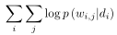

For computing this probability, a simple neural network was designed with a softmax output layer of | V | (vocabulary size) nodes and n nodes in the input layer which represented the document vector. Upon comparison with the bag-of-ngram, it was observed that the DV-ngram model outperformed it due to its inclusion of semantic attributes. This model also achieved state-of-the-art result among other deep learning models showing that its performance can be improved by adding more unlabeled data.

3) Bharti, O. (2016). SENTIMENT ANALYSIS, 5(6), 625–633.

This report aimed to provide an introduction to sentiment analysis and introduce a framework that performs sentiment analysis on online mobile phone reviews by combining a modified K-Means algorithm with KNN and Naive-Bayes classification. The proposed architecture consisted of four modules, namely, a user interface, log pre-processing, Feature clustering using Naive Bayes Classification and Modified K-means, training and testing using KNN in order to get more accuracy while categorizing the opinions. This model was designed to obtain more accuracy and reduce irrelevant data by combining the modified K-means and Naive Bayes algorithm. The Naive Bayes Classifier is said to perform reasonably well for non-linearly separable problems and extremely well for linearly separable problems. The Modified K-means was designed to work well with large datasets, therefore avoiding getting into locally optimal solution. Upon execution, it was observed that proposed architecture performed much better than the KNN, Modified K-means and Naive Bayes algorithms when used individually by obtaining an accuracy of 91%.

4) Shobharani, M., Karim, M., & Das, S. (2018). A Hierarchical multi-input and output Bi-GRU Model for Sentiment Analysis on Customer Reviews A Hierarchical multi-input and output Bi-GRU Model for Sentiment Analysis on Customer Reviews.

This paper focuses on multi-label sentiment classification and proposes a hierarchical multi-input and output model based bi-directional recurrent neural network, which will be able to represent the semantic and lexical information of emotional expression. In contrast to most common neural networks which have only one input layer and one output layer, the model proposed in this paper has two input layers and two output layers. In order to have some constraints on the learning part of the speech, auxiliary labels are placed in the middle output layer. The middle outputs are considered as part of the hidden feature for predicting final sentiment labels. Pairs of words and their POS are fed into an embedding layer which embeds them into a semantic fixed dimension space. There are two embedding layers which are combined to a single layer for updateable training. The next step involves applying two independent Bi-GRU layers to study the representation of the text words and POS. The product of the corresponding hidden unit of forward and backward layers is used as a semantic representation. In the hierarchical output structure, the lexical feature is used to predict the probability distribution of the auxiliary labels: The emotional semantic of text can be modeled by the weighted representation of the word. Finally, the probability distribution of the auxiliary tag is also taken as a feature, which is combined with weighted word feature to predict the final sentiment labels.

The final result shows that this model outperforms traditional ML-KNN and HML-KNN algorithms which were used as a baseline which shows that The hierarchical multi-input and output model based on RNNs can both reduce the computational complexity and greatly improve the precision.

5) Lakshmi, B. S., Raj, P. S., & Vikram, R. R. (2017). Sentiment Analysis Using Deep Learning Technique CNN with KMeans, 114(11), 47–57.

This paper proposes a model which is a combination of the deep learning neural networks CNNs and the unsupervised learning algorithm K-means. This model performs sentiment analysis on movie reviews thereby yielding a better estimation of sentiments than any of the existing methods currently available. In the proposed model, the authors have used a movie review dataset containing mixed positive and negative movie reviews. The CNN is used to train and learn the system. The CNN is implemented using the tensorflow framework. The input to the system consists of sentences which are converted to a matrix by multilevel convolutions. The features extracted from the CNN are then used to divide the reviews into positive and negative clusters through K-means algorithm. Therefore, the complete dataset will be grouped accordingly. Upon execution, it was observed that the accuracy was more and the loss was less when CNN-Kmeans was used for large datasets, whereas CNN-KNN worked better for smaller datasets.

6) Maas, A. L., Daly, R. E., Pham, P. T., Huang, D., Ng, A. Y., & Potts, C. (2011). Learning Word Vectors for Sentiment Analysis, 142–150.

This report presents a model which uses a mix of supervised and unsupervised techniques to learn word vectors capturing semantic term–document information as well as rich sentiment content. This model makes use of non-sentiment annotations and both multidimensional and continuous information. The model is instantiated to make use of the Document-level sentiment polarity annotations present in many online documents in the form of scores or star-ratings. This model is evaluated using small, widely used sentiment and subjectivity corpora and it is observed that it out-performs several previously introduced methods for sentiment classification. The model’s probabilistic foundation gives a theoretically justified technique for word vector induction as an alternative to a large number of matrix factorization-based techniques which are commonly used. This model is parameterized as a log-bilinear model following recent success in using similar techniques for language models and it is related to probabilistic latent topic models. The unsupervised model was extended to include the overwhelming amount of sentiment-labeled text online to generate word representations to capture both semantic and sentiment relations.

7) Akhtar, S., Kumar, A., Ekbal, A., & Bhattacharyya, P. (2016). A Hybrid Deep Learning Architecture for Sentiment Analysis, 482–493.

This research introduces a novel hybrid deep learning model which is highly efficient for sentiment analysis for less-resourced languages such as Hindi. CNNs were used to learn sentiment embedded vectors as CNNs are very capable in capturing lexical and structural features. SVM is used on the sentiment embedded vectors to generate a decision hyperplane with more accuracy by projecting the features of the CNN into a higher dimension. Furthermore, a MOO-based feature selection technique is used to obtain an optimal set of features which assisted the SVM to obtain more accurate predictions. The ANOVA test was also executed for 10 times with varying parameter settings. The observed variance in the mean accuracy between the state-of-the-art methods and the observed methods was less than 5% which statistically signifies the improvement over baseline approaches. It was also observed that 13% and 5.8% of misclassified test instances were accurately predicted by the CNN-SVM model for Twitter and reviews domain.

8) Socher, R., Perelygin, A., Wu, J. Y., Chuang, J., Manning, C. D., Ng, A. Y., & Potts, C. (2013). Recursive Deep Models for Semantic Compositionality Over a Sentiment Treebank, (October), 1631–1642.

The paper highlights a or problem with sentiment word spaces in which they can’t be used to express the meaning of longer phrases in a principled way. To alleviate this problem, the paper introduces a sentiment treebank which includes fine-grained sentiment labels for 215,154 phrases in the parse trees of 11,855 sentences and presents new challenges for sentiment compositionality. To address these, the paper presents a Recursive Neural Tensor Network which outperforms all the methods used previously on several metrics, when trained on the Treebank. The combination of data and new modal results in a system for single sentence sentiment detection that pushes the-state-of-the-art by 5.4% for positive/negative sentence classification. Apart from this standard setting, the dataset also introduces important new challenges and allows for new evaluation metrics. For instance, the RNTN obtains 80.7% accuracy on fine-grained sentiment prediction across all phrases and captures negation of different sentiments and scope more accurately than previous models.

9) Glorot, X. (2011). Domain Adaptation for Large-Scale Sentiment Classification: A Deep Learning Approach, (1).

As Reviews span a multitude of domains over the internet, it would be very difficult to obtain training data. This paper attempts to tackle this problem by studying the domain adaptive capabilities of Sentiment classifiers. For this, the paper introduces a deep learning system based on Stack Denoising Auto-Encoders having sparse rectifier units that can perform an unsupervised feature-extraction which would greatly benefit the domain adaptive capabilities of Sentiment classifiers. In order to reduce transfer loss i.e. the difference between transfer error and in-domain baseline error, the paper introduces the following metrics: Transfer ratio, which characterizes the transfer and In-domain ratio which assists in measuring the In-domain error. The model proposed by this paper was compared to three methods introduced in the literature on the benchmark of four domains. After this, the benchmark was performed on a much larger version of the data, with a more realistic version of the real-world and its domains than those of the previous experiments. Upon experimentation, it was observed that linear classifiers trained with this higher-level learned feature representation of review are able to outperform the current state-of-the-art. Furthermore, the experiment successfully performs domain adaptation on an industrial-scale dataset of 22 domains, where the generalization over the baseline have been significantly improved and over a similarly structured but purely supervised alternative.
10) Deep Convolutional Neural Networks for Sentiment Analysis of Short Texts. (2014), 69–78.

It is very challenging to accurately perform sentiment analysis on short text such as tweets due to the limited contextual information that they contain. To address this problem the paper proposes a new deep CNN model that exploits from character to sentence-level information which allows it to perform sentiment analysis more effectively on shorter text. This approach was applied to two corpora of different domains: the Stanford Twitter Sentiment corpus (STS), which contains Twitter messages and the Stanford Sentiment Treebank (SSTb), which contains sentences from movie reviews.

The proposed network, named Character to Sentence Convolutional Neural Network (CharSCNN), makes use of two convolutional layers which allows it to extract relevant features from sentences and words of any size. The proposed network can easily explore the vast field of word embeddings which is generated by unsupervised pre-training. Experiments that were executed show the effectiveness of CharSCNN for sentiment analysis of texts from two domains: Twitter messages (tweets) and movie review sentences. CharSCNN achieves state-of-the-art results for the two domains. Additionally, these experiments provide information about the effectiveness of sentence-level features to detect negation, the contribution of character-level features; and the usefulness of unsupervised pre-training. This approach has been able to achieve state-of-the-art results for single sentence sentiment prediction with an accuracy of 85.7% in binary positive/negative classification, and 48.3% accuracy for fine-grained classification. For the STS corpus, this model achieves a sentiment prediction accuracy of 86.4%.

Methodology

Overview of data without pre-processing

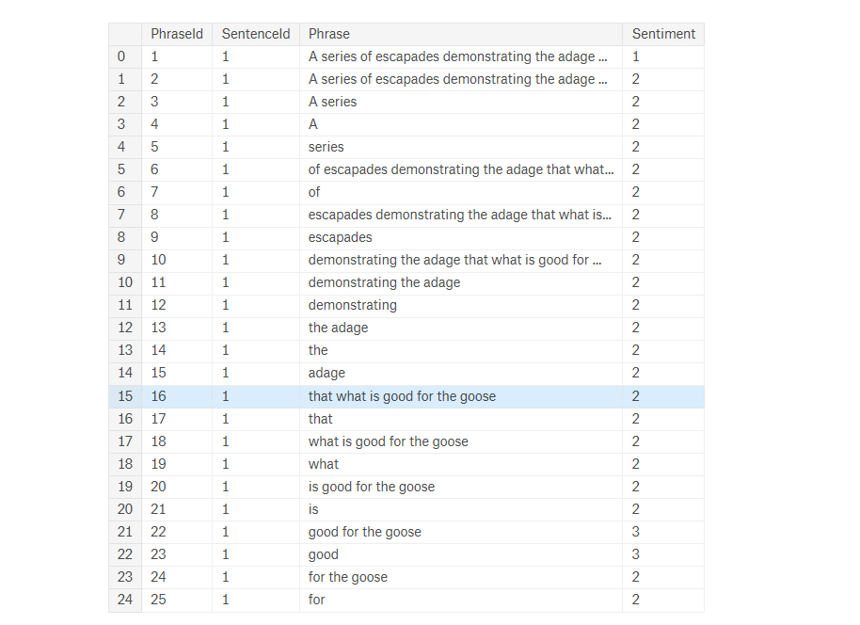

Distribution of sentiment in the data where –
- 0 = "Negative"
- 1 = "Somewhat negative"
- 2 = "Neutral"
- 3 = "Somewhat positive"
- 4 = "Positive"

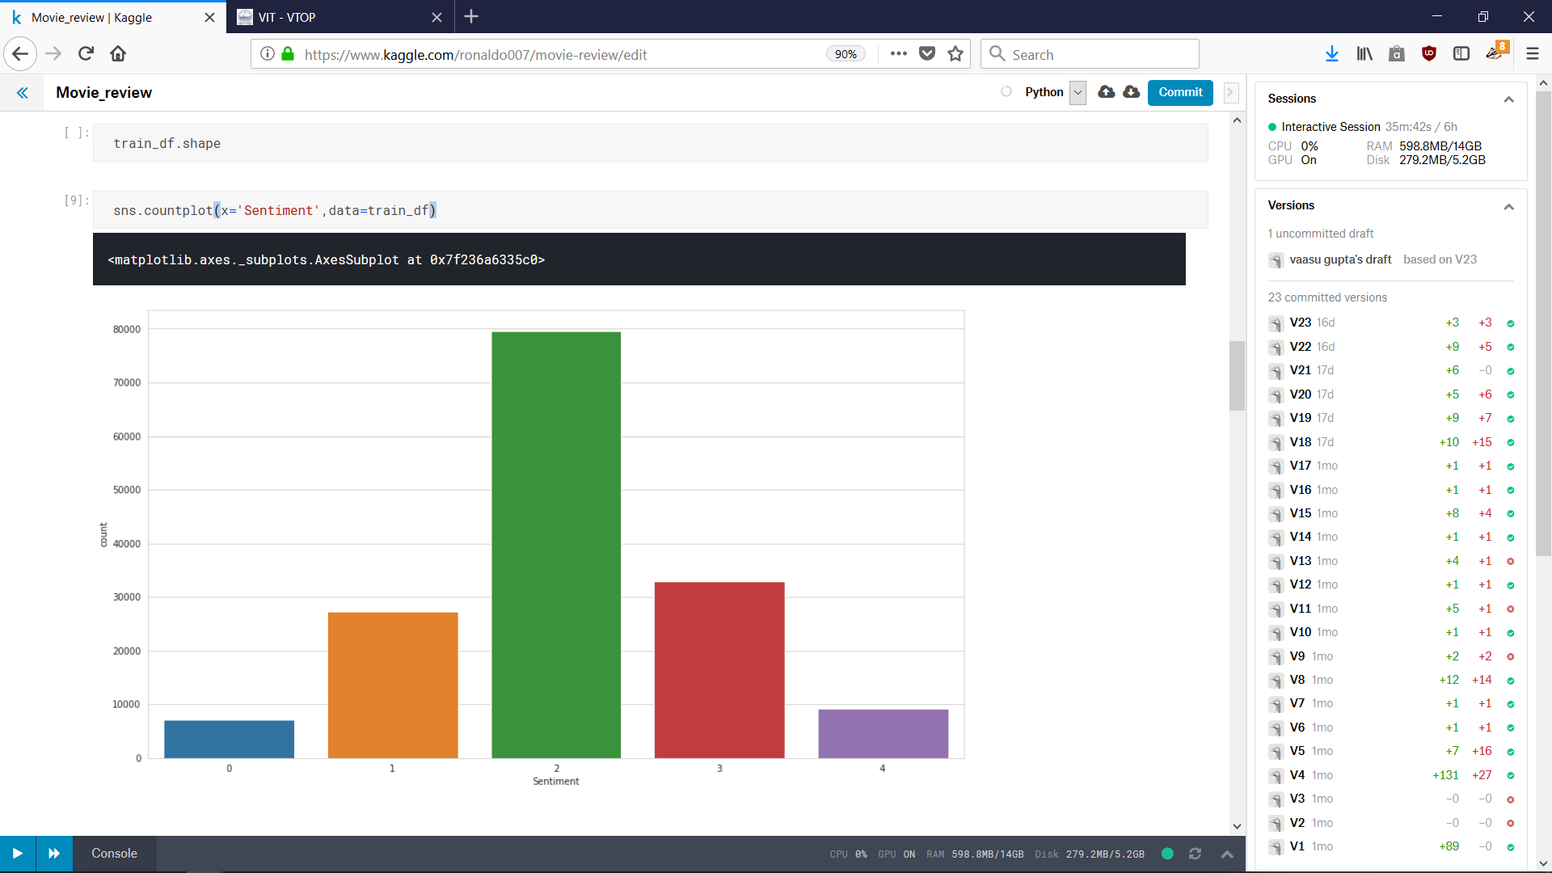

Two approaches to build NLP pipeline

1) Using Stemming

Using either Porter Stemmer and Lancaster Stemmer to get to the root of the word.
Porter stemmer uses a rule based approach to reduce the word.
Lancaster Stemmer uses a Lexical approach to reduce words to roots which are most suitable.

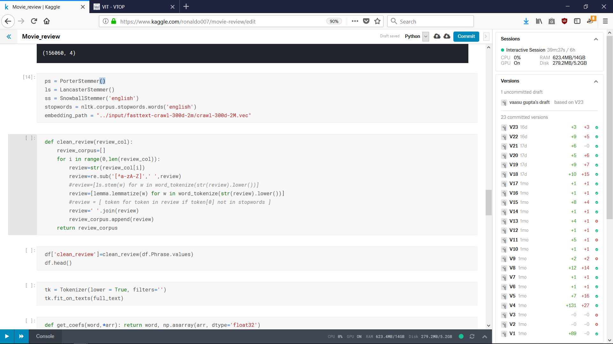

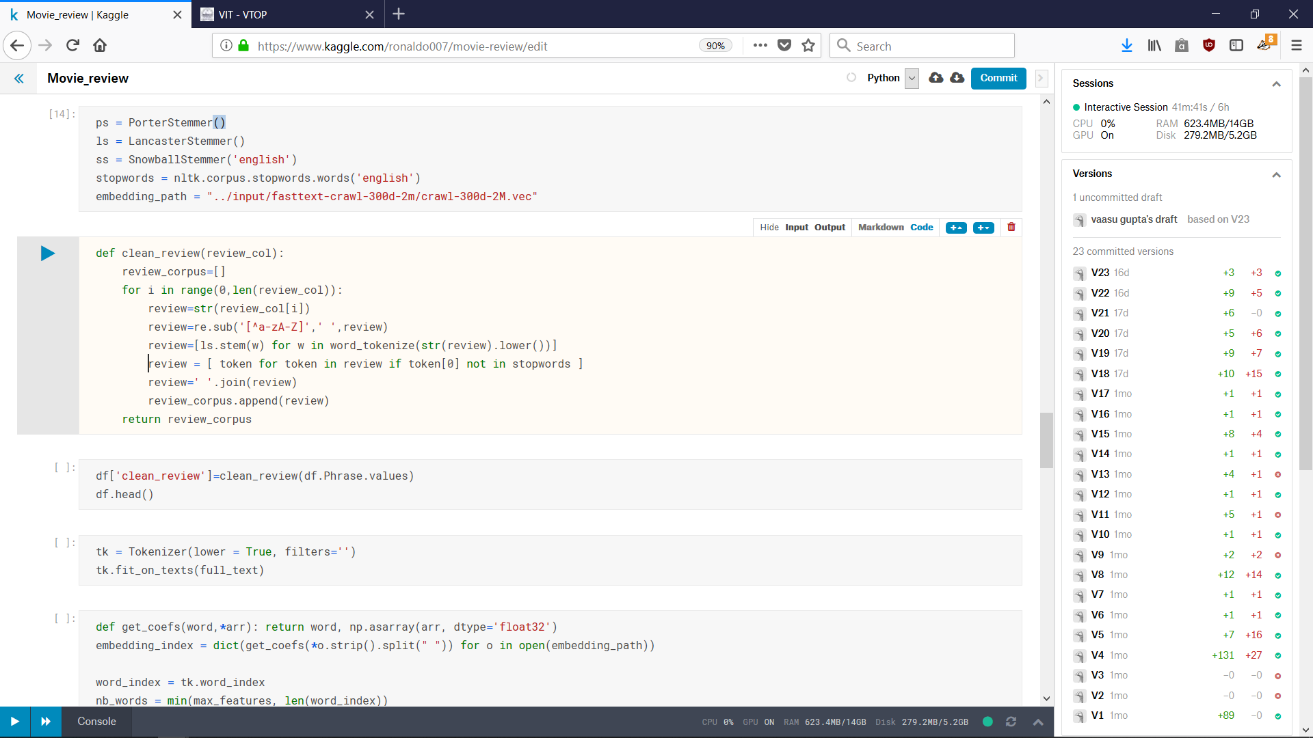

2) Using Lemmatization

Here we have used the WordNet lemmatizer to import the lexicons.

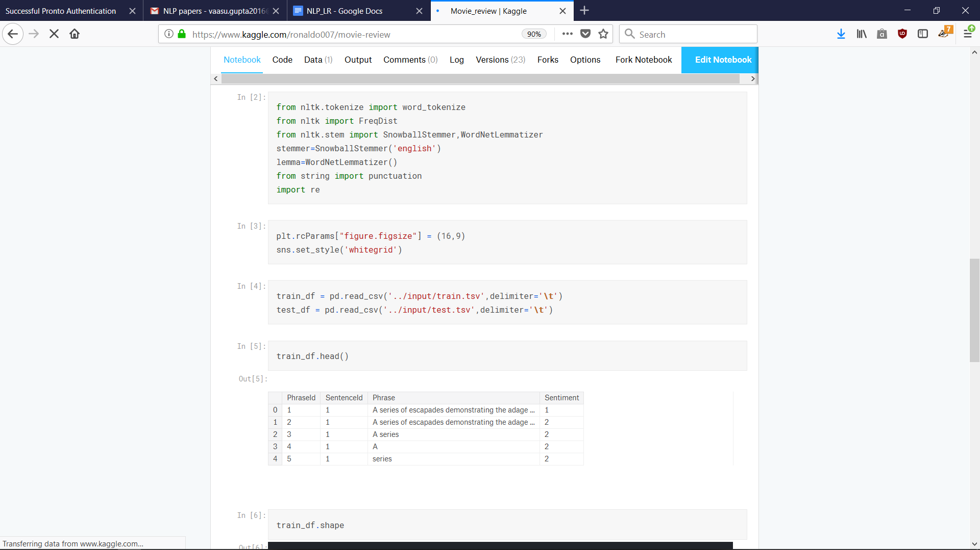
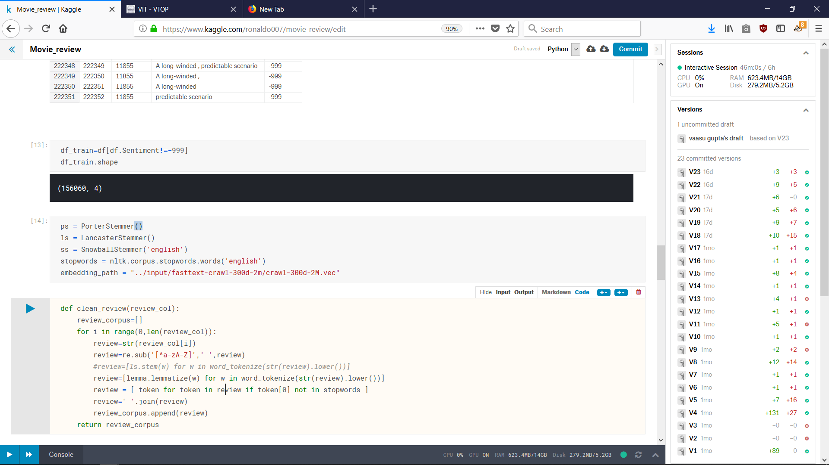

Some NLP techniques used in these approaches

- Regular Expressions

A regular expression is a special sequence of characters that helps you match or find other strings or sets of strings, using a specialized syntax held in a pattern.
In these approach it limits the use of characters to just Alphabets in both lower and upper case.

- Stemming / lemmatization

Stemming algorithms work by cutting off the end or the beginning of the word, taking into account a list of common prefixes and suffixes that can be found in an inflected word. This indiscriminate cutting can be successful in some occasions, but not always, and that is why we affirm that this approach presents some limitations.

Lemmatization, on the other hand, takes into consideration the morphological analysis of the words. To do so, it is necessary to have detailed dictionaries which the algorithm can look through to link the form back to its lemma.

- Stop words

A stop word is a commonly used word (such as "the") that a search engine has been programmed to ignore, both when indexing entries for searching and when retrieving them as the result of a search query.

In these approach we tried both with and without stop words.

After the cleaning process we get:

1) Using Stemming (Lancaster Stemmer)

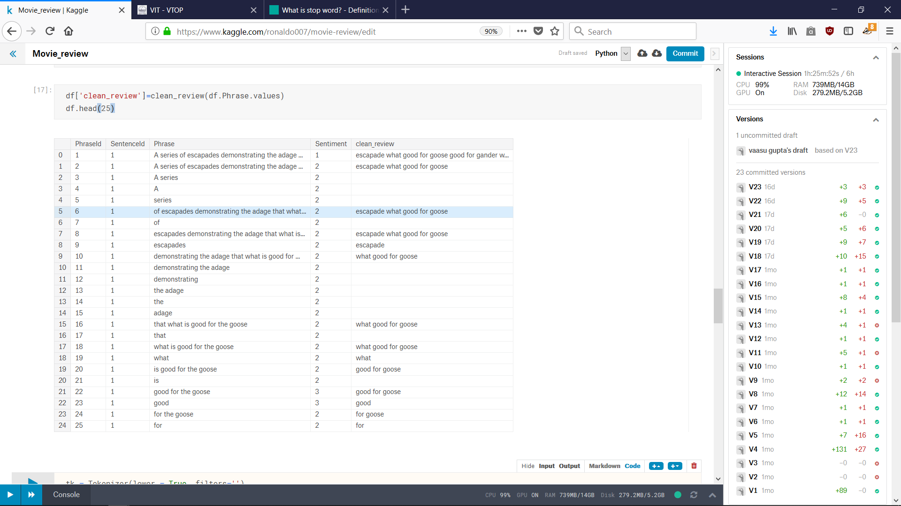

2) Using Stemming (Porter Stemmer)

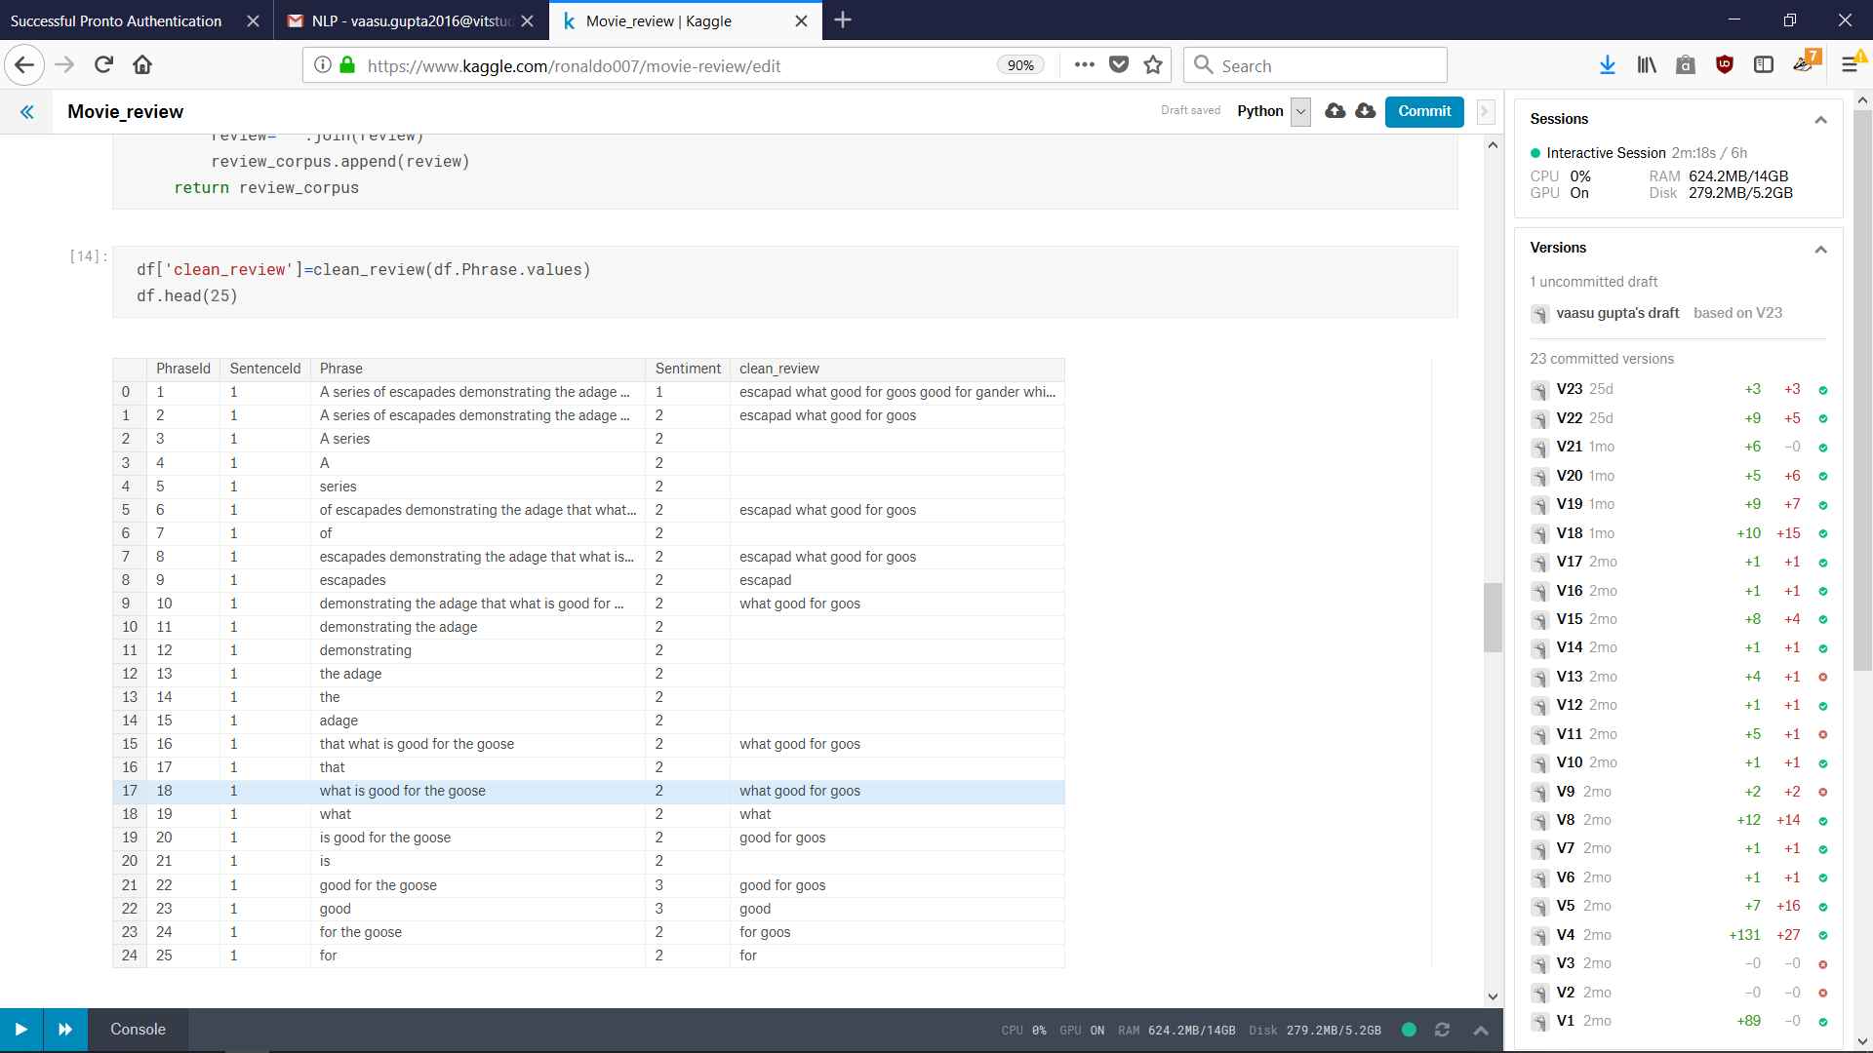

3) Using Lemmatization

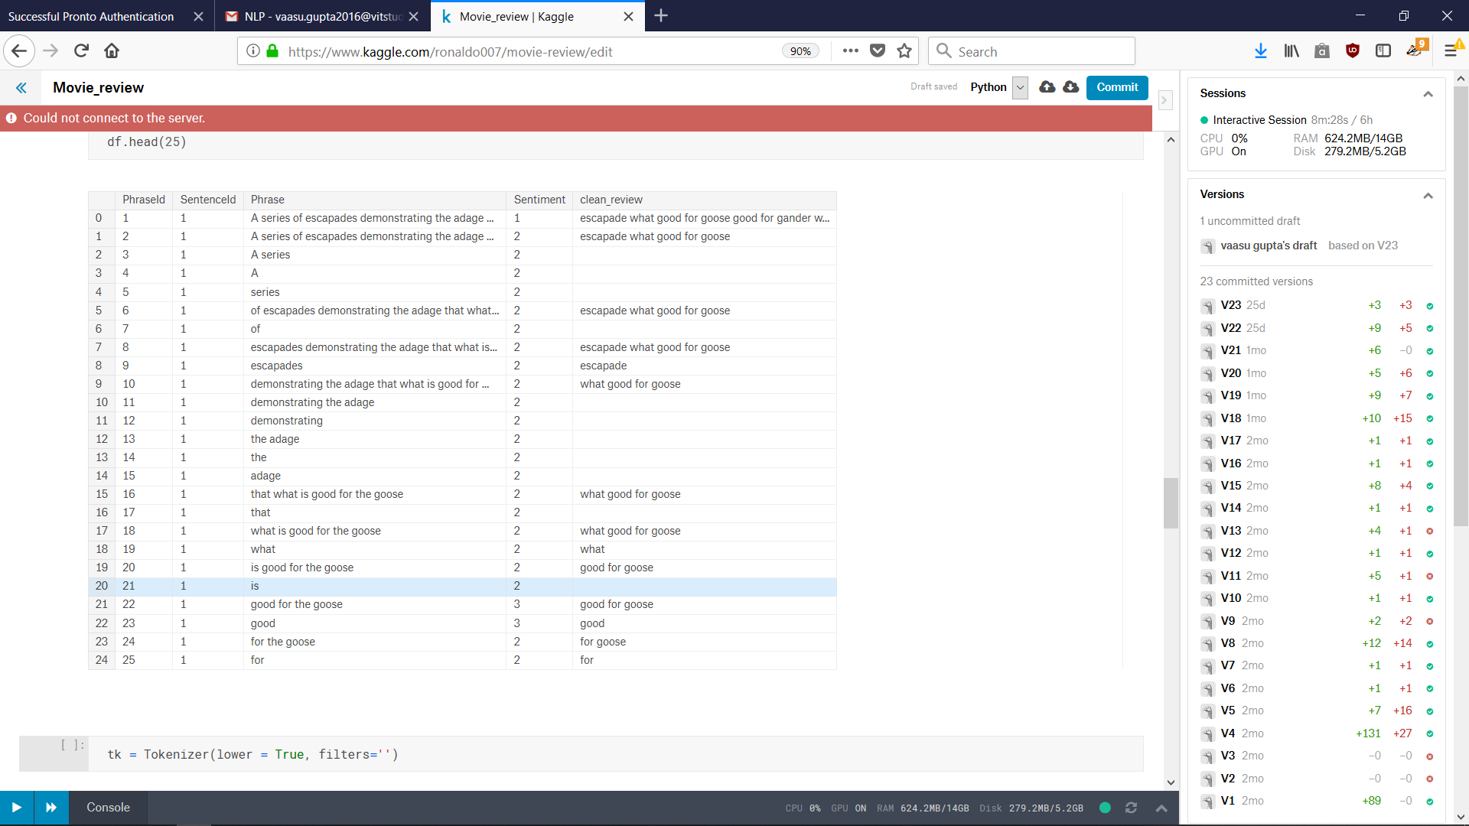

After Cleaning the review, we get a simplified textual data, but textual data cannot be used as input to neural networks. Hence we need to convert text to numeric data.

To create our own embeddings we need find

- No of unique words
- Max Clean review length

Using Keras Embedding function we can create our own Word Embeddings. This can now be fed to Neural Networks.

Result

- LSTM / GRU MODEL
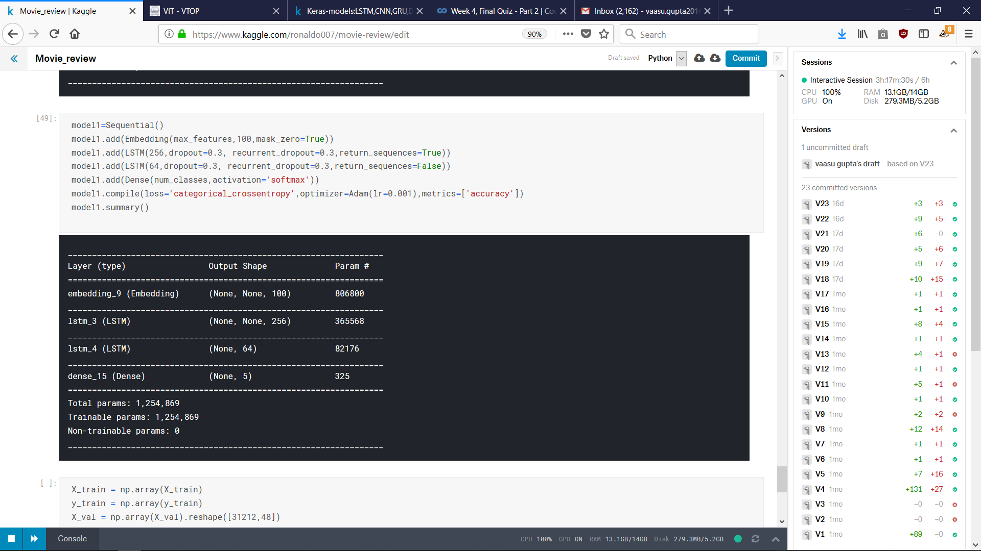

- CNN MODEL
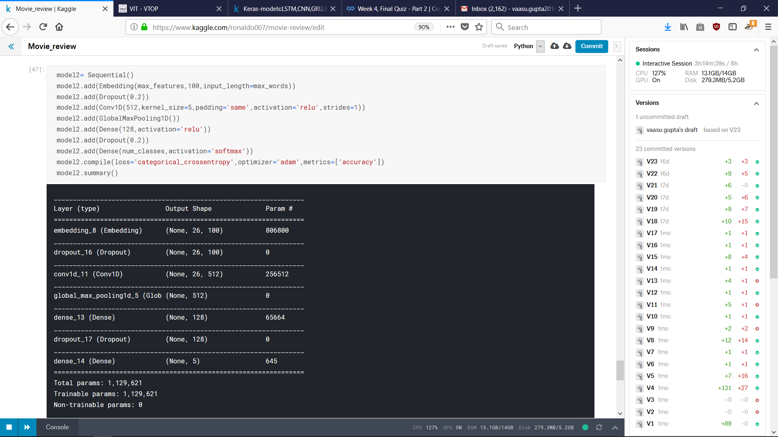

- CNN – LSTM / GRU MODEL

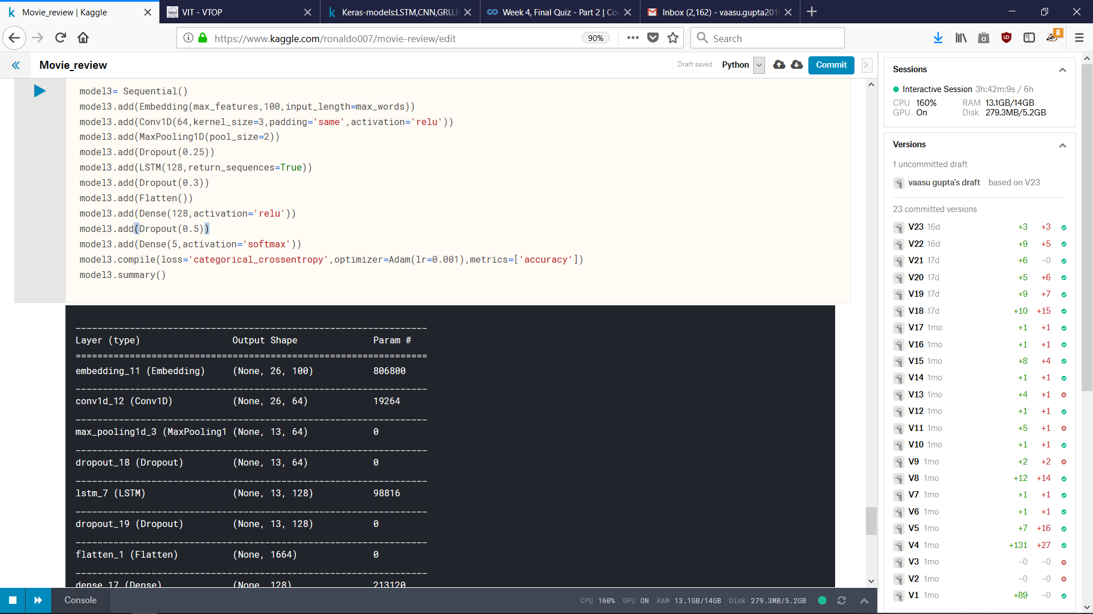

- BI-GRU MODEL

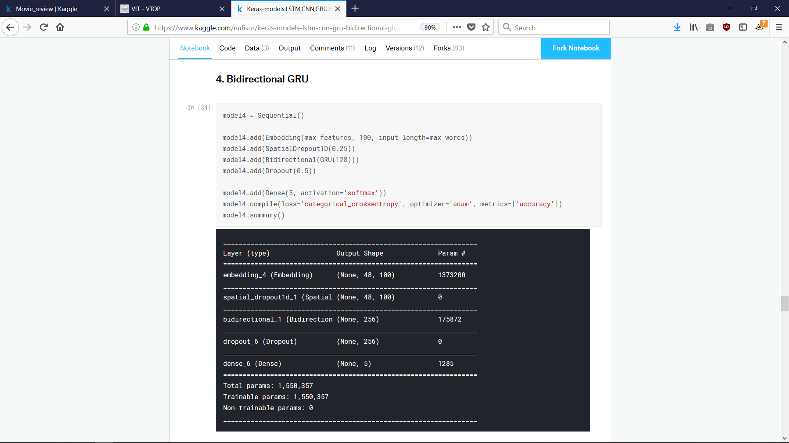

- LSTM / GRU – CNN

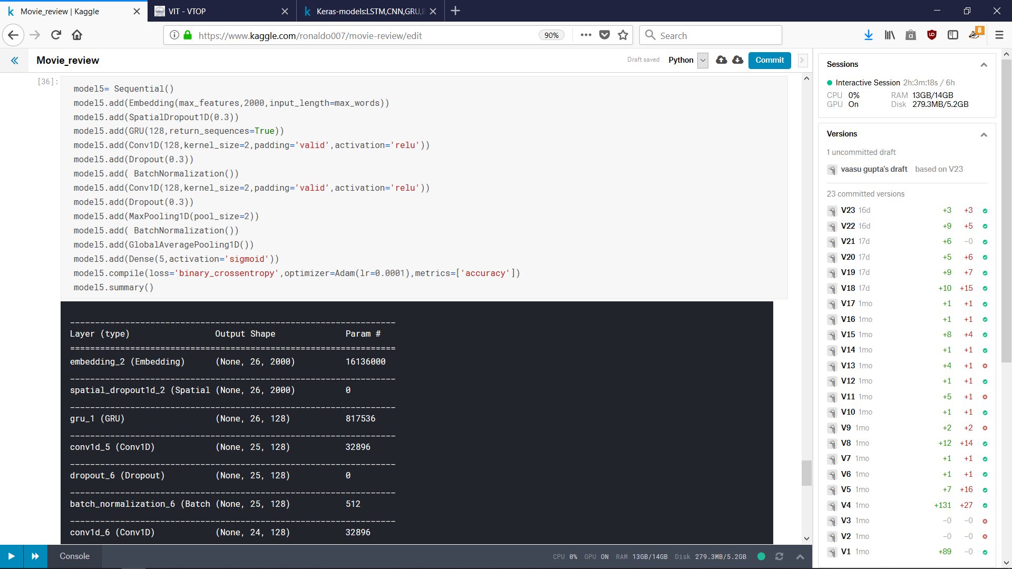

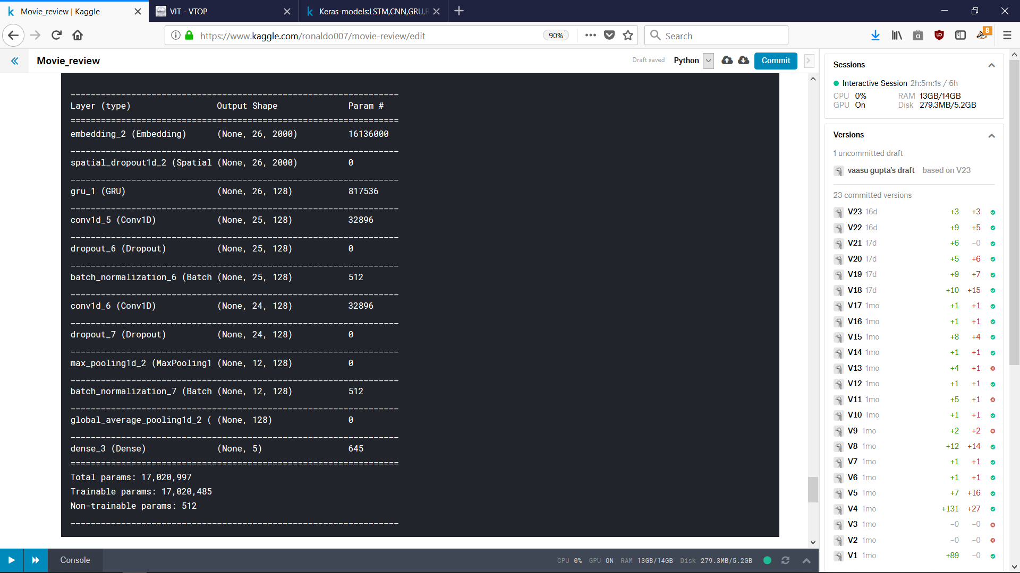

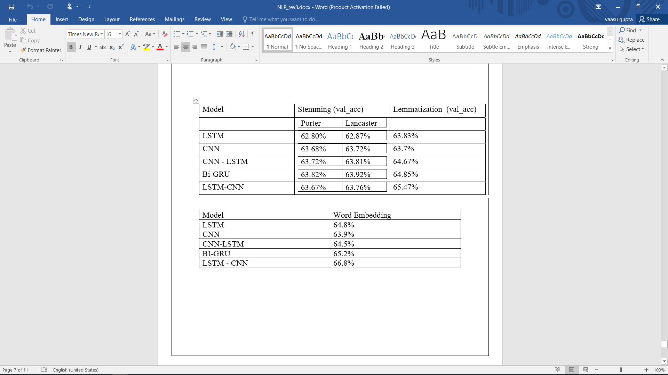

Conclusion

As we can see with the result of this survey Natural Language Processing is essential to the accuracy of our model. Stemming/lemmatization or Porter/Lancaster Stemmer can alter the output significantly.
From the result we can conclude that Lancaster stemmer gets slightly higher accuracies which shows that lexicon based stemmers perform better in such datasets than rule based stemmers.
Also lemmatization does much better than stemming. During the research for this project I have learned that-
The real difference between stemming and lemmatization is threefold:
- Stemming reduces word-forms to (pseudo)stems, whereas lemmatization reduces the word-forms to linguistically valid lemmas. This difference is apparent in languages with more complex morphology, but may be irrelevant for many IR applications;
- Lemmatization deals only with inflectional variance, whereas stemming may also deal with derivational variance;
- In terms of implementation, lemmatization is usually more sophisticated (especially for morphologically complex languages) and usually requires some sort of lexica. Satisfactory stemming, on the other hand, can be achieved with rather simple rule-based approaches.
In both of these approaches we create embeddings based on the given corpora.
But when we import Word embeddings which are made from a much bigger corpus hence has better co-relation we find a huge jump in accuracy.
This also proves the importance of a corpus in such tasks.

V1. References

[1] Liu B. Sentiment analysis: mining opinions, sentiments, and emotions. The Cambridge University Press,
[2] B. Heredia, T. M. Khoshgoftaar, J. Prusa, and M. Crawford, Cross-
Domain Sentiment Analysis: An Empirical Investigation, 2016 IEEE 17th
Int. Conf. Inf. Reuse Integr., pp. 160165, 2016.
[3] F. Luo, C. Li, and Z. Cao, Affective-feature-based sentiment analysis
using SVM classifier, 2016 IEEE 20th Int. Conf. Comput. Support. Coop.
Work Des., pp. 276281, 2016.
[4] M. Haenlein and A. M. Kaplan, An empirical analysis of attitudinal and
behavioral reactions toward the abandonment of unprofitable customer
relationships, J. Relatsh. Mark., vol. 9, no. 4, pp. 200228, 2010.
[5] M. Day and C. Lee, Deep Learning for Financial Sentiment Analysis on
Finance News Providers, no. 1, pp. 11271134, 2016.
[6] P. Vateekul and T. Koomsubha, A Study of Sentiment Analysis Using
Deep Learning Techniques on Thai Twitter Data, 2016.
[7] Y. Zhang, M. J. Er, N. Wang, M. Pratama, and R. Venkatesan, Sentiment
Classification Using Comprehensive Attention Recurrent Models, pp.
15621569, 2016.
[8] Collobert, Ronan, et al. (2001) Natural language processing (almost) from scratch.
The Journal of Machine
Learning Research
12: 2493-2537.
[9] Mikolov, Tomas, et al. (2013) Distributed representations of words and phrases and their compositionality.
Advances in neural information processing systems
. 2013.
[10] Socher, Richard, et al. (2011) Parsing natural scenes and natural language with recursive neural networks.
Proceedings of the 28th international conference on machine learning (ICML-11)

 

