Q1) Excerpt from *“Cities with Maximum Road Accidents in India” by by Usha V.Sagar* (<https://www.mapsofindia.com/my-india/india/cities-with-maximum-road-accidents-in-india>)

On an average, 1317 accidents and 413 deaths due to accidents take place on Indian roads every day; or 55 accidents and 17 deaths every hour. This is an alarming number. Although there is decline by 4.1 per in the road accident compared to 2015, the death of persons killed in road crash has increased by 3.2 per cent over 2015.

The annual report on Road Accidents in India – 2016, released by the Ministry of Road Transport and Highways, records road accident data for cities with 50 Million plus population. These cities accounted for 18.7 percent of the total road accidents in the country during 2016.

Chennai leads the pack with total of 7486 accidents followed by Delhi and Bengaluru. The maximum deaths are recorded in Delhi followed by Chennai.

|  |  |  |  |
| --- | --- | --- | --- |
| **S. No.** | **Cities** | **Total Accidents** | **No of persons killed** |
| 1 | Chennai | 7486 | 1183 |
| 2 | Delhi | 7375 | 1591 |
| 3 | Bengaluru | 5323 | 835 |
| 4 | Indore | 5143 | 431 |
| 5 | Kolkata | 4104 | 407 |
| 6 | Bhopal | 3571 | 248 |
| 7 | Mumbai | 3379 | 562 |
| 8 | Jabalpur | 3256 | 352 |
| 9 | Jaipur | 3004 | 890 |
| 10 | Hyderabad | 2945 | 448 |
| 11 | Mallapuram | 2738 | 402 |
| 12 | Kochi | 2573 | 169 |
| 13 | Thiruvanthapuram | 2453 | 180 |
| 14 | Raipur | 2240 | 415 |
| 15 | Gwalior | 1993 | 244 |
| 16 | Ahmedabad | 1783 | 428 |
| 17 | Kollam | 1677 | 207 |
| 18 | Vijaywada city | 1640 | 379 |
| 19 | Lucknow | 1639 | 631 |
| 20 | Khozikode | 1542 | 145 |
| 21 | Vishakapatnam | 1538 | 327 |
| 22 | Kanpur | 1451 | 684 |
| 23 | Pune | 1376 | 410 |
| 24 | Nagpur | 1373 | 307 |
| 25 | Thrissur | 1357 | 128 |
| 26 | Coimbatore | 1354 | 288 |
| 27 | Allahabad | 1100 | 488 |
| 28 | Agra | 1062 | 522 |
| 29 | Vadodra | 1046 | 214 |
| 30 | Nashik | 1031 | 213 |
| 31 | Meerut | 977 | 421 |
| 32 | Madurai | 946 | 222 |
| 33 | Patna | 923 | 484 |
| 34 | Ghaziabad | 887 | 421 |
| 35 | Surat | 790 | 283 |
| 36 | Rajkot | 719 | 154 |
| 37 | Aurangabad | 666 | 143 |
| 38 | Tiruchirapalli | 657 | 144 |
| 39 | Faridabad | 624 | 212 |
| 40 | Kota | 590 | 102 |
| 41 | Ludhiana | 549 | 384 |
| 42 | Kannur | 504 | 52 |
| 43 | Varanasi | 456 | 226 |
| 44 | Chandigarh | 428 | 151 |
| 45 | Asansol -Durgapur | 416 | 243 |
| 46 | Srinagar | 324 | 51 |
| 47 | Jodhpur | 270 | 100 |
| 48 | Dhanbad | 217 | 97 |
| 49 | Jamshedpur | 188 | 77 |
| 50 | Amritsar | 152 | 102 |
|  | Total | 89835 | 17797 |

a) *On an average, 1317 accidents and 413 deaths due to accidents take place on Indian roads every day; or 55 accidents and 17 deaths every hour.* Are these two statements equivalent? Does the total number of accidents and deaths caused by these accidents in major cities conform to the above statement?

b) If an accident has been reported, what is the probability that the incident took place in Gwalior? What is the probability that a person involved in that accident will not survive?

c) On a particular day you turn on a TV where the news of a fatal accident in a Metropolitan city of India (shaded in grey in table) is being reported. You have missed out the name of the city. What are the chances that the city is Delhi?

d) In an article “Fatal Road Accident Characteristics in Metro-Plus Cities of India” by C. Vigneshkumar published in International Journal of Science and Research following table is given

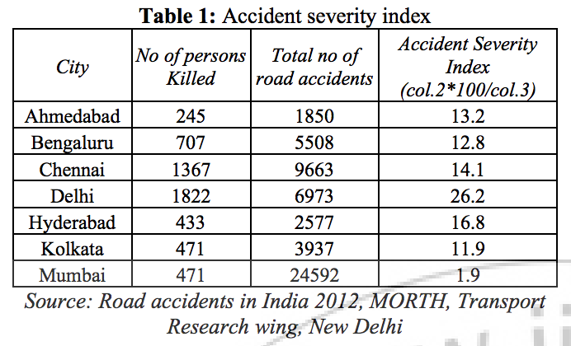

The article concludes as

*In general, the number of fatal accidents in Delhi, Mumbai and Hyderabad decreases year by year. This indicates that traffic operation management in these may have improved.*

Does the data of 2016 support this statement?