

Software Design Description
SDD
Vacanza
Team 2

Ahmet Serhat Şahin, 22101813
Damla Alçay, 22002369
Göksu Uzun, 22102745
Ömer Faruk Asil, 22002781
Ufuk Zencirci, 22102476

Bilkent University
Department of Information Systems and Technologies

05.01.2026
Change History
File Name | Document Type | Deliverable | Version | Submission Date
Team2_SDD_V1 | Microsoft Word 2024 Document (.docx) | 4 | 1 | 05.01.2026

Project Details
Project Name | Vacanza - AI Powered Travel Application
Software Product Name | Vacanza
Company Name | No sponsor company
Academic Advisor | Neşe Şahin Özçelik
Github URL | https://github.com/VacanzaTravelApp
WEB page | https://vacanza.app
Software Product Information | Vacanza is an AI-powered travel assistant that helps users plan their trips in a smart, personalized, and effortless way. The application uses artificial intelligence to design customized travel routes based on each user’s interests, preferences, and travel style—whether they enjoy culture, food, history, or nature. Vacanza combines everything a traveler needs in one place: cultural and event recommendations, interactive 2D/3D maps, booking connections for flights and accommodation, and calendar synchronization for easy scheduling. Thanks to its AI system, Vacanza can also adapt plans dynamically according to weather, time, or local events, and provide instant suggestions through a friendly chatbot. In short, Vacanza turns travel planning into a smooth, intelligent, and enjoyable experience by offering a truly personalized journey for every user.

Team 2
Name, Surname | Bilkent e-mail | Alternative e-mail
Ahmet Serhat Şahin | serhat.sahin@ug.bilkent.edu.tr | aserhatsahin@gmail.com
Damla Alçay | damla.alcay@ug.bilkent.edu.tr | alcaydamla2@gmail.com
Göksu Uzun | goksu.uzun@ug.bilkent.edu.tr | goksuzun@gmail.com
Ömer Faruk Asil | faruk.asil@ug.bilkent.edu.tr | asilo02@hotmail.com
Ufuk Zencirci | ufuk.zencirci@ug.bilkent.edu.tr | ufuq.zencirci@gmail.com

Individual Contributions Overview
Name, Surname | Summary of Contributions to the SRS Document
Ahmet Serhat Şahin | Detailed Design Diagrams
Damla Alçay | Test Case Design  Test Cases
Göksu Uzun | Design Quality  Selected Architecture  Detailed Design Diagrams  General Formatting
Ömer Faruk Asil | GitHub Access  Process View  Pseudocode
Ufuk Zencirci | Logical View  Physical View

Executive Summary
The Software Design Description document establishes the complete architectural and detailed design framework for the Vacanza, transforming the requirements outlined in previous deliverables into concrete technical specifications and implementation blueprints. The document begins with a high-level design section that presents the use case diagram with increment colorings, identifies the selected software architecture and justifies this choice through explicit connections to non-functional requirements, and explains how architectural decisions address system goals such as scalability, maintainability, and performance. The logical view provides a block diagram illustrating the overall system structure and data flow, accompanied by an Entity-Enhanced Relationship diagram following Chen's notation that defines the database schema with cardinalities, participation rules, and attribute specifications. The physical view presents a UML deployment diagram showing the distribution of software components across hardware nodes and external service dependencies. Design quality considerations systematically address how each non-functional requirement will be satisfied through specific design decisions and detail the verification strategies that will confirm compliance. The test case design section establishes comprehensive approaches for unit, integration, system, and acceptance testing, defining formatting conventions and coverage criteria. Low-level design focuses exclusively on first increment use cases, providing pseudocode, UML communication diagrams that realize each use case through component interactions, and detailed design artifacts including activity, sequence, and class diagrams with complete method signatures, parameter types, return values, and attribute specifications. Corresponding test cases are presented for unit and first increment acceptance validation. The GitHub access section specifies repository structure and mechanisms for tracking individual contributions. The discussions section reflects on challenges encountered during SDD preparation, particularly the compressed timeline coinciding with final examinations, the unequal distribution of technical complexity across sections, coordination difficulties under concurrent implementation pressures, and the strategies employed to address these obstacles through prioritized task management and collaborative review sessions. Overall, this SDD consolidates architectural decisions, database structures, behavioral specifications, and implementation-level details into a cohesive technical blueprint that guides development and establishes measurable criteria for system validation.

Table of Contents
Page Number

1. High-Level Design (Architecture) 8
1.1. Selected Architecture 9
1.2. Logical View 14
1.3. Physical View 18
1.4. Design Quality 19
2. Test Case Design 23
2.1. Unit Tests 23
2.2. Acceptance Tests 24
3. Low Level Design 26
3.1. Pseudocode 26
3.2. Process View 77
3.3. Detailed Design Diagrams 82
3.4. Test Cases 92
4. GitHub Access 98
4.1. GitHub Account Association and Contribution Tracking 98
4.2. Login and Access to GitHub Repositories 98
4.3. Tracking Contributions for the First Increment 98
4.4. Tracking Contributions for the Overall Project 99
5. Discussions 100

List of Figures
Page Number

Figure 1 Use Cases for Vacanza (Including Implemented Ones in First Increment) 8
Figure 2 Block Diagram for Vacanza 14
Figure 3 EER Diagram for Vacanza 16
Figure 4 UML Deployment Diagram for Vacanza 18
Figure 5 (A) UC1.1 Registration (Mobile and Web) 77
Figure 6 (B) UC1.1 Login and Session Store (Mobile) 78
Figure 7 (C) UC1.1 Logout (Mobile and Web) 79
Figure 8 (A) UC1.2 Viewport POI Search 80
Figure 9 (B1) UC1.2 Polygon Selection Search 80
Figure 10 (B2) UC1.2 Filter and Clear Selection 80
Figure 11 (C) UC1.2 Backend Search and Ingest 81
Figure 12 (A) UC1.3 Toggle Map View Mode (Mobile and Web) 81
Figure 13 (B) UC1.3 Marker Reinitalization After Style Change (Mobile and Web) 81
Figure 14 (C) UC1.3 Recenter and Gesture Control Rule (Mobile and Web) 82
Figure 15 (A) Mobile Class Diagram (UC1.1 for UI and BLoC) 83
Figure 16 (B) Mobile Class Diagram (UC1.1 for Repo, Services, Client, DTOs) 84
Figure 17 Mobile Class Diagram (UC1.2 and UC1.3) 85
Figure 18 Web Class Diagram (UC1.1) 86
Figure 19 Backend Class Diagram (UC1.1) 87
Figure 20 Backend Class Diagram (UC1.2) 88
Figure 21 Sequence Diagram (UC1.1 and Session Sync) 89
Figure 22 Sequence Diagram (UC1.2) 90
Figure 23 Sequence Diagram (UC1.3) 91

Abbreviations

AT  CTIS  FReq  NFR  POI | Acceptance Test  Information Systems and Technologies  Functional Requirement  Non-Functional Requirement  Point of Interest
SDD | Software Design Description
SRS  UT | Software Requirements Specification  Unit Test

High-Level Design (Architecture)
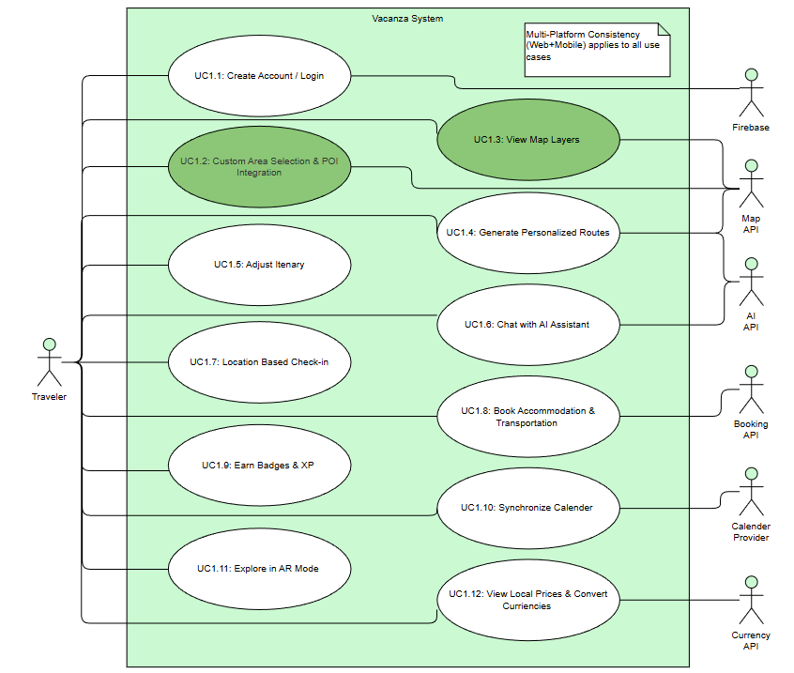
Figure 1 Use Cases for Vacanza (Including Implemented Ones in First Increment)

The system is designed as a multi-platform travel planning assistant that enables travelers to create trips, explore destinations on an interactive map, and progressively build a personalized itinerary through integrated services.
To reflect the increment plan, the use cases implemented in the 1st Increment Prototype should be highlighted using the same Increment 1 color scheme applied in SRS(A)v2, while the remaining use cases should remain uncolored or use the “future increment” colors. For the 1st Increment, the implemented use cases are:
- UC1.1 Create Account / Login (implemented as a baseline enabler; not counted as a major feature percentage contribution)
- UC1.2 Custom Area Selection and POI Integration
- UC1.3 View Map Layers
Brief Functional Description of the Product
Vacanza provides travelers with an end-to-end trip exploration and planning experience. Users authenticate to access their saved trip context, select or draw a target area of interest, and view relevant points of interest (POIs) and map overlays to support planning decisions. In later increments, the system expands toward itinerary editing, AI-supported recommendations and route generation, booking integration, calendar synchronization, gamification elements, and utility features such as currency conversion.
Implemented Use Cases in the 1st Increment Prototype
- UC1.1 Create Account / Login:
In the first increment, Vacanza provides a simple authentication flow that allows a traveler to create an account and sign in. This capability primarily serves as an enabling foundation for personalized features and saved user context across sessions. Although it is not treated as a primary prototype feature contribution, it is included to support consistent access control and basic user identification.
- UC1.2 Custom Area Selection and POI Integration:
Vacanza enables travelers to define a custom geographical area of interest (for example by selecting a region on the map). Based on this selected area, the system retrieves and displays relevant POIs (such as attractions, cultural points, or landmarks) from integrated data sources. This functionality supports early-stage trip exploration by helping users discover what is available within a chosen region before committing to a detailed itinerary.
- UC1.3 View Map Layers:
Vacanza allows travelers to switch between map layers and overlays to better understand the selected area. This includes visual variations such as different base map styles and practical overlays that improve interpretability during exploration. The goal of this use case is to improve usability and decision-making by letting users view geographic information in the most suitable representation for their planning task.

Selected Architecture
Vacanza is developed using a multi-client client–server approach. The system consists of two presentation clients, a React-based web application and a Flutter-based mobile application, both consuming a shared Spring Boot backend API. Persistent data is stored in PostgreSQL. At a high level, this corresponds to a 3-tier structure in which presentation logic is implemented in the clients, business and integration logic resides in the backend, and data persistence is managed by the database layer.
This architectural selection is primarily driven by the project’s goals of cross-platform consistency, modular evolution under academic constraints, and safe integration with third-party services and AI-based functionality.

System-Level Architecture: Multi-Client Client–Server (3-Tier)
The system is organized as multiple clients communicating with a single backend service. This decision supports consistent behavior and shared functionality across web and mobile, while centralizing business logic and data access.
Justification with Non-Functional Requirements
Cross-platform consistency and synchronization are explicitly required, since users should be able to start, update, and view trip plans on either platform without inconsistency or data loss (SRS(A)v2 §6.7.1). A shared backend also supports future extensibility by allowing new modules and third-party integrations to be introduced once at the server layer rather than duplicated across clients (SRS(A)v2 §6.7.2). From a security perspective, centralizing authentication and sensitive operations in the backend reduces exposure and enables uniform enforcement of secure communication and credential handling practices (SRS(A)v2 §6.4 Security). Finally, performance targets related to request rates and external API rate limits can be managed more safely when orchestration is centralized (SRS(A)v2 §6.2 Static Requirements).
Advantages
A single backend reduces duplication of business logic and improves functional alignment between platforms (SRS(A)v2 §6.7.1). It also simplifies the enforcement of consistent security and error-handling policies (SRS(A)v2 §6.4 Security, SRS(A)v2 §6.5).
Disadvantages
The backend becomes the primary integration hub, meaning failures or latency in third-party services can affect both clients at once (SRS(A)v2 §6.5 Integration Dependency, SRS(A)v2 §6.5 Limited Data Source Coverage). This risk must be mitigated through timeouts, retries, and user-visible progress indicators, especially when response time may reach up to 10 seconds due to external APIs (SRS(A)v2 §6.1 Efficiency, SRS(A)v2 §6.5).

Backend Architecture: Layered Architecture (Spring Boot)
The backend uses a layered structure that separates concerns into controllers (API endpoints), services (business logic and orchestration), and repositories (data access). DTO and entity separation is used for safe data transfer and persistence modeling. Cross-cutting concerns such as security, configuration, and centralized exception handling are implemented as dedicated modules.
Justification with Non-Functional Requirements
Maintainability is a key driver for this choice. The project explicitly targets modular, isolated logic and low coupling to support efficient debugging and extension (SRS(A)v2 §6.3 Code Modularity; SRS(A)v2 §6.4 Maintainability). Centralized exception handling supports the requirement for consistent, non-technical error responses and preventing leakage of internal stack traces or secrets (SRS(A)v2 §6.5; SRS(A)v2 §6.5.3). Security requirements are addressed through a dedicated security layer that enables secure credential handling and controlled access to restricted features (SRS(A)v2 §6.4 Security; SRS(A)v2 §6.5.1 Unauthorized Access). Performance targets can also be enforced at the service layer by applying timeouts and limited retries for external API calls (SRS(A)v2 §6.2 Dynamic Requirements; SRS(A)v2 §6.5.2 Recovery).
Advantages
The layered approach provides clarity, testability, and controlled evolution. Changes in data access or integration code can often be handled without rewriting controllers or UI clients (SRS(A)v2 §6.3; SRS(A)v2 §6.7.2).
Disadvantages
Layered systems can introduce boilerplate and additional indirection. If the backend grows beyond prototype scope, further modularization strategies may be needed to avoid a large monolithic codebase, even though that is outside the current academic constraints (SRS(A)v2 §6.5 Academic and Resource Constraints).

Mobile Architecture: Feature-Based Modularization with Layered Separation and BLoC
The mobile client follows a feature-based organization. Shared infrastructure is centralized (networking, storage, navigation, dependency injection), while feature folders separate data concerns (datasources, repositories, models) from presentation concerns (screens, widgets, and BLoC state management). BLoC provides explicit state transitions for loading, success, and failure paths.
Justification with Non-Functional Requirements
Usability requirements emphasize efficient task completion and responsive interactions, including explicit loading indicators when external dependencies cause delays (SRS(A)v2 §6.1 Efficiency). BLoC state modeling supports predictable UI feedback, helping ensure users are informed during operations such as AI calls or route generation (SRS(A)v2 §6.1 Efficiency; SRS(A)v2 §6.2 Dynamic Requirements). Feature modularity supports maintainability and future extensibility by reducing coupling between unrelated modules (SRS(A)v2 §6.3; SRS(A)v2 §6.7.2). Finally, cross-platform consistency is supported by keeping navigation and UI flows structured and repeatable (SRS(A)v2 §6.7.1).
Advantages
Feature modularity improves parallel development and simplifies expansion. Clear state management improves reliability of user experience during slow or failure-prone external calls (SRS(A)v2 §6.5; SRS(A)v2 §6.5).
Disadvantages
The approach requires more structure and boilerplate than simpler UI patterns. Without discipline, business rules may drift into presentation or data folders, weakening separation of concerns over time (SRS(A)v2 §6.3).

Web Architecture: Component-Based SPA (React) with Page-Based Organization
The web client is implemented as a React single-page application. It is organized around pages and reusable components, enabling consistent UI patterns and fast iteration. Integration modules (e.g., Firebase-related configuration) are separated to avoid coupling UI components to external services.
Justification with Non-Functional Requirements
The usability goals require consistent navigation and low error rates, which are supported by reusable components and standardized UI flows (SRS(A)v2 §6.1 Effectiveness). The compatibility requirement states that web and mobile should provide consistent outcomes and interaction behavior; using a clear page and component structure supports this consistency at the presentation layer (SRS(A)v2 §6.7.1). Portability is also supported, since the web client runs on modern browsers without platform-specific dependencies (SRS(A)v2 §6.4 Portability).
Advantages
Component reuse improves UI consistency and reduces duplicated code across pages. SPA interaction patterns support the responsiveness expectations for typical user actions (SRS(A)v2 §6.2 Dynamic Requirements).
Disadvantages
As the UI grows, state and API interaction logic can become difficult to manage unless patterns and conventions are enforced. The web client is also sensitive to backend API contract changes, requiring coordination between teams.
- Impact on the Development Process and Team Organization
Vacanza’s architecture supports parallel development by naturally separating responsibilities into three sub-teams: backend, mobile, and web. This structure reduces cross-team interference and enables independent iteration, while coordination is maintained through a shared API contract and consistent error and security formats.
This division supports maintainability and extensibility goals by limiting the scope of change. For example, backend changes to business rules or integrations can be deployed without redesigning mobile and web UI, provided the API contract remains stable (SRS(A)v2 §6.3; SRS(A)v2 §6.7.2). Consistent error handling and security enforcement are centralized in the backend, enabling both clients to display uniform, non-technical error messages and avoid exposing internal details (SRS(A)v2 §6.5; SRS(A)v2 §6.5.3; SRS(A)v2 §6.4 Security).

Logical View

Block Diagram for the Software Architecture
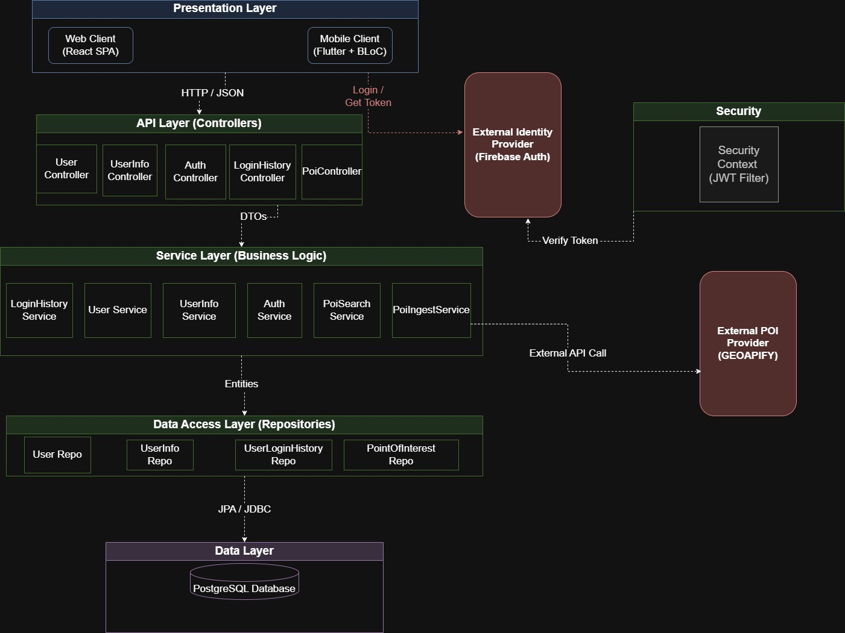
Figure 2 Block Diagram for Vacanza
All the FReq references are from SRS(A)v2 Document.
The logical architecture illustrated in the block diagram reflects the layered and modular design decisions defined in the Vacanza Software Requirements Specification (SRS), particularly the Product Perspective and System Interfaces sections (SRS §3 and §3.1). As specified in the Product Scope (SRS §1), Vacanza is a multi-platform system composed of web and mobile clients, backend services, external integrations, and a centralized data layer. User interaction begins at the Presentation Layer, where travelers access the system through the React-based web client or the Flutter-based mobile application, in line with the multi-platform consistency requirement (FReq12). All user actions including login (FReq1), route generation requests (FReq3), and map interactions (FReq4, FReq14) are transmitted to the backend via secure HTTPS communication using JSON-formatted REST requests, as defined in the Communication Interfaces section of the SRS (§3.5).
Incoming requests are first handled by the API Layer (Controllers), which acts as the system’s entry point and is responsible for request validation, routing, and response formatting. Controllers including AuthController ,UserController, UserController , and PoiController map directly to functional requirements including authentication (FReq1), user management, and POI-based operations (FReq14). Authentication requests are delegated to the External Identity Provider (Firebase Authentication), consistent with the Software Interfaces definition (SRS §3.4), where login credentials are verified and a JWT token is issued. This token is then validated by the Security Layer, implemented via a JWT-based security context, before any protected business operation is executed, satisfying the security requirements outlined in SRS §6.4 and §6.5.
After authorization, validated requests are forwarded to the Service Layer (Business Logic), which encapsulates the core functional behavior of the system. Services including PoiSearchService and PoiIngestService implement the logic for personalized route generation and custom area-based POI retrieval (FReq3 and FReq14), while user-related services support behavior modeling (FReq2) and history tracking. When POI or map-related data is required, the service layer performs controlled external API calls to third-party providers (Geoapify), as defined in the Map/Nav API interface (SRS §3.1), ensuring that Vacanza functions as an intelligent aggregator rather than a primary data source. Persistent data access is handled through the Data Access Layer (Repositories), which abstracts database operations using JPA/JDBC and interacts exclusively with the PostgreSQL Data Layer, in accordance with the Logical Database Requirements (SRS §7.1).
Finally, processed results including generated itineraries, retrieved POIs, or authentication responses are propagated back through the controller layer as DTOs and returned to the client as structured JSON responses. This end-to-end flow ensures a clear separation of concerns, traceability to functional requirements (FReq1–FReq14), secure data handling, and compliance with the architectural constraints defined in the SRS, while supporting extensibility for future integrations such as AI services, booking systems, and administrative monitoring (FReq13).

EER Diagram
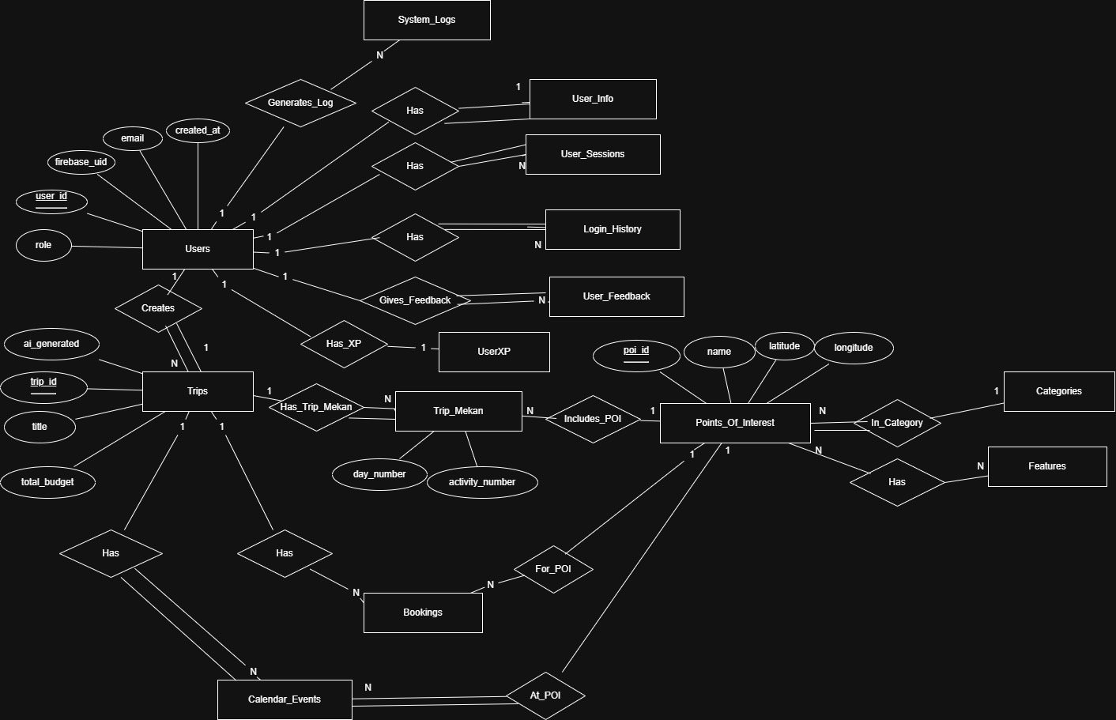
Figure 3 EER Diagram for Vacanza
The Enhanced Entity–Relationship (EER) diagram has been designed based on the Software Requirements Specification (SRS), Section 7.1, and represents the conceptual database structure of the system using Chen’s notation. The model focuses on user management, trip planning, location handling, preferences, events, calendar functionality.
At the center of the model is the Users entity, which represents all registered users of the system. Each user is uniquely identified and may be associated with several related entities. A one-to-one relationship exists between Users and User_Info, indicating that each user has exactly one profile information record, and this information cannot exist independently of a user. Similarly, a one-to-one relationship connects Users and UserXP, representing the experience or points accumulated by a user.
User activity is tracked through Login_History and User_Sessions, both of which are connected to Users via one-to-many relationships. This reflects that a user may log in or create sessions multiple times, while each login or session record must belong to exactly one user. In addition, users can generate System_Logs and provide User_Feedback, both modeled as one-to-many relationships, since multiple logs or feedback entries may be created by a single user.
Trip planning is modeled through the Trips entity. A one-to-many relationship between Users and Trips indicates that a user may create multiple trips, while each trip must be created by exactly one user. Each trip may consist of multiple daily or activity-based entries represented by the Trip_Mekan entity. This is captured through a one-to-many relationship, meaning a trip can include multiple trip segments, but each trip segment belongs to one trip.
Locations are modeled using the Points_Of_Interest (POI) entity. Each Trip_Mekan is associated with exactly one point of interest, while a point of interest may appear in multiple trip segments. This results in a many-to-one relationship from Trip_Mekan to Points_Of_Interest. Each point of interest is further classified into exactly one Category, while a category may contain many points of interest, forming another many-to-one relationship.
The relationship between Points_Of_Interest and Features is modeled as a many-to-many relationship, representing that a point of interest may have multiple features (such as Wi-Fi, parking, or accessibility), and a feature may be shared by multiple points of interest. Although this relationship is implemented in the database through an associative table, it is represented conceptually in the EER diagram in accordance with Chen’s notation.
Event planning is represented through the Events and Calendar_Events entities. Events may occur at specific points of interest, while calendar events are associated with both trips and locations. A one-to-many relationship exists between Trips and Calendar_Events, indicating that a trip may contain multiple scheduled events. Each calendar event is associated with exactly one point of interest, reflecting its physical location.
Finally, the Currency entity is used to model monetary aspects of the system. Trips are associated with a specific currency, indicating that budgeting and cost-related information for a trip is expressed using one currency, while the same currency may be reused across multiple trips.
Overall, the EER diagram accurately captures the system requirements defined in the SRS by clearly modeling entities, relationships, cardinalities, and participation constraints. Mandatory participation is indicated where entities cannot exist independently, and the diagram remains at a conceptual level, independent of physical implementation details.

Physical View
Dd
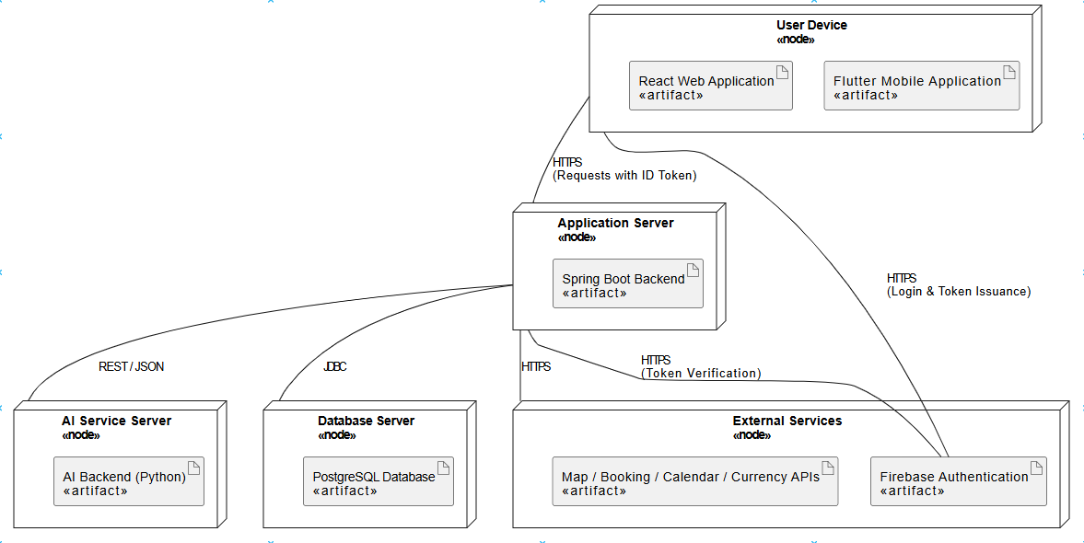
Figure 4 UML Deployment Diagram for Vacanza
The UML Deployment Diagram represents the physical architecture of the system by illustrating how software artifacts are deployed on hardware nodes and how these nodes communicate at runtime. The diagram has been designed based on the system architecture described in the Software Requirements Specification and follows the deployment diagram style presented in the lecture notes.
At the client layer, the system is accessed through a User Device, which hosts both the Flutter Mobile Application and the React Web Application. These client applications are responsible for user interaction and communicate with external services and backend components using secure HTTPS connections.
User authentication is handled directly by Firebase Authentication. The client applications communicate with Firebase to perform user login operations and receive a Firebase ID token upon successful authentication. This token is then attached to subsequent client requests sent to the backend system.
The Application Server hosts the Spring Boot Backend, which contains the core business logic of the system. All client requests are routed to this backend service. Before processing any request, the backend verifies the received Firebase ID token by communicating with Firebase Authentication, ensuring secure and authorized access.
The backend service interacts with an independent AI Service Server, which runs a Python-based AI backend responsible for tasks such as route generation and personalized recommendations. Communication between the application server and the AI service is performed via RESTful APIs using JSON.
Persistent data is managed by a Database Server hosting a PostgreSQL Database. The application server communicates with the database using JDBC to store and retrieve user, trip, booking, and event-related data.
In addition, the system integrates with several External Services, including mapping, booking, calendar, and currency APIs. These services are accessed by the backend through HTTPS to support location-based features, reservations, scheduling, and currency conversion.
Overall, this deployment architecture clearly separates client-side responsibilities, backend processing, authentication, data persistence, and external integrations, resulting in a scalable, secure, and maintainable system design.

Design Quality
This section explains how Vacanza’s design decisions support the non-functional requirements in SRS(A)v2 and how compliance will be verified and validated using the project’s testing strategy and prototype evaluation approach. Since the system is an academic prototype, verification focuses on observable outcomes, timing measurements, and scenario-based acceptance validation rather than production-scale guarantees.

Usability (SRS(A)v2 §6.1)
How the design addresses it: Vacanza’s UI is designed around short task flows for key actions (map exploration, selecting an area, viewing POIs, applying filters) and aims to keep navigation consistent across web and mobile so that the same task yields the same outcome regardless of interaction method (touch vs. cursor) (SRS(A)v2 §6.1 Effectiveness; SRS(A)v2 §6.1 Context of Use; SRS(A)v2 §6.7.1). For operations that may take several seconds due to external services, the UI is expected to provide visible progress feedback to avoid uncertainty during waiting (SRS(A)v2 §6.1 Efficiency).
How we will verify and validate it: Usability will be validated through scenario-based acceptance testing and observation during controlled prototype sessions, consistent with the project’s Acceptance Test approach (Test Section: Acceptance Tests; Non-Functional Test Case Design). For each core workflow in the increment, the team will record the number of user actions and confirm it remains within the intended 3–5 interaction range where applicable (SRS(A)v2 §6.1 Effectiveness). Cross-platform consistency will be verified by executing the same scenario on web and mobile and checking that the outcome is identical (SRS(A)v2 §6.7.1).

Performance (SRS(A)v2 §6.2)
How the design addresses it: Performance in Vacanza is mainly constrained by external APIs and network conditions (SRS(A)v2 §6.5 Limited Data Source Coverage; SRS(A)v2 §6.5 Integration Dependency). For this reason, the design emphasizes responsiveness at the user level, ensuring that typical interactions remain usable while data is being fetched and that time-consuming tasks provide visible progress (SRS(A)v2 §6.1 Efficiency). The system targets prototype-scale concurrency and dataset limits defined for demonstrations, not production-scale scalability (SRS(A)v2 §6.2 Static Requirements; SRS(A)v2 §6.5 Academic and Resource Constraints).
How we will verify and validate it: Performance will be validated using timing measurements during controlled usage scenarios, consistent with the Non-Functional Test Case Design approach in the test section. The team will measure response times for representative actions and compare them to the thresholds stated in SRS(A)v2 §6.2 (e.g., map interaction responsiveness, average user action times, and AI-related response targets where applicable). Concurrency expectations (5 concurrent users) will be approximated by running parallel sessions and observing whether delays remain within acceptable bounds for demonstration usage (SRS(A)v2 §6.2 Static Requirements).

Maintainability (SRS(A)v2 §6.3; SRS(A)v2 §6.4 Maintainability)
How the design addresses it: Maintainability is supported by keeping responsibilities separated within each codebase and by structuring features so changes remain localized. In the backend, separation between request handling, business logic, and data access supports debugging and incremental change (SRS(A)v2 §6.3 Code Modularity). On the client side, feature-based organization and separation of UI from data access reduce the risk that changes in one feature cascade into others (SRS(A)v2 §6.3; SRS(A)v2 §6.7.2). Containerization is treated as a maintainability mechanism where it is actually applied in the project setup, by reducing environment drift across machines (SRS(A)v2 §6.3 Containerization).
How we will verify and validate it: Maintainability will be verified through code reviews and a structural inspection of the codebase to confirm separation of concerns (UI/BLoC/Repository/Service layers), consistent naming, and localized changes during routine feature work.

Security (SRS(A)v2 §6.4 Security)
How the design addresses it: Vacanza aims to protect credentials and personal travel data through secure transport, secure credential handling, and minimal disclosure when interacting with external AI services (SRS(A)v2 §6.4 Security; SRS(A)v2 §6.5 Privacy and Consent Limitation). User-facing error messages are designed to avoid leaking internal details, secrets, or stack traces (SRS(A)v2 §6.5.3). Advanced measures such as continuous audit logging or full RBAC are explicitly out of scope for the prototype (SRS(A)v2 §6.4 Security).
How we will verify and validate it: Security verification will follow a checklist-based validation suitable for an academic prototype, aligned with the test section’s focus on observable constraints. The team will confirm that credentials are not stored in plaintext, that communication in the demo environment uses HTTPS, that API secrets are not exposed in client code, and that error responses do not reveal internal traces or keys (SRS(A)v2 §6.4 Security; SRS(A)v2 §6.5.3). Privacy validation will include inspecting representative AI request payloads to confirm that personally identifiable information is not transmitted (SRS(A)v2 §6.5 Privacy and Consent Limitation).

Error Handling (SRS(A)v2 §6.5)
How the design addresses it: Error handling is designed to be structured and user-friendly for both external and internal faults. Invalid inputs should be blocked with clear messages; timeouts and external API failures should produce concise, non-technical notifications; unauthorized actions should redirect the user to authentication (SRS(A)v2 §6.5.1; SRS(A)v2 §6.5.3). Internal exceptions should be captured by global handlers and logged for developer analysis without exposing sensitive information to end users (SRS(A)v2 §6.5.2; SRS(A)v2 §6.5.3).
How we will verify and validate it: Validation will be carried out using a small failure-case matrix consistent with the unit/acceptance testing style described in the test section. Representative failure conditions will be exercised (invalid input, forced timeout, external API failure, unauthorized access) and the team will verify that the application does not crash, the UI shows a non-technical message, and sensitive details are not exposed (SRS(A)v2 §6.5.1–§6.5.3). Evidence will be recorded via logs and screenshots where appropriate.

Multi-Platform Consistency (FReq 12)
How the design addresses it: Compatibility is addressed by ensuring both clients operate on the same backend data semantics so that trip-related actions produce consistent results across web and mobile (SRS(A)v2 §6.7.1). The design goal is that differences in interaction method do not change the final outcome (SRS(A)v2 §6.1 Context of Use). The team will confirm that the synchronization delay remains within ≤2 seconds as stated in FReq12 acceptance criteria.
How we will verify and validate it: This will be validated through cross-platform scenario testing. The same scenario will be executed on one platform and then verified on the other platform to confirm that the expected state is synchronized and displayed consistently. Deviations will be captured as defects to be addressed within the increment (SRS(A)v2 §6.7.1).

Scalability and Extensibility (SRS(A)v2 §6.7.2)
How the design addresses it: Although Vacanza is not designed for production-scale deployment, it aims to remain extensible by keeping third-party integrations modular and by structuring features so that new modules can be introduced without redesigning existing workflows (SRS(A)v2 §6.6 Other NFR).
How we will verify and validate it: Extensibility will be validated qualitatively by reviewing whether new integrations or feature additions can be implemented by adding or updating isolated modules without requiring redesign of existing workflows, supported by code review evidence.

Test Case Design
Test cases for the Vacanza project are designed according to a layered testing strategy and are aligned with both the functional and non-functional requirements defined in the Software Requirements Specification (SRS). The testing approach explicitly supports the usability, effectiveness, performance, and error-handling goals stated in SRS(A)v2 §6.1 (Effectiveness and Efficiency), §6.2 (Dynamic Requirements / Performance), and §6.5 (Error Handling).
For the scope of the 1st Increment academic prototype, the testing effort focuses on Unit Tests and Acceptance Tests, which are sufficient to validate the correctness, usability, and observable behavior of the implemented features.

Unit Tests
Unit tests focus on verifying the correctness of individual software units such as frontend components, backend service methods, utility functions, and AI-related processing logic. This level of testing primarily supports maintainability, correctness, and controlled error handling as defined in SRS(A)v2 §6.3 (Maintainability) and §6.5 (Error Handling).
The following test design techniques are used:
- Equivalence Partitioning: Input domains are divided into valid and invalid classes, and representative values from each class are tested. This supports correct functional behavior and user effectiveness as required by SRS(A)v2 §6.1 Effectiveness (e.g., budget ranges, time duration inputs in FReq3, password formats in FReq1).
- Boundary Value Analysis: Boundary conditions such as minimum and maximum values are tested to ensure robustness and stability, supporting system reliability and performance constraints defined in SRS(A)v2 §6.2 Dynamic Requirements (e.g., verification code expiration time in FReq1, distance thresholds in FReq9, map response limits in FReq4).
- Decision Table Testing: This technique is used for features with multiple conditions, such as map overlay filters and itinerary adjustment rules, ensuring predictable and correct behavior in line with SRS(A)v2 §6.1 Effectiveness (e.g., FReq4, FReq5).
- Error Guessing: Anticipated error conditions such as missing API tokens, invalid inputs, expired verification codes, or unavailable external services are tested to ensure graceful failure handling, as required by SRS(A)v2 §6.5 Error Handling.
External dependencies such as Firebase Authentication, Mapbox services, and AI APIs are conceptually isolated during unit testing by focusing on the internal logic of individual components rather than external service behavior, supporting modularity and maintainability goals stated in SRS(A)v2 §6.3.

Acceptance Tests
Acceptance tests are designed directly from user stories, use cases, and acceptance criteria specified in the SRS. A scenario-based testing approach is applied to reflect realistic user behavior and interaction flows, directly supporting SRS(A)v2 §6.1 Effectiveness and Efficiency.
Acceptance tests primarily cover high-priority user-facing requirements implemented within the 1st Increment, such as:
- User authentication and access flows (FReq1), supporting SRS(A)v2 §6.4 Security
- Map interaction and filtering (FReq4), supporting SRS(A)v2 §6.1 Usability and §6.2 Performance
- Personalized route and itinerary-related behavior (FReq3, FReq5), supporting SRS(A)v2 §6.1 Effectiveness
Successful execution of acceptance tests confirms that the implemented functionality satisfies its acceptance criteria and that the system meets the usability and performance expectations defined in SRS(A)v2 §6.1 and §6.2, making it ready for demonstration and academic evaluation.
Non-Functional Test Case Design
Non-functional test cases for the Vacanza project evaluate key quality attributes such as usability, performance, and security, as defined in SRS(A)v2 §6.1, §6.2, and §6.4. These tests focus on observable system behavior and measurable constraints rather than detailed functional workflows.
Validation is performed through observation-based evaluation and basic timing measurements during controlled prototype usage scenarios. This approach is consistent with the academic prototype scope and aligns with the error handling and reliability expectations described in SRS(A)v2 §6.5.
Formatting Rules for Test Cases
The following formatting rules are applied consistently when creating test cases for all test levels used in the project, ensuring traceability, clarity, and maintainability as required by SRS(A)v2 §6.3 Maintainability:
- Each test case is assigned a unique identifier (e.g., UT-01 for Unit Tests, AT-01 for Acceptance Tests).
- Each test case includes:
  - Test Case ID
  - Title
  - Related Requirement ID (e.g., FReq3, FReq4)
  - Preconditions (if applicable)
  - Test Data
  - Test Steps written in a clear, numbered sequence
  - Expected Result defined in a measurable and observable manner
Acceptance test cases are traceable to functional requirements and use cases defined in the SRS, supporting verification and validation objectives stated in SRS(A)v2 §6.1 and §6.5. All test cases are written in clear, concise language and remain platform-independent unless explicitly stated.

Low Level Design

Pseudocode

Use Case 1.1: Create Account and Login

Mobile - USER REGISTRATION PSEUDOCODE
BEGIN UserRegistration
INPUT:
- email (required)
- password (required)
- firstName (required)
- middleName (optional)
- lastName (required)
- preferredName (optional)
STEP 1: Firebase User Registration
Call Firebase.createUserWithEmailAndPassword(email, password)
Handle Firebase errors: email-already-in-use, invalid-email, weak-password
User is automatically authenticated after successful registration
STEP 2: Retrieve Firebase ID Token
Call Firebase.currentUser.getIdToken()
Handle error: Token retrieval failure
STEP 3: Secure Token Storage
Store Firebase ID Token in SecureStorage (FlutterSecureStorage)
Handle error: Storage write failure (non-critical, continue)
STEP 4: Backend Profile Synchronization
Send HTTP POST request to /auth/register
Headers: Authorization: Bearer {firebaseIdToken}
Body: {firstName, middleName, lastName, preferredName}
Handle network errors: Connection timeout, no internet
Handle HTTP errors: 400 (validation), 401 (unauthorized), 500 (server error)
Parse error response body for specific error messages
STEP 5: Parse Response
Parse backend response as UserRegisterResponse
{success: boolean, message: string, userId: string}
Handle error: Invalid response format
Validate response.success == true
STEP 6: Store User State
Store userId locally (optional)
Mark user as authenticated in app state
STEP 7: Navigation
Navigate to main application screen
OUTPUT:
Success: User registered and navigated to main screen
Failure: Error message displayed to user
ERROR HANDLING STRATEGY:
Firebase errors: Display user-friendly Turkish error messages
Network errors: Display "Sunucuya ulaşılamadı" message
Backend errors: Display error message from response body
Unexpected errors: Display generic "Beklenmeyen hata oluştu" message
All errors: Stop registration process and reset loading state
END UserRegistration

Mobile - USER LOGIN PSEUDOCODE
BEGIN UserLogin
INPUT:
- email (required)
- password (required)
STEP 1: Firebase Authentication
Call Firebase.signInWithEmailAndPassword(email, password)
Handle Firebase errors: invalid-credential, invalid-login-credentials,
invalid-email, too-many-requests
User is authenticated and currentUser is set
STEP 2: Retrieve Firebase ID Token
Call Firebase.currentUser.getIdToken()
Handle error: Token retrieval failure
STEP 3: Secure Token Storage
Store Firebase ID Token in SecureStorage (FlutterSecureStorage)
Handle error: Storage write failure (non-critical, continue)
STEP 4: Backend Authentication Synchronization
Send HTTP GET request to /auth/login
Headers: Authorization: Bearer {firebaseIdToken}
Handle network errors: Connection timeout, no internet
Handle HTTP errors: 401 (unauthorized), 500 (server error)
Parse error response body for specific error messages
STEP 5: Parse Response
Parse backend response as UserAuthenticationDTO
{userId, firebaseUid, email, role, verified, profileCompleted}
Handle error: Invalid response format
Validate userId is not empty
STEP 6: Store Authentication State
Store authentication data in app state:
- userId
- email
- role
- profileCompleted
Mark user as authenticated
STEP 7: Conditional Navigation
IF profileCompleted == true THEN
Navigate to main application screen
ELSE
Navigate to profile completion screen
END IF
OUTPUT:
Success: User authenticated and navigated
Failure: Error message displayed to user
ERROR HANDLING STRATEGY:
Firebase errors: Display categorized Turkish error messages
Network errors: Display "Login sırasında sunucuya ulaşılamadı"
401 errors: Display "Session expired. Please login again."
Backend errors: Display error message from response body
Unexpected errors: Display generic "Login sırasında beklenmeyen hata oluştu"
All errors: Stop login process and reset loading state
END UserLogin

Mobile - SESSION RESTORE PSEUDOCODE
BEGIN SessionRestore
DESCRIPTION:
Called on app startup to restore user session if Firebase user exists
STEP 1: Check Firebase Current User
Get Firebase.currentUser
IF currentUser is NULL THEN
Navigate to login screen
STOP
END IF
STEP 2: Retrieve Firebase ID Token
Call Firebase.currentUser.getIdToken()
Handle error: No Firebase session found
STEP 3: Store Token
Store Firebase ID Token in SecureStorage
Handle error: Storage write failure (non-critical, continue)
STEP 4: Backend Session Validation
Send HTTP GET request to /auth/login
Headers: Authorization: Bearer {firebaseIdToken}
Handle network errors: Connection timeout, no internet
Handle HTTP errors: 401 (session expired/invalid)
Handle error: Invalid response format
STEP 5: Parse Response
Parse backend response as UserAuthenticationDTO
Validate authenticated == true
STEP 6: Restore User State
Store authentication data in app state:
- userId
- email
- role
- profileCompleted
Mark user as authenticated
STEP 7: Conditional Navigation
IF profileCompleted == true THEN
Navigate to main application screen
ELSE
Navigate to profile completion screen
END IF
ERROR RECOVERY:
IF any error occurs THEN
Clear stored tokens from SecureStorage
Call Firebase.signOut()
Navigate to login screen
END IF
OUTPUT:
Success: Session restored and user navigated
Failure: User logged out and redirected to login screen
END SessionRestore

Mobile - USER LOGOUT PSEUDOCODE
BEGIN UserLogout
STEP 1: Clear Secure Storage
Delete access_token from SecureStorage
Delete refresh_token from SecureStorage (if exists)
Handle error: Deletion failure (log but continue)
STEP 2: Firebase Sign Out
Call Firebase.signOut()
Handle error: Sign out failure (log but continue)
STEP 3: Clear Application State
Clear all user data from memory:
- userId = null
- email = null
- role = null
- authenticated = false
- Clear any cached user-specific data
STEP 4: Navigation
Navigate to login screen
OUTPUT:
User logged out and redirected to login screen
All user data cleared from device
NOTE:
Logout errors are non-critical and should not prevent user from being logged out locally
END UserLogout

Web - USER REGISTRATION PSEUDOCODE
BEGIN WebUserRegistration
INPUT (Form Fields):
- firstName (required)
- middleName (optional)
- lastName (required)
- email (required, valid email format)
- password (required, strength validated)
- confirmPassword (required, must match password)
- agreedToTerms (checkbox, required)
STEP 1: Client-Side Form Validation
Ant Design Form validates all fields
Handle validation errors: Display field-specific error messages
Validate password strength (real-time UI feedback):
Minimum 8 characters
- At least 1 uppercase letter (A-Z)
- At least 1 lowercase letter (a-z)
- At least 1 number (0-9)
- At least 1 special character
Validate confirmPassword matches password
Validate agreedToTerms is checked
IF any validation fails THEN
Display validation errors and STOP
END IF
STEP 2: Set Loading State
Set loading = true
Disable submit button
Show loading spinner on button
STEP 3: Firebase User Registration
Call Firebase.createUserWithEmailAndPassword(email, password)
Handle Firebase errors: email-already-in-use, invalid-email, weak-password
User is automatically authenticated after successful registration
Log success: "Firebase registration successful"
STEP 4: Update Firebase User Profile
Call Firebase.updateProfile(user, {displayName: "${firstName} ${lastName}"})
Handle error: Profile update failure (log but continue, non-critical)
STEP 5: Success Notification
Display success message: "Kayıt başarılı! Haritaya yönlendiriliyorsunuz."
Log: "Registration Successful, redirecting to /map"
STEP 6: Navigation
Set loading = false
Navigate to "/map" page
ERROR RECOVERY:
IF any error occurs THEN
Parse error.code to display user-friendly message:
auth/email-already-in-use → "Bu e-posta adresi zaten kullanımda."
auth/invalid-email → "Geçersiz e-posta formatı."
auth/weak-password → "Şifre çok zayıf. Lütfen daha güçlü bir şifre kullanın."
Other errors → "Kayıt sırasında bir hata oluştu. Lütfen tekrar deneyin."
Display error message (Ant Design message.error)
Set loading = false
STOP
END IF
OUTPUT:
Success: User registered and navigated to map page
Failure: Error message displayed to user
END WebUserRegistration

Web - USER LOGIN PSEUDOCODE
BEGIN WebUserLogin
INPUT (Form Fields):
email (required, valid email format)
password (required)
STEP 1: Client-Side Form Validation
Ant Design Form validates all fields
Handle validation errors: Display field-specific error messages
IF any validation fails THEN
Display validation errors and STOP
END IF
STEP 2: Set Loading State
Set loading = true
Disable submit button
Show loading spinner on button
STEP 3: Firebase Authentication
Call Firebase.signInWithEmailAndPassword(email, password)
Handle Firebase errors: invalid-email, user-not-found,
invalid-credential, wrong-password
Log success: "Firebase login successful"
STEP 4: Backend Synchronization
TRY
Call authApi.login()
This sends Firebase ID Token to backend /auth/login endpoint
Log success: "Backend sync successful"
CATCH syncError
Log warning: "Backend sync skipped: Server returned HTML, but logged in via Firebase"
Continue (Firebase authentication is sufficient)
END TRY
STEP 5: Success Notification
Display success message: "Logged in successfully!"
STEP 6: Navigation
Set loading = false
Navigate to "/map" page
ERROR RECOVERY:
IF Firebase authentication error occurs THEN
Parse error.code to display user-friendly message:
- auth/invalid-email → "Please enter a valid email address."
- auth/user-not-found → "No user found with this email."
- auth/invalid-credential → "Incorrect email or password."
- auth/wrong-password → "Incorrect email or password."
- Other errors → "Login failed. Please try again."
Display error message (Ant Design message.error)
Set loading = false
STOP
END IF
OUTPUT:
Success: User authenticated and navigated to map page
Failure: Error message displayed to user
END WebUserLogin

Backend - USER REGISTRATION PSEUDOCODE
BEGIN BackendUserRegistration
ENDPOINT: POST /auth/register
HEADERS: Authorization: Bearer {Firebase ID Token}
BODY: {firstName, middleName, lastName, preferredName}
STEP 1: Token Validation (FirebaseTokenFilter Layer)
Extract Bearer token from Authorization header
IF token is NULL THEN
Continue to next filter (permitAll in dev environment)
ELSE
Validate token with Firebase Admin SDK
Handle error: Invalid token → Return 401 Unauthorized
Extract user identity from decoded token:
- firebaseUid
- email
- emailVerified
STEP 2: User Resolution (Filter Layer)
Query USER table by firebaseUid
IF user does NOT exist THEN
Create new USER record:
- firebaseUid = extracted from token
- email = extracted from token
- role = USER (default)
Save USER to database
Handle error: Database constraint violation
END IF
Set user in SecurityContext for downstream processing
STEP 3: Retrieve Current User (Service Layer)
Get authenticated user from SecurityContext
This user was set by filter in Step 2
STEP 4: Profile Management
Query USER_INFO table by user
IF USER_INFO does NOT exist THEN
Validate required fields
Handle error: firstName or lastName is blank → Return 400 Bad Request
Create new USER_INFO record:
- user = current user reference
- firstName = from request body (trimmed)
- lastName = from request body (trimmed)
- middleName = from request body (optional)
- preferredName = from request body (optional)
Save USER_INFO to database
Handle error: Database save failure → Return 500 Internal Server Error
ELSE
Update existing USER_INFO (partial update):
IF firstName not null THEN update firstName (trimmed)
IF lastName not null THEN update lastName (trimmed)
IF middleName not null THEN update middleName
IF preferredName not null THEN update preferredName
Save USER_INFO to database
Handle error: Database update failure → Return 500 Internal Server Error
END IF
STEP 5: Build Response
Create UserRegisterResponseDTO:
- success = true
- message = "User registered successfully"
- userId = from saved USER_INFO
STEP 6: Return Response
Return HTTP 200 OK with UserRegisterResponseDTO
OUTPUT:
Success: {success: true, message: "...", userId: "..."}
Failure: HTTP error with error message in response body
ERROR HANDLING:
Invalid token: Return 401 with {"message": "Invalid token"}
Missing required fields: Return 400 with {"message": "firstName and lastName are required"}
Database errors: Return 500 with {"message": "Internal server error"}
All errors include descriptive message in response body
END BackendUserRegistration

Backend - USER LOGIN PSEUDOCODE
BEGIN BackendUserRegistration
ENDPOINT: POST /auth/register
HEADERS: Authorization: Bearer {Firebase ID Token}
BODY: {firstName, middleName, lastName, preferredName}
STEP 1: Token Validation (FirebaseTokenFilter Layer)
Extract Bearer token from Authorization header
IF token is NULL THEN
Continue to next filter (permitAll in dev environment)
ELSE
Validate token with Firebase Admin SDK
Handle error: Invalid token → Return 401 Unauthorized
Extract user identity from decoded token:
- firebaseUid
- email
- emailVerified
STEP 2: User Resolution (Filter Layer)
Query USER table by firebaseUid
IF user does NOT exist THEN
Create new USER record:
- firebaseUid = extracted from token
- email = extracted from token
- role = USER (default)
Save USER to database
Handle error: Database constraint violation
END IF
Set user in SecurityContext for downstream processing
STEP 3: Retrieve Current User (Service Layer)
Get authenticated user from SecurityContext
This user was set by filter in Step 2
STEP 4: Profile Management
Query USER_INFO table by user
IF USER_INFO does NOT exist THEN
Validate required fields
Handle error: firstName or lastName is blank → Return 400 Bad Request
Create new USER_INFO record:
- user = current user reference
- firstName = from request body (trimmed)
- lastName = from request body (trimmed)
- middleName = from request body (optional)
- preferredName = from request body (optional)
Save USER_INFO to database
Handle error: Database save failure → Return 500 Internal Server Error
ELSE
Update existing USER_INFO (partial update):
IF firstName not null THEN update firstName (trimmed)
IF lastName not null THEN update lastName (trimmed)
IF middleName not null THEN update middleName
IF preferredName not null THEN update preferredName
Save USER_INFO to database
Handle error: Database update failure → Return 500 Internal Server Error
END IF
STEP 5: Build Response
Create UserRegisterResponseDTO:
- success = true
- message = "User registered successfully"
- userId = from saved USER_INFO
STEP 6: Return Response
Return HTTP 200 OK with UserRegisterResponseDTO
OUTPUT:
Success: {success: true, message: "...", userId: "..."}
Failure: HTTP error with error message in response body
ERROR HANDLING:
Invalid token: Return 401 with {"message": "Invalid token"}
Missing required fields: Return 400 with {"message": "firstName and lastName are required"}
Database errors: Return 500 with {"message": "Internal server error"}
All errors include descriptive message in response body
END BackendUserRegistration

Use Case 1.3: View Map Layer

Mobile - MAP VIEW MODE CHANGE PSEUDOCODE
BEGIN MapViewModeChange
DESCRIPTION:
Allows users to toggle between three map viewing modes: 2D, 3D, and Satellite.
The mode cycles in order: 2D → 3D → Satellite → 2D
INPUT:
User presses "Toggle View Mode" button on action bar
CURRENT STATE:
viewMode (enum): Current map viewing mode (2D, 3D, or Satellite)
STEP 1: Determine Next View Mode
Get current viewMode from MapBloc state
Calculate next mode based on current:
IF viewMode == 2D THEN
nextMode = 3D
ELSE IF viewMode == 3D THEN
nextMode = Satellite
ELSE IF viewMode == Satellite THEN
nextMode = 2D
END IF
STEP 2: Update Application State
Emit new state with updated viewMode = nextMode
Log state change for debugging
STEP 3: Apply View Mode to Map
Listen for viewMode state changes in widget
When viewMode changes:
Call _applyViewMode(nextMode)
STEP 4: Load Map Style
Determine style URI based on mode:
IF nextMode == Satellite THEN
styleUri = MapboxConfig.styleStandardSatellite
ELSE
styleUri = MapboxConfig.styleStandard
END IF
Load map style:
Call mapboxMap.loadStyleURI(styleUri)
Handle error: Style loading failure (log but continue)
STEP 5: Configure 3D Buildings
IF styleUri == MapboxConfig.styleStandard THEN
Determine 3D buildings visibility:
enable3D = (nextMode == 3D)
Set style configuration:
Call mapboxMap.style.setStyleImportConfigProperties( "Basemap", {show3dObjects: enable3D})
Handle error: Configuration failure (log but continue)
END IF
STEP 6: Animate Camera
Determine camera position based on mode:
IF nextMode == 3D THEN
camera = MapboxConfig.camera3D (includes pitch and bearing)
ELSE
camera = MapboxConfig.camera2D (flat view)
END IF
Animate camera transition:
Call mapboxMap.easeTo(camera, duration: 450ms)
Handle error: Animation failure (log but continue)
STEP 7: Reinitialize Map Markers
IF POI markers controller exists THEN
Call poiMarkers.reinitAfterStyleChange()
This reloads marker layers after style change
Handle error: Marker reinitialization failure (log but continue)
IF POI search has results THEN
Call poiMarkers.setPois(poiState.pois)
ELSE
Call poiMarkers.clear()
END IF
END IF
STEP 8: Update UI Badge
Update mode badge label to display new mode (2D/3D/SAT)
Update action button visual state (3D mode shows as active)
OUTPUT:
Map view mode changed successfully
Visual feedback provided to user via badge and button state
Map style and camera updated
Markers reinitialized
ERROR HANDLING:
Style loading errors: Logged but do not prevent mode change
Camera animation errors: Logged, fallback to instant transition
Marker reinitialization errors: Logged, continue without markers
All errors are non-critical and do not block user interaction
END MapViewModeChange

Mobile - MAP RECENTER PSEUDOCODE
BEGIN MapRecenter
DESCRIPTION:
Returns map camera to the default/initial position based on current view mode. Provides a smooth animated transition.
INPUT:
User presses "Recenter" button on action bar
CURRENT STATE:
viewMode (enum): Current map viewing mode (2D, 3D, or Satellite)
recenterTick (int): Counter that increments on each recenter request
STEP 1: Update State Counter
Increment recenterTick by 1 in MapBloc state
Emit new state with updated recenterTick
Log state change for debugging
STEP 2: Detect Recenter Request
Listen for recenterTick changes in widget
When recenterTick changes (non-zero value detected):
Call _recenter(currentViewMode)
STEP 3: Determine Camera Position
Based on current viewMode:
IF viewMode == 3D THEN
camera = MapboxConfig.camera3D
ELSE
camera = MapboxConfig.camera2D
END IF
Camera configurations include:
- center (lat/lng coordinates)
- zoom level
- bearing (rotation)
- pitch (tilt angle for 3D)
STEP 4: Animate Camera to Center
Call mapboxMap.easeTo(camera, duration: 550ms)
Smooth animated transition to default position
Handle error: Animation failure (log and attempt instant transition)
OUTPUT:
Map camera returned to default position
Smooth animation provides visual feedback
User oriented to initial map view
ERROR HANDLING:
Map controller not initialized: Operation silently ignored
Animation failure: Log error, attempt instant camera move
Invalid camera configuration: Use fallback default position
END MapRecenter

Mobile - MAP INITIALIZATION PSEUDOCODE
BEGIN MapInitialization
DESCRIPTION:
Initializes Mapbox map widget and sets up necessary controllers and listeners. This is called once when the map widget is first created.
STEP 1: Create Mapbox Map Widget
Initialize MapWidget with:
- cameraOptions = MapboxConfig.initialCamera
- styleUri = MapboxConfig.styleStandard (default 2D style)
- onMapCreated callback
- onMapIdleListener callback
STEP 2: Map Created Callback
When Mapbox SDK calls onMapCreated(mapboxMap):
Store mapboxMap reference locally
Call parent onMapCreated callback
Emit MapInitialized event to MapBloc
STEP 3: Update MapBloc State
MapBloc receives MapInitialized event
Store MapboxMap controller reference
Set isMapReady = true in state
Log initialization success
STEP 4: Apply Initial View Mode
Call _applyViewMode(MapViewMode.2D)
- Loads default 2D style
- Sets initial camera position
- Handle error: Style loading failure (retry with timeout)
STEP 5: Initialize POI Markers Controller
Create PoiMarkersController with mapboxMap reference
Call controller.init()
Sets up marker layers and sources in Mapbox
Handle error: Marker layer initialization failure (log and continue)
Store controller reference in state
STEP 6: Set Up Viewport Tracking
onMapIdleListener is triggered when map movement stops
On first idle event:
Set _initialViewportSent = true
Compute and emit initial viewport bbox immediately
On subsequent idle events:
Schedule debounced viewport bbox computation
STEP 7: Viewport Bbox Computation
Get current camera state from map
Call mapboxMap.coordinateBoundsForCamera() to get visible bounds
Extract coordinates:
- southwest (minLng, minLat)
- northeast (maxLng, maxLat)
Create BboxArea object with bounds
Emit to AreaQueryBloc via ViewportChanged event
Handle error: Coordinate computation failure (ignore and retry on next idle)
OUTPUT:
Map fully initialized and ready for interaction
Initial viewport bounds computed and emitted
Marker controller ready to display POIs
Map state synchronized with BLoC
ERROR HANDLING:
Map creation failure: Show error message and retry
Style loading failure: Retry with exponential backoff
Marker initialization failure: Continue without markers, log error
Viewport computation failure: Silently ignore, will retry on next idle
All critical errors prevent map usage until resolved
END MapInitialization

Mobile - MAP VIEWPORT TRACKING PSEUDOCODE
BEGIN ViewportTracking
DESCRIPTION:
Continuously tracks the visible map area (viewport) and emits bbox updates when the user moves, zooms, or rotates the map. Uses debouncing to avoid excessive updates during rapid map movements.
STEP 1: Map Idle Event Detection
Mapbox SDK triggers onMapIdleListener when:
- User stops panning/zooming
- Animation completes
- Style fully loaded
STEP 2: Initial Viewport Emission
On first idle event after map creation:
Set _initialViewportSent = true
Immediately compute and emit viewport bbox
No debouncing for initial viewport
STOP
STEP 3: Debounced Viewport Updates
On subsequent idle events:
Cancel any pending debounce timer
Start new debounce timer (500ms)
STEP 4: Compute Viewport Bbox (after debounce)
Get current camera state:
cameraState = mapboxMap.getCameraState()
Contains: center, zoom, bearing, pitch
Compute coordinate bounds for camera:
bounds = mapboxMap.coordinateBoundsForCamera(cameraState)
Returns southwest and northeast corner coordinates
Handle error: Computation failure (return null)
Extract bbox coordinates:
- southwest = bounds.southwest.coordinates
- northeast = bounds.northeast.coordinates
- minLng = southwest[0]
- minLat = southwest[1]
- maxLng = northeast[0]
- maxLat = northeast[1]
Create BboxArea object:
bbox = BboxArea(minLat, minLng, maxLat, maxLng)
STEP 5: Emit Viewport to AreaQueryBloc
Send ViewportChanged event with bbox to AreaQueryBloc
This triggers POI search for visible area
Handle error: Event emission failure (log and ignore)
STEP 6: AreaQueryBloc Processing
AreaQueryBloc receives ViewportChanged event
Update context with:
areaSource = AreaSource.viewport
area = received bbox
Emit new state
STEP 7: POI Search Trigger
Widget listens for AreaQueryBloc state changes
When areaSource == viewport AND area is BboxArea:
Send ViewportChanged event to PoiSearchBloc
This initiates POI search for the viewport
POI search is handled separately (not in this use case)
OUTPUT:
Continuous tracking of visible map area
Debounced bbox updates to prevent excessive API calls
Viewport data available for POI search and other features
ERROR HANDLING:
Camera state retrieval failure: Skip update, retry on next idle
Coordinate bounds computation failure: Skip update, log error
Debounce timer cancellation errors: Ignored, non-critical
Event emission errors: Logged but do not interrupt tracking
END ViewportTracking

Mobile - MAP GESTURE CONTROL PSEUDOCODE
BEGIN MapGestureControl
DESCRIPTION:
Manages whether map gestures (pan, zoom, rotate) are enabled or disabled. Gestures are disabled during drawing mode to prevent accidental map movements.
CURRENT STATE:
isDrawing (boolean): Whether freehand drawing mode is active
STEP 1: Monitor Drawing State
Widget watches MapBloc.state.isDrawing
When isDrawing changes:
Update gesture ignore state
STEP 2: Apply Gesture Ignore
Wrap MapWidget with IgnorePointer:
ignoring = isDrawing
IF isDrawing == true THEN
All map gestures are disabled
User can only interact with drawing overlay
ELSE
Map gestures are enabled normally
END IF
STEP 3: Visual Feedback
Update drawing button visual state:
IF isDrawing THEN
Button shows active state (gradient background)
Tooltip shows "Drawing: ON"
ELSE
Button shows inactive state (white background)
Tooltip shows "Drawing: OFF"
END IF
OUTPUT:
Map gestures disabled during drawing mode
Map gestures enabled during normal mode
Visual feedback provided to user
END MapGestureControl

Web - MAP VIEW MODE CHANGE PSEUDOCODE
BEGIN WebMapViewModeChange
DESCRIPTION:
Cycles through 5 Mapbox map styles and toggles 2D/3D camera pitch
INPUT:
User clicks style change button OR 2D/3D toggle button
MAP STYLES:
Array of 5 Mapbox style URIs: Outdoors, Streets, Night, Satellite, Monochrome
STEP 1: Style Change
Calculate next style index: (currentIndex + 1) % 5
Update map style via react-map-gl mapStyle prop
Map automatically applies new style
STEP 2: 2D/3D Toggle
Toggle is3D state
Calculate camera pitch: 3D=60°, 2D=0°
Animate camera: map.easeTo({pitch, bearing: 0, duration: 650ms})
Handle error: Animation failure (log, continue)
STEP 3: Visual Feedback
Update button states: Active (blue border) / Inactive (gray border)
ERROR HANDLING:
Map instance unavailable: Operation ignored
Animation errors: Logged, state updated without animation
END WebMapViewModeChange

Web - MAP INITIALIZATION PSEUDOCODE
BEGIN WebMapInitialization
DESCRIPTION:
Initializes Mapbox GL map with React Map GL library
STEP 1: Verify Mapbox Token
Check VITE_MAPBOX_ACCESS_TOKEN environment variable
If missing: Display error, stop initialization
STEP 2: Initialize State
Set initial camera: Ankara (lat: 39.9334, lng: 32.8597, zoom: 8)
Set initial style: Streets (index 1)
Set interaction states: 3D=false, freehand=false
STEP 3: Render Map Component
Create react-map-gl Map with:
- Controlled viewState (camera position)
- onMove handler (updates state on user interaction)
- Current mapStyle and mapboxAccessToken
- onLoad callback for post-initialization
STEP 4: Initialize Draw Control (onLoad)
Create MapboxDraw instance with custom polygon styles
Add to map via mapRef.current.addControl(draw)
Handle error: Control addition failure (log, continue)
STEP 5: Add Built-in Controls
NavigationControl (zoom buttons, bottom-right)
GeolocateControl (user location, bottom-right)
STEP 6: Configure Gestures
Set dragPan and dragRotate based on freehand mode
Set custom cursor (pen SVG when drawing)
STEP 7: Authentication Check
Monitor Firebase auth state
If no user: Navigate to login
If user exists: Continue map rendering
OUTPUT:
Map initialized and rendered
Controls ready for interaction
User authenticated
ERROR HANDLING:
Missing token: Show error, prevent map
Auth errors: Redirect to login
Map/control errors: Logged, do not crash app
END WebMapInitialization

Web - MAP VIEWPORT TRACKING PSEUDOCODE
BEGIN WebViewportTracking
DESCRIPTION:
Tracks map camera position as user interacts (controlled mode)
STEP 1: User Interaction
User pans, zooms, or rotates map
STEP 2: onMove Event
react-map-gl triggers onMove with new viewState
STEP 3: Update State
setViewState(event.viewState)
React re-renders map with updated position
OUTPUT:
viewState continuously synchronized with map
Camera position available for programmatic control
END WebViewportTracking

Web - MAP GESTURE CONTROL PSEUDOCODE
BEGIN WebMapGestureControl
DESCRIPTION:
Disables pan/rotate during freehand drawing mode
CURRENT STATE:
freehandEnabled (boolean)
STEP 1: Configure Gestures
Pass props to react-map-gl Map:
- dragPan={!freehandEnabled}
- dragRotate={!freehandEnabled}
- cursor={freehandEnabled ? PEN_CURSOR : "grab"}
STEP 2: Visual Feedback
Update freehand button border:
- Active: Blue border
- Inactive: Gray border
OUTPUT:
Gestures disabled during drawing
Custom cursor provides visual feedback
END WebMapGestureControl

Use Case 1.2: Custom Area Selection & POI Integration

Mobile - POI SEARCH IN AREA PSEUDOCODE
BEGIN PoiSearchInArea
DESCRIPTION: Searches for Points of Interest (POIs) within a selected map area. Supports both viewport-based automatic search and user-drawn polygon search. Provides category filtering and sorting options.
INPUT:
selectedArea: Geographic area (BboxArea or PolygonArea)
categories: List of POI categories to filter (optional)
page: Pagination page number (default: 0)
limit: Maximum results per page (default: 200, max: 500)
sort: Sort order (RATING_DESC or DISTANCE_TO_CENTER)
CURRENT STATE:
areaSource: Source of area (viewport or userSelection)
selectedCategories: Active category filters
status: Search status (idle, loading, success, error)
pois: Current POI results
countsByCategory: POI counts per category
STEP 1: Validate Search Preconditions
Check if area is usable:
IF selectedArea is NoArea OR NOT area.isUsable THEN
STOP (no search)
END IF
Check if area is too large (anti-spam):
Calculate area span:
latSpan = abs(maxLat - minLat)
lngSpan = abs(maxLng - minLng)
IF latSpan > 0.15 OR lngSpan > 0.15 THEN
Log: "IGNORE search (bbox too large) -> zoom in"
STOP
END IF
STEP 2: Prepare Request Parameters
Normalize pagination:
page = clamp(page, 0, infinity)
limit = clamp(limit, 1, 500)
Normalize categories:
IF categories is empty OR null THEN
categories = null (backend interprets as no filter)
ELSE
categories = trim, lowercase, unique for each category
END IF
Set sort order (default: DISTANCE_TO_CENTER)
STEP 3: Update State to Loading
Emit state update:
- status = loading
- errorCode = null
- errorMessage = null
- page = 0
STEP 4: Build Request DTO
Create PoiSearchInAreaRequestDTO:
IF selectedArea is BboxArea THEN
selectionType = "BBOX"
bbox = {minLat, minLng, maxLat, maxLng}
ELSE IF selectedArea is PolygonArea THEN
selectionType = "POLYGON"
polygon = array of {lat, lng} points
Validate polygon constraints:
- Minimum 3 points
- Maximum 200 points
- Handle error: Validation failure
END IF
categories = normalized category list
page = page number
limit = limit value
sort = sort type enum string
STEP 5: Send HTTP Request
Send POST request to /pois/search-in-area
Headers: Authorization: Bearer {firebaseIdToken}
Body: PoiSearchInAreaRequestDTO (JSON)
Wait for response asynchronously
Handle network errors: Connection timeout, no internet
Handle HTTP errors: 400, 401, 500
STEP 6: Parse Response
TRY
Parse PoiSearchInAreaResponseDTO:
count: Total number of POIs found
pois: Array of POI objects
countsByCategory: Map of category → count
Each POI contains:
- poiId (UUID)
- name
- category
- latitude, longitude
- rating (optional)
- priceLevel (optional)
- externalId (optional)
CATCH PoiSearchRepositoryException
Extract error code and message:
Backend error format: "CODE: message"
Parse code and message parts
Log error details
Emit error state:
- status = error
- errorCode = extracted code
- errorMessage = extracted message
STOP
CATCH FormatException
Emit error state:
- status = error
- errorCode = "INVALID_RESPONSE"
- errorMessage = "Invalid response format"
STOP
CATCH generic exception
Emit error state:
- status = error
- errorCode = "UNKNOWN_ERROR"
- errorMessage = "Request failed"
STOP
STEP 7: Update State with Results
Emit success state:
- status = success
- count = total POI count
- pois = parsed POI list
- countsByCategory = category counts map
STEP 8: Trigger Map Marker Update
Widget layer listens for POI state changes
When status == success:
Call PoiMarkersController.setPois(pois)
Displays POI markers on map
Handle error: Marker display failure (log, continue)
OUTPUT:
POI search results displayed on map
Category counts available for filtering
Error message shown if search fails
ERROR HANDLING:
Area too large: Search ignored, logged
Network errors: Display "Connection failed" message
400 errors: Display validation error from backend
401 errors: Display "Unauthorized" message
500 errors: Display "Server error" message
Invalid response: Display "Invalid response format"
Unknown errors: Display "Request failed"
END PoiSearchInArea

Mobile - VIEWPORT-BASED POI SEARCH PSEUDOCODE
BEGIN ViewportBasedPoiSearch
DESCRIPTION: Automatically searches for POIs when user moves the map viewport. Uses debouncing to prevent excessive API calls during rapid map movements.
TRIGGER:
Map idle event (user stops panning/zooming)
Viewport bbox computation completes
STEP 1: Receive Viewport Update
AreaQueryBloc emits ViewportChanged event with bbox
STEP 2: Cache Viewport Bbox
Store bbox in _lastViewportBbox for later use
Used when user clears selection to restore viewport search
STEP 3: Check if User Selection is Active
IF areaSource == userSelection THEN
Log: "IGNORE viewport (USER_SELECTION active)"
STOP
END IF
STEP 4: Check for Duplicate Bbox
IF current selectedArea == new bbox THEN
STOP (prevent duplicate request)
END IF
STEP 5: Update Search Area State
Emit PoiSearchBloc state:
- areaSource = viewport
- selectedArea = new bbox
- page = 0
STEP 6: Trigger Automatic Search
Dispatch SearchRequested event to PoiSearchBloc
Follows standard search flow (see PoiSearchInArea)
OUTPUT:
POIs automatically loaded for visible map area
Updates as user navigates map
No manual search trigger needed
NOTE:
Viewport updates are ignored during user selection mode
Last viewport bbox cached for restoration after selection cleared
END ViewportBasedPoiSearch

Mobile - USER SELECTION POI SEARCH PSEUDOCODE
BEGIN UserSelectionPoiSearch
DESCRIPTION: Searches for POIs within a user-drawn polygon area. Overrides viewport-based search until selection is cleared.
TRIGGER:
User completes freehand drawing on map
Polygon area finalized
STEP 1: Receive User Selection
MapDrawingOverlay calls onPolygonFinished(polygon)
Polygon validated: minimum 3 points, maximum 200 points
STEP 2: Update Area Query State
AreaQueryBloc receives UserSelectionChanged event:
areaSource = userSelection
area = polygon
STEP 3: Update POI Search State
PoiSearchBloc receives AreaChanged event:
- areaSource = userSelection
- selectedArea = polygon
- page = 0
STEP 4: Open Filter Panel
HomeMapScreen detects areaSource change to userSelection
Call _openFilters() to display category filter panel
STEP 5: Trigger Search
Dispatch SearchRequested event to PoiSearchBloc
Follows standard search flow (see PoiSearchInArea)
Backend converts polygon to bbox for database query
STEP 6: Disable Drawing Mode
MapBloc receives SetDrawingEnabled(false)
- Map gestures re-enabled
- Drawing overlay hidden
- Drawing button returns to inactive state
OUTPUT:
POIs displayed for user-drawn area
Filter panel opened for category selection
Viewport updates ignored until selection cleared
User can refine search with category filters
END UserSelectionPoiSearch

Mobile - CATEGORY FILTER PSEUDOCODE
BEGIN CategoryFilter
DESCRIPTION: Allows user to filter POI search results by category. Shows count of available POIs per category.
AVAILABLE CATEGORIES:
- restaurants
- cafe
- museum
- monuments
- parks
CURRENT STATE:
selectedCategories: List of active category filters
countsByCategory: Map of category → count from last search
STEP 1: Display Filter Panel
Render category list with:
- Category icon (themed by type)
- Category label
- POI count badge
- Selection state (active/inactive)
Categories with count = 0 displayed as disabled (gray)
STEP 2: User Toggles Category
When user taps category item:
Get current selected categories set
IF category is currently selected THEN
Remove category from set
ELSE
Add category to set
END IF
STEP 3: Update Search State
Dispatch CategoryChanged event to PoiSearchBloc:
selectedCategories = updated list
page = 0 (reset pagination)
STEP 4: Trigger Re-search
IF active area is usable THEN
Dispatch SearchRequested event
Uses same area with new category filters
Follows standard search flow
END IF
STEP 5: Update UI
Filter panel updates:
- Selected categories highlighted with color
- Count badges updated from new search results
- Disabled categories remain unselectable
OUTPUT:
POI results filtered by selected categories
Count badges reflect current filter state
User can select multiple categories simultaneously
NOTE:
Empty category selection = no filter (all POIs)
Category changes trigger immediate re-search
Counts update after each search completes
END CategoryFilter

Mobile - CLEAR SELECTION PSEUDOCODE
BEGIN ClearSelection
DESCRIPTION: Clears user-drawn selection and returns to viewport-based search.
TRIGGER:
- User closes filter panel
- User clicks drawing button while drawing active
- Drawing cancelled
STEP 1: Clear User Selection State
AreaQueryBloc receives ClearUserSelection event
STEP 2: Restore Viewport Mode
Determine fallback area:
IF _lastViewportBbox exists THEN
fallback = _lastViewportBbox
ELSE
fallback = NoArea
END IF
Emit AreaQueryBloc state:
- areaSource = viewport
- area = fallback
STEP 3: Clear POI Search State
PoiSearchBloc receives AreaCleared event
Emit state:
- areaSource = viewport
- selectedArea = fallback
- page = 0
- status = idle
- Clear all error states
- count = 0
- pois = empty
- countsByCategory = empty
STEP 4: Trigger Viewport Search
IF fallback.isUsable THEN
Dispatch SearchRequested event
Restores POIs for current viewport
ELSE
Wait for next viewport update
END IF
STEP 5: Close Filter Panel
HomeMapScreen closes filter panel overlay
Map returns to normal interaction mode
OUTPUT:
User selection cleared
Map returns to viewport-based POI search
Filter panel hidden
Previous viewport POIs restored
END ClearSelection

Backend - POI SEARCH IN AREA PSEUDOCODE
BEGIN BackendPoiSearchInArea
ENDPOINT: POST /pois/search-in-area
HEADERS: Authorization: Bearer {Firebase ID Token}
BODY: PoiSearchInAreaRequestDTO

REQUEST DTO:
- selectionType: "BBOX" or "POLYGON"
- bbox: {minLat, minLng, maxLat, maxLng} (if BBOX)
- polygon: [{lat, lng}, ...] (if POLYGON)
- categories: [string] (optional, frontend category names)
- page: int (default: 0)
- limit: int (default: 200, max: 500)
- sort: "RATING_DESC" or "DISTANCE_TO_CENTER"
STEP 1: Validate Request (PoiAreaRequestValidator)
Validate selectionType:
Must be BBOX or POLYGON
Handle error: Invalid type → 400 Bad Request
IF selectionType == BBOX THEN
Validate bbox coordinates:
minLat < maxLat
minLng < maxLng
Coordinates within valid ranges
Handle error: Invalid bbox → 400 Bad Request
END IF
IF selectionType == POLYGON THEN
Validate polygon constraints:
Minimum 3 points
Maximum 200 points
All coordinates valid
Handle error: Invalid polygon → 400 Bad Request
END IF
Validate pagination:
page >= 0
limit between 1 and 500
Handle error: Invalid parameters → 400 Bad Request
STEP 2: Normalize Request Parameters
Set defaults:
page = request.page OR 0
limit = request.limit OR 200
Normalize categories:
frontendCategories = request.categories.map(toLowerCase).distinct()
IF categories is null OR empty THEN
frontendCategories = empty list (no filter)
END IF
STEP 3: Resolve Search Bbox
IF selectionType == BBOX THEN
bbox = request.bbox
ELSE IF selectionType == POLYGON THEN
Calculate bounding box from polygon:
minLat = minimum lat from all points
minLng = minimum lng from all points
maxLat = maximum lat from all points
maxLng = maximum lng from all points
bbox = {minLat, minLng, maxLat, maxLng}
END IF
STEP 4: Query Database
IF frontendCategories is empty THEN
Query: Find all POIs in bbox
poiRepository.findByLatitudeBetweenAndLongitudeBetween(bbox.minLat, bbox.maxLat,
bbox.minLng, bbox.maxLng)
ELSE
Query: Find POIs in bbox with category filter
poiRepository.findByLatitudeBetweenAndLongitudeBetweenAndCategoryIn(
bbox.minLat, bbox.maxLat, bbox.minLng, bbox.maxLng, frontendCategories)
END IF
Store results in: all (List<PointOfInterest>)
STEP 5: Check if Database is Empty
IF all is empty THEN
Call PoiIngestService to fetch from Geoapify API (See BackendPoiIngest pseudocode)
Re-query database after ingest
Handle error: Ingest failure (continue with empty results)
END IF
STEP 6: Sort Results
IF sort == DISTANCE_TO_CENTER THEN
Calculate bbox center:
centerLat = (minLat + maxLat) / 2
centerLng = (minLng + maxLng) / 2
Sort by distance to center (ascending):
distance = sqrt((lat - centerLat)² + (lng - centerLng)²)
ELSE (RATING_DESC)
Sort by rating (descending):
Nulls last
Higher ratings first
END IF
STEP 7: Calculate Category Counts
Group POIs by category:
countsByCategory = Map<String, Integer>
FOR each POI in all:
category = POI.category
countsByCategory[category] += 1
END FOR
STEP 8: Apply Pagination
Calculate pagination bounds:
from = min(page * limit, all.size())
to = min(from + limit, all.size())
Extract page slice:
pagedPois = all.subList(from, to)
STEP 9: Map to Response DTOs
FOR each POI in pagedPois:
Create PoiSummaryDTO:
- poiId
- name
- category
- latitude, longitude
- rating
- priceLevel
- externalId
END FOR
STEP 10: Build Response
Create PoiSearchInAreaResponseDTO:
- count: all.size() (total before pagination)
- pois: List of PoiSummaryDTO
- countsByCategory: Map<String, Integer>
STEP 11: Return Response
Return HTTP 200 OK with PoiSearchInAreaResponseDTO
OUTPUT:
POI search results with pagination
Category counts for filtering
Sorted according to request preference
ERROR HANDLING:
Validation errors: Return 400 with error message
Database errors: Return 500 with generic message
Geoapify API errors: Logged, return empty results
All errors include descriptive messages in response body
END BackendPoiSearchInArea

Backend - POI INGEST FROM GEOAPIFY PSEUDOCODE
BEGIN BackendPoiIngest
DESCRIPTION: Fetches POI data from Geoapify API when database is empty for requested area. Stores fetched POIs in the database for future queries.
INPUT:
filter: Geoapify geometry filter (rect or polygon format)
frontendCategories: List of frontend category names
limit: Maximum POIs to fetch per category (default: 20)
STEP 1: Iterate Through Categories
FOR each frontendCategory in frontendCategories:
Map frontend category to Geoapify category:
- restaurant → catering.restaurant
- cafe → catering.cafe
- museum → entertainment.museum
- monuments → tourism.attraction
- parks → leisure.park
IF mapping not found THEN
Skip this category
CONTINUE
END IF
Call ingestSingleCategory(filter, geoapifyCategory, frontendCategory, limit)
END FOR
STEP 2: Single Category Ingest
Build Geoapify API request:
Endpoint: GET /v2/places
Query parameters:
- filter: geometry filter (e.g., "rect:minLng,minLat,maxLng,maxLat")
- categories: Geoapify category (e.g., "catering.restaurant")
- limit: number of results
- apiKey: Geoapify API key (auto-appended by WebClient filter)
STEP 3: Send HTTP Request
Send GET request via WebClient
Wait for GeoapifyResponse
Handle errors: 429 (rate limit), 5xx (server error)
Retry logic: Exponential backoff (2 retries, 1-5 seconds)
Handle error: All retries failed (return empty)
STEP 4: Parse Geoapify Response
GeoapifyResponse contains:
features: Array of place object
Each feature contains:
properties: {name, category, rating, place_id, price_level}
geometry: {coordinates: [lng, lat]}
STEP 5: Process Each Feature
FOR each feature in response.features:
Validate feature data:
IF properties OR geometry is null THEN
Skip feature
CONTINUE
END IF
Extract external ID:
externalId = properties.place_id
Check for duplicates:
IF externalId is null OR exists in database THEN
Skip feature (already ingested)
CONTINUE
END IF
Extract coordinates:
coordinates = geometry.coordinates
IF coordinates is null OR size < 2 THEN
Skip feature (invalid coordinates)
CONTINUE
END IF
longitude = coordinates[0]
latitude = coordinates[1]
Create PointOfInterest entity:
- externalId = properties.place_id
- name = properties.name OR "Unnamed"
- latitude = extracted latitude
- longitude = extracted longitude
- category = frontendCategory (internal category name)
- rating = properties.rating (optional)
- priceLevel = properties.price_level (optional)
Save to database:
poiRepository.save(poi)
Increment saved counter
END FOR
STEP 6: Return Ingest Count
Return total number of POIs saved across all categories
OUTPUT:
New POIs stored in database
Subsequent queries for same area will use cached data
Ingest count logged for monitoring
ERROR HANDLING:
Geoapify API errors: Logged, empty results returned
Rate limit (429): Automatic retry with backoff
Server errors (5xx): Automatic retry with backoff
Invalid response data: Skipped, processing continues
Duplicate detection: Prevents duplicate entries
Database errors: Logged, transaction rolled back
NOTE:
Ingest happens automatically when database is empty
Limited to INGEST_LIMIT (20) POIs per category to control API usage
External IDs prevent duplicate ingestion
Frontend category names stored for consistent filtering
END BackendPoiIngest

Web - POI SEARCH IN AREA PSEUDOCODE
BEGIN WebPoiSearchInArea
DESCRIPTION: Searches for Points of Interest (POIs) within viewport or user-drawn polygon area. Displays POI markers on map with category-based styling. Provides category filtering with visual feedback.
INPUT:
- selectionType: "BBOX" or "POLYGON"
- bbox: {minLat, minLng, maxLat, maxLng} (if BBOX)
- polygon: [{lat, lng}, ...] (if POLYGON)
- categories: Array of category keys (empty array = no filter)
- page: Pagination page (default: 0)
- limit: Results limit (default: 200)
- sort: Sort type (default: "RATING_DESC")
CURRENT STATE:
- mode: "VIEWPORT" or "SELECTION"
- poisRaw: Raw POI data from backend
- selectedCats: Category filter state object
- selection: User-drawn polygon data
- filterOpen: Filter panel visibility
STEP 1: Build Request Body
Create request DTO:
selectionType = "BBOX" or "POLYGON"
IF selectionType == "BBOX" THEN
bbox = current viewport bounds
polygon = null
ELSE IF selectionType == "POLYGON" THEN
bbox = null
polygon = user-drawn polygon points
END IF
categories = array of selected backend category keys
Empty array = no filter (all POIs)
["restaurant", "cafe"] = filter specific categories
page = 0
limit = 200
sort = "RATING_DESC"
STEP 2: Set Loading State
Set poiLoading = true
Disable filter buttons
STEP 3: Send HTTP Request
Send POST request to backend:
URL: http://165.232.69.83:9002/pois/search-in-area
Headers: Content-Type: application/json
Body: Request DTO (JSON)
Wait for response
Handle network errors: Connection timeout, fetch failure
Handle HTTP errors: 400, 401, 500
STEP 4: Parse Response
TRY
Parse JSON response
Extract pois array from response.pois
IF pois is not array THEN
Set poisRaw = empty array
ELSE
Set poisRaw = parsed pois
END IF
CATCH error
Log error to console
Set poisRaw = empty array
END TRY
STEP 5: Update State
Set poiLoading = false
Enable filter buttons
POI data now available for rendering
OUTPUT:
Raw POI data stored in state
Ready for marker display on map
Filter counts can be calculated
ERROR HANDLING:
Network errors: Logged, empty results displayed
Non-200 responses: Logged, empty results displayed
Invalid response format: Logged, empty results displayed
All errors result in empty POI list, no crash
END WebPoiSearchInArea

Web - VIEWPORT-BASED POI SEARCH PSEUDOCODE
BEGIN WebViewportPoiSearch
DESCRIPTION: Automatically fetches POIs when user moves map viewport. Uses debouncing to prevent excessive API calls during rapid movements.
TRIGGER:
Map moveEnd event
Initial map load
Category filter change (in VIEWPORT mode)
STEP 1: Check Mode
IF mode != "VIEWPORT" THEN
STOP (user selection mode active)
END IF
STEP 2: Get Viewport Bounds
Get mapbox-gl map instance from ref
Call map.getBounds() to get current viewport
Extract coordinates:
southwest = bounds.getSouthWest()
northeast = bounds.getNorthEast()
Create bbox object:
bbox = {
minLat: southwest.lat,
minLng: southwest.lng,
maxLat: northeast.lat,
maxLng: northeast.lng}
STEP 3: Schedule Debounced Fetch
Cancel any pending timeout (debounceRef)
Set new timeout (500ms):
When timeout fires:
IF mode still == "VIEWPORT" THEN
Call fetchPois with:
selectionType: "BBOX"
bbox: computed bbox
categoriesOverride: undefined (use current filters)
END IF
STEP 4: Fetch POIs
Call fetchPois (see WebPoiSearchInArea)
Builds request with BBOX selection type
Sends to backend
Updates poisRaw state
OUTPUT:
POIs automatically loaded for visible area
Updates as user navigates map
Debouncing prevents API spam during rapid movements
END WebViewportPoiSearch

Web - USER SELECTION POI SEARCH PSEUDOCODE
BEGIN WebUserSelectionPoiSearch
DESCRIPTION: Searches for POIs within user-drawn freehand polygon area.
TRIGGER: User completes freehand drawing (mouseUp event)
STEP 1: Start Freehand Drawing
User clicks draw button:
Set mode = "SELECTION"
Set freehandEnabled = true
Close filter panel
Initialize drawing state:
drawingRef = {isDown: false, points: []}
Clear preview line
Clear existing selection
STEP 2: Mouse Down Event
When user clicks on map:
IF NOT freehandEnabled THEN
STOP
END IF
Set drawingRef.isDown = true
Initialize points array with first point: [{lng: event.lngLat.lng, lat: event.lngLat.lat}]
Create preview line feature:
LineString with single coordinate
STEP 3: Mouse Move Event
While mouse moves with button down:
IF NOT freehandEnabled OR NOT drawingRef.isDown THEN
STOP
END IF
Add current mouse position to points array
Update preview line:
LineString with all accumulated points
Display with gradient styling
STEP 4: Mouse Up Event
When user releases mouse:
IF NOT freehandEnabled OR NOT drawingRef.isDown THEN
STOP
END IF
Set drawingRef.isDown = false
Get accumulated points
Clear preview line
Set freehandEnabled = false
Validate polygon:
IF points.length < 3 THEN
Clear selection
Return to VIEWPORT mode
STOP
END IF
Create polygon from points:
polygon = [{lat, lng}, ...]
Update selection state:
selection = {mode: "polygon", polygon: polygon}
STEP 5: Fetch POIs for Polygon
Call fetchPois with:
selectionType: "POLYGON"
polygon: user-drawn polygon points
Backend converts polygon to bbox for query
Follows standard search flow
STEP 6: Open Filter Panel
Set filterOpen = true
User can now filter POIs by category
OUTPUT:
Polygon drawn and displayed on map
POIs fetched for polygon area
Filter panel opened for refinement
Mode switched to SELECTION (viewport updates ignored)
END WebUserSelectionPoiSearch

Web - CATEGORY FILTER PSEUDOCODE
BEGIN WebCategoryFilter
DESCRIPTION: Filters displayed POI markers by category selection. Provides visual feedback with category-themed styling.
AVAILABLE CATEGORIES: Each category has:
- key (backend identifier)
- label (display name)
- emoji (icon)
- ring color (border)
- fill color (background)
- pill color (selected state)
CURRENT STATE:
selectedCats: Object mapping category key → boolean
filterOpen: Filter panel visibility
STEP 1: Display Filter Panel
IF filterOpen THEN
Render panel overlay with:
"Filter" header with loading indicator
"Reset Area" button
Close button
Category list
END IF
STEP 2: Render Category List
FOR each category in UI_CATEGORIES:
Render button with:
Emoji icon in colored circle
Category label
Selected state border (2px colored vs 1px gray)
Selected state background (pill color vs white)
Button disabled when poiLoading = true
STEP 3: User Toggles Category
When user clicks category button:
Update selectedCats state:
Toggle boolean value for clicked category
Example:
IF selectedCats["restaurant"] == true THEN
selectedCats["restaurant"] = false
ELSE
selectedCats["restaurant"] = true
END IF
STEP 4: Trigger Re-fetch
IF mode == "VIEWPORT" THEN
useEffect hook detects selectedBackendCats change
Get current viewport bbox
Call fetchPois with:
selectionType: "BBOX"
bbox: current viewport
categories: updated category list
END IF
IF mode == "SELECTION" THEN
Category change does NOT trigger refetch
Instead, client-side filtering applied (see Step 5)
END IF
STEP 5: Client-Side Filtering
Filter poisRaw array:
1. IF mode == "SELECTION" AND polygon exists THEN
Filter POIs inside polygon:
Use point-in-polygon algorithm
Keep only POIs where (lat, lng) inside polygon
END IF
2. Get active category keys:
activeKeys = categories where selectedCats[key] == true
3. Filter by active categories:
FOR each POI:
Get POI category icon data
IF icon.uiKey in activeKeys THEN
Keep POI
ELSE
Remove POI
END IF
END FOR
STEP 6: Update Marker Display
Filtered pois array automatically triggers re-render
Mapbox Marker components render for visible POIs only
OUTPUT:
Category filter updates POI visibility
VIEWPORT mode: Triggers backend refetch
SELECTION mode: Applies client-side filter
Visual feedback via button styling
Real-time marker updates
END WebCategoryFilter

Web - RESET AREA PSEUDOCODE
BEGIN WebResetArea
DESCRIPTION: Clears user selection and returns to viewport-based search. Removes category filter to show all POIs in current viewport.
TRIGGER: User clicks "Reset Area" button in filter panel
STEP 1: Clear Drawing State
Set freehandEnabled = false
Set previewLine = null
Clear drawing reference state
STEP 2: Clear Selection
Set selection = {mode: null, polygon: []}
Polygon overlay removed from map
STEP 3: Return to Viewport Mode
Set mode = "VIEWPORT"
STEP 4: Get Current Viewport
Call getViewportBbox() to get current map bounds
STEP 5: Fetch All POIs
Call fetchPois with:
selectionType: "BBOX"
bbox: current viewport bounds
categoriesOverride: [] (empty array)
Backend interprets empty array as "no filter"
Returns all POIs in bbox regardless of category
STEP 6: Open Filter Panel
Set filterOpen = true
User can now apply category filters to viewport results
OUTPUT:
User selection cleared
Map returns to viewport mode
All POIs displayed (no category filter)
Category filters can be reapplied
Polygon overlay removed
END WebResetArea

Web - POI MARKER DISPLAY PSEUDOCODE
BEGIN WebPoiMarkerDisplay
DESCRIPTION: Displays POI markers on map with category-based emoji icons and styling.
INPUT: pois: Filtered array of POI objects
STEP 1: Get POI Styling
FOR each poi in pois:
Determine icon, colors, and title from category
Handle error: Unknown category → Use default pin icon
STEP 2: Render Markers
Create react-map-gl Marker components:
Position: poi.longitude, poi.latitude
Display: Circular emoji icon with colored border
Tooltip: Show POI name on hover
OUTPUT:
POI markers displayed at correct map coordinates
Visual distinction by category (colors, emojis)
Tooltips show POI names
NOTE:
Markers are React components (not Mapbox layers)
Performance acceptable for ~200 POIs
END WebPoiMarkerDisplay

Web - POINT IN POLYGON CHECK PSEUDOCODE
BEGIN WebPointInPolygonCheck
DESCRIPTION: Determines if a POI coordinate is inside user-drawn polygon. Uses ray casting algorithm.
INPUT: lat, lng: POI coordinates, polygonLatLng: Array of polygon vertices
ALGORITHM: Ray Casting
Cast ray from point to infinity
Count edge intersections
Odd count = inside, Even count = outside
STEP 1: Validate Polygon
IF polygon has less than 3 vertices THEN
Return false
END IF
STEP 2: Ray Casting Calculation
Initialize inside = false
FOR each polygon edge:
Check if ray intersects edge
IF intersects THEN
Toggle inside state
END IF
END FOR
STEP 3: Return Result
Return inside boolean
OUTPUT:
true: Point inside polygon
false: Point outside polygon
NOTE:
Used in SELECTION mode for client-side filtering
Backend returns bbox results, client filters to polygon
END WebPointInPolygonCheck

Process View
First 3 figures are hard to see, we had an issue about .svg, we had to put .png. We are going to forward all figures to the instructor.
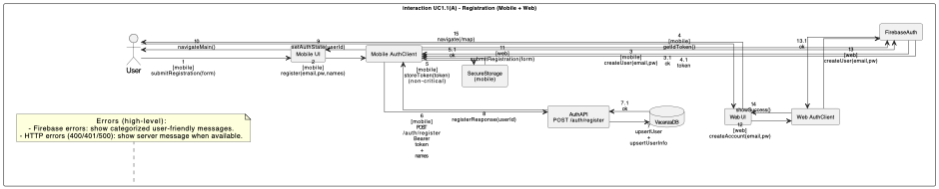
Figure 5 (A) UC1.1 Registration (Mobile and Web)
This diagram shows the account creation flow for both Mobile and Web clients. The client registers the user in Firebase, retrieves a Firebase ID token, and then synchronizes the profile with the backend via POST /auth/register. Mobile additionally stores the token in secure storage (non-critical).
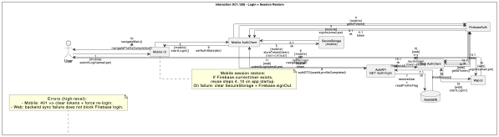
Figure 6 (B) UC1.1 Login and Session Store (Mobile)
This diagram covers login for both Mobile and Web clients. After Firebase authentication, the client retrieves an ID token and synchronizes the session with the backend via GET /auth/login to obtain user metadata (e.g., profileCompleted). Mobile session restore reuses the same token+backend validation path on app startup.
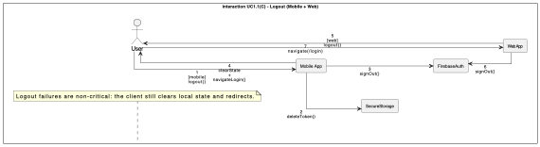
Figure 7 (C) UC1.1 Logout (Mobile and Web)

This diagram shows logout behavior on both platforms. Mobile clears secure storage, signs out from Firebase, clears in-memory state, and navigates to login. Web signs out from Firebase and navigates to login. Logout errors are treated as non-blocking.

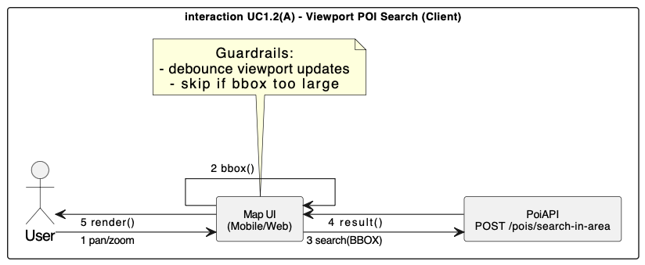
Figure 8 (A) UC1.2 Viewport POI Search
Shows viewport-driven POI search on the client: viewport bounds are computed (BBOX), guarded by debouncing/size checks, and sent to the backend; results are rendered as markers and category counts.
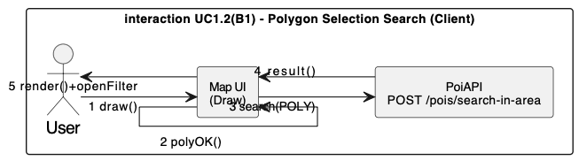
Figure 9 (B1) UC1.2 Polygon Selection Search
Shows polygon selection flow: the user draws and finalizes a polygon, a POLYGON search is issued, and the filter panel is opened after results return.
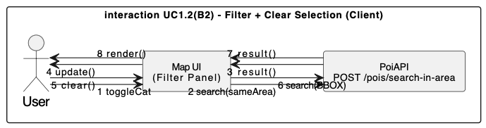
Figure 10 (B2) UC1.2 Filter and Clear Selection
Shows filter and clear flow: category toggles trigger a re-search for the same area; clearing selection switches back to viewport (BBOX) search.
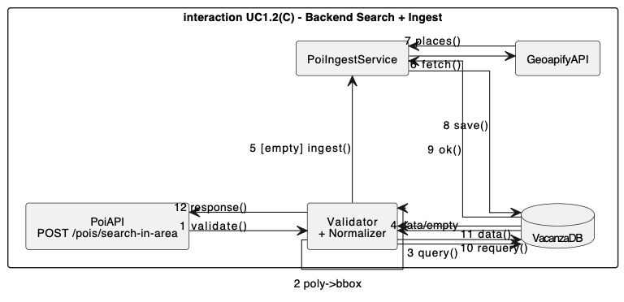
Figure 11 (C) UC1.2 Backend Search and Ingest
Shows backend request handling: validate + normalize (POLYGON→BBOX), query DB, ingest from Geoapify when empty, persist, re-query, and return response DTO.
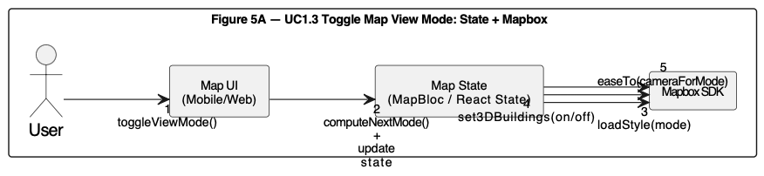
Figure 12 (A) UC1.3 Toggle Map View Mode (Mobile and Web)
This diagram shows how the user cycles map view modes (2D → 3D → Satellite). The UI triggers a mode change, the state layer computes the next mode and updates state, and the Mapbox SDK applies the corresponding style, 3D building visibility, and camera animation. This flow is frontend-only and does not call backend services.
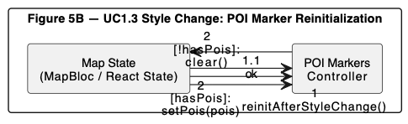
Figure 13 (B) UC1.3 Marker Reinitalization After Style Change (Mobile and Web)
This diagram shows how POI markers are kept consistent after a style switch. After Mapbox loads a new style, the POI marker controller is reinitialized so that sources/layers are recreated if needed; then the controller either re-renders the current POIs or clears markers if no results exist. This prevents markers from disappearing or referencing stale layers after style reloads.
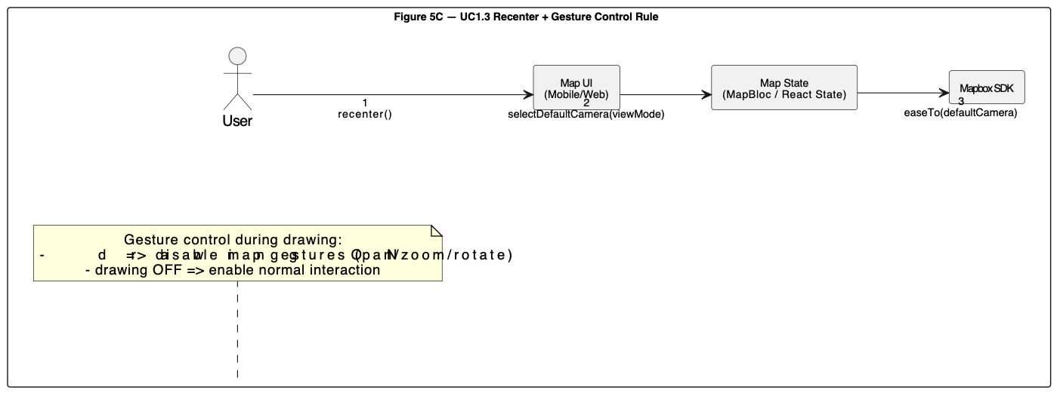
Figure 14 (C) UC1.3 Recenter and Gesture Control Rule (Mobile and Web)
This diagram shows recenter behavior and the gesture control rule during drawing. When the user taps recenter, the state layer selects the default camera configuration based on the current view mode and animates the camera via Mapbox. Additionally, when drawing mode is enabled, map gestures (pan/zoom/rotate) are disabled to avoid accidental camera movement; they are re-enabled when drawing mode is turned off.

Detailed Design Diagrams
Detailed Design Diagrams in this section present the design-level structure and runtime interactions of the First Increment scope (UC1.1, UC1.2, and UC1.3). The diagrams collectively cover both frontend (mobile/web) and backend components, highlighting key modules, responsibilities, and dependencies, as well as the end-to-end request flows across controller, service, repository, and external integration layers.

Class Diagrams
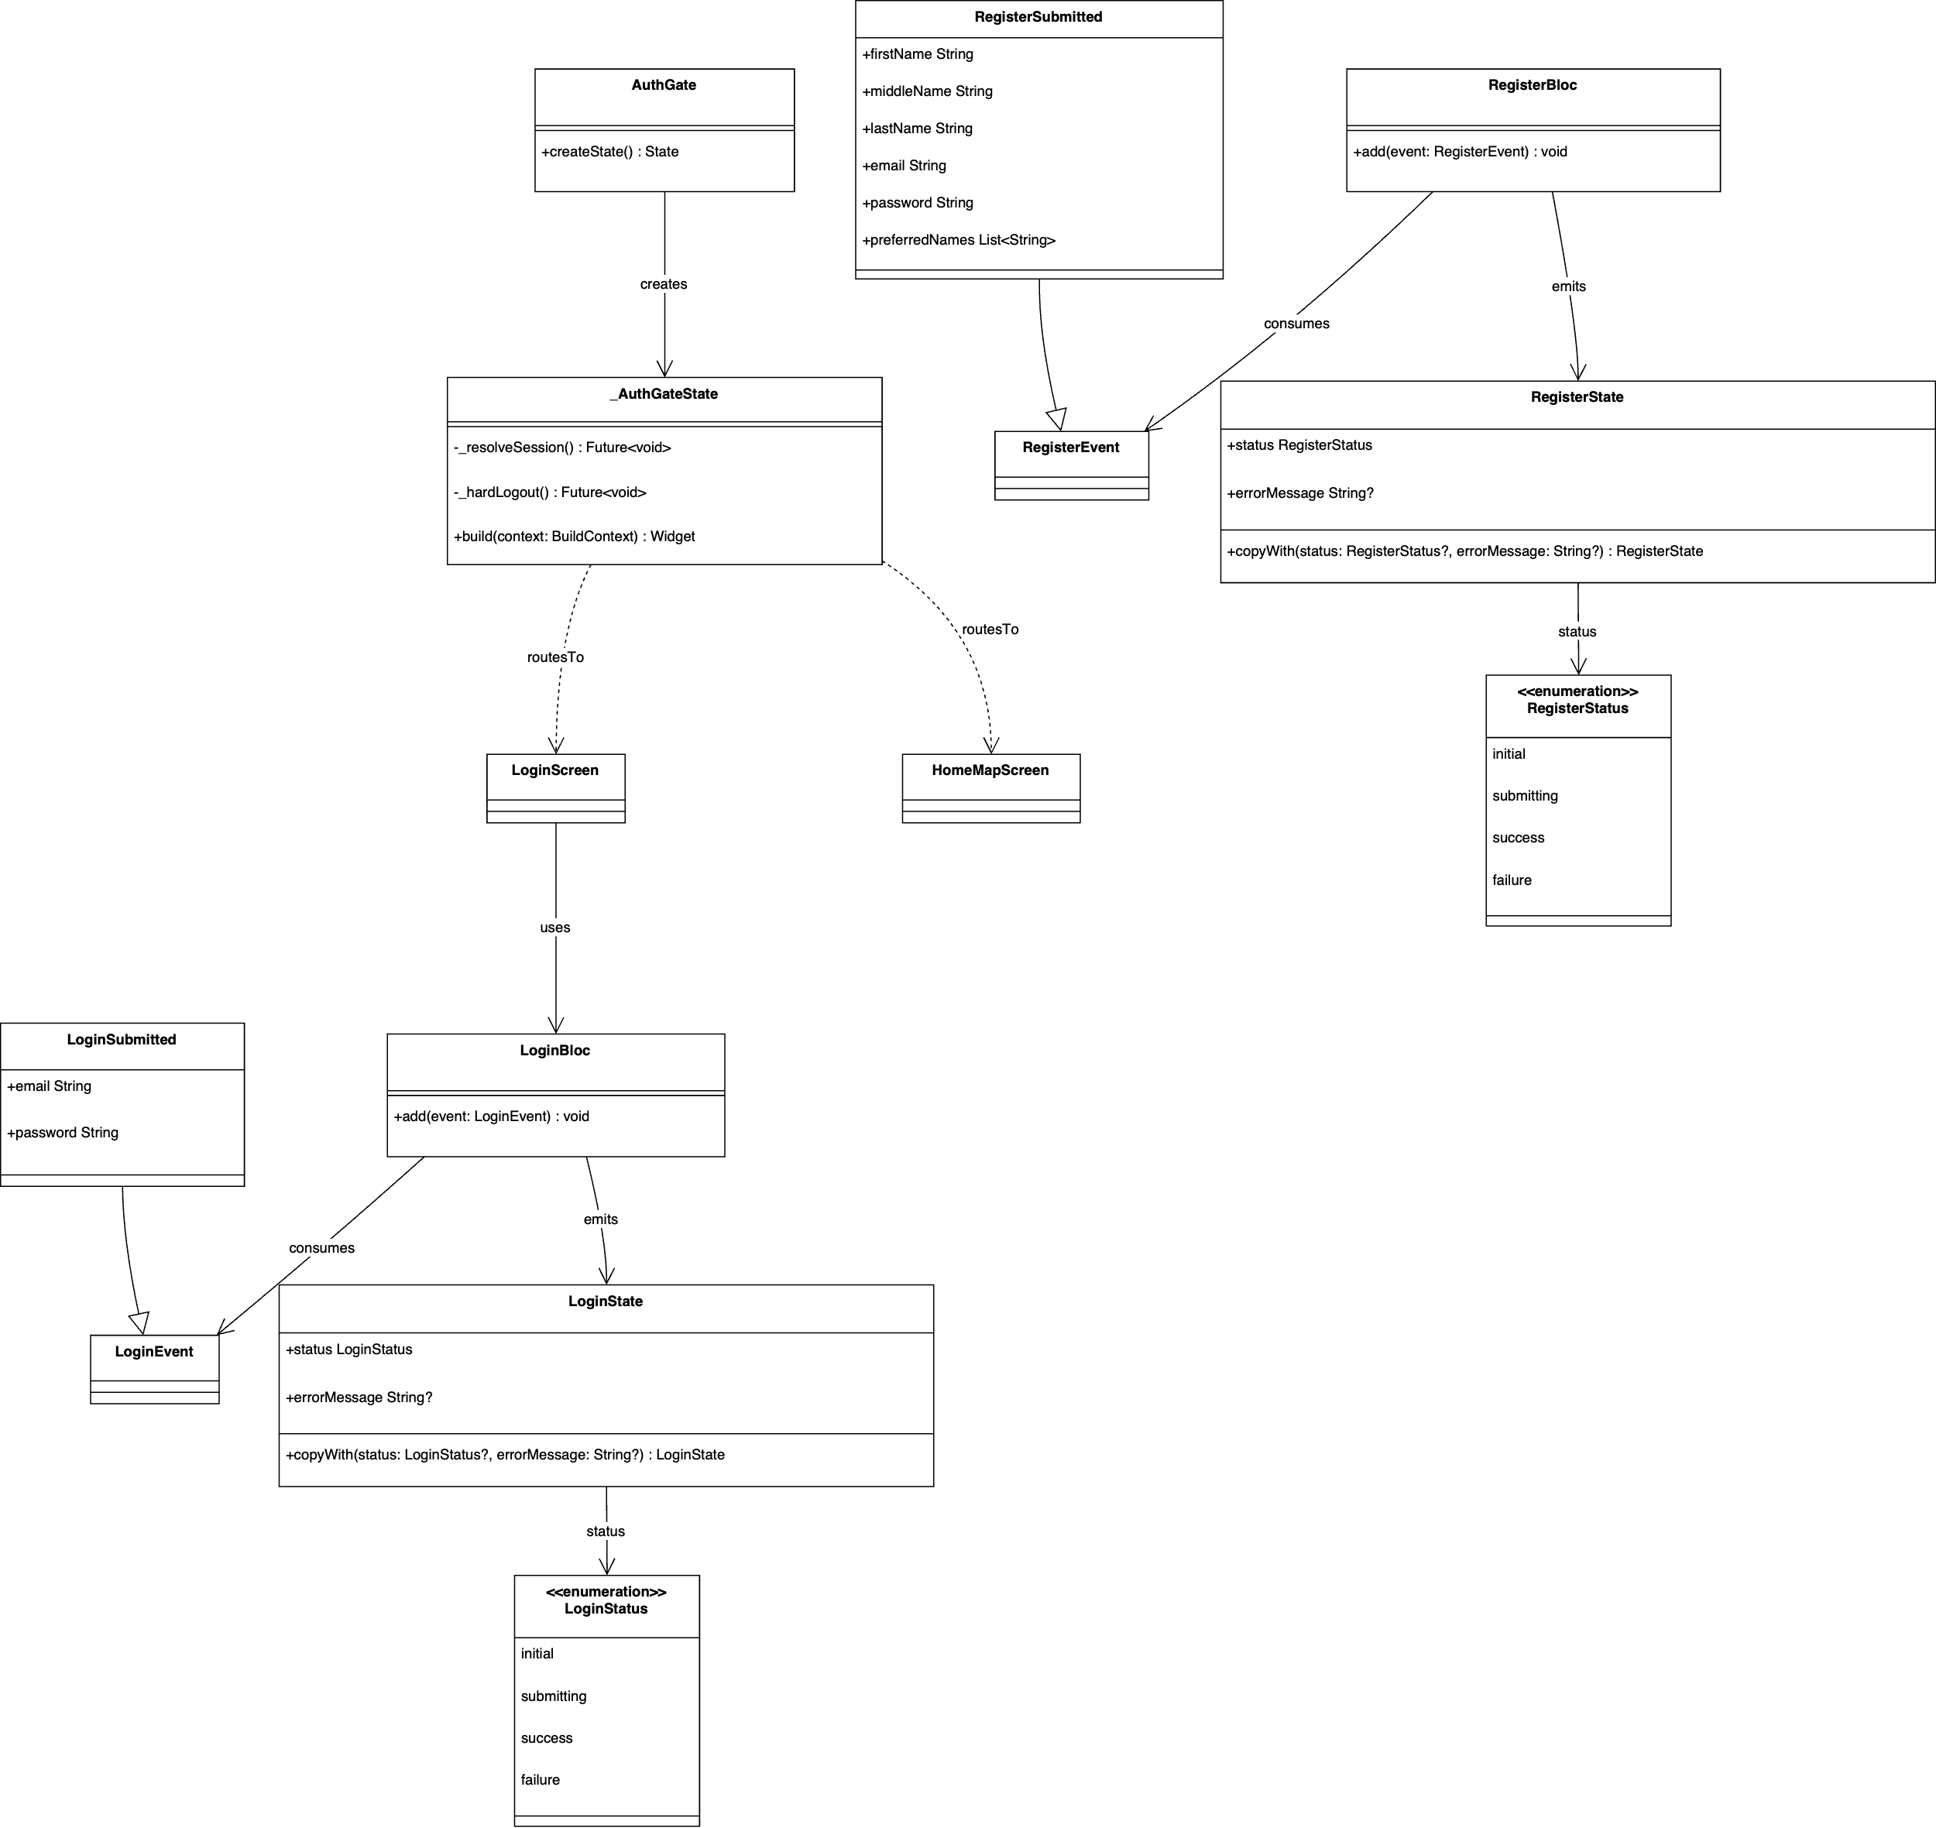
Figure 15 (A) Mobile Class Diagram (UC1.1 for UI and BLoC)
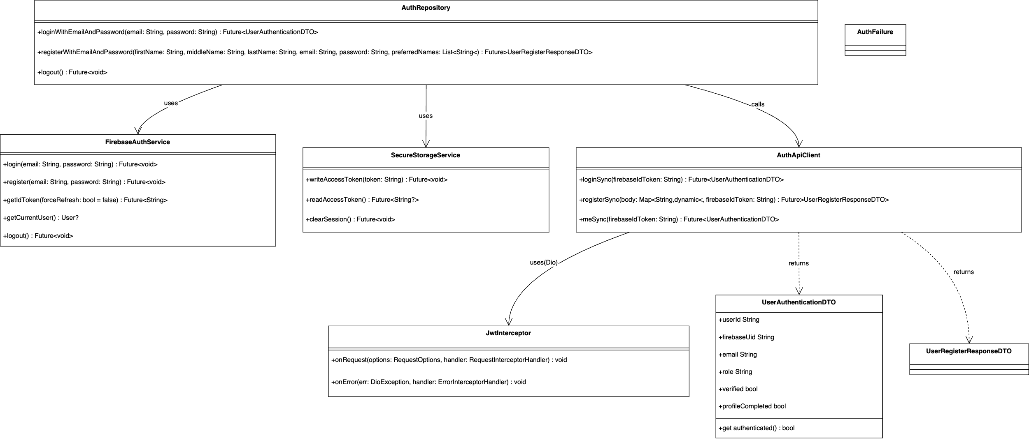
Figure 16 (B) Mobile Class Diagram (UC1.1 for Repo, Services, Client, DTOs)
These diagrams present the First Increment mobile UC1.1 design, showing how the UI, BLoCs, repository layer, Firebase integration, and backend sync client collaborate to establish and maintain a user session. Figure 15 focuses on the UI and BLoC structure, where user actions on the authentication screens dispatch events to the BLoCs. The BLoCs then invoke the authentication operations through AuthRepository, which is detailed in Figure 16 together with the supporting services and the backend synchronization client that returns the authentication DTOs. Figure 16 is a continuation of Figure 15; the UC1.1 mobile authentication class diagram is split into these two parts to improve readability and avoid visual clutter while preserving the same design scope and relationships.
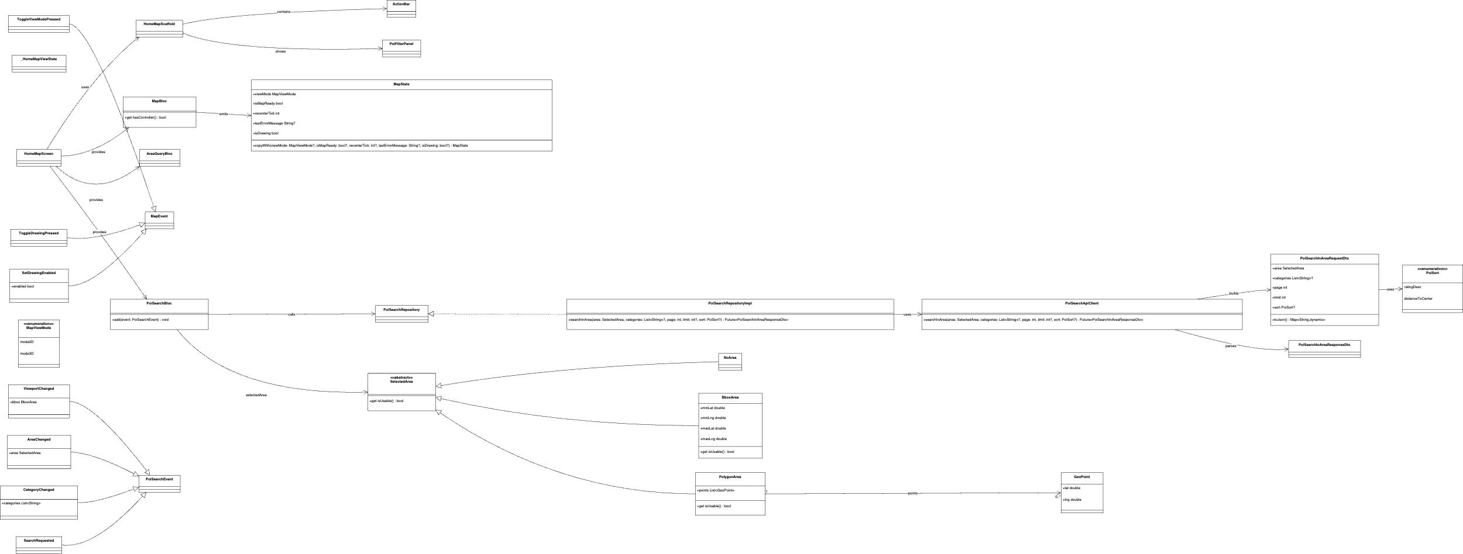
Figure 17 Mobile Class Diagram (UC1.2 and UC1.3)
This diagram shows the First Increment mobile map and POI search design, including map state management, area selection (BBOX/POLYGON), category selection, and the repository/API client structure used to request POIs from the backend.
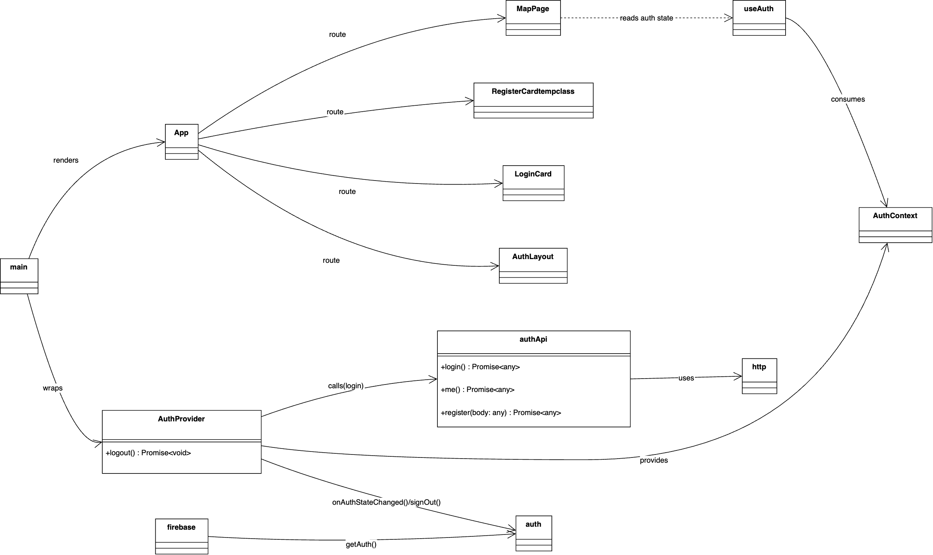
Figure 18 Web Class Diagram (UC1.1)
This diagram summarizes the First Increment web authentication design at a high level, focusing on routing, AuthProvider/AuthContext usage, and the API modules responsible for login/me/register calls.
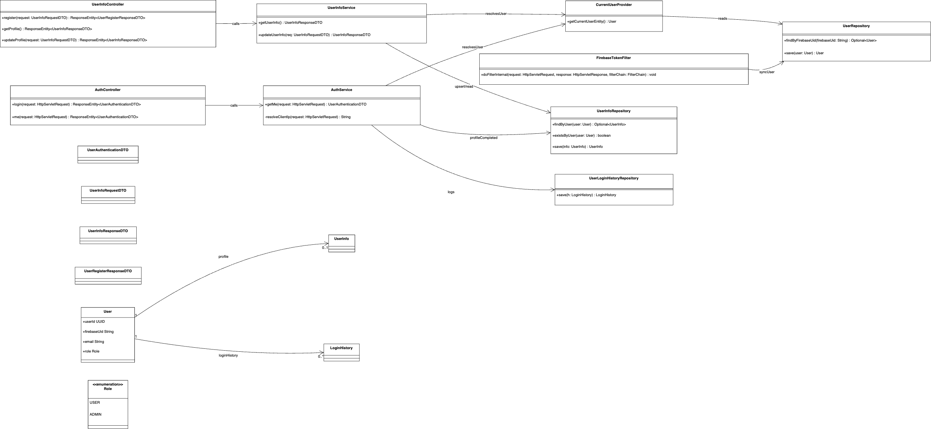
Figure 19 Backend Class Diagram (UC1.1)
This diagram illustrates the backend authentication and profile design, including token verification, current-user resolution, user synchronization, login history logging, and profile upsert operations through controller/service/repository layers.
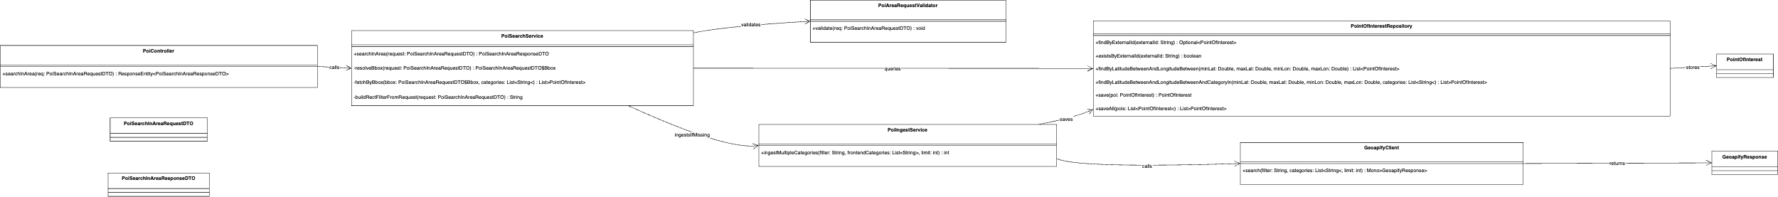
Figure 20 Backend Class Diagram (UC1.2)
This diagram presents the backend POI search design for First Increment, detailing validation, query/ingest logic, repository access, and external Geoapify integration used to return POIs and category counts.

Sequence Diagrams
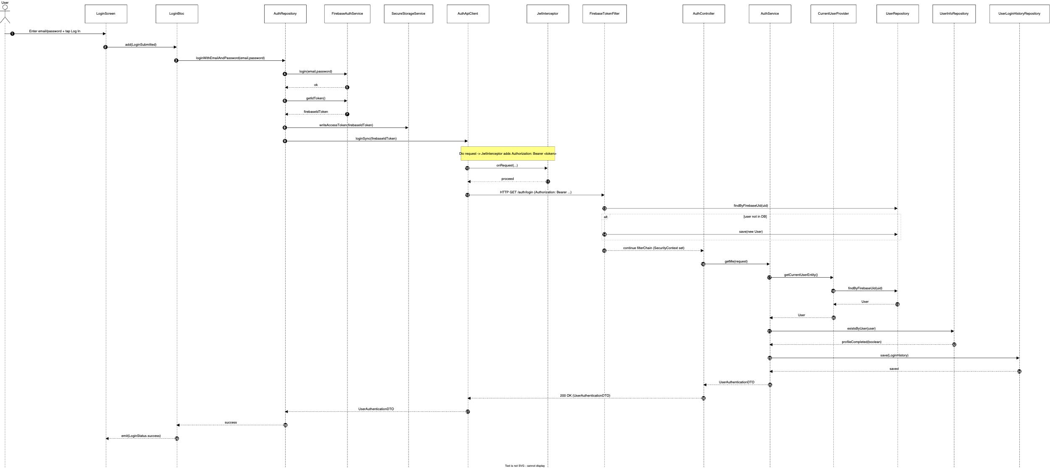
Figure 21 Sequence Diagram (UC1.1 and Session Sync)
This sequence diagram shows the end-to-end login flow from the mobile UI to Firebase authentication, token propagation to the backend, security filtering, user synchronization, and the final authentication response returned to the client.
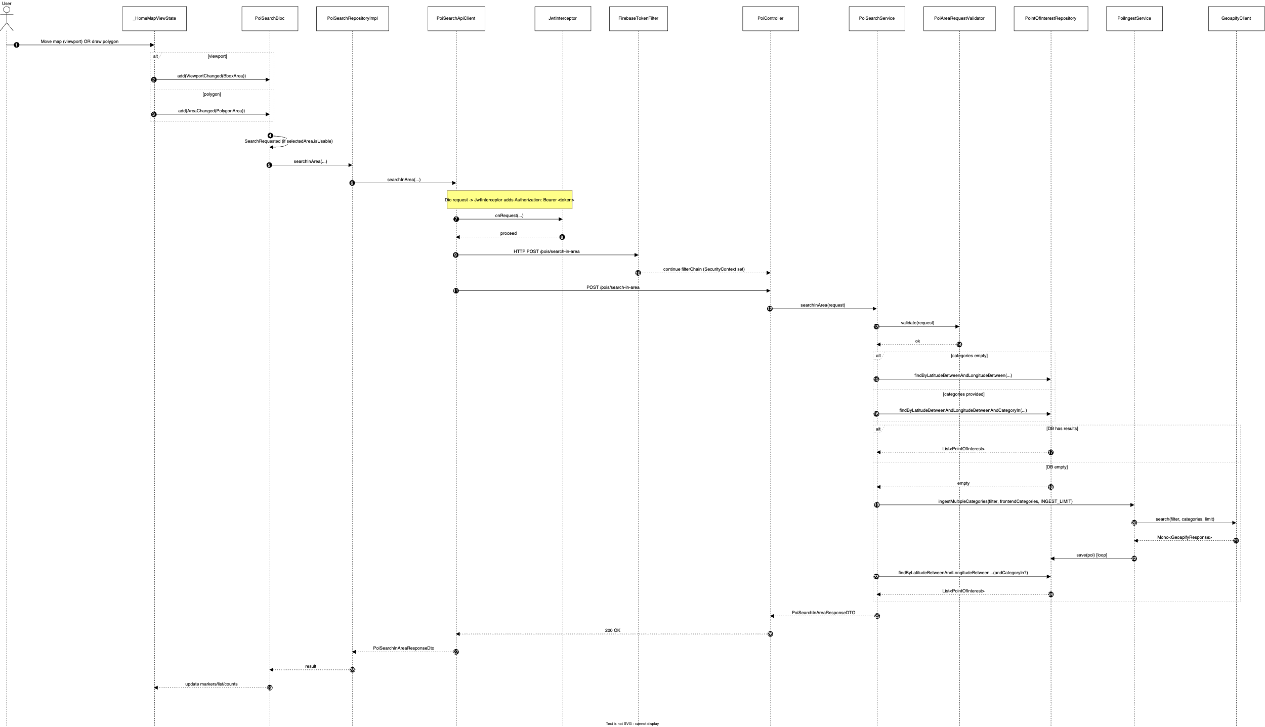
Figure 22 Sequence Diagram (UC1.2)
This sequence diagram describes the POI retrieval flow for BBOX/POLYGON selections, including request propagation through controller/service/repository layers and the fallback ingest path when the database does not contain matching POIs.
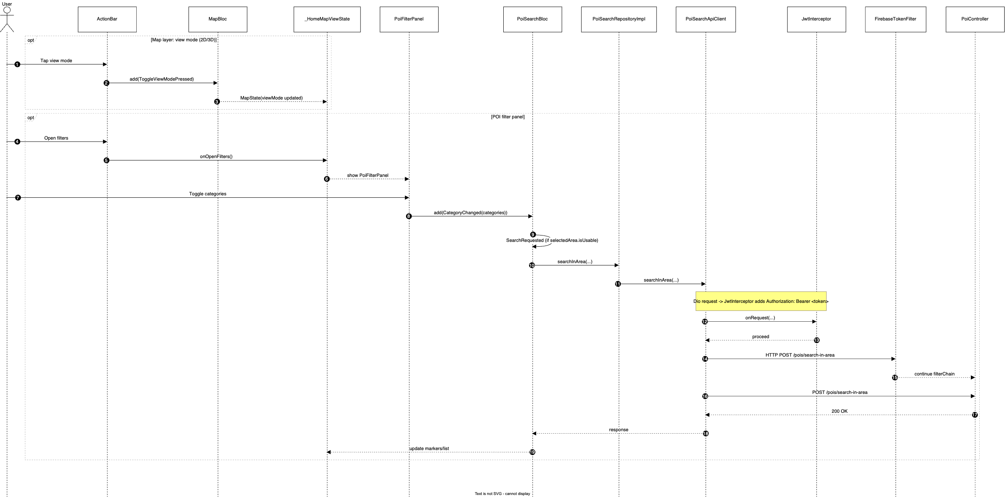
Figure 23 Sequence Diagram (UC1.3)
This sequence diagram shows how view mode changes are handled in the client and how category toggles trigger a new POI search request, updating the UI with refreshed markers and list content.

Test Cases

Unit Test Cases
All FReq References are from SRS(A)v2 Document.

UT-01 – Default Map Loads with POI Pins
Test Case ID: UT-01
Title: Load default map and render POI pins
Related Requirement ID: FReq4
Preconditions: Map component is initialized
Test Data: Default POI category configuration
Test Steps:
- Initialize the map component.
- Wait until the map loading process completes.
Expected Result: The map component loads successfully and POI pin components are rendered without runtime errors.

UT-02 – Map Layer Button Updates View
Test Case ID: UT-02
Title: Clicking the map layer button updates the map view
Related Requirement ID: FReq4
Preconditions: Map component is rendered and visible
Test Data: Layer (map style) button on the right-side map controls
Test Steps:
- Click the Layer (map style) button located on the right-side control panel.
- Observe the map appearance.
- Click the same button again.
Expected Result: The map layer changes on each button click, and the map remains responsive without visual or functional errors.

UT-03 – Category Filter Updates Visible POI Pins
Test Case ID: UT-03
Title: Applying category filters updates visible POI pins
Related Requirement ID: FReq4
Preconditions: Filter panel is open and visible
Test Data: Category filter buttons (e.g., Restaurants, Cafes, Museums, Monuments, Parks)
Test Steps:
- Click a category filter button in the filter panel to deactivate it.
- Observe the displayed POI pins on the map. Click the same category filter button again to activate it.
Expected Result: POI pins are updated on the map according to the currently active category filters, without delay or visual errors.

UT-04 – Drawing Mode Filters and Displays POIs Within Selected Area
Test Case ID: UT-04
Title: Drawing an area filters and displays POIs within the selected region
Related Requirement ID: FReq14
Preconditions:
- Map component is rendered
- Draw area button is visible
- At least one POI category is active
Test Data: Freehand area drawing input, active POI categories (e.g., Restaurants, Cafes)
Test Steps:
- Click the Pen (drawing) button on the map controls.
- Draw a closed area on the map.
- Complete the drawing action.
Expected Result: The drawn area is highlighted on the map, and only POIs located within the selected area are displayed with their names according to the active category filters.

UT-05 – Filter Panel Reappears After Area Drawing
Test Case ID: UT-05
Title: Filter panel becomes visible after area drawing is completed
Related Requirement ID: FReq14
Preconditions:
- Map component is rendered
- Draw Area mode is available
Test Data: Valid polygon area selection
Test Steps:
- Click the Pen (drawing) button.
- Draw and complete a valid area on the map.
- Observe the filter panel state.
Expected Result: The filter panel automatically becomes visible after the drawing operation is completed.

UT-06 – Invalid Area Drawing Does Not Apply Filters
Test Case ID: UT-06
Title: Invalid area drawing does not apply area-based filtering
Related Requirement ID: FReq14
Preconditions:
- Map component is rendered
- Draw Area mode is enabled
Test Data: Invalid drawing input (e.g., incomplete or self-intersecting shape)
Test Steps:
- Click the Pen (drawing) button.
- Attempt to draw an invalid or incomplete area.
- Finish the drawing action.
Expected Result: The system does not apply area based filtering, and POI results remain unchanged while no area highlight is displayed.

Acceptance Test Cases

AT-01 – User Opens Map and Sees Default POIs
Test Case ID: AT-01
Title: User opens the map screen and views default POIs
Related Requirement ID: FReq4
Preconditions:
User is authenticated and navigates to the map screen
Test Data: Default active POI categories
Test Steps:
- Open the map screen.
- Observe the map content and displayed POI pins.
Expected Result: The map screen is displayed as the main interface, and POI pins belonging to the default active categories are visible on the map.

AT-02 – User Changes Map Layer Using Layer Button
Test Case ID: AT-02
Title: User changes the map layer using the layer button
Related Requirement ID: FReq4
Preconditions: Map screen is open
Test Data: Layer (map style) button on the right-side map controls
Test Steps:
- The user clicks the Layer (map style) button on the map control panel.
- The user clicks the same button multiple times.
Expected Result: The map appearance updates according to the selected layer on each interaction, and the map remains usable and responsive.

AT-03 – User Applies Category Filters
Test Case ID: AT-03
Title: User applies POI category filters from the filter panel
Related Requirement ID: FReq4
Preconditions:
- Map screen is open
- Filter panel is accessible from the map interface
Test Data: Category filter buttons in the filter panel (e.g., Restaurants, Cafes, Parks, Museums, Monuments)
Test Steps:
- User opens the filter panel from the map interface.
- User disables all categories except one (e.g., Restaurants).
- User observes the POIs displayed on the map.
Expected Result: Only POIs belonging to the selected category are displayed on the map, and all other category POIs are hidden.

AT-04 – User Draws an Area on the Map
Test Case ID: AT-04
Title: User draws an area and the system highlights the selected region
Related Requirement ID: FReq14
Preconditions:
- Map screen is open
- Pen (drawing) icon is visible on the map controls
Test Data: Freehand area selection drawn by the user
Test Steps:
- User clicks the Pen (drawing) button on the map interface.
- User draws a closed area on the map.
- User completes the drawing action.
Expected Result: The selected area is detected and visually highlighted on the map, indicating that the area selection has been successfully applied.

AT-05 – Filters Apply Within Selected Area
Test Case ID: AT-05
Title: Category filters affect POIs only within the selected area
Related Requirement ID: FReq14
Preconditions:
- A valid area has been drawn on the map using the Draw Area feature
- Filter panel is visible
Test Data: POI category selection (e.g., Monuments)
Test Steps:
- User completes drawing a valid area on the map.
- User opens the category filter panel.
- User disables one POI category.
Expected Result: POI results are updated based on the selected category and only POIs located within the drawn area are displayed on the map.

AT-06 – “Results in Your Area” List Appears After Area Selection
Test Case ID: AT-06
Title: List of POIs within the selected area is displayed after drawing
Related Requirement ID: FReq14
Preconditions:
- Map screen is open
- Draw Area feature is available
Test Data: POIs located inside the user drawn area
Test Steps:
- The user clicks the Pen (drawing) button.
- The user draws and completes a valid area on the map.
- The user observes the lower section of the map screen.
Expected Result: A “Results in Your Area” panel appears at the bottom of the screen, displaying a list of POIs located within the drawn area. The listed results reflect the current category filter state, if any filters are applied.

AT-07 – User Resets Selected Area (for Web Only)
Test Case ID: AT-07
Title: User resets the selected area using the Reset Area button
Related Requirement ID: FReq14
Related NFR(s): SRS(A)v2 §6.1 Effectiveness; §6.1 Efficiency; §6.5 Error Handling
Preconditions:
- Map screen is open
- A valid area has been drawn on the map
- Filter panel is visible
Test Data: Reset Area button in the filter panel
Test Steps:
- User clicks the Reset Area button in the filter panel.
- User observes the map view and displayed POIs.
Expected Result: The previously drawn area is removed from the map and area based filtering is cleared. POIs are displayed based on the current viewport and the currently active category filters, and the map returns to its default interaction state without any visual artifacts or functional errors.

GitHub Access

GitHub Account Association and Contribution Tracking
A dedicated GitHub account named VacanzaTravelApp was created using a project-specific email address and is used as the owner of the project repositories. Under this account, a single public repository named Vacanza has been created and structured as a mono-repository, containing separate directories for backend, web, and mobile components. This structure allows all parts of the system to be developed and tracked within a single centralized repository.
The project repository is publicly accessible at:
https://github.com/VacanzaTravelApp/Vacanza.git

Login and Access to GitHub Repositories
The Project Advisor and the CTIS 411 Instructor are associated with the project by being invited as collaborators to the Vacanza repository. The Project Advisor (Neşe Şahin Özçelik) has had collaborator access since the early stages of repository creation. At the time of writing this document, the CTIS 411 Instructor (Umut Hüseyinoğlu) has been invited as a collaborator, and the invitation is currently pending acceptance.
Once the invitation is accepted, both the Project Advisor and the Instructor can log in to GitHub using their existing personal GitHub accounts and access the Vacanza repository directly. All collaborators have read and write permissions on the repository, while administrative privileges are restricted exclusively to the VacanzaTravelApp account to ensure controlled and secure repository management.

Tracking Contributions for the First Increment
All development activities are carried out by team members using their own personal GitHub accounts, each of which is added to the repository as a collaborator. As a result, every commit, branch, and pull request is directly associated with an individual GitHub user, making authorship fully traceable.
However, evaluating contributions for the first increment cannot rely solely on GitHub statistics. While GitHub provides the technical record of implementation (commits, branches, pull requests, authorship, and timestamps), a complete and accurate assessment requires examining GitHub together with Jira.
The project follows a Scrum-based workflow supported by Jira. For the first increment, all planned work is defined through increment-specific Jira epics and tasks, each assigned to specific team members. Development is performed on task-specific branches created from the production branch and named using the corresponding Jira task identifiers. Commit messages consistently include the related Jira task ID along with a brief description of the implemented changes.
By reviewing Jira tasks created for the first increment together with their linked GitHub branches, commits, and pull requests, the Project Advisor and Instructor can clearly determine who was responsible for which tasks and how much work was completed during the first increment period.

Tracking Contributions for the Overall Project
For evaluating contributions across the entire project lifecycle, GitHub provides multiple built-in mechanisms such as commit history, pull requests, branch activity, and contributor statistics. These mechanisms offer a quantitative overview of the technical output produced by each team member.
However, similar to the first increment, GitHub alone does not fully capture responsibility boundaries or task ownership across the whole project. Therefore, overall contribution assessment is performed by correlating GitHub activity with Jira task assignments and progress history. GitHub reflects how the work was implemented, while Jira reflects what was planned, who was responsible, and when tasks were carried out across different increments.
The repository also provides access to the Insights → Contributors section, which summarizes overall contribution statistics. While this view may emphasize the main branch, it is complemented by branch histories, pull request records, and Jira task tracking, ensuring a comprehensive, fair, and context-aware evaluation of individual contributions throughout the entire project.
Furthermore, Jira tasks are explicitly assigned to individuals and remain accessible for review. If required, the Project Advisor and Instructor may also be granted access to Jira to cross-check task ownership, progress, and linked GitHub activity, ensuring full transparency between project management records and source code contributions.

Discussions
The preparation of the Software Design Description document presented our team with significant challenges, primarily due to timing constraints. We were only able to begin working on the SDD during the final week before project submission, as this period coincided with final exams across all our courses. This compressed timeline meant working under considerable time pressure while simultaneously managing exam preparations and other academic responsibilities.
Building upon our experiences with the SRS and SPMP documents, we encountered familiar but intensified challenges. The division of work remained problematic—sections such as the architectural design, EER diagram creation, and low-level design for the first increment use cases required substantially more effort and technical depth than other parts. Unlike previous deliverables, the SDD's technical diagrams and design decisions required specific domain knowledge, making it difficult to reassign tasks midway. We maintained our collaborative approach with team members who completed their sections earlier assisting others, but the tight deadline limited how much balancing we could achieve.
The level of detail required proved more demanding than anticipated. Creating UML diagrams with proper notation, cardinalities, and relationships required multiple iterations and peer reviews. The EER diagram needed several revisions as we discovered inconsistencies between our database design and the functional requirements outlined in our SRS. Each revision had cascading effects on other sections, requiring updates to the logical view and deployment diagrams.
Coordination challenges were amplified by concurrent work on implementation and finals. Scheduling team meetings became increasingly difficult, forcing us to rely heavily on asynchronous communication. This sometimes led to delays in receiving feedback on critical design decisions. Despite these difficulties, the process has been valuable for understanding software engineering practices and has strengthened our team coordination capabilities under pressure.

Anthropic Claude 4.5 Prompt: “write an executive summary related to the work we have carried out while preparing this SDD, ensuring that a reader who is reviewing this document for the first time can easily understand its content”
ChatGPT 5.2 Prompt: “*figure is given and use cases are explained*briefly describe main functionalities and clearly mark the 1st Increment scope by stating that UC1.1 (Create Account/Login) is included as a baseline enabler, while UC1.2 and UC1.3 are implemented in Increment 1.”
ChatGPT 5.2 Prompt: “describe the system as multi-client client–server and link the choice to NFRs with traceable references (e.g., SRS(A)v2 §6.1), including brief pros/cons and noting the team split into web, mobile, and backend responsibilities.”
ChatGPT 5.2 Prompt: “Create a detailed block diagram representing the logical software architecture for the "Vacanza" travel application. The diagram must follow a strict Layered Architecture pattern.”
ChatGPT 5.2 Prompt: “Provide a detailed academic narration explaining how the system functions, explicitly mapping the architectural components to the Functional Requirements (FReqs) and sections (e.g., §3.1, §7.1) from the Software Requirements Specification (SRS)”
ChatGPT 5 Prompt: “Narrate the EER diagram.”
ChatGPT 5.2 Prompt: “I want you to generate a conceptual Enhanced Entity–Relationship (EER) diagram using Chen’s notation, based on the Software Requirements Specification (SRS) document of our system (Section 7.1 – Database Design).”
ChatGPT 5.2 Prompt: “I want u to analyse spesifcaly physical view part of lecture notes and help me with generating UML Deployment Diagram.”
ChatGPT 5.2 Prompt: “can you narrate the given diagram”
ChatGPT 5.2 Prompt: “*all the NFreqs are given, after all the discussions* explain how the design addresses each NFReq category in SRS(A)v2 (SRS(A)v2 §6.1–§6.7.2) and how compliance will be verified/validated using the document’s testing approach, without claiming unimplemented practices or repeating the Selected Architecture text.”
ChatGPT 5.2 Prompt: “Review SRS(A)v2 and prepare a Test Case Design section and write descriptions according to given instructions”
ChatGPT 5.2 Prompt: “I need your assistance in analyzing the code I've provided and generating pseudocode for the SDD document. Please make the pseudocode sufficiently descriptive so that someone viewing it from the outside can quickly grasp the purpose and functionality of the code.”
ChatGPT 5.2 Prompt: “can you provide an introduction paragraph the section”
ChatGPT 5.2 Prompt: “Based on the Vacanza project’s SRSv2, generate Unit and 1st Increment Acceptance Test Cases for the implemented map and POI features”
ChatGPT 5.2 Prompt: “A detailed description of the project’s GitHub repository structure, access permissions, branch and pull request workflow, Jira–GitHub integration, and contribution tracking approach was provided to an AI tool, and this information was used to support the preparation of a clear and academically consistent response to the instructor’s questions regarding individual contributions.”
ChatGPT 5.2 Prompt: “*all the challenges and solutions are explained* can you write them in academic english”

